**A Symbiotic System Model for the Development for Canadian Oil Sands**

David J. Taylor1, Alexander H. Slocum1, Santiago Paiva2, Kevin P. Simon1, Mark Bartlett 3

1 Massachusetts Institute of Technology, Cambridge, MA, USA

2 McGill University, Montreal, QC, Canada

3 Unifor Windsor Regional Environment Council, Windsor, ON, Canada

**Abstract.** We propose a symbiotic system model for the development of Canadian Oil Sands: for example, if 10 % of Canadian Oil Sands income (priced at US$75 per barrel of oil) were to be invested in renewable-energy machines as part of reclamation efforts for the land that is mined, then three significant results can follow. First, we estimate that in 36 years as much CO2 will have been kept from the air from burning coal to make electricity as was released into the air from mining the oil sands and consuming the oil. Second, the investment is a better and more productive alternative to the Carbon Tax because the money is put directly to use to benefit oil sands development in the short term and renewable power generation in the long term, and the resources remain on the development companies’ balance sheets. Finally, during periods of peak electrical power generation, the power can be sold back to the grid, power electric underground heaters for liquefying bitumen for extraction without mining operations, or to power operations for cleaning contaminated water of Poly-Aromatic Hydrocarbons (PAH), which can be hydrocracked into useful compounds.

**1- Introduction**

The Northern Alberta region contains 98% of the Canadian oil sands, covering about 140,200 square kilometers [Alberta Energy. “About Oil Sands: Facts and Statistics”. Retrieved on March 13, 2014 from Alberta Energy Website: http://www.energy.alberta.ca]. It is also estimated that these regions hold proven reserves up to 1.75 trillion barrels of bitumen [Alberta Environment. (2008). “[Alberta's Oil Sands: Opportunity, Balance](http://www.environment.alberta.ca/documents/Oil_Sands_Opportunity_Balance.pdf)”. Retrieved on March 19, 2014 from Alberta Environment Website: http://environment.alberta.ca]. About two tons of oil sands must be dug up, moved, and processed to produce one barrel of synthetic oil [Alberta Energy. “Oil Sands 101”. Retrieved on August 20, 2014 from Alberta Energy Website: http://www.energy.alberta.ca]. Detractors hypothesize that mining, processing, and using the oil from the oil sands will greatly exacerbate global carbon dioxide (CO2) problems, and extend this argument as a reason for the US to deny permission to grant approval for the Keystone XL pipeline. Proponents say that global CO2 impact will be no different than from other sources of oil, and the pipeline is safer than rail shipments. All parties must agree however, that the Energy Return on Investment (EROI) from oil sand extraction is lower than conventional oil extraction.

We hypothesize that through a symbiotic system, we can mitigate environmental concerns and facilitate the development of the Keystone XL pipeline. Specifically, we propose a system where oil companies are required to invest a portion of their revenues in renewable energy generation on site and are further required to reinvest some of the money saved by that renewable generation.

**2- Methods**

Our proposed symbiotic system would require oil companies to invest in renewable energy generation as a part their land reclamation. The investment amount is a function of the number of barrels of oil sold and the amount of renewable energy generated by the generation capacity installed as part of this system. We investigated investments into wind generation capacity and the impact of different required investment rates in US dollars and different reinvestment into wind turbine purchase and maintenance.

To account for the environmental benefits of the proposed symbiotic system, we considered the ratio of the carbon offset by wind power, to the carbon produced by the oil sands. Specifically, we considered the marginal carbon impact of the oil sands compared to conventional oil (Production), and the total carbon cost of producing and consuming oil from the oil sands (Total). Further, we considered both the instantaneous carbon ratio (ICR) of these numbers at any given point in time, and the cumulative carbon ratio (CCR), which considers the total amount of emissions and offset emissions since the start of the project.

Comparisons across the published studies of GHG life-cycle emissions intensities for fuels derived from different sources are sensitive to each study’s choice of boundaries and input parameters Lattanzio (2012) reviewed data from the primary studies of the U.S. Department of State (DOS) and contractor ICF International L.L.C, and the analysis from the Final Environmental Impact Statement (EIS), finding the following emission numbers [Lattanzio, R. (2012). Canadian Oil Sands: Life-Cycle assessments of Green House Emissions. Congressional Research Service]

* Carbon emissions from oil sand production (Well-to-Tank)
  + Well-to-Tank GHG emissions are valued at 18 g CO2e/MJ LHV
  + Equivalent to MT CO2e/bbl
* carbon emissions from oil consumption (end use) (Tank-to-Wheel or Combustion)
  + Tank-to-Wheel GHH emissions are valued at 73 g CO2e/MJ LHV
  + Equivalent to MT CO2e/bbl
* carbon emissions from oil sands production and consumption (Well-to-Wheel)
  + Well-to-Wheel GHG emissions are valued at 91 g CO2e/MJ LHV
  + Equivalent to MT CO2e/bbl

The bitumen production by the Alberta’s oil sands industry has reached 1.9 million barrels/day [http://oilsands.alberta.ca/resource.html]

|  |  |
| --- | --- |
| Carbon emissions from oil sand production per year | 76.14 MT CO2e |
| Carbon emission from oil sand (end use) per year | 308.81 MT CO2e |
| Total carbon emission from oil sand production and consumption per year | 384.96 MT CO2e |

*2.1 Accounting for the GHG Emissions of Oil Sands*

To account for the climate impact of the Canadian oil sands, we use the metric of kg CO2,eq/bbl of refined oil. We account for these GHG emissions in three categories:

1. the incremental emissions caused by the carbon intensive production, upgrading, refining, and transportation of oil sands, as compared to the 2005 average GHG emissions of oil refined in the US;
2. the total GHG emissions associated with production, upgrading, refining, and transportation of oil (well-to-tank); and
3. the total GHG emission from production through end consumption (well-to-wheel).

Studies vary up to 30% on the emissions of even a single type of crude oil [1]. Further complicating the matter, the GHG emissions of different oil sands extraction techniques, upgrading processes and quality of the oil can add up to almost 100%. Instead of adding to or choosing between the existing and vast literature on this topic, we built a Microsoft Excel-based tool to help policy makers, industry analysts, and researchers determine the potential benefits of the solutions proposed in this paper. The results presented in this paper use IHS CERA’s estimate for the emissions of the average oil sands refined in the US in 2011, using a wide system boundary, but the modeling tool is provided (as-is) in the Supplemental Information available online.

|  |  |  |  |
| --- | --- | --- | --- |
| GHG Emissions of the Oil Sands (Kg CO2,eq/bbl) | Incremental | Well-to-Tank | Well-To-Wheel |
| **“Average oil sands” (2011) wide boundary [1]** | **70.8** | **172.3** | **556** |
| “Average oil sands” (2011) narrow boundary [1] | 52.9 | 140.4 | 525 |
| Canadian Oil Sands: SAGD SCO (wide boundary) [1] | 111.3 | 212.8 | 598 |
| Canadian Oil Sands: Mining Dilbit (narrow boundary) [1] | 9.3 | 96.8 | 482 |
| AVG 2005 for oil refined in the US (narrow boundary) | -- | 87.5 | 473 |
| AVG 2005 for oil refined in the US (wide boundary) | -- | 101.5 | 487 |

For reference, Table Y summarizes the average and extreme values for the emissions summarized by [1]. The incremental value was calculated as the difference between a given process and the average US barrel refined in the US. Emissions values calculated with a “wide boundary” were accordingly compared to the 2005 average values calculated with a similarly “wide boundary.” While there are many available meta-analyses, we selected to use the values from IHS CERA because it was generated as an independent report and uses units of per barrel which are useful for the first-order model presented herein.

*2.2 Accounting for the GHG Emissions of Wind Turbines*

Again the focus of this study was not to accurately quantify the GHG emissions of wind turbines but to provide a decision-making tool. ~~Weisser’s review of 15 life cycle assessments of wind turbines concluded that onshore wind had an equivalent carbon emission ranging between 8 and 30 gCO~~~~2~~~~eq/kWh (electricity I think).~~ Raadal et al. reviewed 22 papers that assessed the GHG emissions associated with 1-5MW turbines; they found a range of 4-22 with a mean of 10.4 g CO2-eq/kWh [2]. This simple number however neglects the strong dependency on the capacity factor. Steel and concrete production account for the largest components of this carbon impact.

Raadal et al (2014) conducted a specific life cycle GHG emissions from wind power generation from six different 5 MW offshore wind turbine. The relatively large ranges in GHG emissions and energy performance are mainly the result of the differing steel masses required for the analyzed platforms. The default wind farm assessed is assumed to have a 20-year lifetime and a Capacity Factor (CF) of 46%

* Life cycle carbon emissions from wind turbine manufacturing and installation for a 5 MW offshore wind turbine [Raadal et al. (2014). GHG emissions and energy performance of offshore wind power. Renewable Energy 66 314-324]:
  + [18 – 31.4] g CO2e/KWh which averages to 24.7 g CO2e/KWh

Carbon emissions for Alberta and Canadian electricity generation [Mallia,E, Lewis, G (2012). Life cycle greenhouse gas emissions of electricity generation in the province of Ontario, Canada]:

* GHG intensity of electricity generation in Alberta to be 880 t CO2e/GWh
* GHG intensity of electricity generation in Canada to be 210 t CO2e/GWh

**Input assumptions.** Input assumptions can impact model results at each stage of the assessment. Key input assumptions include: two (three?) key constrains in the model:

* + $2/Watt cost with installation [ref needed!]
  + The 5% annual maintenance [ref needed!]
  + The total number of turbines capped at 70,000 ( approximately 1 per square km) of wind turbines to be built
  + Max amount of electricity generated?

*2.3 Emissions Offsets for Electricity Generation*

Generating electricity is only helpful when the generation of that power means that a more harmful generation technology can be turned off. The climate impact of adding wind turbines in a country with only hydro power is evidently different than in a country with only coal power. Further, the scale of wind production proposed in this model is extremely large and requires major power transportation outside the region where it was produced. As a first-order model, we considered four levels of resolution for carbon offsetting:

|  |  |  |
| --- | --- | --- |
| Location | Representative Distance (km) | GHG Emissions of Generation Mix |
| Onsite Usage | 0 | *Cogen: as a first estimate, 40% to electricity, 50% to usable heat with 10% loss[1]. Therefore 75% efficiency NG source of electricity generation. NG taken at 45% as an average between 35-42 for simple cycle and 52-60% for combined cycle* |
| Alberta | 500 |  |
| California | 2800 |  |
| Canada | 4000 | 85 Mt in 2013 [NIR report] to elec gen |
| United States | 5500 |  |

In Canada, official, regional, GHG emissions are reported with electricity and heating sources combined. To normalize for this, we instead used the mean GHG emissions associated with different supply types [3] and scaled these by the official generation mix numbers.

*2.4 Grid Capacity*

Because of the variability of wind power, a grid supplied by 100% wind from a single geographic location would evidently be unstable. Electricity system operators compensate for this instability in two ways: first by limiting the total percent of wind power they allow into their system, and second by purchasing dispatchable generation to supplement when the wind is not blowing. This model does not account for the emissions associated with this dispatchable generation; it is implicitly therefore assumed to be equivalent to the baseline generation mix. The capacity of reach regional unit and the additional wind percentage it will allow was taken as input to the model. The presented results assume that 20% wind power is an acceptable ratio.

|  |  |  |  |
| --- | --- | --- | --- |
| Location | Representative Distance (km) | Average Yearly Load (GW) | Current Wind Fraction |
| Onsite Usage | 0 | 1.1[2] | 0%[3] |
| Alberta | 500 | 8.8 [5] | 7% [5] |
| California | 2800 | 33.9 [6] | 8.1% [6] |
| Canada | 4000 | 71.6 [7] - 8.8 [5] = 62.8 | 1.6% [7] [0.8% w/o Alb] |
| United States | 5500 | 467 [8] - 33.9 [6] = 433.1 | 4.2% [8] [3.9% w/o Cali] |

*Transmission*

Delucci and Jacobson found that the cost of high power transmission lines ranged from $299-$429/MW/km of transmission capacity; their mean value was $372$/MW/km [9]. Long transmission lines that are not grid-connected can pose serious issues if they are ever interrupted as there is no method for the power to dissipate; previous proposals to export power from the oil sands to California have failed to overcome this issue [Ref needed]. Off-shore wind farms overcome this by requiring independent transmission lines to account for the possibility of one of them failing. Delucci and Jacobson did not account for this, but this factor is a variable in the Excel model and is taken as 2 for the results presented.

Transmission stations are expected to have a lifetime of approximately 30 years, while transmission towers and lines may last for 50-70 years [9]. The details of this modeling were beyond the scope of this proposal and so the built transmission capacity was assumed to last for the 40 year modelling window. The incremental emissions from transmission line construction and the losses incurred in transmission are left to a future version of the model.

*Cost of Wind*

We modeled the upfront costs of wind generation as US$5/MW, annual maintenance as 5%.

**3- Results**

The proposed symbiotic system considers the potential environmental benefits of installing wind turbines as a part of oil sands reclamation efforts.

* We used a mean carbon values from Lattanzio (2012), and we plugged it into an excel spreadsheet to investigate model behavior
* We looked at what happens if we force the carbon tax to get reinvested into wind turbines with and without reinvestment
* We also looked at if the carbon tax is applied to only the production emissions, or also the consumption emissions, yielding investment net values of $2/bbl and $15/bbl

It follows that with enough 4,160 wind turbines, the marginal climate damage caused by oil sands compared to conventional oil is offset. This amount of electricity generation is equivalent to that of Alberta’s 2012 electricity consumption. If 70,000 turbines (approximately one per square kilometer) were installed, the total carbon emissions of production and consumption of the oil sands could be offset in T years, as shown in Table X.

|  |  |  |  |  |  |
| --- | --- | --- | --- | --- | --- |
| Turbines Installed | 1000 | 4160 | 10000 | 30000 | 70000 |
| Carbon Emissions from Manufacturing and Installation (MT) |  |  |  |  |  |
| Density (Turbines/(km)^2) | 0.014 | 0.059 | 0.14 | 0.43 | 1.00 |
| Name Plate Capacity (GW) | 5 | 20.8 | 50 | 150 | 350 |
| Generation (GW) | 2 | 8.32 | 20 | 60 | 140 |
| Annual Carbon Offset (MT) | 12.76 | 53.08 | 127.58 | 382.75 | 893.09 |
| Total Instantaneous Carbon Ratio | 0.04 | 0.15 | 0.37 | 1.10 | 2.57 |
| Production Instantaneous Carbon Ratio | 0.26 | 1.07 | 2.57 | 7.70 | 17.96 |
| Percent of Alberta's Electricity | 0.24 | 1.00 | 2.40 | 7.21 | 16.82 |
| Percent of Canada's Electricity | 0.02 | 0.06 | 0.15 | 0.46 | 1.07 |

**Table X.**

Despite what may be an immediate reaction of ‘Impossible!’ or ‘Unaffordable!’, through imposing a levy per barrel of oil to fund the construction of wind turbines and by further reinvestment a portion of their revenue into building more turbines, this plan is achievable. The feasibility depends strongly on how much companies are required to reinvest of the wind turbine revenues; for reference, Fig Y shows investment amounts of $2/bbl, $7/bbl, and $15/bbl, and reinvestment requirements of $0/kWh, $0.03/kWh, and $0.06/kWh. The investment of $2/bbl is equivalent to the proposed Alberta carbon tax applied to the production emissions of the oil sands, while $15/bbl is equivalent to the proposed tax applied to the production and end use emissions. $0.06/kWh was our estimate [ref needed!] for the cheapest grid electricity pricing and therefore serves as an upper limit to the feasibility of reinvestment charges.

If the goal is to achieve a production CCR of one within the next 40 years, the current carbon tax could be used with a reinvestment level of $0.06/kWh, or higher per barrel rates with lower per kWh charges, as in Fig Y. The only shown scenario to reach a total CCR of one was the $15/bbl with $0.06/kWh. One method of framing this investment charge would be as a carbon tax applied at the time of production for the production and consumption of the oil, or as a flat rate tariff.

* TODO: Mention that testing a wide range of parameters within an excel spreadsheet, we find the set of pareto-optimal solutions
* TODO: ‘Magic numbers’ based on our carbon values for the investment and for reinvestment policy

Many of these scenarios would generate more electricity than currently required by the oil sands, to achieve a total ICR of one would require enough wind to supply 45% of Canada’s electricity requirements. Methods of using and distributing this excess power is discussed in the SI.

* TODO: Transmission lines and electricity co-generation
* TODO: Different applications with the excess power generation

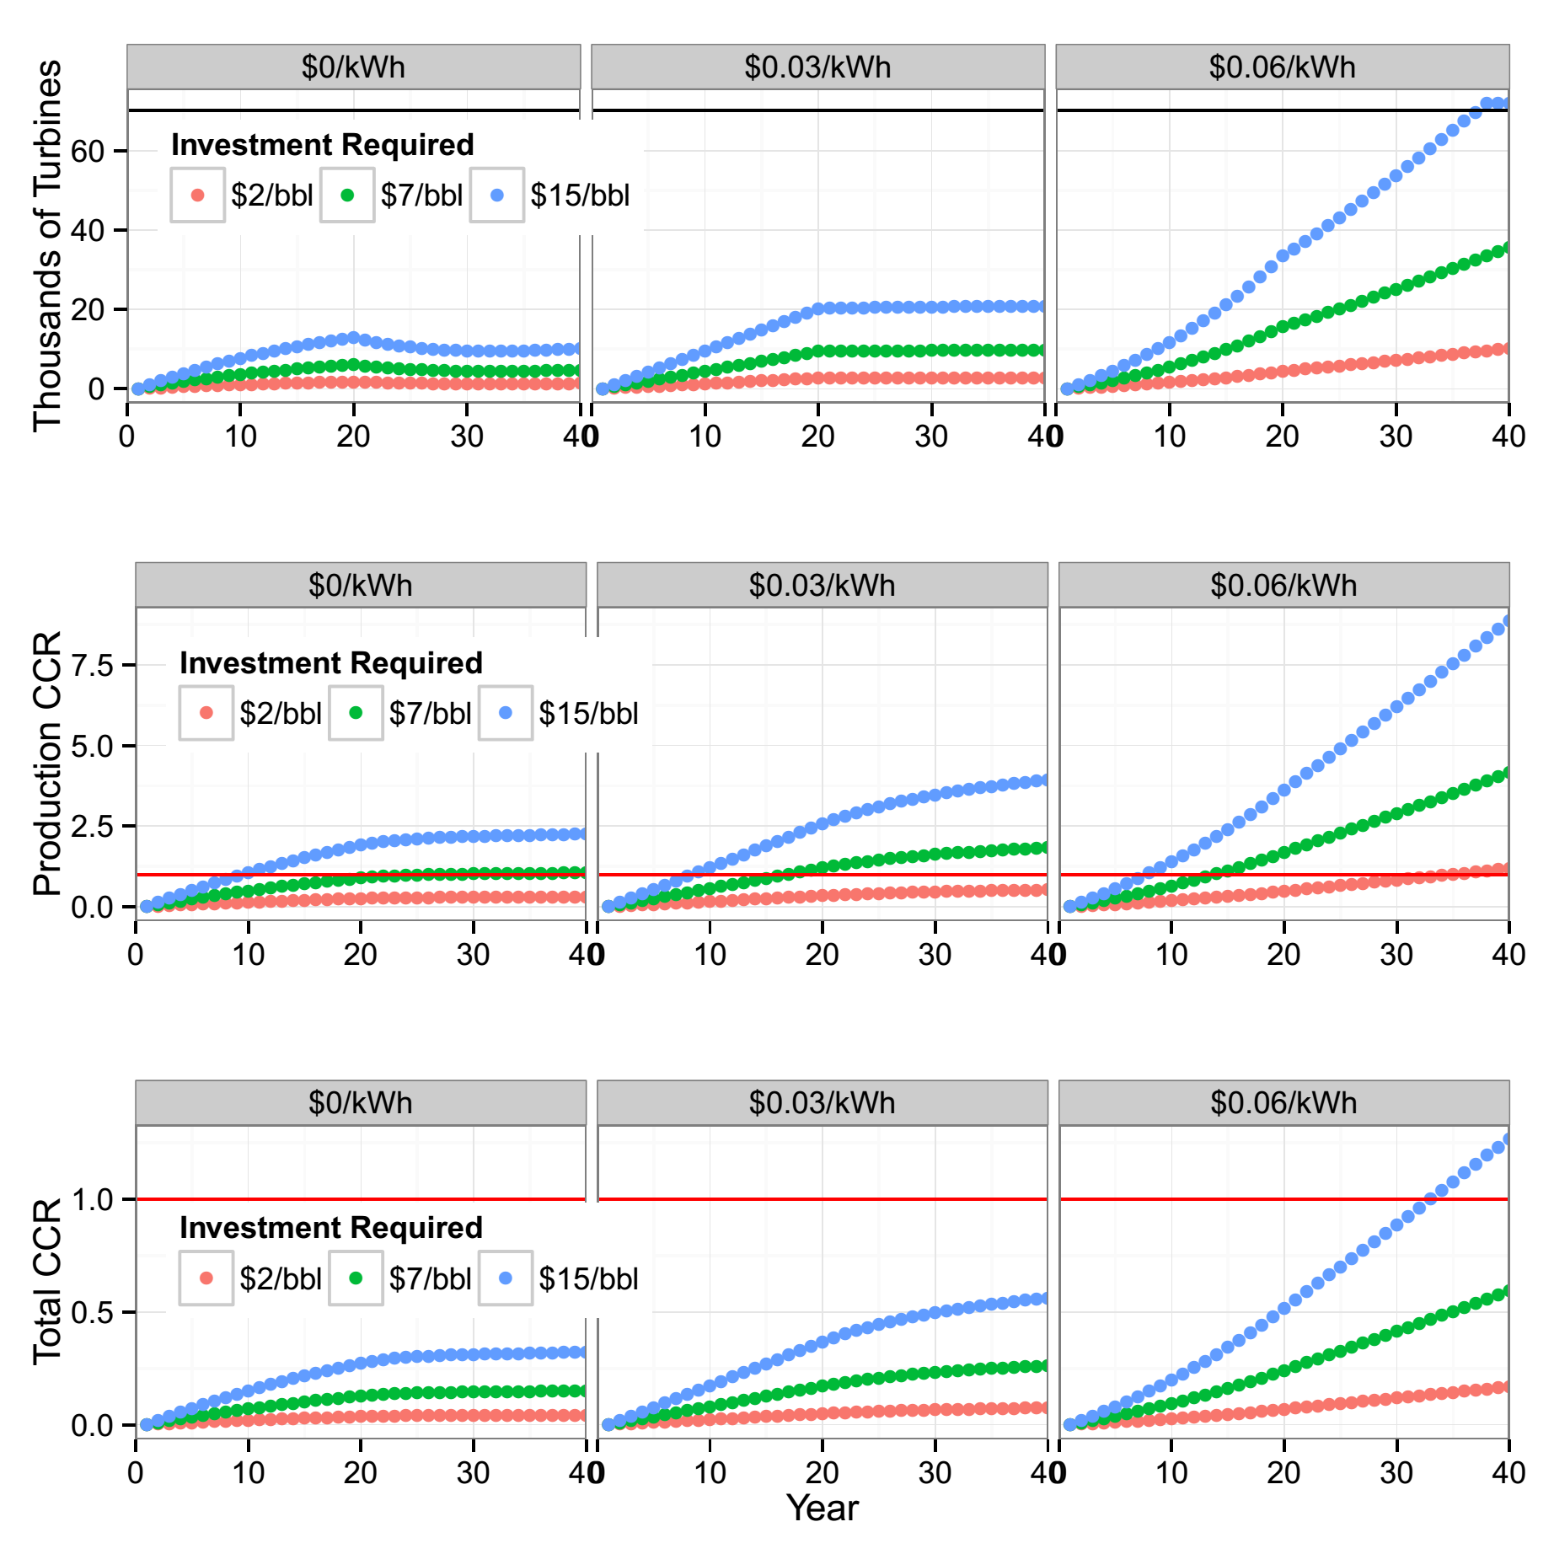

**Figure Y.**

**4- Conclusion**

This paper explored economic models to short and long term energy needs in the Canadian oil sand region that can lead to an overall reduction in atmospheric CO2.

We propose to install a small number of wind turbines on reclaimed oil sands land in order to better investigate the hypothesis presented here to ascertain true costs, risks, and benefits.

# Acknowledgments

The co-authors of this paper would like to deeply thank Professor Alexander H. Slocum for providing the vision behind this project and the idea that shaped the economic models for wind and solar energy presented in this paper. We would also like to show our gratitude to Canadian labour union Unifor who saw the vision of this project and provided insightful ideas that were key in this paper. Finally, we also thank economist Jim Stanford who gave us comments that greatly improved this paper.

**References**

[1] IHS CERA, “Oil Sands, Greenhouse Gases, and US Oil Supply: Getting the Numbers Right - 2012 Update,” IHS CERA, 2012.

[2] H. L. Raadal, L. Gagnon, I. S. Modahl, and O. J. Hanssen, “Life cycle greenhouse gas (GHG) emissions from the generation of wind and hydro power,” *Renew. Sustain. Energy Rev.*, vol. 15, no. 7, pp. 3417–3422, Sep. 2011.

[3] D. Weisser, “A guide to life-cycle greenhouse gas (GHG) emissions from electric supply technologies,” *Energy*, vol. 32, no. 9, pp. 1543–1559, Sep. 2007.

[4] AESO, “Future Demand Outlook,” Alberta Electric System Operator, 2008.

[5] AESO, “AESO 2014 Long-term Outlook,” Alberta Electric System Operator, 2014.

[6] California Energy Comission, “Total System Power,” *Energy Almanac*, Seot-2015. [Online]. Available: http://energyalmanac.ca.gov/electricity/total_system_power.html. [Accessed: 21-Sep-2015].

[7] NEB, “Electricity Generation,” *National Energy Board*, 16-Sep-2015. [Online]. Available: https://www.neb-one.gc.ca/nrg/ntgrtd/ftr/2013/ppndcs/pxlctrctgnrtn-eng.html. [Accessed: 21-Sep-2015].

[8] EIA, “Electric Power Monthly,” *US Energy Information Administration*, 26-Aug-2015. [Online]. Available: http://www.eia.gov/electricity/monthly/epm_table_grapher.cfm?t=epmt_1_1. [Accessed: 21-Sep-2015].

[9] M. A. Delucchi and M. Z. Jacobson, “Providing all global energy with wind, water, and solar power, Part II: Reliability, system and transmission costs, and policies,” *Energy Policy*, vol. 39, no. 3, pp. 1170–1190, 2011.

1. <https://www.clarke-energy.com/chp-cogeneration/>
2. Calculated based on 1.9 bbl/day [1] and 14 kWh/bbl [4]
3. No wind installed in Northeast or Northwest [5]