An assessment of the potential of mitigating oil-sands emissions by co-locating massive amounts of wind power

David Donald James Taylor (dtaylor@mit.edu)

Massachusetts Institute of Technology

Santiago Paiva (santiago.paiva@mail.mcgill.ca)

McGill University

Prof. Alexander H. Slocum (slocum@mit.edu)

Massachusetts Institute of Technology

**Abstract**

This paper used a reconfigurable model to assess the efficacy of installing up to 35,000 5MW wind turbines to mitigate the greenhouse gas emissions of the Canadian Oil Sands. The evaluated scheme proposed to co-locate wind turbines with oil sands extraction to avoid NIMBY problems and proposed to require oil companies to invest a fixed amount per barrel of refined oil into building wind turbines (instead of a carbon tax). Scenarios where companies were additionally required to reinvest a fraction of the revenue from the electricity generation were found to be more economically viable. Unfortunately, low annual wind speeds in the oil sands region led to a very poor capacity factor (8.9%); the most expensive scenarios evaluated could only reduce 86% of incremental greenhouse gas emissions, and the cost effectiveness of this proposal was found to be $192/ ton of CO2-eq. However, the proposed scheme becomes would have been more economically viable had the capacity factor been at least 30%. Importantly, this work provides readers with a model that can be used to rapidly assess the feasibility of applying such a proposal to their region where the capacity factor could be higher. Finally, independent of the assumed capacity factor, if the Canadian and US power grids were all supplied with 20% wind power, only 93% of the total emissions of the oil sands would be offset.

# Introduction

The success of the oil sands is very connected to the success of the Albertan economy [Government of Alberta. Highlights of the Alberta Economy. Alberta Economic Development and Trade (2015), p.11, p.16]. The recent denial of the Keystone Pipeline has sent a clear signal that the perceived environmental impact of the oil sands is preventing its growth. Accordingly, there has been renewed interest in increased carbon taxes [1]. However, most of these proposals do not specifically address how the money raised would actually be used to offset the environmental impact of the oil sands. Two potential pitfalls are associated with a carbon tax scheme: first, the money may end up diverted to important but non-environmental issues, and second, the government may not be able to spend the money to mitigate environmental impacts as efficiently as a private company.

This paper explores an alternate environmental mitigation scheme where oil extraction companies are mandated to build, operate, and maintain wind turbines at their extractions sites. For every barrel of oil sold, they would have to invest a fixed amount into wind turbine production. Further, oil companies would need to reinvest an additional amount based on the amount of wind power generated. The proposed scheme has four benefits:

1. The money cannot be diverted away from environmental mitigation efforts,
2. The money is spent with the efficiency of the private sector,
3. Additional revenues are generated through energy harvesting and could be applied to additional environmental mitigation, and
4. Large-scale renewable energy projects often fail because of the public’s not-in-my-back-yard (NIMBY) attitude; on-site installation at oil extraction sites would avoid this phenomenon.

We therefore hypothesize, that by mandating that oil companies invest in on-site wind turbines, the green-house gas (GHG) emissions from the oil sands can be mitigated. We further hypothesize that such a plan is economically feasible if oil companies are also mandated to use a fraction of the revenue from the wind turbines to invest in the installation of even more wind turbines.

# Methods

## An Excel-Based Modeling Tool

Uncertainty is high with projects such as the one proposed in this paper; we address this uncertainty by clearly stating what values we have used in the model and by providing the modeling tool in the *Supplemental Information* (SI) so that readers can adjust the findings to match their circumstances, location, or perspective on what the `correct’ number should have been for any one of the many estimations made in this paper.

## Accounting for the GHG Emissions of Oil Sands

To account for the climate impact of the Canadian oil sands, we use the metric of GHG emissions measured by their mass of CO2 equivalent per barrel of refined oil (CO2-eq/bbl). We account for these GHG emissions in three categories:

1. *incremental emissions*: the incremental emissions caused by production, upgrading, refining, and transportation of oil from the oil sands, as compared to the 2005 average GHG emissions of oil refined in the US;
2. *production emissions:* the total GHG emissions associated with production, upgrading, refining, and transportation of oil from the oil sands(well-to-tank); and
3. *total emissions:* the total GHG emissions from production through end consumption (well-to-wheel).

Many meta-analyses on oil-sands emissions were found. We used the IHS CERA report because it was an independent report and conveniently used units of per barrel of refined oil [2]. To aggregate the highly-varied estimates of oil-sands emissions, we used IHS CERA’s “average oil sands refined in the US (2011),” which accounted for emissions from production, upgrading, transport, refining, further transport, and product combustion; it also accounted for the emissions associated with fuels used in the production the oil [2]. The incremental emissions, production emissions, and total emissions used in our model were 70.8, 172.3, and 556 kg CO2,eq/bbl, respectively [2].

## Accounting for the GHG Emissions of Wind Turbines

Raadal et al. reviewed 22 papers that assessed the GHG emissions associated with 1-5MW turbines; they found a range of 4-22 g CO2-eq/kWh with a mean of 10.4 g CO2-eq/kWh [3]. This simple number however neglects the strong dependency on the capacity factor, as does the presented model.

## Emissions Offsets for Electricity Generation

Wind energy generation only has a net positive benefit on GHG emissions when a more emitting generation technology can be turned off. As a first-order model, we assumed that the GHG intensity of the generation technology that would be turned off would be the average GHG intensity of the region to which the power was transmitted. The scale of wind production proposed in this model required transmission over long distances to different regions. Our first order model considered only five levels of resolution for the destination of the wind energy: onsite electricity usage, Alberta’s grid, the rest of Canada, California, and the rest of the United States (Table 1).

## Grid Capacity

Because of the variability of wind power, a grid supplied by 100% wind from a single geographic location would be unstable. Electricity system operators compensate for this instability in two ways: first, by limiting the total percent of wind power they allow into their system; and second, by purchasing dispatchable generation to supplement when the wind is not blowing. This model does not account for the emissions associated with this dispatchable generation; it is therefore, implicitly assumed to have the same GHG intensity as the region’s baseline generation mix.

The model dispatches electricity to different regions according to a user definable transmission priority. When one region reaches its maximum capacity for wind power, here assumed to be 20% [REF needed], the model then starts to build transmission lines to the next best option. Transmission priorities and the current wind-supply fraction of different grids is summarized in Table 1.

Table : Capacity and GHG intensity of North American grids

|  |  |  |  |  |  |
| --- | --- | --- | --- | --- | --- |
| Location | Transmission Priority | Nominal Distance (km) | Average Yearly Load (GW) | GHG Intensity (MT CO2,eq/GW-year) | Current Wind Fraction |
| Onsite Usage | 1 | 0 | 1.1 [see SI] | 2891 [see SI] | 0% [see SI] |
| Alberta (AB) | 2 | 500 | 8.8 [4] | 7542 [5] | 7% [4] |
| United States (excluding CA) | 3 | 5500 | 433.1 = 467 [6] - 33.9 [7] | 4710 [5], [8] | 3.9% (4.2% including CA [6]) |
| California (CA) | 4 | 2800 | 33.9 [7] | 2800 [9] | 8.1% [7] |
| Canada  (excluding AB) | 5 | 4000 | 62.8 = 71.6 [10] - 8.8 [4] | 585 [5] | 0.8% (1.6% including AB [10]) |

## Transmission

Delucci and Jacobson’s estimate the cost of high-voltage, long-distance power transmission to be $372$/MW/km [11]. However, long transmission lines that are not grid-connected can pose serious issues if they are ever interrupted as there is no method for the power to dissipate. The modelling tool has a variable to allow lines to be in duplicate, but the presented analysis does not include transmission duplication. Costs and emissions from transmission line construction and transmission losses are left to a future version of the model.

Transmission stations are expected to have a lifetime of approximately 30 years, and transmission towers and lines may last for 50-70 years [11]. The first-order model assumed all transmission components last for the entire 40 year modelling window.

## Cost of Wind Turbines

We modeled the upfront costs of wind generation as US$2/W of nameplate capacity [S.D. Johnson, E.J. Moyer. Energy Policy 49 (2012) p.509], and assumed that the required annual maintenance was 5% of the capital costs [M.I. Blanco. Renewable and Sustainable Energy Reviews 13 (2009) p.1375], and that the life expectancy of a turbine was 20 years [D. Nugent, B.K. Sovacool. Energy Policy 65 (2014) p.239].

## Capacity Factor

RETScreen was used for its extensive wind turbine database [5]. Capacity factor numbers were based on Repower’s 5MW, 117m turbine. Using a wind shear exponent of 0.2, the average found by Schwartz and Elliot [12], the capacity factor was determined based on an average annual wind speed at Fort McMurray airport (2.7m/s) to be 8.9% [5] .

## Performance Metrics

The environmental benefits of the proposed solutions were assessed as the ratio of GHG emissions from the oil sands compared to the GHG offsets generated by the wind power. This ratio was calculated for the incremental, production, and total emissions. All three ratios were evaluated for a given moment in time (Instantaneous Carbon Ratio (Eq1)) and over the duration of the proposed project (Cumulative Carbon Ratio (Eq2)) (Table 2).

$\text{Instantaneous Carbon Ratio}= \frac{\text{Rate of GHG-emission offsets from wind power}}{\text{Rate of GHG emissions from the oil sands}}$ (1)

$\text{Cumulative Carbon Ratio}(t)= \frac{\text{1}}{\text{t}}\int_{0}^{t}{\left(\text{Instantaneous Carbon Ratio}\right)dt}$ (2)

Table : Performance Metrics

|  |  |  |  |
| --- | --- | --- | --- |
|  | Incremental Emissions | Production Emissions | Total Emissions |
| Instantaneous | Incremental Carbon Ratio | Production Carbon Ratio | Total Carbon Ratio |
| Cumulative | Incremental Cumulative Carbon Ratio  (Incremental CCR) | Production Cumulative Carbon Ratio  (Production CCR) | Total Cumulative Carbon Ratio  (Total CCR) |

The financial viability of the model was assessed by considering two separate funding mechanisms: a per barrel required investment, used to build wind turbines, and a required reinvestment amount which levies an additional charge per kWh of generated power to cover turbine maintenance and to build additional turbines. Investment amounts of $3, 10$, and $17/bbl, and reinvestment requirement amounts of $0, $0.02, and $0.04/kWhwind were considered. An investment of $3/bbl is equivalent to theAlberta’s 2016 carbon tax ($20/ton [1]) applied to the production emissions of the oil sands, while $17/bbl is equivalent to the proposed 2017 tax ($30/ton [1]) applied to the total emissions. The 2014 average wholesale electricity price in Alberta was $0.049 [13]. An upper limit on reinvestment charges was therefore chosen to be $0.04/kWhwind in order to maintain incentives for oil companies to keep the turbines spinning.

To keep the financial model clear, the investment required was presented in dollars per barrel of oil produced. A better system would base required investment amounts on carbon emissions to incentivize innovation and emissions reductions.

# Results

## Instantaneous efficacy of wind power to offset GHG emissions

With 21,507 5MW wind turbines, the incremental GHG emissions caused by oil sands as compared to conventional oil would be offset. This amount of electricity generation is equivalent to 86% of Alberta’s electricity generation (Table 3), but is actually sold to both Albertan and American grids. Unfortunately, due to the low capacity factor, at the maximum turbine density of one per two square kilometers (35,050 5MW turbines), only 65% of the production emissions can be offset (Table 3). Beyond the land and capacity factor constraints, the model demonstrated that if Canadian and American grids can only handle 20% wind energy, only 93% of the total emissions of the oil sands could be offset with wind power (Table 3).

## Cumulative efficacy and financial feasibility of wind power to offset GHG emissions

With the abysmal capacity factor of 8.9%, it was not surprising that this proposal was not financially viable when evaluated with the metrics defined in Equation 2 and Table 2. Even at the highest tariff scheme of $17/bbl and $0.04/ kWhwind, the incremental CCR reached only 86% (Fig Y). While some might tout this as a victory worth pursuing, the effective cost of carbon reduction through this scheme was $192/ton of CO2-eq (Figure 2).

If the capacity factor were improved, the cost-effectiveness of this proposal would dramatically increase (Figure 2). Had the oil sands been located in a region with a capacity factor of 30%, for example, the highest tariff scheme would have had an incremental CCR of 285% and a production CCR of 121% (Figure 3). Readers interested in exploring further how to improve these results are directed to the model available in the SI. Such explorations will highlight that the reinvestment rate can create a positive feedback mechanism and help the project reach scale quickly.

# Conclusions

The proposed massive investment in wind energy co-located with Alberta’s oil sands was not found to be viable. However, the concept and evaluation tool may still hold promise for two reasons: first, were oil sands companies able to manage the NIMBY problem in southern Alberta and secure land-use contacts for a reasonable price, the capacity factor and viability would increase; second, in other locations of large scale extraction where average wind speeds are higher, as perhaps in some part of the US northwest [Sailor et al. Renewable Energy 33 (2008) p.2397] and [Gorsevski et al. Energy Policy 55 (2013) p.375], the modelling tool could help to efficiently evaluate the applicability of this proposal.

This work validated that large numbers of wind turbines can offset the incremental emissions of the oil sands, but given the low wind speeds in the Fort McMurray area, the model was not found to be financially viable. Importantly, however, this work demonstrates a new top-down method of analyzing large-scale proposals for GHG emission reduction and provides readers with a rapid scenario evaluation tool to help understand when and where such innovative proposals can apply.

Table : Instantaneous model of wind turbine impact

|  |  |  |  |  |  |
| --- | --- | --- | --- | --- | --- |
| Scenarios | 1000 Turbines | Incremental Offset | Max Density | Production Offset | Saturating the Grid with 20% Wind |
| Turbines Built | 1,000 | 21,507 | 35,050 | 54,909 | 196,596 |
| Turbine Density (#/(km)^2) | 0.01 | 0.31 | 0.50 | 0.78 | 2.80 |
| Wind Turbine Cost ($ Billions) | 10.0 | 215.1 | 350.5 | 549.1 | 1966.0 |
| Transmission Cost ($ Billions) | 0.0 | 9.7 | 16.9 | 27.4 | 105.4 |
| Name Plate Capacity (GW) | 5.0 | 107.5 | 175.3 | 274.5 | 983.0 |
| Generation (GW) | 0.4 | 9.6 | 15.6 | 24.4 | 87.5 |
| Wind Turbine Emissions  (MT CO2-eq) | 41 | 872 | 1421 | 2226 | 7970 |
| Annual Carbon Offset  (MT CO2-eq) | 2,285 | 47,889 | 75,725 | 116,544 | 350,327 |
| Incremental Carbon Ratio | 5% | 100% | 158% | 243% | 732% |
| Production Carbon Ratio | 2% | 41% | 65% | 100% | 301% |
| Total Carbon Ratio | 1% | 13% | 20% | 31% | 93% |
| Percent of Alberta's Generation | 4% | 86% | 141% | 220% | 788% |
| Percent of Canada's Generation | 1% | 15% | 25% | 39% | 139% |

Figure : The viability of the proposed scheme with 8.9% capacity factor, charging $17/bbl and $0.04/kWhwind

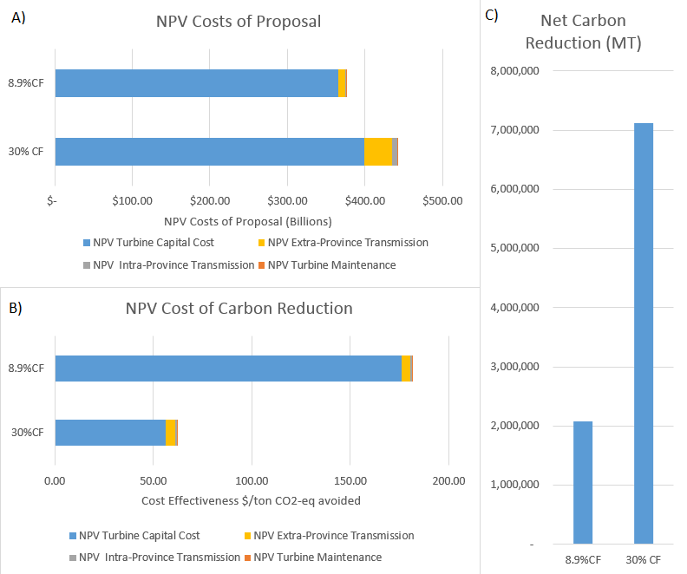

Figure : The effect capacity factor has on the net present value (NPV) of the proposal’s total costs (A), cost effectiveness (B), and net emissions reductions (C). Two scenarios are compared: the predicted scenario at Fort McMurray – a capacity factor of 8.9% (8.9% CF) and a hypothesized alternative scenario with a capacity factor of 30% (30% CF).

# References

[1] J. Giovannetti, “Alberta to double carbon tax by 2017, strengthen emissions reduction targets,” *The Globe and Mail*, Toronto, Canada, 25-Jun-2015.

[2] IHS CERA, “Oil Sands, Greenhouse Gases, and US Oil Supply: Getting the Numbers Right - 2012 Update,” IHS CERA, 2012.

[3] H. L. Raadal, L. Gagnon, I. S. Modahl, and O. J. Hanssen, “Life cycle greenhouse gas (GHG) emissions from the generation of wind and hydro power,” *Renew. Sustain. Energy Rev.*, vol. 15, no. 7, pp. 3417–3422, Sep. 2011.

[4] AESO, “AESO 2014 Long-term Outlook,” Alberta Electric System Operator, 2014.

[5] Natural Resources Canada, “RETScreen 4,” *RETScreen International*, 14-Jun-2013. [Online]. Available: http://www.retscreen.net/ang/version4.php. [Accessed: 10-Nov-2015].

[6] EIA, “Electric Power Monthly,” *US Energy Information Administration*, 26-Aug-2015. [Online]. Available: http://www.eia.gov/electricity/monthly/epm_table_grapher.cfm?t=epmt_1_1. [Accessed: 21-Sep-2015].

[7] California Energy Comission, “Total System Power,” *Energy Almanac*, Seot-2015. [Online]. Available: http://energyalmanac.ca.gov/electricity/total_system_power.html. [Accessed: 21-Sep-2015].

[8] California Energy Comission, “2014 Integrated Energy Policy Report,” California Energy Commission, CEC-100-2014-001-CMF, 2014.

[9] California EPA, “California Greenhouse Gas Emission Inventory: 2000-2013,” California Environmental Protection Agency: Air Resources Board, 2015 Edition, Jun. 2015.

[10] NEB, “Electricity Generation,” *National Energy Board*, 16-Sep-2015. [Online]. Available: https://www.neb-one.gc.ca/nrg/ntgrtd/ftr/2013/ppndcs/pxlctrctgnrtn-eng.html. [Accessed: 21-Sep-2015].

[11] M. A. Delucchi and M. Z. Jacobson, “Providing all global energy with wind, water, and solar power, Part II: Reliability, system and transmission costs, and policies,” *Energy Policy*, vol. 39, no. 3, pp. 1170–1190, 2011.

[12] M. N. Schwartz and D. L. Elliott, “Wind shear characteristics at central plains tall towers,” presented at the American Wind Energy Association WindPower 2006 Conference, 2006.

[13] AESO, “2014 Annual Market Statistics,” Alberta Electric System Operator, Calgary, Feb. 2015.

[14] Clarke Energy, “Cogeneration & CHP,” *Clarke Energy: Engineer - Install - Maintain*. [Online]. Available: https://www.clarke-energy.com/chp-cogeneration/. [Accessed: 11-Nov-2015].

[15] D. Weisser, “A guide to life-cycle greenhouse gas (GHG) emissions from electric supply technologies,” *Energy*, vol. 32, no. 9, pp. 1543–1559, Sep. 2007.

[16] AESO, “Future Demand Outlook,” Alberta Electric System Operator, 2008.

# Supplemental Information

## Methods

### Modelling the GHG intensity of on-site cogeneration

As a first order estimate, the industrial-scale cogeneration of electricity and steam was taken to produce 40% electricity, 50% usable heat and 10% losses [14]. We therefore modelled this process as 75% efficient electricity generation from natural gas. Natural gas generation was modelled as having an average efficiency of 45% -- a balance of the 35-42% efficiency of simple cycle and the efficiency of 52-60% for combined cycle. The emissions of cogeneration where therefore taken to be 2891 MT CO2-eq/GW (60% of those for standard natural-gas-fired electricity generation, 4818 MT CO2-eq/GW [15]).

### Modelling the current capacity and wind usage of on-site electricity

The annual average load for onsite electricity was taken to be 1.1 GW, based on 1.9 million bbl/day [2] of oil production with an electricity intensity (using natural gas for steam extraction) of 14 kWh/bbl [16]. The Alberta Electricity System Operator reports that no significant wind generation is present in the northeast or northwest of Alberta [4], therefore it was assumed that no significant wind energy was present on-site.

## Additional Model Capacities

### Modelling the shift to electrically-assisted extraction techniques

The model has the additional ability to model the shift from current extraction techniques to electrically powered techniques. The Alberta Electric System Operator predicts that a shift to electrically-assisted extraction techniques could increase the electrical demand of the oil sands by 10 fold [4]. The additional nine times current demand would replace the current steam assisted gravity extraction, the majority of which is produced by natural gas. The GHG emission values by fuel source are per unit of electrical energy produced, which would overestimate the GHG emissions of steam creation. Instead an efficiency of NG electricity generation was assumed to be 45% and scaled the NG GHG emissions down to 2168 MT CO2-eq/GWheat. Without steam generation, cogeneration will no longer be an onsite option and the remaining process electricity was assumed to have a GHG intensity of the Albertan grid.

### Modelling new destinations for the electricity

To allow for the inclusion of locations where the supply mix is known but where the GHG intensity is unknown, an approximate GHG emission rate associated with different supply types [15] can be scaled by the official generation mix numbers. This additional capacity was not used in the model presented herein.

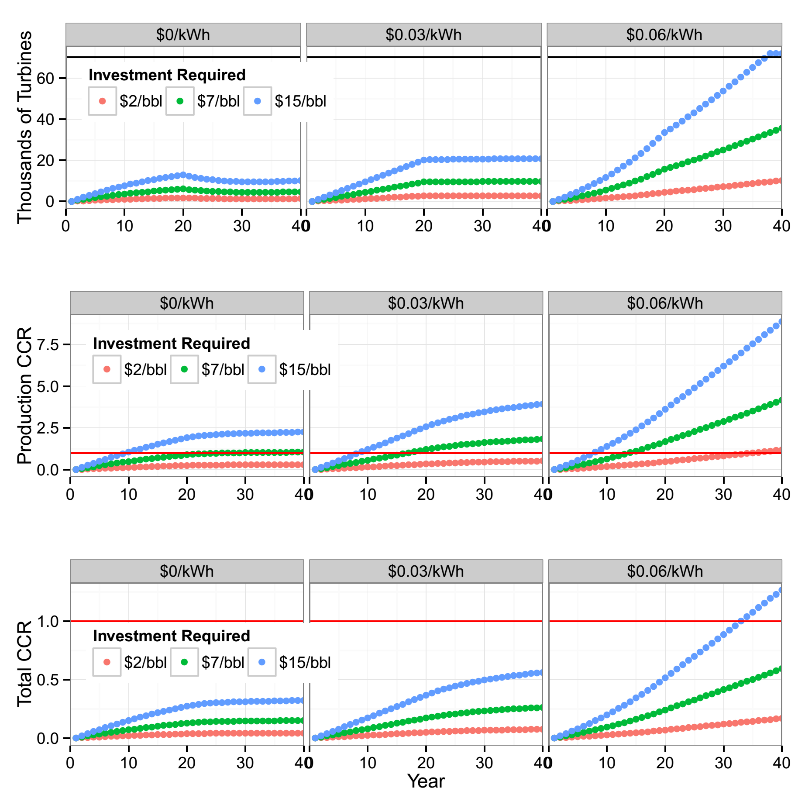

TO BE ADJUSTED

Figure : Model results with a capacity factor inflated to 30%