Offsetting the Greenhouse Gas Emissions of the Athabasca Oil Sands with Gigawatts of On-Site Wind Power

David Donald James Taylor (dtaylor@mit.edu)

Massachusetts Institute of Technology

Santiago Paiva (santiago.paiva@mail.mcgill.ca)

McGill University

Alexander H. Slocum (slocum@mit.edu)

Massachusetts Institute of Technology

**Abstract**

A reconfigurable model is developed to assess how the installation of up to 71 thousand 3.5MW wind turbines would the impact the greenhouse gas emissions (GHG) of the Athabasca oil sands. As an alternative to the anticipated increases in carbon taxes, the proposed scheme would be funded by oil producers investing a fixed amount per barrel of crude oil into building wind turbines. A fraction of the revenue from the electricity generation would then also be reinvested into purchasing more wind turbines. These wind turbines would be located on-site in the Athabasca oil sands to avoid the typical challenge of locating wind farms elsewhere: community resistance. In spite of the low wind capacity factor (17%), scenarios with investments of at least $10 (U.S. dollars) per barrel (bbl) were able to completely offset the incremental GHG emissions associated with the oil sands as compared to conventional crude oil extraction. This is an exciting finding, but due to the low capacity factor, the cost per ton of offset carbon was found to be $59/ton of CO2 equivalent — 55% more expensive than other onshore windfarm estimates. Had the capacity factor been closer to a more typical 30%, the cost effectiveness would then have been $35/ton and the total production and refining emissions of the oil sands could be offset. As such, the proposed scheme would be more viable in other oil producing locations or in large farming regions instead of the Athabasca region. Should crude oil prices return to above $90/bbl, this proposed levy of $10/bbl would be feasible. Importantly, this work demonstrates that, with significant investment, the climate impacts of the Athabasca oil sands, as compared to conventional crude oil, can be offset. The full model provided to readers, enables the rapid assessment of the feasibility of such proposals under a range of scenarios.

# Introduction

The Athabasca oil sands are an integral part of the Albertan economy [1]. The recent denial of the Keystone XL Pipeline has sent a clear signal that the perceived environmental impact of the oil sands is preventing its growth. Accordingly, there has been renewed interest in increasing carbon taxes in Alberta to C$30 (Canadian dollars) per ton of carbon dioxide (CO2) in 2017[2]. Traditional carbon tax schemes have two potential pitfalls: first, the money might end up being diverted to urgent but non-environmental issues, which happened with tobacco taxes in Massachusetts [3]; and second, the government might not be able to spend or manage the money as efficiently as the private sector.

Adding to the challenges facing the Athabasca oil sands, the price of oil (the price in Cushings, Oklahoma of West Texas Intermediate) has fallen from a 2013 average of $98 (U.S. dollars) per barrel (bbl) to a 2015 average of $50/bbl [4] – $50 is close to, if not below, the cost of producing and upgrading bitumen from the oil sands [5]. Morgan Stanley estimates crude oil production costs from the oil sands are between $47–$84/bbl, which is significantly higher than Middle East oil production which costs between $10–$36/bbl [5]. Canada’s largest synthetic crude oil producer announced in August 2015 that its break-even production cost for refinery-ready crude oil was $43.46/bbl and $47.27 for fully upgraded crude oil [6]. Under low market prices for crude oil, schemes to offset environmental impact must be creatively funded and cost efficient. As a benchmark for any GHG reduction scheme, California’s 2015 cap and trade prices for GHG emissions have ranged from $11–$13/ton of CO2 equivalent (CO2e) [7]. Creyts et al. reported that for less than $50/ ton of CO2e, the United States (U.S.) could offset between 1,300 and 4,500 megatons (MT) of CO2e annually [8]. Viable mitigation schemes need to be more cost efficient than $50/ ton of CO2e.

This paper explores an innovative scheme that mandates oil producers to operate, and maintain wind turbines at their extraction sites. For every barrel of crude oil produced, they would have to invest a fixed dollar amount into building, maintaining, and operating wind turbines. Further, oil producers would have to reinvest a fraction of the revenues from the wind power into building more wind turbines. The proposed scheme has four benefits:

1. The money cannot be diverted away from environmental mitigation efforts,
2. The money is spent with the efficiency of the private sector,
3. Reinvesting revenues from the wind generation lowers the required per barrel investment, and
4. Locating the turbines at oil extraction sites avoids the traditional pitfall of wind projects: the public’s “not-in-my-back-yard” (NIMBY) attitude.

Nobel Laureate and climate change expert Mario Molina opined that future mitigation and adaptation measures will be costly unless they are done creatively [9]. This paper evaluates one such creative option. We hypothesize that mandating oil producers to invest in on-site wind turbines would offset the greenhouse gas (GHG) emissions from the production and end-use of crude oil from the oil sands. We further hypothesize that such a plan is economically feasible if oil producers are also mandated to reinvest a fraction of the revenue from the wind turbines in the installation of more wind turbines.

# Methods

## An Excel-Based Modeling Tool

Uncertainty is high with projects such as the one proposed in this paper; we address this uncertainty by clearly stating the values we have used in the model and by providing the Microsoft Excel-based modeling tool in the *Supplemental Information* (SI) so that readers can adjust the model inputs to match their circumstances, location, or perspective on what the 'correct’ number should have been for any one of the many estimations made in this paper (Figure 1). (For more details on fine-tuning the model, see the SI.)

## The Use of U.S. Dollars for Currency Accounting

Most of the published cost and price estimates for wind turbines and crude oil are reported in U.S. Dollars ($). Given the volatility of the U.S.–Canada exchange rates from 2000–2015, the model’s accuracy would be compromised by working in Canadian dollars (C$) [10]. Instead, U.S. Dollars are used exclusively and where needed converted for reference to Canadian dollars using a rate of C$1 = 0.75$ [10]. As such, these findings exclude currency exchange risk.

## Accounting for the GHG Emissions of the Athabasca Oil Sands

To account for the climate impact of the Athabasca oil sands, we use the metric of CO2e per barrel of refined crude oil (CO2e/bbl). We account for these GHG emissions by using three categories:

1. *incremental emissions*: the incremental emissions caused by production, upgrading, refining, and transportation of crude oil from the oil sands, as compared to the 2005 average GHG emissions of crude oil refined in the US;
2. *production emissions:* the total GHG emissions caused by production, upgrading, refining, and transportation of crude oil from the oil sands (well-to-tank); and
3. *total emissions:* the total GHG emissions caused by all steps from production through end consumption of crude oil from the oil sands (well-to-wheel).

Among the many meta-analyses of the emissions of the Athabasca oil sands, we used the IHS CERA report because it was an independent report that used units per barrel of refined crude oil [11]. To aggregate the highly-varied estimates of the oil sands’ emissions, we used IHS CERA’s “average oil sands refined in the U.S. (2011),” which included emissions from production, upgrading, transport, refining, further transport, and the final product’s combustion; it also accounted for the emissions associated with fuels used in production and upgrading of the crude oil [11]. The incremental emissions, production emissions, and total emissions used in our model were 70.8, 172, and 556 kg CO2e/bbl, respectively [11].

The annual production of the oil sands was taken to be 676.4 million barrels per year [12], with a fixed annual growth rate of 1%. Given the volatility in global oil prices from late 2014 through 2015, one prediction was as credible as the next; 1% was chosen to ensure that the recommendations did not rely on the projected growth.

## Accounting for the GHG Emissions of Wind Turbines

Raadal et al. reviewed 22 papers that assessed the GHG emissions associated with 1–5 MW turbines; they found a range of 4­–22 g CO2e/kWh with a mean of 10.4 g CO2e/kWh [13]. This simple number however neglects the strong dependency on the capacity factor, as does the model presented herein.

## Emissions Offsets for Electricity Generation

Wind energy generation has a net positive benefit on GHG emissions only when a generation technology which emits more can be turned off. In the case of this first-order model, we assumed that the GHG intensity of the generation technology that would be turned off would be the average GHG intensity of the region to which the power was transmitted. The scale of wind production proposed in this model required transmission over long distances to different regions. Our first-order model considered only five levels of resolution for the destination of the wind energy: onsite electricity usage, Alberta’s grid, the rest of Canada, California, and the rest of the United States (Table 1).

## Grid Capacity

Because of the variability of wind power, a grid supplied by 100% wind from a single geographic location would be unstable. Electricity system operators compensate for this instability in two ways: first, by limiting the total percent of wind power they allow into their system; and second, by purchasing dispatchable generation to supplement for when the wind is not blowing. This model does not account for the emissions associated with this dispatchable generation; it is therefore, implicitly assumed to have the same GHG intensity as the region’s existing generation mix.

The model dispatches electricity to different regions according to a user-definable transmission priority. When one region reaches its maximum capacity for wind power, here assumed to be 20% [14], the model then starts to build transmission lines to the next best option. Transmission priorities and the current fraction of wind-supply in different grids is summarized in Table 1.

Table : Capacity and GHG intensity of North American grids

|  |  |  |  |  |  |
| --- | --- | --- | --- | --- | --- |
| Location | Transmission Priority | Nominal Distance (km) | Average Yearly Load (GW) | GHG Intensity (MT CO2e/GW-year) | Current Wind Fraction |
| Onsite Usage | 1 | 0 | 1.1 [see SI] | 2.89 [see SI] | 0% [see SI] |
| Alberta (AB) | 2 | 500 | 8.8 [15] | 7.54 [16] | 7% [15] |
| United States (excluding CA) | 3 | 5500 | 433.1 = 467 [17] - 33.9 [18] | 4.71 [16], [19] | 3.9% (4.2% including CA [17]) |
| California (CA) | 4 | 2800 | 33.9 [18] | 2.80 [20] | 8.1% [18] |
| Canada  (excluding AB) | 5 | 4000 | 62.8 = 71.6 [21] - 8.8 [15] | 0.59 [16] | 0.8% (1.6% including AB [21]) |

## Transmission

Delucci and Jacobson estimated the cost of high-voltage, long-distance power transmission to be $372/MW/km [22]. However, long transmission lines that are not grid-connected can pose serious issues if they are ever interrupted, as there is no method for the power to dissipate. The modeling tool has a variable to allow lines to be in duplicate, but the presented analysis does not include transmission duplication. The emissions associated with transmission-line construction and transmission losses are left to a future version of the model.

Transmission stations are expected to have a lifetime of approximately 30 years, and transmission towers and lines may last for 50–70 years [22]. The first-order model assumed all transmission components last for the entire 40 year modeling timeframe.

## Cost of Wind Turbines

We modeled the upfront capital costs of wind generation as inelastic and $1.71/W of nameplate capacity [23]. Wiser and Bolinger reported operation and maintenance (O&M) costs normalized by the total power generated; however, the EIA suggests that wind-turbine O&M costs are actually fixed and not variable [24]. To allow the model to be accurate over a wide range of capacity factors, we therefore used the EIA 2010 estimate for O&M of $0.031/W/year [24]. The life expectancy of a turbine was taken to be 20 years (the minimum estimate as summarized from literature by Nugent and Sovacool [25]).

## Land Area and Turbine Density

The Athabasca oil sands cover a geographic area of 142,200 km2 [26], of which the Environmental Protection and Enhancement Act has approved 1,444 km2 for development by oil producers [27]. The model here assumes that 50% of the total geographic area of the Athabasca oil sands is available for use as a gigawatt-scale wind farm. Patel recommends that large wind farms be spaced 8–12 rotor diameters apart perpendicular to the prevailing wind, and 2–4 diameters apart in the direction of the prevailing wind [28]. The Vestas V126 has a rotor diameter of 126m leading a minimum spacing of 1.3 turbines per km2. Conservatively, we therefore assumed a turbine density of one per km2.

## Capacity Factor

The RETScreen Software tool was used to convert average annual wind speeds into capacity factors using turbine power curve data [16]. We selected the Vestas V126 3.45 MW turbine as a reference turbine. More detailed power-curve data was available for the V126 3.3 MW version and this was used to generate the capacity factor, which was applied without modification to the 3.45 MW version. Using a wind-shear exponent of 0.2, the average found by Schwartz and Elliot [29], the capacity factor was determined to be 17% based on the average annual wind speed at Fort McMurray airport (2.7m/s) [16] .

## Discount Rate

To calculate the net present value of the costs associated with the proposed project, a discount rate was required. Cox and Murphy calculated the implied weighted average cost of capital for seven publicly-traded Canadian oil companies to be between 7–9% [30]. The model used the lower bound of 7% to be conservative (the model involves only expenses, so a higher discount rate improves the favorability proposed scheme).

## Performance Metrics

*GHG Emission Metrics:* The environmental benefits of the proposed solutions were assessed as the ratio of GHG emissions from the oil sands compared to the GHG offsets generated by the wind power. This ratio was calculated for the incremental, production, and total emissions. All three ratios were evaluated for a given moment in time (Instantaneous Carbon Ratio (Equation 1)) and over the duration of the proposed project (Cumulative Carbon Ratio (Equation 2)) (Table 2). No discounting factor was used to distinguish between future and present GHG emissions.

|  |  |
| --- | --- |
| $$\text{Instantaneous Carbon Ratio}= \frac{\text{Rate of GHG-emission offsets from wind power}}{\text{Rate of GHG emissions from the oil sands}}$$ | (1) |
| $$\text{Cumulative Carbon Ratio}(t)= \frac{\text{1}}{\text{t}}\int_{0}^{t}{\left(\text{Instantaneous Carbon Ratio}\right)dt}$$ | (2) |

Table : Performance Metrics

|  |  |  |  |
| --- | --- | --- | --- |
|  | Incremental Emissions | Production Emissions | Total Emissions |
| Instantaneous | Incremental Carbon Ratio | Production Carbon Ratio | Total Carbon Ratio |
| Cumulative | Incremental Cumulative Carbon Ratio  (Incremental CCR) | Production Cumulative Carbon Ratio  (Production CCR) | Total Cumulative Carbon Ratio  (Total CCR) |

*Financial Viability Metrics:* The financial viability of the model was assessed by considering two separate funding mechanisms: a per-barrel required investment, used to purchase and install wind turbines, and a required reinvestment amount which levies an additional charge per kWh of generated power to pay for turbine maintenance and to add additional turbines. We investigated investment amounts ranging from $3–$13/bbl, and reinvestment requirement amounts from $0–$0.03/kWhwind. An investment of $2/bbl is equivalent to Alberta’s 2016 carbon tax (C$20/ton [2]) applied to the production emissions of the oil sands, while $13/bbl is equivalent to the proposed 2017 tax (C$30/ton [2]) applied to the total emissions. The upper limit on reinvestment charges was chosen to be $0.03/kWhwind in order to maintain incentives for oil companies to keep the turbines spinning (2014 average wholesale electricity price in Alberta was C$0.049 [31]).

To evaluate cost effectiveness, the equivalent cost per ton of GHG emissions avoided was taken as the net present value of all expenditures required from the oil company divided by the total avoided GHG emissions. To keep the financial model clear, the investment required was presented in dollars per barrel of crude oil produced. A better system would base required investment amounts on carbon emissions to incentivize innovation and emissions reductions.

# Results

## Instantaneous Efficacy of Wind Power to Offset GHG Emissions

With 16 thousand 3.45 MW wind turbines, the incremental GHG emissions caused by oil sands as compared to conventional oil would be offset. This amount of electricity generation is equivalent to 86% of Alberta’s electricity generation (Table 3), but in the model it is actually sold to both Albertan and American grids. With 71 thousand 3.45 MW turbines (the maximum turbine density of one per two square kilometers), 410% of the incremental emissions can be offset, which is equivalent to 168% of the production emissions or 52% of the total (production and end-use) emissions (Table 3). Beyond the land area constraints, the model also shows that if Canadian and American grids can only handle 20% wind energy (currently 3.9%, Table 1), 93% of the total annual emissions of the oil sands could be offset with wind power (Table 3). Importantly, this shows that if GHG emissions from other hydrocarbon sources are to be offset by renewables, the grid must be able to handle significantly more renewable energy, which indicates a significant need for energy storage devices.

## Cumulative Efficacy and Financial Feasibility of Wind Power to Offset GHG Emissions

Within the range of investment and reinvestment amounts explored, the maximum possible incremental CCR (Equation 2) was 126% (Figure 2). It was therefore possible to mitigate the incremental GHG emissions of the oil sands as compared to conventional crude oil, but it was not possible to achieve a production CCR or a total CCR of 100%.

To achieve an incremental CCR of 100%, the lowest reinvestment rate possible was $0.003/kWhwind accompanied by an investment of $13/bbl (Figure 2). The lowest possible per barrel rate was $10/bbl accompanied by a reinvestment of $0.03/kWhwind (Figure 2).

A moderate reinvestment rate of $0.015/kWhwind and an investment of $12/bbl achieved an incremental CCR of 103% (Figure 2). While this balanced funding scheme created a total of 32 thousand wind turbines, the land area could have supported 71 thousand turbines (Figure 3). The lifespan of the turbines sharply limited the ability for the model to expand after 20 years (Figure 3). Designing turbines with longer life expectancies would increase the benefits of any wind farm proposal, including this one.

Importantly, these results demonstrate that the proposed scheme can offset the incremental GHG emissions of the oil sands and that these benefits can be realized with investments of $10-$12/bbl, even with a capacity factor as low as 17%. Before implementing such a scheme however, its relative efficacy must be considered.

## Relative Efficacy of Wind Turbines Located with the Athabasca Oil Sands

The net present cost of this scheme is $146 billion and it offsets 2,485 MT of CO2e; it therefore has a net efficiency of $59/ton CO2e (Figure 5). The proposed scheme therefore costs 55% more per ton of offset CO2e than other estimates for high-penetration wind power in the U.S. Even less favorably, the costs are double the proposed Albertan carbon taxes or California’s current cap and trade prices (Figure 5). This result is highly sensitive to the input discount rate.

The largest cause of the proposed scheme’s inefficiency is the wind turbines’ low capacity factor. Had there been a more typical capacity factor of 30%, the efficacy would have matched the estimates in the literature of $35/ton CO2e. With this improved capacity factor would make it possible to achieve a production CCR of 107%, and should such a location exist, it should be pursued (Figure 7). Interestingly, with this higher capacity factor, the model exhibits nonlinearities, which make the reinvestment rates more important than the investment rates (Figure 7). In addition to proving the idea is viable under higher wind speeds, the agreement with published values helps validate the model.

With the predicted wind capacity factor of 17%, turbine installation and maintenance accounted for 93% of the costs ($55/ton CO2e) (Figure 5) – despite transmitting power across the continent. This was a surprising and important result; it suggests that the distance to the consumer is less important than the capacity factor available at the windfarm site and that alternate sites for the proposed scheme should be considered.

Given the 2015 low crude oil prices, adding $10-$12/bbl to the production costs of crude oil is not likely feasible (Figure 6). However, should markets rebound to 2013 prices, there would be enough of a margin to support the proposed scheme even if it is not optimally located (Figure 6). Locating the proposed scheme somewhere with higher wind speeds would be even more promising.

# Conclusions and Recommendations

The proposed investment in wind energy installed in the Athabasca oil sands was found to be able to offset the incremental GHG emissions with investments ranging from $10–12/bbl. Given 2015 oil prices, ten dollars per barrel is not likely feasible unless the environmental concerns which limit industry growth were quantified and included in the model. Independent of its affordability, the proposed scheme was found to cost 55% more per GHG offset than other on-shore wind projects due to the low wind speeds.

Whether or not the proposed scheme is feasible, the concept and reconfigurable model hold promise for two reasons: first, were crude oil producers able to manage issues with resistance to wind energy in southern Alberta and secure land-use contacts for a reasonable price, the capacity factor would increase and the proposal’s viability would dramatically increase. Second, in other locations of large-scale extraction where average wind speeds are higher, such as in North Dakota, the reconfigurable model could efficiently evaluate the applicability of this proposal.

This work has validated the notion that gigawatts of wind power can offset the incremental GHG emissions of the Athabasca oil sands and that such a scheme can be realized with investments as low as $10/bbl. Additionally, this work demonstrates a new top-down method of analyzing large-scale proposals for reducing GHG emissions and provides readers with a reconfigurable model, which can help them understand when and where the proposed innovative scheme could apply. Should the political atmosphere shift to require carbon taxes to be of the order of $60/ton instead of the current $30/ton, the analysis and scheme presented here would become even more relevant.

# Acknowledgements

The authors are grateful for the support of Mark Bartlett from the Windsor Unifor Regional Environment Council and economist Jim Stanford for their helpful feedback.

Table : Instantaneous model of wind turbine impact

|  |  |  |  |  |
| --- | --- | --- | --- | --- |
|  | **Scenarios:** | | | |
|  | **Incremental Offset** | **Production Offset** | **Max Density** | **Saturating the Grid with 20% Wind** |
| **Turbines Built (Thousands)** | 16 | 42 | 71 | 149 |
| **Turbine Density (#/(km)^2)** | 0.11 | 0.29 | 0.50 | 1.05 |
| **Wind Turbine Cost ($ Billions)** | 96.3 | 245.8 | 419.5 | 880.0 |
| **Transmission Cost ($ Billions)** | 9.7 | 27.4 | 47.9 | 105.4 |
| **Name Plate Capacity (GW)** | 56.3 | 143.7 | 245.3 | 514.6 |
| **Generation (GW)** | 9.6 | 24.4 | 41.7 | 87.5 |
| **Wind Turbine Emissions  (MT CO2e)** | 872 | 2226 | 3799 | 7970 |
| **Annual Carbon Offset  (MT CO2e)** | 48 | 117 | 196 | 350 |
| **Incremental Carbon Ratio** | 100% | 243% | 410% | 732% |
| **Production Carbon Ratio** | 41% | 100% | 168% | 301% |
| **Total Carbon Ratio** | 13% | 31% | 52% | 93% |
| **Percent of Alberta's Generation** | 86% | 220% | 376% | 788% |
| **Percent of Canada's Generation** | 15% | 39% | 66% | 139% |

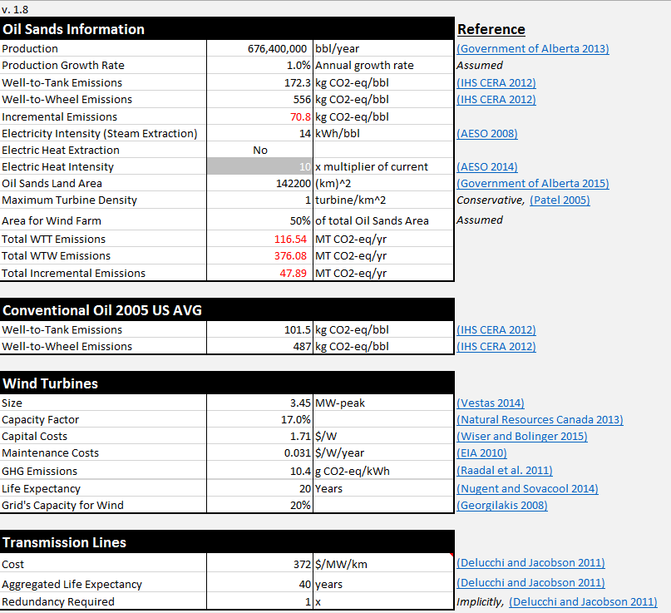

Figure : Input panel for the reconfigurable model, provided in the SI. Red cells are calculated values

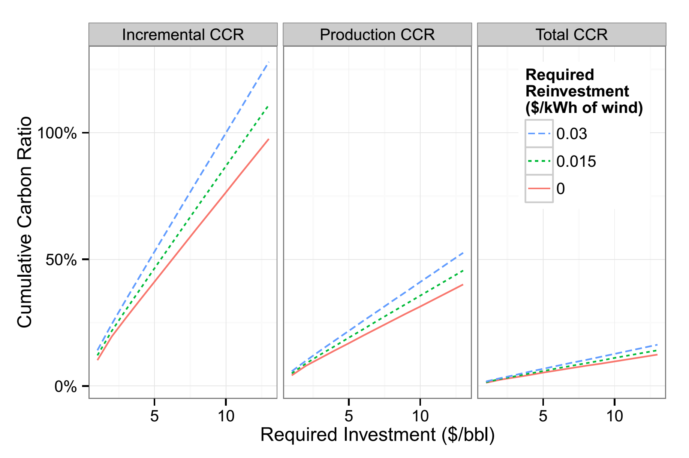

Figure : The model’s cumulative carbon ratio after 40 years of different investment and reinvestment rates.

Figure : The annual expenditures [left axis] and the number of active wind turbines [right axis] for the proposed scheme with 17% capacity factor, charging $11.5/bbl and $0.015/kWhwind

Figure : Equivalent cost of GHG reduction, using the net present value (NPV) of future expenditures and separating the cost into capital expenditures (CapX), turbine maintenance, transmission line construction within Alberta (intra-province transmission), and all other transmission line construction costs (extra-province transmission). Reference costs are for 2015 Cap and Trade pricing in California, high-penetration onshore wind, and the maximum cost to achieve an annual abatement of 3,000 MT/ CO2e per year in the U.S.

Figure : The production cost of upgraded oil from the oil sands compared to the market price in 2013, 2014, and 2015, where error bars show the monthly minimum and maximum prices and the uncertainty in production cost estimates. Production costs also show the proposed addition of a $10/bbl tariff.

# References

[1] Alberta Economic Development and Trade, “Highlights of the Alberta Economy 2015,” Alberta Government, 2015.

[2] J. Giovannetti, “Alberta to double carbon tax by 2017, strengthen emissions reduction targets,” *The Globe and Mail*, Toronto, Canada, 25-Jun-2015.

[3] W. A. Ritch and M. E. Begay, “Smoke and mirrors: how Massachusetts diverted millions in tobacco tax revenues,” *Tob. Control*, vol. 10, no. 4, pp. 309–316, Dec. 2001.

[4] EIA, “Spot Prices for Crude Oil and Petroleum Products,” *US Energy Information Administration*, 02-Dec-2015. [Online]. Available: http://www.eia.gov/dnav/pet/pet_pri_spt_s1_m.htm. [Accessed: 04-Dec-2015].

[5] Morgan Stanley Research, “Crude Cost of Production Rises as Demand Grows,” Morgan Stanley, May 2014.

[6] N. Williams, “Even losing $6 per barrel, top Canada oil sands project unlikely to close,” *Reuters Canada*, 19-Aug-2015. [Online]. Available: http://ca.reuters.com/article/businessNews/idCAKCN0QO25I20150819. [Accessed: 04-Dec-2015].

[7] Climate Policy Initiative, “California Carbon Dashboard,” 02-Dec-2015. [Online]. Available: calcarbondash.org. [Accessed: 04-Dec-2015].

[8] J. Creyts, A. Derkach, S. Nyquist, K. Ostrowski, and J. Stephenson, “Reducing U.S. Greenhouse Gas Emissions: How Much at What Cost?,” McKinsey & Company, Executive Report, Dec. 2007.

[9] J. Webber, “Paris climate talks: Nobel chemist optimistic on pledges,” *Financial Times*, 29-Nov-2015.

[10] CanadianForex, “Canadian Dollar Trends Dashboard,” *CanadianForex*, 2015. [Online]. Available: http://www.canadianforex.ca/forex-tools/my-fx-dashboard#. [Accessed: 04-Dec-2015].

[11] IHS CERA, “Oil Sands, Greenhouse Gases, and US Oil Supply: Getting the Numbers Right - 2012 Update,” IHS CERA, 2012.

[12] Government of Alberta, “Oil Sands: The Resource,” Government of Alberta, Sep. 2013.

[13] H. L. Raadal, L. Gagnon, I. S. Modahl, and O. J. Hanssen, “Life cycle greenhouse gas (GHG) emissions from the generation of wind and hydro power,” *Renew. Sustain. Energy Rev.*, vol. 15, no. 7, pp. 3417–3422, Sep. 2011.

[14] P. S. Georgilakis, “Technical challenges associated with the integration of wind power into power systems,” *Renew. Sustain. Energy Rev.*, vol. 12, no. 3, pp. 852–863, Apr. 2008.

[15] AESO, “AESO 2014 Long-term Outlook,” Alberta Electric System Operator, Calgary, 2014.

[16] Natural Resources Canada, “RETScreen 4,” *RETScreen International*, 14-Jun-2013. [Online]. Available: http://www.retscreen.net/ang/version4.php. [Accessed: 10-Nov-2015].

[17] EIA, “Electric Power Monthly,” *US Energy Information Administration*, 26-Aug-2015. [Online]. Available: http://www.eia.gov/electricity/monthly/epm_table_grapher.cfm?t=epmt_1_1. [Accessed: 21-Sep-2015].

[18] California Energy Commission, “Total Electricity System Power,” *Energy Almanac*, Sep-2015. [Online]. Available: http://energyalmanac.ca.gov/electricity/total_system_power.html. [Accessed: 27-Sep-2015].

[19] California Energy Commission, “2014 Integrated Energy Policy Report,” California Energy Commission, CEC-100-2014-001-CMF, 2014.

[20] California EPA, “California Greenhouse Gas Emission Inventory: 2000-2013,” California Environmental Protection Agency: Air Resources Board, 2015 Edition, Jun. 2015.

[21] NEB, “Electricity Generation,” *National Energy Board*, 16-Sep-2015. [Online]. Available: https://www.neb-one.gc.ca/nrg/ntgrtd/ftr/2013/ppndcs/pxlctrctgnrtn-eng.html. [Accessed: 21-Sep-2015].

[22] M. A. Delucchi and M. Z. Jacobson, “Providing all global energy with wind, water, and solar power, Part II: Reliability, system and transmission costs, and policies,” *Energy Policy*, vol. 39, no. 3, pp. 1170–1190, 2011.

[23] R. Wiser and M. Bolinger, “2014 Wind Technologies Market Report,” Lawrence Berkeley National Lab, Berkeley, CA, DOE/GO--102015-4702, Aug. 2015.

[24] EIA, “Assumptions to the Annual Energy Outlook 2010,” US Energy Information Administration, Office of Integrated Analysis and Forecasting, DOE/EIA-0554(2010), Apr. 2010.

[25] D. Nugent and B. K. Sovacool, “Assessing the lifecycle greenhouse gas emissions from solar PV and wind energy: A critical meta-survey,” *Energy Policy*, vol. 65, pp. 229–244, 2014.

[26] Government of Alberta, “Facts and Statistics,” *Alberta Energy*, 20-Jun-2007. [Online]. Available: http://www.energy.alberta.ca/oilsands/791.asp. [Accessed: 30-Nov-2015].

[27] Government of Alberta, “Oil Sands Mine Reclamation and Disturbance Tracking by Year,” *Alberta Environment and Parks*, 19-May-2015. [Online]. Available: http://osip.alberta.ca/library/Dataset/Details/27#. [Accessed: 30-Nov-2015].

[28] M. R. Patel, *Wind and Solar Power Systems: Design, Analysis, and Operation, Second Edition*. CRC Press, 2005.

[29] M. N. Schwartz and D. L. Elliott, “Wind shear characteristics at central plains tall towers,” presented at the American Wind Energy Association WindPower 2006 Conference, 2006.

[30] C. Cox and M. Murphy, “Energy,” Raymond James Ltd., Vancouver, BC, Industry Report.

[31] AESO, “2014 Annual Market Statistics,” Alberta Electric System Operator, Calgary, Feb. 2015.

[32] Clarke Energy, “Cogeneration & CHP,” *Clarke Energy: Engineer - Install - Maintain*. [Online]. Available: https://www.clarke-energy.com/chp-cogeneration/. [Accessed: 11-Nov-2015].

[33] D. Weisser, “A guide to life-cycle greenhouse gas (GHG) emissions from electric supply technologies,” *Energy*, vol. 32, no. 9, pp. 1543–1559, Sep. 2007.

[34] AESO, “Future Demand Outlook,” Alberta Electric System Operator, Calgary, 2008.

# Supplemental Information (SI)

## Additional Methods Details

### Modeling the GHG intensity of on-site cogeneration

As a first order estimate, the industrial-scale cogeneration of electricity and steam was taken to produce 40% electricity, 50% usable heat and 10% losses [32]. We therefore modeled this process as 75% efficient electricity generation from natural gas. Natural gas generation was modeled as having an average efficiency of 45% — a balance of the 35–42% efficiency of simple cycle and the efficiency of 52–60% for combined cycle. The emissions of cogeneration where therefore taken to be 2891 MT CO2e/GW (60% of those for standard natural-gas-fired electricity generation, 4.82 MT CO2e/GW [33]).

### Modeling the current capacity and wind usage of on-site electricity

The annual average load for on-site electricity was taken to be 1.1 GW, based on 1.9 million bbl/day [11] of oil production with an electricity intensity (using natural gas for steam extraction) of 14 kWh/bbl [34]. The Alberta Electricity System Operator reports that no significant wind generation is present in the northeast or northwest of Alberta [15]; therefore it was assumed that no significant wind energy was present on site.

## Additional Model Capacities

### Modeling the shift to electrically-assisted extraction techniques

The model has the additional ability to model the shift from current extraction techniques to electrically powered techniques. The Alberta Electric System Operator predicts that a shift to electrically-assisted extraction techniques could multiply the electrical demand of the oil sands by ten-times [15]. A multiplication of ten times, means an additional nine-times the current demand would replace the current steam-assisted gravity extraction, of which the majority of which is currently produced by natural gas. The GHG emission values by fuel source are per unit of electrical energy produced, which would overestimate the GHG emissions of steam creation. Instead an efficiency of NG electricity generation was assumed to be 45% and scaled the NG GHG emissions down to 2.17 MT CO2e/GWheat. Without steam generation, cogeneration will no longer be an on-site option and the remaining process electricity was assumed to have a GHG intensity of the Albertan grid.

### Modeling new destinations for the electricity

To allow for the inclusion of locations where the supply mix is known but where the GHG intensity is unknown, an approximate GHG emission rate associated with different supply types [33] can be scaled by the official generation mix numbers. This additional capacity was not used in the model presented herein but is included to assist the reader in rapidly modeling alternate scenarios.

### Determining the equivalent IRR for oil producers

In addition to the economic benefits derived by mitigating the current environmentally-founded concerns with the Keystone XL Pipeline, the model also calculates an equivalent internal rate of return (IRR) based on an assumed sale price for wind energy and an avoided carbon tax by participating in the proposed scheme. Wiser and Bolinger reported the 2012–2014 average contracted price for wind power in the West of the United States to be $0.06/kWh, while nationally the average was $0.026/kWh [23].

For example, consider a scenario with a wind capacity factor of 17%, where oil producers avoid a carbon tax of $12/bbl by investing $12/bbl in wind turbines, earn $0.06/kWh on the sale of the wind power, and reinvest $0.015/kWh of these earnings into more wind turbines. In this scenario, the IRR was found to be 17%.

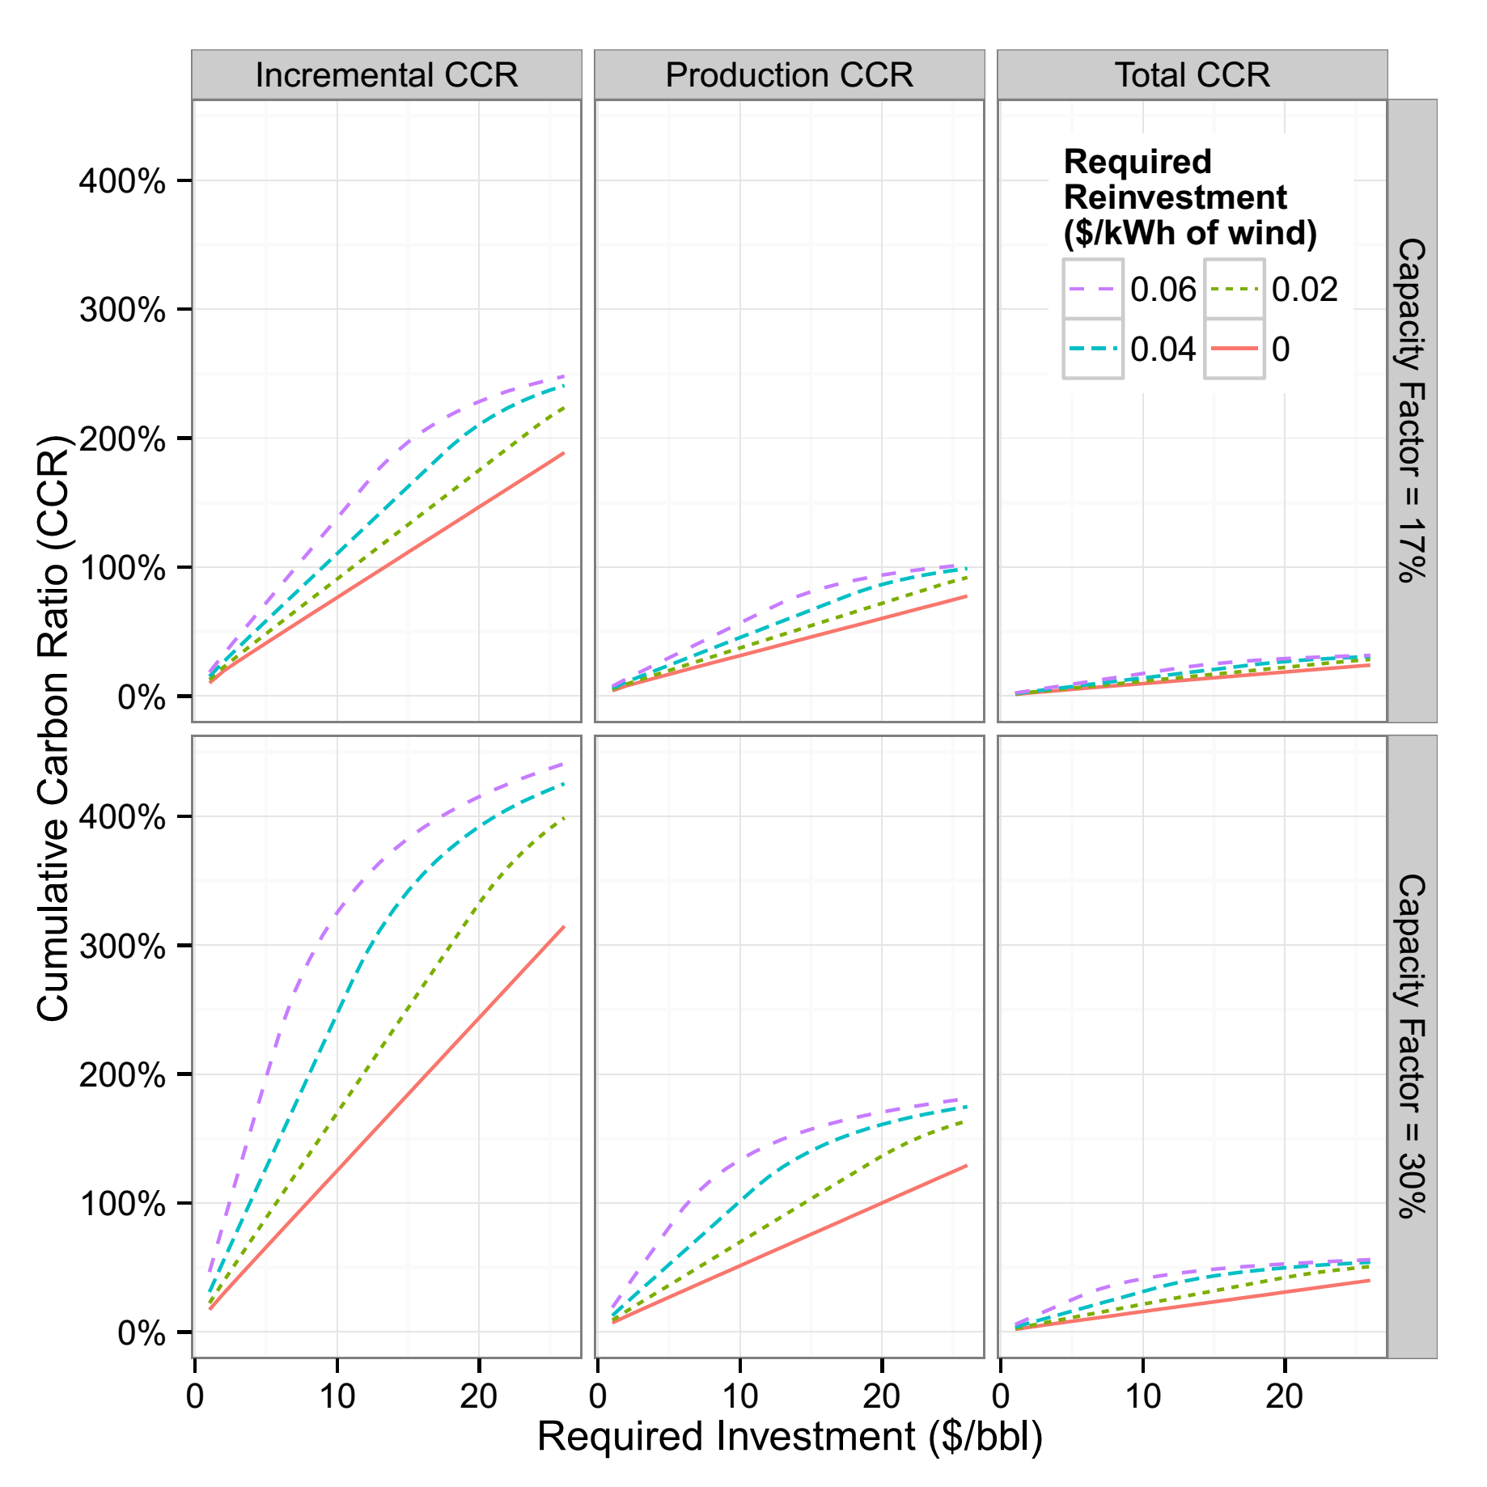

Figure : The model’s cumulative carbon ratio (CCR) after 40 years of different investment and reinvestment rates. Each column summarizes a different CCR metric. The two rows of this graph show how the model changes for the expected capacity factor of 17% and for a more typical capacity factor for wind projects (30%).