**A Symbiotic System Model for the Development for Canadian Oil Sands**

**1- Introduction**

The Northern Alberta region contains 98% of the Canadian oil sands, covering about 140,200 square kilometers. It is also estimated that these regions hold proven reserves up to 1.75 trillion barrels of bitumen. About two tons of oil sands must be dug up, moved, and processed to produce 1 barrel of synthetic oil. Detractors hypothesize that mining, processing, and using the oil from the oil sands will greatly exacerbate global carbon dioxide (CO2) problems, and extend this argument as a reason for the US to deny permission to grant approval for the Keystone XL pipeline. Proponents say that global CO2 impact will be no different than from other sources of oil, and the pipeline is safer than rail shipments. All parties must agree however, that the Energy Return on Investment (EROI) from oil sand extraction is lower than conventional oil extraction.

We hypothesize that through a symbiotic system, we can mitigate environmental concerns and facilitate the development of the Keystone XL pipeline. Specifically, we propose a system where oil companies are required to invest a portion of their revenues in renewable energy generation on site and are further required to reinvest some of the money saved by that renewable generation.

**2- Methods**

Our proposed symbiotic system would require oil companies to invest in renewable energy generation as a part their land reclamation. The investment amount is a function of the number of barrels of oil sold and the amount of renewable energy generated by the generation capacity installed as part of this system. We investigated investments into wind generation capacity and the impact of different required investment rates in US dollars and different reinvestment into wind turbine purchase and maintenance.

To account for the environmental benefits of the proposed symbiotic system, we considered the ratio of the carbon offset by wind power, to the carbon produced by the oil sands. Specifically, we considered the marginal carbon impact of the oil sands compared to conventional oil (Production), and the total carbon cost of producing and consuming oil from the oil sands (Total). Further, we considered both the instantaneous carbon ratio (ICR) of these numbers at any given point in time, and the cumulative carbon ratio (CCR), which considers the total amount of emissions and offset emissions since the start of the project.

Comparisons across the published studies of GHG life-cycle emissions intensities for fuels derived from different sources are sensitive to each study’s choice of boundaries and input parameters Lattanzio (2012) reviewed data from the primary studies of the U.S. Department of State (DOS) and contractor ICF International L.L.C, and the analysis from the Final Environmental Impact Statement (EIS), finding the following emission numbers [1]:

* Carbon emissions from oil sand production (Well-to-Tank)
  + Well-to-Tank GHG emissions are valued at 18 g CO2e/MJ LHV
  + Equivalent to MT CO2e/bbl
* carbon emissions from oil consumption (end use) (Tank-to-Wheel or Combustion)
  + Tank-to-Wheel GHH emissions are valued at 73 g CO2e/MJ LHV
  + Equivalent to MT CO2e/bbl
* carbon emissions from oil sands production and consumption (Well-to-Wheel)
  + Well-to-Wheel GHG emissions are valued at 91 g CO2e/MJ LHV
  + Equivalent to MT CO2e/bbl

The bitumen production by the Alberta’s oil sands industry has reached 1.9 million barrels/day [4]

|  |  |
| --- | --- |
| Carbon emissions from oil sand production per year | 76.14 MT CO2e |
| Carbon emission from oil sand (end use) per year | 308.81 MT CO2e |
| Total carbon emission from oil sand production and consumption per year | 384.96 MT CO2e |

Raadal et al (2014) conducted a specific life cycle GHG emissions from wind power generation from six different 5 MW offshore wind turbine. The relatively large ranges in GHG emissions and energy performance are mainly the result of the differing steel masses required for the analyzed platforms. The default wind farm assessed is assumed to have a 20-year lifetime and a Capacity Factor (CF) of 46%

* Life cycle carbon emissions from wind turbine manufacturing and installation for a 5 MW offshore wind turbine [2]:
  + [18 – 31.4] g CO2e/KWh which averages to 24.7 g CO2e/KWh

Carbon emissions for Alberta and Canadian electricity generation [3]:

* GHG intensity of electricity generation in Alberta to be 880 t CO2e/GWh
* GHG intensity of electricity generation in Canada to be 210 t CO2e/GWh

**Input assumptions.** Input assumptions can impact model results at each stage of the assessment. Key input assumptions include: two (three?) key constrains in the model:

* + $2/Watt cost with installation [ref needed!]
  + The 5% annual maintenance [ref needed!]
  + The total number of turbines capped at 70,000 ( approximately 1 per square km) of wind turbines to be built
  + Max amount of electricity generated?

**3- Results**

The proposed symbiotic system considers the potential environmental benefits of installing wind turbines as a part of oil sands reclamation efforts.

* We used a mean carbon values from Lattanzio (2012), and we plugged it into an excel spreadsheet to investigate model behavior
* We looked at what happens if we force the carbon tax to get reinvested into wind turbines with and without reinvestment
* We also looked at if the carbon tax is applied to only the production emissions, or also the consumption emissions, yielding investment net values of $2/bbl and $15/bbl

It follows that with enough 4,160 wind turbines, the marginal climate damage caused by oil sands compared to conventional oil is offset. This amount of electricity generation is equivalent to that of Alberta’s 2012 electricity consumption. If 70,000 turbines (approximately one per square kilometer) were installed, the total carbon emissions of production and consumption of the oil sands could be offset in T years, as shown in Table X.

|  |  |  |  |  |  |
| --- | --- | --- | --- | --- | --- |
| Turbines Installed | 1000 | 4160 | 10000 | 30000 | 70000 |
| Carbon Emissions from Manufacturing and Installation (MT) |  |  |  |  |  |
| Density (Turbines/(km)^2) | 0.014 | 0.059 | 0.14 | 0.43 | 1.00 |
| Name Plate Capacity (GW) | 5 | 20.8 | 50 | 150 | 350 |
| Generation (GW) | 2 | 8.32 | 20 | 60 | 140 |
| Annual Carbon Offset (MT) | 12.76 | 53.08 | 127.58 | 382.75 | 893.09 |
| Total Instantaneous Carbon Ratio | 0.04 | 0.15 | 0.37 | 1.10 | 2.57 |
| Production Instantaneous Carbon Ratio | 0.26 | 1.07 | 2.57 | 7.70 | 17.96 |
| Percent of Alberta's Electricity | 0.24 | 1.00 | 2.40 | 7.21 | 16.82 |
| Percent of Canada's Electricity | 0.02 | 0.06 | 0.15 | 0.46 | 1.07 |

**Table X.**

Despite what may be an immediate reaction of ‘Impossible!’ or ‘Unaffordable!’, through imposing a levy per barrel of oil to fund the construction of wind turbines and by further reinvestment a portion of their revenue into building more turbines, this plan is achievable. The feasibility depends strongly on how much companies are required to reinvest of the wind turbine revenues; for reference, Fig Y shows investment amounts of $2/bbl, $7/bbl, and $15/bbl, and reinvestment requirements of $0/kWh, $0.03/kWh, and $0.06/kWh. The investment of $2/bbl is equivalent to the proposed Alberta carbon tax applied to the production emissions of the oil sands, while $15/bbl is equivalent to the proposed tax applied to the production and end use emissions. $0.06/kWh was our estimate [ref needed!] for the cheapest grid electricity pricing and therefore serves as an upper limit to the feasibility of reinvestment charges.

If the goal is to achieve a production CCR of one within the next 40 years, the current carbon tax could be used with a reinvestment level of $0.06/kWh, or higher per barrel rates with lower per kWh charges, as in Fig Y. The only shown scenario to reach a total CCR of one was the $15/bbl with $0.06/kWh. One method of framing this investment charge would be as a carbon tax applied at the time of production for the production and consumption of the oil, or as a flat rate tariff.

* TODO: Mention that testing a wide range of parameters within an excel spreadsheet, we find the set of pareto-optimal solutions
* TODO: ‘Magic numbers’ based on our carbon values for the investment and for reinvestment policy

Many of these scenarios would generate more electricity than currently required by the oil sands, to achieve a total ICR of one would require enough wind to supply 45% of Canada’s electricity requirements. Methods of using and distributing this excess power is discussed in the SI.

* TODO: Transmission lines and electricity co-generation
* TODO: Different applications with the excess power generation

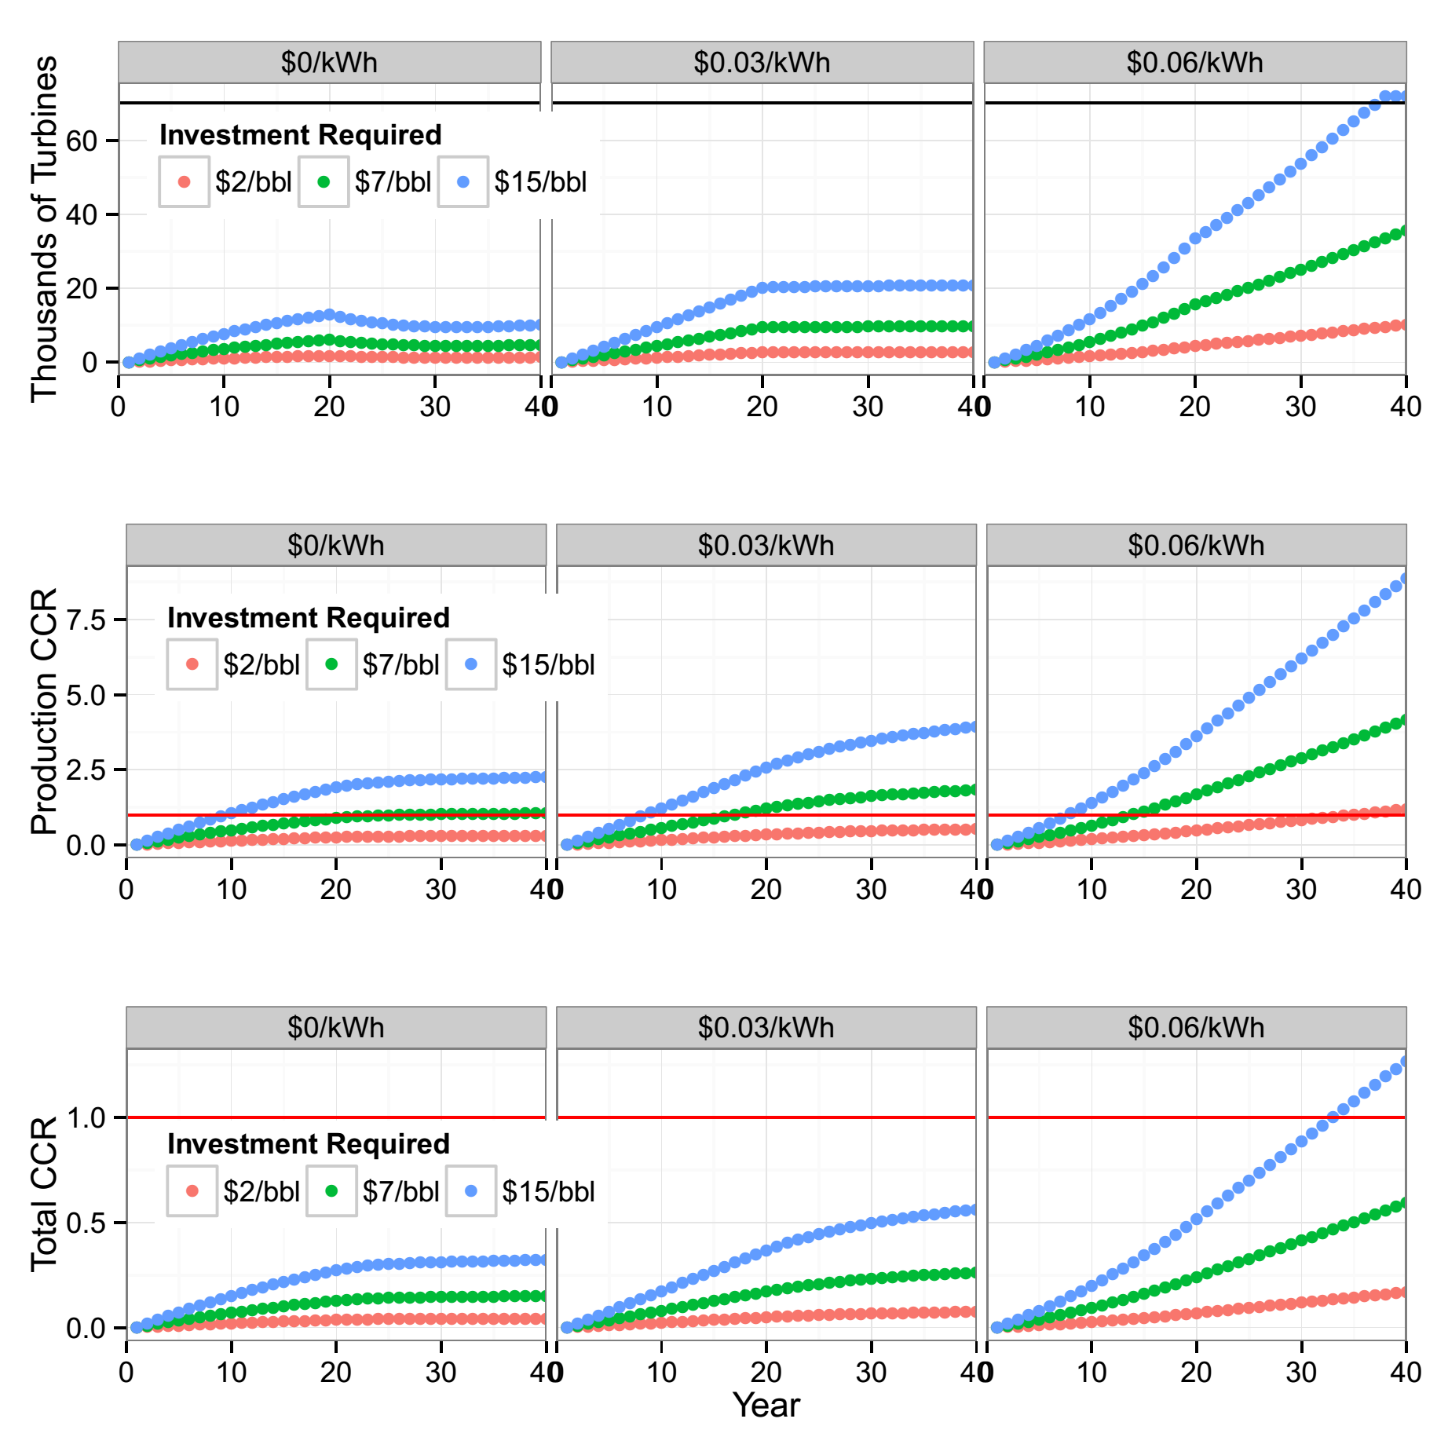

**Figure Y.**

**FIXME: 4- Conclusion**

This paper explored economic models to short and long term energy needs in the Canadian oil sand region that can lead to an overall reduction in atmospheric CO2.

We propose to install a small number of wind turbines on reclaimed oil sands land in order to better investigate the hypothesis presented here to ascertain true costs, risks, and benefits.

**References**

1. Lattanzio, R. (2012). Canadian Oil Sands: Life-Cycle assessments of Green House Emissions. Congressional Research Service
2. Raadal et al. (2014). GHG emissions and energy performance of offshore wind power. Renewable Energy 66 314-324
3. Mallia,E, Lewis, G (2012). Life cycle greenhouse gas emissions of electricity generation in the province of Ontario, Canada
4. http://oilsands.alberta.ca/resource.html
5. Bari et al. (2014). A wintertime investigation of atmospheric deposition of metals and polycyclic aromatic hydrocarbons in the Athabasca Oil Sands Region, Canada. Science of the Total Environment 485: 180-192