3.Software Methodology

3.1. Software Methodology

A software methodology is kind of framework that’s is used for software development which helps to do the developing in structure, plan and control the process of developing(Professionals, n.d.). Using software methodology, we will get a tracking of the development of the software.

There are plenty of process out there to manage or develop a software, thus it is impossible to find a particular way of development. Software methodology will reduce the risk of project by cutting down the process into smaller, this will help to develop the software more easier and easy of changing the development any time (alliancesoftware, n.d.).

It is very hard to find which methodology we have to follow the development, but it can be solved by understanding the all the software development methodology. Working under a development methodology will help the client and the developer to deliver a well-organized software and well discipline code.

We have decided to choose Rapid Application Development(RAD), is a form an agile software development, which works on user feedback and strict planning and freezing the requirements. In short, we can say Rapid Application Development(RAD) is “less talk more action “. But it need more testing for the software because it is built in fast paced environment. (Anderson, 2017)

RAD is mainly focus on the software development rather than the planning, requirement is generally freeze so that it helps to start the prototyping. RAD methodology generally breaks the project into small task, where it can be accomplished more quickly. As a result, this will give effective communication, faster development and better efficiency. (Team, 2018)

**Generally, Raid Application Development focused follow four main phases**:

1.Requirement planning:

2.User design

3.Rapid Construction

4.Cutcover

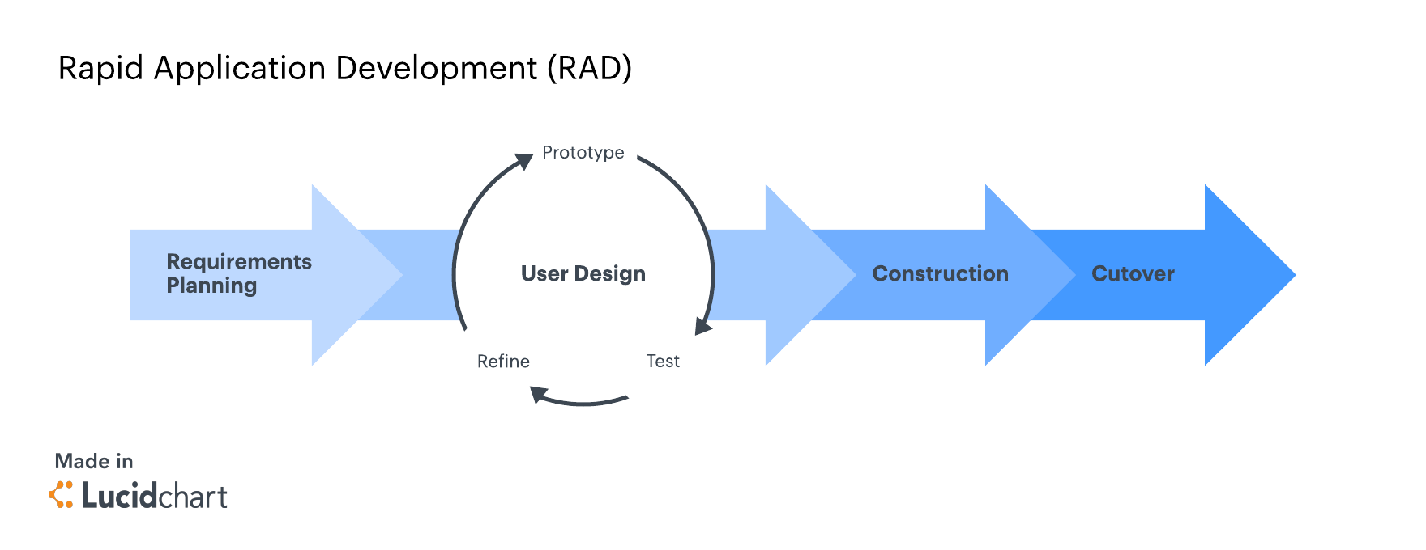

Figure :Rapid Application Methodology Phases (Team, 2018).

1.Requirment Planning:

This is critical step because in RAD there is no regular meeting for the requirement planning, when a meeting is called client, developer and design will come together and discus about the project and break down the stages that involves in the project. And also, they make sure to freeze the project so that they can start the prototyping the project. (Team, 2018)

2.User Design:

So once the requirement is fixed, they jump into the development and start the prototyping the various design. This will be working more closely with client, to make sure developer are meeting the all the requirement and changes that client needs. (Team, 2018)

3.Rapid Construction:

After the design meeting all the requirement it’s the time to start the rapid development, In this stage the development will be in fast pace. The software development team start the coding, integration and testing and also work together to make sure everything goes as per the plan. This stage is very important because client get the beta application where he can make changes or rise and issue before it goes live. (Team, 2018)

4.CutOver

This is the last stage of the development, where is product comes in finished state and move to live environment. In this stage product will be moved into the new system, data conversions, and may also give training to the users. (Team, 2018)