Java project structure

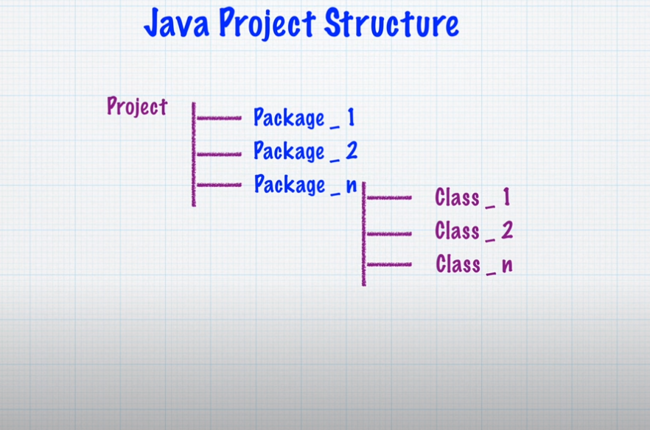

At least one main method any of the class

**Main** Structure

**package** lecture;

**public** **class** main {

**public** **static** **void** main(String[] args) {

}

}

Print

Example-1

**package** lecture;

**public** **class** main {

**public** **static** **void** main(String[] args) {

System.***out***.println("This is my first java program ");

}

}

Output: This is my first java program

Example-2

**package** lecture;

**public** **class** main {

**public** **static** **void** main(String[] args) {

System.***out***.println("Bangladesh");

System.***out***.println("India");

System.***out***.println("Thailand");

}

}

Output:

Bangladesh

India

Thailand

Example-3

**package** lecture;

**public** **class** main {

**public** **static** **void** main(String[] args) {

System.***out***.print("Bangladesh");

System.***out***.print("India");

System.***out***.print("Thailand");

}

}

Output: BangladeshIndiaThailand

Example-5

**package** lecture;

**public** **class** main {

**public** **static** **void** main(String[] args) {

System.***out***.print("Bangladesh\t");

System.***out***.print("India\t");

System.***out***.print("Thailand");

}

}

Output:

Bangladesh India Thailand

Note: \t= give one tabe

Example-6

**package** lecture;

**public** **class** main {

**public** **static** **void** main(String[] args) {

System.***out***.print("Hello\n\n\nHi ");

}

}

Output:

Hello

Hi

Note: \n = new line