# Variables

# 2.PNG

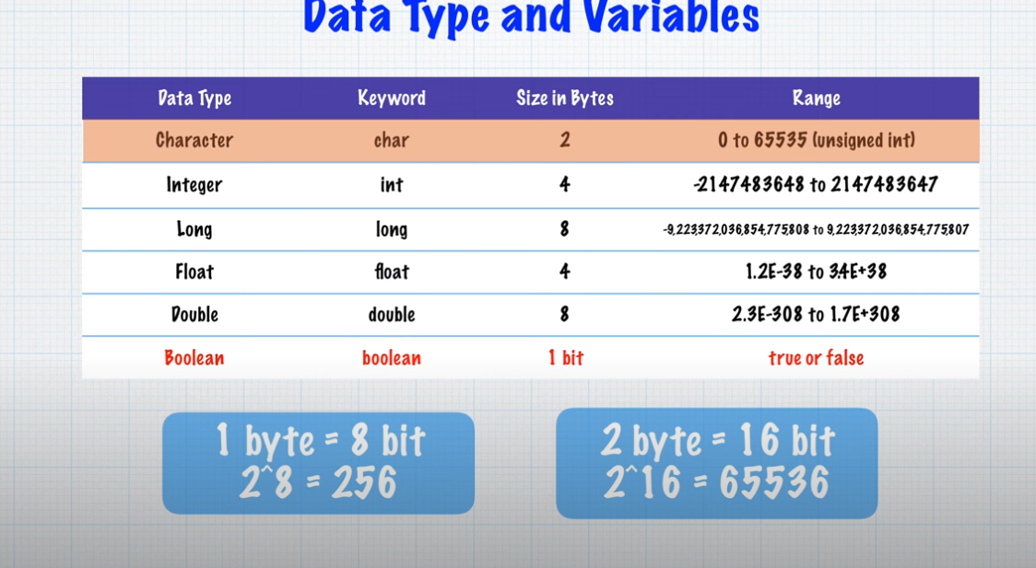

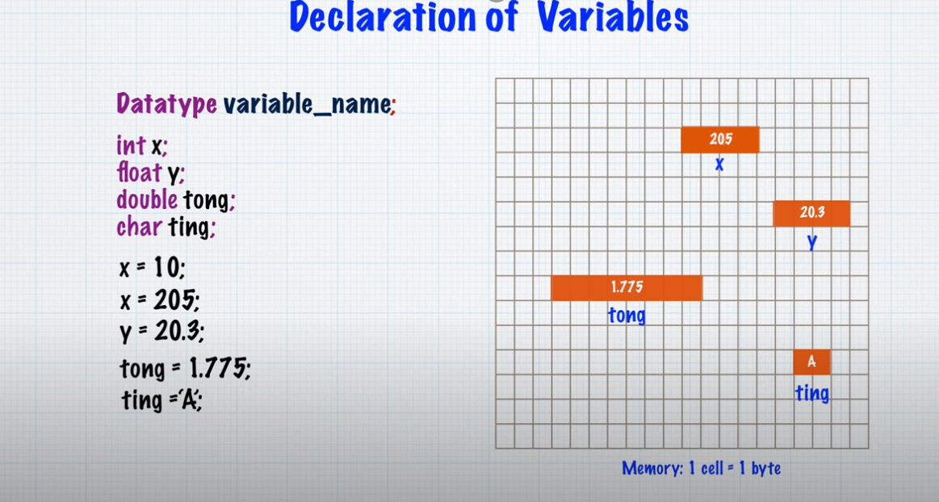

Example-1:

**package** lecture;

**public** **class** main {

**public** **static** **void** main(String[]args)

{

**int** myvar;

myvar=100;

System.***out***.println("valu of myvar is:" + myvar);

}

}

Example-2

**package** lecture;

**public** **class** main {

**public** **static** **void** main(String[]args)

{

**int** myvar;

myvar=100;

myvar=myvar+10;

System.***out***.println("valu of myvar is:" + myvar);

}

}

Example-3

**package** lecture;

**public** **class** main {

**public** **static** **void** main(String[]args)

{

**double** myvar;

myvar=500.100;

myvar=myvar+10;

System.***out***.println("valu of myvar is:" + myvar);

}

}

Example:4

**package** lecture;

**public** **class** main {

**public** **static** **void** main(String[]args)

{

**int** x=1500;

System.***out***.println("Stipend of student-1:" + (3.80*x));

System.***out***.println("Stipend of student-1:" + (3.50*x));

System.***out***.println("Stipend of student-1:" + (3.30*x));

System.***out***.println("Stipend of student-1:" + (3.10*x));

System.***out***.println("Stipend of student-1:" + (2.80*x));

System.***out***.println("Stipend of student-1:" + (2.50*x));

}

}

Example-5

**package** lecture;

**public** **class** main {

**public** **static** **void** main(String[]args)

{

**int** a, b, c;

a=10;

b=-14;

c=15;

**float** avg;

avg=(a+b+c)/3;

System.***out***.println(avg);

}

}

Output:3

Example-6

**package** lecture;

**public** **class** main {

**public** **static** **void** main(String[]args)

{

**int** a, b, c;

a=10;

b=-14;

c=15;

**float** avg;

avg=(**float**)(a+b+c)/3;

System.***out***.println(avg);

}

}

Output-3.6666667

Example-7

**package** lecture;

**public** **class** main {

**public** **static** **void** main(String[]args)

{

**long** a, b, c;

a=5678934;

b=-987651;

c=3452378;

**float** avg;

avg=(**float**)(a+b+c)/3;

System.***out***.println(avg);

}

}

Output-2714553.8

Example-8

**package** lecture;

**public** **class** main {

**public** **static** **void** main(String[]args)

{

**boolean** x;

x= **true**;

System.***out***.println("value of x is:"+x);

}

}

Example-9

**package** lecture;

**public** **class** main {

**public** **static** **void** main(String[]args)

{

**double** a, b, c,avg;

a=10;

b=-14;

c=15;

avg=(a+b+c)/3;

System.***out***.println(avg);

}

}

Example-10

**package** lecture;

**public** **class** main {

**public** **static** **void** main(String[]args)

{

**char** x;

x= '7';

System.***out***.println("value of x is:"+x);

}

}

Example-11:

**package** lecture;

**public** **class** main {

**public** **static** **void** main(String[]args)

{

**char** x;

x= '7';

x='@';

System.***out***.println("value of x is:"+x);

}

}

Example-12

**package** lecture;

**public** **class** main {

**public** **static** **void** main(String[]args)

{

**int** x=50, y=9, z=44;

System.***out***.println("Sum of the values is:"+(x+y+z));

}

}