**Architectural Analysis**

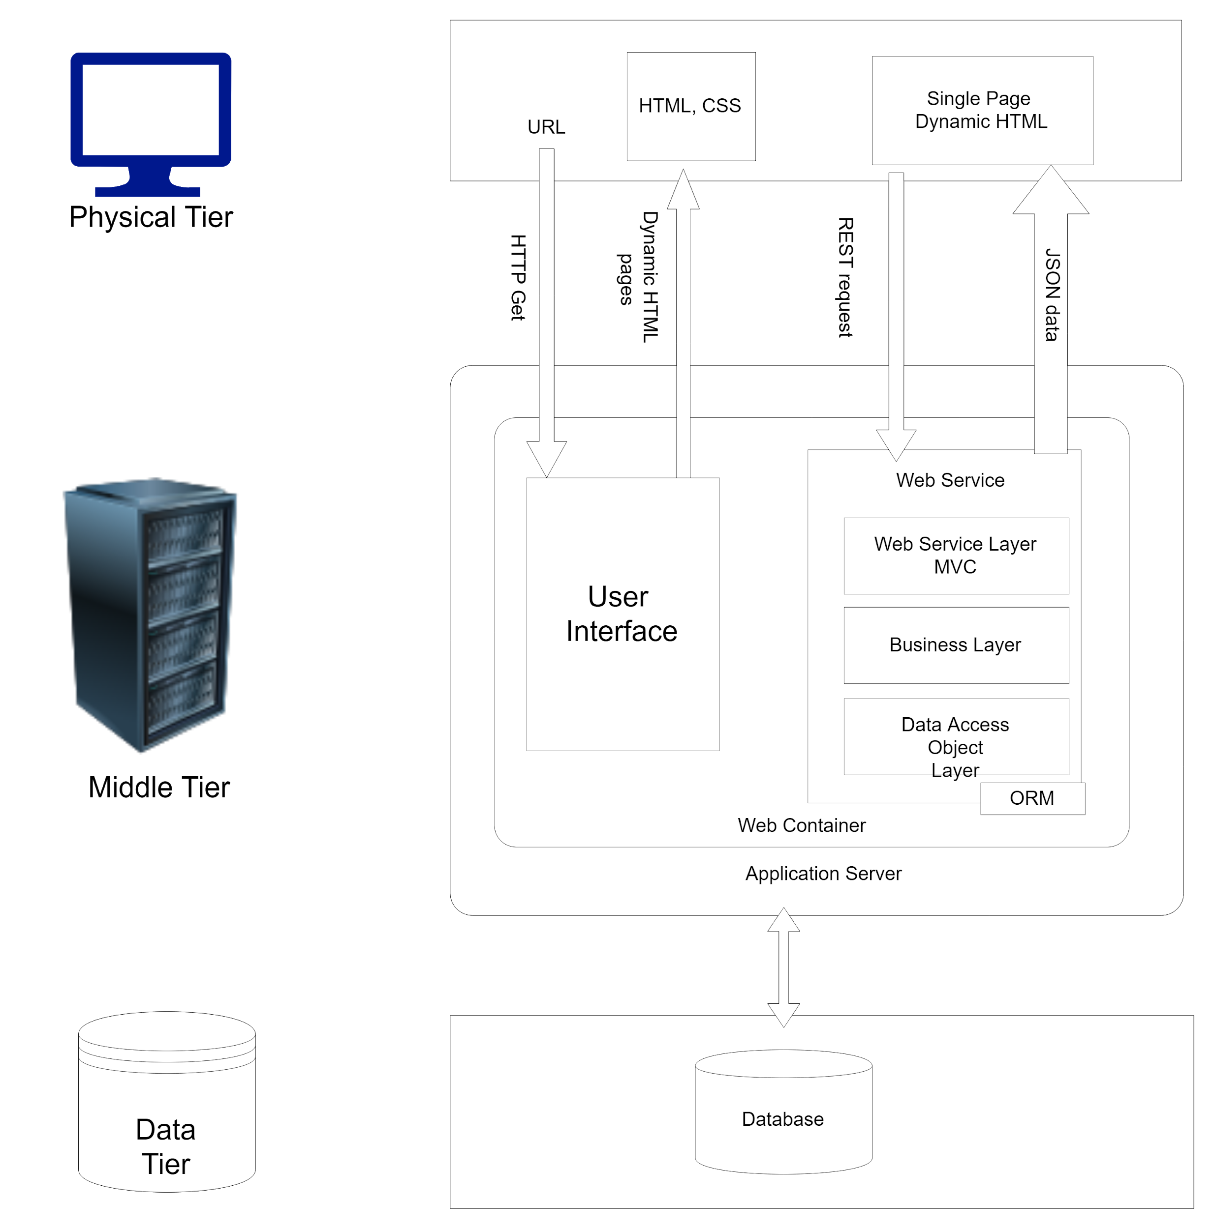

**KEY ABSTRACTIONS**

1. Student

2. Faculty

3. System Administrator

4. Course(Main Courses)

5. Tutorial Session

6. Tutor Request