**MIU Tutoring Platform SRS Document**

1. **Use Cases**
   1. **Use case diagram**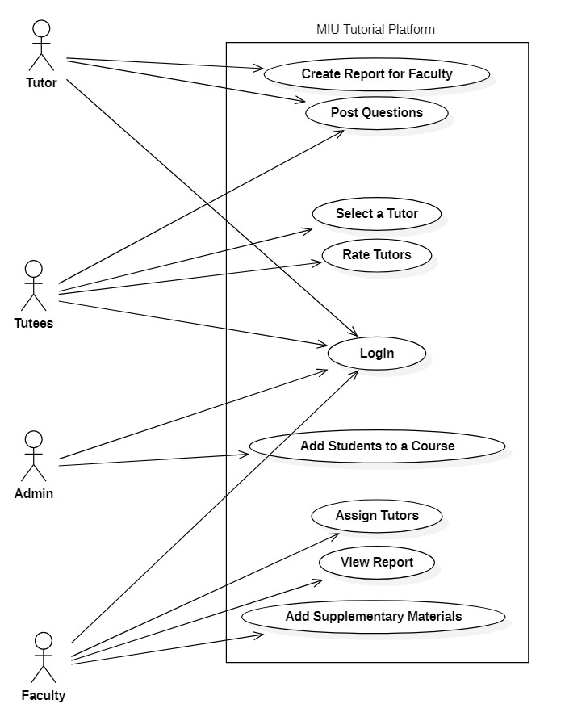
   2. **Use case descriptions**

|  |  |  |
| --- | --- | --- |
| **Use Case Number: 1** | | |
| **Name** : Login | | |
| **Brief description** : Login to the system | | |
| **Actors** : Tutor, Tutee, Faculty, System Admin | | |
| **Preconditions** | | |
| The login page is displayed | | |
| **Flows of Events:** | | |
| **1. Basic Flows** | | |
| **Login** | | |
| **Step** | **User Actions** | **System Actions** |
| 1 | The tutor will put in his credentials and select the login option | The system validates the email and password and displays the homepage |
| **Post conditions** | | |
| The tutor page will opened for the tutor | | |
| **Business Rules** | | |
| The user should have an existing username and password | | |
| **Alternate Paths** | | |
| If the user entered invalid credentials an error should be displayed | | |
|  | | |
| **Use Case Number: 2** | | |
| **Name** : Post a question | | |
| **Brief description** :this use case provides a functionality for posting questions | | |
| **Actors** : Tutor | | |
| **Preconditions** | | |
| The tutor is signed and on the tutorial page | | |
| **Flows of Events:** | | |
| **1. Basic Flows** | | |
| **Post a question** | | |
| **Steps** | User Action | System Response |
| **1** | The tutor select the option to post the question | The system will display text box to write and post the question |
| **2** | The tutor write the question and post | The system will display post the question on the page |
| **Post conditions** | | |
| The question of the tutor will be posted on the page | | |

|  |  |  |
| --- | --- | --- |
|  | | |
| **Use Case Number: 3** | | |
| **Name** : Create a report for faculty | | |
| **Brief description** :This use case allows the tutor to create a performance report about the tutee | | |
| **Actors** : **Tutor** | | |
| **Preconditions** | | |
| The tutor is signed and on the tutorial page | | |
| **Flows of Events:** | | |
| **1. Basic Flows** | | |
| **Create a report for faculty** | | |
| **Steps** | User Action | System Response |
| **1** | The tutor select the command report | The system displays the form |
| **2** | The tutor write the report on the form and submit | The system saves the information to the database and returns the success message |
| **Post conditions** | | |
| The report will be created and submitted | | |