**Use Case Analysis for MIU - Tutoring Platform**

1. Sequence Diagrams
   1. Select Tutor

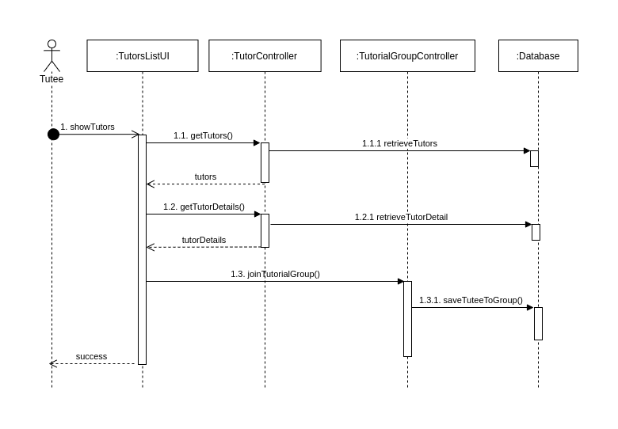

* 1. Assign Tutor

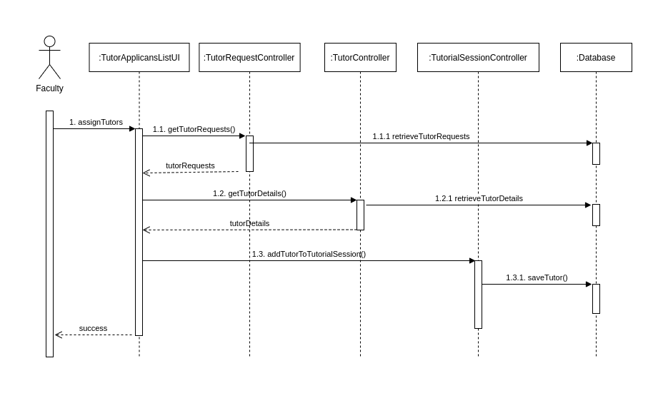

* 1. Post Questions

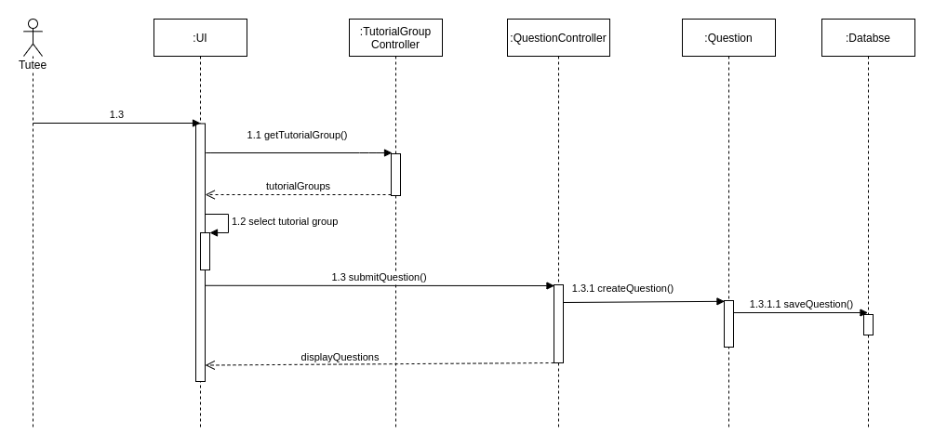

* 1. Create a report for faculty

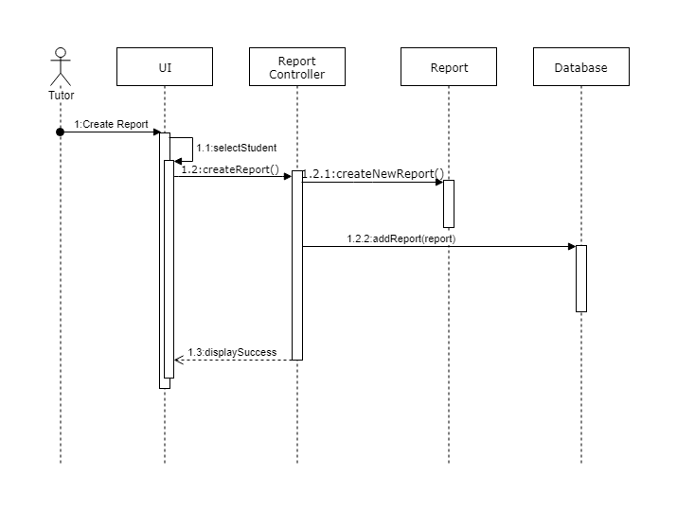

1. Collaborations Diagrams
   1. Select Tutor

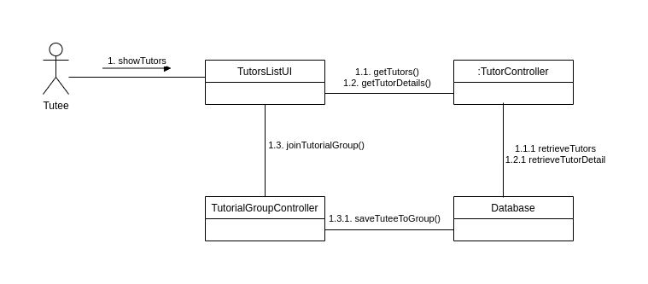

* 1. Assign Tutor

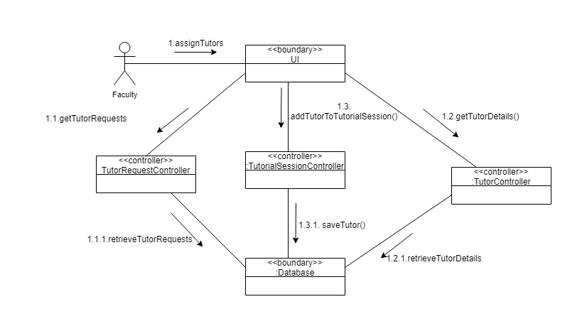

* 1. Post Questions

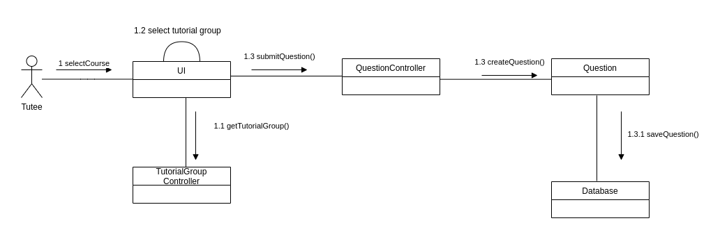

* 1. Create a report for faculty

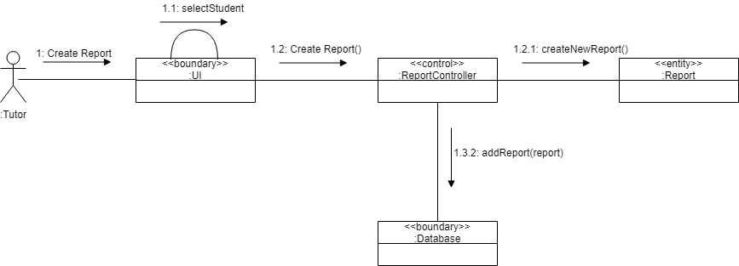

1. VOPC Diagrams
   1. Select Tutor

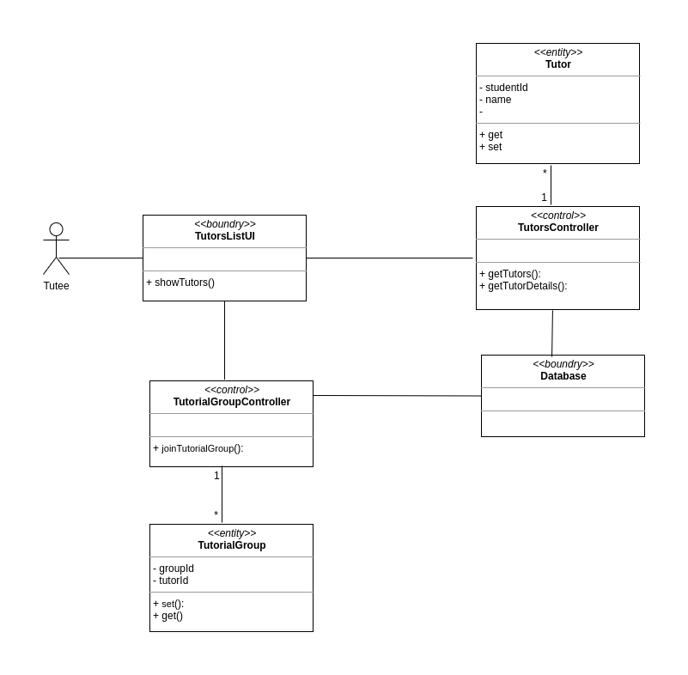

* 1. Assign Tutor

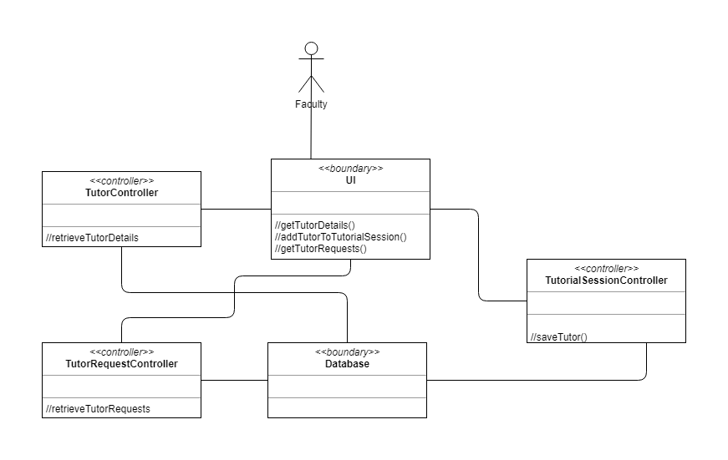

* 1. Post Questions

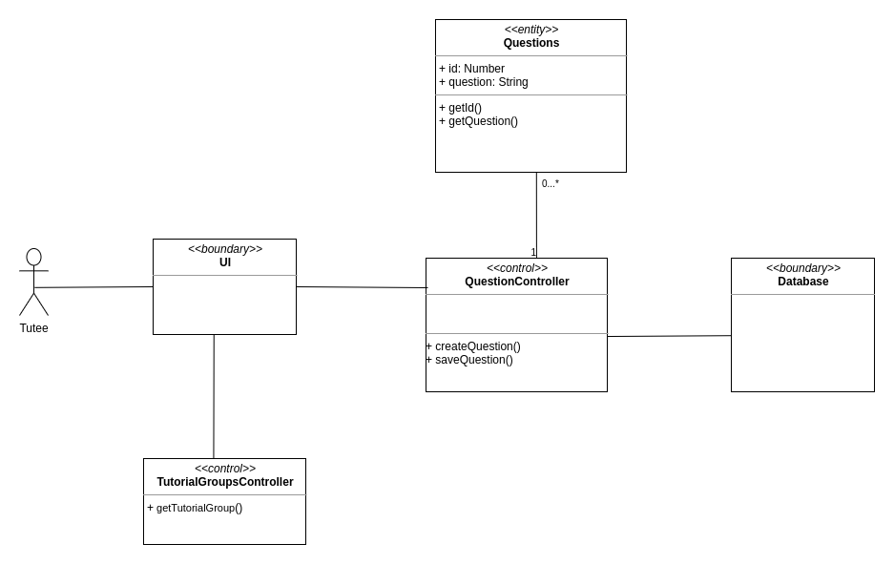

* 1. Create a report for faculty

