**Capital University of Science & Technology**

**Term Project Proposal**

Department of Electrical and Computer Engineering

|  |  |  |  |
| --- | --- | --- | --- |
| **Project Title** | | **Spelling Practice Application with Feedback** | |
| **Course Title** | | **CYG-1611** | |
| **Sr. No.** | **Student Name** | | **Registration Number** |
| **01.** | Muhammad Bin Khalid | | BCPE 243046 |
| **02.** | Ahmad Arshad | | BCY 243001 |

**Idea:**

The **Spelling Practice Application with Feedback** is a console-based tool designed to help users improve their spelling skills. Through interactive exercises and immediate feedback, users can practice spelling words from predefined or personalized word lists, enhancing their learning experience in an engaging and structured manner.

**Objective:**

1. Provide a platform for users to practice spelling words interactively.
2. Enable immediate feedback on user attempts to reinforce learning.
3. Allow users to create, edit, and manage custom word lists for targeted practice.
4. Ensure data persistence for saving and loading word lists.
5. Maintain simplicity and accessibility by leveraging a console-based interface.

**Application:**

1. **Education**:
   * Assists students and language learners in improving spelling and vocabulary.
2. **Language Learning**:
   * Supports non-native speakers in developing their spelling skills.
3. **Personal Development**:
   * Provides a self-paced learning tool for individuals to enhance their communication skills.
4. **Test Preparation**:
   * Acts as a practice platform for spelling bees, language tests, and similar assessments.

**Block Diagram:**

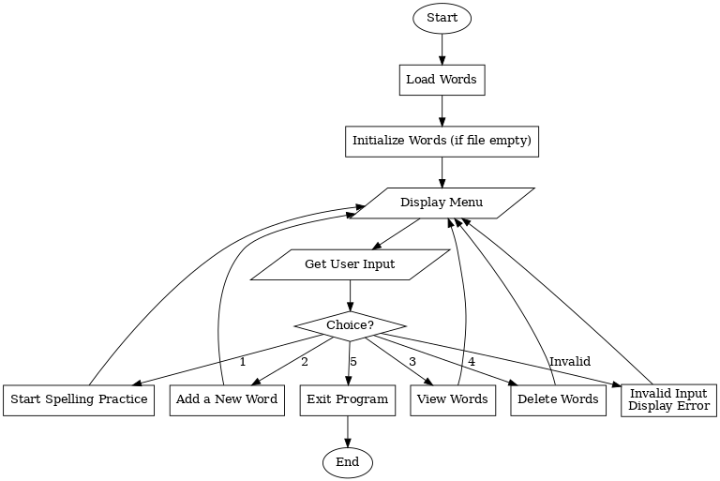

**Instructor Remarks Student 1 Signature: __________________**

**Student 2 Signature: __________________**

**Instructor’s Signature: __________________ Date: __________________**