AI-Powered Feedback System for Student Assignments

Submitted By:
Muhammad Ibrahim

Supervised By:
Dr. Rabeeh Ayaz Abbasi

Session: 2022-2026
Department of Computer Science
Quaid-e-Azam University Islamabad

CERTIFICATE OF APPROVAL
This is to certify that the project “AI-Powered Feedback System for Student Assignments”, submitted by Muhammad Ibrahim (Reg. No. 04072213025), has been accepted by the Department of Computer Science, Quaid-e-Azam University, Islamabad, in partial fulfillment of the requirements for the Bachelor’s in Computer Science. The work was completed under the supervision of Prof. Dr. Rabeeh Ayaz Abbasi and has been reviewed and recommended for acceptance by the undersigned.

Supervisor: __________________________
Dr. Rabeeh Ayaz Abbasi
Department of Computer Science,
Quaid-e-Azam University, Islamabad.

Chairperson: __________________________
Dr. Ayaz Hussain
Department of Computer Science,
Quaid-e-Azam University, Islamabad.
Date: _____________

ACKNOWLEDGEMENT

First and foremost, all praise is due to Almighty Allah, who granted me the strength and knowledge, and patience to complete this project timely and successfully.
I would like to express my heartfelt gratitude to faculty of the Department of Computer Science, Dr. Ayyaz Hussain, Dr. Rabeeh Ayaz Abbasi, Dr. Onaiza Maqbool, Dr. Mudassar Azam Sindhu, Dr. Khalid Saleem, Dr. Ghazanfar Farooq, Dr. Muhammad Naqi, Dr. Shuaib Karim, Dr. Umer Rasheed, Dr. Muazzam Khattak, Miss Ifrah Farrukh, and Miss Memoona Afsheen, for their guidance, support, and mentorship throughout my project and academic journey. Their dedication, hard work and supportive nature have been helpful in strengthening my foundation and confidence in computer science.
I am especially thankful to my supervisor, Dr. Rabeeh Ayaz Abbasi, for continuous guidance, valuable suggestions, and constructive feedback that greatly contributed to the timely successful completion of this project.
Apart from that, I would also like to thank my friends for their encouragement and moral support, and companionship during this journey.
Furthermore, I’m grateful to my parents for their support throughout this journey.

ABSTRACT
It is time consuming job to provide constructive feedback on student assignments on time due to which students often do not receive feedback promptly.
This project Presents an AI-Powered Feedback System Web App that analyzes assignments using techniques such as Natural Language Processing (NLP), Optical Character Recognition (OCR) with AI pipeline working as its core for handwritten submissions, and code-analysis mechanisms for programming tasks to timely generate constructive feedback.
Students are allowed to upload single file for quick feedback and an option to download the report as pdf. Instructors must apply for faculty verification and be approved by an Admin, after which a Pro subscription is required which will unlock instructor features such as batch submissions (up to 30 files), plagiarism checking, grade generation, student name editing, and batch report exports.
The AI feedback engine uses an agentic pipeline (Specialist, Judge, Senior) to refine and validate feedback quality. Admins manage faculty approvals, give pro access, and policy enforcement including sensitive data warnings and blocks.

TABLE OF CONTENTS

ACKNOWLEDGEMENT 3
ABSTRACT 4
TABLE OF CONTENTS 5
Chapter 1 8
Software Project Management Plan 8
1.1 Introduction 9
1.1.1 Project Overview 9
1.1.2 Project Deliverables 9
1.2 Project Organization 9
1.2.1 Software Process Model 9
1.2.2 Roles and Responsibilities 10
1.2.3 Method Tools and Techniques 10
1.3 Project Management Plan 11
1.3.1 Tasks 11
1.3.2 Description 11
1.3.3 Schedule Summary 11
1.3.4 Project Plan 12
Chapter 2 13
Software Requirements Specification 13
2.1 Introduction 14
2.1.1 Purpose 14
2.1.2 Scope 14
2.1.3 Objectives 15
2.2 Overall Description 15
2.2.1 Product Perspective 15
2.2.2 Product Functions 15
2.2.3 User Characteristics 16
2.2.4 Constraints 16
2.3 Specific Requirements 16
2.3.1 External Interfaces 16
2.3.2 Functional Requirements 17
2.3.3 Use Case Diagram 19
2.3.4 Use Case Descriptions 20
2.3.5 Non-Functional Requirements 33
2.3.6 System Sequence Diagrams 33
2.4 Domain Model 48
2.5 Database Requirement 49
Chapter 3 50
Software Design Description 50
3.1 Introduction 51
3.1.2 Design Overview 51
3.1.3 Requirement Traceability Matrix 51
3.2 System Architectural Design 53
3.2.1 Chosen System Architecture 53
3.2.2 Reasons 53
3.2.3 Architecture Diagram 53
3.2.4 Alternative Designs 54
3.2.5 System Interface Description 55
3.3 Detailed Description of Components 55
3.4 Class Diagram 70
3.5 DBS Schema 71
3.6 User Interface Design 73
3.6.1 Description of the User Interface 73
3.6.2 Screen Images 73
3.6.3 Objects and Actions 81
Chapter 4 82
Test Planning and Strategy 82
4.1 Introduction 83
4.1.2 System Overview 83
4.1.3 Test Approach 83
4.2 Test Plan 83
4.2.1 Features To Be Tested 83
4.2.2 Test Cases 84
4.3 References 91

Chapter 1

Software Project Management Plan

1.1 Introduction
The AI-Powered Feedback System for Student Assignments is a web application that provides constructive and AI-generated feedback on student work using natural language processing, optical character recognition (OCR) with AI pipeline for handwritten submissions, and coding analysis for programming assignments furthermore the system aims to reduce the time and efforts required for manual feedback and deliver timely, consistent, and accurate feedback to both students and instructors.

1.1.1 Project Overview
AI Powered Feedback web app uses AI to generate instant and valuable feedback to students that will reduce instructor’s manual efforts. The app Uses Ai Pipeline in the back to process, evaluate and give timely analysis for the submitted assignments. The web app will support 3 roles that are student (they are free and can submit single submissions only), Instructor (it requires faculty verification and afterwards pro subscription for batch submission and more advance features) and the last role is admin which handles the faculty approvals, pro access grants and ensure fair policy usage with warnings and blocks.

1.1.2 Project Deliverables
The following are the project Deliverables:
- SPMP (Software Project Management Plan)
- SRS (Software Requirements Specification)
- SDD (Software Design Description)
- STD (Software Test Documentation)
- Source Code
- Final Deployed Product
- User Manual and Technical Documentation

1.2 Project Organization

1.2.1 Software Process Model
We opted for Agile development process and it was chosen for the reasons below:
- Continuous Feedback: agile has sprint reviews which ensures continuous feedback, due to which all requirements are met iteratively.
- Scalability: Agile development allows incremental feature additions without disrupting existing functionality.
- Risk Management: Breaking the project into short iterations helps identify and resolve issues early before they escalate.
- Adaptability: Agile allows the team to quickly adapt to changing requirements or new insights during development.

1.2.2 Roles and Responsibilities
Role | Responsibilities
Project Lead | Overall project coordination, stakeholder communication, timeline management
Requirements Analyst | Gather and document requirements, create use cases, validate with stakeholders
System Designer | Create system architecture, design database schema, plan component integration
Frontend Developer | Implement user interfaces, ensure responsive design, integrate with backend APIs
Backend Developer | Develop server logic, implement APIs, integrate AI models and external services
AI/ML Engineer | Configure and optimize AI models, implement feedback pipeline, tune model parameters
QA Engineer | Design test cases, perform testing, document bugs, verify fixes
Technical Writer | Create documentation, write user manuals, maintain project wiki

1.2.3 Method Tools and Techniques
Tools:
- Planning: MS Word, ProjectLibre
- Analysis: Draw.io, ArgoUML, PowerPoint
- Design: Figma,Plant uml, MS Word, HTML/CSS
- Database: Firebase Firestore
- Development: Visual Studio Code, PyCharm, GitHub, Postman, Antigravity
Methodology:
- Object-Oriented Approach
- Agile model for the project

1.3 Project Management Plan

1.3.1 Tasks
- Requirements gathering
- Analysis
- Design
- Development
- Testing

1.3.2 Description
Requirements Gathering: the purpose of this phase is to search and identify all the requirements and needs for this project, furthermore to Identify constraints and risks, also to define the process model, establish scope and objectives, define use cases, develop a use case diagram and then analysis models.
Design Phase: This phase Includes system architectural design, UI design, class design, and database design.
Development Phase: This Phase includes frontend as well as backend development by the use of suitable technologies and frameworks furthermore the integration of Artificial intelligence models, code sandbox, OCR engine and Firebase services as well.
Testing: Designing and testing test cases to ensure all system features such as authentication, submission, AI pipeline, plagiarism detection, generation of grades, and exportation of reports.

1.3.3 Schedule Summary
A brief summary of the project schedule is as follows:
- 3 weeks for Requirements Gathering (Week 1 – Week 3)
- 3 weeks for System Design (Week 4 – Week 6)
- 8 weeks for Development (Week 7 – Week 14)
- 3 weeks for Testing and QA (Week 15 – Week 17)
- 2 weeks for Deployment and Documentation (Week 18 – Week 19)
Phase | Duration | Start | End
Requirements Analysis | 3 weeks | Week 1 | Week 3
System Design | 3 weeks | Week 4 | Week 6
Implementation | 8 weeks | Week 7 | Week 14
Testing & QA | 3 weeks | Week 15 | Week 17
Deployment & Documentation | 2 weeks | Week 18 | Week 19

1.3.4 Project Plan
Work Activities:
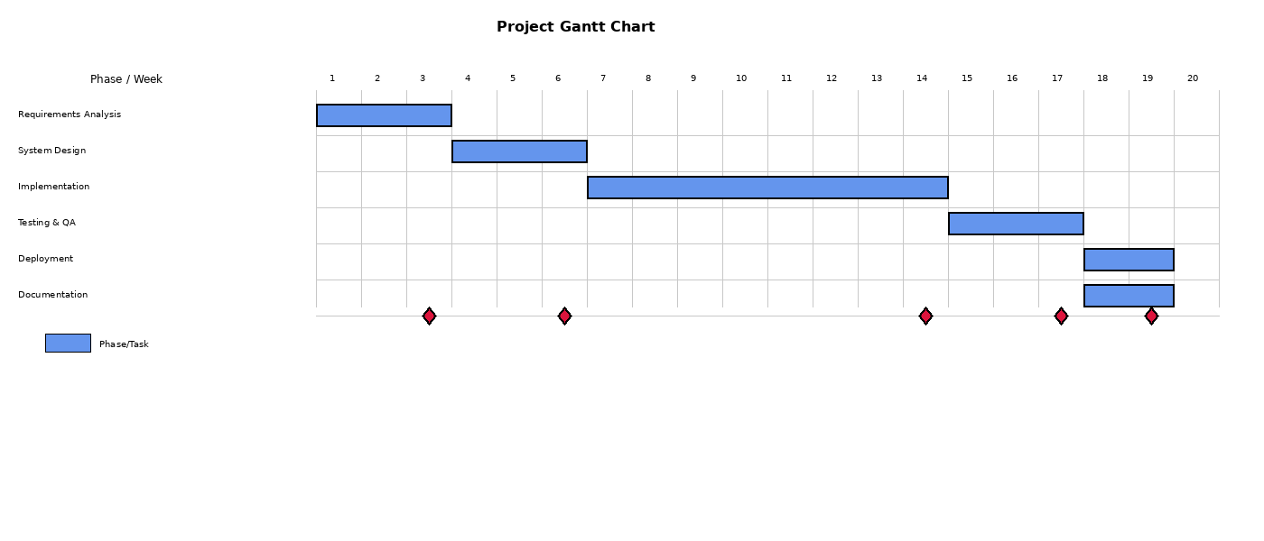
Figure 1.1: Gantt Chart – Project Timeline
Project Plan - AI-Powered Feedback System

Name | Duration | Start | Finish | Predecessors | Resource Names
Planning |  | 13 days 01/06/25 8:00 AM | 01/22/25 5:00 PM
Define Project Scope & Objectives (AI Feedback System) | 2 days | 01/06/25 8:00 AM | 01/07/25 5:00 PM |  | MS Word, Ibrahim
Define Project Stakeholders & Documentation Strategy (SRS/SDD/STC) | 2 days | 01/08/25 8:00 AM | 01/09/25 5:00 PM | 2 | MS Word, Ibrahim
Define Risk Management Plan (Security, AI Model Accuracy) | 2 days | 01/10/25 8:00 AM | 01/13/25 5:00 PM | 3 | MS Word, Ibrahim
Define Roles & Responsibilities (Student/Supervisor/Co-Supervisor) | 2 days | 01/14/25 8:00 AM | 01/15/25 5:00 PM | 4 | MS Word, Ibrahim
Define Quality Assurance & Testing Strategy (Prompt Validation) | 1 day | 01/16/25 8:00 AM | 01/16/25 5:00 PM | 5 | MS Word, Ibrahim
Verify SPMP | 1 day | 01/17/25 8:00 AM | 01/17/25 5:00 PM | 6 | Dr. Rabeeh Ayaz Abbasi
Requirements |  | 11 days 01/20/25 8:00 AM | 02/03/25 5:00 PM
Describe Scope & Objectives (Problem + Application Context) | 2 days | 01/20/25 8:00 AM | 01/21/25 5:00 PM | 7 | MS Word, Ibrahim
Define Use Cases (Students, Instructors, Admins) | 4 days | 01/22/25 8:00 AM | 01/27/25 5:00 PM | 8 | MS Word, PlantUML, Ibrahim
Define Use Cases (Submit, Feedback, SOAP Draft, OCR/NLP Support) | 3 days | 01/28/25 8:00 AM | 01/30/25 5:00 PM | 9 | MS Word, Visual Paradigm, Ibrahim
Define Use Cases (Batch Upload, Plagiarism, Grading) | 2 days | 01/31/25 8:00 AM | 02/03/25 5:00 PM | 10 | MS Word, PlantUML, Ibrahim
Draw System Sequence Diagrams (for flows) | 2 days | 01/20/25 8:00 AM | 01/21/25 5:00 PM | 12 | PlantUML, Visual Paradigm, Ibrahim
Draw Domain Model (core entities) | 1 day | 01/22/25 8:00 AM | 01/22/25 5:00 PM | 13 | PlantUML, Draw.io, Ibrahim
Verify SRS | 1 day | 02/03/25 8:00 AM | 02/03/25 5:00 PM | 14 | Dr. Rabeeh Ayaz Abbasi
Software Design |  | 20 days 02/04/25 8:00 AM | 03/03/25 5:00 PM
Design User Interfaces Traceability Notes (RTM) | 3 days | 02/04/25 8:00 AM | 02/06/25 5:00 PM | 15 | MS Word, Excel, Ibrahim
Design System Architecture (Client + Backend + AI Pipeline + Storage) | 3 days | 02/07/25 8:00 AM | 02/11/25 5:00 PM | 16 | PlantUML, Draw.io, Ibrahim
Design Sequence Diagrams (Student Submit, Instructor Uploads + Internal AI) | 3 days | 02/12/25 8:00 AM | 02/14/25 5:00 PM | 17 | PlantUML, Visual Paradigm, Ibrahim
Describe System Components (APIs, NLP, Node Editor, Auth, Auth/Login) | 3 days | 02/17/25 8:00 AM | 02/19/25 5:00 PM | 18 | MS Word, Draw.io, Ibrahim
Draw Class Diagram (Authentication, Submission, Feedback, Admin→Report) | 3 days | 02/20/25 8:00 AM | 02/24/25 5:00 PM | 19 | PlantUML, Visual Paradigm, Ibrahim
Draw Class Diagram | 2 days | 02/25/25 8:00 AM | 02/26/25 5:00 PM | 20 | PlantUML, ArgoUML, Ibrahim
Describe Database (Firestore: users, submissions, feedback, reports) | 3 days | 02/27/25 8:00 AM | 03/03/25 5:00 PM | 21 | PlantUML, Draw.io, Ibrahim
Verify SDD | 1 day | 03/03/25 8:00 AM | 03/03/25 5:00 PM | 22 | Dr. Rabeeh Ayaz Abbasi
Interfacing and Validation |  | 15 days 03/04/25 8:00 AM | 03/24/25 5:00 PM
Define Test Approach (Test Black-box + validation criteria) | 2 days | 03/04/25 8:00 AM | 03/05/25 5:00 PM | 23 | MS Word, Ibrahim
Make Test Plan (features, environment, datasets, success criteria) | 3 days | 03/06/25 8:00 AM | 03/10/25 5:00 PM | 24 | MS Word, Excel, Ibrahim
Write Test Cases (Security, Integration, SOAP draft, code-snippets) | 7 days | 03/11/25 8:00 AM | 03/19/25 5:00 PM | 25 | MS Word, TestLink, Ibrahim
Verify STD | 3 days | 03/20/25 8:00 AM | 03/24/25 5:00 PM | 26 | Dr. Rabeeh Ayaz Abbasi
Implementation |  | 45 days 03/25/25 8:00 AM | 05/23/25 5:00 PM
Setup Development Environment (Python, Flask, Firebase) | 2 days | 03/25/25 8:00 AM | 03/26/25 5:00 PM | 27 | VS Code, PyCharm, Git, Ibrahim
Implement Authentication Module (Google OAuth, Firebase Auth) | 5 days | 03/27/25 8:00 AM | 04/02/25 5:00 PM | 28 | VS Code, Firebase Console, Ibrahim
Implement Frontend UI (Student Dashboard, Instructor Dashboard) | 7 days | 04/03/25 8:00 AM | 04/11/25 5:00 PM | 29 | VS Code, Figma, HTML/CSS, Ibrahim
Implement OCR Module (Tesseract Integration) | 4 days | 04/14/25 8:00 AM | 04/17/25 5:00 PM | 30 | PyCharm, Tesseract, Python, Ibrahim
Implement AI Feedback Pipeline (Specialist/Judge/Senior Agents) | 10 days | 04/18/25 8:00 AM | 05/01/25 5:00 PM | 31 | PyCharm, LM Studio, OpenAI, Ibrahim
Implement Code Execution Sandbox | 5 days | 05/02/25 8:00 AM | 05/08/25 5:00 PM | 32 | PyCharm, Docker, Python, Ibrahim
Implement Plagiarism Detection Module | 5 days | 05/09/25 8:00 AM | 05/15/25 5:00 PM | 33 | PyCharm, Python, NLP Libraries, Ibrahim
Implement Grade Generation with Rubrics | 4 days | 05/16/25 8:00 AM | 05/21/25 5:00 PM | 34 | PyCharm, OpenAI API, Ibrahim
Implement Report Export (PDF, Excel) | 3 days | 05/20/25 8:00 AM | 05/22/25 5:00 PM | 35 | PyCharm, ReportLab, openpyxl, Ibrahim
Verify Implementation | 1 day | 05/23/25 8:00 AM | 05/23/25 5:00 PM | 36 | Dr. Rabeeh Ayaz Abbasi
Testing |  | 15 days 05/26/25 8:00 AM | 06/13/25 5:00 PM
Execute Test Cases (Authentication, Submission, Feedback) | 5 days | 05/26/25 8:00 AM | 05/30/25 5:00 PM | 37 | Postman, Selenium, Ibrahim
Execute Test Cases (Batch Upload, Plagiarism, Grading) | 5 days | 06/02/25 8:00 AM | 06/06/25 5:00 PM | 38 | Postman, pytest, Ibrahim
Bug Fixing and Retesting | 4 days | 06/09/25 8:00 AM | 06/12/25 5:00 PM | 39 | VS Code, GitHub, Ibrahim
Verify Testing Results | 1 day | 06/13/25 8:00 AM | 06/13/25 5:00 PM | 40 | Dr. Rabeeh Ayaz Abbasi
Deployment |  | 5 days 06/16/25 8:00 AM | 06/20/25 5:00 PM
Deploy to Firebase Hosting | 2 days | 06/16/25 8:00 AM | 06/17/25 5:00 PM | 41 | Firebase CLI, GitHub Actions, Ibrahim
Configure Production Environment | 2 days | 06/18/25 8:00 AM | 06/19/25 5:00 PM | 42 | Firebase Console, VS Code, Ibrahim
Final Verification and Sign-off | 1 day | 06/20/25 8:00 AM | 06/20/25 5:00 PM | 43 | Dr. Rabeeh Ayaz Abbasi

Figure 1.2: Project Plan

Chapter 2

Software Requirements Specification

2.1 Introduction
This chapter gives the Software Requirements Specification of the AI-Powered Feedback System. It specifies both non-functional and functional requirements of the system. Functional requirements define the actual functionalities that should be adopted, whereas the nonfunctional requirements deal with the quality properties, and the working features of the system.

2.1.1 Purpose
The aim and Purpose of this document are to specify the AI-Powered Feedback System in detail and exhaustively to all stakeholders such as the development team, supervisor as well as end users. It is a contractual agreement on what the system will perform and how it will act including the user roles, system functions, constraints, use cases, and interface requirements.

2.1.2 Scope
Stakeholders: Student, Instructor, Admin
Functions:
- Students can register via Google Sign-In and submit assignments for instant AI-generated feedback.
- Instructors can apply for faculty verification and access Pro features upon approval and subscription.
- Admin can approve or reject faculty applications, grant Pro subscriptions, and manage user warnings.
- System processes text, handwritten, and coding assignments through a multi-stage AI pipeline.
- System generates downloadable PDF reports for students and Excel/PDF batch exports for instructors.
- System performs plagiarism detection and rubric-based grade generation for Pro instructors.

2.1.3 Objectives
Minimize Manual Feedback Cost: The main goal is to automate the feedback in the assignment assignments, to save much time and effort to manually assess and comment on the assignments of the students.
Correct AI-Generated Grading and Feedback: The system provides accurate, rubric-consistent grades and constructive feedback in a three stage AI pipeline (Specialist - Judge - Senior) so that there are consistency and quality in the overall evaluation of all kinds of submissions.
Support Multiple Submission Formats: The system supports texts, hand written, scanned and coding assignments and thus, enhances accessibility to students who have alternative approaches to submitting assignments.

2.2 Overall Description

2.2.1 Product Perspective
The AI-Powered Feedback System is a single web application which communicates with outside AI models, OCR engines, Firebase authentication and storage services, and code execution sandboxes. It is an automatic assignment feedback generator that supplements the traditional manual grading. The system layer connects with Google OAuth to log in, Firebase Firestore to store data, Firebase Storage to handle files, and locally hosted AI models as an open-source through LM Studio at the stage of testing.

2.2.2 Product Functions
The major functions of the AI-Powered Feedback System are summarized as follows:
- User authentication via Google Sign-In and role-based access control (Student, Instructor, Admin)
- Single assignment submission for students with instant AI feedback and PDF report download
- For handwritten text/scanned documents, OCR will be used.
- Instructors will submit faculty verification application that will be accepted/rejected by the admin/s.
- System Includes Pro subscription feature that can only be granted by the admin/purchased.
- Pro subscription holders will have the feature to upload 30 files as a batch at once.
- Turnitin-style student name editing before batch processing
- Plagiarism detection with online source comparison and similarity scoring
- AI-powered grade generation based on instructor-provided rubrics
- Batch report export in Excel-only or Excel + individual PDF formats
- Admin warning management for policy violations (sensitive data submissions)

2.2.3 User Characteristics
- Students: Students can get fast and clear feedback with very easy to use interface as they are basic users who want quick feedback.
- Instructors: Faculty members or teaching assistants requiring batch evaluation, grading, and reporting tools. Moderate to advanced technical skills.
- Admins: System developers acting as back-office administrators. They manage faculty verifications, Pro subscriptions, and warning enforcement. Not available via public sign-up.

2.2.4 Constraints
- Only language supported by the system will be English.
- Student submissions are limited to 1 file (max 1MB) or 5000 characters of pasted text
- Instructor batch submissions are limited to 30 items per batch with 100MB total size
- Plagiarism checking and grade generation require instructor-provided prompts and rubrics
- Code execution is restricted to C++, Java, and Python in a sandboxed environment
- Admin role is restricted to system developers and is not available via public sign-up
- During the testing phase, the payment will be processed using sandbox simulation.

2.3 Specific Requirements

2.3.1 External Interfaces
The system integrates with the following external components:
- Google OAuth 2.0: Secure authentication for all users (Student, Instructor, Admin)
- Firebase Firestore: NoSQL cloud database for user data, submissions, and results
- Firebase Storage: Cloud storage for uploaded files and generated reports
- LM Studio: Local model serving for AI inference during testing
- OCR Engine (Tesseract): Text extraction from handwritten and scanned documents
- Code Sandbox: Restricted isolated execution environment for C++, Java, Python

2.3.1.1 User Interfaces
- Login/Sign-In Screen: Google OAuth Sign-In button accessible by all three user roles
- Role Selection Screen: Displayed after first login; Student or Instructor role selection
- Student Interface: Dashboard with upload zone, assignment type selector, and feedback display
- Instructor Interface: Batch upload dashboard with prompt/rubric fields, name table, and export options
- Admin Interface: Panel to review faculty applications, grant Pro access, and manage warnings

2.3.1.2 Hardware Interfaces
The system is web-based and operates on standard devices. Requirements include:
- Standard web browser (Chrome, Firefox, Safari, Edge)
- Stable internet connectivity, minimum of 1mbps.
- Minimum 2GB RAM recommended

2.3.1.3 Software Interfaces
- Frontend: HTML5, CSS3, JavaScript (ES6+)
- Backend: Python 3.x with Flask framework
- Database: Firebase Firestore (NoSQL)
- Storage: Firebase Storage
- Authentication: Firebase Auth with Google OAuth 2.0
- AI Models: Open-source models via LM Studio
- OCR: Tesseract OCR engine
- PDF Generation: ReportLab
- Excel Generation: openpyxl or xlsxwriter

2.3.1.4 Communication Protocols
- HTTPS/TLS: All client-server communication encrypted in transit
- RESTful API: Backend follows REST architectural principles
- WebSocket: Real-time progress updates during processing
- JSON: Standard data exchange format for all API requests and responses

2.3.2 Functional Requirements
The functional requirements of the system are:
1. Sign In via Google OAuth (Student, Instructor, Admin)
2. Submit Single Assignment (Text, Handwritten, Coding, Custom)
3. View AI-Generated Feedback
4. Download PDF Feedback Report
5. Apply for Faculty Verification
6. Subscribe to Pro
7. Batch Upload (up to 30 files)
8. Edit Student Names (Turnitin-style)
9. Check Plagiarism
10. Generate Grades with Rubric
11. Export Batch Reports (Excel / Excel + PDF)
12. Approve/Reject Faculty Application (Admin)
13. Grant Pro Access (Admin)
14. Manage Warnings (Admin)

2.3.3 Use Case Diagram
Use case diagram involves actors and defines what the system does and how actors interact with it features and it shows the relationships between the system and the users.
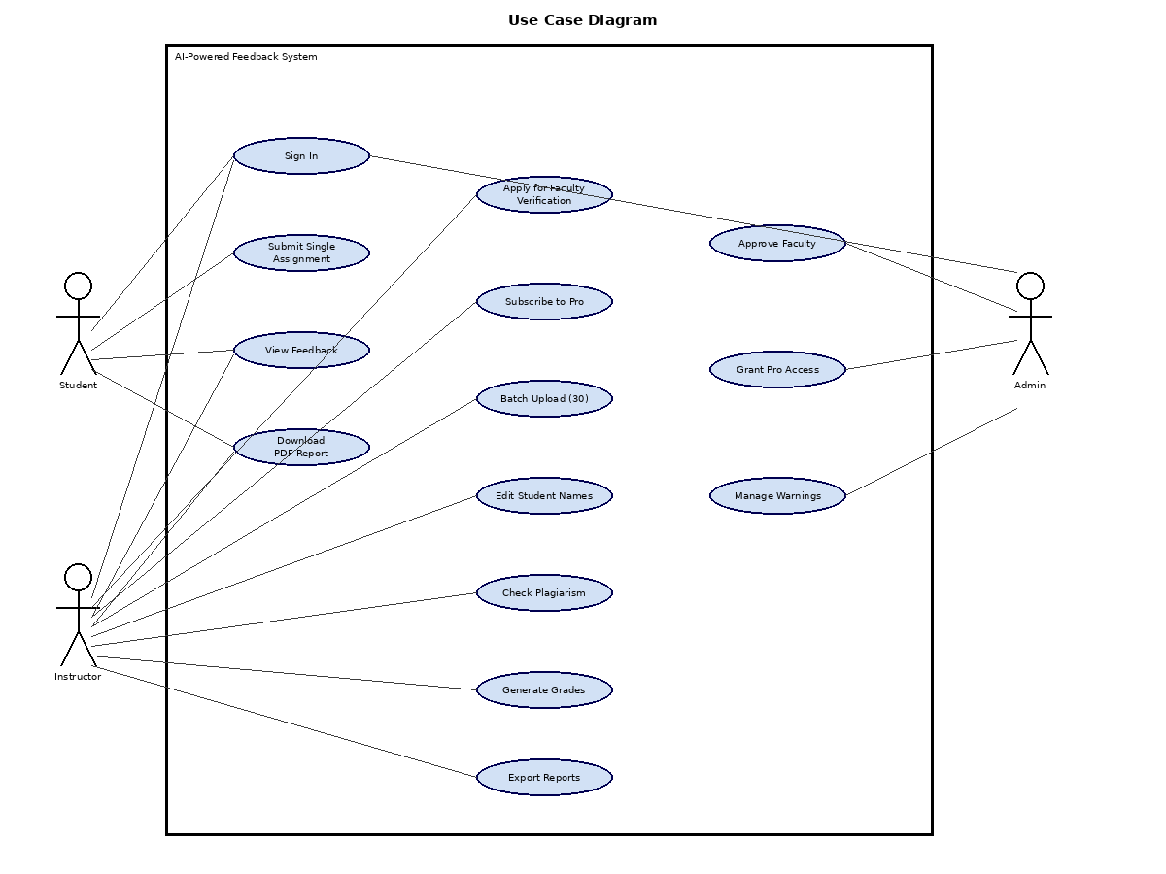Figure 2.1: Use Case Diagram

2.3.4 Use Case Descriptions
Table 2.1: UC-1 – Sign In
Use Case ID | UC-1
Use Case Name | Sign In
Primary Actor(s) | User (Student, Instructor, Admin)
Pre-conditions | User is not currently logged in to the system.
Trigger | User navigates to the application and clicks 'Sign in with Google'.
Main Success Scenario | 1. System displays Google OAuth sign-in interface.  2. User selects their Google account.  3. User grants requested permissions.  4. System authenticates user via Firebase Auth.  5. System creates or updates the user profile in Firestore.  6. If first login, system redirects user to role selection screen.  7. Returning users are directed to their role-specific dashboard.
Alternate/Exception Flows | A1: User denies permissions ,System displays error and returns to login screen.  A2: Network failure ,System prompts user to retry.
Post Conditions | User is authenticated with an active session. Profile exists in Firestore.

Table 2.2: UC-2 – Submit Single Assignment
Use Case ID | UC-2
Use Case Name | Submit Single Assignment
Primary Actor(s) | Student
Pre-conditions | Student is signed in with the Student role.
Trigger | Student clicks 'Submit Assignment' on the student dashboard.
Main Success Scenario | 1. System displays the submission form.  2. Student uploads a file (PDF/DOCX/TXT/Image up to 1MB) or pastes text up to 5000 characters.  3. Student selects assignment type: Text-based, Coding, Handwritten, or Custom.  4. Student optionally enters assignment prompt and grading rubric.  5. System validates the file format and size.  6. System applies OCR if submission is handwritten or scanned.  7. System runs the AI feedback pipeline (Specialist ,Judge ,Senior).  8. System displays a feedback summary screen (UC-3).  9. System generates a PDF report and provides a download link (UC-4).
Alternate/Exception Flows | A1: Invalid file format or size exceeded ,System rejects with error message.  A2: Processing failure ,System retries or displays error.  A3: OCR fails ,System notifies student to improve image quality and retry.
Post Conditions | AI feedback is delivered on screen. PDF report is available for download.

Table 2.3: UC-3 – View Feedback
Use Case ID | UC-3
Use Case Name | View Feedback
Primary Actor(s) | Student / Instructor
Pre-conditions | AI feedback pipeline has completed processing. Feedback results are available.
Trigger | System automatically displays feedback after submission processing completes.
Main Success Scenario | 1. System displays a feedback summary screen.  2. Screen shows overall score, status (Pass/Fail), and key highlights.  3. User scrolls to read detailed feedback sections.  4. Feedback includes strengths, weaknesses, and improvement suggestions.  5. User can expand individual rubric sections if rubric was provided.  6. System provides a link to download the full PDF report.
Alternate/Exception Flows | A1: Feedback generation failed ,System displays error message and option to resubmit.  A2: User navigates away ,Feedback remains accessible via session until browser closes.
Post Conditions | User has reviewed the AI-generated feedback on screen.

Table 2.4: UC-4 – Download PDF Report
Use Case ID | UC-4
Use Case Name | Download PDF Report
Primary Actor(s) | Student / Instructor
Pre-conditions | Feedback has been generated and a PDF report is ready.
Trigger | User clicks the 'Download PDF Report' link on the feedback or results screen.
Main Success Scenario | 1. System generates the PDF report containing full feedback, scores, and analysis.  2. A secure clickable link to download will be provided by the system.  3. then the user will select/click the downloadable link.  4. The download is started in the browser.  5. The report is saved on the user’s device.
Alternate/Exception Flows | A1: PDF generation fails ,System retries automatically.  A2: Download link expires ,System regenerates the report on demand.
Post Conditions | User has successfully downloaded the complete PDF feedback report.

Table 2.5: UC-5 – Apply for Faculty Verification
Use Case ID | UC-5
Use Case Name | Apply for Faculty Verification
Primary Actor(s) | Instructor
Pre-conditions | User is signed in with the Instructor role. Faculty verification has not been submitted or approved.
Trigger | Instructor attempts to access instructor-only features and is prompted to apply for verification.
Main Success Scenario | 1. faculty verification application form is displayed by the system.  2. then the full name and university and department, designation, and official email is entered by the instructor.  3. proof document such as ID/employment letter is uploaded by the instructor.  4. Then all the required fields and the proof document is validated by the system.  5. The application is then saved in the system by ‘pending’ tag.  6. The submission is then confirmed by the system and feedback is shown to the instructor that features remain locked pending review.
Alternate/Exception Flows | A1: Proof document missing ,System displays validation error and blocks submission.  A2: Invalid document format ,System rejects the upload with an error message.
Post Conditions | Faculty application is saved with Pending status. Instructor features remain locked.

Table 2.6: UC-6 – Subscribe to Pro
Use Case ID | UC-6
Use Case Name | Subscribe to Pro
Primary Actor(s) | Instructor
Pre-conditions | Instructor has an Approved faculty verification status.
Trigger | Instructor navigates to the subscription section to activate Pro.
Main Success Scenario | 1. Pro subscription Option with pricing is displayed by the system.  2. a subscription plan is then selected by the instructor.  3. A sandbox payment gateway is presented by the system.  4. Payment details are entered by the instructor and then confirmed afterwards.  5. payment is processed by the system.  6. Instructor received the pro subscription as the system activates it.  7. Pro features such as batch upload, plagiarism check, grade generation, export reports etc are unlocked by the system.
Alternate/Exception Flows | A1: Payment simulation fails, System notifies instructor. Subscription remains inactive.  A2: Instructor is not verified ,System blocks subscription and redirects to faculty application.
Post Conditions | Pro subscription is activated. All Pro features are now accessible to the instructor.

Table 2.7: UC-7 – Batch Upload (30)
Use Case ID | UC-7
Use Case Name | Batch Upload (30)
Primary Actor(s) | Instructor
Pre-conditions | Instructor is signed in, has Approved faculty status, and an active Pro subscription.
Trigger | Instructor clicks 'Batch Upload' on the instructor dashboard.
Main Success Scenario | 1. files up to 30 are uploaded by the instructor.  2. Assignment prompt/question is entered by the instructor(mandatory).  3. Instructor enters grading rubric and checking criteria.  4. System extracts student names from uploaded filenames.  5. System displays an editable name mapping table (UC-8).  6. Instructor confirms or edits student names.  7. System validates that no student name fields are empty.  8. System processes the entire batch through the AI pipeline.  9. System generates feedback and grades for each submission.  10. System provides export options (UC-11).
Alternate/Exception Flows | A1: Assignment prompt missing ,System blocks submission with validation error.  A2: Batch exceeds 30 items or 100MB ,System displays error requesting correction.  A3: Empty student name fields ,System highlights affected rows and blocks submission.
Post Conditions | Batch is accepted and processing begins. Results are made available for export.

Table 2.8: UC-8 – Edit Student Names
Use Case ID | UC-8
Use Case Name | Edit Student Names
Primary Actor(s) | Instructor
Pre-conditions | Batch files have been uploaded. Student names have been auto extracted from filenames.
Trigger | System displays the editable name mapping table after batch file upload.
Main Success Scenario | 1. System displays a table mapping each filename to an auto-extracted student name.  2. Instructor reviews the extracted names.  3. Instructor clicks any cell to edit a student name.  4. Instructor confirms the final name mapping.  5. System validates that all name fields are non-empty.  6. System uses confirmed names in all generated reports and exports.
Alternate/Exception Flows | A1: One or more name fields left empty, System highlights empty cells and blocks confirmation.
Post Conditions | All student names are finalized and will be used in all generated reports.

Table 2.9: UC-9 – Check Plagiarism
Use Case ID | UC-9
Use Case Name | Check Plagiarism
Primary Actor(s) | Instructor
Pre-conditions | Pro subscription is active. Assignment prompt has been provided.
Trigger | Instructor enables the plagiarism check option during batch submission setup.
Main Success Scenario | 1. System uses the assignment prompt to retrieve 5–10 reference answers from online sources.  2. System searches and retrieves relevant content from online academic sources.  3. System compares each student submission against the collected references.  4. System calculates a similarity percentage for each submission.  5. Matched/identical piece of text are identified and highlighted.  6. Source URLs for each match are stored.  7. In the final report, these plagiarism results are included.
Alternate/Exception Flows | A1: if no online reference is found then system continues with limited data.  A2: if there is no assignment prompt, system doesn’t do plagiarism check.
Post Conditions | Plagiarism report generated with per-submission similarity scores and source references.

Table 2.10: UC-10 – Generate Grades
Use Case ID | UC-10
Use Case Name | Generate Grades
Primary Actor(s) | Instructor
Pre-conditions | Pro subscription is active. Assignment prompt and rubric have been provided.
Trigger | Instructor provides rubric criteria during batch submission setup.
Main Success Scenario | - Instructor provides detailed rubric criteria in the submission form.  - System passes the assignment content and rubric to the AI grading pipeline.  - Specialist model evaluates each submission against each rubric dimension.  - System assigns a numeric score per rubric criterion.  - Judge model validates the scoring for consistency.  - Senior model produces the final grade and written justification.  - Grades and justifications are included in all export reports.
Alternate/Exception Flows | - A1: Rubric missing ,System generates qualitative feedback only, without numeric scoring.  - A2: Submission cannot be mapped to rubric ,System flags the entry for manual review.
Post Conditions | Rubric-based numeric grades and written justifications are included in all generated reports.

Table 2.11: UC-11 – Export Reports
Use Case ID | UC-11
Use Case Name | Export Reports
Primary Actor(s) | Instructor
Pre-conditions | Batch processing is complete. Feedback, grades, and plagiarism results are ready.
Trigger | Instructor selects the export option after batch processing completes.
Main Success Scenario | - System presents two export options: Excel Only or Excel + PDF.  - Excel Only: System generates a spreadsheet with student names, scores, and summaries.  - Excel + PDF: System additionally generates individual PDF feedback reports per student.  - System provides download links for all generated files.  - System stores the latest 2 batch submissions in instructor history.
Alternate/Exception Flows | A1: Report generation fails ,System retries automatically.  A2: Storage limit exceeded ,System deletes oldest batch history entry first.
Post Conditions | All report files are generated and download links are provided to the instructor.

Table 2.12: UC-12 – Approve Faculty
Use Case ID | UC-12
Use Case Name | Approve Faculty
Primary Actor(s) | Admin
Pre-conditions | Admin is signed in. At least one faculty application with Pending status exists.
Trigger | Admin navigates to the admin panel to review pending faculty applications.
Main Success Scenario | - Admin views the list of all pending faculty applications.  - Admin opens a specific application to review submitted details and proof document.  - Admin selects Approve or Reject.  - System updates the application status accordingly.  - If Approved: system unlocks instructor features for that user account.  - If Rejected: system stores the rejection reason and instructor features remain locked.
Alternate/Exception Flows | A1: No pending applications ,Admin panel shows empty queue with confirmation message.
Post Conditions | Application status updated to Approved or Rejected. Instructor features unlocked if approved.

Table 2.13: UC-13 – Grant Pro Access
Use Case ID | UC-13
Use Case Name | Grant Pro Access
Primary Actor(s) | Admin
Pre-conditions | Admin is signed in. The target instructor has an Approved faculty status.
Trigger | Admin chooses to manually grant Pro subscription to an instructor.
Main Success Scenario | - Admin navigates to the instructor management section of the admin panel.  - Admin selects the target instructor from the list.  - Admin clicks 'Grant Pro Access'.  - System activates the Pro subscription for that instructor.  - System unlocks all Pro features: batch upload, plagiarism check, grade generation, export reports.  - System confirms activation to the admin.
Alternate/Exception Flows | A1: Instructor not yet verified ,System blocks the action and displays error.  A2: Admin revokes Pro ,Pro features are immediately deactivated for that instructor.
Post Conditions | Pro subscription is activated for the selected instructor. All Pro features are now accessible.

Table 2.14: UC-14 – Manage Warnings
Use Case ID | UC-14
Use Case Name | Manage Warnings
Primary Actor(s) | Admin
Pre-conditions | Admin is signed in. The system has flagged one or more users for policy violations.
Trigger | System detects sensitive data in a submission and logs a warning against the user's account.
Main Success Scenario | - System detects sensitive data (e.g., personal ID numbers, financial data) in a submission.  - System logs a warning against the submitting user's account.  - Admin views the warnings panel listing all flagged users.  - Admin reviews the flagged submission details.  - On the third violation by the same user, system automatically blocks the account for 24 hours.  - Admin can manually dismiss a warning or extend the block duration if necessary.
Alternate/Exception Flows | A1: False positive detection ,Admin can dismiss the warning after review.  A2: User disputes the warning ,Admin reviews and adjusts as appropriate.
Post Conditions | Warning is recorded against the user. Repeat violations result in a 24-hour account block.

2.3.5 Non-Functional Requirements
- Performance: The system shall process single student submissions within 30 seconds. Batch submissions of 30 items shall complete within 20 minutes. OCR shall complete within 8 seconds. Report generation shall not exceed 10 seconds per document.
- Security: Only authenticated users with appropriate roles shall access system features. All data is encrypted in transit via HTTPS/TLS. Sensitive data is stored encrypted in Firebase. Code execution occurs in isolated sandbox environments.
- Usability: The system shall provide an intuitive interface requiring no technical training. All upload processes include progress indicators. Error messages are specific and actionable. The UI is responsive across desktop and mobile devices.
- Reliability: The system shall operate without failure under normal conditions. It shall handle unexpected inputs gracefully and maintain data integrity at all times.
- Availability: The system shall be available 24/7 and accessible at any time by all user roles.
- Maintainability: The system shall be modular, allowing components to be updated or replaced independently without affecting core functionality.
- Portability: The web application shall run on any modern browser without installation and shall support different screen sizes and operating systems.

2.3.6 System Sequence Diagrams
The System sequence diagrams consist of a sequence of interactions conducted between an actor (user) and the system in a given use case. They indicate the sequence of the messages exchanged between the system and the actor, as well as system self-calls to internal tasks.

- SSQ-1: Sign In

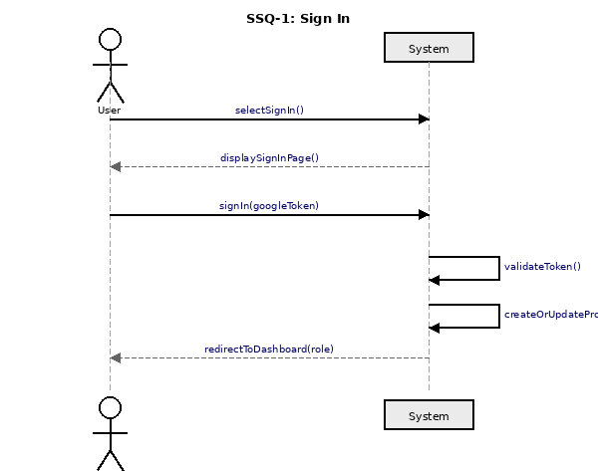
Figure 2.7: System Sequence Diagram – Sign In
The user clicks on sign in, the system shows the sign-in screen and the user types in his or her Google token. This system validates the token internally and makes or updates the user profile and redirects the user to the role-specific dashboard.
- SSQ-2: Submit Single Assignment

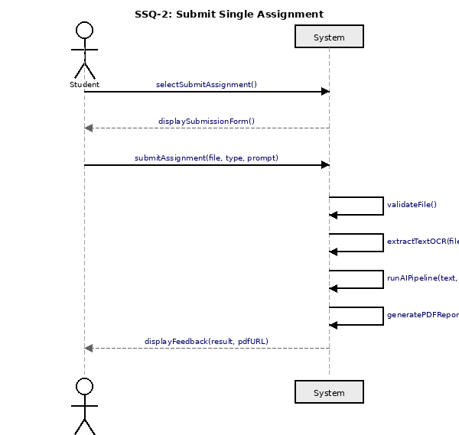
Figure 2.8: System Sequence Diagram – Submit Single Assignment
The student clicks on the submission form and uploads a file with the type of assignment and prompt option chosen. The system verifies the file, OCR in the case of a handwritten or a scanned file, executes the AI pipeline, and produces a PDF report, and provides the feedback with a download option.

- SSQ-3: View Feedback

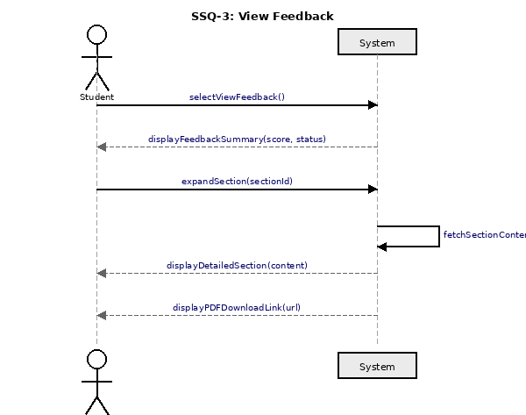
Figure 2.9: System Sequence Diagram – View Feedback
The student asks the feedback screen. The feedback summary with the score and status is shown on the system. The student has the option to expand on separate sections that the system will fetch and show as well as a download link in form of PDF.
- SSQ-4: Download PDF Report

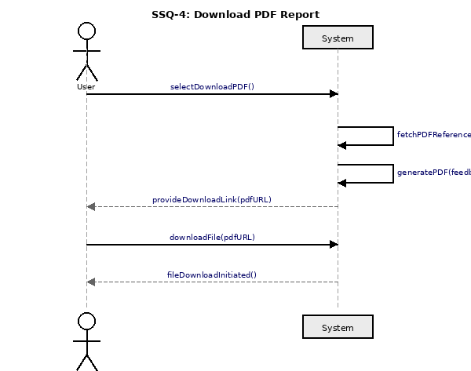
Figure 2.10: System Sequence Diagram – Download PDF Report
The user selects download PDF. The system fetches the report reference, generates the PDF, and provides a download link. The user clicks the link and the system initiates the file download.

- SSQ-5: Apply for Faculty Verification

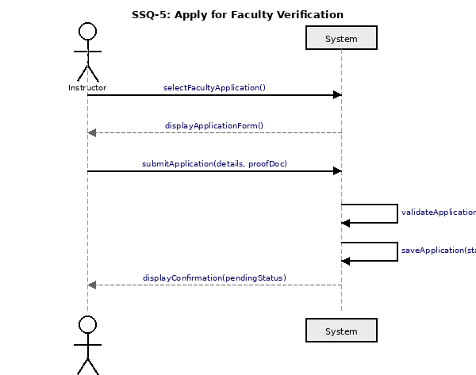
Figure 2.11: System Sequence Diagram – Apply for Faculty Verification
The teacher chooses the faculty application. The application form is posted on the system. The teacher provides his or her information and evidence document. The system checks the fields and stores the application under the Pending status and gives a confirmation message.
- SSQ-6: Subscribe to Pro

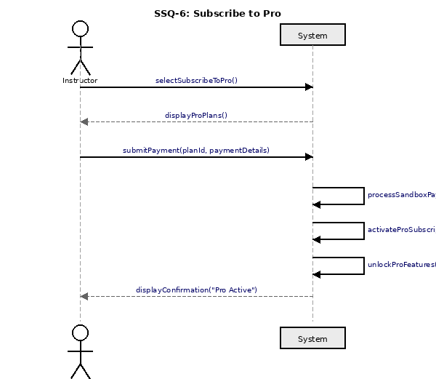
Figure 2.12: System Sequence Diagram – Subscribe to Pro
The teacher goes to the subscription section. The system presents Pro plans. The teacher pays Sandbox information. The payment is processed and the Pro subscription is activated, the Pro features are unlocked and the instructor is presented with a confirmation.
- SSQ-7: Batch Upload (30)

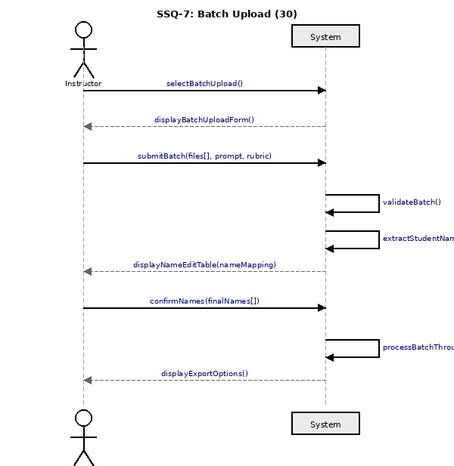
Figure 2.13: System Sequence Diagram – Batch Upload
The instructor clicks on the batch upload form and uploads a maximum of 30 files with a prompt and rubric. The system will check the batch, cut out the name of the students in the filenames and show a list of names that are editable. Once the instructor has confirmed the names, the system runs the batch along the AI pipeline generating export options.
- SSQ-8: Edit Student Names

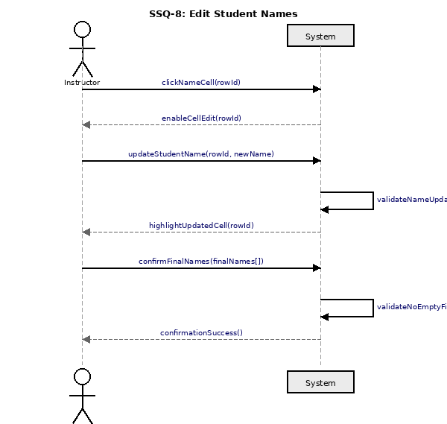
Figure 2.14: System Sequence Diagram – Edit Student Names
The name cell which is clicked by the instructor in the mapping table corresponds to a certain name. The system enables editing. The corrected name is typed in by the instructor and the system points out the point of the changed cell. The system is set up to ensure that when the instructor does the name verification, no fields will be left blank and the system will send a confirmation.
- SSQ-9: Check Plagiarism

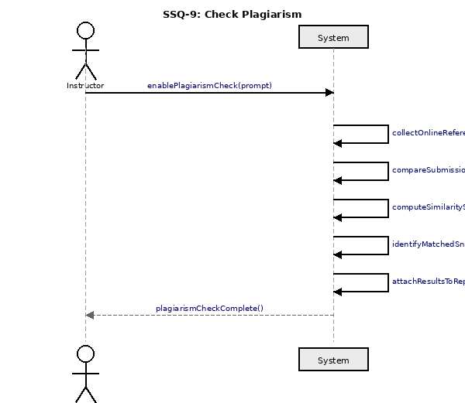
Figure 2.15: System Sequence Diagram – Check Plagiarism
The plagiarism checking is made possible by the instructor with the assignment prompt. This system will internally gather reference content over the internet, match each submission, calculate similarity, extract matching snippets, and place the output on the report, and inform a person that the check is finished.
- SSQ-10: Generate Grades

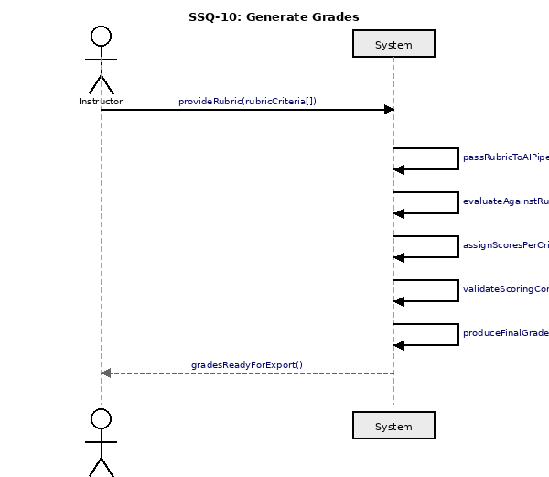
Figure 2.16: System Sequence Diagram – Generate Grades
The teacher gives rubric standards. They are then sent to the AI pipeline where they are checked against the rubric and graded on each submission according to each criterion, the scoring consistency is tested, and a final grade with a written explanation is produced. The instructor gets informed that the grades are export ready.
- SSQ-11: Export Reports

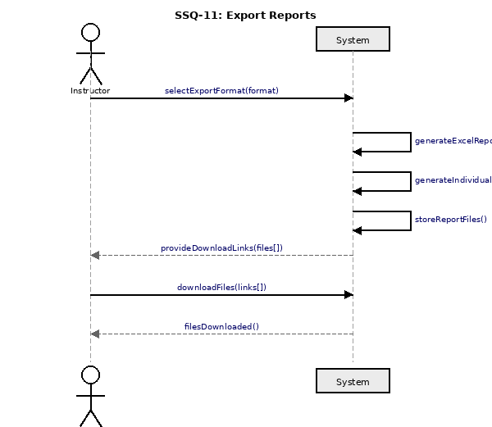
Figure 2.17: System Sequence Diagram – Export Reports
The teacher chooses a format of export. The system produces the Excel report and in case of the Excel + PDF, also produces separate PDF. Storing of the files and provision of download links happens in the system. The files are downloaded by the instructor.
- SSQ-12: Approve Faculty

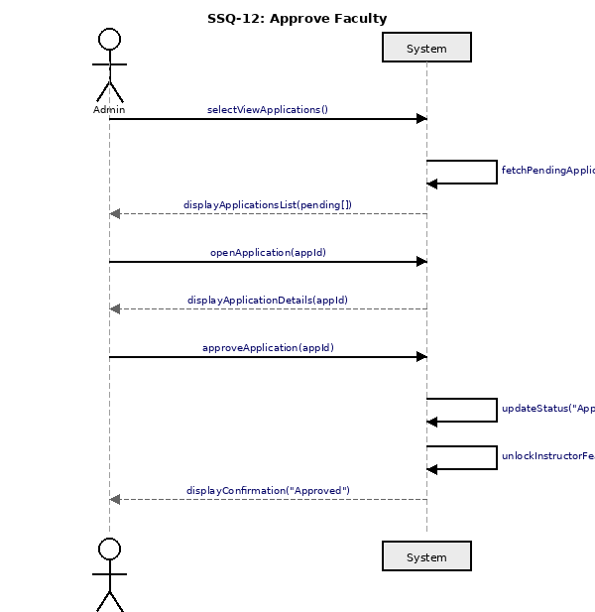
Figure 2.18: System Sequence Diagram – Approve Faculty
The admin accesses applications in progress. The list is fetched and displayed by the system. The person being accurately reviewed by the admin opens an application and clicks Approve. The system changes the status to Approved and unlocks instructor functionality of that user and shows a confirmation.
- SSQ-13: Grant Pro Access

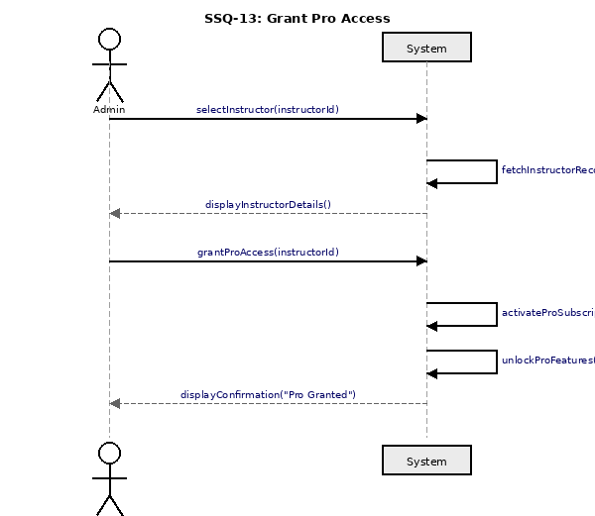
Figure 2.19: System Sequence Diagram – Grant Pro Access
An instructor is selected by the management panel by the admin. The system retrieves and shows the details of instructor. The administrative activities Grant Pro Access. The system switches on the Pro subscription, opens the Pro features and notifies the admin.
- SSQ-14: Manage Warnings

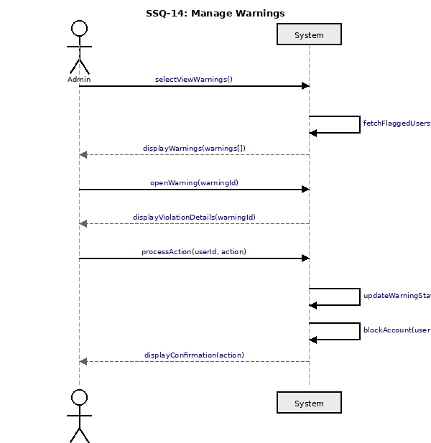
Figure 2.20: System Sequence Diagram – Manage Warnings
The warnings panel is displayed to the admin. The system will fetch and display flagged users. The admin logs in and opens a warning with the details of the violation and chooses an action. The system changes the warning status, freezes the account notifying (auto-activated in the case of the third violation) and shows a confirmation.

2.4 Domain Model
Domain model- It is a model of a real-life entity and relationship display of the AI-Powered Feedback System. It represents the main concepts, their features, and the connection between these concepts.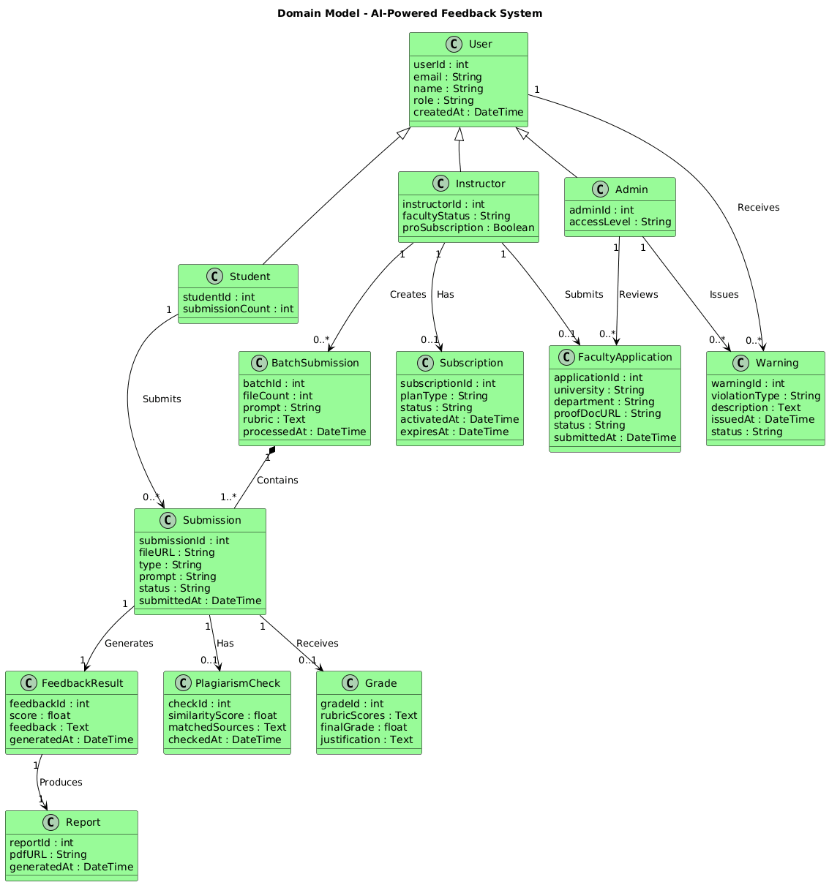
Figure 2.6: Domain Model

2.5 Database Requirement

- Data Storage: The database shall store information about users (students, instructors, admins), faculty applications, submissions, AI-generated feedback, grades, plagiarism results, warnings, Pro subscriptions, reports, and batch submission history.
- Data Integrity: Validation checks shall prevent duplicate user registrations. Referential integrity shall be maintained between submissions, feedback records, and report files.
- Scalability: The database shall handle increasing numbers of users and submissions without performance degradation. Firebase Firestore's horizontal scaling capabilities are leveraged for this purpose.
- Backup: Regular automated backups shall be configured to prevent data loss, utilizing Firebase's built-in backup and restore features.
- Privacy: Student submission content shall not be permanently stored. Only metadata required for report access shall be retained. Sensitive personal information shall be encrypted.

Chapter 3

Software Design Description

3.1 Introduction

This chapter entails the description of the software design of the AI-Powered Feedback System. It contains system architecture, interaction between components, class structure, database and user interface schema. The design decisions described in this paper are informed by the requirements listed in Chapter 2 and aimed at the development of a scalable, maintainable and secure system.

3.1.2 Design Overview
The system is designed to give feedback on student assignments as per a three tier web architecture through AI. It is a stack of a Flask (object-oriented) and Firebase cloud based system, an AI-powered inference engine in the form of the LM Studio (Specialist, Judge, Senior), an OCR engine that scores handwritten submissions, a code-sandbox to write programming tasks, a plagiarism detector, and a report-generation unit. The process consists of three major steps that are content extraction and preprocessing, AI-based analysis, grading, and feedback production and report formatting and delivery.

3.1.3 Requirement Traceability Matrix
A requirement traceability matrix will be used in order to make sure that the entire functional requirements have been fulfilled throughout the software life cycle. It overlays the use cases onto the system sequence diagram, user interface and test case.
Requirement ID | Requirement Name | Analysis Phase (SSQ) | Interface | Test Case
UC-1 | Sign In | SSQ-1 | YES | TC-1
UC-2 | Submit Single Assignment | SSQ-2 | YES | TC-2
UC-3 | View Feedback | SSQ-2 | YES | TC-3
UC-4 | Download PDF Report | SSQ-2 | YES | TC-4
UC-5 | Apply for Faculty Verification | SSQ-3 | YES | TC-5
UC-6 | Subscribe to Pro | SSQ-3 | YES | TC-6
UC-7 | Batch Upload (30) | SSQ-4 | YES | TC-7
UC-8 | Edit Student Names | SSQ-4 | YES | TC-8
UC-9 | Check Plagiarism | SSQ-4 | YES | TC-9
UC-10 | Generate Grades | SSQ-4 | YES | TC-10
UC-11 | Export Reports | SSQ-4 | YES | TC-11
UC-12 | Approve Faculty | SSQ-3 | YES | TC-12
UC-13 | Grant Pro Access | SSQ-3 | YES | TC-13
UC-14 | Manage Warnings | SSQ-2 | YES | TC-14

3.2 System Architectural Design

3.2.1 Chosen System Architecture
- MVC Architecture: The AI-Powered Feedback System is designed with the help of the Model-View-Controller (MVC) architecture, which breaks down the application into three related units with the well-defined roles.
- Model Layer: Handles all data management and business logic. Handles user accounts, submission data, feedback data, faculty and warning history, subscriptions, and plagiarism data, in Firebase Firestore.
- View Layer: Manages the user interface and presentation. Makes the student dashboard, batch upload interface, faculty application form, feedback display screen, administrative panel, and report download interface.
- Controller Layer: Acts as intermediary between Model and View. Which is processing of user requests, role-based access control, input validation, as well as coordination of calls to the AI pipeline, OCR engine, plagiarism checker, and report generator.

3.2.2 Reasons
The Selection of MVC architecture is based on the following reasons:
- Scalable: Components can be scaled independently based on demand.
- Maintainable: Changes to the UI do not affect business logic, and vice versa.
- Modular: New features (e.g., new assignment types, additional AI models) can be added without affecting other layers.
- Reusable: Core modules such as the AI pipeline, OCR module, and plagiarism checker can be reused across multiple controller actions.
- Testable: each component/layer can be tested in isolation to ensure the reliability.

3.2.3 Architecture Diagram
The architecture diagram is a graphical representation of the component structures and system layers and interactions.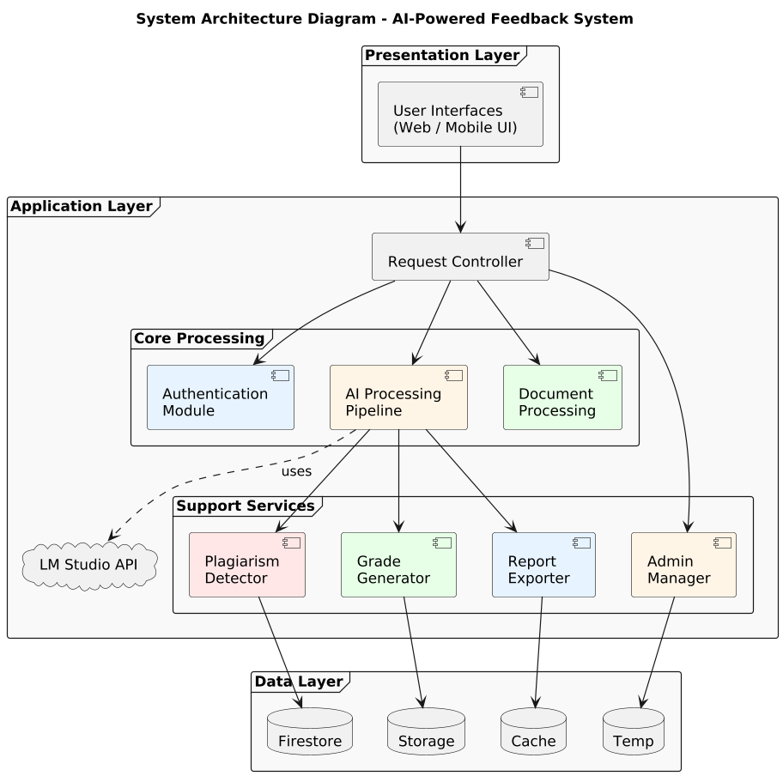
Figure 3.1: System Architecture Diagram

3.2.4 Alternative Designs

The alternative architectural patterns that were an option include the following:

- 3-Tier architecture: This divides the system into a presentation, application logic and Data layer. Like MVC but not so fine in the separation of the UI presentation and controller code. Suitable but less flexible.
- 2-Tier Architecture: Frontend It uses the database without passing through another application. Kept off because of security issues and the inability to centralize AI pipeline organization.
- Monolithic Architecture: Everything is made deployable in one unit. In rejected because it is not readily scalable or maintainable and new AI models and functionality added to the system.

3.2.5 System Interface Description
It has numerous interfaces that allow the modules to communicate with each other:
- User Interface (View Layer): It provides user-friendly interfaces in all three roles of users. Responsive web pages help users to submit assignments, make batch uploads, see feedback, receive export reports, handle faculty applications, grant Pro access, and handle warnings.
- Controller Layer: Interprets all the user inputs, role-based access control (Student, Instructor, Admin), validation of all data and coordinates the actions with the AI process, OCR service and plagiarism detector, the grade generator, and report generator.
- Model Layer: Takes care of all data saving, all business logic. Applies Firestore requests to create, read, update and delete records comprising of users, submissions, feedback, warnings and application state.
- Backend Communication API and Backend API offers flask backend services that are used by frontend services and exposed through a series of RESTful API endpoints. APIs are standard and use the standard HTTP verbs (GET, POST, PUT, DELETE) and employ a JSON response. Auth and storage operations are required by firebase SDK.

3.3 Detailed Description of Components
The sequence diagrams depict the interaction between the internal elements of the system; Actor, System, Controller and Database to complete each operation. They explain the sequence of the messages between objects to accomplish a given use case.

- SQ-1: Sign In

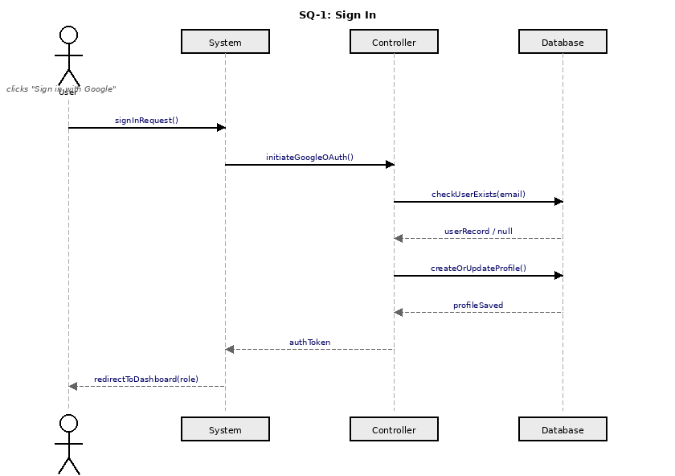
Figure 3.2: Sequence Diagram – Sign In
The System receives a sign-in request by the user. The System invokes the Controller that is responsible to inquire in the Database to establish whether a user profile exists. Otherwise, a new profile is generated. The Controller sends auth token to the System that redirects the user to his or her role-specific dashboard..

- SQ-2: Submit Single Assignment

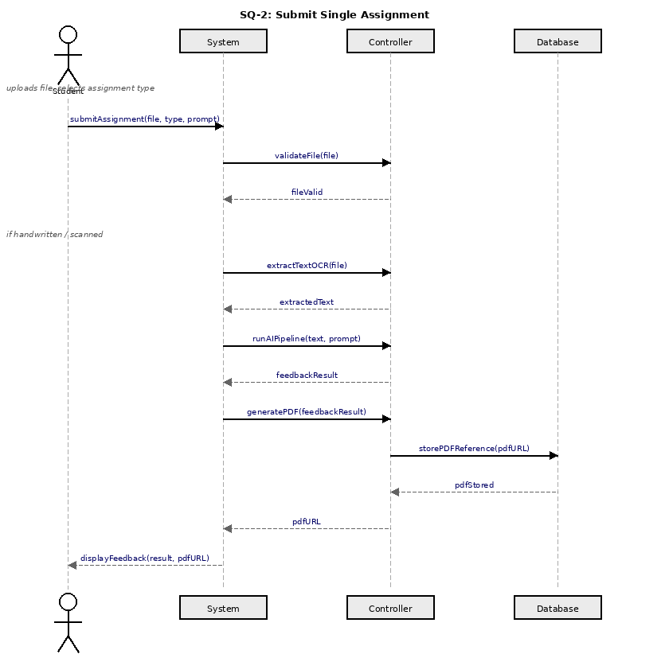
Figure 3.3: Sequence Diagram – Submit Single Assignment
The student submits a file with type and prompt. The Controller is called by the System to authenticate/validate the file. In case the submission is in a handwritten or scanned form, OCR is used. The AI pipeline is operated by the Controller who provides a feedback. The PDF will be generated, and its reference will be added to the Database, and the feedback including a download link will be provided back to the student.

- SQ-3: View Feedback

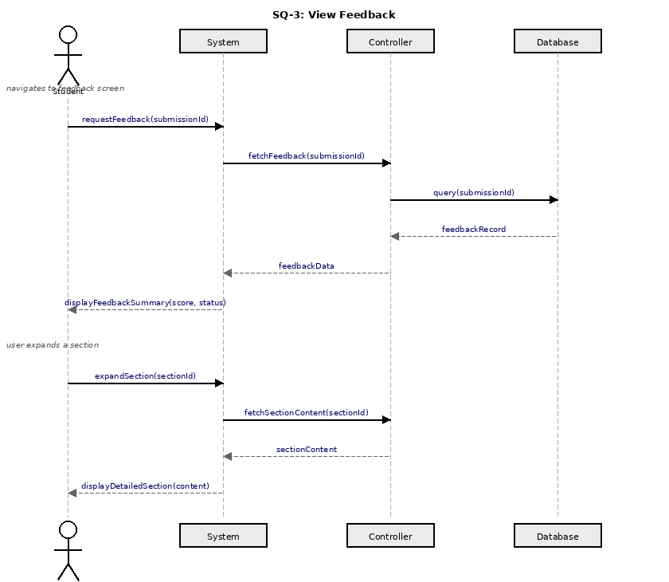
Figure 3.4: Sequence Diagram – View Feedback
The student asks to have feedback on a submission. The Controller which queries the Database to get the feedback record is called by the System and then The summary of the feedback is presented. The Controller will fetch the content of the section and give it back to the student when it is expanded.
- SQ-4: Download PDF Report

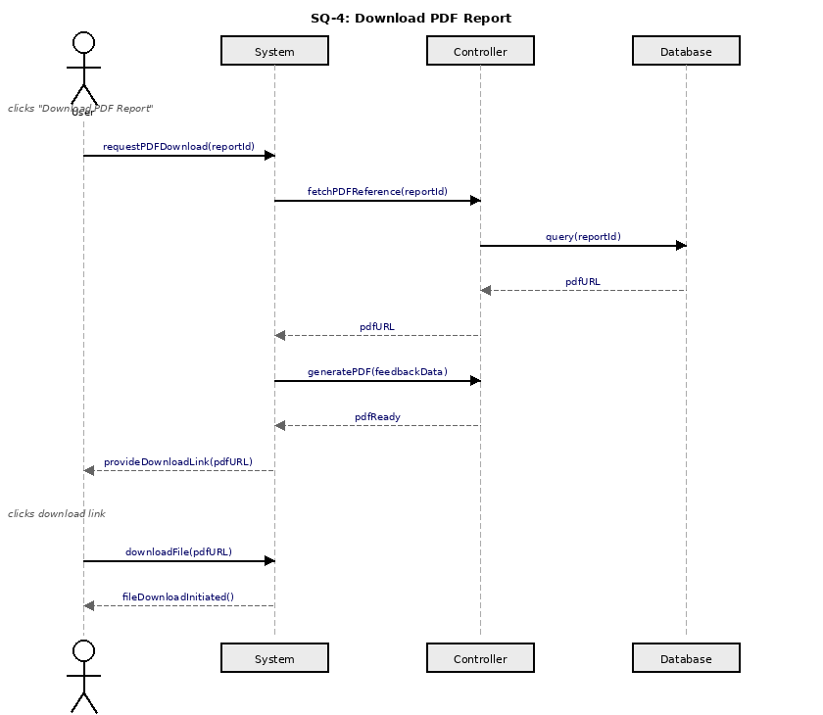
Figure 3.5: Sequence Diagram – Download PDF Report
It is a PDF download requested by the user. The Controller is called by the System to receive the PDF reference in the Database. The PDF is created by the Controller and the URL is sent back to the System to provide the user with the download link. The user clicks the link and the download of the file is started.
- SQ-5: Apply for Faculty Verification

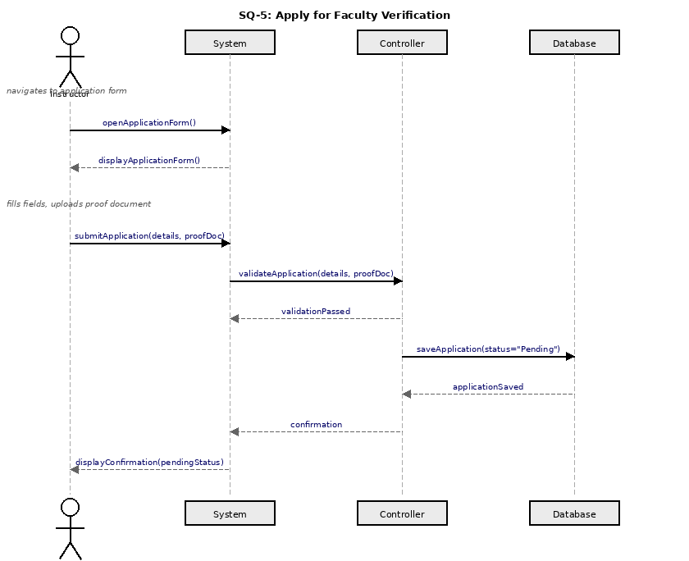
Figure 3.6: Sequence Diagram – Apply for Faculty Verification
The application form is opened by the instructor. The System sends the details and proof document and calls the Controller to verify the input. When validated, the Controller stores the application in the Database in Pending status and gives back the confirmation to the System, which is presented to the instructor.
- SQ-6: Subscribe to Pro

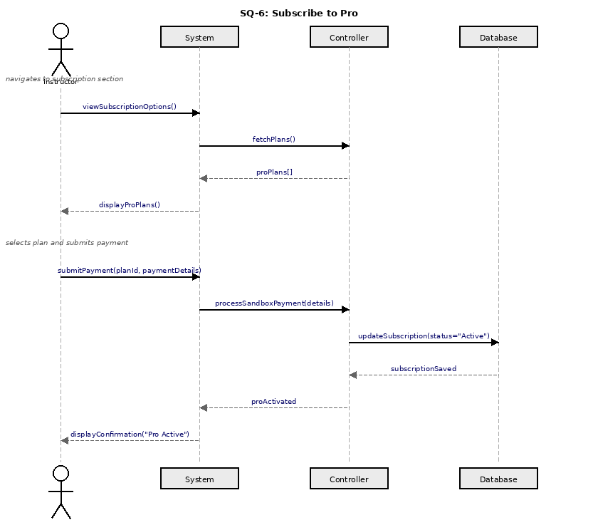
Figure 3.7: Sequence Diagram – Subscribe to Pro
The Controller fetches subscription plans which are viewed by the instructor. Upon entering payment information, the Controller makes payment sandbox, then modifies the record of the subscription in the Database to Active and responds with a confirmation. The System shows the Pro activation confirmation to the instructor.
- SQ-7: Batch Upload (30)

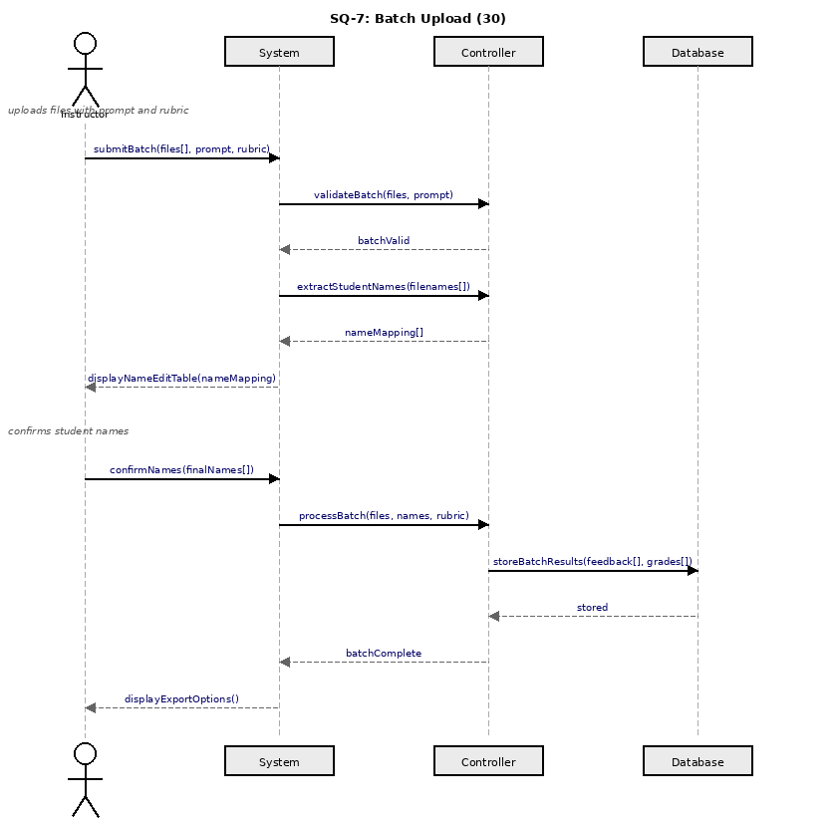
Figure 3.8: Sequence Diagram – Batch Upload
The teacher demonstrates up to 30 files with rubric. The Controller checks the batch and retrieves names of students and gives a mapping of names to the System. Once the names are verified by the instructor, the Controller runs the entire batch with AI, it is stored in the Database and the System shows the export options.
- SQ-8: Edit Student Names

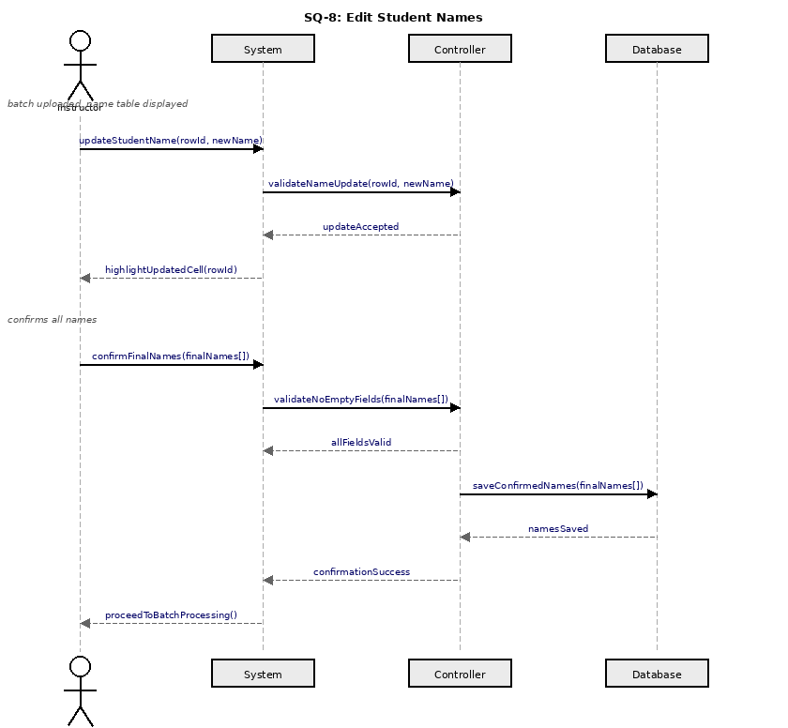
Figure 3.9: Sequence Diagram – Edit Student Names
The teacher makes an update on a student name in the table. The Controller authentication of the update and the System indicate the highlight on the cell. Upon confirmation of the names by the instructor, the Controller ensures that there are no empty fields, enters the confirmed names into the Database and sends a confirmation success message that starts the batch processing.

- SQ-9: Check Plagiarism

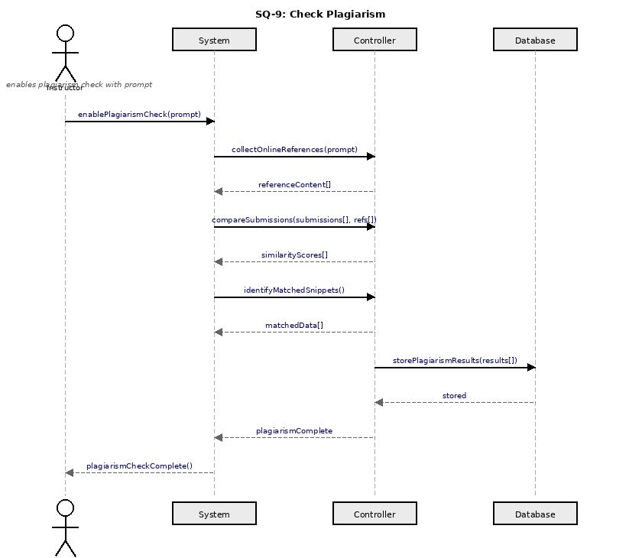
Figure 3.10: Sequence Diagram – Check Plagiarism
The teacher allows checking plagiarism. The Controller gathers internet reference materials, submissions are compared, similarity scores are calculated and matching snippets are found. Through the System the plagiarism results are logged into the Database and a notification of completion sent back to the instructor.

- SQ-10: Generate Grades

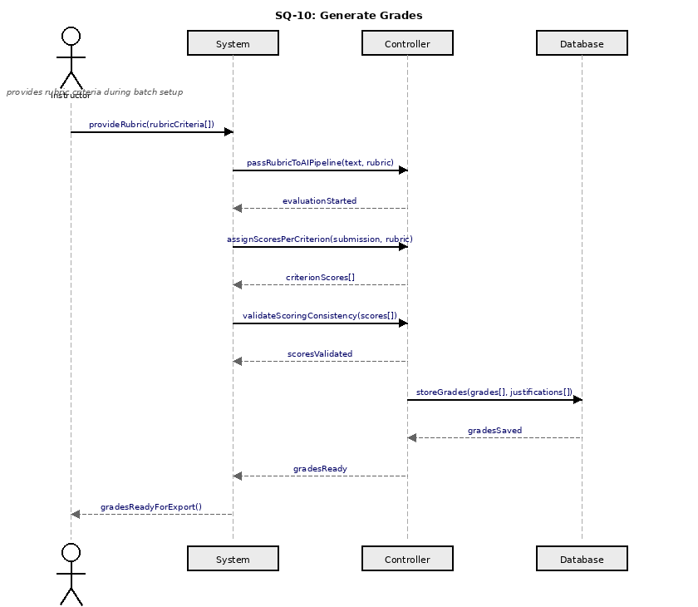
Figure 3.11: Sequence Diagram – Generate Grades
Criteria of rubrics is given by the instructor. The Controller forwards them to the AI pipeline, rates each submission on each dimension of the rubric and allocates criterion scores and makes sure they are consistent. The Database stores finalized grades and justifications and the instructor is informed that they are ready to be exported.

- SQ-11: Export Reports

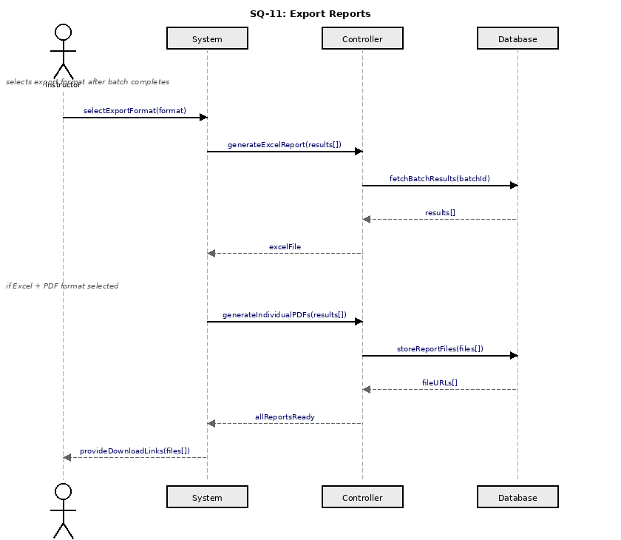
Figure 3.12: Sequence Diagram – Export Reports
The instructor picks a format of export. The Controller retrieves batch result on the Database and creates the Excel report. When Excel + PDF is chosen, they are also created and stored in PDFs. Filed URLs are sent back to the System and their download links sent to the instructor.

- SQ-12: Approve Faculty

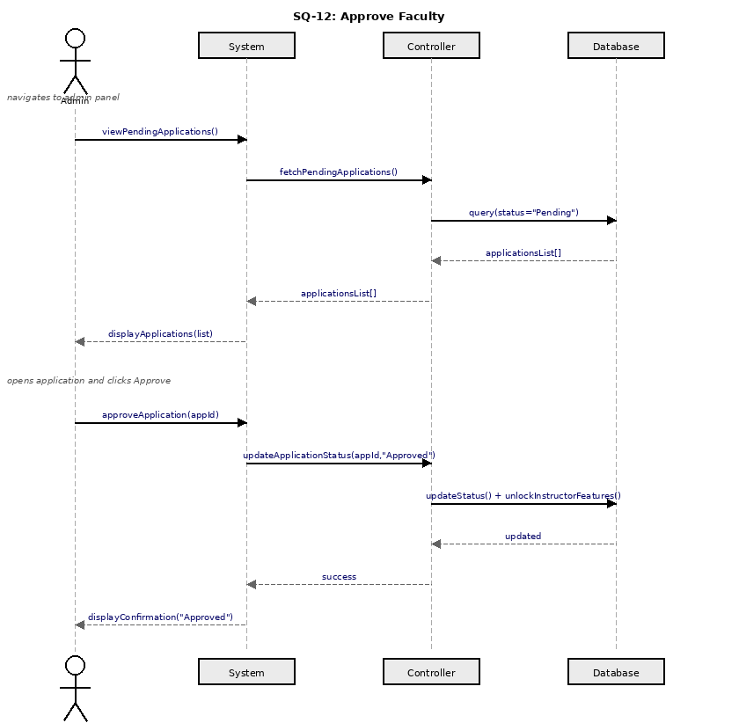
Figure 3.13: Sequence Diagram – Approve Faculty
The administrative assistant perceives applications in progress and The Database is queried by the Controller which is the list returned and Upon the approval of an application by the admin, the Controller changes the status to Approved and opens instructor features in the Database and finally The System is informed of a success and shown to the admin.

- SQ-13: Grant Pro Access

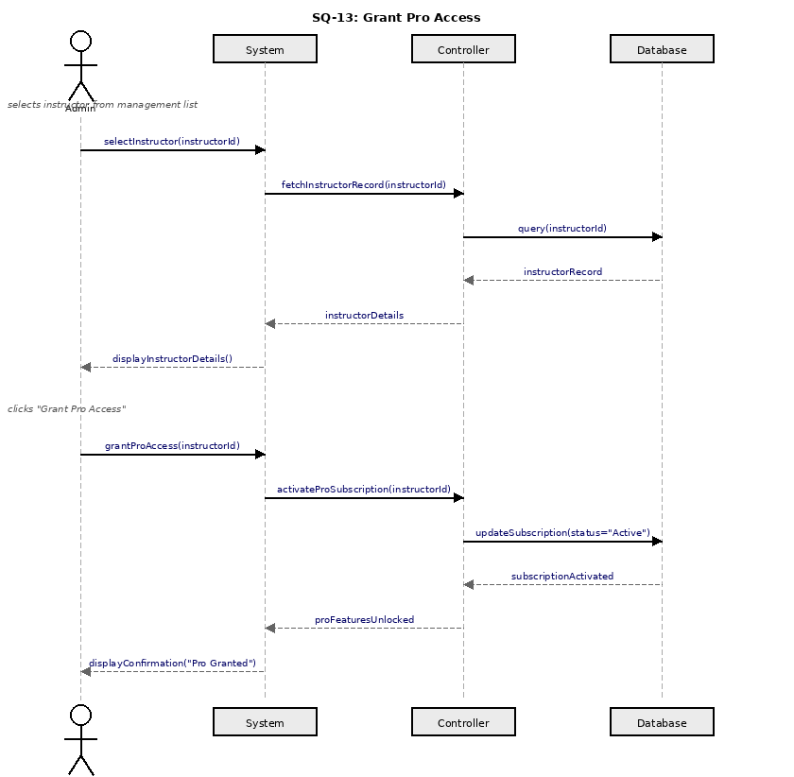
Figure 3.14: Sequence Diagram – Grant Pro Access
The administrator chooses a teacher and The Controller gets the record of the instructor in the Database and Once the admin has provided Pro access, the Controller changes the subscription to Active in the Database and unlocks Pro functionality, finally A reply is given to the System and shown to the admin.
- SQ-14: Manage Warnings

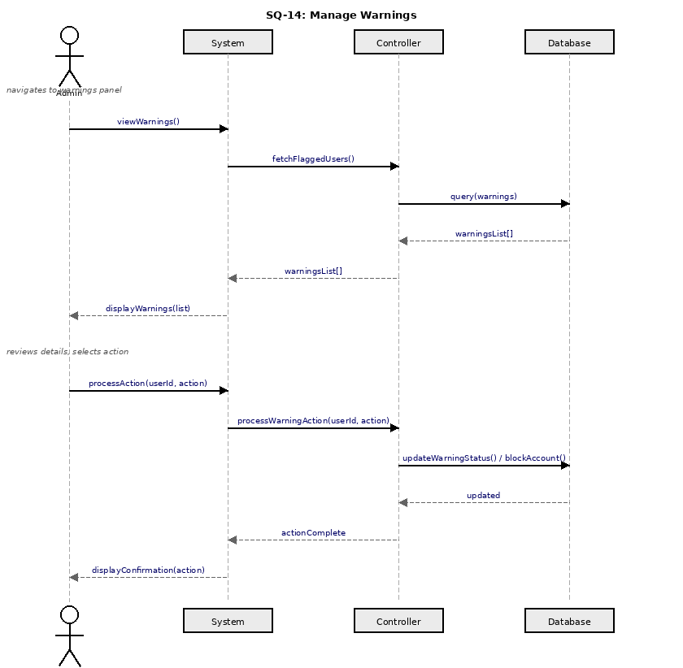
Figure 3.15: Sequence Diagram – Manage Warnings
The warnings panel is displayed to the admin and The Controller asks Questions flagged user records of the Database and sends them out and Once the admin decides on an action, the Controller changes the warning status, blocks the account in the Database, finally A reply is given to the System and shown to the admin.

3.4 Class Diagram
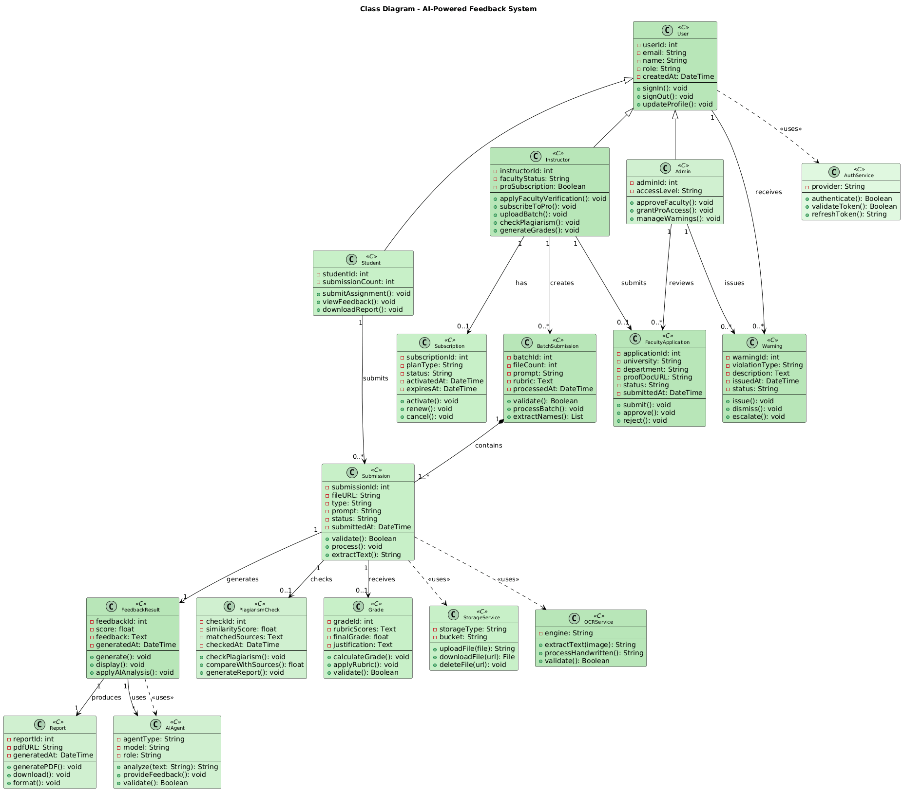
The class diagram shows the object-oriented design of the AI-Powered Feedback System, depicting classes, their attributes and methods, and the relationships between them.

Figure 3.6: Class Diagram

3.5 DBS Schema
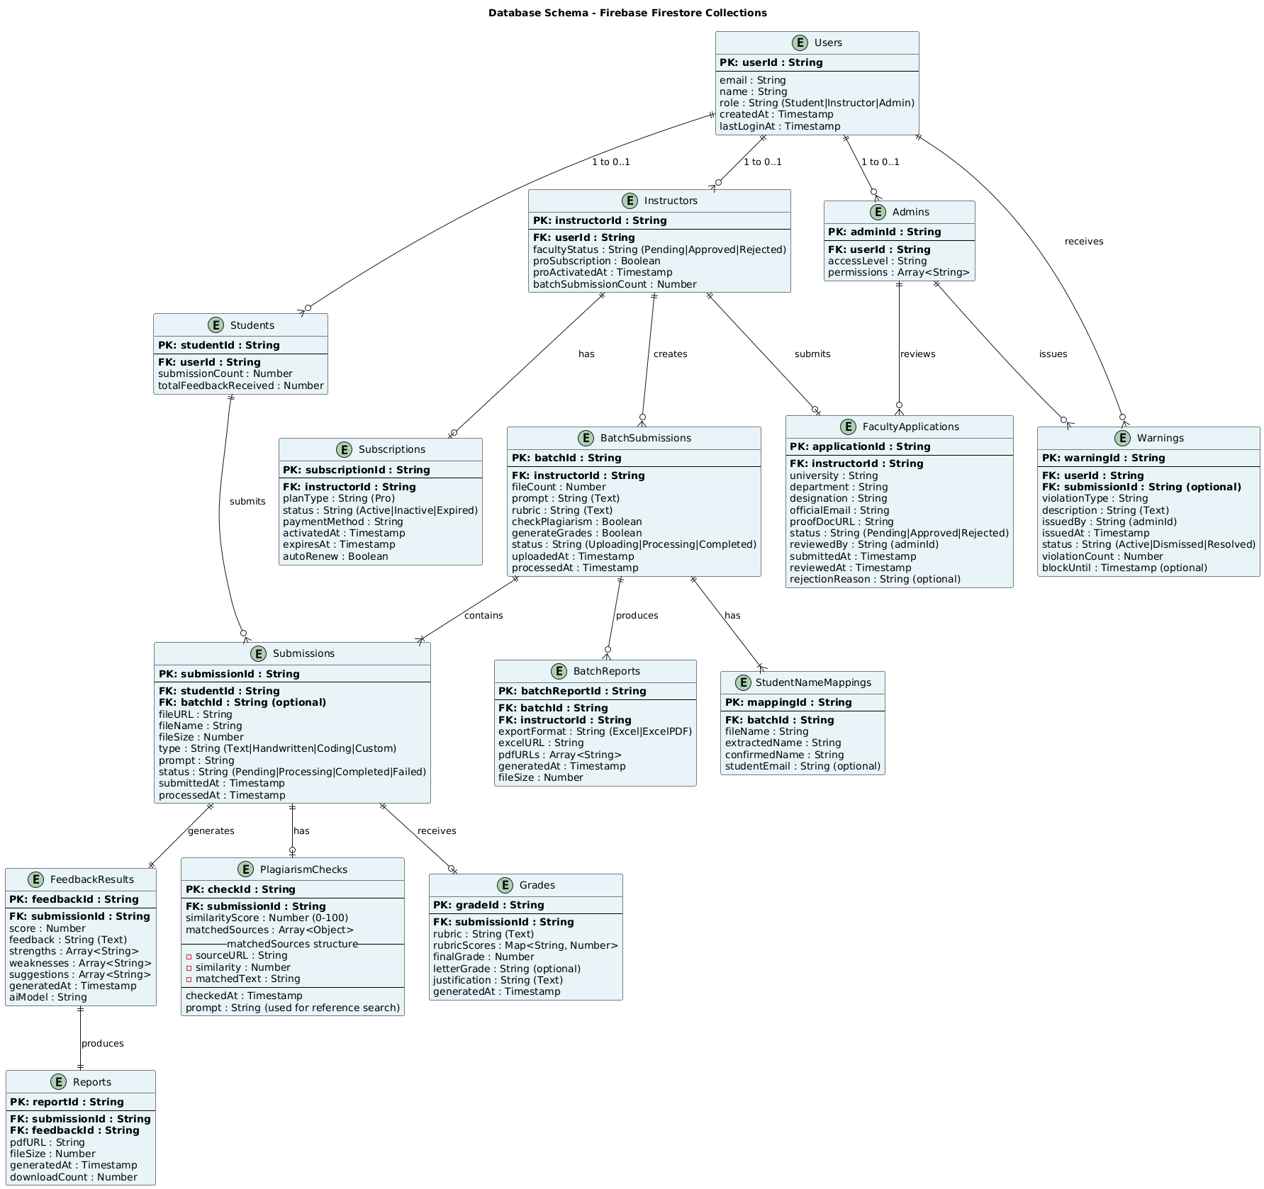
The database schema illustrates the Firestore collections, their key fields, and the relationships between collections.

Figure 3.7: DBS Schema
Key collections and their roles:
- Users: Users: The stores store the authentication details, role and profile details of all registered users.
- Students: aids Users who have an id of a student including number of submissions.
- Instructors: Stores faculty verification status, Pro subscription flag, and batch history.
- Faculty Applications: Tracks each application including proof document, status, and timestamps.
- Submissions: Stores submission metadata, assignment type, and processing status.
- Feedback Results: Stores AI-generated feedback text, rubric scores, and pipeline outputs.
- Reports: References to generated PDF and Excel files in Firebase Storage.
- Subscriptions: Tracks Pro subscription status and activation dates per instructor.
- Plagiarism Checks: Stores similarity scores, matched snippets, and source URLs.
- Warnings: Logs policy violations per user with timestamps and violation details.

3.6 User Interface Design

3.6.1 Description of the User Interface
The system consists of interfaces where there is effective communication within the system modules and the system users. It has an interactive, convenient and user friendly user interface. It relies on the modern design culture like monochrome color palette, efficient visual hierarchy, convenient layouts, which can be seen on desktop and mobile equipment.

3.6.2 Screen Images

Landing Page
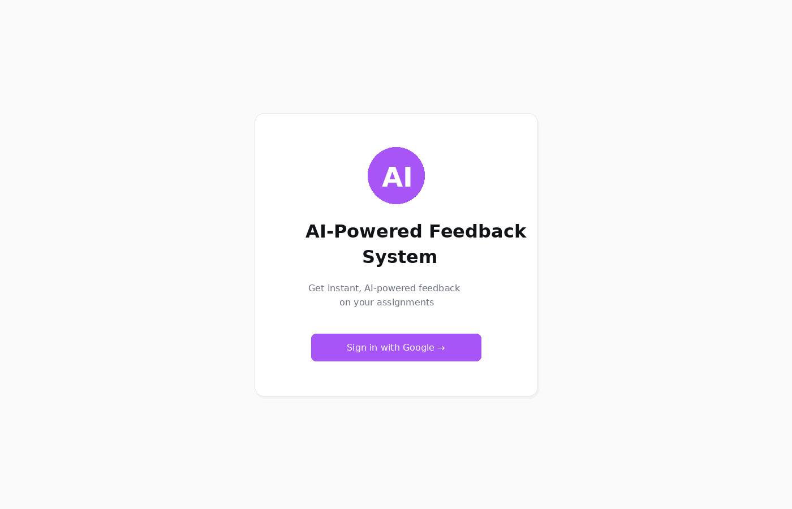
Figure 3.8: Landing Page

Role Selection Interface
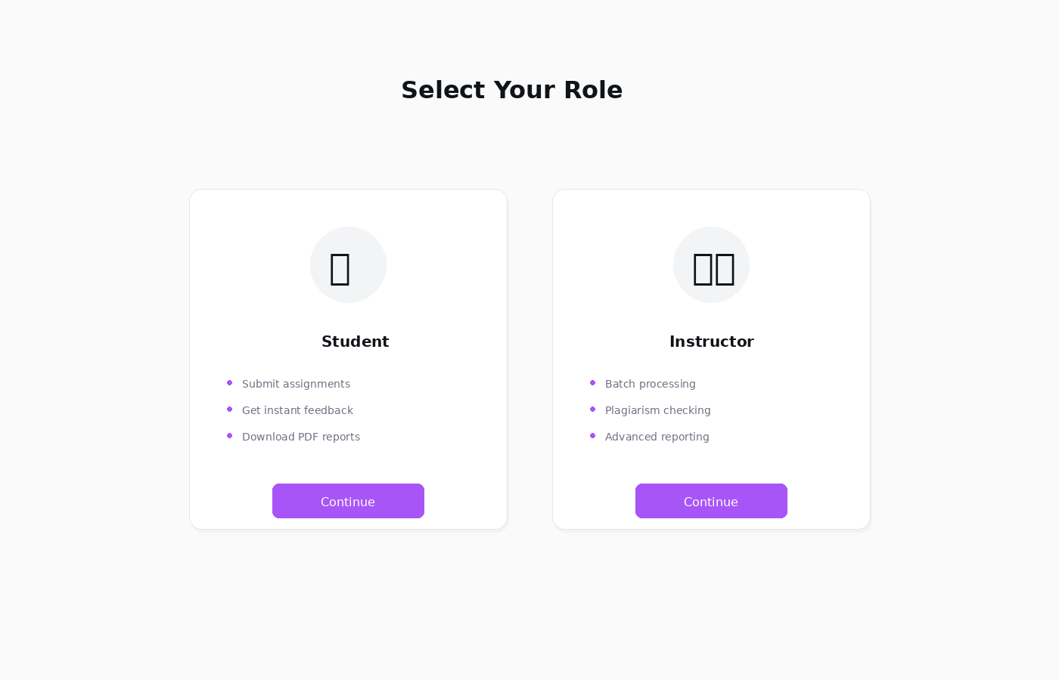
Figure 3.9: Role Selection Screen

Student Dashboard
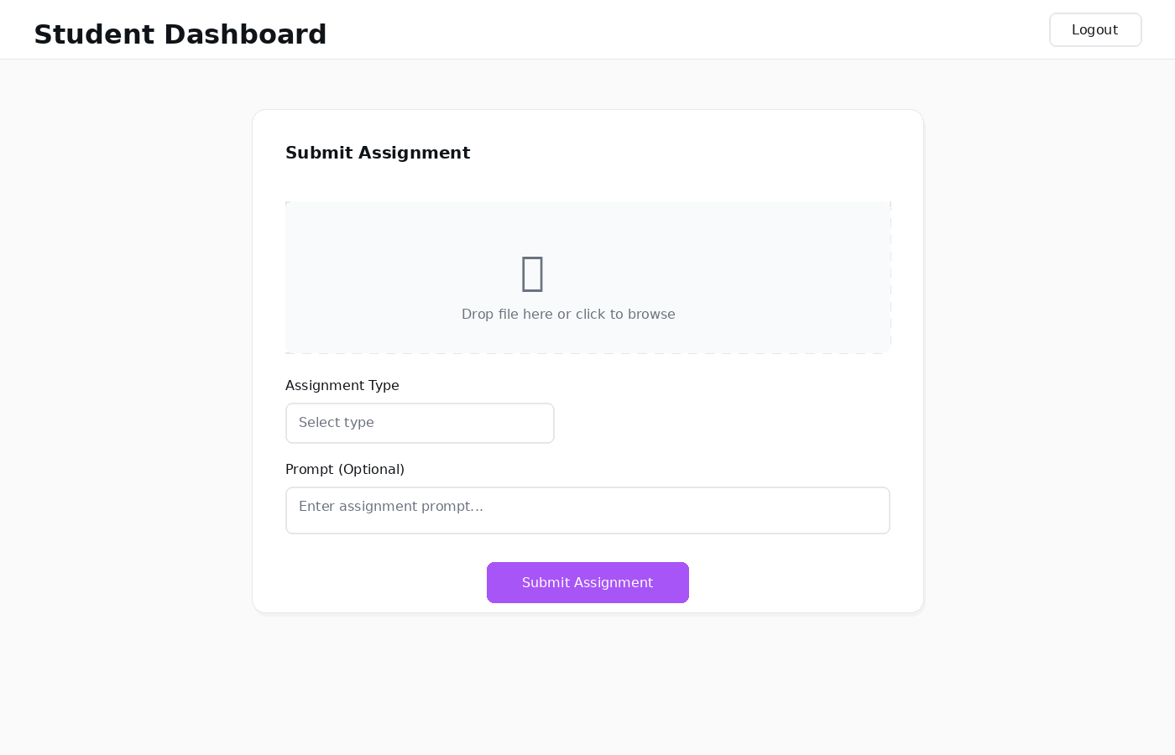
Figure 3.10: Student Dashboard

Faculty Application Form
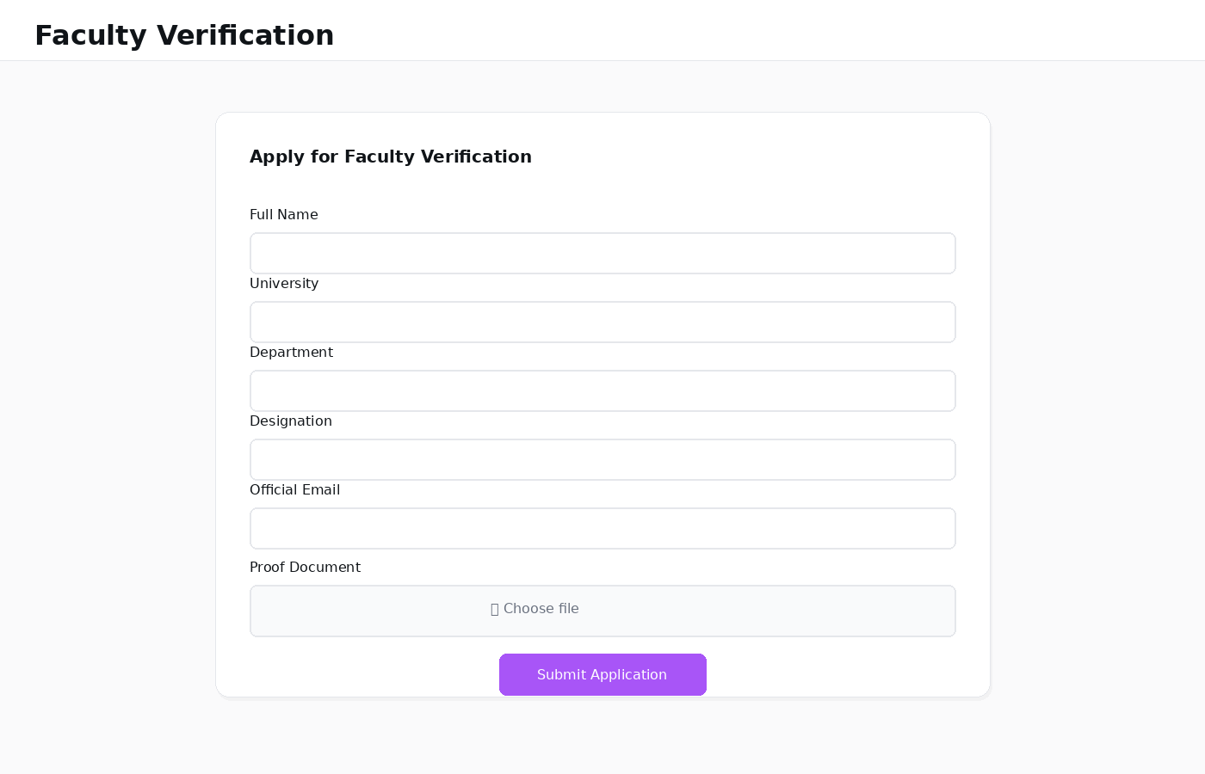
Figure 3.11: Faculty Application Form
.

Instructor Dashboard
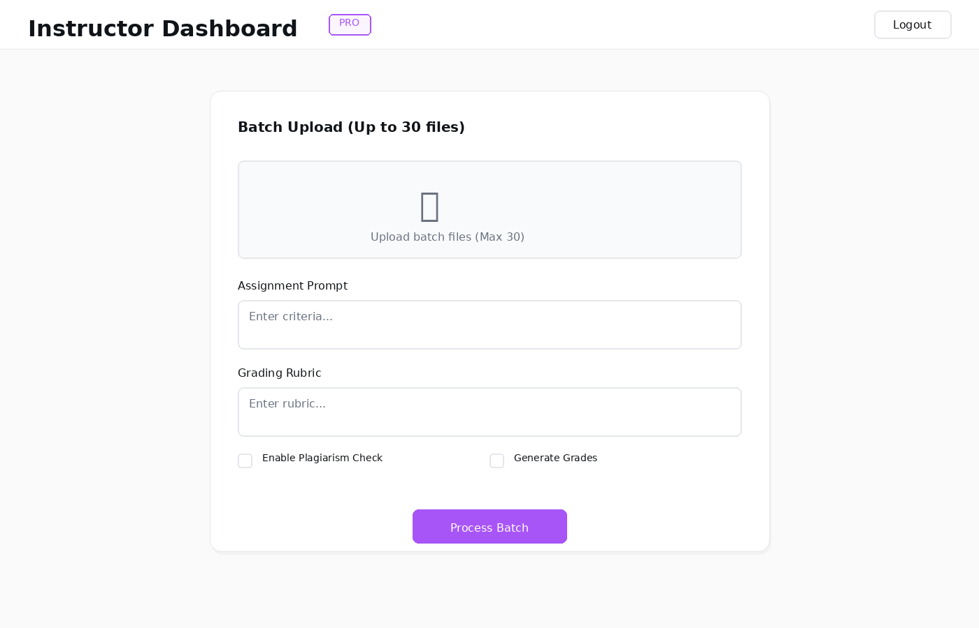
Figure 3.12: Instructor Dashboard – Batch Upload

Student Name Editing
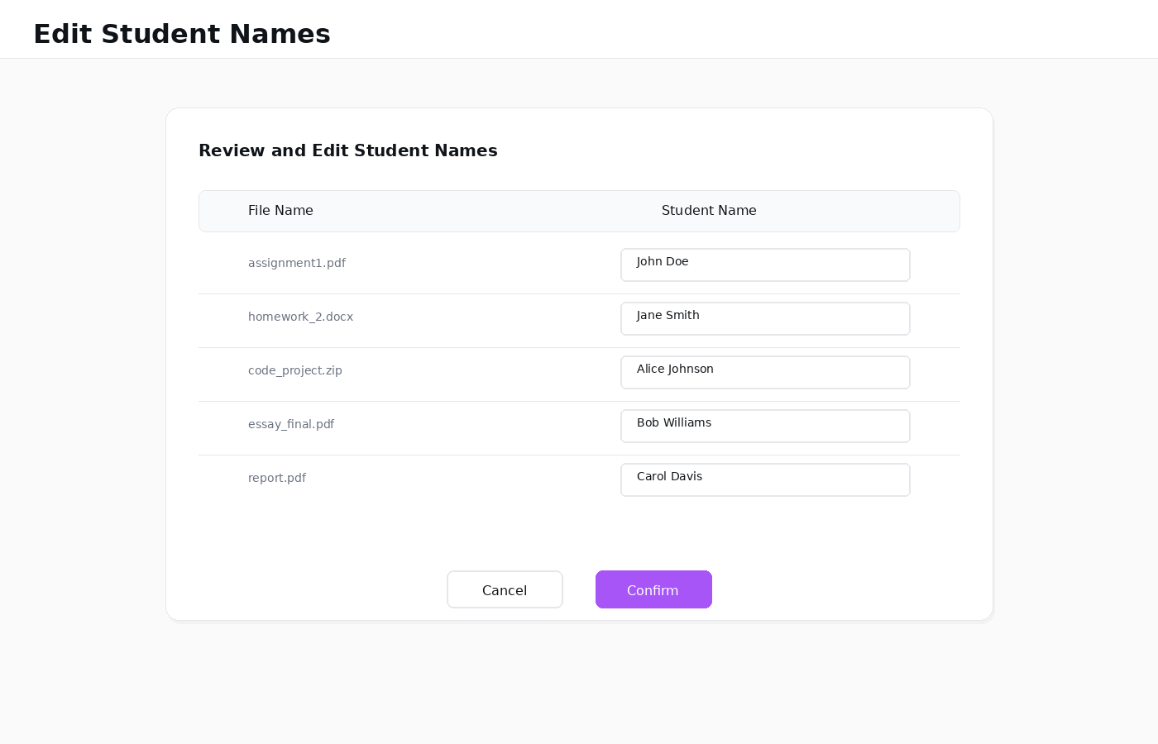
Figure 3.13: Edit Student Names

Feedback Display
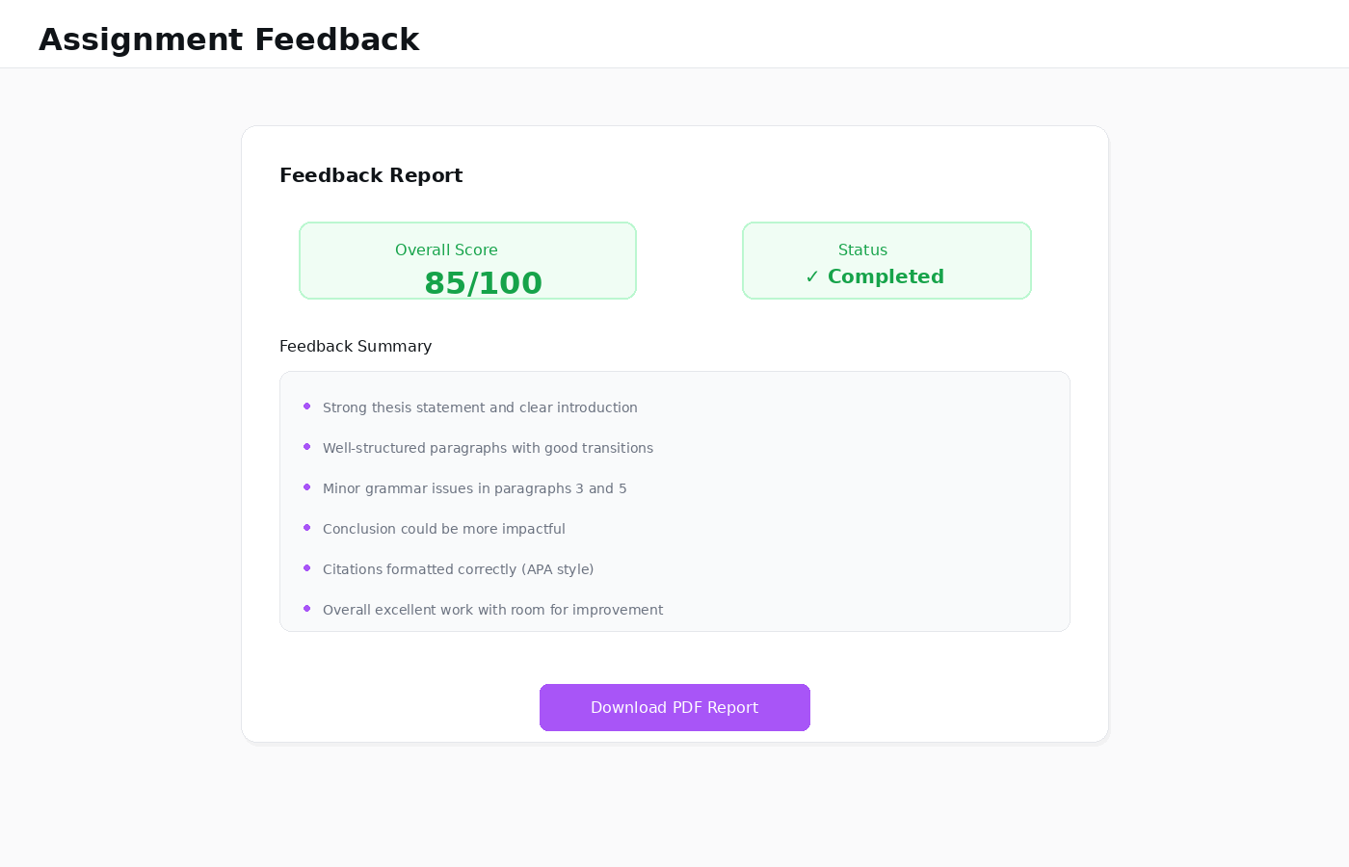
Figure 3.14: View Feedback Screen

Admin Panel
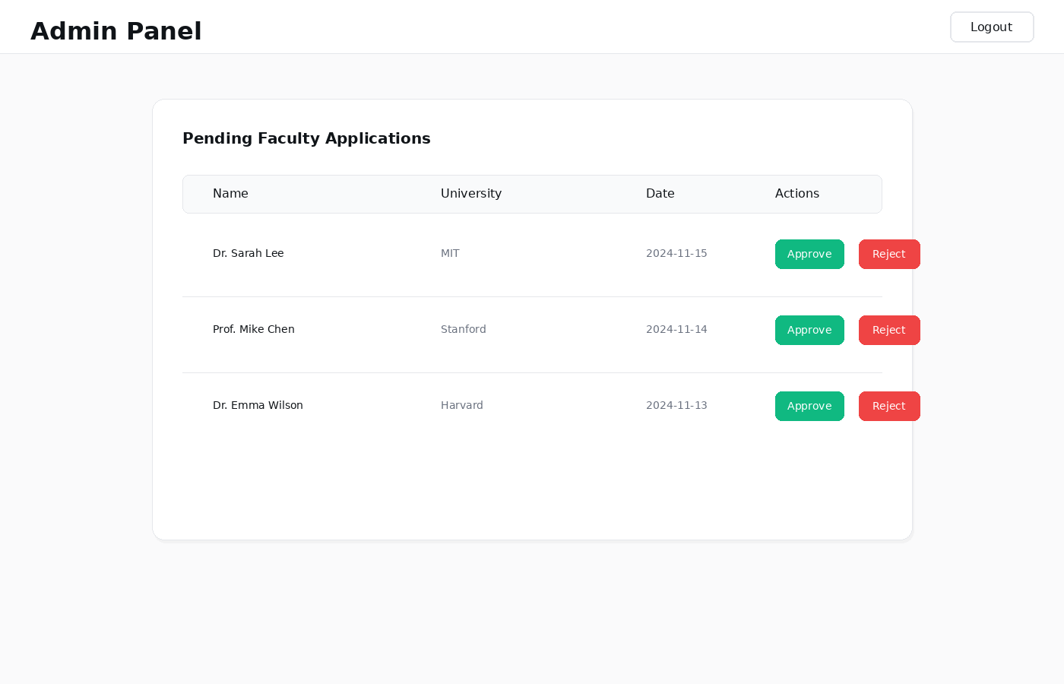
Figure 3.15: Admin Panel
.

Report Export Selection
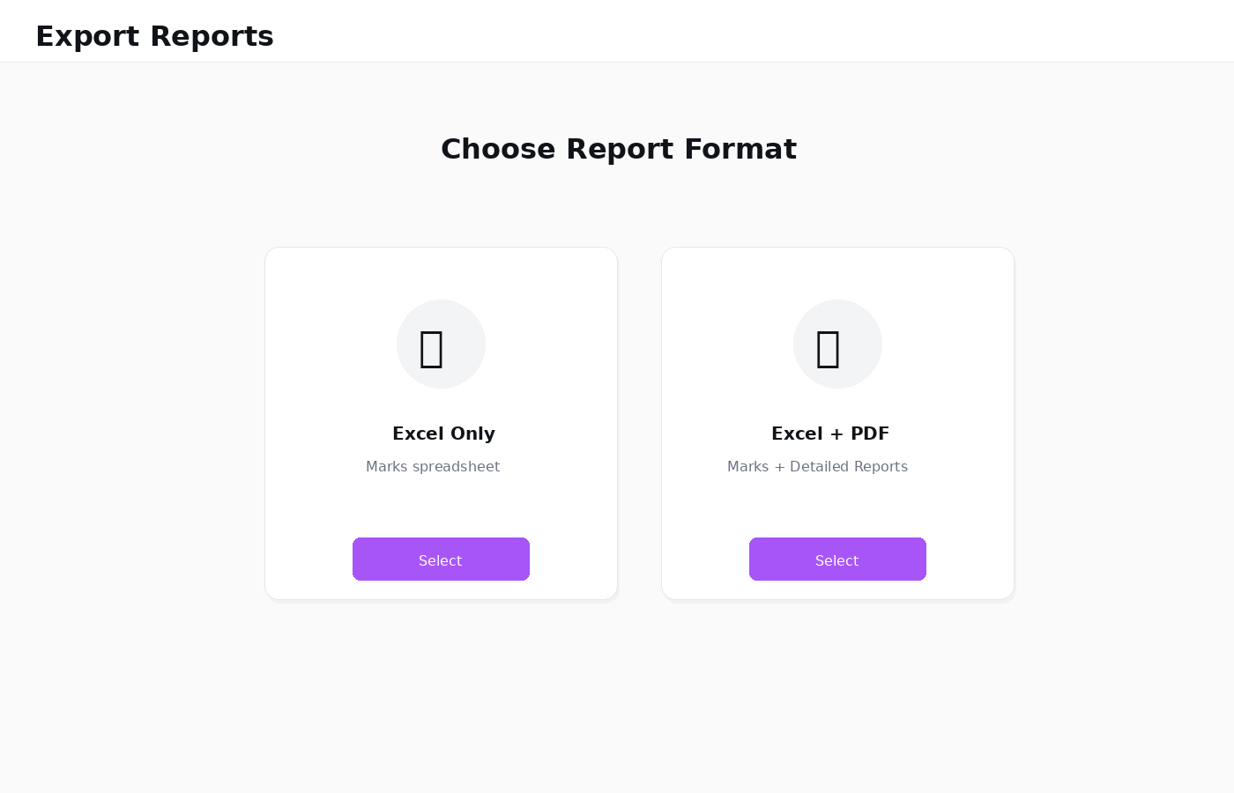
Figure 3.16: Export Reports Screen

3.6.3 Objects and Actions
Each screen contains multiple interactive objects that support user interactions:
- Buttons: Used for navigation, form submission, approvals, rejections, and report downloads.
- Text Fields: Allow users to input prompts, rubric criteria, student names, and credentials.
- File Upload Zone: Supports click-to-browse and drag-and-drop for assignments and proof documents.
- Dropdown Selectors: Enable selection of assignment type, export format, and other predefined options.
- Editable Table: Allows instructors to click and edit auto-extracted student names after batch upload.
- Progress Bar: Provides real-time visual feedback during file processing and AI pipeline execution.
- Icons: Represent quick actions such as approve, reject, edit, delete, and download.
- Links: Provide actions such as downloading reports or navigating to additional sections.

Chapter 4

Test Planning and Strategy

4.1 Introduction

The testing is a crucial stage in the software development lifecycle that is necessary to assure that the AI-Powered Feedback System meets all the requirements specified in the way and in the manner they are supposed to be and It consists of running the software or some of it to detect bugs and ensure proper functionality and The primary objective of testing is to test the software to its requirements and This chapter will specify the testing methodology, approach and the test cases used to prove all the functional and nonfunctional requirements. Assessment will be done post implementation.

4.1.2 System Overview
The AI-Powered Feedback System system under test is a web application between three user groups: Student, Instructor, and Admin - and an AI-powered assignment evaluation pipeline. It is an integrated system that incorporates Google OAuth, Firebase Firestore and Firebase storage, an OCR engine, a 3-step AI inference pipeline (Specialist, Judge ,Senior), a code execution sandbox, plagiarism detector, rubric-generated grades, report export, and administrator warning policies. Outstanding testing All the integrated components are tested to make sure everything works as intended.

4.1.3 Test Approach
Test Case Development: Each use case has the test case which is created to ensure that all the requirements are met. Every test case implies the conditions of setting up and manual steps and outcomes.
Test Case Execution: Test cases are implemented following the implementation stage. The outcome will be registered in Pass or Fail. Tests are conducted on failures and fixed then re-tested.

4.2 Test Plan

4.2.1 Features to Be Tested
- Sign In via Google OAuth (all three user roles)
- Submit Single Assignment (Text, Handwritten, Coding, Custom)
- View AI-Generated Feedback
- Download PDF Feedback Report
- Apply for Faculty Verification
- Subscribe to Pro
- Batch Upload (up to 30 files)
- Edit Student Names
- Check Plagiarism
- Generate Grades with Rubric
- Export Batch Reports (Excel / Excel + PDF)
- Approve / Reject Faculty Application (Admin)
- Grant Pro Access (Admin)
- Manage Warnings (Admin)

4.2.2 Test Cases
Test Case | TC-1
 | Sign In
Explanation | Verifies that all three user roles (Student, Instructor, Admin) can successfully authenticate via Google OAuth and be redirected to the appropriate dashboard.
Setup | 1. User has internet access.  2. User has a valid Google account.  3. User is not currently logged in.
Instructions | 1. Navigate to the application landing page.  2. Click the 'Sign in with Google' button.  3. Select a valid Google account and grant permissions.
Expected Results | 1. System authenticates user via Firebase Auth.  2. User profile is created or retrieved in Firestore.  3. First-time user is redirected to role selection screen.  4. Returning user is directed to their role-specific dashboard.
Verdict Pass/Fail
Table 4.1 – Sign in Test Case
Test Case | TC-2
 | Submit Single Assignment
Explanation | Verifies that a student can upload an assignment file, receive AI-generated feedback, and view the results screen.
Setup | 1. User has internet access.  2. User is logged in as a Student.
Instructions | 1. Navigate to the student dashboard.  2. Upload a valid PDF file under 1MB.  3. Select assignment type 'Text-based'.  4. Click 'Submit Assignment'.
Expected Results | 1. System validates and accepts the file.  2. System processes the submission through the AI pipeline.  3. Feedback summary is displayed on screen.  4. PDF report download link is provided.
Verdict Pass/Fail
Table 4.2 –Single submit Assignment Test Case
Test Case | TC-3
 | View Feedback
Explanation | Verifies that the feedback display screen correctly shows AI-generated scores, highlights, and detailed sections.
Setup | 1. User has internet access.  2. A submission has been processed successfully.
Instructions | 1. After submission processing, observe the feedback screen.  2. Scroll through all feedback sections.
Expected Results | 1. Overall score and Pass/Fail status are displayed.  2. Strengths, weaknesses, and improvement suggestions are shown.  3. Rubric scores are displayed if rubric was provided.  4. PDF download link is accessible.
Verdict Pass/Fail
Table 4.3 – View Feedback Test Case

Test Case | TC-4
 | Download PDF Report
Explanation | Verifies that the system generates and provides a downloadable PDF containing complete feedback details.
Setup | 1. User has internet access.  2. Feedback has been generated.
Instructions | 1. On the feedback screen, click 'Download PDF Report'.  2. Save the downloaded file.
Expected Results | 1. System generates the PDF report.  2. Browser initiates the file download.  3.Downloaded PDF contains full feedback and scores.
Verdict Pass/Fail
Table 4.4 –Download PDF Report Test Case
Test Case | TC-5
 | Apply for Faculty Verification
Explanation | Verifies that an instructor can submit a complete faculty verification application.
Setup | 1. User has internet access.  2.User is logged in with the instructor role.  3.No previous application has been submitted.
Instructions | 1.Navigate to the faculty application form.  2.Fill all required fields: name, university, department, designation, email.  3. Upload a valid proof document.  4. Click 'Submit Application'.
Expected Results | 1. System validates all fields and the proof document.  2.Application is saved with Pending status.  3. Confirmation message is displayed.  4. Instructor features remain locked.
Verdict Pass/Fail
Table 4.5 – Apply for faculty verification Test Case
Test Case | TC-6
 | Subscribe to Pro
Explanation | Verifies that a verified instructor can activate a Pro subscription via sandbox payment.
Setup | 1. User has internet access.  2. User is logged in as an Instructor with Approved faculty status.
Instructions | 1. Navigate to the subscription section.  2. Select a Pro subscription plan.  3. Complete the sandbox payment form.  4. Confirm the subscription.
Expected Results | 1.Sandbox payment is processed successfully.  2. Pro subscription is activated.  3.Batch upload, plagiarism, grade generation, and export features are unlocked.
Verdict Pass/Fail
Table 4.6 – Subscribe to Pro Test Case
Test Case | TC-7
 | Batch Upload (30 Files)
Explanation | Verifies that a Pro instructor can upload and process a batch of up to 30 assignment files.
Setup | 1. User has internet access.  2. User is logged in as a Pro Instructor.  3. 30 valid assignment files are prepared.
Instructions | 1. Navigate to batch upload section.  2. Upload 30 assignment files.  3. Enter assignment prompt and rubric.  4. Confirm student names.  5. Click 'Process Batch'.
Expected Results | - All 30 files are validated and accepted.  - System processes the batch through the AI pipeline.  - Feedback and grades are generated for each submission.  - Export options become available.
Verdict Pass/Fail
Table 4.7 – Batch Upload Test Case
Test Case | TC-8
 | Edit Student Names
Explanation | Verifies that an instructor can edit auto-extracted student names before batch processing.
Setup | 1. User has internet access.  2. User is logged in as a Pro Instructor.  3. Batch files have been uploaded.
Instructions | 1. View the auto-populated name mapping table.  2. Click a name cell and edit it.  3. Confirm the updated name mapping.
Expected Results | 1. Edited names are saved correctly.  2. Updated names appear in all generated reports.  3.System validates no name fields are empty before allowing confirmation.
Verdict Pass/Fail
Table 4.8 – Edit Student Names Test Case
Test Case | TC-9
 | Check Plagiarism
Explanation | Verifies that the plagiarism detection module computes similarity scores and provides source references.
Setup | 1. User has internet access.  2. User is logged in as a Pro Instructor.  3. Assignment prompt is provided.
Instructions | 1. During batch upload setup, enable the plagiarism check option.  2. Submit the batch.
Expected Results | - The system gathers reference materials on the internet.  - Each entry is calculated in terms of similarities percentage.  - The export report shows matched snippets of text and their URLs of source.
Verdict Pass/Fail
Table 4.9 – check Plagiarism Test Case
Test Case | TC-10
 | Generate Grades
Explanation | Verifies that rubric-based numeric grades are generated and included in reports.
Setup | 1. User has internet access.  2. User is logged in as a Pro Instructor.  3.Assignment prompt and rubric are prepared.
Instructions | 1. Enter assignment prompt and detailed rubric.  2. Submit the batch for processing.
Expected Results | 1. System evaluates each submission against the rubric.  2. Numeric scores are assigned per criterion.  3. Grades and justifications appear in Excel and PDF exports.
Verdict Pass/Fail
Table 4.10 –Generate Grades Test Case
Test Case | TC-11
 | Export Reports
Explanation | Verifies that batch reports can be exported in both Excel-only and Excel + PDF formats.
Setup | 1. User has internet access.  2. User is logged in as a Pro Instructor.  3. Batch processing has completed.
Instructions | 1. Navigate to the export reports screen.  2. Select 'Excel Only' ,download and verify.  3. Select 'Excel + PDF' ,download and verify.
Expected Results | - Excel Only: spreadsheet with names of students and their scores and a summary are produced.  - Excel + PDF: it is created in spreadsheet and an individual PDF report per learners.  - Every download hyper/link is working.
Verdict Pass/Fail
Table 4.11 – Export reports Test Case
Test Case | TC-12
 | Approve Faculty
Explanation | Verifies that an admin can review and approve a pending faculty application.
Setup | 1. User has internet access.  2. User is logged in as Admin.  3. A Pending faculty application exists.
Instructions | 1. Navigate to the admin panel.  2. Open a pending application.  3. Review details and click 'Approve'.
Expected Results | 1. Application status updated to Approved.  2. Instructor features unlocked for the approved user.  3. Confirmation displayed to admin.
Verdict Pass/Fail
Table 4.12 – Approve Faculty Test Case
Test Case | TC-13
 | Grant Pro Access
Explanation | Verifies that an admin can manually activate Pro subscription for a verified instructor.
Setup | 1. User has internet access.  2. User is logged in as Admin.  3. Target instructor has Approved faculty status.
Instructions | 1. Navigate to instructor management in admin panel.  2. Select the target instructor.  3. Click 'Grant Pro Access'.
Expected Results | 1. Pro subscription is activated for the instructor.  2. All Pro features become accessible.  3. Confirmation is displayed to admin.
Verdict Pass/Fail
Table 4.13 – Grant pro Test Case
Test Case | TC-14
 | Manage Warnings
Explanation | Verifies that the system logs warnings for sensitive data violations and blocks accounts after three violations.
Setup | 1. User has internet access.  2. User is logged in as Admin.  3. A user has submitted content containing sensitive data.
Instructions | - Through the navigatory menu to the warnings panel in the admin panel.  - Check the allocated warnings.  - Get a third violation so that the same user is allowed access. Observe account status.
Expected Results | - It gives a warning against the account of the user.  - Admin has an opportunity to see the flagged submission details.  - Once the user violates the account in the third time then they are automatically blocked out of the system within a span of 24 hours.  - Block extensions and warnings may be dismissed manually by the administrator.
Verdict Pass/Fail
Table 4.13 – Manage warnings Test Case

4.3 References

REFERENCES

Ref No. | Source | Link
1 | IEEE Std 829-2008, IEEE Standard for Software and System Test Documentation | https://standards.ieee.org/standard/829-2008.html
2 | ISO/IEC 25010:2011, Systems and software Quality Requirements and Evaluation (SQuaRE) | https://www.iso.org/standard/35733.html
3 | Firebase Documentation. Firebase Firestore - NoSQL Cloud Database | https://firebase.google.com/docs/firestore
4 | Flask Documentation. Flask Web Framework (Version 3.0) | https://flask.palletsprojects.com/
5 | Tesseract OCR Documentation. Open Source OCR Engine | https://tesseract-ocr.github.io/tessdoc/
6 | OpenAI. API Reference - Language Models and Integration | https://platform.openai.com/docs/api-reference
7 | Google Developers. OAuth 2.0 for Web Server Applications | https://developers.google.com/identity/protocols/oauth2/web-server
8 | Vaswani, A. et al. "Attention Is All You Need" - Transformer Architecture for NLP | https://arxiv.org/abs/1706.03762
9 | Devlin, J. et al. "BERT: Pre-training of Deep Bidirectional Transformers for Language Understanding" | https://arxiv.org/abs/1810.04805
10 | Brown, T. et al. "Language Models are Few-Shot Learners" (GPT-3) | https://arxiv.org/abs/2005.14165
11 | PyTorch Documentation. Deep Learning Framework | https://pytorch.org/docs/stable/index.html
12 | Hugging Face. Transformers Library Documentation - NLP Models | https://huggingface.co/docs/transformers/
13 | Stanford University. CS224N: Natural Language Processing with Deep Learning | https://web.stanford.edu/class/cs224n/
14 | ACM Digital Library. "Automated Feedback Generation for Programming Assignments using LLMs" | https://dl.acm.org/doi/10.1145/3568812.3603463
15 | IEEE Xplore. "LSTM-Based Plagiarism Detection in Student Submissions" | https://ieeexplore.ieee.org/document/9612045
16 | Springer. "Deep Learning Approaches for Handwriting Recognition in Education" | https://link.springer.com/article/10.1007/s10032-023-00421-5
17 | arXiv. "OCR Post-Processing for Improving Handwritten Document Recognition" | https://arxiv.org/abs/2304.07654
18 | OWASP. Web Application Security Testing Guide | https://owasp.org/www-project-web-security-testing-guide/
19 | Python Software Foundation. Python Documentation (Version 3.11) | https://docs.python.org/3/
20 | GitHub. Version Control and Collaboration Platform | https://docs.github.com/

