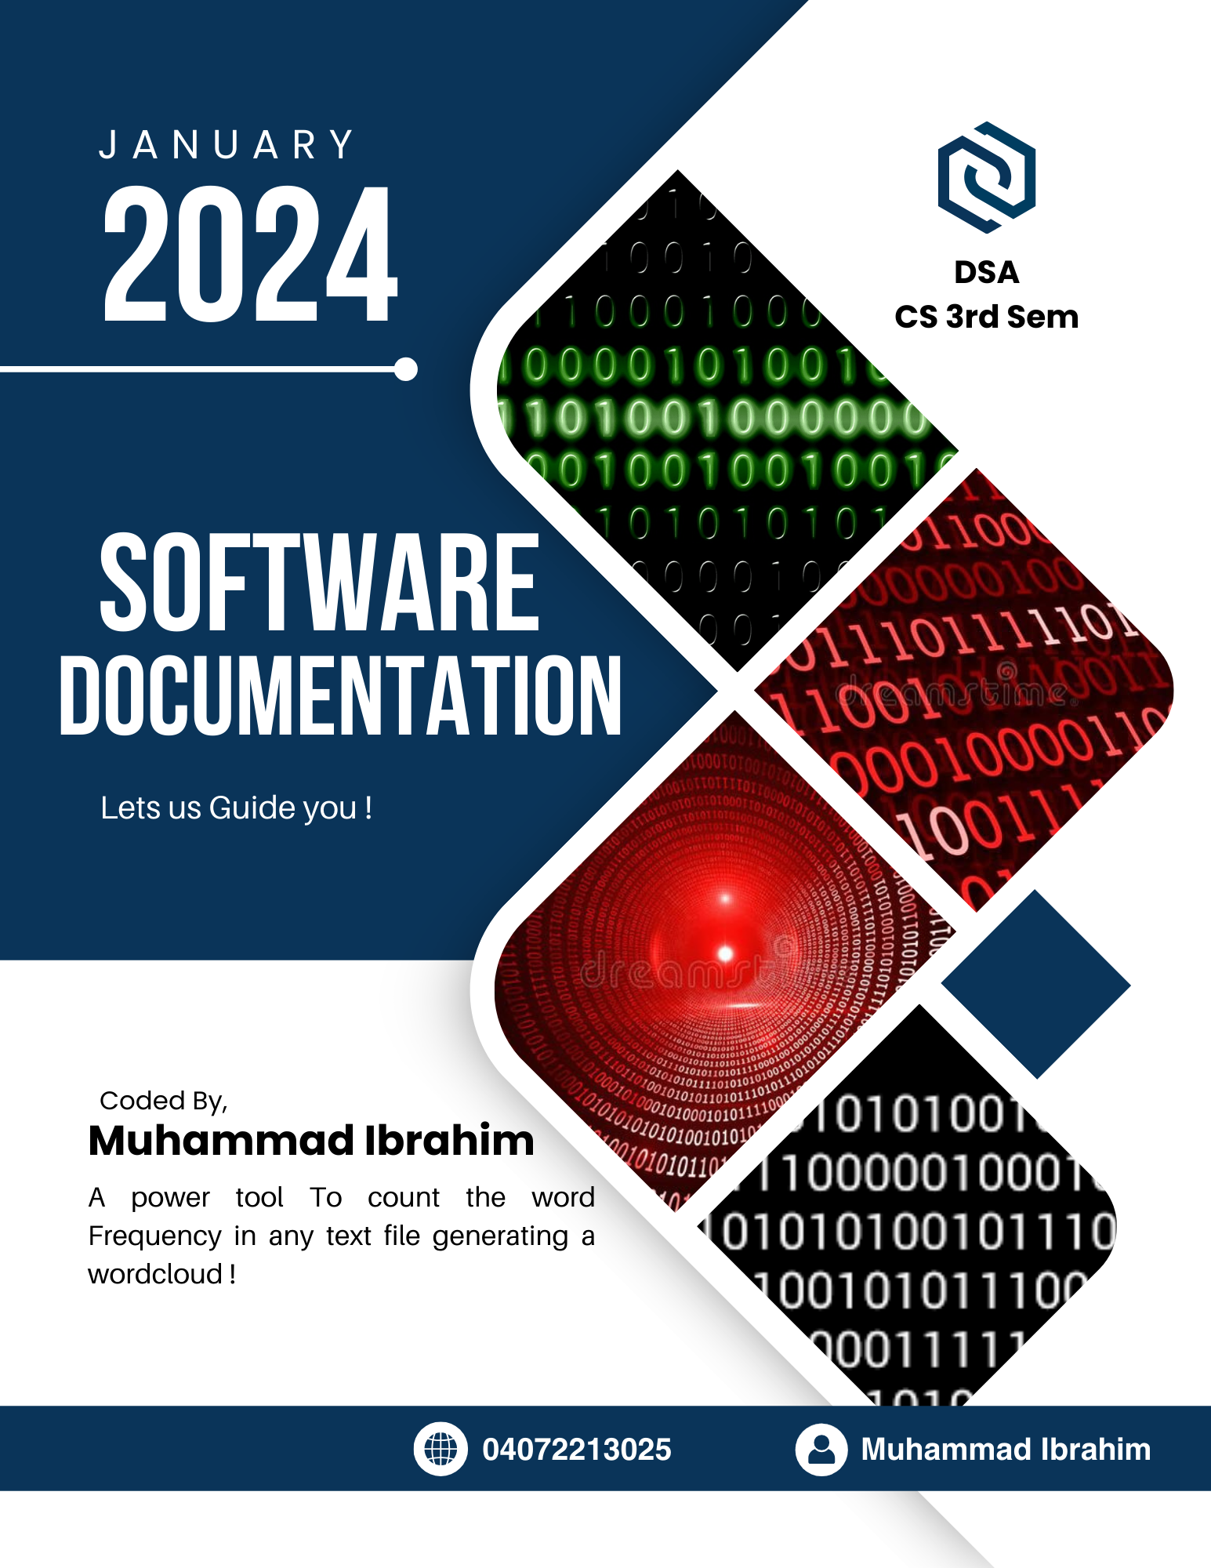

**Word Frequency Documentation**

**(Question-2)**

**Table Of Contents**

1. **Introduction**
   1. Overview
   2. Purpose
2. **User Guide**
   1. Feature And Functionality
   2. How to Use
3. **Additional**
   1. Common issue
4. **Contact Information**
   1. Support Email

.

1.Introduction

This is a Word-Frequency Software and is used to count the frequency of a word from any text file!

**1.1-Overview**

The software aims at helping out the user count the frequency of a word present in a text file. It Purifies the Data and Generate a Word Cloud for the user as well!

**1.1-Purpose**

The sole Purpose of the program is to measure frequency of the words in a given file! so it saves user’s time.

2.User Guide

Following are the user guides to help you get started!

**2.1-Features and Functionality**

* Counts the Frequency of each word
* Removes the Punctuation from the word
* Keeps track of different variations of the same word
* Generates a Word Cloud
* Generates an Excel Sheet

**2.2-How to Use**

* Compile the Code
* When the Program starts, it will ask you for the file name, please enter the correct file name, for example “wordlist.txt”.
* After the correct file name is given, it will generate the excel sheet containing the details and html file containing the word cloud!
* That’s it! smart And Easy!

4.Additional

**2.2-Common Issues**

* wrong file name or Non-Existent name
* Stopwords.txt missing

5.Case Uses

**Case :-1**

* If the user directly runs from the cpp file by compiling it, the program will ask for the file name and then corresponding details will be generated.

**Step 1**



**Step 2** 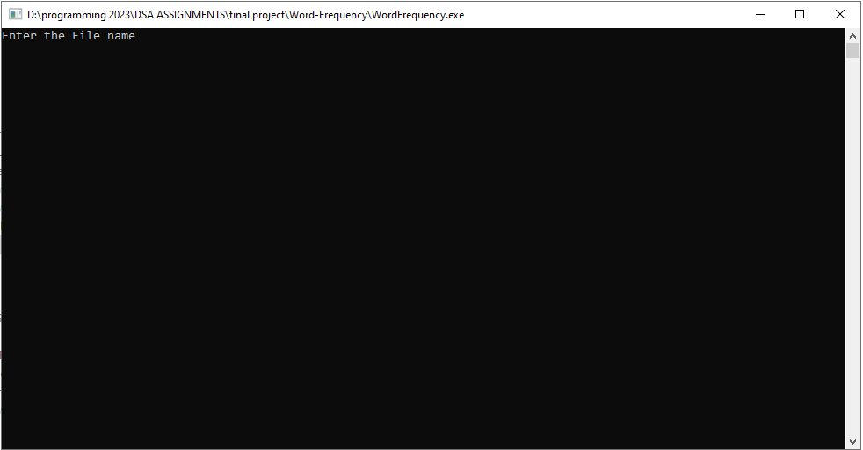

**Case :-2**

* If the user uses command line to run the program by compiling it first using cl, it will again ask for the file name and generate the details.

**Step 1**



**Step 2**



**Case :-3**

* If the user uses command line to run the program by compiling it first using cl and then giving the file name as a command line argument, then it will automatically read the file and generate the details without waiting!
* **Step 1**



**Step 2**



And then the Results will be generated



6.Program Functions

Program uses the following functions.

* lowercaseConvertor() that converts to lowercase.
* StopwordsLoader() that loads the stop words from the text file stopwords.
* StopWordFound() compares the word to the list of stop words .

**Contact information**

* Mail us your queries at elitetg67@gmail.com