**Using image recognition to improve Planograms and Realograms comparisons**

by

Michiel van der Merwe

ID number

9707315151085

submitted in partial fulfilment of the requirements for the bachelor’s degree in Computing

The Belgium Campus

Supervisor:

Mr. Comsmas Kajengo

Co-Supervisor:

Date of Submission

04/30/2019

# ABSTRACT

In the age where Machine learning and Artificial intelligences is becoming a huge part of business it is imperative for a business of any kind to use this advancement in technology to their advantages In the case of this papier the type of business we will be focusing on is retail and how they can use Machine learning to their advantages. The research question asked in this papier was How will the automation of planograms and realograms effect Retail? Qualitative Research is mainly used is Exploratory research. It is used to understand the underlying reasons, opinions and motivations for doing the researcher in the first place. It provides a in dept investigation of the problem or helps to develop the hypotheses for a quantitative research this in combination with the Quantitative research was used to form a very holistic idea to try and answer the research question. The research question has been answered, It will affect the retail in a positive way optimizing the current process is a big way there are various proves to the answer that was done in this research namely the ROI as well as the literature and the survey uncovered some very interesting findings as well as observations and the interviews help in answering the question and gain a deeper understanding of how unoptimized the processes really is.

DECLARATION

“I hereby declare that this document:

Using image recognition to improve Planograms and Realograms comparisons , submitted for evaluation towards the requirements of the subject: DISSERTATION 481 as part of the Bachelor’s Degree in Computing, at the Belgium Campus, is my own original work and has not previously been submitted to any other institution of higher learning or subject for evaluation. All sources used or quoted in this document are indicated and acknowledged by means of a comprehensive list of references”.

Surname, Initials: M.F van der Merwe

ID Number: 9707315151085

Signature ______M.F.van.der.Merwe___________ Date: dd/mm/2019

# TABLE OF CONTENTS

ABSTRACT ii

TABLE OF CONTENTS iv

TABLE OF FIGURES vii

CHAPTER 1: INTRODUCTION 1

1.1 INTRODUCTION 1

1.2 BACKGROUND 1

1.3 PROBLEM STATEMENT AND RESEARCH QUESTIONS 2

1.3.1 Reason(s) for research 2

1.3.2 Problem statement 2

1.3.3 Research question(s) 3

1.3.4 Research hypothesis 3

1.3.5 Research objective(s) 3

1.4 IMPORTANCE OF THE STUDY 3

1.5 DELINEATIONS AND LIMITATIONS 4

1.6 ASSUMPTIONS 4

1.7 ETHICAL CONSIDERATIONS 5

1.8 CHAPTER OUTLINE/OVERVIEW 6

1.9 CONCLUSION 6

CHAPTER 2: LITERATURE STUDY 8

2.1 INTRODUCTION 8

2.2 CONCEPTual framework 8

2.2.2 Planogram 10

2.2.3 REALOGRAM 11

2.2.4 Automation 11

2.2.5 Algorithms 12

2.3 Definition of Terms 13

2.4 CONCLUSION 14

CHAPTER 3: METHODOLOGY 15

3.1 INTRODUCTION 15

3.2 RESEARCH PHILOSOPHY 15

3.3 RESEARCH APPROACH 16

3.4 RESEARCH STRATEGY 18

3.5 RESEARCH METHOD(S) 19

3.6 DATA COLLECTION 21

3.6.1 Population and Sampling 24

3.6.2 Research Instruments 26

3.7 DATA ANALYSIS 28

3.8 TRUSTWORTHINESS 29

3.9 CONCLUSION 30

CHAPTER 4: RESULTS 32

4.1 INTRODUCTION 32

4.2 RESULTS AND INTERPRETATION 32

4.2.1 Current processes 34

4.2.2 Figure 4.2.2.1 Current processes 34

4.2.3 will image Recognition make a difference? 35

4.2.4 Figure 4.2.4.1 will image Recognition make a difference? 35

4.2.5 Are you afraid of losing your job? 36

4.2.6 Figure 4.2.6.1 Are you afraid of losing your job? 36

4.2.7 What is your job description? 37

4.2.8 Figure 4.2.8.1 What is your job description? 37

4.2.9 Normal distribution of hours worked 38

4.2.10 Figure 4.2.10.1 Normal distribution of hours worked 38

4.2.11 Are you a consultant? 39

4.3 CONCLUSION 41

CHAPTER 5: FINDINGS AND CONCLUSIONS 42

5.1 INTRODUCTION 42

5.2 FINDINGS 42

5.3 SHORTCOMINGS AND LIMITATIONS 43

5.4 BENEFITS TO THE FIELD OF STUDY 43

5.5 PROPOSED NEW RESEARCH/RECOMMENDATIONS 44

5.6 CONCLUSION 44

References 46

APPENDIX A: DATA COLLECTION INSTRUMENTS 48

# TABLE OF FIGURES

Figure 1.3.1.1 Image recognition in action 2

Figure 1.3.5.1 Chapter overview 6

Figure 2.2.5.1 System flow 12

Figure 2.2.5.1 deductive Approach 17

Figure 2.2.5.2 Inductive Approach 18

Figure 2.2.5.1 Observation guide 24

Figure 3.6.2.1 What is image Recognition 33

4.2.2 Figure 4.2.2.1 Current processes 34

4.2.4 Figure 4.2.4.1 will image Recognition make a difference? 35

4.2.6 Figure 4.2.6.1 Are you afraid of losing your job? 36

4.2.8 Figure 4.2.8.1 What is your job description? 37

4.2.10 Figure 4.2.10.1 Normal distribution of hours worked 38

Figure 4.2.11.1 Are you a consultant? 39

# INTRODUCTION

## INTRODUCTION

In the age where Machine learning and Artificial intelligences is becoming a huge part of business it is imperative for a business of any kind to use this advancement in technology to their advantages In the case of this papier the type of business we will be focusing on is retail and how they can use Machine learning to their advantages. It is important that businesses use this because of a couple of reasons one of the main reasons is return on investment (ROI). This papier will focus on employing Image recondition to improve the time it takes to compare planogram and realograms and will also look at the idea to of how we can employee a Machine learning to do the planogram automatically and what will be the effect of these ideas on business. The idea behind this research is to look at how business can employee Machine learning specially image recognition to improve the profit margin and improve employee productivity and how machine basis can be a huge factor in the case of this type of Machine learning algorithm

## BACKGROUND

Machine learning (ML) refers to the Study of statistical models and mathematical Algorithms these algorithms gets implemented into a computer via some sort of programming langue and then this computer Algorithms can then perform task, most of the time predictive task without present parameters. Planograms refers to schematic representation of a retail’s stores shelf the physical location of the products and the brands with the barcode as the reference to the image that correlates with the inventory list. ML is not a new concept Facebooks use ML to profile image The below example show how Facebook uses some sort of image recognition to see that there is one person in the picture, and this is very significant because this gives us an idea of how strong the image recognition technology is and how powerful the tech has become, the concept of image recognition is not a new it the thing it has been around for a while. Realograms refers to the list of products this list shows how a retail should pack their shelf and this data is currently represented in excel they currently have a person taking picture then manually comparing the picture to the realograms and the planogram to see if they match. This process is not streamlined and is not optimal. With this current process a lot of human interaction is required

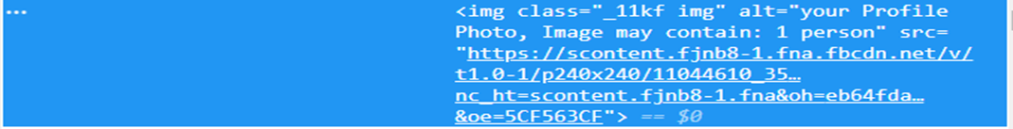

Figure 1.3.1.1 Image recognition in action

## PROBLEM STATEMENT AND RESEARCH QUESTIONS

### Reason(s) for research

The traditional way business has been setting up planograms and then manually comparing the realogram is not at all the most effective nor most profitable and therefore it is imperative that one must stream line and make this process more efficient and this is one what this papier will focus on. Automation does not need to be our enemy. The researcher think machines can make life easier for men, if men do not let the machines dominate them - John F. Kennedy (Anon., 2015). This quote was made by the former president of the US in 1963

### Problem statement

Manually comparing Planogram and Realograms cannot be effective at all it is a manual process that takes a lot of time and as with any manually process human error is a huge problem. Retailers that use Realograms and Planograms are typically very large Chains and as their size increase so does the amount of data that needs to be processes and managed, and at some point, it will become infeasible to do these comparisons manually.

A huge problem that is a direct effect of the manual process is that the Planograms and Realograms is not updated to a day to day there is always a delay on the updated documents because of the time it takes to process all the picture.

Because of this process not being as efficient as it can be the gap in the market is huge and globally there is not public software that does image recognition on shelf images and then compare the planogram and Realograms and then flag the differences there is image recognition software available like:

• Talkwalker (https://www.talkwalker.com/image-recognition)

• Amazon recognition(https://aws.amazon.com/rekognition)

* Uber Ludwig (<https://uber.github.io/ludwig/>)

There is a lot more software the above only list three types of image recondition software but the problem with this software is that it is a generic solution to the problem, the idea is to tailor a solution to this specifically for this problem. The generic software could work but the big problem is that the software does not have a build in compression algorithm to compare the results of the image recondition to the planogram

### Research question(s)

How will the automation of planograms and realograms effect Retail?

### Research hypothesis

The Return on investment will be high as well the user acceptance will be high because it will replace the tides parts of the people comparing the planograms and realograms jobs.

### Research objective(s)

**Main Objective**

Prove that the implementation of an image recondition algorithm will improve the effectiveness of process of comparing planograms and realograms

**Sub-Objectives**

By implementing the proposed algorithm, we can also automate the shelf planning or planogram

## IMPORTANCE OF THE STUDY

The idea discussed in this papier is very important to only to the consumer but to business in general because of a couple of reasons because the first being it can significantly impact the consumers shopping experience because the way that the shelfs are pack directly influence your decision on what product you will choose. The second important aspect of this study involves the actual monetary gain a retailer will get from this and not only the retailer but the brands of products the retailer sells because now that the process have the ability to automate one can have an unbiased way of planning the shelf.

Besides the monetary gain through saving a planogram and realogram comparation there is also a gain for retailers to take away the tidiness of comparing planograms and realograms now is take away and that means happier employees and happier employees means higher productivity and higher productivity means that a retailer might have an even higher profit margin.

This being a potential gold mine for a retailer to invest some time and effort in looking to build this solution and then implementing it.

## DELINEATIONS AND LIMITATIONS

This paper is responsible for a theoretical background and research on if an image recognition could be integrated and used to optimize the current process, how effective will it be, this research is purely theoretical and hasn’t been tested practically that doesn’t mean that the hypothesis is far fetch all the ideas that will be mentioned and tested theoretically and mathematically will be in the realm of possibility. This research paper can be used as prove in the future if someone wants to implement the idea practically.

Keep in mind that the surveys data comes from experts on planograms and realograms they are by no means experts on image recognition so that means that the data is not necessarily an opinion on the side of planograms and realograms but on the side of the image recognition that might be more opinionated that means that all the statically algorithms answers are opinion (image recognition) in the future the people’s opinion may image recognitions gets more common placed and is better understood, Future researchers may prove my algorithms answers wrong, based on their surveys. The idea that will be discussed in this thesis will be based on the current available computer hardware specs and the current available algorithm that have been researched.

## ASSUMPTIONS

Certain assumptions that can be assumed is that Machine learning technology exists and that it is functional in such a way that it can be implemented without a lot of change to the existing algorithm.

There is also an assumption that planograms and realograms takes a lot of time to use correctly and that because it is a manual system there is some degree of error as well as biases by that statement the researcher is not saying that Machine learning algorithms is not biases the researcher is simply saying that machine learning algorithms can be trained to be less biases that people. As stated previously the surveys data is coming from experts but the information that is derived from the data (via statistics) can be used as a reference.

## ETHICAL CONSIDERATIONS

The Ethical consideration that must be considered in the research of this paper is that people answering the surveys might be biased in answering the question because of being afraid that their answers will be mentioned in the research that is why the researcher must say in the introduction of the survey that their names and surnames will be kept confidential between the researcher and the organization called Belgium campus.

They will only be asked to fill in their name and surname as well as their email address so if the researcher have more questions on something, they might have selected him/her will be able to contact them.

Has well as their job title and hours spend each day on comparing and setting up planograms and realograms this will be eventually be used to create a Return on investment calculation base on their average year earnings based on additional research do externally from the person filling in the survey and that data will be referenced as normal. The person taking the survey does not Know that the their will be a return on investment calculation done but no names will be mentioned at any point in the research and or discussion during presentation as it is done in confidence between Belgium campus , the research and the person talking the person filling in the survey and this needs to be made very clear to the person filling in the survey to make sure that the person filling in the survey answers as clear and honest as possible without the fear of being judged for his/her answers

## CHAPTER OUTLINE/OVERVIEW

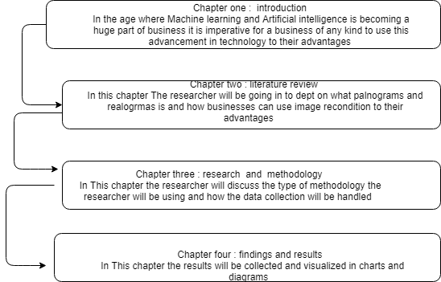

Figure 1.3.5.1 Chapter overview

## CONCLUSION

In conclusion automating the planogram and realogram manual comparing the two is unoptimized and cannot be maintained as the business grows and become larger and larger so the processes will and can start causing businesses a lot of money and that opens the market for a new way of doing this processes more efficient and better way this makes the potential Return on investment is enormous and this will be the main focus of the research how can we streamline this processes and held a huge profit for the business in terms of employees needing less time to compare planograms and realograms saving the tidiness of comparing this. The potential for client a client when this is implement will great The researcher will not only effect sales in the retail space but the proposed system can also effect human resources and marketing the reason why the researcher is stating this is because it can and will affect the employees mood because if you don’t have to do all the task s that takes time and that is not as repetitive.

The idea that this can help improve quality of life to the job place this may affect productivity in a positive way and that has a direct influence of the return on investment and that is the goal of this study to try and prove that if and when one should implement this idea and do The researcher well the results will be great in terms of the hole retail space because now the retailer that can stay ahead of market trends and keep their planograms update all in the fraction of the time that it will take their competitors to do the same thing this will be very good for the retailer but this will make the retail industry more different to automate and stream line their processes.

All these good things can have a good effect of retail businesses and generally the economy in conclusion the idea can have a good effect of the market but also bad in terms of small retail shops needing to step up their game and this may cause them money.

# LITERATURE STUDY

## INTRODUCTION

In the previous Chapter the Reacher briefly explained what a planogram, realogram is and how does image recognition fit into the picture. The goal of this chapter is to explain in detail why planograms and realogram is important to a business and why exactly a business would want to automate the process of comparing planograms and realogram via image recognition. As per the research question the idea of reach papier is to use image recognition to reduce time and then in turn save the company money.

The whole idea of this research is to prove in a real-world business-like retail that implementing Machine learning in our case image recognition to improve the quality of live for employees and stakeholders alike , but don’t misunderstand image recondition is not some magical thing that can be deployed and that can fix everything for this idea to be implemented the data and the historic data should be in such a way that one can train an image recondition algorithm and that the data is within a reasonable means of accuracy. This chapter will explain the three major pillars of the research:

image reignition, planogram and realogram key concepts part of this papier will explain these three concepts in detail and how they will be integrated into on system as well as how that will be accomplished and a few diagrams to show how the proposed system will work and how the stakeholders and actors will interact with the software.

## CONCEPTual framework

* + 1. **Image recognition**

Image recognition refers to the ability of a computer to see an image and understand the context of a image and this property of image recognition makes it perfect for the idea of “seeing” what is on the shelf. The algorithm that the research will be using is called the Invariant Moment algorithm. This algorithm was invented by mathematician who called it Algebraic Invariants and Algebraic Invariants came with German mathematician David Hilbert, this led to the introduction of the Invariant Moment and this introduction was made by Hu (Mohammad Arafah, 2016).As stated by Mohammad According to Hu, Invariant Moments can be used as features for image recognition. He introduced a set of 2D regular Invariant Moments which depends on Cartesian’s domain.

Hus Invariant Moments have usable properties of being Invariant within an image scaling (Mohammad Arafah, 2016). The previous stamen is exactly why the research is focusing on the Invariant Moment algorithm because of the scaling capability and the ability for one to adapt this algorithm to use 3D type image and can be scaled to handle big data for big retail type store and because of the flexibility of the algorithm even smaller retail type store can use this idea. The invariant moment algorithm is also called the hu moment algorithm. As we enter an age were artificial intelligence and Machine learning are become more readily available it is important to consider the impact on business and how it will effect day to day tasks for employees in terms of what they do and for how long they do specific tasks and how long that tasks will take if machine learning were to be implemented into the business day to day operations.

One of the biggest challenges data scientist face is that because machine learning is still very new getting users and business to accept that the outputs are correct so User acceptance will definitely a challenge one other big problem that might also halt full integration into a business is the fact that the data of business might not be in a such a way that you can use a Machine learning without spending a lot of time fix the data , to ensure the Machine learning algorithm can run and work as it is indented Machine learning is to a magical stick one can just feed it dirty data and expect the algorithm to run and give the correct results.

Business environment factors, such as rapid technological change and borderless marketing, force various businesses to face competition among their own field. Besides, being able to cope with changes, using right strategies help businesses survive and become successful. For instance, the ability to create positive image to promote the organization’s reputation that can lead to its own success in the near future the above statement made above was made by (Sunisa Dokmaipum, 2019) and this proves my statement of before. To gain a completive advantage is a must in the markets today it is imperative to stay ahead of the curve and the way to do this is to integrate ML into business

### Planogram

Planograms refer to a type of diagram to ensure that the shelf is plan and packet in an optimal way so that one can ensure that no brand is been put at n disadvantage and that all the brands/products is given an even chance. One might be inclined to ask well why it matters to the retailer selling the products that brands is give an even chance well it doesn’t but what does matter is customer satisfaction. If you can “force” then to look at other products they might have overlook in the past, then they might get a better deal on “unknown” brands and if one can give the customer the illusion of you caring for the customer that give you a advantage over other retailers. As stated by the researchers Kiran shehzadi, Muhammad ahmad-ur-rehman, Anam mehmood cheema, and Alishba ahkam (Kiran shehzadi, 2016) the lack of impulse control can result in spontaneous or unplanned buying and promote more impulsiveness. This lack of impulse control when comes to a certain point, chronic loss of impulse control accumulated that might develop into compulsive buying.

Why is impulsive behavior relevant to this papier? Well because that is what retailers tend research when setting up a planograms question like Why does certain product sell better that other as it is not the purpose of this study the researcher will not be going into detail in attempting to answer that question but Kiran shehzadi, Muhammad ahmad-ur-rehman, Anam mehmood cheema and Alishba ahkam does answer it in their research so the reason why the researcher is mentioning this study is because if this data is available that means one can automate the planogram part of the process as well by using the ML that reignition that automates the comparison just by expanding the capabilities of the ml to automatically generate the planogram as well. The algorithm can analyze market trends and then by using trend analysis the ML algorithm can predict how the shelf should be packed. Then the research of consumers impulse becomes one of the cornerstones of the algorithm.

Planograms have some clear advantages when applied correctly and as stated before it is only one component of three the other two being image recondition and the realogram. All these components must be done perfectly in order for this idea to work and all of these components needs to be understood in order for one the apply this idea and actually get a good return on investment making it feasible and worthwhile for business small and huge comparation alike

### REALOGRAM

This refers to the execution of the planogram the plan becoming a reality if you will. The plan needs to be as perfect as the execution for this idea to work one needs to be as meticulous for the consumers as well as the stores to have the best experience and ultimately greatest result on the planogram

The whole concept of planogram and realogram is that you plan and the execute it as close as possible to the plan. That being said this is not a perfect world and there is unknown variables and that means that there will always be some degree of difference between the planogram and realogram the goal of the image recognition and this papier is to explore the possibility a way of decreasing the time that is spend comparing the planogram and realogram and doing so effortlessly and then flagging the differences automatically and then form their one can do nice Business intelligent analysis

Realograms is the 3 leg of this idea for the time being the scanners (people how take pictures of the shelf) can still do this part manually and then at a later stage one can automate this part as well cutting labuor cost and having a greater return that you already have with just 2 parts automated

### Automation

The term automation is being used a lot in Computer science related subject matter in the case of this study we look at automation in the sense of where we can optimize a current process.

The reason why one would like to automate the compassion between planogram and realogram because it takes the most time and concentration and it is done manual and for this reason it makes perfect sense to automate the process because were humans are involved error of some sort will occur at some point in time so we automate the task that take time and effort by using machine learning Algorithms.

The current process is not optimized because they currently set up the planograms manually and then people go and take pictures of the shelfs and then set up a realogram and then a person sits and compare the product shelf for shelf product for product

### Algorithms

In this papier the researcher has elected the invariant moment algorithm because of the ability to have different moments of the same image these moments help the algorithm detect what image it is even thou the image is not in the perfect position. There is other algorithms to use for computer vision, Floyd–Steinberg dithering is one such algorithm the Floyd–Steinberg dithering algorithm is an example of an error diffusion algorithm this means that for every pixel an error is generated meaning the algorithm will take a 2 dimensional image and then run it through the algorithm, each pixel is compared to a threshold t:

 P < t → A

P > t → B

t can be equal (b-a/2) to attribute value, mean value or median etc., t can also be location depended. The researcher can go into detail on how this algorithm work but the effort is not worth it because the algorithm takes only 2 d image in to consideration but as previously discussed the real world is not perfect and the biggest problem with the algorithm is that it doesn’t take in to consideration that a packet might be backwards or skewed.

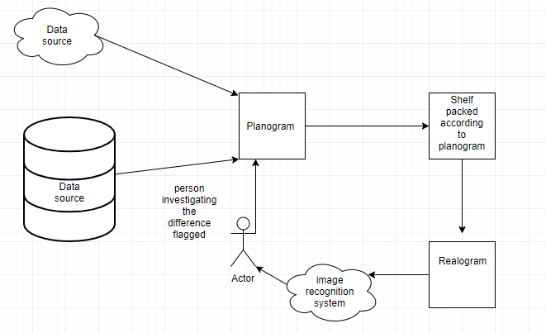

Figure 2.2.5.1 System flow

## Definition of Terms

Machine learning is an application of artificial intelligence (AI) that provides systems the ability to automatically learn and improve from experience without being explicitly programmed. **Machine learning focuses on the development of computer programs** that can access data and use it learn for themselves (Expert System Team, 2019)

A planogram is a diagram that shows how and where specific retail products should be placed on retail shelves or displays in order to increase customer purchases (Rouse, 2019)

A realogram is an exact virtual copy of a category as it currently is in a store before any optimization has taken place. A realogram is not a form of mystery shopping because store staff have knowledge of when realograms are being collected. Proper Realograms include POS data for the category and are analyzed in planogram software (DotActiv Team, 2016)

Return on Investment (ROI) is a performance measure used to evaluate the efficiency of an investment or compare the efficiency of several different investments. ROI tries to directly measure the amount of return on a particular investment, relative to the investment’s cost. (CHEN, 2019)

A retail sale occurs when a business sells a product or service to an individual consumer for his or her own use. The transaction itself can occur through several different sales channels, such as online, in a brick-and-mortar storefront, through direct sales, or direct mail. The aspect of the sale that qualifies it as a retail transaction is that the end user is the buyer. (shopify, 2019)

## CONCLUSION

In conclusion the best way to go forward to implement this idea in existing and new retail store is to use an image reignition by using the invariant moment algorithm to achieve the best result. The reasoning behind why the researcher chose this algorithm above the any other algorithm is because of the very nature of the algorithm caters for the nature of retail dynamic and fast past as well as a lot of data inconsistence and that will be a problem if the algorithm does not accommodate for it will have a very lower accuracy and that is counter intuitive to what the researcher would want to archive so the optimal algorithm for this idea to work excellent. The diagram below shows the flow of the system

# METHODOLOGY

## INTRODUCTION

The previous Chapter had a lot of research that was done by different researcher on a couple of subjects was discussed but the main focus was towards Image recognition and what type of algorithm will be used, planograms and finally realograms the three above statements was discussed in chaper2: Literature study

This chapter will aim to discuss the other types of methodology that will be used to capture the accurate information in order to promote the idea of an using an image recognition to automate the planogram and realogram comparison and at a later stage in time automate the actual set up of these planogram. The researcher will be using the previous chapters literature that was references as a base for most of the assumptions and most of the conclusions will be made mostly from the existing literature, Chapter 2 contains a lot of existing research as well as some of the researcher own research and the researcher own diagram of the proposed systems

## RESEARCH PHILOSOPHY

Objectivism integrates subjectivity and objectivity because it argues that objective knowledge requires active, sophisticated subjective processes—such as perception, analytical reasoning, synthetic reasoning, logical deduction, and the distinction of essences from appearances. Conversely, subjective processes can enhance objective comprehension of the world.

Objectivism was enunciated by DILTHEY in his articulation of the cultural sciences. The key procedure in the cultural sciences was a qualitative hermeneutic interpretation of life expressions. Hermeneutic interpretation requires that the researcher employ an active, sophisticated subjectivity to objectively comprehend subjective experience in life expressions (Ratner, 2002)

Realism research philosophy relies on the idea of independence of reality from the human mind. This philosophy assumes of a scientific approach to the development of knowledge. Realism can be divided into two groups: direct and critical. Direct realism, also known as naive realism, can be described as “what you see is what you get”. In other words, direct realism portrays the world through personal human senses. Critical realism, on the other hand, argues that humans do experience the sensations and images of the real world. According to critical realism, sensations and images of the real world can be deceptive and they usually do not portray the real world. (Dudovskiy, 2018)

This papier will use both an Objectivism and a Realism philosophy because of the nature of this research being more of research of how different ideas can be implemented to improve a current processes all the ideas have being research before but one have tried incorporating into one system , because of this nature of the research the researcher have established that the best philosophy will be Objectivism Realism

## RESEARCH APPROACH

The Research question in chapter 1 asked the very important questions, How will the automation of planograms and realograms effect Retail? Seeing as there are a lot of literature about machine learning specifically image recondition, realograms and planograms using that as n base to answer the research question, but the answer will use the literature as refence and support for the statements that the researcher will make.

However, the literature will not be the only prove that will be provided to support the statements even more there will be Quantitative Research the data will come for online survey that will be distributed then the data will be analyzed by using analytic software to provided visual representation of the data in the form of graphs these include pie charts histograms and bar graphs etc. to help strengthen the answer provided more hypnosis testing will be done it is a form of statistical analyses to help prove the answer no only theoretical but to show that the math’s works behind it.

Deductive reasoning works from the more general to the more specific. Sometimes this is informally called a "top-down" approach. We might begin with thinking up a theory about our topic of interest. We then narrow that down into more specific hypotheses that we can test. We narrow down even further when we collect observations to address the hypotheses. This ultimately leads us to be able to test the hypotheses with specific data -- a confirmation (or not) of our original theories. (socialresearchmethods, 2018)

#### Deductive Approach

Figure 2.2.5.1 deductive Approach

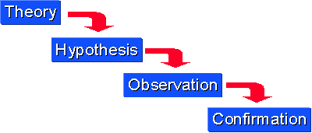

(socialresearchmethods, 2018)

Inductive reasoning begins with specific observations or real examples of events, trends, or social processes and progresses analytically to broader generalizations and theories based on those observed cases. This is sometimes called a “bottom up” approach because it starts with specific cases on the ground and works its way up to the abstract level of theory. With this method, once a researcher has identified patterns and trends amongst a set of data, he or she can then formulate some hypotheses to test, and finally develop some general conclusions or theories.

A classic example of inductive reasoning within sociology is the premise of Émile Durkheim's study of suicide. Considered one of the first works of social science research, the famous and widely taught book, Suicide, details how Durkheim created a sociological theory of suicide -- as opposed to a psychological one -- based on his scientific study of suicide rates among Catholics and Protestants. Durkheim found that suicide was more common among Protestants than Catholics, and he drew on his training in social theory to create some typologies of suicide and a general theory of how suicide rates fluctuate according to significant changes in social structure and norms.

However, while inductive reasoning is commonly used in scientific research, it is not always logically valid because it is not always accurate to assume that a general principle is correct based on a limited number of cases. Some critics have suggested that Durkheim's theory is not universally true because the trends he observed could possibly be explained by other phenomena particular to the region from which his data came. (Crossman, 2018)

#### Inductive Approach

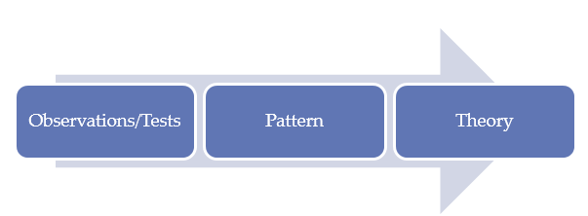

Figure 2.2.5.2 Inductive Approach

(Dudovskiy, 2018)

For the research approach the researcher will not exclusively be using deductive or inductive but rather a mix between the two

## RESEARCH STRATEGY

Survey research is the collection of data attained by asking individuals questions either in person, on paper, by phone or online. Conducting surveys is one form of primary research, which is the gathering data first-hand from its source. The information collected may also be accessed subsequently by other parties in secondary research.

Survey research is used to gather the opinions, beliefs and feelings of selected groups of individuals, often chosen for demographic sampling. These demographics include age, gender, ethnicity or income levels. The most famous public survey focused on demographics is the United States Census, which occurs every ten years (Rouse, n.d.).

By using Case study strategy, the researcher will analyze the existing literature. Case study empirical inquiry that investigates a phenomenon within its real-life context. Case studies are based on an in-depth investigation of a single individual, group or event to explore the causes of underlying principles. A case study is a descriptive and exploratory analysis of a person, group or event. A case study research can be single or multiple case studies, includes quantitative evidence, relies on multiple sources of evidence and benefits from the prior development of theoretical propositions. Case studies are analysis of persons, groups, events, decisions, periods, policies, institutions or other systems that are studied holistically by one or more methods. (PressAcademia, 2018)

This research the researcher will employee a 2 of the many data collections namely observation, interviews as well a. The reason why the researcher will be employee observation is because of the fact that he/she will physical go to a randomly chosen store to observe how the shelfs is packed this will be accomplished by using an observation guide to ensure that the research stays focus. The interviews and the surveys will be used to establish what the users and the effect parties will feel if this idea was ever implemented.

## RESEARCH METHOD(S)

The sample is the group of individuals who actually participate in your study. These are the individuals who you end up interviewing (e.g., in a qualitative study) or who actually complete your survey (e.g., in a quantitative study). People who could have been participants in your study but did not actually participate are not considered part of your sample. For example, say you e-mailed study invitations to 200 people on a listserv and 100 of them end up participating in your study (i.e., complete your survey or your experiment). Your sample is the 100 individuals who participated in your study.

The 100 individuals who received invitations but did not participate would not be considered part of your sample; rather, they are part of what is often called the sampling frame. Your sampling frame is the group of individuals who could possibly be in your study. On the other hand, your population is the broader group of people to whom you intend to generalize the results of your study. Your sample will always be a subset of your population. Your exact population will depend on the scope of your study. For instance, say your research question asks if there is an association between emotional intelligence and job satisfaction in nurses. In this case, your population might be nurses in the United States.

However, if the scope of your study is narrower (e.g., if your study deals with a local problem or a specific specialty/industry), then your population would be more specific, such as “nurses in the state of Florida” or “licensed practical nurses in the United States.” Importantly, your population should only include people to whom your results will apply. For example, if you do not have good reason to believe that your results will apply to all nurses in the United States, then your population will need to be more specific. If you are stuck on defining your population, think about how you would fill in the blank in the following sentence: “The results of my study will apply to _____.” Your answer will help determine how you define your population.

A general rule of the thumb is to always use the largest sample possible. The larger the sample the more representative it is going to be, smaller samples produce less accurate results because they are likely to be less representative of the population. The literature reviewed indicated that challenges exist even before contraceptive use can be initiated, and during the use of contraceptives. The structured interview tool was formulated to capture contraceptive challenges facing women before contraceptive use can be initiated, and those that are experienced during the use of contraceptives. The structured interview schedules (David, 2018).

For the purpose of this research the population will be kept at a Statically significant size of between 20 and 25 people the reason for the small size is that the survey will be more an option based one and very few facts will arise from the survey but there will still be a couple that will be required in answering the research Question.

The only reason why the researcher will employee the use surveys to gain an understanding how the normal non-technical person preserves the idea of using the idea discussed in this research. One might ask why is important to understand the users “feelings” the answer is simple it is only because people drive business ,Business strategy and Business change and it is important to gain a understanding of feeling inside a business setting of this idea to effectively answer the question will this Prove that the implementation of an image recondition algorithm will improve the effectiveness of process of comparing planograms and realograms? and is this is the goal of the research is to understand this effects of this question and then finally answer it

## DATA COLLECTION

Qualitative Research is mainly used is Exploratory research. It is used to understand the underlying reasons, opinions and motivations for doing the researcher in the first place. It provides a in dept investigation of the problem or helps to develop the hypotheses for a quantitative research. Qualitative Research is also used to uncover trends in thought and opinions, and dive deeper into the problem.

Quantitative Research is used to quantify the problem by way of generating numerical data or data that can be transformed into usable statistics. It is used to quantify attitudes, opinions, behaviors, and other defined variables – and generalize results from a larger sample population. Quantitative Research uses measurable data to formulate facts and uncover patterns in research. Quantitative data collection methods are much more structured than Qualitative data collection methods. Quantitative data collection methods include various forms of surveys – [online surveys](https://www.snapsurveys.com/online-surveys/), [paper surveys](https://www.snapsurveys.com/paper-surveys/), [mobile surveys and kiosk surveys](https://www.snapsurveys.com/mobile-surveys/), face-to-face online surveys , telephone online surveys , longitudinal studies, website interceptors, online polls, and systematic observations

As previously stated by the researcher the type of data collection tools that will be used is observation, interview as well as questioner. The researcher is going to conduct an unstructured interview and after that the researcher will be handing out the questioner to get even more data to analyze. Interviews a great way to get a deeper understanding of the human condition and attitude towards the idea. More the importantly the interview gives you a way to understand what the industry (retail and shelf planning space) understand the idea and if they grasp what the idea will mean for their day to day work life.

The disadvantage of an interview is that because it is a face to face interaction the person getting interviewed might feel the obligation to agree and may be scared to give his/her option. To counter this the researcher have decided to give questioners in the form of online surveys that can be complete separate from the interview. Online surveys is a great way to get the truth but disadvantage in the case of this study is that the research will not be able to get a understanding of the emotion and the attitude towards the research that is the reason why there will be a interview and an online survey.

Lastly the researcher will be conducting an observation in the office where planograms and realograms are set up as well as in the store to try and observe the what kind of strategy is followed when packing a shelf.

Observation, as the name implies, is a way of collecting data through observing. Observation data collection method is classified as a participatory study, because the researcher must immerse herself in the setting where her respondents are, while taking notes and/or recording. Observation as a data collection method can be structured or unstructured. In structured or systematic observation, data collection is conducted using specific variables and according to a pre-defined schedule. Unstructured observation, on the other hand, is conducted in an open and free manner in a sense that there would be no pre-determined variables or objectives. (Dudovskiy, 2018)

An interview is a conversation for gathering information. A research interview involves an interviewer, who coordinates the process of the conversation and asks questions, and an interviewee, who responds to those questions. Interviews can be conducted face-to-face or over the telephone. The internet is also emerging as a tool for interviewing (M. Easwaramoorthy & Fataneh Zarinpoush, 2006)

Helping to guide the researcher in the interview an interview guide has been set up and is as follow:

Question 1: What do you do in terms of planogram and realogram compression?

Questions 2: How long does it take to compare a planogram and a realogram?

Question 3: Are you a consultant or do work for insert company name here?

Question 3: How do you usually set up a planogram?

After the interview the survey has been set up and is as follow:

Questions 1: What is your Job title?

Questions 2: How do you use the Realogram? Before: to analyze store layouts, Market Share,

Stock availability get Product images & Sizes.

Question 3: Do you know what Image Recognition?

Question 4: Is the current Processes of manually comparing Realograms and Planograms to

be ineffective?

Question 5: Will Image Recognition be able to assist Marketing teams to do the Realogram,

Planogram comparisons faster and more effectively?

Question 6: Will an Image Recognition Algorithm help you to be more effective in you day to

day activates?

Question 7: Please give a short description of why and a approximate number of hours per day you

will save?

Question 8: Please give a short description of why and a approximate number of hours per day you

will save?

Question 9: why you think that it will not improve the time it takes to compare Realograms

and Planograms?

Question 10: Are you afraid of losing your job IF this idea is implemented?

Question 11: Please describe why you think you will lose your job?

The observation guide is as follow:



Figure 2.2.5.1 Observation guide

The researcher will use this guide to physically go into the store and take down the prices of the same product but different brands by dividing the shelf up into grid like the above picture the researcher will be able to see the tendency of the pack the shelf comparted to the planogram which the research will data mine form the interview

### Population and Sampling

The sample is the group of individuals who actually participate in your study. These are the individuals who you end up interviewing (e.g., in a qualitative study) or who completed your survey (e.g., in a quantitative study). People who could have been participants in your study but did not actually participate are not considered part of your sample. For example, say you e-mailed study invitations to 200 people on a listserv and 100 of them end up participating in your study (i.e., complete your survey or your experiment). Your sample is the 100 individuals who participated in your study.

The 100 individuals who received invitations but did not participate would not be considered part of your sample; rather, they are part of what is often called the sampling frame. Your sampling frame is the group of individuals who could possibly be in your study. On the other hand, your population is the broader group of people to whom you intend to generalize the results of your study. Your sample will always be a subset of your population. Your exact population will depend on the scope of your study. For instance, say your research question asks if there is an association between emotional intelligence and job satisfaction in nurses. In this case, your population might be nurses in the United States.

However, if the scope of your study is narrower (e.g., if your study deals with a local problem or a specific specialty/industry), then your population would be more specific, such as “nurses in the state of Florida” or “licensed practical nurses in the United States.” Importantly, your population should only include people to whom your results will apply. For example, if you do not have good reason to believe that your results will apply to all nurses in the United States, then your population will need to be more specific. If you are stuck on defining your population, think about how you would fill in the blank in the following sentence: “The results of my study will apply to _____.” Your answer will help determine how you define your population.

A general rule of the thumb is to always use the largest sample possible. The larger the sample the more representative it is going to be, smaller samples produce less accurate results because they are likely to be less representative of the population. The literature reviewed indicated that challenges exist even before contraceptive use can be initiated, and during the use of contraceptives. The structured interview tool was formulated to capture contraceptive challenges facing women before contraceptive use can be initiated, and those that are experienced during the use of contraceptives. The structured interview schedules (David, 2018).

For the purpose of this research the population will be kept at a Statically significant size of between 20 and 25 people the reason for the small size is that the survey will be more an option based one and very few facts will arise from the survey but there will still be a couple that will be required in answering the research Question.

The only reason why the researcher will employee the use surveys to gain an understanding how the normal non-technical person preserves the idea of using the idea discussed in this research. One might ask why is important to understand the users “feelings” the answer is simple it is only because people drive business ,Business strategy and Business change and it is important to gain a understanding of feeling inside a business setting of this idea to effectively answer the question will this Prove that the implementation of an image recondition algorithm will improve the effectiveness of process of comparing planograms and realograms? and is this is the goal of the research is to understand this effects of this question and then finally answer it

### Research Instruments

This research the researcher will employee a 2 of the many data collections namely observation, interviews as well a. The reason why the researcher will be employee observation is because of the fact that he/she will physical go to a randomly chosen store to observe how the shelfs is packed this will be accomplished by using an observation guide to ensure that the research stays focus. The interviews and the surveys will be used to establish what the users and the effect parties will feel if this idea was ever implemented.

Online surveys, whose aim is to identify opinions regarding a particular research subject, and direct contact between interviewers and interviewees, as What is more, unstructured online surveys offer flexibility in terms of the flow of the interview, thereby leaving room for the generation of conclusions that were not initially meant to be derived regarding a research subject.

Qualitative Research is mainly used is Exploratory research. It is used to understand the underlying reasons, opinions and motivations for doing the researcher in the first place. It provides a in dept investigation of the problem or helps to develop the hypotheses for a quantitative research. Qualitative Research is also used to uncover trends in thought and opinions, and dive deeper into the problem. (DeFranzo, 2011)

Quantitative Research is used to quantify the problem by way of generating numerical data or data that can be transformed into usable statistics. It is used to quantify attitudes, opinions, behaviors, and other defined variables – and generalize results from a larger sample population. Quantitative Research uses measurable data to formulate facts and uncover patterns in research. Quantitative data collection methods are much more structured than Qualitative data collection methods. Quantitative data collection methods include various forms of surveys – [online surveys](https://www.snapsurveys.com/online-surveys/), [paper surveys](https://www.snapsurveys.com/paper-surveys/), [mobile surveys and kiosk surveys](https://www.snapsurveys.com/mobile-surveys/), face-to-face online surveys , telephone online surveys , longitudinal studies, website interceptors, online polls, and systematic observations (Surendran, 2019)

Qualitative research may include multiple methods such as, case studies, ethnography and participant observation, grounded theory, biographical and participative inquiries (Strauss/Corbin 1994). Within the field of qualitative IB research, the case study methodology is the most prevalent method. Similarly, there are a range of specific methods for collecting empirical material, such as interviewing, observational techniques, semiotic analysis etc. The analysis of text-based in-depth online surveys is the most widely employed methodology for firm-level IB research, as published material in major journals such as, Journal of International Business Studies (JIBS), Management International Review (MIR), Journal of World Business (JWB) and International Business Review (IBR) reveal (Ghauri, 2008)

The results from the selected dissertations of students from the School of Education of the University of Dar es Salaam–showed that most of them who opted to use the qualitative inquiry approach used quantitative trustworthiness criteria to ensure the integrity of their research findings. The findings indicated that of 245dissertations that employed the qualitative methodology, 238 used the quantitative trustworthiness criteria of validity and reliability to ensure the credibility of the research instruments and the authenticity their findings, while only 7 dissertations used the qualitative criteria. Likewise, dissertations from the Open University of Tanzania revealed similar results as 64 dissertations used the quantitative criteria to ensure the authenticity of the instruments and findings, while only 14 dissertations used the correct qualitative criteria of dependability, confirmability, credibility and transferability. The extracts from students’ dissertations are presented in Tables 2 and 3 from Faculty/School of the University of Dares Salaam and Open University of Tanzania. The researcher did not present all the extracts from the dissertations because the data had reached saturation point since all the students had used similar strategies in their dissertations. (Anney, 2014)

To maintain the integrity of the research the proper interview etiquette and survey etiquette will be followed. The names of all participants will be kept confidential to ensure privacy by doing this we can ensure a more honest answer form the participants to increase the trustworthiness tremendously. This research will be kept as objectively as possible to ensure that the reader gets the best possible reading experience. The researcher will only be analyzing the data available at the time this papier is written and make conclusions on that data and base on that the research question will be answered.

## DATA ANALYSIS

A large set of data sitting in a spreadsheet does not help us to understand the characteristics of the population we are working with or describe the changes brought about by our projects. We need to use the data to create information. In our case study example, we may have interviewed children working on the street in Karachi and collected all the data together in a spreadsheet; however, we need to analyses and summaries the data to answer our research questions. We need to understand what percentage of children are involved in different work types. For instance, we may want to understand if girls and boys carry out similar tasks or are exposed to similar risks. Statistics help us turn quantitative data into useful information to help with decision-making.

We can use statistics to summaries our data, describing patterns, relationships and connections. Statistics can be descriptive or inferential. Descriptive statistics help us to summaries our data whereas inferential statistics are used to identify statistically significant differences between groups of data (such as intervention and control groups in a randomized control study). During this module our focus will be on descriptive rather than inferential statistics: this will also help to give a short introduction to the most common descriptive statistics. (The open University, 2010)

The data that will be analyzed will be the data from the surveys, interview and observations and seeing as the case studies will come from trusted sources so the information does not be refined to draw a conclusion. The survey data will be refined by using hypothesis testing algorithm and all the correlating statistical algorithms to refine the data so that it is less technical and more readable and understandable. The existing literature on the subject will sourced and use as a prove that the concept is not far-fetched and that it is not only theoretical possible but also practically doable and more immortally it is implementable.

The Mathematical proofs that will be used include propositional logic, petri nets and combinatorics and graph theory. Propositional logic will help express the simple facts of the research in an attempt to make it less technical for the less technical reader. Petri nets this notation is suitable for explaining the dynamic aspects for the system to give the more technical user a better understanding of what this research as found on the subject of image recognition, planograms and realograms how it can be integrated into one system.

Combinatorics and graph theory this type of Mathematical proof is a branch that deals with the arrangement or ordering of discrete entities it will attempt to answer given entities that are arranged according to a specific pattern what are the characteristics of such arrangements this is a more visual strategy. This type of proof is of much interested in the information technology because it can describe various entities and their attributes and property’s.

Lastly a very preliminary ROI will be calculated to help prove the point even further. The researcher will use available data on pay and from the surveys the time a person will spend on doing planogram and realogram comparisons and based on that data one can estimate the ROI and keep in mind it is just a estimate the real value might be much higher or lower depending on the scenario were in the ROI is measured

## TRUSTWORTHINESS

Qualitative research may include multiple methods such as, case studies, ethnography and participant observation, grounded theory, biographical and participative inquiries (Strauss/Corbin 1994). Within the field of qualitative IB research, the case study methodology is the most prevalent method. Similarly, there are a range of specific methods for collecting empirical material, such as interviewing, observational techniques, semiotic analysis etc. The analysis of text-based in-depth online surveys is the most widely employed methodology for firm-level IB research, as published material in major journals such as, Journal of International Business Studies (JIBS), Management International Review (MIR), Journal of World Business (JWB) and International Business Review (IBR) reveal (Ghauri, 2008)

The results from the selected dissertations of students from the School of Education of the University of Dar es Salaam–showed that most of them who opted to use the qualitative inquiry approach used quantitative trustworthiness criteria to ensure the integrity of their research findings. The findings indicated that of 245dissertations that employed the qualitative methodology, 238 used the quantitative trustworthiness criteria of validity and reliability to ensure the credibility of the research instruments and the authenticity their findings, while only 7 dissertations used the qualitative criteria. Likewise, dissertations from the Open University of Tanzania revealed similar results as 64 dissertations used the quantitative criteria to ensure the authenticity of the instruments and findings, while only 14 dissertations used the correct qualitative criteria of dependability, confirmability, credibility and transferability. The extracts from students’ dissertations are presented in Tables 2 and 3 from Faculty/School of the University of Dares Salaam and Open University of Tanzania. The researcher did not present all the extracts from the dissertations because the data had reached saturation point since all the students had used similar strategies in their dissertations. (Anney, 2014)

To maintain the integrity of the research the proper interview etiquette and survey etiquette will be followed. The names of all participants will be kept confidential to ensure privacy by doing this we can ensure a more honest answer form the participants to increase the trustworthiness tremendously. This research will be kept as objectively as possible to ensure that the reader gets the best possible reading experience. The researcher will only be analyzing the data available at the time this papier is written and make conclusions on that data and base on that the research question will be answered.

## CONCLUSION

In conclusion the researcher will take an object view at the results based on various methods of collection to try establishing patterns in order to analyzed the data to gain some insight in to the research and this will help answer the question and prove the hypothesis and help the reader to gain a deeper understanding of image recognition and how it can be integrated into a processes and how it can automate and stream line a processes to the extent where it starts saving a business a lot of money be it corporate or small family owned the goal of this papier is to establish were does machine learning fit in to business and where the tech is in terms of development and where people think it is and where they think machine learning fits in in terms of “replacing” the manual processes. In the next chapter the data gather will presented in graphs and the researcher will code a very preliminary example of what he is purposing the image recognition will be coded in the python programing langue

# RESULTS

## INTRODUCTION

The previous chapter focused on how the research will be done were as this chapter will focus on what the researcher found in conducting the interview, observations as well as the online questioner. This chapter will be representing the data in graphs and some of the induvial that the Reacher interviewed will be quoted, however to keep the research objective and ethical no names or titles will be mentioned in the represented of the data the data will be represented in anonymous fashion. There will also be an attached prove of concept code of how the image recondition will work keep in mind that the attached code is a very preliminary example of how the proposed algorithm work this algorithm is the Hu monuments or invariant algorithm as previously mentioned.

## RESULTS AND INTERPRETATION

As mentioned in chapter 3 surveys, interviews and observations the surveys and the interviews were used to in a expletory fashion to gain a deeper understanding on the option and attuite towards machine learning and how the non-technical person preserve the concept of using a machine learning algorithm to automate a big part of their jobs as one of the survey takers sated “There is a large amount of data available on the software. An image recognition algorithm makes life easier because it can detect duplicates for example and match the right image to the right bar code making life easier for the space planner. This saves a significant amount of time. Depending on the size of the planogram it would determine how many hours an algorithm would save. Approximately 4-5 hours.” This statement gives the researcher a good idea that if the research would materialize and the idea explored in this papier were to be implemented it would be for the most part accepted and used. Few survey takers are worried that if such a system were to be implemented, they would lose their jobs “Automation is taking over all the industries it is just a matter of time before computers take over retail and replace all the repetitive work”. The next part of this chapter the as part the data analysis part the researcher will discuss the statically findings of the interviews and the surveys and observations.

**4.3.1 What is image Recognition**

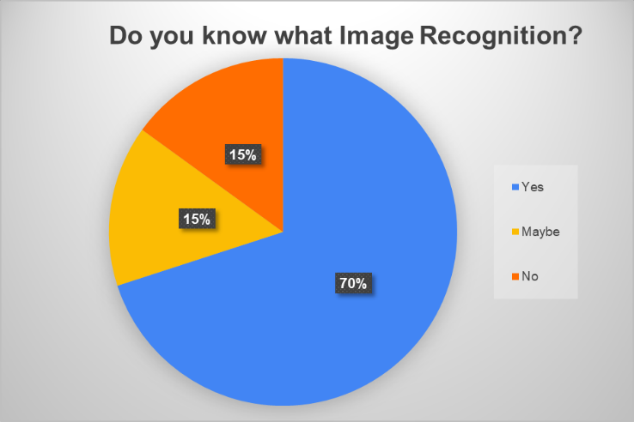

Figure 3.6.2.1 What is image Recognition

The data above was obtained from the surveys and the title of the graph is the question that was asked this shows that the bigger part of the population that answered that they know what image recognition and this is important, because seeing as the surveys theme is about image recondition it is important to have context so that you can answer the survey more objectively.

### Current processes

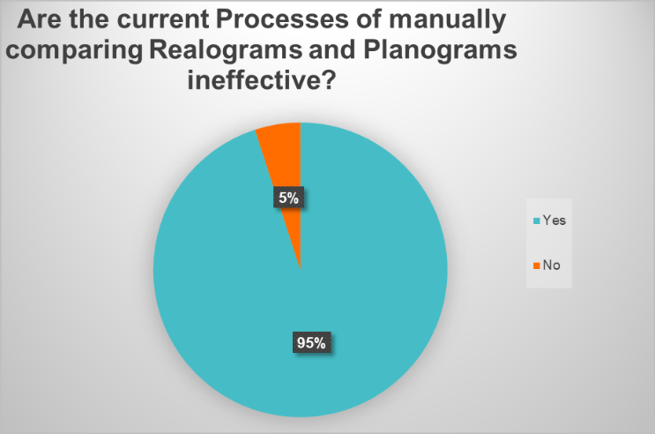

### Figure . Current processes

The above data is very interesting to the researcher because of two reasons, because it tells the researcher if the idea was to be commercialized that it would not take much convincing to help them understand that it is a necessity and not a nice to have in other words it tells the researcher that the market is ready for automatization in this space and that it will be accepted for the most part well 95% of the population will accept the idea the other 5% might have failed to understand what the question meant or they are afraid and biased towards technology. The next thing that this graph shows the researcher is that the people working in the industry of planograms and realograms realize that the process is not optimal and that it can be made more optimal.

### will image Recognition make a difference?

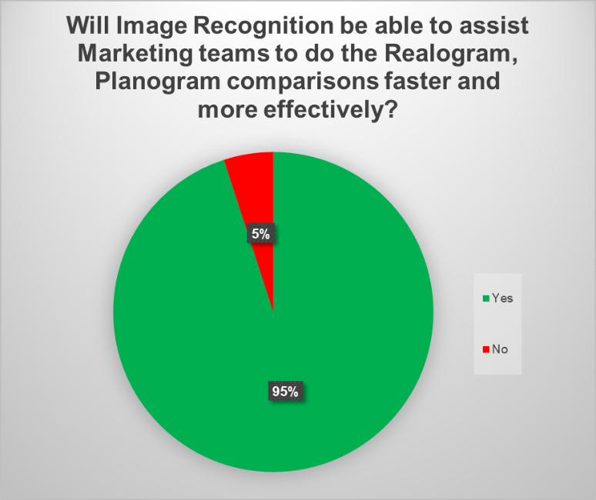

### Figure . will image Recognition make a difference?

The graph above shows as that the suspicions the researcher had if the above paragraph was true and that if it were to be implemented the market is ready for the advancement in machine learning.

### Are you afraid of losing your job?

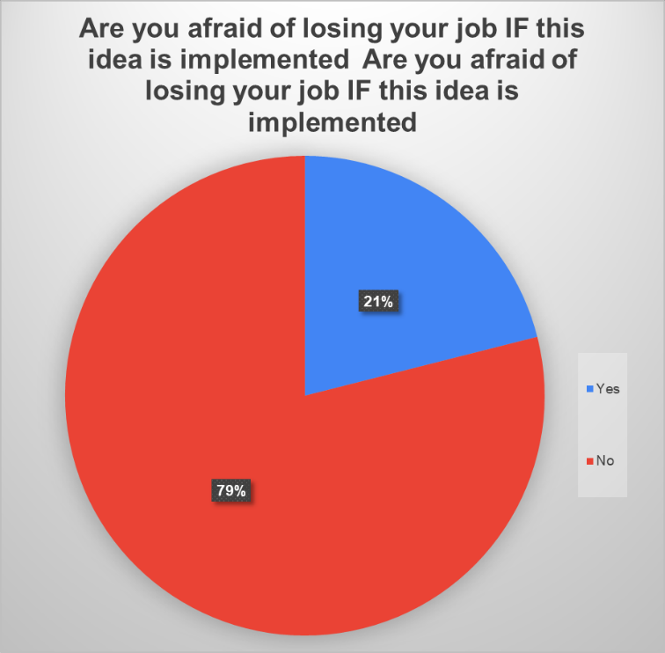

### Figure . Are you afraid of losing your job?

The graph resented above show that there was some bias or fear towards the fact the automation might take some jobs in this case the survey takers jobs reasons begin “It will take over most people's jobs because everything will be automated”, or “Automation is taking over all the industries it is just a matter of time before computers take over retail and replace all the repetitive work” and even reasons like “Because computers never get sick or tired they are always productive”.

### What is your job description?

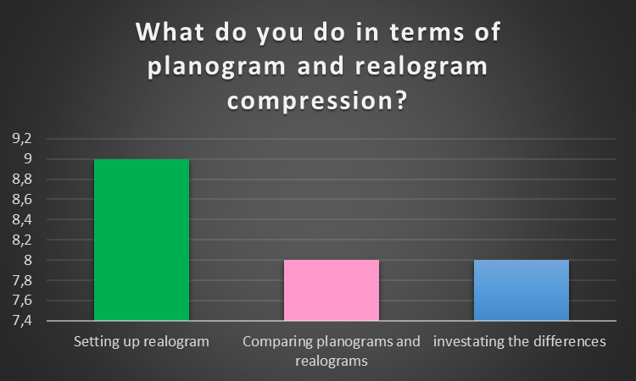

### Figure . What is your job description?

The graph represented here comes from the interview data gathered and it shows, how the population interacts with planograms and realograms and what they contribute towards the processes.

### Normal distribution of hours worked

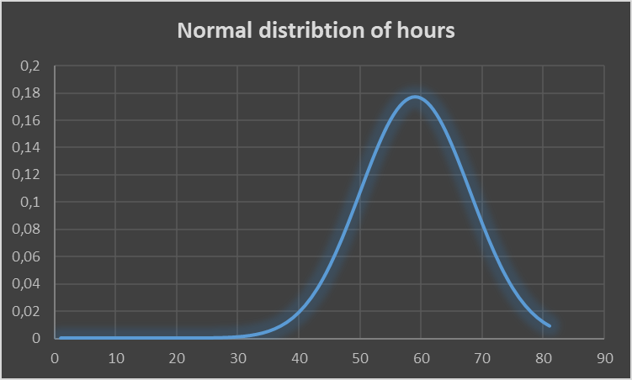

### Figure . Normal distribution of hours worked

This graph also obtained from the interview shows something very interesting it shows that the hours spent does not follow a normal distribution it is skewed towards the right which shows us that the average hours spend does not cluster around the average and that it is not good, because ideally you want the curve to be symmetric and that the average hours should be normally distributed.

### Are you a consultant?

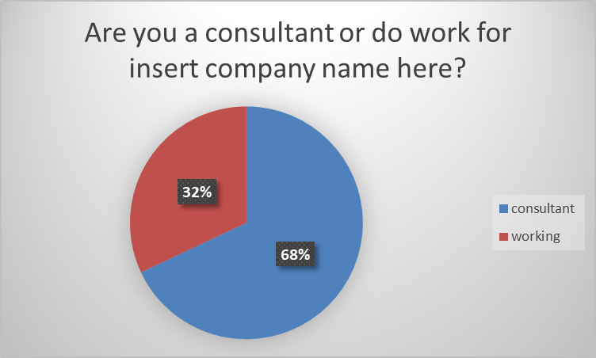

Figure 4.2.11.1 Are you a consultant?

The graph above gives us a very interesting perspective, on how the industry is currently operating because it shows us that the majority of the population is consultants and that tells the researcher that the expected money spend by businesses is even more than initially expected. The processes is already so inefficient that alone is costing business a lot of money added the fact that most of the people in this space is consulting it is adding to the cost fact. What this research is showing is that the there is a lot of room to streamline the process and make it much more affordable for a business to invest in automating the process.

From the above graphs some interesting facts can be derived for example a preliminary ROI shows that if a space planner were to be paid per hour that would cost a company R 389 965 per year according to (Indeed, 2019) so for the purpose of this ROI calculation this is what will be used. Assuming the company that will implement this algorithm already have hardware/servers to train and deploy the algorithm as well as that the algorithm would take a year to design, train, and test this is what the ROI will be if a Data scientist earns R 588 814 per year according to (Indeed, 2019).Then 588 814 – 389 965 = -194 849 meaning that in 1 year after the algorithm is running it will not make up the investment yet a year and one month will equal -162 352 year and 2 months -129 855 , year and three months -97 358 , a year and 4 months -64 861 , year and 5 months -32 364 and then a year and 6 months 133 this all means that the time till ROI is made up will be a year and 6 months also keep in mind this is only assuming that one space planer is doing the work and one data scientist is writing/implanting the algorithm.

From the interview and questionnaire one can gather that the processes takes a lot of time and it and it is ineffective and one can also see that the people working in this space also think that automating the processes can save them a lot of time and that tells the researcher that there is a need to automate.

Form observations made over a few months the researcher correlated it with market trends and saw that shelfs was not packed optimally because in the ideal world you would want you in-house brands to be packed on eye level and the more other brands to be packed higher so that the buyer may be enticed to rather buy the in-house product instead of the other brands. Same logic applies for the more expensive ones as a business you would like to sell more of the expensive brands/products this is what was said to the researcher in the interview. But the observation did not confirm it meaning that there is a clear difference between what is planned and what is really happing.

The fact that the majority of the population who works in the space planning industry and knows what image recognition is tells the researcher that that the industry is aware of what it is and that there is not a big misconception on what is. This is very important because if the industry knows what it is then they understand how it can help them and how it can automate their day to day activities to such a extend that they would streamline the processes and help them accomplish their task easier and more effective. This is also backed by the fact that the majority of people are not afraid to of losing their jobs as show by the graph above is also promising to the researcher because it tells the story of people needing help and is willing to accept the idea and understanding that the whole idea of this research is to streamline a process not replace the people how does the work but rather assist them. At least that is the idea for this research future research might automate it to such a extend that it will replace the whole human side.

## CONCLUSION

In conclusion If this research were to be implemented and done whit in a year a business can save a very large amount of money in the long run and as the research shows the industry in terms of the people what the researcher means by this is that the people working in the industry is already aware that the processes is not efficient and that there is a possibility that it can be optimized

The research question posted in the first chapter can finally answered and can be objectively answered and can give a very complete way as well. The question How will the automation of planograms and realograms effect Retail? Well there is very good answer on this and the simple answer is that it will effect the retail space positively very positively because as seen in the above ROI and charts one can see that form a business perspective it can save a lot of money and from the human side it is not like the people in the industry is against the idea in fact the majority is in favour for the automation to happened and that is very good because if one was to commercialize the idea the industry would not fail to accept the software.

The research hypnotises, The Return on investment will be high as well the user acceptance will be high because it will replace the tides parts of the people comparing the planograms and realograms jobs. This hypnotises can now be accepted by the researcher and can be proven by the research already done above and this hypnotises can be even accepted more in terms of the ROI Is so good that it makes sense for a business to employee this research to automate it on their and they can justify this research for the investment.

# FINDINGS AND CONCLUSIONS

## INTRODUCTION

The age of Machine learning is upon us and every day new advances are made on a daily basis in machine learning and we are getting closer to general Artificial intelligence. Discussed in the previous chapter the researcher discussed the overall attitude towards machine learning and its integration into the life of a space planer in this chapter the researcher will discuss the overall findings in terms of what chapter 2 and 4 said and what is the overall findings of the research and why it is important , as well as what this research will contribute in the future and what the research contributed now.

The research question was answered in the previous chapter the goal of this chapter will not be to re-answer the question rather to expand on the answer so that one can form a more complete idea of what the findings is and to give the reader as well as potential researchers looking to expand on this research.

## FINDINGS

According to the research a few interesting facts was revealed namely that the industry is metal ready for automation in the planogram and realogram space. This statement is proven by the graphs in the previous chapter. The literature in Chapter 2 shows as that the idea is not farfetched and it is not just theoretical it is possible to implement this solution and deploy it in a cooperate setting and yes data wise the company might not be ready but the ability to implement the idea in a perfect world. The data collected as well as the literature looks very promising in terms of User acceptance and if it is possible to implement.

From a business case perspective, it is also makes a lot of sense to implement it because of the ROI done in the previous chapter The ROI is very good and within a 3 years a business can start making a huge profit just based on the man hours one would save as shown by the graph in chapter 4 meaning there is an incentive as well for the business to implement the solution this is good because at the end of the day that is the only thing a business cares about and this thesis proves that by automating that part of the processes a business can save money. The question has also been answered in detail in the previous chapter by the research the short answer is that yes it can save business a lot of money and yes, it is practically feasible to implement as solution as suggested in this research.

The research has also revealed that there is clear need for optimization and that most of the people working in the planogram space can benefit immensely for such an algorithm and implementation

## SHORTCOMINGS AND LIMITATIONS

This study was conducted by analyzing existing literature and then analyzing the findings of the observation as well as the interviews and surveys so that the research can first establish if it will be possible to implement the idea practical enough to be implement in the real world. There is a couple of limitation when looking at the research namely the surveys was manly filled in by people working as space planers so there is a big possibility that there could have been a bias towards the question when answered so most of the question was ask objectively but that cannot be said towards the answer , the same applies for the interviews.

The observations were done in 2 stores in the researcher’s local area and that means that the observation made in those stores might not apply to all retail stores worldwide. The limitation of this research was that the researcher did not speak to COE or C level executive’s because ultimately, they are the decision makers in any business.

## BENEFITS TO THE FIELD OF STUDY

This research has contributed a lot towards how the current proses of compering planograms and realograms is view , the research has proven that there is much better and optimized way to do it and this is proven by the data collected via the interviews , surveys and observation as well as the literature that was used in this papier and all of this benefit the retail industry in a positive light because it can save companies in the retail space so there is a big money component to it as well and at the end of the day that is what will incentivize big cooperate and small business to implement this idea.

## PROPOSED NEW RESEARCH/RECOMMENDATIONS

The researcher Propose that any future research that needs to be done needs to focus more on how to automate the rest of the process for example how do you automate the set up planogram automatically and how do automate and integrate the systems in such a way that you can effectively remove the human part ? Some research can be done on how to optimize the algorithm that the researcher has chosen namely the Hu moments image recognition algorithm and how effective is it in a real-world example and does the algorithm in the real world as effective as this papier suggest.

If future research will be based on this papier one might consider doing some research based on the socioeconomical and sociopolitical impact that such an integration and automation might have in the retail and space planning industry.

## CONCLUSION

In conclusion the research looked at how can planogram and Realograms or in more broad terms the space plaining industry can be automated via an image recognition algorithm namely the hu moments algorithm can be used to automate the bigger part of the manual processes, comparing planograms and Realograms.

The research has proven very useful in uncovering a few interesting facts and one of the facts begin that the automation is very urgently needed in this field and even more than the researcher initially thought. The Roi is off the charts the amount of money a company can save is so great that if a company would be able to implement it, it can make a serious difference in business bottom line and help then to achieve a more elegant and effective processes and way to do business.

These days the word ML and Ai is such a buss word in all industry that one might read this and think that that it is just a theoretical concept but that is not true in the appendix a prove of concept attached to prove that it is a practically implementable and that one can do it easily. This is important because this research can make a real difference how a planogram and Realograms is compared and later even change the way it is set up; this could potentially revolutionize the industry.The research question has thus been answered, It will affect the retail in a positive way optimizing the current process is a big way and with this the hypostasis can now be accepted and can be proven.

# References

Anney, V. N., 2014. Ensuring the Quality of the Findings of Qualitative Research:. *Journal of Emerging Trends in Educational Research and Policy Studies ,* pp. 272-281.

Anon., 2015. *Automation Quotes.* [Online]   
Available at: https://www.azquotes.com/quotes/topics/automation.html  
[Accessed 04 03 2019].

CHEN, J., 2019. *Return on Investment (ROI).* [Online]   
Available at: https://www.investopedia.com/terms/r/returnoninvestment.asp

Crossman, A., 2018. *Deductive vs Inductive Reasoning - What's the Difference?.* [Online]   
Available at: https://www.thoughtco.com/deductive-vs-inductive-reasoning-3026549

David, 2018. *What is the Difference Between Population and Sample?.* [Online]   
Available at: http://www.statisticssolutions.com/what-is-the-difference-between-population-and-sample/

DeFranzo, S. E., 2011. *Snap Surveys - Home.* [Online]   
Available at: https://www.snapsurveys.com/blog/qualitative-vs-quantitative-research/  
[Accessed 20 08 2019].

DotActiv Team, 2016. *The Differences Between Realograms, Plano Guides And Planograms.* [Online]   
Available at: https://www.dotactiv.com/blog/realograms-plano-guides-planograms

Dudovskiy, J., 2018. *Inductive Approach (Inductive Reasoning).* [Online]   
Available at: https://research-methodology.net/research-methodology/research-approach/inductive-approach-2/  
[Accessed 09 07 2019].

Dudovskiy, J., 2018. Research Methodology. In: *The Ultimate Guide to Writing a Dissertation in Business Studies: A Step-by-Step Assistance.* online: https://research-methodology.net/, p. 50.

Expert System Team, 2019. *What is Machine Learning? A definition.* [Online]   
Available at: https://www.expertsystem.com/machine-learning-definition/

Ghauri, R. R. S. ·. E. P. ·. P. N., 2008. *Enhancing the Trustworthiness of Qualitative,* s.l.: MIR.

Indeed, 2019. *Planner Salaries in South Africa.* [Online]   
Available at: https://www.indeed.co.za/salaries/Planner-Salaries  
[Accessed 25 09 2019].

Kiran shehzadi, M. a.-u.-r. A. m. c. a. A. a., 2016. Impact of Personality Traits on Compulsive Buying Behavior: Mediating Role of Impulsive Buying. *Journal of Service Science and Management,* pp. 1-17.

M. Easwaramoorthy & Fataneh Zarinpoush, I. C., 2006. *INTERVIEWING FOR RESEARCH,* Toronto: Imagine Canada.

Mohammad Arafah, Q. A. M., 2016. Efficient Image Recognition Technique Using Invariant Moments and Principle Component Analysis. *Data Analysis and Information Processing.*

PressAcademia, 2018. *Definition of Case Study.* [Online]   
Available at: https://www.pressacademia.org/definition-of-case-study/  
[Accessed 19 08 2019].

Ratner, C., 2002. Subjectivity and Objectivity in Qualitative Methodology. *Ratner,* 3(3), pp. 8-10.

Rouse, M., 2019. *planogram.* [Online]   
Available at: https://whatis.techtarget.com/definition/planogram

Rouse, M., n.d. *survey research.* [Online]   
Available at: https://whatis.techtarget.com/definition/survey-research  
[Accessed 11 07 2019].

shopify, 2019. *Retail.* [Online]   
Available at: https://www.shopify.co.za/encyclopedia/retail

socialresearchmethods, 2018. *Deduction and Induction.* [Online]   
Available at: https://socialresearchmethods.net/kb/dedind.php  
[Accessed 09 07 2019].

Sunisa Dokmaipum, N. K. R. P., 2019. Corporate Image Management of Retail Business (Downstream). *Open Journal of Business and Management,* p. 16.

Surendran, A., 2019. *Market Research.* [Online]   
Available at: https://www.questionpro.com/blog/quantitative-research/  
[Accessed 20 08 2019].

The open University, 2010. 6 Methods of data collection and analysis. *Monitoring, Evaluation,Accountability and Learning (MEAL),* pp. 2-30.

# APPENDIX A: DATA COLLECTION INSTRUMENTS

<https://docs.google.com/forms/d/e/1FAIpQLScQu7fyMe8wqIMhdc5GhxkZW7ab4YPUxxgEIC-P37VoKYm1vw/viewform>

[Data collection\Image recognition to Automate Comparing Planogram to Realogram (Responses).xlsx](Data%20collection/Image%20recognition%20to%20Automate%20Comparing%20Planogram%20to%20Realogram%20(Responses).xlsx)

[Data collection\interview data.xlsx](Data%20collection/interview%20data.xlsx)

[Data collection\OBSERVATION GUIDE.PNG](Data%20collection/OBSERVATION%20GUIDE.PNG)

[Data collection\ROI FOr Thesis.xlsx](Data%20collection/ROI%20FOr%20Thesis.xlsx)

[Data collection\Image-Moments-in-Python-master\opencv.py](Data%20collection/Image-Moments-in-Python-master/opencv.py)