HOME CREDIT DEFAULT RISK

Data Analytics Project
Technical Report
Dataset details • preprocessing • EDA • feature engineering • model training • web application • deployment

SOURCE-OF-TRUTH RULE: Notebook pipeline steps, feature counts, metrics, and analytical claims are taken from mainul.ipynb and mainul_2nd.ipynb. The web application extension is taken from the implemented CreditScope source code, README, data assets, and tests. Any notebook inconsistency or deployment boundary is stated explicitly.

Prepared from the captured notebook state and the implemented CreditScope repository. Notebook cell references use 0-based cell order; application sections describe the current source code and tested local runtime.

Contents
1. Project data inventory and data roles
2. Raw application dataset and target
3. Multi-table feature engineering and the exact +40 columns
4. Exploratory data analysis and evidence-backed claims
5. Cleaning, missing values, duplicates, and outliers
6. Categorical encoding and numeric-model preprocessing
7. Feature reduction, standardization, and the two modeling representations
8. Model training and validation results
9. Feature and model summaries
10. Final Kaggle submission
11. Notebook audit: exact implementation caveats
12. Reproducible visualization code
Appendix A. Exact final feature lists
13. Productization from notebook to application
14. CreditScope architecture and execution flow
15. Website pages and user functions
16. Prediction, batch scoring, and model deployment
17. API and implementation function reference
18. Security, testing, and deployment boundaries
19. Installation, operation, and maintenance
Appendix B. Project files and runtime responsibilities

1. Project data inventory and data roles
The project starts by inventorying all supplied Home Credit CSV files. The notebook reads row and column counts directly from each file header and line count (mainul.ipynb cells 1–2).
CSV | Rows | Columns | Role in the implemented notebook
application_train.csv | 307,511 | 122 | Primary labeled applicant table; TARGET present
application_test.csv | 48,744 | 121 | Kaggle test applicant table; TARGET absent
bureau.csv | 1,716,428 | 17 | Previous Credit Bureau credits; used
bureau_balance.csv | 27,299,925 | 3 | Monthly bureau status history; used
credit_card_balance.csv | 3,840,312 | 23 | Available in dataset; not used in implemented feature merge
installments_payments.csv | 13,605,401 | 8 | Installment repayment history; used
POS_CASH_balance.csv | 10,001,358 | 8 | Available in dataset; not used in implemented feature merge
previous_application.csv | 1,670,214 | 37 | Previous Home Credit applications; used
HomeCredit_columns_description.csv | 219 | 5 | Metadata; used to inspect bureau definitions
sample_submission.csv | 48,744 | 2 | Kaggle submission format; used

Important: credit_card_balance.csv and POS_CASH_balance.csv are present and counted, but the uploaded notebooks do not use them to create the implemented 40 added features. They should therefore not be described as merged sources in the completed pipeline unless a later notebook actually adds them.

1.1 Tables actually contributing to the final engineered dataset
- application_train.csv — base labeled applicant table and five applicant-level engineered variables.
- bureau.csv — previous external credit counts, active/overdue behavior, debt burden, and debt/income features.
- bureau_balance.csv — monthly status history summarized first per bureau credit, then per applicant.
- previous_application.csv — counts and rates for prior Home Credit application outcomes plus previous requested/credit amounts.
- installments_payments.csv — late-payment, average delay, and underpayment behavior.
- application_test.csv — receives corresponding transformations for submission.
- sample_submission.csv — supplies final SK_ID_CURR ordering/format.

2. Raw application dataset and target
application_train.csv is loaded with shape 307,511 × 122. The notebook identifies 16 object/categorical columns and 106 numerical columns; the 106 include SK_ID_CURR and TARGET. The target is strongly imbalanced.
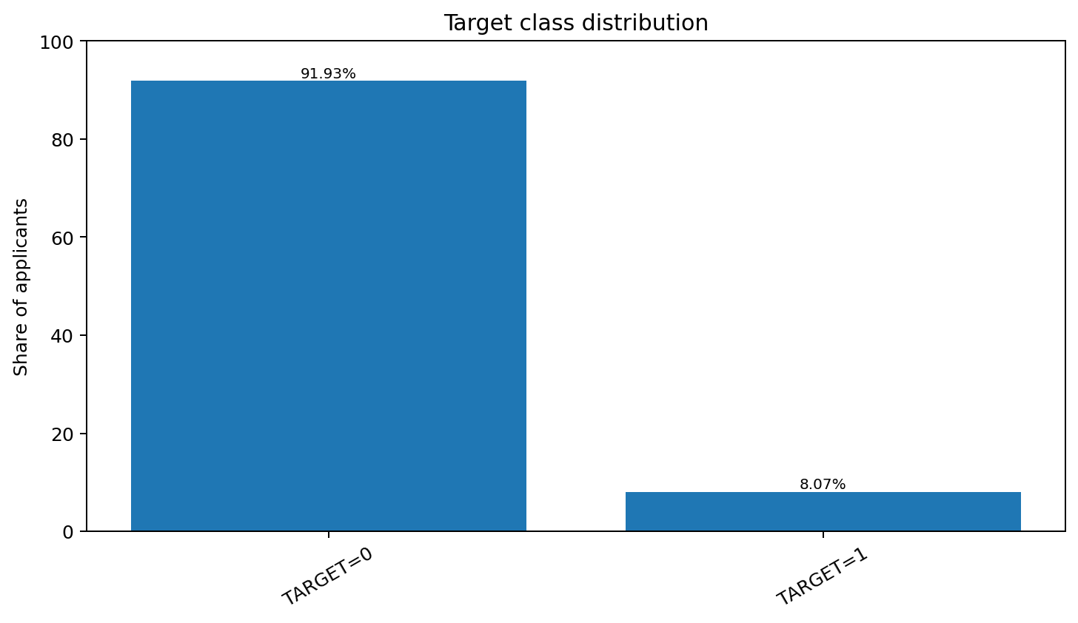
Figure 1. TARGET=1 represents repayment difficulty; only 8.07% of training applicants are positive.
TARGET | Count | Share
0 | 282,686 | 91.93%
1 | 24,825 | 8.07%

2.1 Raw missingness
The raw application table contains 67 columns with at least one missing value. The notebook initially inspects all columns at or above 50% missingness, then later applies a >50% rule only to numerical columns after all merged features have been created.
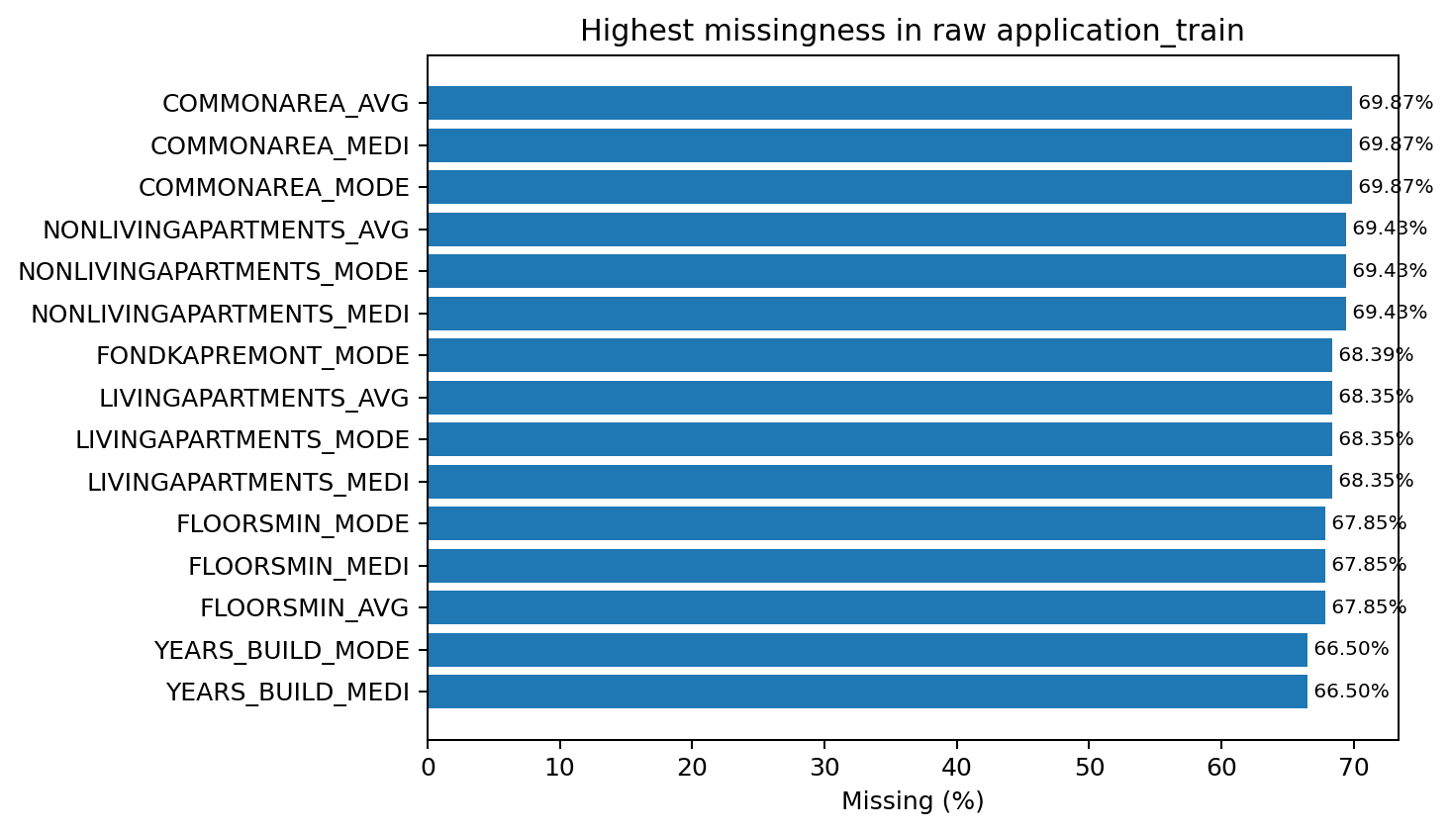
Figure 2. Highest raw application missingness percentages.
Missingness is not random with respect to TARGET. Two notebook examples are: EXT_SOURCE_1 missing → TARGET mean 8.5195% versus 7.4955% when present; COMMONAREA_AVG missing → 8.5742% versus 6.9102% when present. This is why the notebook inspects missingness as an EDA signal before dropping high-missing numerical columns.

3. Multi-table feature engineering and the exact +40 columns
The notebook does not simply start with 121 predictors and remove columns. It first expands the base table. Five applicant-level variables are added during EDA, then bureau, bureau_balance, previous_application, and installments aggregates are merged. After duplicate payment-feature variants are cleaned, the dataset contains 162 columns: the original 122 columns plus exactly 40 extra columns (mainul.ipynb cell 153).
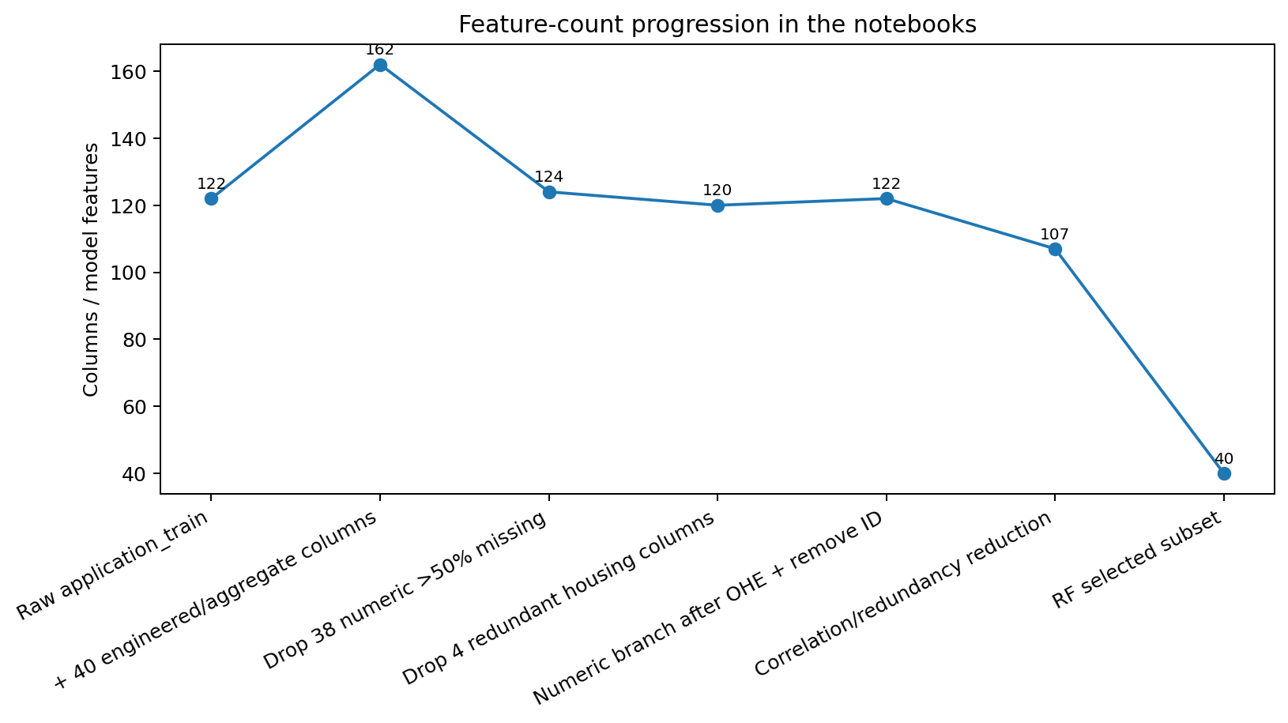
Figure 3. Feature-count progression. Counts follow the notebook objects, so early counts include TARGET and SK_ID_CURR where they are still present.

3.1 Build sequence and shapes
Stage | Observed notebook shape
application_train after 5 application-level engineered fields | 307,511 × 127
merge 6 first bureau aggregate fields | 307,511 × 133
add bureau flags/groups/debt features, then 7 bureau_balance aggregates + history flag | 307,511 × 149
merge 9 previous_application aggregate fields | 307,511 × 158
merge installment aggregates; temporary x/y duplicates appear | 307,511 × 165
drop 3 duplicate payment variants and rename y versions | 307,511 × 162

3.2 Exact lineage of all 40 added columns
# | Source | Feature | Construction in notebook | Meaning / purpose
1 | application_train.csv | INCOME_GROUP | pd.qcut(AMT_INCOME_TOTAL, q=5) | Income quintile used for EDA/modeling
2 | application_train.csv | CREDIT_GROUP | pd.qcut(AMT_CREDIT, q=5) | Credit amount quintile
3 | application_train.csv | CREDIT_INCOME_RATIO | AMT_CREDIT / AMT_INCOME_TOTAL | Loan size relative to income
4 | application_train.csv | AGE_YEARS | -DAYS_BIRTH / 365 | Applicant age in years
5 | application_train.csv | AGE_GROUP | pd.cut(AGE_YEARS, [18,25,35,45,55,65,100]) | Age bucket
6 | bureau.csv | BUREAU_CREDIT_COUNT | groupby(SK_ID_CURR).size() | Number of bureau credit records
7 | bureau.csv | BUREAU_ACTIVE_COUNT | count CREDIT_ACTIVE == Active | Number of active bureau credits
8 | bureau.csv | BUREAU_ACTIVE_RATIO | BUREAU_ACTIVE_COUNT / BUREAU_CREDIT_COUNT | Share of bureau credits still active
9 | bureau.csv | BUREAU_OVERDUE_COUNT | Train: count AMT_CREDIT_SUM_OVERDUE > 0 | Count of bureau credits currently overdue
10 | bureau.csv | BUREAU_OVERDUE_RATIO | BUREAU_OVERDUE_COUNT / BUREAU_CREDIT_COUNT | Fraction of bureau credits overdue
11 | bureau.csv | BUREAU_MAX_OVERDUE_DAYS | max(CREDIT_DAY_OVERDUE) | Worst days overdue
12 | bureau.csv | HAS_BUREAU_HISTORY | BUREAU_CREDIT_COUNT > 0 | Indicator that bureau history exists
13 | bureau.csv | HAS_BUREAU_OVERDUE | BUREAU_OVERDUE_COUNT > 0 | Indicator of any previous overdue credit
14 | bureau.csv | OVERDUE_SEVERITY | cut max overdue days: 0, 1–30, 31–90, 91–180, 180+ | Severity bucket
15 | bureau.csv | BUREAU_CREDIT_GROUP | cut credit count into 1–2, 3–5, 6–10, 11–20, 20+ | Credit-history volume bucket
16 | bureau.csv + application | BUREAU_TOTAL_DEBT | sum(AMT_CREDIT_SUM_DEBT), then clip(lower=0) | Total reported bureau debt
17 | bureau.csv + application | BUREAU_DEBT_INCOME_RATIO | BUREAU_TOTAL_DEBT / AMT_INCOME_TOTAL | Debt burden relative to income
18 | bureau.csv + application | BUREAU_DEBT_INCOME_GROUP | Train notebook initially uses qcut on debt/income ratio | Debt/income bucket (implementation differs on test; see audit)
19 | bureau.csv + application | DEBT_INCOME_GROUP | fixed bins: no debt, 0–1×, 1–2×, 2–4×, 4–8×, 8×+ | Interpretable debt-burden bucket
20 | bureau_balance.csv | BUREAU_BALANCE_CREDIT_COUNT | Train: nunique(SK_ID_BUREAU) with monthly history | Number of bureau credits having monthly balance history
21 | bureau_balance.csv | BUREAU_AVG_MONTHS_REPORTED | mean(BUREAU_MONTHS_REPORTED) | Average available bureau-history length
22 | bureau_balance.csv | BUREAU_TOTAL_OVERDUE_MONTHS | sum(BUREAU_OVERDUE_MONTHS) | Total months in status 1–5
23 | bureau_balance.csv | BUREAU_AVG_OVERDUE_RATIO | mean(BUREAU_OVERDUE_MONTH_RATIO) | Average share of months overdue
24 | bureau_balance.csv | BUREAU_TOTAL_SEVERE_OVERDUE_MONTHS | sum(BUREAU_SEVERE_OVERDUE_MONTHS) | Total months in status 3–5
25 | bureau_balance.csv | BUREAU_AVG_SEVERE_OVERDUE_RATIO | mean(BUREAU_SEVERE_OVERDUE_RATIO) | Average severe-overdue month share
26 | bureau_balance.csv | BUREAU_MAX_OVERDUE_RATIO | max(BUREAU_OVERDUE_MONTH_RATIO) | Worst per-credit overdue-month ratio
27 | bureau_balance.csv | HAS_BUREAU_BALANCE_HISTORY | BUREAU_BALANCE_CREDIT_COUNT is not missing / > 0 | Indicator that monthly bureau history exists
28 | previous_application.csv | PREVIOUS_APP_COUNT | nunique(SK_ID_PREV) | Number of previous Home Credit applications
29 | previous_application.csv | PREVIOUS_APPROVED_COUNT | count status == Approved | Previous approvals
30 | previous_application.csv | PREVIOUS_REFUSED_COUNT | count status == Refused | Previous refusals
31 | previous_application.csv | PREVIOUS_CANCELED_COUNT | count status == Canceled | Previous cancellations
32 | previous_application.csv | PREVIOUS_UNUSED_COUNT | count status == Unused offer | Unused previous offers
33 | previous_application.csv | PREVIOUS_AVG_CREDIT | mean(AMT_CREDIT) | Average previous credit
34 | previous_application.csv | PREVIOUS_AVG_APPLICATION | mean(AMT_APPLICATION) | Average previous requested amount
35 | previous_application.csv | PREVIOUS_APPROVAL_RATE | PREVIOUS_APPROVED_COUNT / PREVIOUS_APP_COUNT | Approval history rate
36 | previous_application.csv | PREVIOUS_REFUSAL_RATE | PREVIOUS_REFUSED_COUNT / PREVIOUS_APP_COUNT | Refusal history rate
37 | installments_payments.csv | LATE_PAYMENT_COUNT | count(PAYMENT_DELAY > 0) | Number of late installment payments
38 | installments_payments.csv | LATE_PAYMENT_RATE | late payments / installment records | Share of installments paid late
39 | installments_payments.csv | AVG_PAYMENT_DELAY | mean(DAYS_ENTRY_PAYMENT - DAYS_INSTALMENT) | Average payment timing; negative means early
40 | installments_payments.csv | UNDERPAYMENT_RATE | mean(AMT_PAYMENT < AMT_INSTALMENT) | Share of installments underpaid

3.3 Merge mechanics
# Example: applicant-level bureau aggregation is left-joined to application rows
application_bureau = application_train.merge(
bureau_features,
on='SK_ID_CURR',
how='left'
)
# Previous applications and installment aggregates are also merged by SK_ID_CURR
application_bureau_previous = application_bureau.merge(
previous_features, on='SK_ID_CURR', how='left'
)
application_bureau_previous_installments = application_bureau_previous.merge(
installment_features, on='SK_ID_CURR', how='left'
)

The use of left joins preserves all 307,511 training applicants. Applicant histories that do not exist in a secondary table become missing after the merge and are handled according to feature semantics: some aggregate counts are explicitly filled with 0, while later remaining numerical missing values are median-imputed.

4. Exploratory data analysis and evidence-backed claims
This section records only claims that appear in notebook calculations or markdown interpretation. Percentages below are observed associations, not causal effects.

4.1 Income, credit amount, and credit/income ratio
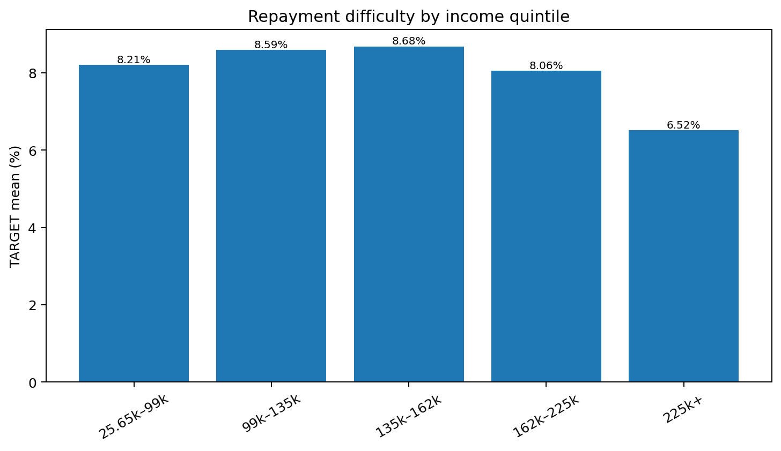
Figure 4. Highest income quintile has the lowest observed repayment-difficulty rate (6.52%); the pattern is not perfectly monotonic.
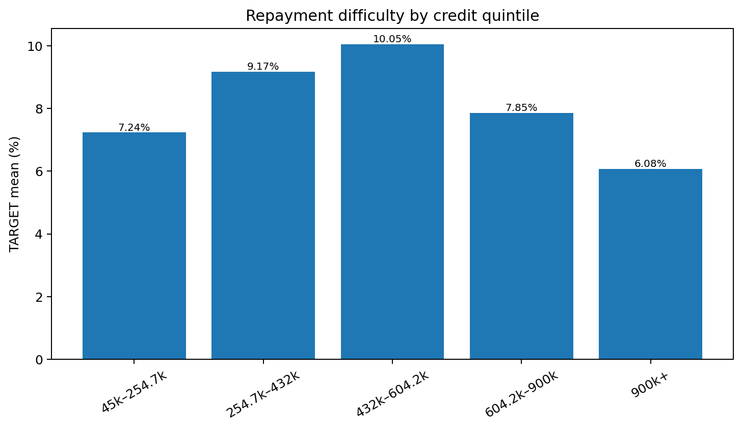
Figure 5. Middle credit amounts are riskier than both extremes; the 432k–604k quintile has the highest observed rate (10.05%).
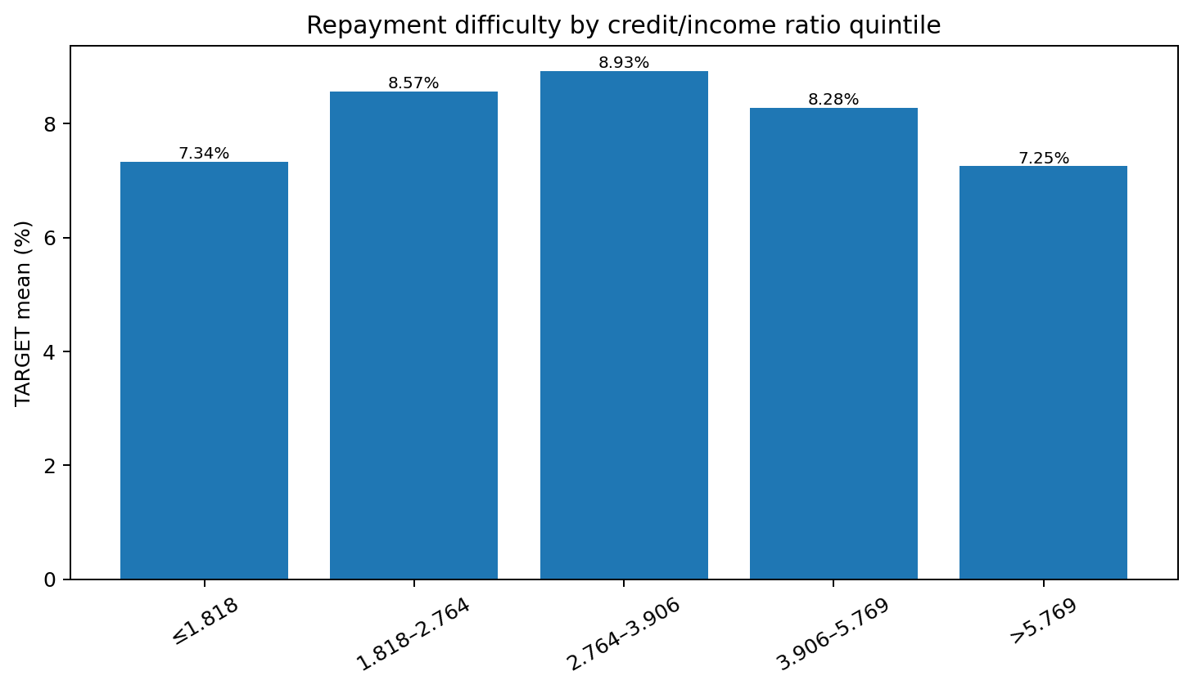
Figure 6. Credit/income ratio also shows a non-linear relationship, peaking in the middle quintile.

4.2 Age, gender, education, and income type
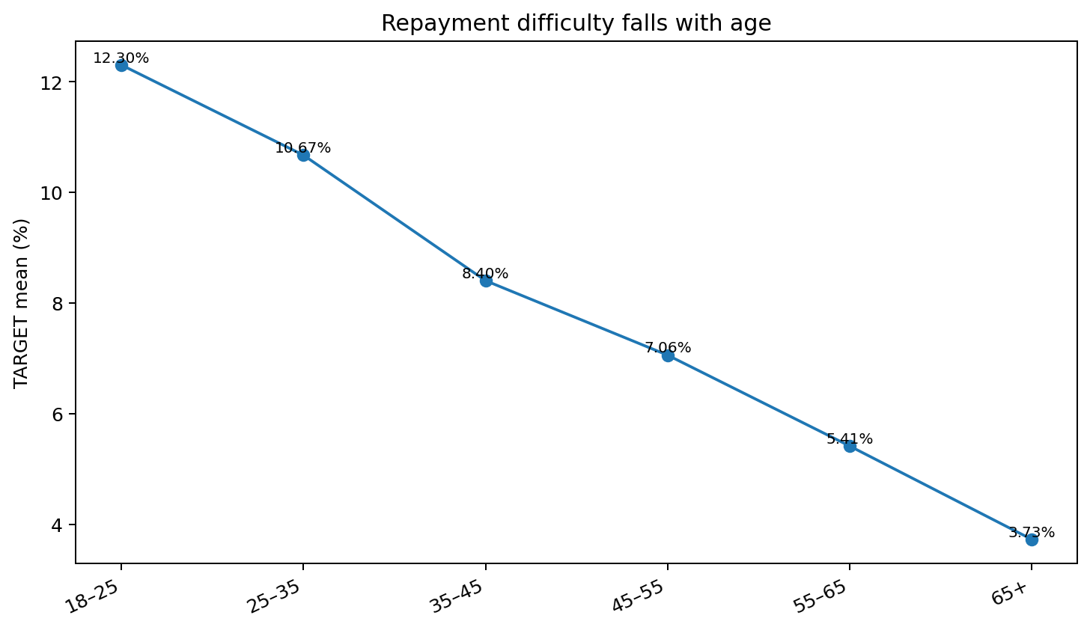
Figure 7. Age has an almost monotonic inverse relationship with TARGET: 12.30% for age 18–25 versus 3.73% for 65+.
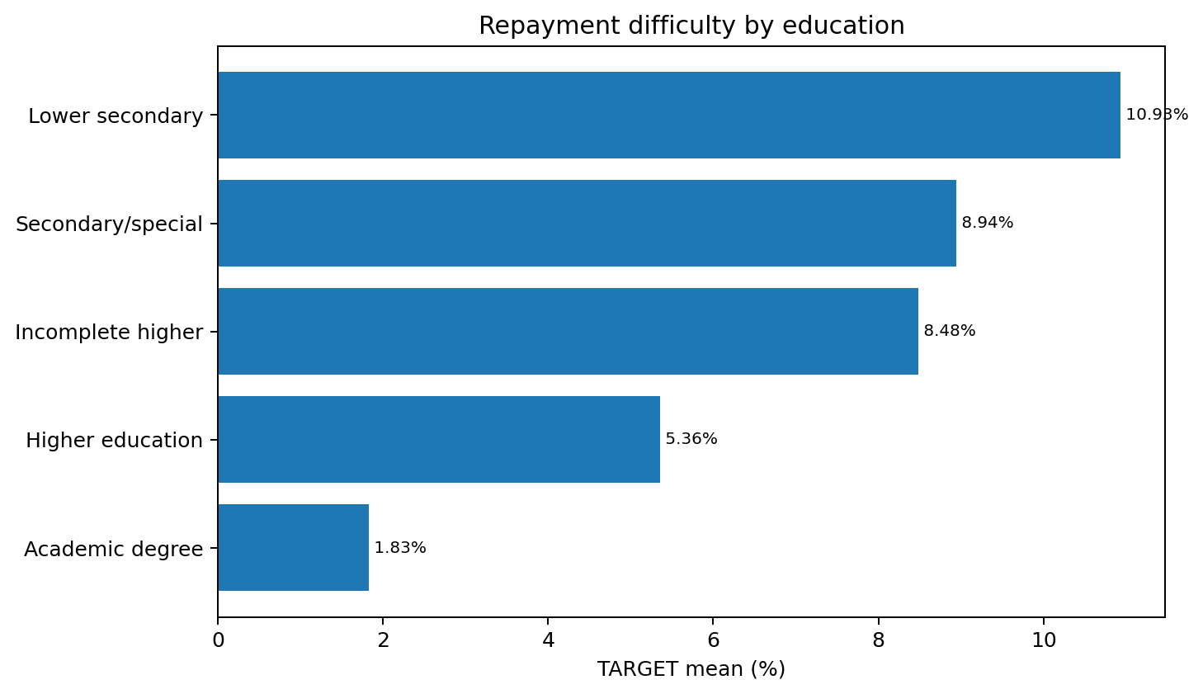
Figure 8. Lower educational attainment is associated with higher observed TARGET rates.
- Male applicants: 10.1419% TARGET vs female applicants: 6.9993%; XNA has only four records and is not treated as a substantive group.
- Working applicants: 9.5885%; Commercial associates: 7.4843%; State servants: 5.7550%; Pensioners: 5.3864%. Tiny groups such as maternity leave (n=5), unemployed (n=22), student (n=18), and businessman (n=10) are explicitly treated cautiously in the notebook.

4.3 Bureau history and external credit behavior
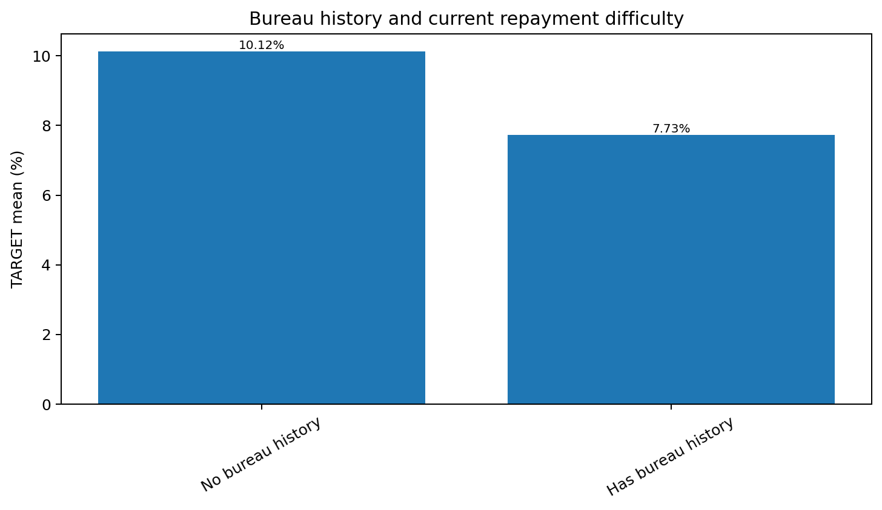
Figure 9. Applicants without bureau history show a higher observed TARGET rate: 10.12% vs 7.73%.
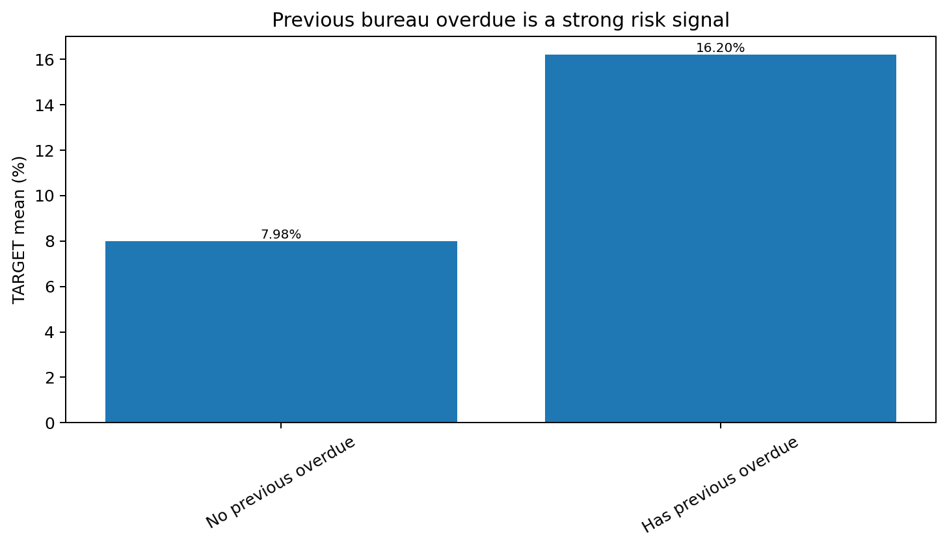
Figure 10. Any previous bureau overdue roughly doubles the observed TARGET rate: 16.20% vs 7.98%.
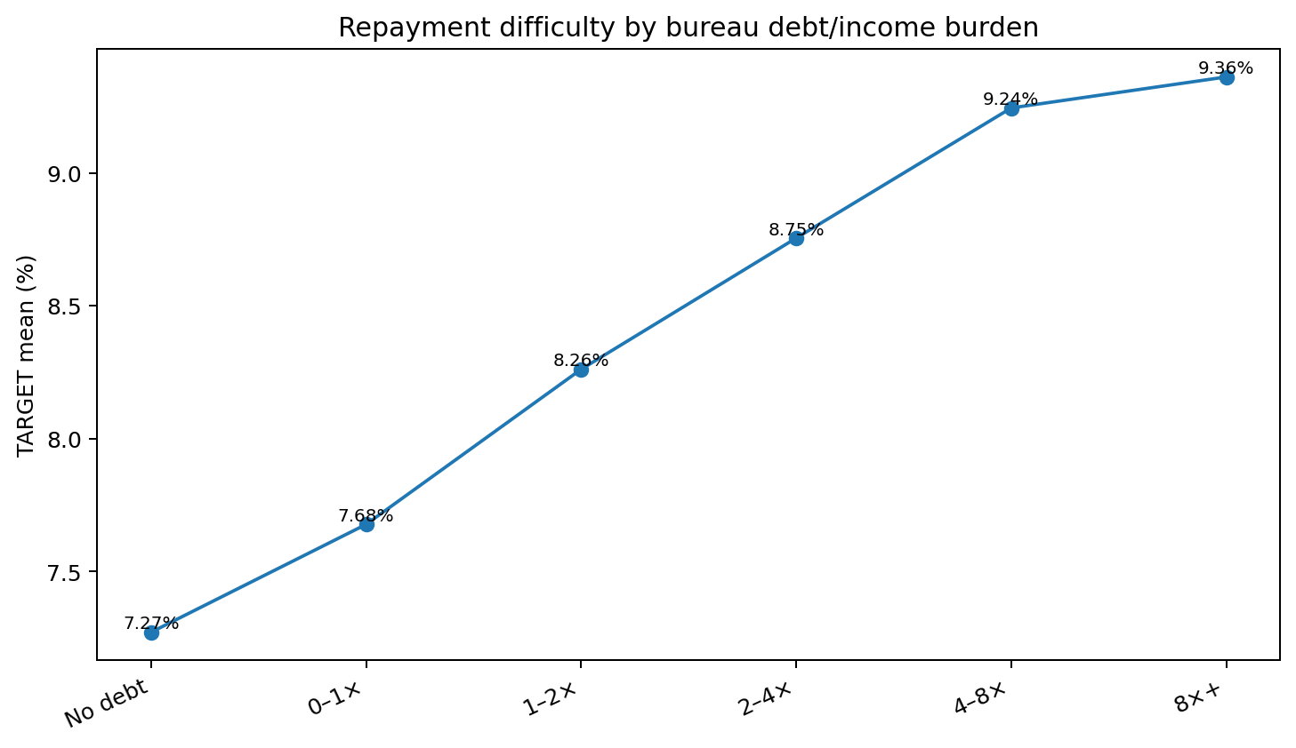
Figure 11. After clipping negative total bureau debt to zero, higher debt/income burden generally corresponds to higher current repayment difficulty.
- Bureau credit records per customer: mean 5.61, median 4, maximum 116.
- Overdue duration itself is non-linear: 1–30 days 18.38%, 31–90 days 17.34%, 91–180 days 15.56%, 180+ days 10.24%; therefore the notebook correctly avoids claiming “longer overdue always means higher current default.”
- Applicants with 20+ bureau credits have an 11.18% observed TARGET rate versus about 7.4–8.2% for most lower-count groups.

4.4 Previous Home Credit applications
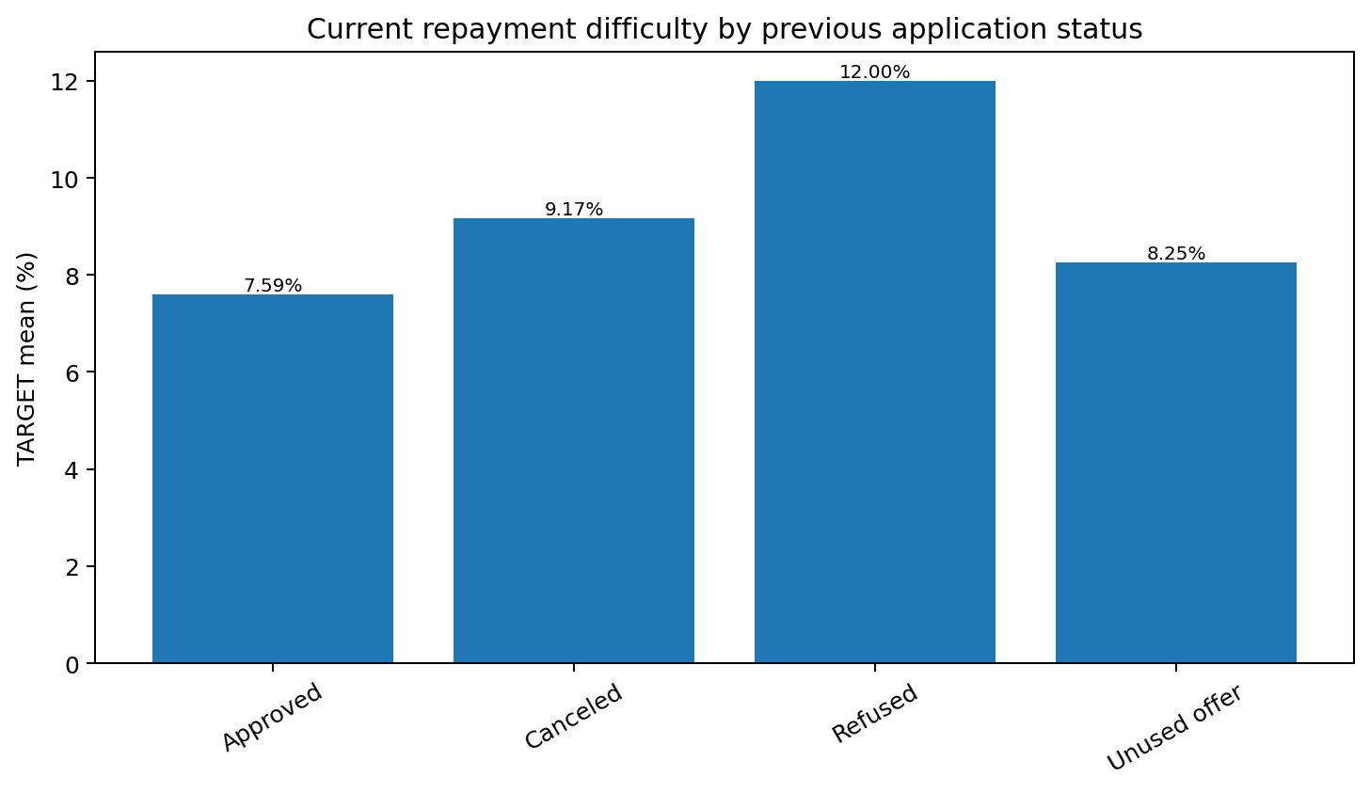
Figure 12. Previous refused applications are the strongest status-level signal: 12.00% current TARGET vs 7.59% after previously approved applications.
- Previous application count is also non-linear: 3–4 previous applications show 7.70%, while 8+ show 9.17%.
- Correlation with TARGET among engineered previous-application features: PREVIOUS_REFUSAL_RATE = +0.07767; PREVIOUS_REFUSED_COUNT = +0.06447; PREVIOUS_APPROVAL_RATE = −0.06352.
- Average previous credit and application amounts are slightly lower for TARGET=1 applicants in the notebook means.

4.5 Installment repayment behavior
- Across installment records, 8.428% have PAYMENT_DELAY > 0.
- LATE_PAYMENT_RATE quintiles show only a weak/non-monotonic relationship with TARGET (roughly 7.95%–8.26%).
- AVG_PAYMENT_DELAY quintiles are also weak/non-monotonic (roughly 7.84%–8.26%).
- UNDERPAYMENT_RATE groups are similarly weak (about 8.00%–8.23%). The notebook therefore treats these as potentially useful in combination rather than strong stand-alone risk variables.

5. Cleaning, missing values, duplicates, and outliers

5.1 Categorical missing values
At the 162-column stage, categorical columns are cast to object and missing values are filled with the literal category "Missing". This retains missingness information instead of median/mode-filling categories.
categorical_cols = df.select_dtypes(include=['object','category','bool']).columns.tolist()
df[categorical_cols] = df[categorical_cols].astype('object').fillna('Missing')

5.2 High-missing numerical column removal
The notebook computes missing percentages only for numerical columns and drops every numerical feature with missing_percent > 50. Exactly 38 columns are removed, reducing 162 → 124 columns.
38 dropped numerical columns (>50% missing)
COMMONAREA_AVG
COMMONAREA_MEDI
COMMONAREA_MODE
NONLIVINGAPARTMENTS_MODE
NONLIVINGAPARTMENTS_AVG
NONLIVINGAPARTMENTS_MEDI
LIVINGAPARTMENTS_MEDI
LIVINGAPARTMENTS_AVG
LIVINGAPARTMENTS_MODE
FLOORSMIN_MODE
FLOORSMIN_AVG
FLOORSMIN_MEDI
YEARS_BUILD_MODE
YEARS_BUILD_MEDI
YEARS_BUILD_AVG
OWN_CAR_AGE
LANDAREA_AVG
LANDAREA_MODE
LANDAREA_MEDI
BASEMENTAREA_MODE
BASEMENTAREA_MEDI
BASEMENTAREA_AVG
EXT_SOURCE_1
NONLIVINGAREA_MODE
NONLIVINGAREA_MEDI
NONLIVINGAREA_AVG
ELEVATORS_MEDI
ELEVATORS_AVG
ELEVATORS_MODE
APARTMENTS_MODE
APARTMENTS_MEDI
APARTMENTS_AVG
ENTRANCES_MEDI
ENTRANCES_MODE
ENTRANCES_AVG
LIVINGAREA_AVG
LIVINGAREA_MODE
LIVINGAREA_MEDI

5.3 Median imputation
After the 38-column removal, all remaining int64/float64 columns are filled with their column median. The notebook verifies total remaining missing values = 0. AMT_ANNUITY, for example, has only 12 missing values before this step.
numerical_cols = df.select_dtypes(include=['int64','float64']).columns.tolist()
df[numerical_cols] = df[numerical_cols].fillna(df[numerical_cols].median())
assert df.isna().sum().sum() == 0

5.4 Duplicate checks — what the notebook actually does
- After merging and cleaning, SK_ID_CURR.duplicated().sum() returns 0, confirming one training row per applicant.
- Cell 153 reports no duplicate column names at the 162-column stage.
- The CatBoost construction initially creates duplicate OCCUPATION_TYPE and ORGANIZATION_TYPE columns; these are explicitly removed by de-duplicating the feature-name list, producing 103 unique CatBoost features.
- There is no notebook step that globally drops duplicate full rows from application_train. The only drop_duplicates() call is used while building a previous-application EDA table of unique SK_ID_CURR values. This distinction is important for an accurate report.

5.5 Outlier diagnosis and handling
The notebook calculates 1.5×IQR outlier counts for every numerical column after median imputation. It finds at least one IQR outlier in 89 numerical columns, with very large counts for LATE_PAYMENT_RATE, LATE_PAYMENT_COUNT, housing variables and TOTALAREA_MODE. This is a diagnostic step only: the notebook does not globally remove rows or cap every IQR outlier.
- BUREAU_TOTAL_DEBT contains 1,296 negative applicant totals, with minimum −6,981,558. The implemented domain correction is df["BUREAU_TOTAL_DEBT"].clip(lower=0), followed by recomputing the debt/income ratio.
- PAYMENT_RATIO is first observed to produce infinities when AMT_INSTALMENT=0; the notebook then recalculates it only where AMT_INSTALMENT > 0. PAYMENT_RATIO itself is not one of the final 40 added features; UNDERPAYMENT_RATE is retained.
- The notebook verifies zero infinite numerical values after the main cleaning stage.

5.6 Additional redundancy removal before encoding
The notebook compares AVG/MODE/MEDI housing variants with TARGET and drops four redundant/weak variants while retaining MEDI versions: YEARS_BEGINEXPLUATATION_AVG, YEARS_BEGINEXPLUATATION_MODE, FLOORSMAX_AVG, and FLOORSMAX_MODE. Shape: 124 → 120 columns.

6. Categorical encoding and numeric-model preprocessing
The numeric-model branch progressively converts all remaining categorical information to numbers. The CatBoost branch is built separately later and keeps 11 original categorical variables as strings.

6.1 Binary mapping
Feature | Mapping
NAME_CONTRACT_TYPE | Cash loans→0; Revolving loans→1
CODE_GENDER | F→0; M→1; XNA/Other→0
FLAG_OWN_CAR | N→0; Y→1
FLAG_OWN_REALTY | N→0; Y→1
HAS_BUREAU_HISTORY | False→0; True→1
HAS_BUREAU_OVERDUE | False→0; True→1
HAS_BUREAU_BALANCE_HISTORY | False→0; True→1

The notebook contains an intermediate failed mapping of NAME_CONTRACT_TYPE using Y/N, which produced zero unique non-missing values. It immediately restores NAME_CONTRACT_TYPE from application_train by SK_ID_CURR and then correctly maps Cash loans/Revolving loans. The report records the final effective mapping, while this debugging event is preserved here for reproducibility.

6.2 Ordered / ordinal encodings
Feature | Final coding
NAME_EDUCATION_TYPE | Lower secondary=1, Secondary/special=2, Incomplete higher=3, Higher education=4, Academic degree=5
OVERDUE_SEVERITY | No overdue=1, 1–30=2, 31–90=3, 91–180=4, 180+=5
DEBT_INCOME_GROUP | No debt=0, 0–1×=1, 1–2×=2, 2–4×=3, 4–8×=4, 8×+=5
BUREAU_CREDIT_GROUP | Missing=0, 1–2=1, 3–5=2, 6–10=3, 11–20=4, 20+=5
INCOME_GROUP / CREDIT_GROUP / AGE_GROUP | Interval categories are converted to categorical codes before final saved numeric matrices
BUREAU_DEBT_INCOME_GROUP | Converted to categorical codes in the final training feature matrix

6.3 Frequency encoding for high-cardinality categoricals
OCCUPATION_TYPE (19 levels including Missing after filling) and ORGANIZATION_TYPE (58 levels) are frequency encoded. Frequencies are derived from the training data and used to map both train and test categories.
occupation_freq = train_features['OCCUPATION_TYPE'].value_counts(normalize=True)
organization_freq = train_features['ORGANIZATION_TYPE'].value_counts(normalize=True)
train_features['OCCUPATION_TYPE'] = train_features['OCCUPATION_TYPE'].map(occupation_freq)
application_test['OCCUPATION_TYPE'] = application_test['OCCUPATION_TYPE'].map(occupation_freq)
train_features['ORGANIZATION_TYPE'] = train_features['ORGANIZATION_TYPE'].map(organization_freq)
application_test['ORGANIZATION_TYPE'] = application_test['ORGANIZATION_TYPE'].map(organization_freq)

6.4 Association-based categorical reduction
For the remaining nine nominal categorical variables, the notebook calculates chi-square p-values and Cramér’s V. Reported Cramér’s V values are: NAME_INCOME_TYPE 0.06385, WALLSMATERIAL_MODE 0.04414, EMERGENCYSTATE_MODE 0.04221, HOUSETYPE_MODE 0.04070, NAME_FAMILY_STATUS 0.04051, NAME_HOUSING_TYPE 0.03698, FONDKAPREMONT_MODE 0.03027, NAME_TYPE_SUITE 0.01212, WEEKDAY_APPR_PROCESS_START 0.00707.
The implemented numeric branch drops six columns: NAME_TYPE_SUITE, NAME_FAMILY_STATUS, NAME_HOUSING_TYPE, WEEKDAY_APPR_PROCESS_START, FONDKAPREMONT_MODE, and HOUSETYPE_MODE. It retains NAME_INCOME_TYPE, WALLSMATERIAL_MODE, and EMERGENCYSTATE_MODE for one-hot encoding.

6.5 Rare-category grouping and one-hot encoding
Before one-hot encoding, four extremely rare income types—Unemployed, Student, Businessman, and Maternity leave—are collapsed into Other. Then pd.get_dummies(..., drop_first=True) is applied to NAME_INCOME_TYPE, WALLSMATERIAL_MODE, and EMERGENCYSTATE_MODE, creating 13 dummy columns and avoiding a full redundant dummy basis.
One-hot columns created
NAME_INCOME_TYPE_Other
NAME_INCOME_TYPE_Pensioner
NAME_INCOME_TYPE_State servant
NAME_INCOME_TYPE_Working
WALLSMATERIAL_MODE_Missing
WALLSMATERIAL_MODE_Mixed
WALLSMATERIAL_MODE_Monolithic
WALLSMATERIAL_MODE_Others
WALLSMATERIAL_MODE_Panel
WALLSMATERIAL_MODE_Stone, brick
WALLSMATERIAL_MODE_Wooden
EMERGENCYSTATE_MODE_No
EMERGENCYSTATE_MODE_Yes

6.6 Test missing-value alignment
After train/test columns are matched, the test matrix still has 177,000 missing cells across 37 numeric columns. Each is filled with the corresponding train_features column median. Then SK_ID_CURR is removed. At that point both full train and test numeric feature matrices contain 122 columns before correlation/redundancy reduction.

7. Feature reduction, standardization, and the two modeling representations

7.1 Correlation/redundancy reduction: 122 → 107
The notebook performs a stratified 80/20 split, inspects absolute correlation among training features, and removes redundant variables. Examples from the reported top correlations include DAYS_BIRTH vs AGE_YEARS = 1.0000, OBS_30 vs OBS_60 social-circle counts = 0.9985, AMT_CREDIT vs AMT_GOODS_PRICE = 0.9868, PREVIOUS_AVG_CREDIT vs PREVIOUS_AVG_APPLICATION = 0.9771, and REGION_RATING_CLIENT vs REGION_RATING_CLIENT_W_CITY = 0.9512.
15 features removed in the final 122 → 107 reduction
DAYS_BIRTH
OBS_60_CNT_SOCIAL_CIRCLE
AMT_GOODS_PRICE
PREVIOUS_AVG_APPLICATION
REGION_RATING_CLIENT_W_CITY
BUREAU_CREDIT_GROUP
CNT_FAM_MEMBERS
REG_REGION_NOT_WORK_REGION
DEF_60_CNT_SOCIAL_CIRCLE
REG_CITY_NOT_WORK_CITY
BUREAU_AVG_MONTHS_REPORTED
BUREAU_AVG_OVERDUE_RATIO
PREVIOUS_APPROVED_COUNT
BUREAU_AVG_SEVERE_OVERDUE_RATIO
PREVIOUS_UNUSED_COUNT

After the final alignment and a fresh stratified split, the saved files have X_train 246,008 × 107, X_val 61,503 × 107, y_train 246,008, y_val 61,503, and application_test 48,744 × 107. Positive prevalence is 8.0729% in both train and validation.
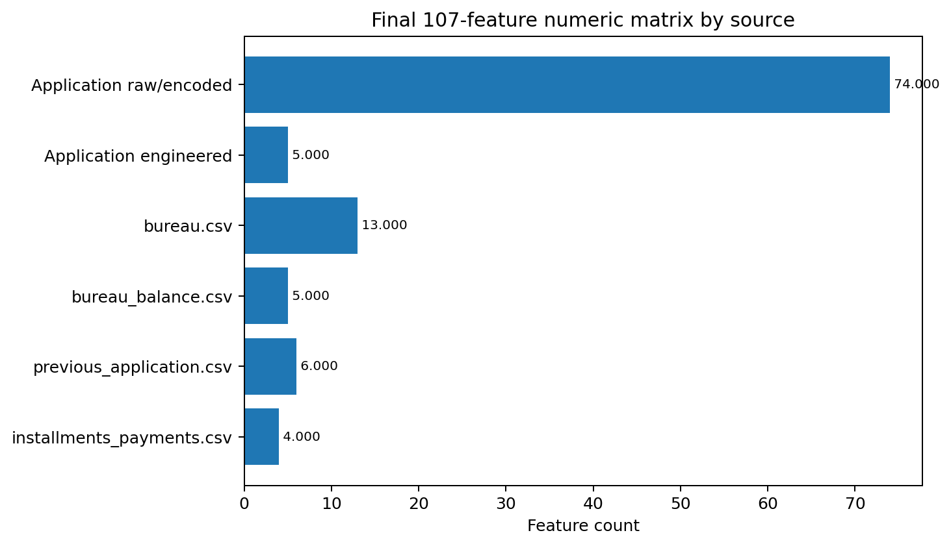
Figure 13. Source composition of the reconstructed final 107-feature numeric matrix.

7.2 Random-Forest feature-selection experiment: 107 → 40
mainul_2nd.ipynb reloads the saved 107-feature matrices and fits a RandomForestClassifier with 100 trees and class_weight="balanced" as a feature selector. Cumulative importance reaches 80% at 33 features, 85% at 38, and 90% at 45. The experiment chooses the top 40 features.
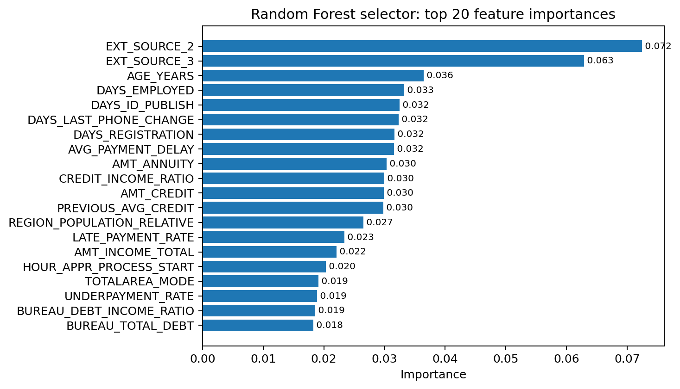
Figure 14. Top 20 Random-Forest selector importances from mainul_2nd.ipynb.
Selected top 40 features
1. EXT_SOURCE_2
2. EXT_SOURCE_3
3. AGE_YEARS
4. DAYS_EMPLOYED
5. DAYS_ID_PUBLISH
6. DAYS_LAST_PHONE_CHANGE
7. DAYS_REGISTRATION
8. AVG_PAYMENT_DELAY
9. AMT_ANNUITY
10. CREDIT_INCOME_RATIO
11. AMT_CREDIT
12. PREVIOUS_AVG_CREDIT
13. REGION_POPULATION_RELATIVE
14. LATE_PAYMENT_RATE
15. AMT_INCOME_TOTAL
16. HOUR_APPR_PROCESS_START
17. TOTALAREA_MODE
18. UNDERPAYMENT_RATE
19. BUREAU_DEBT_INCOME_RATIO
20. BUREAU_TOTAL_DEBT
21. BUREAU_ACTIVE_RATIO
22. ORGANIZATION_TYPE
23. BUREAU_CREDIT_COUNT
24. YEARS_BEGINEXPLUATATION_MEDI
25. PREVIOUS_APP_COUNT
26. PREVIOUS_APPROVAL_RATE
27. OCCUPATION_TYPE
28. PREVIOUS_REFUSAL_RATE
29. LATE_PAYMENT_COUNT
30. OBS_30_CNT_SOCIAL_CIRCLE
31. AMT_REQ_CREDIT_BUREAU_YEAR
32. BUREAU_ACTIVE_COUNT
33. NAME_EDUCATION_TYPE
34. AGE_GROUP
35. INCOME_GROUP
36. BUREAU_BALANCE_CREDIT_COUNT
37. CREDIT_GROUP
38. PREVIOUS_REFUSED_COUNT
39. FLOORSMAX_MEDI
40. PREVIOUS_CANCELED_COUNT

7.3 Standardization
StandardScaler is not applied to all models. It is fitted on X_train only and used for Logistic Regression experiments: first on the selected 40-feature subset, then again on all 107 features. Random Forest, LightGBM, XGBoost, and CatBoost are trained without standardization.
scaler = StandardScaler()
X_train_scaled = scaler.fit_transform(X_train_selected)
X_val_scaled = scaler.transform(X_val_selected)
# Separate experiment on all 107 features
scaler_all = StandardScaler()
X_train_all_scaled = scaler_all.fit_transform(X_train)
X_val_all_scaled = scaler_all.transform(X_val)

7.4 Separate CatBoost representation: 103 features with native categoricals
CatBoost is deliberately not trained on the one-hot/frequency-only representation. The notebook starts from the 107 processed feature names, removes the 13 one-hot dummy columns, and adds back 11 raw categorical variables from application_bureau_previous_installments. OCCUPATION_TYPE and ORGANIZATION_TYPE appear twice at first, so duplicate names are removed. The final CatBoost matrices are 246,008 × 103 and 61,503 × 103 with 11 categorical columns retained as strings.
11 CatBoost categorical features
NAME_TYPE_SUITE
NAME_INCOME_TYPE
NAME_FAMILY_STATUS
NAME_HOUSING_TYPE
OCCUPATION_TYPE
WEEKDAY_APPR_PROCESS_START
ORGANIZATION_TYPE
FONDKAPREMONT_MODE
HOUSETYPE_MODE
WALLSMATERIAL_MODE
EMERGENCYSTATE_MODE

Four interval columns—INCOME_GROUP, CREDIT_GROUP, AGE_GROUP, and BUREAU_DEBT_INCOME_GROUP—are converted to category codes before fitting CatBoost. The notebook verifies no missing or infinite values in X_train_cat/X_val_cat.

8. Model training and validation results

8.1 Class imbalance handling
- Logistic Regression: class_weight="balanced".
- Random Forest: class_weight="balanced".
- LightGBM main model: class_weight="balanced".
- CatBoost: auto_class_weights="Balanced".
- XGBoost: scale_pos_weight = negatives / positives = 226,148 / 19,860 ≈ 11.3871.

8.2 Model configurations
Model | Feature representation | Key notebook parameters
Logistic Regression | 40 selected and 107 all-feature variants | max_iter=1000; class_weight=balanced; random_state=42; StandardScaler
Random Forest | 40 selected features | n_estimators=200; class_weight=balanced; random_state=42; n_jobs=-1
LightGBM | 107 numeric features | 1500 trees; lr=0.03; num_leaves=31; subsample=0.8; colsample=0.8; reg_alpha=0.1; reg_lambda=0.1; balanced; early stop 100
CatBoost | 103 features, 11 native categorical | iterations=3000; lr=0.03; depth=8; AUC; Balanced; GPU; early stop 150; best iteration 706
XGBoost | 107 numeric features | 2000 trees; lr=0.03; depth=8; min_child_weight=5; subsample/colsample=0.85; gamma=0.1; GPU hist; scale_pos_weight≈11.387; early stop 100

8.3 Validation metrics
Model | ROC-AUC | PR-AUC | Precision | Recall | F1 | Accuracy
Logistic Regression — top 40 | 0.741752 | — | 0.158895 | 0.671903 | 0.257011 | 0.686389
Random Forest — top 40 | 0.733209 | — | 0.342857 | 0.002417 | 0.004800 | 0.919093
Logistic Regression — all 107 | 0.753775 | — | 0.163433 | 0.680363 | 0.263556 | not printed
LightGBM — balanced 107 | 0.764678 | 0.254421 | 0.18 (class 1) | 0.67 (class 1) | 0.28 (class 1) | 0.73
CatBoost — 103 native-cat | 0.765365 | 0.257852 | not printed | not printed | not printed | not printed
XGBoost — 107 | 0.760887 | 0.249473 | not printed | not printed | not printed | not printed
Best tested 3-model blend | 0.766916 | 0.259271 | n/a | n/a | n/a | n/a

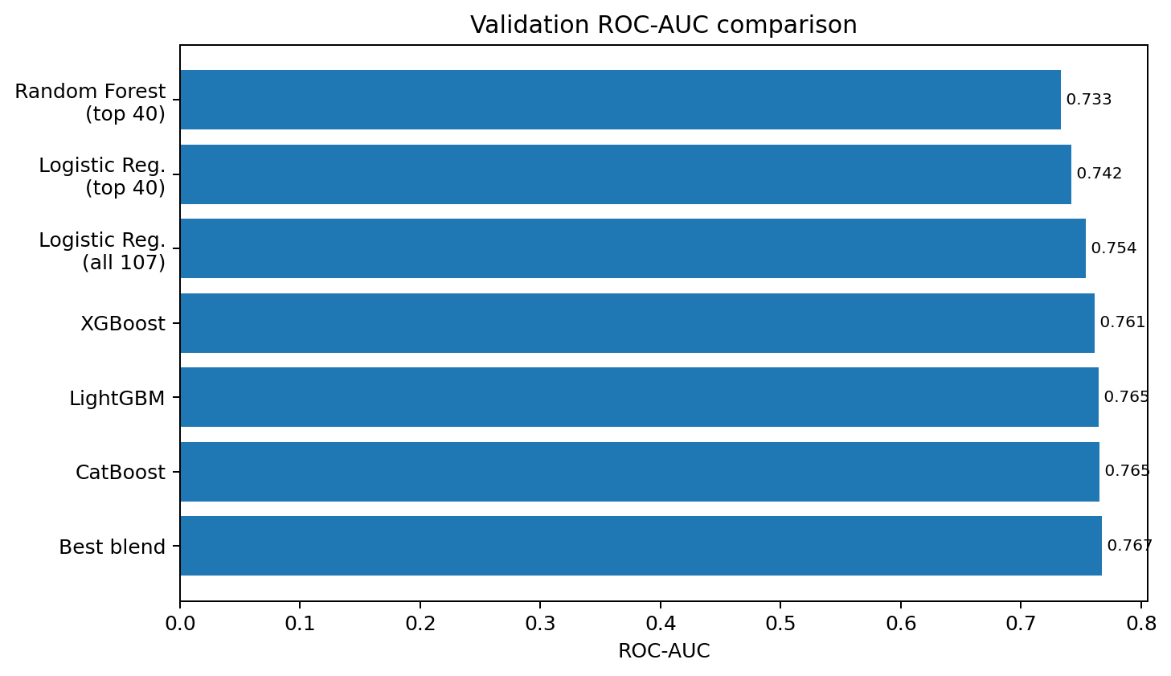
Figure 15. ROC-AUC comparison. CatBoost is the best individual model; the tested blend is slightly higher.
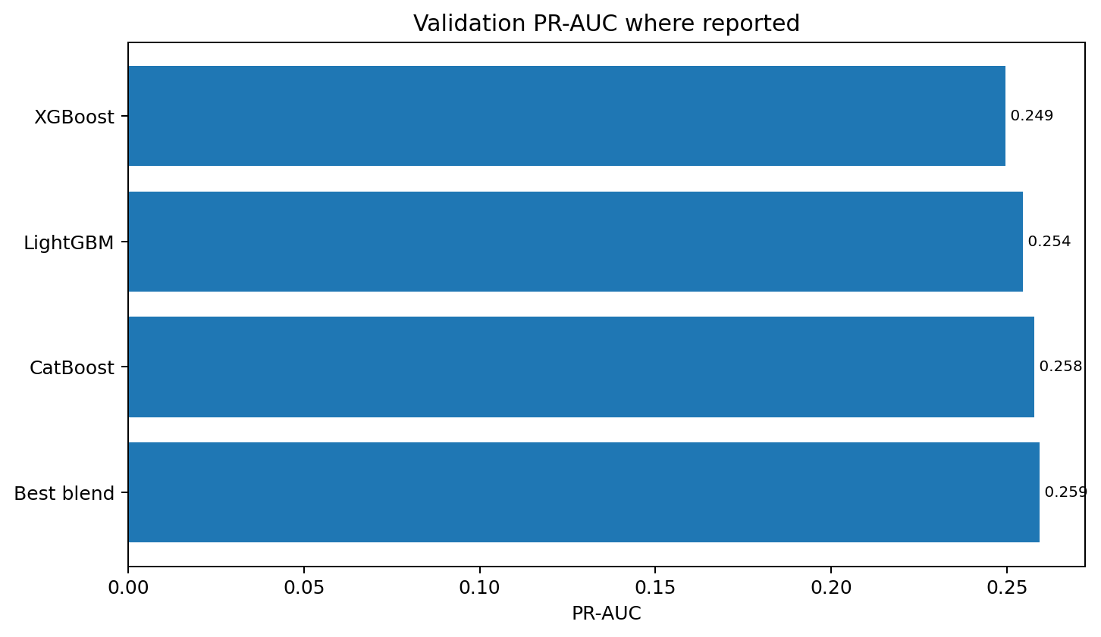
Figure 16. PR-AUC comparison for the models where the notebook reports PR-AUC.

8.4 Confusion matrices and threshold behavior
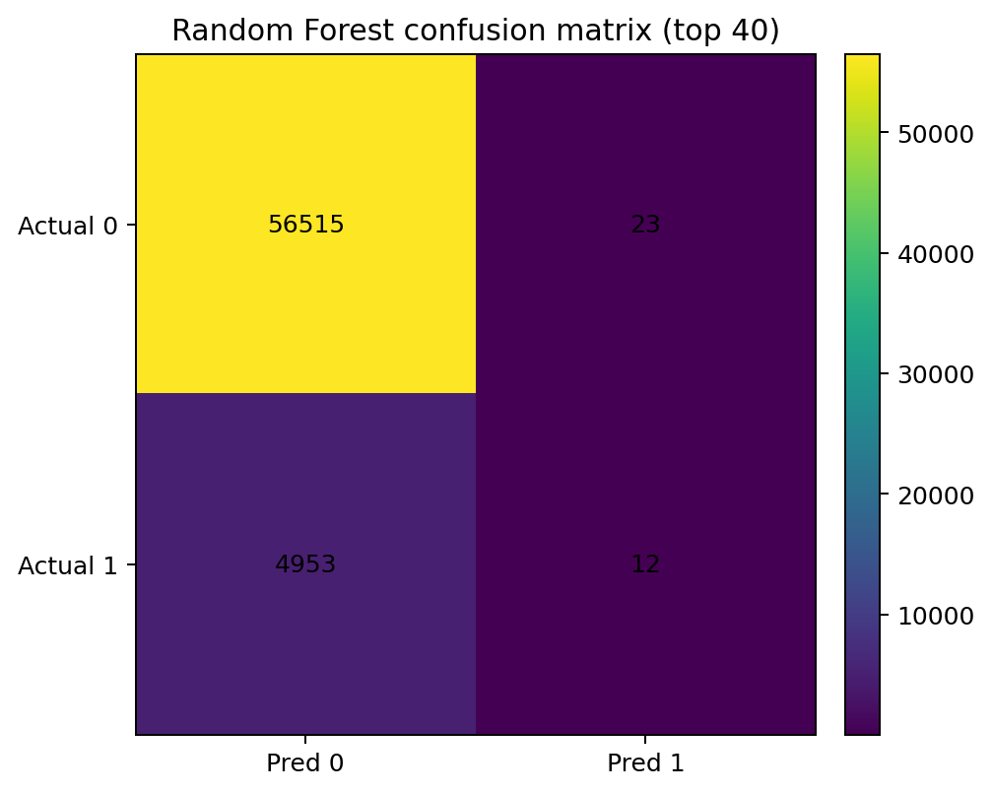
Figure 17. Random Forest at default threshold predicts almost every case as class 0; this explains high accuracy but only 0.24% recall for class 1.
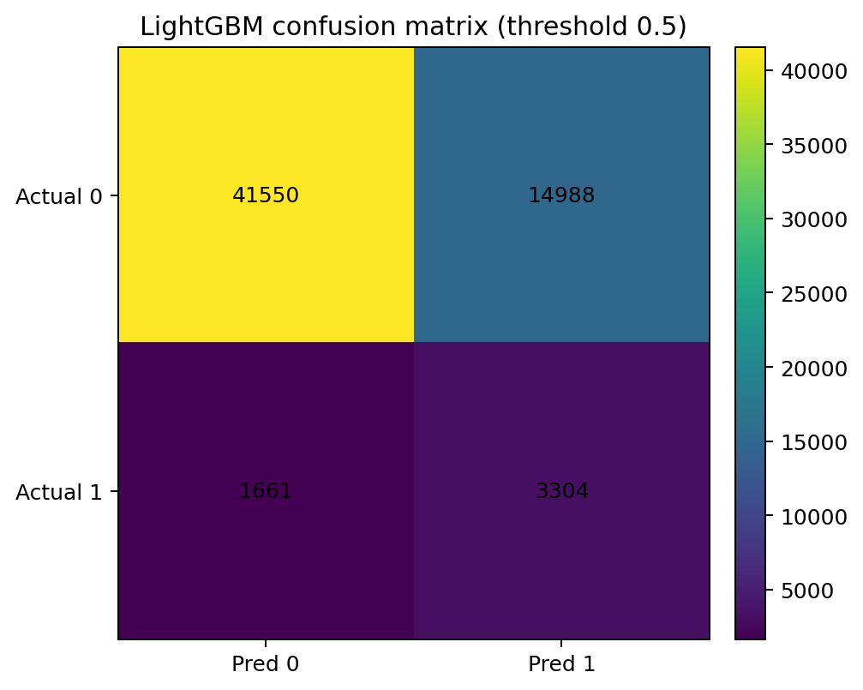
Figure 18. Balanced LightGBM at threshold 0.5 captures 3,304 of 4,965 positives, with many false positives as the cost of higher recall.

8.5 LightGBM variants and ensemble experiments
- Balanced LightGBM, num_leaves=31: best validation AUC 0.764678 at iteration 757.
- Balanced LightGBM, num_leaves=63: best AUC 0.763842 at iteration 496.
- Unweighted LightGBM: best AUC 0.763984 at iteration 876. Thus the original balanced 31-leaf model is the best of these three LightGBM variants.
- CatBoost best validation AUC: 0.765365 at iteration 706; PR-AUC 0.257852.
- Best two-model tested blend: 50% CatBoost + 50% LightGBM → ROC-AUC 0.766861, PR-AUC 0.259233.
- Best three-model tested blend: 40% LightGBM + 50% CatBoost + 10% XGBoost → ROC-AUC 0.766916, PR-AUC 0.259271.

9. Feature and model summaries

9.1 Feature importance
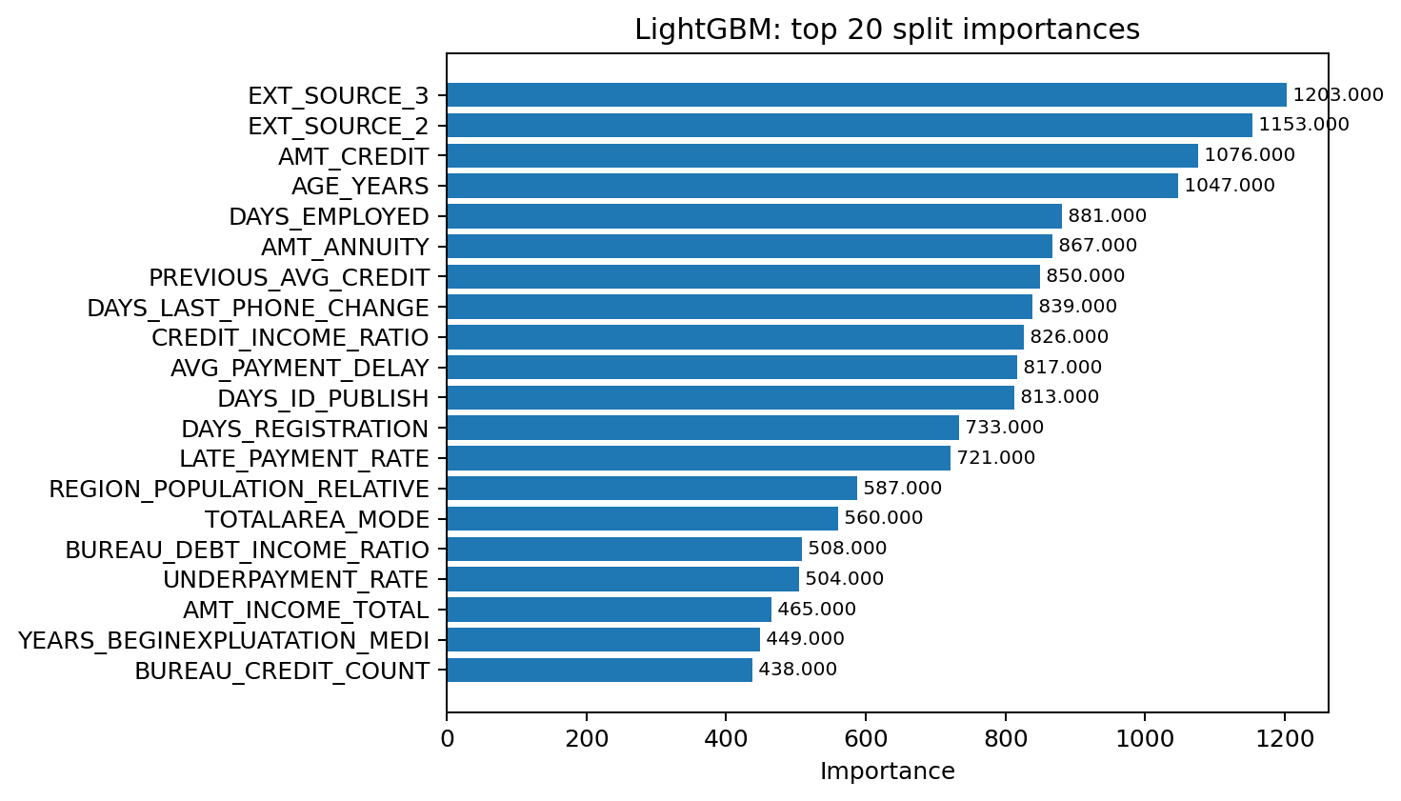
Figure 19. LightGBM top 20 split importances. EXT_SOURCE_3, EXT_SOURCE_2, AMT_CREDIT and AGE_YEARS are the strongest by this measure.
The Random-Forest selector and LightGBM agree on many high-value predictors: EXT_SOURCE_2/3, AGE_YEARS, DAYS_EMPLOYED, AMT_CREDIT, AMT_ANNUITY, CREDIT_INCOME_RATIO, PREVIOUS_AVG_CREDIT, repayment timing, and debt/income burden. This convergence supports the importance of combining current applicant attributes with historical credit and repayment behavior.

9.2 Zero-importance LightGBM features
The notebook reports 14 zero-importance features in the trained LightGBM model:
Zero-importance feature
FLAG_DOCUMENT_7
FLAG_MOBIL
FLAG_CONT_MOBILE
FLAG_DOCUMENT_4
FLAG_DOCUMENT_2
AMT_REQ_CREDIT_BUREAU_HOUR
OVERDUE_SEVERITY
HAS_BUREAU_OVERDUE
FLAG_DOCUMENT_20
FLAG_DOCUMENT_12
FLAG_DOCUMENT_10
FLAG_DOCUMENT_19
NAME_INCOME_TYPE_Other
WALLSMATERIAL_MODE_Mixed

10. Final Kaggle submission
Although CatBoost is the strongest individual validation model and the blend is stronger still, the final executed submission cell in mainul.ipynb explicitly creates a LightGBM-only submission. It rebuilds X_test_lgb from the final 107-column application_test matrix, cleans feature names exactly as in training, enforces the X_train_lgb column order, predicts probabilities, and writes submission.csv.
Submission validation check | Notebook result
Rows | 48,744
Columns | SK_ID_CURR, TARGET
Missing IDs | 0
Missing predictions | 0
Duplicate IDs | 0
Prediction range | all between 0 and 1
Mean TARGET probability | 0.319657
Min / max | 0.008469 / 0.921318

First ten executed predictions: 100001→0.288733, 100005→0.690076, 100013→0.080752, 100028→0.296417, 100038→0.528141, 100042→0.276324, 100057→0.140003, 100065→0.232211, 100066→0.060486, 100067→0.414349.
The final submission is therefore not the mathematically best validation model. It is the model for which the notebook successfully constructs a complete aligned test matrix and executes a submission file. This distinction should be stated in the project report/presentation.

11. Notebook audit: exact implementation caveats
These are not invented criticisms; they are direct differences or debugging states visible in the uploaded notebook code. They matter if the pipeline is rerun for a final competition submission.
Area | Observed notebook behavior | Clean rerun recommendation
Unused source tables | credit_card_balance.csv and POS_CASH_balance.csv are inventoried but never used in the implemented +40 feature set. | Do not claim they were merged unless a later notebook adds them.
Duplicate-row claim | No global full-row drop_duplicates() is applied to application_train. One unique-ID drop is used only for previous-application EDA; final merged SK_ID_CURR duplicates are checked and equal 0. | Describe this as duplicate-key validation, not blanket row deduplication.
BUREAU_OVERDUE_COUNT definition | Train construction uses AMT_CREDIT_SUM_OVERDUE > 0; test construction uses CREDIT_DAY_OVERDUE > 0. | Unify the definition before a clean final rerun.
BUREAU_DEBT_INCOME_GROUP | Train is initially built with qcut before negative debt is clipped; test is built with fixed debt/income bins. | Recompute train and test from the same fixed bin edges or learn bin edges on train and apply to test.
bureau_balance test aggregation | Train first aggregates monthly rows per SK_ID_BUREAU and then per applicant. Test code merges bureau with raw bureau_balance rows again and aggregates; this produces values such as BUREAU_BALANCE_CREDIT_COUNT=172 for applicant 100001, versus a count of credits in train. | Use the same two-stage bureau_balance feature function for train and test.
Installment no-late cases | Train late-payment series is built only from customers with at least one late payment, so no-late customers become missing and are later median-imputed; test groupby directly yields zeros. | Build counts/rates for all customers consistently, explicitly filling zero where no late payments occurred.
Frequency-encoding debugging | OCCUPATION_TYPE is accidentally mapped twice, producing NaNs, then restored from raw data and remapped. | Keep only the final single train-derived mapping in the clean pipeline.
CatBoost test matrix | The notebook constructs X_train_cat and X_val_cat but does not construct a fully parallel X_test_cat before the final submission. | Create test CatBoost features using the same 103-column raw-category path before using CatBoost/blend for Kaggle.

12. Reproducible visualization code
The following plotting blocks reproduce the main EDA claims and model/feature summaries using the notebook variables. They are written as concise reusable code rather than screenshots.

12.1 Target and missingness
import matplotlib.pyplot as plt
# Target distribution
(application_train['TARGET'].value_counts(normalize=True).sort_index()*100).plot(kind='bar')
plt.ylabel('Applicants (%)'); plt.title('TARGET distribution'); plt.show()
# Highest missingness
missing_pct = application_train.isna().mean().mul(100).sort_values(ascending=False).head(15)
missing_pct.sort_values().plot(kind='barh')
plt.xlabel('Missing (%)'); plt.title('Top missing columns'); plt.show()

12.2 Applicant EDA claims
# Income quintiles
income_plot = application_train.assign(
INCOME_Q=pd.qcut(application_train['AMT_INCOME_TOTAL'], 5, duplicates='drop')
).groupby('INCOME_Q', observed=True)['TARGET'].mean().mul(100)
income_plot.plot(kind='bar'); plt.ylabel('TARGET mean (%)'); plt.title('Income quintile risk'); plt.show()
# Credit quintiles
credit_plot = application_train.assign(
CREDIT_Q=pd.qcut(application_train['AMT_CREDIT'], 5, duplicates='drop')
).groupby('CREDIT_Q', observed=True)['TARGET'].mean().mul(100)
credit_plot.plot(kind='bar'); plt.ylabel('TARGET mean (%)'); plt.title('Credit quintile risk'); plt.show()
# Age groups
age_plot = application_train.groupby('AGE_GROUP', observed=True)['TARGET'].mean().mul(100)
age_plot.plot(marker='o'); plt.ylabel('TARGET mean (%)'); plt.title('Risk by age group'); plt.show()
# Education
edu_plot = application_train.groupby('NAME_EDUCATION_TYPE')['TARGET'].mean().sort_values().mul(100)
edu_plot.plot(kind='barh'); plt.xlabel('TARGET mean (%)'); plt.title('Risk by education'); plt.show()

12.3 Bureau / previous / installment EDA
# Bureau history / overdue
for col in ['HAS_BUREAU_HISTORY','HAS_BUREAU_OVERDUE']:
s = application_bureau.groupby(col)['TARGET'].mean().mul(100)
s.plot(kind='bar'); plt.ylabel('TARGET mean (%)'); plt.title(col); plt.show()
# Debt-income burden
debt_plot = application_bureau.groupby('DEBT_INCOME_GROUP', observed=True)['TARGET'].mean().mul(100)
debt_plot.plot(marker='o'); plt.ylabel('TARGET mean (%)'); plt.title('Bureau debt / income burden'); plt.show()
# Previous application status
previous_status_plot = previous_application.merge(
application_train[['SK_ID_CURR','TARGET']], on='SK_ID_CURR', how='inner'
).groupby('NAME_CONTRACT_STATUS')['TARGET'].mean().mul(100)
previous_status_plot.plot(kind='bar'); plt.ylabel('TARGET mean (%)'); plt.title('Previous application status'); plt.show()
# Installment late-payment rate
late_plot = application_bureau_previous.groupby(
pd.qcut(application_bureau_previous['LATE_PAYMENT_RATE'], 5, duplicates='drop'), observed=True
)['TARGET'].mean().mul(100)
late_plot.plot(kind='bar'); plt.ylabel('TARGET mean (%)'); plt.title('Late-payment-rate groups'); plt.show()

12.4 Feature summary plots
# Random-Forest selector importance
feature_importance.head(20).sort_values('importance').plot(
x='feature', y='importance', kind='barh', legend=False
)
plt.xlabel('Importance'); plt.title('Top 20 RF selector features'); plt.show()
# LightGBM importance
feature_importance_lgb.head(20).sort_values('importance').plot(
x='feature', y='importance', kind='barh', legend=False
)
plt.xlabel('Split importance'); plt.title('Top 20 LightGBM features'); plt.show()

12.5 Model-summary and confusion-matrix plots
from sklearn.metrics import ConfusionMatrixDisplay
import pandas as pd
import matplotlib.pyplot as plt
model_summary = pd.DataFrame({
'Model': ['RF top40','LR top40','LR 107','XGBoost','LightGBM','CatBoost','Best blend'],
'ROC_AUC': [0.733209,0.741752,0.753775,0.760887,0.764678,0.765365,0.766916]
}).sort_values('ROC_AUC')
model_summary.plot(x='Model', y='ROC_AUC', kind='barh', legend=False)
plt.xlabel('Validation ROC-AUC'); plt.title('Model comparison'); plt.show()
ConfusionMatrixDisplay.from_predictions(y_val, y_val_pred_lgb)
plt.title('LightGBM confusion matrix'); plt.show()

Appendix A. Exact final feature lists

A.1 Final numeric-model matrix: 107 features
This list is reconstructed exactly from the notebook column operations that lead to the saved X_train.csv / X_val.csv / application_test.csv shapes of 107 features.
# | Feature
1 | NAME_CONTRACT_TYPE
2 | CODE_GENDER
3 | FLAG_OWN_CAR
4 | FLAG_OWN_REALTY
5 | CNT_CHILDREN
6 | AMT_INCOME_TOTAL
7 | AMT_CREDIT
8 | AMT_ANNUITY
9 | NAME_EDUCATION_TYPE
10 | REGION_POPULATION_RELATIVE
11 | DAYS_EMPLOYED
12 | DAYS_REGISTRATION
13 | DAYS_ID_PUBLISH
14 | FLAG_MOBIL
15 | FLAG_EMP_PHONE
16 | FLAG_WORK_PHONE
17 | FLAG_CONT_MOBILE
18 | FLAG_PHONE
19 | FLAG_EMAIL
20 | OCCUPATION_TYPE
21 | REGION_RATING_CLIENT
22 | HOUR_APPR_PROCESS_START
23 | REG_REGION_NOT_LIVE_REGION
24 | LIVE_REGION_NOT_WORK_REGION
25 | REG_CITY_NOT_LIVE_CITY
26 | LIVE_CITY_NOT_WORK_CITY
27 | ORGANIZATION_TYPE
28 | EXT_SOURCE_2
29 | EXT_SOURCE_3
30 | YEARS_BEGINEXPLUATATION_MEDI
31 | FLOORSMAX_MEDI
32 | TOTALAREA_MODE
33 | OBS_30_CNT_SOCIAL_CIRCLE
34 | DEF_30_CNT_SOCIAL_CIRCLE
35 | DAYS_LAST_PHONE_CHANGE
36 | FLAG_DOCUMENT_2
37 | FLAG_DOCUMENT_3
38 | FLAG_DOCUMENT_4
39 | FLAG_DOCUMENT_5
40 | FLAG_DOCUMENT_6
41 | FLAG_DOCUMENT_7
42 | FLAG_DOCUMENT_8
43 | FLAG_DOCUMENT_9
44 | FLAG_DOCUMENT_10
45 | FLAG_DOCUMENT_11
46 | FLAG_DOCUMENT_12
47 | FLAG_DOCUMENT_13
48 | FLAG_DOCUMENT_14
49 | FLAG_DOCUMENT_15
50 | FLAG_DOCUMENT_16
51 | FLAG_DOCUMENT_17
52 | FLAG_DOCUMENT_18
53 | FLAG_DOCUMENT_19
54 | FLAG_DOCUMENT_20
55 | FLAG_DOCUMENT_21
56 | AMT_REQ_CREDIT_BUREAU_HOUR
57 | AMT_REQ_CREDIT_BUREAU_DAY
58 | AMT_REQ_CREDIT_BUREAU_WEEK
59 | AMT_REQ_CREDIT_BUREAU_MON
60 | AMT_REQ_CREDIT_BUREAU_QRT
61 | AMT_REQ_CREDIT_BUREAU_YEAR
62 | INCOME_GROUP
63 | CREDIT_GROUP
64 | CREDIT_INCOME_RATIO
65 | AGE_YEARS
66 | AGE_GROUP
67 | BUREAU_CREDIT_COUNT
68 | BUREAU_ACTIVE_COUNT
69 | BUREAU_ACTIVE_RATIO
70 | BUREAU_OVERDUE_COUNT
71 | BUREAU_OVERDUE_RATIO
72 | BUREAU_MAX_OVERDUE_DAYS
73 | HAS_BUREAU_HISTORY
74 | HAS_BUREAU_OVERDUE
75 | OVERDUE_SEVERITY
76 | BUREAU_TOTAL_DEBT
77 | BUREAU_DEBT_INCOME_RATIO
78 | BUREAU_DEBT_INCOME_GROUP
79 | DEBT_INCOME_GROUP
80 | BUREAU_BALANCE_CREDIT_COUNT
81 | BUREAU_TOTAL_OVERDUE_MONTHS
82 | BUREAU_TOTAL_SEVERE_OVERDUE_MONTHS
83 | BUREAU_MAX_OVERDUE_RATIO
84 | HAS_BUREAU_BALANCE_HISTORY
85 | PREVIOUS_APP_COUNT
86 | PREVIOUS_REFUSED_COUNT
87 | PREVIOUS_CANCELED_COUNT
88 | PREVIOUS_AVG_CREDIT
89 | PREVIOUS_APPROVAL_RATE
90 | PREVIOUS_REFUSAL_RATE
91 | LATE_PAYMENT_COUNT
92 | LATE_PAYMENT_RATE
93 | AVG_PAYMENT_DELAY
94 | UNDERPAYMENT_RATE
95 | NAME_INCOME_TYPE_Other
96 | NAME_INCOME_TYPE_Pensioner
97 | NAME_INCOME_TYPE_State servant
98 | NAME_INCOME_TYPE_Working
99 | WALLSMATERIAL_MODE_Missing
100 | WALLSMATERIAL_MODE_Mixed
101 | WALLSMATERIAL_MODE_Monolithic
102 | WALLSMATERIAL_MODE_Others
103 | WALLSMATERIAL_MODE_Panel
104 | WALLSMATERIAL_MODE_Stone, brick
105 | WALLSMATERIAL_MODE_Wooden
106 | EMERGENCYSTATE_MODE_No
107 | EMERGENCYSTATE_MODE_Yes

A.2 CatBoost matrix: 103 features
The CatBoost matrix starts from the processed subset, removes 13 one-hot dummy columns, adds back 11 raw categorical variables, and removes duplicate OCCUPATION_TYPE / ORGANIZATION_TYPE names. The resulting list contains 103 unique features.
# | Feature
1 | NAME_CONTRACT_TYPE
2 | CODE_GENDER
3 | FLAG_OWN_CAR
4 | FLAG_OWN_REALTY
5 | CNT_CHILDREN
6 | AMT_INCOME_TOTAL
7 | AMT_CREDIT
8 | AMT_ANNUITY
9 | NAME_EDUCATION_TYPE
10 | REGION_POPULATION_RELATIVE
11 | DAYS_EMPLOYED
12 | DAYS_REGISTRATION
13 | DAYS_ID_PUBLISH
14 | FLAG_MOBIL
15 | FLAG_EMP_PHONE
16 | FLAG_WORK_PHONE
17 | FLAG_CONT_MOBILE
18 | FLAG_PHONE
19 | FLAG_EMAIL
20 | OCCUPATION_TYPE
21 | REGION_RATING_CLIENT
22 | HOUR_APPR_PROCESS_START
23 | REG_REGION_NOT_LIVE_REGION
24 | LIVE_REGION_NOT_WORK_REGION
25 | REG_CITY_NOT_LIVE_CITY
26 | LIVE_CITY_NOT_WORK_CITY
27 | ORGANIZATION_TYPE
28 | EXT_SOURCE_2
29 | EXT_SOURCE_3
30 | YEARS_BEGINEXPLUATATION_MEDI
31 | FLOORSMAX_MEDI
32 | TOTALAREA_MODE
33 | OBS_30_CNT_SOCIAL_CIRCLE
34 | DEF_30_CNT_SOCIAL_CIRCLE
35 | DAYS_LAST_PHONE_CHANGE
36 | FLAG_DOCUMENT_2
37 | FLAG_DOCUMENT_3
38 | FLAG_DOCUMENT_4
39 | FLAG_DOCUMENT_5
40 | FLAG_DOCUMENT_6
41 | FLAG_DOCUMENT_7
42 | FLAG_DOCUMENT_8
43 | FLAG_DOCUMENT_9
44 | FLAG_DOCUMENT_10
45 | FLAG_DOCUMENT_11
46 | FLAG_DOCUMENT_12
47 | FLAG_DOCUMENT_13
48 | FLAG_DOCUMENT_14
49 | FLAG_DOCUMENT_15
50 | FLAG_DOCUMENT_16
51 | FLAG_DOCUMENT_17
52 | FLAG_DOCUMENT_18
53 | FLAG_DOCUMENT_19
54 | FLAG_DOCUMENT_20
55 | FLAG_DOCUMENT_21
56 | AMT_REQ_CREDIT_BUREAU_HOUR
57 | AMT_REQ_CREDIT_BUREAU_DAY
58 | AMT_REQ_CREDIT_BUREAU_WEEK
59 | AMT_REQ_CREDIT_BUREAU_MON
60 | AMT_REQ_CREDIT_BUREAU_QRT
61 | AMT_REQ_CREDIT_BUREAU_YEAR
62 | INCOME_GROUP
63 | CREDIT_GROUP
64 | CREDIT_INCOME_RATIO
65 | AGE_YEARS
66 | AGE_GROUP
67 | BUREAU_CREDIT_COUNT
68 | BUREAU_ACTIVE_COUNT
69 | BUREAU_ACTIVE_RATIO
70 | BUREAU_OVERDUE_COUNT
71 | BUREAU_OVERDUE_RATIO
72 | BUREAU_MAX_OVERDUE_DAYS
73 | HAS_BUREAU_HISTORY
74 | HAS_BUREAU_OVERDUE
75 | OVERDUE_SEVERITY
76 | BUREAU_TOTAL_DEBT
77 | BUREAU_DEBT_INCOME_RATIO
78 | BUREAU_DEBT_INCOME_GROUP
79 | DEBT_INCOME_GROUP
80 | BUREAU_BALANCE_CREDIT_COUNT
81 | BUREAU_TOTAL_OVERDUE_MONTHS
82 | BUREAU_TOTAL_SEVERE_OVERDUE_MONTHS
83 | BUREAU_MAX_OVERDUE_RATIO
84 | HAS_BUREAU_BALANCE_HISTORY
85 | PREVIOUS_APP_COUNT
86 | PREVIOUS_REFUSED_COUNT
87 | PREVIOUS_CANCELED_COUNT
88 | PREVIOUS_AVG_CREDIT
89 | PREVIOUS_APPROVAL_RATE
90 | PREVIOUS_REFUSAL_RATE
91 | LATE_PAYMENT_COUNT
92 | LATE_PAYMENT_RATE
93 | AVG_PAYMENT_DELAY
94 | UNDERPAYMENT_RATE
95 | NAME_TYPE_SUITE
96 | NAME_INCOME_TYPE
97 | NAME_FAMILY_STATUS
98 | NAME_HOUSING_TYPE
99 | WEEKDAY_APPR_PROCESS_START
100 | FONDKAPREMONT_MODE
101 | HOUSETYPE_MODE
102 | WALLSMATERIAL_MODE
103 | EMERGENCYSTATE_MODE

A.3 Reproducibility checklist
- Load all raw CSVs and confirm inventory shapes.
- Create the five application-level engineered variables.
- Aggregate bureau to applicant level; fill no-history aggregate counts/ratios appropriately.
- Aggregate bureau_balance per bureau credit, then per applicant; use the same function for train and test.
- Aggregate previous_application and installments_payments per SK_ID_CURR.
- Left-merge all applicant-level aggregates; verify exactly one row per SK_ID_CURR.
- Fill categorical missing values with Missing.
- Drop the 38 numerical columns with >50% missingness.
- Median-impute remaining numerical features using training statistics; apply those statistics to validation/test.
- Apply domain correction for negative total bureau debt and recompute dependent ratios/groups consistently.
- Drop the four pre-encoding redundant housing variants.
- Build the numeric branch: binary/ordinal mappings, train-derived frequency maps, association-based nominal reduction, one-hot encoding, bool/interval numeric conversion.
- Align train/test columns, remove SK_ID_CURR, then apply the final 15-column redundancy reduction to reach 107 numeric features.
- Stratified split with random_state=42.
- For Logistic Regression only, fit StandardScaler on X_train and transform validation/test.
- For CatBoost, rebuild the 103-feature native-categorical branch with 11 string categorical columns and an identically constructed X_test_cat.
- Fit and compare Logistic Regression, Random Forest, LightGBM, CatBoost, and XGBoost using ROC-AUC and PR-AUC, not accuracy alone.
- If using a blend, create all component test matrices with the same preprocessing logic as validation before producing submission probabilities.
- Validate submission row count, IDs, duplicate IDs, missing values, and probability bounds before saving.

Part Two CreditScope Web Application
The notebook work was extended into CreditScope, a local research application that connects the saved Home Credit analysis to an interactive dashboard, deployable model registry, individual and batch prediction workflows, downloadable reports, and optional AI assistance. The application keeps the notebook evidence visible while separating historical observations from live model scores.

13 Productization from Notebook to Application

Purpose of the application extension
The notebooks establish the data preparation, exploratory analysis, engineered features, model comparisons, and final submission logic. Productization adds the runtime pieces needed to browse those results, load trained artifacts safely, rebuild model inputs in a fixed order, score new cases, process CSV batches, and expose the same capabilities through a browser and API.
- Keep the full 307,511-row applicant snapshot available for interactive cohort analysis.
- Preserve notebook-derived research tables, plots, preprocessing stages, feature lineage, and model metrics as read-only application assets.
- Allow multiple trained model formats to be deployed only after schema and inference validation.
- Show assumptions and local sensitivities with every applicant score so users can see which values were entered, derived, supplied by CSV, or filled from training defaults.
- Treat CreditScope as a local research tool rather than an automated credit-decision system.

Repository data and generated assets
Asset | Created or loaded by | Application use
data/applicants.pkl | scripts/import_project.py | Full applicant snapshot used by dashboard filters and peer-cohort calculations
data/schema.json | Import/export process | Ordered feature defaults, methods, quantile boundaries, and model input schema
data/provenance.json | Import process | Source and preparation notes displayed by the application
data/gallery.json and data/eda | Notebook plot import | Catalog and files for all 45 saved EDA/model figures
data/research/*.csv | Notebook extraction | Feature lineage, preprocessing stages, correlations, model metrics, curves, thresholds, and ensemble results
data/global_risk.json | Project data asset | Country-level banking and macroeconomic context used by Worldwide statistics
storage/models | Deploy model workflow | Validated local model packages available for prediction
storage/archived | Model removal workflow | Recoverable archive for models removed from the active registry

Notebook to runtime sequence
- Run the notebook pipeline and save the trained artifact, ordered feature list, preprocessing object when required, threshold, and validation metadata.
- Import the notebook and Power BI outputs into stable local assets without executing notebook code inside the web server.
- Start the FastAPI application and load the applicant snapshot, schema, research tables, gallery index, and model registry on demand.
- Select a deployed model and construct its exact ordered feature row from a form submission or CSV row.
- Apply the matching preprocessor when the model package stores preprocessing separately, then calculate the class-1 score.
- Compare the score with the saved validation threshold and return the flag, assumptions, local sensitivities, and model caveats.
- Present results in the browser, export JSON or CSV, or send verified case context to the selected assistant.

14 CreditScope Architecture and Execution Flow

Application layers
Layer | Main components | Responsibility
Browser interface | frontend/index.html, styles.css, app.js | Navigation, filters, charts, forms, uploads, result rendering, downloads, and assistant interaction
Static documentation | frontend/docs.html and docs.js | Local interactive API reference at /docs
HTTP application | backend/main.py | FastAPI routes, request validation, upload handling, security middleware, assistant connections, and static-file serving
Analytics | backend/analytics.py | Cached applicant data, six filters, cohort summaries, grouped rates, and research CSV access
Feature construction | backend/features.py | Twelve-field applicant schema, derived variables, defaults, categorical handling, and exact feature ordering
Model runtime | backend/models.py and backend/dcn.py | Registry, artifact loading, preprocessing, multi-framework inference, thresholding, and sensitivity calculations
Batch runtime | backend/batch.py | CSV parsing, row validation, model-column pass-through, temporary session storage, and selected-row retrieval
Report export | backend/reporting.py | Two-page PDF dashboard summary built from the active filter state
Local data and models | data and storage directories | Imported analytical assets, active model packages, and recoverable model archives

Request and response flow
- The browser calls the shared api function, which prefixes /api, adds JSON headers or an administrator token when needed, and surfaces server errors as user messages.
- FastAPI validates host, origin, request schema, file type, size, field ranges, and model identifier before application logic runs.
- The selected backend module calculates analytics, builds feature rows, loads a cached model, scores applicants, or prepares assistant context.
- The API returns JSON for interactive screens, CSV/JSON content for client-side downloads, or a streamed PDF for dashboard reporting.
- Frontend render functions update the active page and bind buttons, dialogs, filters, charts, downloads, and navigation events.

Runtime stack
Technology | Use in CreditScope
FastAPI and Pydantic | API routing, validation, file upload forms, and generated OpenAPI schema
pandas and NumPy | Applicant analytics, feature rows, CSV batch preparation, and model inputs
scikit-learn and joblib | Pipeline/estimator loading and fitted preprocessing
LightGBM and CatBoost | Native loading of text and CBM model artifacts
PyTorch | DCN checkpoint and TorchScript inference on CPU
TensorFlow optional runtime | Safe loading of complete Keras models when requirements-keras.txt is installed
ReportLab | Filtered executive dashboard PDF export
HTML, CSS, and vanilla JavaScript | Responsive single-page browser application without a frontend framework
Ollama and Google Gemini | Optional local or cloud assistant backends

15 Website Pages and User Functions
CreditScope uses hash-based navigation and keeps shared application state in the browser. Each page requests only the data it needs and reuses the same loaded configuration, model registry, dashboard filters, selected case, and assistant histories.

Seven navigation sections
Page | Functions available to the user
Executive overview | View the full portfolio or filter cohorts; review counts, rates, averages, exposure, age/debt/income/education profiles, age-income matrix, scenario loss, and export a PDF summary
Worldwide statistics | Select a country on an interactive Robinson-projection map; compare World Bank indicators and a sourced banking exposure scenario
Individual prediction | Enter 12 applicant fields, choose a deployed model, obtain a score and threshold flag, inspect sensitivities and full feature provenance, compare models, and export JSON
Batch CSV check | Upload a named-column or 107-feature-order CSV, score as many as 50,000 rows, review errors and ranked results, export results, and inspect one row in detail
Explore the data | Browse 45 saved plots, filter the gallery, review preprocessing stages, view the 11-model leaderboard, and inspect research metrics
AI assistant | Use Ollama or Gemini for project questions and optionally attach a verified scored applicant plus historical peer cohort
Deploy model | Upload trusted model packages, validate metadata and feature order, run a reference-case smoke test, activate successful models, and archive removed models

Executive overview
The dashboard starts with all 307,511 applicant records. Six filters are available: age group, gender, education, income type, bureau overdue status, and debt-to-income group. The backend applies selected values to the snapshot and recalculates every metric, group chart, and matrix from the resulting cohort.
- Headline measures: applicant count, recorded repayment-difficulty cases and rate, average income, average credit, total requested-credit exposure, difficulty exposure, average age, and average credit-to-income ratio.
- Breakdowns: age group, debt-to-income group, income type, education, and a two-dimensional age by income-quintile matrix.
- Scenario calculation: users can combine the observed rate or another displayed score with loss given default and exposure assumptions. The result is a scenario estimate, not an accounting provision.
- Export: /api/dashboard/report creates a two-page PDF using the same active filters and excludes applicant-level rows.

Worldwide statistics
The worldwide page combines a local map asset with a stored country snapshot. It displays bank non-performing loans, GDP growth, inflation, unemployment, lending interest rate, bank capital to assets, and private-sector credit relative to GDP. Metric information dialogs state what each value means and how it should be interpreted. External links identify the World Bank indicators and the Natural Earth map source.

Explore the data
The research page loads the plot catalog from gallery.json and the notebook-derived insight, preprocessing, and model-metric tables from data/research. Users can search and filter plots, switch among research groupings, read preprocessing stages, and compare the 11 recorded models without rerunning the notebooks.

AI assistant
The assistant page supports a local Ollama model and Google Gemini. Each assistant keeps a separate browser-memory conversation. General questions receive aggregate dashboard, notebook, research-metric, EDA, and model-registry context. When a case is attached, the server adds its verified model score, threshold, entered values, top local sensitivities, the portfolio observed rate, and a peer cohort defined by age within five years and income within 25 percent.
- Ollama defaults to gemma3:4b at a loopback URL and is rejected if configured to a non-local hostname.
- Gemini uses GEMINI_API_KEY and the configured Gemini model; the key remains server-side.
- Assistant instructions require evidence-grounded answers and prohibit inventing missing model files or results.
- Selected case context can be cleared before continuing a general conversation.

16 Prediction Batch Scoring and Model Deployment

Individual applicant inputs
Input | Validation or transformation
Age | 19 to 100; used directly and converted to the notebook age band
Annual income | 1,000 to 100,000,000; used in credit/income and debt/income derivatives
Credit amount | 1,000 to 100,000,000; used directly and converted to the notebook credit quantile
Loan annuity | 1 to 10,000,000
Employment duration | 0 to 85 years and cannot imply employment before age 14; converted to negative DAYS_EMPLOYED
Education | Five ordered levels mapped to the notebook ordinal code
Income type | Working, Commercial associate, Pensioner, State servant, or Other; rebuilds one-hot fields where required
Contract type | Cash loans or Revolving loans mapped to 0 or 1
Car ownership | Boolean mapped to FLAG_OWN_CAR
External score 2 | Optional value from 0 to 1; otherwise the training default is used
External score 3 | Optional value from 0 to 1; otherwise the training default is used
Late payment rate | Optional value from 0 to 1; otherwise the training default is used

Exact online feature reconstruction
make_model_features builds the exact ordered input declared by the selected model. Entered values override defaults, derived groups and ratios are recomputed, supplied CSV model columns can pass through, native CatBoost categoricals remain strings, and unsupported feature names stop the request. Numeric missing history is filled from schema defaults; low-cardinality categoricals use training modes when the form cannot provide them.
- Validate the applicant with the Pydantic Applicant model.
- Read the model metadata and feature order from its active registry folder.
- Build one numeric or mixed categorical row in exactly that order and record the source of every value.
- Load and cache the model and fitted preprocessor required by its framework.
- Calculate the class-1 score and verify that it is finite and between 0 and 1.
- Compare the score with the saved threshold and return the research flag.
- Replace one entered input or supplied feature at a time with its reference value to calculate local sensitivity differences.
The sensitivity values are one-at-a-time counterfactual score differences. They are not SHAP values, additive contributions, causal explanations, or evidence that changing one field would change an actual lending outcome. Scores from weighted or SMOTE-trained models are also not assumed to be calibrated population default probabilities.

Batch CSV workflow
- Accepted files must be UTF-8 CSV data and no larger than 60 MB.
- The parser detects comma, tab, semicolon, or pipe delimiters and rejects inconsistent row widths or duplicate/blank headers.
- Named-column files may use human-readable input names, raw Home Credit names, or exact model-feature names.
- Headerless numeric files are accepted only when they contain exactly the 107 columns in CreditScope feature order.
- A batch can contain at most 50,000 applicants. Invalid rows are reported while valid rows continue to scoring.
- Results include row number, applicant identifier, exposure, score, threshold flag, and assumed-feature count.
- The server keeps at most two batch sessions in memory for one hour so a user can open one selected row with full feature provenance and sensitivities.

Supported deployment formats
Model kind | Artifact and required companion files | Validation performed
Scikit-learn | .joblib or .pkl; metadata; ordered features; fitted preprocessor unless the pipeline contains it or metadata declares none | predict_proba, classes [0,1], feature count/order, and reference prediction
PyTorch DCN checkpoint | .pth or .pt checkpoint plus matching preprocessor | Checkpoint feature order, DCN state dictionary, input dimension, threshold, and reference prediction
PyTorch TorchScript | .pt plus matching preprocessor and metadata | TorchScript load, input transformation, output range, and reference prediction
LightGBM | .txt plus metadata and ordered features | Native Booster load, feature count, output range, and reference prediction
CatBoost | .cbm plus metadata, ordered features, and categorical feature list | Native model load, feature-name order, categorical membership, output range, and reference prediction
Keras | Complete .keras or .h5 model; metadata; ordered features; optional fitted preprocessor | Safe-mode model load, input width, output shape/range, and reference prediction

Deployment and removal behavior
A deployment request must identify the model kind, include a trusted-files confirmation, and provide compatible metadata. Uploaded files are first written to a temporary directory. CreditScope validates file extensions, feature names, threshold, preprocessors, categorical declarations, model structure, and a real reference-case inference. Only a successful package is moved into storage/models and exposed to prediction. Removing a model clears its cache and moves its folder to storage/archived; original notebook artifacts outside the application are never deleted.

17 API and Implementation Function Reference

HTTP endpoints
Method and path | Purpose
GET /api/health | Return data readiness, assistant configuration, selected model names, and administrator-token status
GET /api/config | Return dashboard filter options, reference applicant, provenance, global indicators, and health information
GET /api/dashboard | Apply query-string cohort filters and return recalculated dashboard measures and groups
GET /api/dashboard/report | Create a filtered two-page PDF executive dashboard report
GET /api/eda | Return plot catalog, notebook insights, preprocessing stages, and model metrics
GET /api/models | List active validated model packages
GET /api/models/template | Return starter model metadata for a CreditScope numeric model
POST /api/models | Validate and deploy a trusted model package
DELETE /api/models/{model_id} | Archive an active model and remove it from prediction
POST /api/predict | Score one validated applicant with one deployed model
POST /api/compare | Score one applicant across every compatible active model
POST /api/batch/predict | Parse, validate, and score a CSV batch
POST /api/batch/detail | Reconstruct one retained batch row and return full prediction details
POST /api/chat | Send project or selected-applicant context to Ollama or Gemini
GET / | Serve the CreditScope browser application
GET /docs | Serve the local API reference interface

Backend functions
Module | Function or class | Responsibility
analytics.py | applicants | Load and cache the applicant snapshot
analytics.py | records | Convert a DataFrame to JSON-ready records
analytics.py | research | Load a named research CSV
analytics.py | group | Calculate count, positive cases, and rate by one column
analytics.py | dashboard | Apply six filters and compute all dashboard measures, groups, and matrix cells
analytics.py | filter_options | Return distinct values for each dashboard filter
features.py | Applicant | Validate the 12 human-readable input fields
features.py | schema | Load saved defaults, methods, bins, and features
features.py | bucket | Apply right-closed notebook-style bins and clamp out-of-range inputs
features.py | make_features | Build supported numeric features and provenance from one applicant
features.py | category_mode | Return a cached training mode for a categorical field
features.py | category_frequency | Return cached training frequencies for high-cardinality categories
features.py | make_model_features | Build the exact ordered numeric/native-categorical model row
features.py | reference_case | Construct the baseline applicant from saved training defaults
models.py | read_metadata | Read one deployed model's metadata
models.py | registry | List valid active model folders in name order
models.py | model_folder | Validate a model identifier and locate its active folder
models.py | load | Load, validate, smoke-test, and cache a framework-specific predictor
models.py | transform | Apply a saved pipeline, scaler, or imputer/scaler pair
models.py | predict_case | Score one case, apply the threshold, expose assumptions, and calculate local sensitivities
batch.py | remember | Store up to two recent batches and remove sessions older than one hour
batch.py | selected | Retrieve one row from an unexpired batch session
batch.py | parse_csv | Detect delimiter/header mode and validate batch dimensions and encoding
batch.py | recognized_columns | Find uploaded columns that can affect the applicant or selected model
batch.py | applicant_from_row | Map human-readable, raw, or encoded CSV fields into Applicant
batch.py | model_values | Pass through exact model columns and encode selected raw categoricals
dcn.py | CrossLayer | Implement one explicit cross-feature layer
dcn.py | DeepCrossNetwork | Combine three cross layers with the deep network used by the checkpoint adapter
reporting.py | build_dashboard_report | Build the filtered dashboard PDF in memory
main.py | boundaries | Enforce local host/origin boundaries and response security headers
main.py | admin | Require the optional administrator token for protected operations
main.py | health and config | Describe readiness, assistants, filters, provenance, reference case, and global data
main.py | dashboard and dashboard_report | Serve dashboard JSON and the filtered PDF
main.py | eda and model_list | Serve research assets and the current model registry
main.py | batch_predict and batch_detail | Score uploaded CSV rows and inspect a retained row
main.py | predict and compare | Score one model or compare all compatible models
main.py | save_upload and deploy | Limit, validate, smoke-test, and activate uploaded artifacts
main.py | delete | Move an active model into the recoverable archive
main.py | chat_instructions and applicant_brief | Create evidence-grounded assistant context
main.py | ollama_url and chat | Restrict the local provider URL and call Ollama or Gemini
main.py | index and api_docs | Serve the main application and local API documentation

Frontend functions
Function group | Responsibility
api | Send API requests, attach JSON/admin headers, parse responses, and raise readable errors
download and toast | Create local downloads and display temporary status messages
heading, stat, panel, field | Generate reusable page headings, metric cards, panels, and form controls
infoButton and bindInfoButtons | Open plain-language metric definitions and interpretation guidance
bars and matrix | Render grouped rates and the age-income matrix
robinsonPoint | Project stored latitude/longitude coordinates onto the browser map
indicatorCard and globalRiskMarkup | Render country indicators, source notes, and the world map
defaultRiskPulseMarkup | Show the selected country's non-performing-loan position
lossPanelMarkup and bindLossPanel | Render and update expected-loss scenario controls
portfolioLossMarkup and bindGlobalRisk | Apply scenario logic to portfolio and global pages
renderGlobal | Load and display Worldwide statistics
renderOverview and refreshDashboard | Render the executive overview and recalculate after filters
readCase | Read the 12 applicant form values
renderPredict | Build the prediction screen and submit or compare a case
selectChatCase | Attach a scored case to the assistant workflow
renderBatch and renderBatchResults | Upload CSV data, display ranked results/errors, and export results
resultMarkup and bindResult | Display score, threshold, sensitivities, assumptions, exports, and follow-up actions
renderEDA and renderEDABody | Load and filter the notebook research page
researchMetrics and renderGallery | Summarize metrics and render plot cards
currentAssistant and formattedAnswer | Select an assistant and safely convert its Markdown response
renderCaseChat, renderAssistant, renderMessages | Render assistant selection, selected-case context, and chat history
sendChat | Submit a general or case-grounded assistant request
adminInput and bindAdmin | Keep the optional administrator token in page memory
renderModels and refreshModels | Render model deployment/removal controls and refresh the active registry
currentPage, navigate, start | Control hash navigation, route rendering, initial configuration, and startup

18 Security Testing and Deployment Boundaries

Implemented local controls
- Requests are limited to localhost, loopback addresses, and the test host unless a secured reverse proxy is added.
- Cross-origin POST, PUT, PATCH, and DELETE requests are rejected.
- Responses include content-type sniffing, referrer, framing, and content-security-policy headers.
- Pydantic forbids unexpected applicant fields, rejects non-finite numbers, and enforces numeric ranges and employment-age consistency.
- Upload size, extension, metadata, feature order, framework requirements, threshold, and actual inference output are checked before activation.
- Serialized joblib and pickle files are accepted only after the user confirms they are trusted because loading them can execute code.
- An optional CREDITSCOPE_ADMIN_TOKEN protects model mutation and AI use; remote model management is blocked when no token is configured.
- Removed models are archived instead of permanently deleted.

Automated verification
The current repository test run completed 16 tests successfully. The suite isolates the model registry and checks dashboard totals and empty cohorts, feature transformations and ordering, real MLP parity, original DCN loading, trusted upload and archival, invalid inputs, host and origin protections, assistant setup errors, batch behavior, selected-applicant context, and chart assets. Artifact-dependent checks are skipped only when the corresponding original model files are unavailable.
.\.venv\Scripts\python.exe -m pytest tests -q

Boundaries before remote hosting
Current local design | Required for an internet-facing service
Single local user with optional administrator token | Full authentication, authorization, roles, session controls, and audit logging
Loopback host and same-origin mutation checks | HTTPS, secured reverse proxy, explicit trusted hosts/origins, and network controls
In-process model loading | Isolated model-loading workers or containers with resource and filesystem restrictions
Basic request and upload limits | Rate limiting, quotas, malware scanning, timeout policy, and abuse monitoring
Local files for models and archives | Backups, retention policy, encryption, disaster recovery, and controlled artifact promotion
Research applicant snapshot | Reviewed borrower-data governance, access policy, minimization, consent/legal basis, and deletion procedures
Local operational visibility | Central logs, metrics, alerts, model drift monitoring, incident response, and service-level objectives

19 Installation Operation and Maintenance

Clone and start on Windows
git lfs install
git clone https://github.com/MImahin/CreditScope.git
cd CreditScope
git lfs pull
python -m venv .venv
.\.venv\Scripts\python.exe -m pip install --upgrade pip
.\.venv\Scripts\python.exe -m pip install -r requirements.txt
Copy-Item .env.example .env
.\start.bat

After the launcher reports that startup is complete, open http://127.0.0.1:8000 and keep the launcher window running. The launcher checks the environment and imports the project data if the local snapshot is missing. Press Ctrl+C in the launcher window to stop the service.

Optional configuration
Setting | Purpose
CREDITSCOPE_SOURCE | Use a different original dataset folder when rebuilding imported assets
CREDITSCOPE_ADMIN_TOKEN | Protect model mutation and assistant requests
CHAT_PROVIDER | Select the default assistant provider
OLLAMA_BASE_URL | Local Ollama base URL; only loopback hostnames are accepted
OLLAMA_MODEL | Local assistant model name, default gemma3:4b
GEMINI_API_KEY | Enable the Gemini assistant
GEMINI_MODEL | Gemini model name, default gemini-3.5-flash-lite

Routine operating checklist
- Confirm data/schema.json and data/applicants.pkl are present, or rebuild them with scripts/import_project.py.
- Start CreditScope and verify /api/health reports status ok and data_ready true.
- Deploy each trained model with the exact artifact, feature list, metadata, categorical list, and preprocessor from one package folder.
- Run an individual reference case and a small CSV batch before a demonstration or analysis session.
- Use the dashboard source notes and model caveats when presenting results; do not describe a model score as a calibrated probability unless its metadata supports that claim.
- Run the automated tests after modifying feature construction, model loading, API validation, security middleware, or frontend assets.
- Archive obsolete models through the application and back up storage/models, storage/archived, and any updated data assets before moving computers.

Rebuilding imported research data
.\.venv\Scripts\python.exe scripts\import_project.py

The importer reads the original project sources and writes the local application snapshot. It does not execute notebook code or modify the source files. The dashboard is therefore based on a local snapshot rather than a live Power BI connection; rerun the importer and restart the application when source data changes. Original amount units are preserved and no currency conversion is inferred.

Appendix B Project Files and Runtime Responsibilities
Path | Role
backend/main.py | FastAPI application, routes, middleware, model upload/removal, chat providers, and static serving
backend/analytics.py | Applicant snapshot loading, filters, cohort metrics, grouped rates, and research table access
backend/features.py | Applicant validation, defaults, feature derivation, categoricals, aliases, and ordered model rows
backend/models.py | Active registry, multi-framework loaders, preprocessors, scoring, threshold flags, and sensitivities
backend/batch.py | CSV parsing, row mapping, model-value pass-through, and short-lived batch sessions
backend/dcn.py | Deep and Cross Network architecture for original checkpoint compatibility
backend/reporting.py | Filtered executive dashboard PDF generation
frontend/index.html | Application shell, dialogs, navigation, and page mount points
frontend/styles.css | Responsive visual system for the dashboard and forms
frontend/app.js | State, page rendering, interactions, API calls, downloads, maps, charts, prediction, batch, registry, and chat
frontend/docs.html and docs.js | Local OpenAPI documentation interface
scripts/import_project.py | Build application data and research assets from the original project sources
scripts/export_smote_models.py | Package already-trained SMOTE estimators for deployment without retraining or inference-time resampling
tests/test_api.py | Integration tests using temporary model registries
start.bat | Windows launcher and environment/data readiness checks
requirements.txt | Core Python runtime dependencies
requirements-keras.txt | Optional TensorFlow dependency for Keras models
README.md | User setup, model deployment, interpretation, testing, and boundary guidance

End to end completion checklist
- Complete the notebook pipeline and retain its feature, metric, and caveat evidence.
- Export each production model with its exact ordered input schema, preprocessing object, threshold, and validation metadata.
- Import the applicant snapshot, plots, research tables, provenance, and global context into the CreditScope data directory.
- Start the local FastAPI service and confirm dashboard and EDA assets load.
- Deploy trusted model packages and confirm the reference inference smoke test passes.
- Verify individual scoring, comparison, feature provenance, local sensitivities, batch upload/detail, and downloads.
- Verify Ollama and Gemini separately if those optional assistants will be demonstrated.
- Run the test suite and review the security and research-use boundaries before sharing the application.

