♔ CHESS GAME ♚
Object-Oriented Programming Project Report

Submitted By
Muhammad Hamza(25F-0692)
Muhammad Ishaq Khalid(25F-0653)

Course: Object-Oriented Programming (OOP)
Language Used: C++
Section : 2B
Date: 8 May 2026

Department of Computer Science

1. Introduction
This report documents the development of a fully functional Chess Game implemented in C++ as a final project for the Object-Oriented Programming (OOP) course. The project was built by Muhammad Hamza and Muhammad Ishaq with the primary objective of applying and demonstrating core OOP principles in a practical, real-world application.
Chess is a two-player strategy board game played on an 8×8 grid. Each player controls sixteen pieces — a King, Queen, two Rooks, two Bishops, two Knights, and eight Pawns — each with its own distinct movement rules. The game ends when a player's King is put into checkmate, a position from which it cannot escape.
The game was implemented entirely in C++ without using STL containers such as vectors, relying instead on raw arrays and pointers to manage the board and piece data. The console UI was enriched with Unicode chess symbols and ANSI colour escape codes to produce a polished, readable terminal display.
1.1 Project Objectives
- Design a clean class hierarchy that accurately models chess pieces and game logic.
- Implement all six standard piece types with correct movement validation.
- Enforce legal move rules including path obstruction, self-capture prevention, and check detection.
- Detect checkmate and declare the winner automatically.
- Provide a user-friendly terminal interface with colour coding and Unicode symbols.
- Apply OOP concepts — encapsulation, inheritance, polymorphism, and abstraction — throughout the codebase.

1.2 Development Environment
Language: C++
Compiler: g++ / MinGW (Windows) or g++ (Linux/macOS)
Platform: Cross-platform (Windows & Unix via preprocessor directives)
IDE / Editor: Any C++-capable editor (VS Code, Code::Blocks, Dev-C++)
Libraries: Standard C++ only — <iostream>, <cmath>, <cstring>, <cstdlib>

2. Explanation of OOP Concepts
The Chess Game was designed from the ground up around Object-Oriented Programming principles. Every major entity in the game — a piece, a board position, the board itself, the game loop, and even the console utilities — is modelled as a class. The following sections explain each OOP concept and how it appears in the implementation.

2.1 Classes and Objects
A class is a blueprint for creating objects. In this project, ten distinct classes were defined, each encapsulating a specific responsibility. Objects of these classes are instantiated at runtime to represent the live state of the game.

Class Name | Parent Class | Purpose / Responsibility
Position | — | Stores (row, col) coordinates; validates bounds; compares positions.
Piece | — (Abstract) | Abstract base for all chess pieces; holds symbol, colour, position, and hasMoved flag.
Pawn | Piece | Implements forward movement, double-step from start row, and diagonal capture.
Rook | Piece | Implements horizontal and vertical movement with path-obstruction check.
Knight | Piece | Implements the L-shaped move; no path obstruction needed.
Bishop | Piece | Implements diagonal movement with path-obstruction check.
Queen | Piece | Combines Rook and Bishop movement in one class.
King | Piece | Allows one-step move in any direction.
Board | — | Owns the 8×8 grid of Piece pointers; handles moves, check, and checkmate.
ChessGame | — | Owns a Board; drives the main game loop and parses user input.
Menu | — | Static class providing loading screen and menu UI.
Console | — | Static utility class for cross-platform sleep and screen-clear.
Style | — | Holds ANSI escape-code constants for terminal colour formatting.

2.2 Encapsulation
Encapsulation is the practice of bundling data (attributes) and the functions that operate on that data together inside a class, while hiding internal details from the outside world.

- The Piece class declares symbol, isWhite, pos, and hasMoved as protected members, preventing external code from modifying piece state directly.
- Access to these fields is provided only through explicit getter and setter methods such as getIsWhite(), getSymbol(), getPosition(), and setHasMoved().
- The Board class declares its 8×8 squares array and the whiteTurn flag as private. The internal helper methods isPositionUnderAttack(), isKingInCheck(), and isCheckmate() are also private, preventing misuse from outside.
- The Position class encapsulates row/col integers behind getRow(), getCol(), setRow(), and setCol() accessors, along with isValid() and equals() validation helpers.

2.3 Inheritance
Inheritance allows a derived class to reuse, extend, and specialise the behaviour of a base class. This project uses single-level inheritance: six concrete piece classes (Pawn, Rook, Knight, Bishop, Queen, King) each inherit from the abstract base class Piece.
The Piece base class provides:
- Common data members: symbol, isWhite, pos, hasMoved.
- Shared implementations of getters and setters.
- Three pure virtual methods that every derived class must override: isValidMove(), getUnicodeSymbol(), and getName().
Each derived class calls the Piece constructor via its initialiser list (e.g., Piece(white ? 'P' : 'p', white, p)) and then provides its own movement logic. This design avoids duplicating shared data and behaviour across six separate classes.
2.4 Polymorphism
Polymorphism allows a single interface to represent different underlying forms. This project uses runtime polymorphism through virtual functions and base-class pointers.

- The Board class stores all pieces as Piece* pointers in a Piece* squares[8][8] array. At runtime each pointer actually points to a Pawn, Rook, Knight, Bishop, Queen, or King object.
- When piece->isValidMove(dest, squares) is called, C++ dispatches to the correct derived-class implementation automatically — no manual type checking is required.
- Similarly, piece->getUnicodeSymbol() returns the correct Unicode character (♙ for white Pawn, ♟ for black Pawn, etc.) and piece->getName() returns the human-readable piece name, both resolved at runtime.
- The virtual destructor in Piece ensures that deleting a Piece* correctly calls the destructor of the actual derived object, preventing memory leaks.

2.5 Abstraction
Abstraction hides implementation complexity behind a clean interface. The Piece class is declared as an abstract base class by declaring isValidMove(), getUnicodeSymbol(), and getName() as pure virtual functions (= 0). This means:
- It is impossible to instantiate a Piece object directly — the compiler enforces this at compile time.
- Any class that inherits from Piece must provide its own concrete implementation of all three methods.
- The rest of the system (Board, ChessGame) interacts only with the Piece interface and never needs to know the concrete type of a piece to call isValidMove() or display it.

2.6 OOP Concept Summary

OOP Concept | How It Was Used | Example in Code
Classes & Objects | 10+ classes model every game entity (pieces, board, game, UI) | Pawn, Rook, Board, ChessGame, Menu, Console
Encapsulation | Private/protected data with public getter/setter methods only | Piece::isWhite is protected; Board::squares is private
Inheritance | Six piece classes inherit common data and interface from Piece | class Pawn : public Piece
Polymorphism | Piece* pointers call correct isValidMove() at runtime via vtable | squares[i][j]->isValidMove(dest, squares)
Abstraction | Piece is abstract; concrete classes must override three pure virtuals | virtual bool isValidMove(...) const = 0
Destructor / Memory | Virtual destructor in Piece; Board::~Board deletes all pieces | delete squares[i][j] in loop

3. Implemented Game Features
The following features were fully implemented and tested during the development of this project.

3.1 Complete Piece Movement Logic
All six chess piece types have been implemented with accurate movement rules:

- Pawn — moves one square forward (or two from the starting row); captures diagonally; direction is colour-dependent.
- Rook — moves any number of squares horizontally or vertically; blocked by intervening pieces.
- Knight — moves in an L-shape (2+1 squares); the only piece that can jump over others.
- Bishop — moves any number of squares diagonally; blocked by intervening pieces.
- Queen — combines Rook and Bishop movement in all eight directions.
- King — moves exactly one square in any direction.

3.2 Move Validation & Safety Rules
- Self-capture prevention — a piece cannot move to a square occupied by a friendly piece.
- Path obstruction — Rook, Bishop, and Queen check every intermediate square for blocking pieces.
- Own-king safety — after executing a move temporarily, the system checks whether the player's own King is now in check; if so, the move is rejected and the board is restored.

3.3 Check and Checkmate Detection
- isKingInCheck() scans every opponent piece and tests whether any can legally reach the King's position.
- isCheckmate() first verifies the King is in check, then exhaustively tries every legal move of every friendly piece; if none resolves the check, checkmate is declared and the winner is announced.

3.4 Interactive Console UI
- Colour-coded output using ANSI escape codes: white pieces appear in white, black pieces in red, board borders in blue, status messages in yellow/green.
- Unicode chess symbols (♔ ♕ ♖ ♗ ♘ ♙ / ♚ ♛ ♜ ♝ ♞ ♟) render directly in the terminal for a visually rich board.
- A loading screen with animated dots and an ASCII-art title banner greet the player on launch.
- A structured menu (Start Game / Instructions / About / Exit) provides clean navigation.
- File labels (a–h) and rank numbers (1–8) are displayed around the board for easy coordinate reference.

3.5 Input Parsing
Moves are entered using standard algebraic notation, for example e2 e4. The parseInput() method converts the file character (a–h) to a column index (0–7) and the rank digit (1–8) to a row index (0–7). Input is validated and the player is re-prompted on invalid entries.

3.6 Cross-Platform Compatibility
Platform-specific behaviour (screen clearing and sleep delays) is handled through preprocessor directives (#ifdef _WIN32), ensuring the game compiles and runs correctly on both Windows and Unix-based systems.

4. Screenshots of Output
The following screenshots illustrate the key screens of the running application. Because the game relies on ANSI colour escape codes and Unicode chess symbols, it is best viewed in a terminal that supports both (such as Windows Terminal, PowerShell, or any Linux/macOS terminal emulator).

4.1 Loading / Splash Screen
On launch, an ASCII-art chess title banner is displayed along with an animated loading bar. The banner spells out CHESS in block letters and the loading indicator advances across the screen using short timed delays.

██████╗██╗ ██╗███████╗███████╗███████╗
██╔════╝██║ ██║██╔════╝██╔════╝██╔════╝
██║ ███████║█████╗ ███████╗███████╗
██║ ██╔══██║██╔══╝ ╚════██║╚════██║
╚██████╗██║ ██║███████╗███████║███████║
╚═════╝╚═╝ ╚═╝╚══════╝╚══════╝╚══════╝
♔ ♕ ♖ ♗ ♘ ♙ ♚ ♛ ♜ ♝ ♞ ♟
OOP CHESS GAME PROJECT
Loading Game ■ ■ ■ ■ ■ ■

4.2 Main Menu
After loading, a structured menu is displayed with four options: Start Game, Instructions, About Project, and Exit.

╔══════════════════════════════════════╗
║ ♔ CHESS MENU ♚ ║
╠══════════════════════════════════════╣
║ ║
║ [1] Start Game ║
║ [2] Instructions ║
║ [3] About Project ║
║ [4] Exit ║
║ ║
╚══════════════════════════════════════╝
Enter Choice: _

4.3 Chess Board Display
During gameplay, the board is rendered with a double-line Unicode border, coordinate labels on all four sides, and colour-differentiated pieces. White pieces are displayed in white and black pieces in yellow.

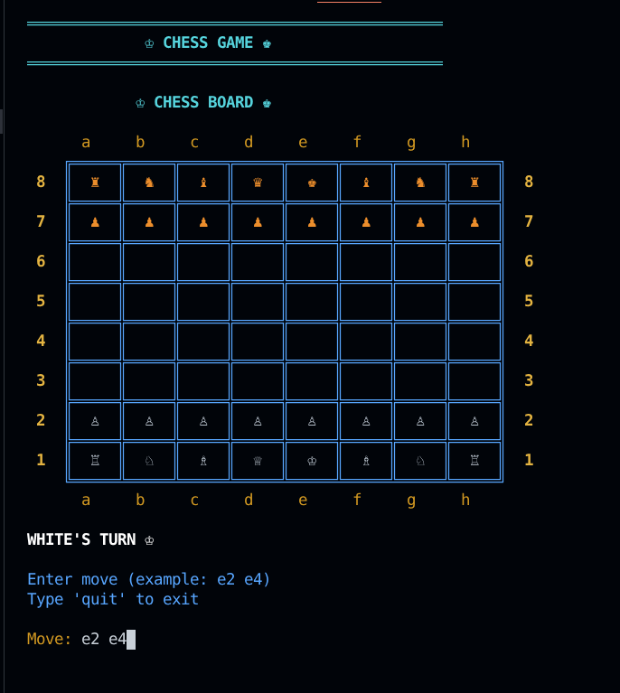

4.4 Check and Checkmate Notification
When a player's King is placed in check, the message 'Check!' is displayed in yellow. If no legal move can escape the check, the game announces 'Checkmate!' and names the winning side in green text.

Check!
Checkmate! White wins!

5. Conclusion
This project successfully demonstrates the application of Object-Oriented Programming principles in building a non-trivial, interactive C++ application. Every feature — from piece movement validation and check/checkmate detection to the colour-coded terminal interface — was implemented using classes, inheritance, polymorphism, and encapsulation.

The project reinforced the value of clean class design: separating concerns into dedicated classes (Position, Piece hierarchy, Board, ChessGame, Console, Menu, Style) made the codebase readable, extensible, and easy to debug. The abstract Piece base class and runtime polymorphism through virtual functions were particularly powerful — adding a new piece type would require only a new derived class with no changes to the Board or game-loop logic.

Through this project, M. Hamza and M. Ishaq gained hands-on experience with class hierarchies, virtual dispatch, raw pointer management, manual memory allocation and deallocation, cross-platform C++ code, and terminal UI design.

Possible Future Enhancements
- En passant and castling move support.
- Pawn promotion to any desired piece.
- Stalemate detection.
- AI opponent using the Minimax algorithm.
- Graphical user interface using a library such as SFML or SDL2.
- Game save and load functionality.

— End of Report —

