

**Welcome to KAP Irwanto, Hary dan Usman**

**History**

KAP Drs. Irwanto, a registered public accountant was formed in Year 1993 as the great response for assisting business society challenging various issues in business activities that need a professional touch. In Year 2017, the firm changed its name into KAP Irwanto, Hary dan Usman (IHU Firm).

For the need of high quality services for clients, we maintain to perform services based on respective client’s problems and objectives. Supporting by high professional personnel and strongly understand of client’s business entities, we will be able to share significant contributions for enhancing client’s business performance and efficiency.

Our commitment for providing excellent services reflected on the increasing demand upon our services from several business entities in field of banking, manufacture, mining, timber industry, insurance, hospital and health care, telecommunication, non-profit organization, trading, services, etc.



**Message from Our Managing Partner –**

**Irwanto, SE. Ak., CA., CPA., CRA.**

Since the foundation, KAP Irwanto, Hary dan Usman, has aimed to be a trusted Auditing, Accounting, Management Consulting, Taxation, Training and Human Resource Development, and Public-Sector Services. We have placed value on the Independency and offer high-quality and specialized services.

In our firm, all the team members communicate closely with clients, have discussions from multiple perspectives and offer tailored advice and professional service. Managers and Partners not only check the conclusions formed by staff but also visit on site by themselves before giving appropriate advices suitable to clients’ situations.

Our auditing team consists of CPAs with high experience and all the team members exchanges their opinion as a professional within the team. Through discussions, we offer efficient, cost-effective and relationship-focused services. Recent years, business environment around Indonesia has changed drastically.

The ASEAN integration is attracting more business activities specially in Accounting and Auditing. To deal with these rapid changes, KAP Irwanto, Hary dan Usman is the right partner to share and get consulting services from us to meet your demands as our clients and we offer high-quality Auditing, Accounting, Management Consulting, Taxation, Training and Human Resource Development, and Public-Sector Services.

Best Regards,

Irwanto

Management

***Partners***

**Irwanto, SE. Ak., CA., CPA., CRA.**

Irwanto is the Managing Partner and founder of KAP Irwanto, Hary dan Usman, a Registered Public Accountant Firm and has involved in accounting practice for more than 30 years. His depth experiences as an auditor and consultant in accounting, taxation, system development and other field of management have indicated his competency and qualification as a reliable professional associate.

**Hary Suganda, SE., Ak., CPA., CA., BKP.**

Hary is a signing partner and co-founder of KAP Irwanto, Hary dan Usman and has involved in accounting, auditing and tax practice for more than 30 years. Previously, he is a managing partner in his own firm named KAP Hary Suganda. Currently he leads the branch office of KAP Irwanto, Hary dan Usman in Depok.

**Usman, SE., CPA., CA.**

Usman is a signing partner and co-founder of KAP Irwanto, Hary dan Usman and has involved in auditing for more than 30 years. He has involved in many kinds of clients and industries.

**Endy Rochim, SE., CPA.**

Endy is a signing partner of KAP Irwanto, Hary dan Usman and has involved in accounting and auditing for more than 20 years. He earned his Bachelor Degree in Accounting from STIE YKPN Yogyakarta.

**Rudi R, SE., MM., Ak., CA., CPA., ACPA.**

Rudi is a signing partner of KAP Irwanto, Hary dan Usman and he has had expertise in Assurance and Accounting fields for more than 17 years, both in Audit Firm and Commercial Areas. He earned his Bachelor Degree in Accounting and Master Degree in Financial Management, both from Universitas Tarumanagara.

Licenses

***Licenses***

– Public Accounting Firm License, issued by Ministry of Finance No. Kep-080/KM.17/1999 and Kep-1170/KM.17/1998. The latest updates No. 967/KM.1/2016

– Public Accountant License No.98.1.0555 and Public Accountant Firm License No.99.2.0296. The latest updates No. AP.0432

– Drs. Irwanto is registered as a member at FORUM AKUNTAN PASAR MODAL with letter No. APM-139 issued by IKATAN AKUNTAN INDONESIA on 22 May 1995.

– Drs. Irwanto is registered as a partner at Kejaksaan Agung with letter No. B-202/F.FS/02.2000 issued by Kejaksaan Agung Republik Indonesia Jakarta on 25 February 2000.

– Drs. Irwanto is registered at BAPEPAM with letter No. 273/PM/STTD-AP/2000 issued by Departemen Keuangan Republik Indonesia, Badan Pengawas Pasar Modal on 8 November 2000.

– Drs. Irwanto is registered at Bank Indonesia with letter No. 4/254/DPIP/DtB issued by Bank Indonesia on 5 August 2002.

– Drs. Irwanto is registered as a partner at Badan Pemeriksa Keuangan with letter No. 041/STT/V/2009 issued by Badan Pemeriksa Keuangan Republik Indonesia on 5 May 2009.

– Drs. Irwanto is registered as a partner at Bank MANDIRI with letter No. RMN.CRP/CRE.775/2009 issued by PT Bank Mandiri (Persero) Tbk on 30 June 2009.

– Based on Tax Director General Decree KEP-00084/WPJ.04/KP.0503/1999, Drs. Irwanto has been registered in Kantor Pelayanan Pajak Pratama Jakarta Kramatjati with tax number (NPWP): 06.726.620.5-005.000.

Our Values, Vision, and Mission

***Our Vision***

 Become a strategic partner of choice for our clients.

***Our Values***

We support and promotes all the values and principles in the way we provide our services that reflects:  
  
– Quality  
– Always strive for excellence through evaluation and continuous improvement.

***Our Mission***

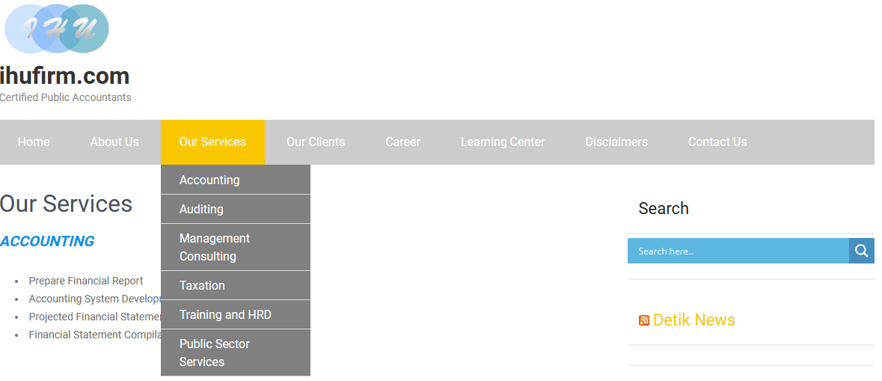

Our Services

***ACCOUNTING***

* Prepare Financial Report
* Accounting System Development
* Projected Financial Statement
* Financial Statement Compilations and Review

***AUDITING***

* Financial Statement Audit
* Special Audit
* Due Diligence
* Compliance Audit
* Performance Audit
* Comprehensive Audit
* Management Audit

***MANAGEMENT*** ***CONSULTING***

* Corporate Planning
* Financial Restructuring
* Operational Reviews
* Budget Preparation
* Financial Feasibility Studies

***TAXATION***

* Taxation Consulting
* Corporate Tax Planning and Review
* Tax Audit Representation
* Arrangement Tax Return

***TRAINING*** ***AND HUMAN RESOURCE DEVELOPMENT***

* Accounting / Auditing Training
* Taxation Training
* Outsourcing Search

***PUBLIC SECTOR SERVICES***

* Budget Preparation
* Accounting System Development
* Financial Report Preparation
* Implementation of Risk Based Management
* Risk Based Audit



Our Clients

***Our Clients’ Industries***

* Consumer products
* Industrial & manufacturing
* Public infrastructure
* Travel agency
* Insurance
* Plantation
* Banking and capital markets
* Pension funds
* Media & entertainment
* Hospital
* Transportation
* Real estate
* Pharmaceutical
* Automotive
* Non-government & not-for-profit organization
* Micro and Small Enterprises Project



Career

***Our Human Resources***

We realize that human resource is the most valuable asset for our profession. Therefore, we have strong commitment for developing our human resources.

We have specialist who expert in their field of Accounting, Auditing, Financial Consultant, Taxation and Management Consultant. Most of our key personnel have reach more than 10 years working experience in their respective area.

Regularly, we accompany our talented staffs in various professions’ education and training program, seminar and workshop. Besides, we also conduct in house training for our staff and simultaneously the staff could enhance their ability while running the assignment as well.

***Open vacant positions***

– [Junior Auditor](http://www.ihufirm.com/index.php/career/junior-auditor)

– [Senior Auditor](http://www.ihufirm.com/index.php/career/senior-auditor)

– [Senior Consultant](http://www.ihufirm.com/index.php/career/senior-consultant)

Junior Auditor

***Junior Auditor***

Requirements:

* Bachelor in Accounting from reputable university (Fresh graduate, D3 / S1)
* GPA min 2,75
* Able to work in a team
* Willing to work in multi task job, fast learner, well-organized, hard worker, and detailed
* Able to work under pressure
* Willing to work overtime and out of the town (when needed)
* Have a good communication skill
* Have a good and professional personality
* Fluent in English both written and verbal
* Able to work using Ms. Office (Word, Excel) and using Internet

Send your CV to : [hrd@ihufirm.com](mailto:hrd@ihufirm.com)

Senior Auditor

***Senior Auditor***

Requirements**:**

* Bachelor in Accounting from reputable university (S1)
* GPA min 2,75
* Able to work in a team
* Willing to work in multi task job, fast learner, well-organized, hard worker, and detailed
* Able to work under pressure
* Minimum 5 year working experience as a Senior Auditor at Accounting Firm
* Willing to work overtime and out of the town (when needed)
* Able to work individually (minimum supervision) or as a part of team.
* Have a good communication skill
* Have a good and professional personality
* Fluent in English both written and verbal
* Able to work using Ms. Office (Word, Excel) and using Internet

Send your CV to :  [hrd@ihufirm.com](mailto:hrd@ihufirm.com)

Senior Consultant

***Senior*** ***Consultant***

Requirements:

* Bachelor Degree in Accounting from reputable university with GPA min 3.0;
* Minimum 5 year working experience as a Senior Auditor at Accounting Firm
* Willing to work in multi task job, fast learner, well-organized, hard worker, and detailed
* Able to work under pressure
* Willing to work overtime and out of the town (when needed)
* Proficient with Visio and flowcharting techniques
* Strong understanding of business process, financial information system and related internal control
* Have strong communication skills
* Have a good and professional personality
* Knowledge of telecom business processes is a plus
* Fluent in English both written and verbal

Send your CV to : [hrd@ihufirm.com](mailto:hrd@ihufirm.com)





Disclaimers

***DISCLAIMER***

Thank you for visiting KAP Irwanto, Hary dan Usman’s website. The information contained in this website, each of useful links and resources section of this site is intended as general information and therefore it is not intended to be, nor should it be construed to be legal advice whatsoever. You should not rely on any information contained herein in evaluating any specific legal issues you may have. Given the changing nature of laws, rules, government regulations, executorial regulations, and local bylaw products, there may be delays, omissions or inaccuracies in the information contained in this site, therefore KAP Irwanto, Hary dan Usman does not represent that the information in each of useful links and resources section of this site is accurate, verified, or current. For this reason, you are hereby should neither relay nor act upon any of the information contained in these pages and, if you do so, it shall be entirely at your own risk. KAP Irwanto, Hary dan Usman does not and will not consider or treat any unsolicited e-mails or information sent to KAP Irwanto, Hary dan Usman or to any of our staff by persons seeking advice or other non-clients to be confidential and the firm reserves the unconditional right to disclose or use any such unsolicited e-mails or information for any purpose. Do not send KAP Irwanto, Hary dan Usman information about your issues until you speak to the KAP Irwanto, Hary dan Usman’s authorized staff and get authorization to do so. Your use of KAP Irwanto, Hary dan Usman’s website and/or sending e-mail to KAP Irwanto, Hary dan Usman or one of KAP Irwanto, Hary dan Usman’s staff does not create a firm-client relationship. A firm-client relationship is not created except by a written acknowledgment of an engagement signed by one of the founders of KAP Irwanto, Hary dan Usman.

For your convenience, KAP Irwanto, Hary dan Usman’s website may contain links to other third-party sites. KAP Irwanto, Hary dan Usman does not endorse or verify the accuracy of information on those sites and does not responsible for the contents of any of these third-party resources. The inclusion of such link on this site does not imply the endorsement, recommendation or approval of that site by KAP Irwanto, Hary dan Usman.



