**RESIDENTIAL PROPERTY RENTAL SYSTEM**

The Residential Property Rental System is a database system designed to manage rental properties, renters, owners, and booking details within the real estate domain. It serves as a centralized platform to facilitate the renting process for residential properties, ensuring smooth interactions between property owners and renters.

**ER DIAGRAM:**

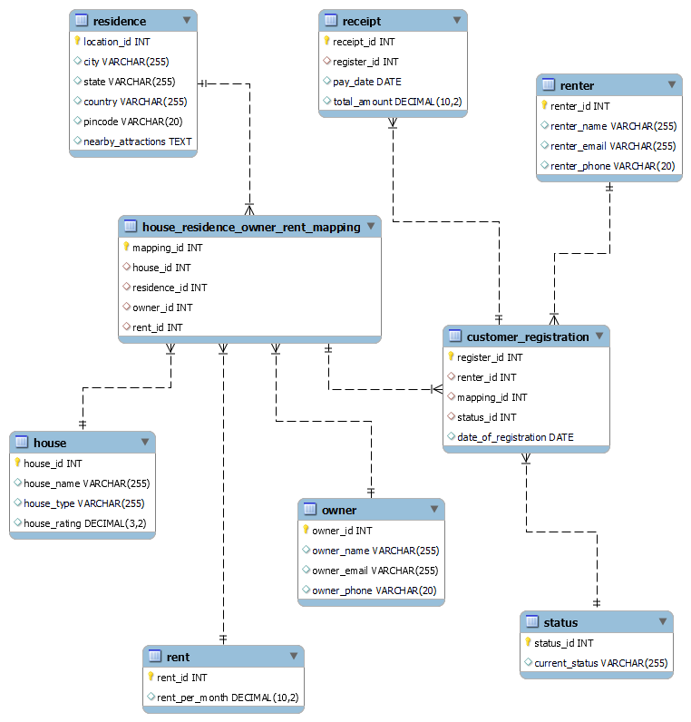

***Table Attributes, Data Types, and Constraints:***

**House Table:**

| **Field** | **Data Type** | **Constraints** |
| --- | --- | --- |
| house_id | INT | Primary Key |
| house_name | VARCHAR |  |
| house_type | VARCHAR |  |
| house_rating | DECIMAL(3,2) |  |

**Residence Table:**

| **Field** | **Data Type** | **Constraints** |
| --- | --- | --- |
| location_id | INT | Primary Key |
| city | VARCHAR |  |
| state | VARCHAR |  |
| country | VARCHAR |  |
| pincode | VARCHAR |  |
| nearby_attractions | TEXT |  |

**Rent Table:**

| **Field** | **Data Type** | **Constraints** |
| --- | --- | --- |
| rent_id | INT | Primary Key |
| rent_per_month | DECIMAL(10,2) |  |

**Owner Table:**

| **Field** | **Data Type** | **Constraints** |
| --- | --- | --- |
| owner_id | INT | Primary Key |
| owner_name | VARCHAR |  |
| owner_email | VARCHAR |  |
| owner_phone | VARCHAR |  |

**Renter Table:**

| **Field** | **Data Type** | **Constraints** |
| --- | --- | --- |
| renter_id | INT | Primary Key |
| renter_name | VARCHAR |  |
| renter_email | VARCHAR |  |
| renter_phone | VARCHAR |  |

**Status Table:**

| **Field** | **Data Type** | **Constraints** |
| --- | --- | --- |
| status_id | INT | Primary Key |
| current_status | VARCHAR |  |

**House Residence Owner Rent Mapping Table:**

| **Field** | **Data Type** | **Constraints** |
| --- | --- | --- |
| mapping_id | INT | Primary Key |
| house_id | INT | Foreign Key (House) |
| residence_id | INT | Foreign Key (Residence) |
| owner_id | INT | Foreign Key (Owner) |
| rent_id | INT | Foreign Key (Rent) |

**Customer Registration Table:**

| **Field** | **Data Type** | **Constraints** |
| --- | --- | --- |
| register_id | INT | Primary Key |
| renter_id | INT | Foreign Key (Renter) |
| mapping_id | INT | Foreign Key (Mapping) |
| status_id | INT | Foreign Key (Status) |
| date_of_registration | DATE |  |

**Receipt Table:**

| **Field** | **Data Type** | **Constraints** |
| --- | --- | --- |
| receipt_id | INT | Primary Key |
| register_id | INT | Foreign Key (Registration) |
| pay_date | DATE |  |
| total_amount | DECIMAL(10,2) |  |