به نام خدا

Project : Adam 4017

|  |  |
| --- | --- |
| ITEM | NEEDED |
| Analog input channel | 8 differential |
| Type input  Input range | V and mA  +-10 V and +-20 mA |
| Output  Speed  Maximum distance | RS-485  1200,2400,4800,9600,19.2k,38.4k,57.6k,115.2k  1.2Km |
| Isolation voltage | 3000 Vdc |
| Resolution | 16 bit |
| Sample rate | Normal mode 10 samples/second  Fast mode 100 samples/second |
| Accuracy | +-0.1 % |
| Zero drift  Spann drift | +- 6 uV/C  +-25 ppm |
| CMR | 120 dB |
| Protocol | MODBUS RTU  MODBUS ASCI |
| Watchdog timer | Selectable between 10 msecond – 2 second |
| Power | 10 – 36 Vdc |

System view

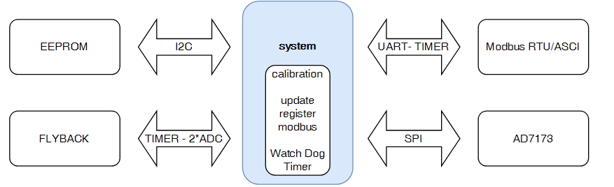

Process code

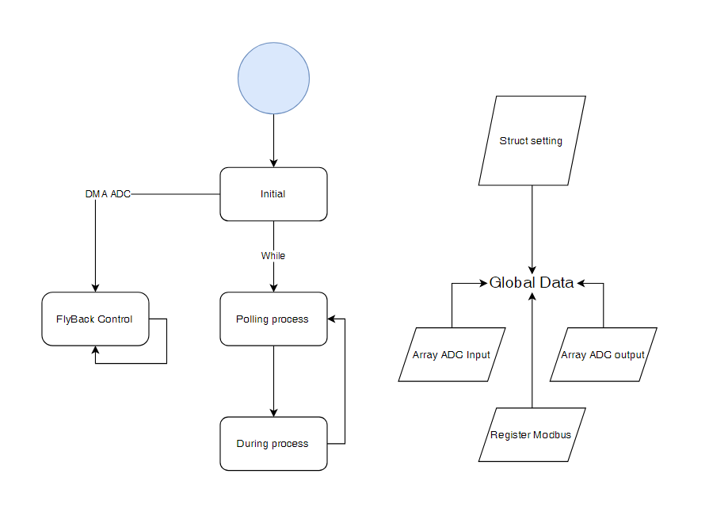

Modbus map register

|  |  |  |  |  |
| --- | --- | --- | --- | --- |
| ADDR 4X | Channel | Item | Attribute | Memo |
| 40001 | 0 | Channel Value | R | 0-65536 |
| 40002 | 1 | Channel Value | R | 0-65536 |
| 40003 | 2 | Channel Value | R | 0-65536 |
| 40004 | 3 | Channel Value | R | 0-65536 |
| 40005 | 4 | Channel Value | R | 0-65536 |
| 40006 | 5 | Channel Value | R | 0-65536 |
| 40007 | 6 | Channel Value | R | 0-65536 |
| 40008 | 7 | Channel Value | R | 0-65536 |
|  |  |  |  |  |
| 40011 | 0 | Type Code | R/W | 0x00 = I – 0x01 =V |
| 40012 | 1 | Type Code | R/W | 0x00 = I – 0x01 =V |
| 40013 | 2 | Type Code | R/W | 0x00 = I – 0x01 =V |
| 40014 | 3 | Type Code | R/W | 0x00 = I – 0x01 =V |
| 40015 | 4 | Type Code | R/W | 0x00 = I – 0x01 =V |
| 40016 | 5 | Type Code | R/W | 0x00 = I – 0x01 =V |
| 40017 | 6 | Type Code | R/W | 0x00 = I – 0x01 =V |
| 40018 | 7 | Type Code | R/W | 0x00 = I – 0x01 =V |
|  |  |  |  |  |
| 40021 |  | Module name1 | R | 0x40 0x17 |
| 40022 |  | Module name1 | R | 0x50 0x00 |
| 40023 |  | Version1 | R | 0x00 0x01 |
| 40024 |  | Version2 | R | 0x00 0x01 |
|  |  |  |  |  |
| 40025 |  | Channel Enable | R/W | 0x00 0xff |
| 40026 |  | Slave Address | R/W | 1 - 247 |
| 40027 |  | Baud rate | R/W | Default = 0x03  0x00 = 1200  0x01 = 2400  0x02 = 4800  0x03 = 9600  0x04 = 19200  0x05 = 38400  0x06 = 57600  0x07 = 115200 |
| 40028 |  | Watch Dog | R/W | 0x10 0x00 |
| 40029 |  | Error | R | 0 - 65535 |
| 40030 |  | Enable Calibrate | R/W | 0 = Disable Calibrate  1 = Enable Calibrate |

|  |  |  |  |  |
| --- | --- | --- | --- | --- |
| ADDR 4X | Channel | Item | Attribute | Memo |
| 40031 | 0 | Start Calibrate Voltage Point1 | R/W | 0 – 1 |
| 40032 | 0 | Set Calibrate Voltage Value Point1 | R/W | 0 – 65535 |
| 40033 | 0 | Start Calibrate Voltage Point2 | R/W | 0 – 1 |
| 40034 | 0 | Set Calibrate Voltage Value Point2 | R/W | 0 – 65535 |
| 40035 | 0 | Start Calibrate Voltage Point3 | R/W | 0 – 1 |
| 40036 | 0 | Set Calibrate Voltage Value Point3 | R/W | 0 – 65535 |
| 40037 | 0 | Start Calibrate Voltage Point4 | R/W | 0 – 1 |
| 40038 | 0 | Set Calibrate Voltage Value Point4 | R/W | 0 – 65535 |
| 40039 | 0 | Start Calibrate Voltage Point5 | R/W | 0 – 1 |
| 40040 | 0 | Set Calibrate Voltage Value Point5 | R/W | 0 – 65535 |
| 40041 | 1 | Start Calibrate Voltage Point1 | R/W | 0 – 1 |
| 40042 | 1 | Set Calibrate Voltage Value Point1 | R/W | 0 – 65535 |
| 40043 | 1 | Start Calibrate Voltage Point2 | R/W | 0 – 1 |
| 40044 | 1 | Set Calibrate Voltage Value Point2 | R/W | 0 – 65535 |
| 40045 | 1 | Start Calibrate Voltage Point3 | R/W | 0 – 1 |
| 40046 | 1 | Set Calibrate Voltage Value Point3 | R/W | 0 – 65535 |
| 40047 | 1 | Start Calibrate Voltage Point4 | R/W | 0 – 1 |
| 40048 | 1 | Set Calibrate Voltage Value Point4 | R/W | 0 – 65535 |
| 40049 | 1 | Start Calibrate Voltage Point5 | R/W | 0 – 1 |
| 40050 | 1 | Set Calibrate Voltage Value Point5 | R/W | 0 – 65535 |
| 40051 | 2 | Start Calibrate Voltage Point1 | R/W | 0 – 1 |
| 40052 | 2 | Set Calibrate Voltage Value Point1 | R/W | 0 – 65535 |
| 40053 | 2 | Start Calibrate Voltage Point2 | R/W | 0 – 1 |
| 40054 | 2 | Set Calibrate Voltage Value Point2 | R/W | 0 – 65535 |
| 40055 | 2 | Start Calibrate Voltage Point3 | R/W | 0 – 1 |
| 40056 | 2 | Set Calibrate Voltage Value Point3 | R/W | 0 – 65535 |
| 40057 | 2 | Start Calibrate Voltage Point4 | R/W | 0 – 1 |
| 40058 | 2 | Set Calibrate Voltage Value Point4 | R/W | 0 – 65535 |
| 40059 | 2 | Start Calibrate Voltage Point5 | R/W | 0 – 1 |
| 40060 | 2 | Set Calibrate Voltage Value Point5 | R/W | 0 – 65535 |
| 40061 | 3 | Start Calibrate Voltage Point1 | R/W | 0 – 1 |
| 40062 | 3 | Set Calibrate Voltage Value Point1 | R/W | 0 – 65535 |
| 40063 | 3 | Start Calibrate Voltage Point2 | R/W | 0 – 1 |
| 40064 | 3 | Set Calibrate Voltage Value Point2 | R/W | 0 – 65535 |
| 40065 | 3 | Start Calibrate Voltage Point3 | R/W | 0 – 1 |
| 40066 | 3 | Set Calibrate Voltage Value Point3 | R/W | 0 – 65535 |
| 40067 | 3 | Start Calibrate Voltage Point4 | R/W | 0 – 1 |
| 40068 | 3 | Set Calibrate Voltage Value Point4 | R/W | 0 – 65535 |
| 40069 | 3 | Start Calibrate Voltage Point5 | R/W | 0 – 1 |
| 40070 | 3 | Set Calibrate Voltage Value Point5 | R/W | 0 – 65535 |

|  |  |  |  |  |
| --- | --- | --- | --- | --- |
| ADDR 4X | Channel | Item | Attribute | Memo |
| 40071 | 4 | Start Calibrate Voltage Point1 | R/W | 0 – 1 |
| 40072 | 4 | Set Calibrate Voltage Value Point1 | R/W | 0 – 65535 |
| 40073 | 4 | Start Calibrate Voltage Point2 | R/W | 0 – 1 |
| 40074 | 4 | Set Calibrate Voltage Value Point2 | R/W | 0 – 65535 |
| 40075 | 4 | Start Calibrate Voltage Point3 | R/W | 0 – 1 |
| 40076 | 4 | Set Calibrate Voltage Value Point3 | R/W | 0 – 65535 |
| 40077 | 4 | Start Calibrate Voltage Point4 | R/W | 0 – 1 |
| 40078 | 4 | Set Calibrate Voltage Value Point4 | R/W | 0 – 65535 |
| 40079 | 4 | Start Calibrate Voltage Point5 | R/W | 0 – 1 |
| 40080 | 4 | Set Calibrate Voltage Value Point5 | R/W | 0 – 65535 |
| 40081 | 5 | Start Calibrate Voltage Point1 | R/W | 0 – 1 |
| 40082 | 5 | Set Calibrate Voltage Value Point1 | R/W | 0 – 65535 |
| 40083 | 5 | Start Calibrate Voltage Point2 | R/W | 0 – 1 |
| 40084 | 5 | Set Calibrate Voltage Value Point2 | R/W | 0 – 65535 |
| 40085 | 5 | Start Calibrate Voltage Point3 | R/W | 0 – 1 |
| 40086 | 5 | Set Calibrate Voltage Value Point3 | R/W | 0 – 65535 |
| 40087 | 5 | Start Calibrate Voltage Point4 | R/W | 0 – 1 |
| 40088 | 5 | Set Calibrate Voltage Value Point4 | R/W | 0 – 65535 |
| 40089 | 5 | Start Calibrate Voltage Point5 | R/W | 0 – 1 |
| 40090 | 5 | Set Calibrate Voltage Value Point5 | R/W | 0 – 65535 |
| 40091 | 6 | Start Calibrate Voltage Point1 | R/W | 0 – 1 |
| 40092 | 6 | Set Calibrate Voltage Value Point1 | R/W | 0 – 65535 |
| 40093 | 6 | Start Calibrate Voltage Point2 | R/W | 0 – 1 |
| 40094 | 6 | Set Calibrate Voltage Value Point2 | R/W | 0 – 65535 |
| 40095 | 6 | Start Calibrate Voltage Point3 | R/W | 0 – 1 |
| 40096 | 6 | Set Calibrate Voltage Value Point3 | R/W | 0 – 65535 |
| 40097 | 6 | Start Calibrate Voltage Point4 | R/W | 0 – 1 |
| 40098 | 6 | Set Calibrate Voltage Value Point4 | R/W | 0 – 65535 |
| 40099 | 6 | Start Calibrate Voltage Point5 | R/W | 0 – 1 |
| 40100 | 7 | Start Calibrate Voltage Point1 | R/W | 0 – 65535 |
| 40101 | 7 | Set Calibrate Voltage Value Point1 | R/W | 0 – 1 |
| 40102 | 7 | Start Calibrate Voltage Point2 | R/W | 0 – 65535 |
| 40103 | 7 | Set Calibrate Voltage Value Point2 | R/W | 0 – 1 |
| 40104 | 7 | Start Calibrate Voltage Point3 | R/W | 0 – 65535 |
| 40105 | 7 | Set Calibrate Voltage Value Point3 | R/W | 0 – 1 |
| 40106 | 7 | Start Calibrate Voltage Point4 | R/W | 0 – 65535 |
| 40107 | 7 | Set Calibrate Voltage Value Point4 | R/W | 0 – 1 |
| 40108 | 7 | Start Calibrate Voltage Point5 | R/W | 0 – 65535 |
| 40109 | 7 | Set Calibrate Voltage Value Point5 | R/W | 0 – 1 |
| 40110 | 7 | Start Calibrate Voltage Point1 | R/W | 0 – 65535 |

|  |  |  |  |  |
| --- | --- | --- | --- | --- |
| ADDR 4X | Channel | Item | Attribute | Memo |
| 40111 | 0 | Start Calibrate Current Point1 | R/W | 0 – 1 |
| 40112 | 0 | Set Calibrate Current Value Point1 | R/W | 0 – 65535 |
| 40113 | 0 | Start Calibrate Current Point2 | R/W | 0 – 1 |
| 40114 | 0 | Set Calibrate Current Value Point2 | R/W | 0 – 65535 |
| 40115 | 0 | Start Calibrate Current Point3 | R/W | 0 – 1 |
| 40116 | 0 | Set Calibrate Current Value Point3 | R/W | 0 – 65535 |
| 40117 | 0 | Start Calibrate Current Point4 | R/W | 0 – 1 |
| 40118 | 0 | Set Calibrate Current Value Point4 | R/W | 0 – 65535 |
| 40119 | 0 | Start Calibrate Current Point5 | R/W | 0 – 1 |
| 40120 | 0 | Set Calibrate Current Value Point5 | R/W | 0 – 65535 |
| 40121 | 1 | Start Calibrate Current Point1 | R/W | 0 – 1 |
| 40122 | 1 | Set Calibrate Current Value Point1 | R/W | 0 – 65535 |
| 40123 | 1 | Start Calibrate Current Point2 | R/W | 0 – 1 |
| 40124 | 1 | Set Calibrate Current Value Point2 | R/W | 0 – 65535 |
| 40125 | 1 | Start Calibrate Current Point3 | R/W | 0 – 1 |
| 40126 | 1 | Set Calibrate Current Value Point3 | R/W | 0 – 65535 |
| 40127 | 1 | Start Calibrate Current Point4 | R/W | 0 – 1 |
| 40128 | 1 | Set Calibrate Current Value Point4 | R/W | 0 – 65535 |
| 40129 | 1 | Start Calibrate Current Point5 | R/W | 0 – 1 |
| 40130 | 1 | Set Calibrate Current Value Point5 | R/W | 0 – 65535 |
| 40131 | 2 | Start Calibrate Current Point1 | R/W | 0 – 1 |
| 40132 | 2 | Set Calibrate Current Value Point1 | R/W | 0 – 65535 |
| 40133 | 2 | Start Calibrate Current Point2 | R/W | 0 – 1 |
| 40134 | 2 | Set Calibrate Current Value Point2 | R/W | 0 – 65535 |
| 40135 | 2 | Start Calibrate Current Point3 | R/W | 0 – 1 |
| 40136 | 2 | Set Calibrate Current Value Point3 | R/W | 0 – 65535 |
| 40137 | 2 | Start Calibrate Current Point4 | R/W | 0 – 1 |
| 40138 | 2 | Set Calibrate Current Value Point4 | R/W | 0 – 65535 |
| 40139 | 2 | Start Calibrate Current Point5 | R/W | 0 – 1 |
| 40140 | 2 | Set Calibrate Current Value Point5 | R/W | 0 – 65535 |
| 40141 | 3 | Start Calibrate Current Point1 | R/W | 0 – 1 |
| 40142 | 3 | Set Calibrate Current Value Point1 | R/W | 0 – 65535 |
| 40143 | 3 | Start Calibrate Current Point2 | R/W | 0 – 1 |
| 40144 | 3 | Set Calibrate Current Value Point2 | R/W | 0 – 65535 |
| 40145 | 3 | Start Calibrate Current Point3 | R/W | 0 – 1 |
| 40146 | 3 | Set Calibrate Current Value Point3 | R/W | 0 – 65535 |
| 40147 | 3 | Start Calibrate Current Point4 | R/W | 0 – 1 |
| 40148 | 3 | Set Calibrate Current Value Point4 | R/W | 0 – 65535 |
| 40149 | 3 | Start Calibrate Current Point5 | R/W | 0 – 1 |
| 40150 | 3 | Set Calibrate Current Value Point5 | R/W | 0 – 65535 |

|  |  |  |  |  |
| --- | --- | --- | --- | --- |
| ADDR 4X | Channel | Item | Attribute | Memo |
| 40151 | 4 | Start Calibrate Current Point1 | R/W | 0 – 1 |
| 40152 | 4 | Set Calibrate Current Value Point1 | R/W | 0 – 65535 |
| 40153 | 4 | Start Calibrate Current Point2 | R/W | 0 – 1 |
| 40154 | 4 | Set Calibrate Current Value Point2 | R/W | 0 – 65535 |
| 40155 | 4 | Start Calibrate Current Point3 | R/W | 0 – 1 |
| 40156 | 4 | Set Calibrate Current Value Point3 | R/W | 0 – 65535 |
| 40157 | 4 | Start Calibrate Current Point4 | R/W | 0 – 1 |
| 40158 | 4 | Set Calibrate Current Value Point4 | R/W | 0 – 65535 |
| 40159 | 4 | Start Calibrate Current Point5 | R/W | 0 – 1 |
| 40160 | 4 | Set Calibrate Current Value Point5 | R/W | 0 – 65535 |
| 40161 | 5 | Start Calibrate Current Point1 | R/W | 0 – 1 |
| 40162 | 5 | Set Calibrate Current Value Point1 | R/W | 0 – 65535 |
| 40163 | 5 | Start Calibrate Current Point2 | R/W | 0 – 1 |
| 40164 | 5 | Set Calibrate Current Value Point2 | R/W | 0 – 65535 |
| 40165 | 5 | Start Calibrate Current Point3 | R/W | 0 – 1 |
| 40166 | 5 | Set Calibrate Current Value Point3 | R/W | 0 – 65535 |
| 40167 | 5 | Start Calibrate Current Point4 | R/W | 0 – 1 |
| 40168 | 5 | Set Calibrate Current Value Point4 | R/W | 0 – 65535 |
| 40169 | 5 | Start Calibrate Current Point5 | R/W | 0 – 1 |
| 40170 | 5 | Set Calibrate Current Value Point5 | R/W | 0 – 65535 |
| 40171 | 6 | Start Calibrate Current Point1 | R/W | 0 – 1 |
| 40172 | 6 | Set Calibrate Current Value Point1 | R/W | 0 – 65535 |
| 40173 | 6 | Start Calibrate Current Point2 | R/W | 0 – 1 |
| 40174 | 6 | Set Calibrate Current Value Point2 | R/W | 0 – 65535 |
| 40175 | 6 | Start Calibrate Current Point3 | R/W | 0 – 1 |
| 40176 | 6 | Set Calibrate Current Value Point3 | R/W | 0 – 65535 |
| 40177 | 6 | Start Calibrate Current Point4 | R/W | 0 – 1 |
| 40178 | 6 | Set Calibrate Current Value Point4 | R/W | 0 – 65535 |
| 40179 | 6 | Start Calibrate Current Point5 | R/W | 0 – 1 |
| 40180 | 6 | Set Calibrate Current Value Point5 | R/W | 0 – 65535 |
| 40181 | 7 | Start Calibrate Current Point1 | R/W | 0 – 1 |
| 40182 | 7 | Set Calibrate Current Value Point1 | R/W | 0 – 65535 |
| 40183 | 7 | Start Calibrate Current Point2 | R/W | 0 – 1 |
| 40184 | 7 | Set Calibrate Current Value Point2 | R/W | 0 – 65535 |
| 40185 | 7 | Start Calibrate Current Point3 | R/W | 0 – 1 |
| 40186 | 7 | Set Calibrate Current Value Point3 | R/W | 0 – 65535 |
| 40187 | 7 | Start Calibrate Current Point4 | R/W | 0 – 1 |
| 40188 | 7 | Set Calibrate Current Value Point4 | R/W | 0 – 65535 |
| 40189 | 7 | Start Calibrate Current Point5 | R/W | 0 – 1 |
| 40190 | 7 | Set Calibrate Current Value Point5 | R/W | 0 – 65535 |

|  |  |  |  |  |
| --- | --- | --- | --- | --- |
| ADDR 4X | Channel | Item | Attribute | Memo |
| 40191 | 0 | Error scale or offset in calibration | R | 0 – 1023 |
| 40192 | 1 | Error scale or offset in calibration | R | 0 – 1023 |
| 40193 | 2 | Error scale or offset in calibration | R | 0 – 1023 |
| 40194 | 3 | Error scale or offset in calibration | R | 0 – 1023 |
| 40195 | 4 | Error scale or offset in calibration | R | 0 – 1023 |
| 40196 | 5 | Error scale or offset in calibration | R | 0 – 1023 |
| 40197 | 6 | Error scale or offset in calibration | R | 0 – 1023 |
| 40198 | 7 | Error scale or offset in calibration | R | 0 – 1023 |
|  |  |  |  |  |
|  |  |  |  |  |