# Leaderboard Submission Guidelines

Download Files

[Data_Dictionary.csv](http://localhost/AnalyzeThis16/campusactivity/down16loads/Data_Dictionary.xlsx) | [Training_Dataset.csv](http://localhost/AnalyzeThis16/campusactivity/down16loads/Training_Dataset.csv) | [Leaderboard_Dataset.csv](http://localhost/AnalyzeThis16/campusactivity/down16loads/Leaderboard_Dataset.csv)|   
  
[Final_Dataset.csv](http://localhost/AnalyzeThis16/campusactivity/down16loads/Final_Dataset.csv) | [2017_Submission_Deck.pptx](http://localhost/AnalyzeThis16/campusactivity/down16loads/2016_Submission_Deck.pptx)

The Leaderboard is an open avenue to test out various models that you build and also to compare as to how well you are faring against competition.  
  
Teams can upload their estimates for Leaderboard_Dataset.csv to the Leader board using the Submit your Solution Tab in the American Express Campus Analyze This website and you will be instantly evaluated and given a score based on your submission.  
  
The score based on your best submission thus far will be used to give you a rank, which will help you figure out how well you are performing with respect to other teams.  
  
Important points to note:

1. Submission needs to be made in a .CSV (comma separated values) format. Any other format would not be accepted.
2. Submission with any incorrect cm_key or blank entries or prediction with any other value apart from **Supp, Elite, or Credit** would not be accepted.

Further details on CSV format upload are given below.

Final Submission Guidelines

There is only one submission allowed for the Final dataset, so please be sure of your solution before you submit. You would need to submit 2 things for the final submission:

1. **Solution for the Final Dataset**. Please ensure the order of cm_key is exactly as you planned.
2. **Solution in the form of Power Point Presentation**. Format for the same is available on this page.

Leaderboard and Final dataset solution CSV Format

Please follow these steps for both the leader board submissions and the final submissions.

1. The order of the cm_keys is very important – the evaluation will occur in this order only.
2. The first column should be the cm_key in order to indicate which customer this offer must be extended to. **DO NOT LABEL THE COLUMN**.
3. Second column should be the offer category. Possible values of offer extensions are:

* **Supp= extend a supplementary card offer to this customer**
* **Elite = extend an elite card offer to this customer**
* **Credit = extend a credit card offer to this customer**

1. Name the file as <Team Name>_<Campus Name>_<Attempt number>.csv. For e.g. a team with name "Champions" from IIT Delhi with attempt number 7 will name the file as Champions_IITDelhi_7.csv

(attempt number is not required for final submission)

1. Save the file in a .csv format. NO OTHER FORMAT IS PERMITTED.
2. Go to Submit your Solution tab. Follow the instructions to upload your .csv file.

*A sample solution .csv file is available at the end of this document.*   
For converting an Excel file to a .csv file, you can refer to: <http://office.microsoft.com/en-in/excel-help/import-or-export-text-txt-or-csv-files-HP010099725.aspx#BMexport>  
SIMPLY RENAMING THE FILE EXTENSION WILL NOT WORK!

Final Presentation Format

The solution logic has to be submitted only for the final dataset responses.

1. You have to submit your solution in the form of Power Point Presentation, which you can download from this page.
2. You will name the presentation in the form of <Team Name>_<Campus>.pptx. E.g. If your team name is Ninja and you are from IIT Kanpur, the name of your PPT would be Ninja_IITKanpur.pptx.
3. After downloading the presentation template from the webpage, you will have to fill all its pages and then upload it on the Submit your solution tab.

Evaluation Criteria

Leader board Submission

The main operational expense for the bank is each call made to customers. One call increases expense by $6. On each call the bank advises only one card offer: Elite card, Supplementary card or Credit Card.

With a budget of $6,000, you can maximize the bank’s profit by suggesting calls to the right customers and extending the right offers. If the bank advises the wrong offer to a customer who ends up inquiring and then still accepting an alternate card offer, it costs $12 for the call since double the time is spent in explaining the two offers.

Your leader board submission will be evaluated as:

1. You start with a budget of $6000.
2. Each call will reduce the remaining budget by $6 or $12 as explained below.
3. Evaluation will be done in the order of your submission file.
4. Evaluation will stop once the budget runs out.
5. For every call advised the scoring logic is:
   1. If you advise the correct offer to a customer, it costs $6 for the call and the score for that call will be 100.
   2. If you advise a call to a customer who is not interested in any one of the offers, it costs $6 for the call and the score for the call will be 0.
   3. If you advise the wrong offer to a customer who ends up accepting an alternate card offer, it costs $12 for the call and the score for the call will be 100.

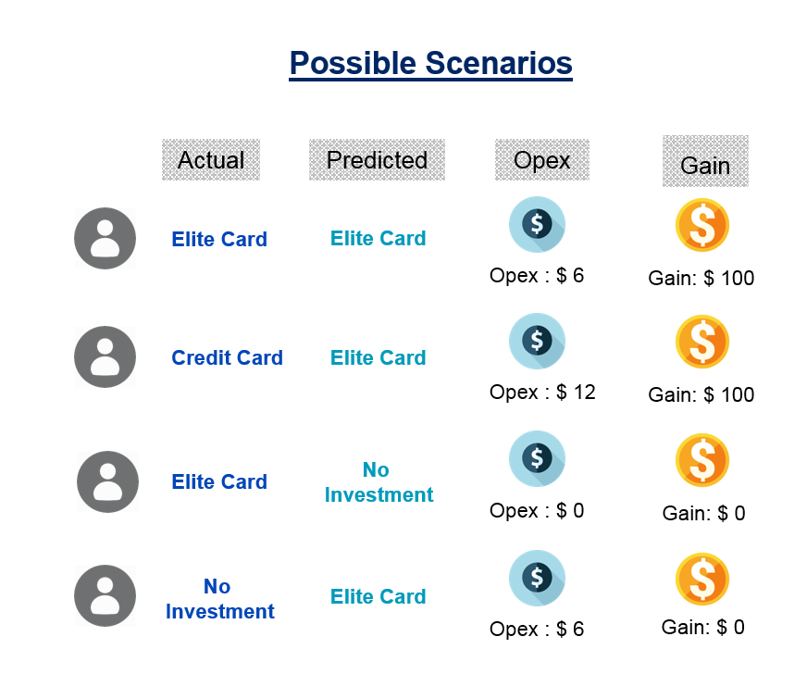

Few points to note:

* As the budget is $6,000, you can make a maximum of 1000 calls.
* The order of the cm_keys is critical as that is the order in which the evaluation will occur.
* The submission will be scored in the order of list provided by you and will stop at the point where you will be left with no budget and the score at that point will be the leaderboard score for that submission.

Your final score will depend on the following parameters

1. 20% weight for highest score achieved on Leaderboard submission
2. 60% weight for score achieved on Final Dataset
3. 20% weight for the technique(s) chosen and the associated reasons for the same

A panel of senior American Express Leaders will be judging the competition. Their decision on all matters will be final and binding.

Any questions regarding the evaluation format/submission guidelines must be sent to the American Express Campus Analyze This Team at amexindiacampus@aexp.com, mentioning “Analyze This Submissions: Query" in the subject line. We will be happy to reply to all your queries/questions.

# Submit your Solution

## Leaderboard and Final dataset solution CSV

Please submit your solution in CSV format. You must name the file as <Team Name> _ <Campus Name> _ <Attempt number> .csv. e.g. A team with name "Champions" from IIT Delhi with attempt number 7 will name the file as Champions _IITDelhi_7.csv (attempt number is not required for final submission)

## Final Presentation

Please submit your solution in MS PowerPoint 2007 format. You must name the presentation in the form of <Team Name> _ <Campus Name> .pptx. E.g. If your team name is Kanpur and you are from IIT Kanpur, so the name of your PPT would be Ninja_IITKanpur.pptx. You can download the Sample CSV solution and blank Submission Deck from the Submission Guidelines section.