
Don’t Crash!!
6G4Z0020 Programming


Marlene JADE KOSSONOU
24825695

Player class:
- - this line declares a variable named ‘playerImage’ of type ‘PImage’. ‘PImage’ is a class used to handle images.
- - this line defines a new class named ‘player’. A class is like a blueprint for creating objects (in this case, players).
- 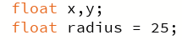- these lines declare 2 variables ‘x’ and ‘y’ which will hold the x and y coordinates of the player. The variable ‘radius’ is set to a value of 25. This represents the radius the player.
- 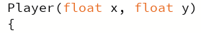 - this is the constructor for the ‘player’ class. It takes 2 parameters, ‘x’ and ‘y’, and it initialises the player’s coordinates with these values.
- 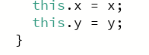- these line sets the player’s x coordinate and y coordinate to the value passed into the constructor.
- - this is a method named ‘display’ that belongs to the ‘player’ class. It will be used to display the player on the screen.
- - this line sets the image mode to ‘CENTER’, meaning the image will be drawn centred at the specified coordinates.
- 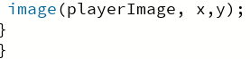- this line draws the ‘playerImage’ at the player’s x and y coordinates.
The purpose of this code is to create a ‘player’ object can be displayed on the screen at specific coordinates using an image. The ‘player’ class encapsulates the player’s positions and provides a method to display the player using an image.

Obstacle class:
- - this line declares a variable named ‘obstacleImage’ of type ‘Pimage’. It will be used to hold the image for the obstacle.
- 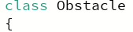- this line defines a new class called ‘obstacle’. Classes are templates for creating objects, and in this case, they represent obstacles in a game.
- 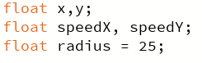- the variables ‘x’ and ‘y’ coordinates of the obstacle. The variables ‘speedX’ and ‘speedY’ represent the speed of the obstacles in the x and y directions. The variable ‘radius’ is set to a value of 25 which represents the size of the obstacle for collision detection.
- - this is the constructor for the ‘obstacle’ class, which takes 2 parameters, ‘startX’ and ‘startY’ to initialise the obstacles position.
- 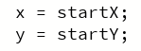- these lines set the obstacle’s x and y coordinates based on the values passed to the constructor.
- 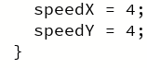- these lines initialise the obstacle’s speed in both directions.
- - this method updated the obstacle’s position based on its speed.
- 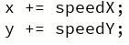- here the obstacle’s position is updated by adding it’s speed to the current coordinates.
- 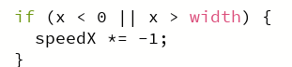- this checks if the obstacles has hit the left or right of the screen. If so, it reverses the speed in the x direction.
- 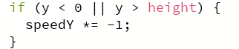- similarly, this checks for collision with the top and bottom edges of the screen and reverses the speed in the y direction.
- 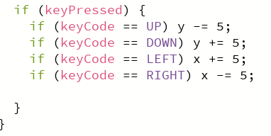- this piece of code allows the user to control the obstacle’s movement using the arrow keys.
- - this method displays the obstacle on screen.
- 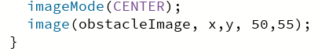- this sets the image mode to center and draws the obstacle image at its x and y coordinates with a width of 50 and height of 55.
- - this method checks for collision between the player and the obstacle.
- - this calculates the distance between the obstacle and the player.
- 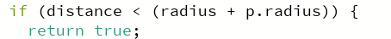- if the distance is less than the sum of the radius the obstacle and player, a collision has occurred and returns it as true. If there is no collision then it returns it as false.
The purpose of this class is to create an ‘obstacle’ object that can move around the screen, bounce off the edges, and be controlled by the user. It also includes functionality to check for collisions with the ‘player’ object.

Main class:
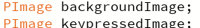- these lines declare variables for images used in the game. One is for the background and one is for the when the keys are pressed.
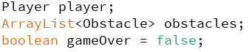- the first line declares a player object. The second line declares an ArrayList to store obstacle objects. The third line initialises a Boolean variable to track if the game is over.
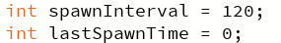- these lines sets the interval for how often new obstacles are spawned and keeps track of the last time an obstacle spawned.
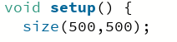- this is the setup function called once when the program starts. It sets the size of the game window to 500x500 pixels.
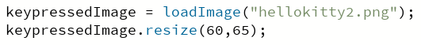- this loads the image when the key is pressed and sets the image size to my desired size which is 60x65 pixels.
- this loads the background image of my game.
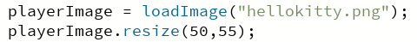- this loads the player image and sets it to 50x55 pixels.
- this lods the obstacle image.
- here I created a new player object in the position 250,250 which is the middle of the screen.
- this initialises the obstacles ArrayList.
- this a loop that runs 5 times to create initial obstacles.
- this adds a new obstacle at a random position within the game window.
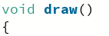- this is the draw function called repeatedly to create the game loop.
- this checks if the game is over
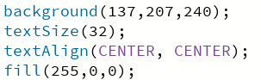- these lines make the game over sign that pops up when the player loses the game. The first line sets the colour of the background, the second sets the text size, the third makes sure the text is aligned in the centre of the screen and the last line sets the colour of the text.
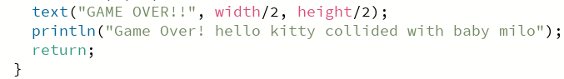- this displays “GAME OVER!!” in the centre of the screen and prints a game over message to the console which them exits the draw function if the game is over.
- this line draws the image background.
- this calls the display method of the player object to draw it on the screen.
- this checks if it’s time to spawn a new obstacle.
- this adds a new obstacle at a random position and updates the last spawn time to current frame count.
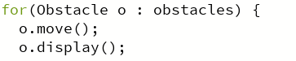- this loops each obstacle, calls the move method pf the obstacle to update its position and calls the display method of the obstacle to draw it on the screen.
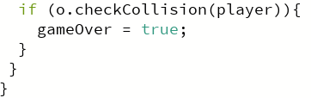- this checks if the obstacle collides with the player and sets gameOver to true if there’s a collision, ending the game.
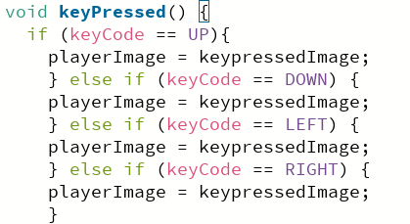- this is a function that is called every time a key is pressed and changes the image when the arrow keys are pressed.
The purpose of this is to create a simple game where the player moves around and tries to avoid obstacles. If the player collides with the obstacle, the game ends with “GAME OVER” message. The code handles setting up the game, displaying the background and player, spawning obstacles at intervals and checking for collisions.

