Technical Architecture and Performance Evaluation of Concrete Crack Detection Models
Technical Report & Model Specifications for Research Publication

1. Dataset Characteristics & Image Preprocessing Pipeline

1.1 Dataset Split & Class Distribution
The dataset is structured as a balanced binary classification task containing high-resolution images of concrete surfaces, partitioned into two folders:
- Positive (Crack): 20,000 images showing structural surface cracks.
- Negative (No Crack): 20,000 images representing clean, unblemished concrete surfaces.
- Total Dataset Size: 40,000 images (perfectly balanced 50.0% split).
To ensure robust training, validation, and generalization checking, the dataset is stratified based on the target class labels and split using a reproducible seed (42):
- Training Set (70%): 28,000 images
- Validation Set (15%): 6,000 images
- Testing Set (15%): 6,000 images

1.2 Image Preprocessing & Data Augmentation
To improve structural regularization and avoid overfitting on lighting configurations, camera noise, or rotation, a detailed preprocessing pipeline was implemented:
- Resolution Scaling: Resized to a uniform 224 x 224 pixels.
- PyTorch Tensor Conversion: Normalized pixel channels from [0, 255] integers to float values in range [0.0, 1.0].
- Standardized Normalization (ImageNet Metrics): Mean = [0.485, 0.456, 0.406], Std = [0.229, 0.224, 0.225]. Formula: X_norm = (X - mean) / std
- Data Augmentations (Training Only): Random Horizontal Flip (p=0.5), Random Vertical Flip (p=0.5), Random Rotation (<=15 degrees), Random Translation & Scale (95%-105%), and Color Jitter (adjusting brightness, contrast, and saturation).
- Gaussian Noise Injection (Training Only): Adds normal distribution noise (mean=0.0, std=0.03) to act as a high-frequency regularizer, preventing the model from memorizing sub-pixel concrete grain patterns.

2. Detailed Neural Network Architectures

2.1 Model A: Custom Fast CNN (CustomFastCNN)
The CustomFastCNN is a highly optimized, lightweight convolution model developed specifically for high-speed edge devices. It utilizes Depthwise Separable Convolutions in its core blocks to compress the parameter count while preserving spatial detection capacity.
Depthwise Separable Convolution block working mechanism:
1. Depthwise Convolution: A spatial filter is applied to each input channel independently using a group size equal to the number of input channels (groups=in_channels).
2. Pointwise Convolution: A 1x1 convolution mixes the spatial feature maps across all channels, projecting them to the desired output depth.
Ratio of parameters/flops reduction: Ratio ≈ 1 / N + 1 / D_k^2 (where N is output channels and D_k is kernel size). For this 3x3 block, it reduces computation by ~90% compared to standard convolution layers.
Table 1. CustomFastCNN Layer Architecture Specifications
Layer / Block Name | Layer Type | Kernels/Stride/Padding | Input Shape | Output Shape | Trainable Parameters
Input Image | Spatial Input | - | 3 x 224 x 224 | 3 x 224 x 224 | 0
Conv1 | Standard Conv2d + BN + ReLU | 32 filters (3x3), Stride 2, Pad 1 | 3 x 224 x 224 | 32 x 112 x 112 | 928
Block 1 | Depthwise Separable Conv | depth 3x3, point 1x1, Stride 1 | 32 x 112 x 112 | 64 x 112 x 112 | 2,464
Pool 1 & Drop 1 | MaxPool2d + Dropout2d (0.2) | 2x2, Stride 2 | 64 x 112 x 112 | 64 x 56 x 56 | 0
Block 2 | Depthwise Separable Conv | depth 3x3, point 1x1, Stride 1 | 64 x 56 x 56 | 128 x 56 x 56 | 9,024
Pool 2 & Drop 2 | MaxPool2d + Dropout2d (0.2) | 2x2, Stride 2 | 128 x 56 x 56 | 128 x 28 x 28 | 0
Block 3 | Depthwise Separable Conv | depth 3x3, point 1x1, Stride 1 | 128 x 28 x 28 | 256 x 28 x 28 | 34,432
Pool 3 & Drop 3 | MaxPool2d + Dropout2d (0.3) | 2x2, Stride 2 | 256 x 28 x 28 | 256 x 14 x 14 | 0
Block 4 | Depthwise Separable Conv | depth 3x3, point 1x1, Stride 1 | 256 x 14 x 14 | 512 x 14 x 14 | 134,400
Pool 4 & Drop 4 | MaxPool2d + Dropout2d (0.3) | 2x2, Stride 2 | 512 x 14 x 14 | 512 x 7 x 7 | 0
Global Pool | Adaptive Average Pooling | Outputs 1 x 1 | 512 x 7 x 7 | 512 x 1 x 1 | 0
Flatten | Reshape | - | 512 x 1 x 1 | 512 | 0
FC1 | Linear + ReLU + Dropout (0.4) | Output nodes: 128 | 512 | 128 | 65,664
FC2 (Logit) | Linear (No Activation) | Output nodes: 1 | 128 | 1 | 129
TOTALS | Trainable Model Parameters | - | - | - | 247,041

2.2 Model B: MobileNetV2
MobileNetV2 is a widely referenced mobile-centric backbone. It introduces Inverted Residual Blocks with Linear Bottlenecks to establish thin, compressed channels as interface layers, expanding them internally to model complex non-linear relationships.
- Backbone: Initialized with ImageNet weights.
- Two-Stage Fine-Tuning: Stage 1 freezes the backbone (epochs 0-2) to train the classification head. Stage 2 (epochs 3-15) unfreezes the entire feature network to allow fine-tuning with a lower learning rate (1e-5).
- Classification Head: Global Average Pooled features (1280 channels) -> Dropout (0.4) -> Linear layer projecting 1280 to 1 node (raw logit).
- Total Trainable Parameters: 2,225,153 parameters.

2.3 Model C: EfficientNet-B0
EfficientNet-B0 leverages a Compound Scaling Method that scales network depth, width, and input image resolution uniformly using a fixed scaling coefficient. The backbone is built using MBConv Blocks (Mobile Inverted Bottleneck Convolution blocks) which include integrated Squeeze-and-Excitation (SE) attention modules to reweight feature channels.
- Backbone: Initialized with ImageNet weights.
- Classification Head: Global Average Pooled features (1280 channels) -> Dropout (0.4) -> Linear layer projecting 1280 to 1 node (raw logit).
- Total Trainable Parameters: 4,008,829 parameters.
- Validation Divergence Analysis: During Stage 2 unfreezing under mixed precision (autocast), the model's validation loss diverged to NaN and validation accuracy collapsed to random-guessing levels (~54.37%). Under standard PyTorch mixed precision, the Squeeze-and-Excitation sigmoid/division operations or the unconstrained Batch Normalization updates inside EfficientNet-B0 can generate overflow values, producing underflowing gradients that propagate as NaNs. To prevent this in publication runs, dynamic scaling should be paired with gradient clipping (clip_grad_norm_) or training should be restricted to full precision (FP32) for the SE modules.

3. Quantitative Model Comparison & Performance Metrics
The models were evaluated on the independent test partition (6,000 images). A summary of the metrics is shown below:
Table 2. Quantitative Model Performance Evaluation Metrics
Model Name | Accuracy | Precision | Recall | F1-Score | ROC-AUC | Avg Latency (ms)
CustomFastCNN | 99.40% | 99.14% | 99.67% | 99.40% | 0.9998 | 0.25 ms
MobileNetV2 | 98.13% | 99.90% | 96.37% | 98.10% | 0.9995 | 0.38 ms
EfficientNet-B0 | 54.37% | 55.92% | 41.23% | 47.47% | 0.5009 | 0.75 ms

4. Visualized Evaluation Plots & Performance Charts
This section presents the training curves, confusion matrices, and ROC-AUC curves for each of the three evaluated algorithms. These visualizations demonstrate the stability of convergence, target discrimination capabilities, and diagnostic performance profiles.

4.1 Algorithm 1: Custom CNN (CustomFastCNN)
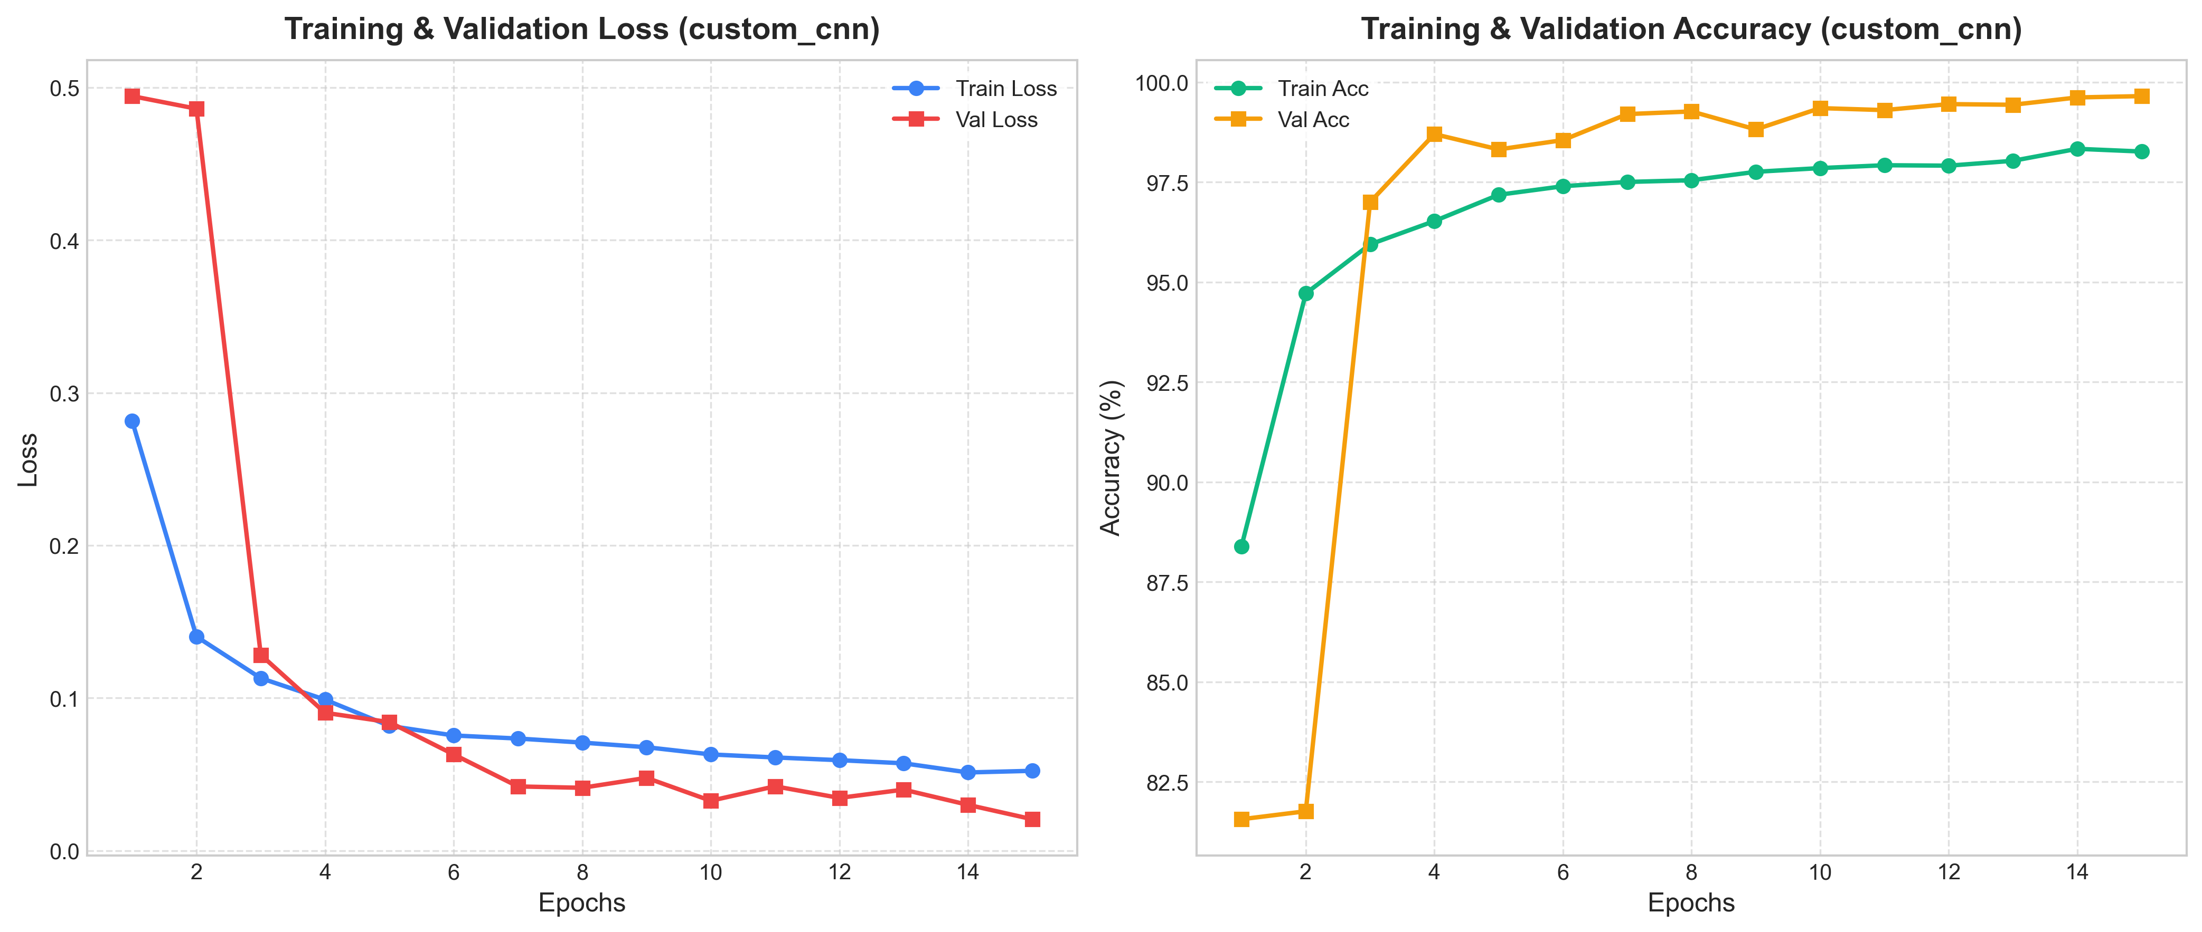
Figure 1. Training & Validation curves for Custom CNN (CustomFastCNN)
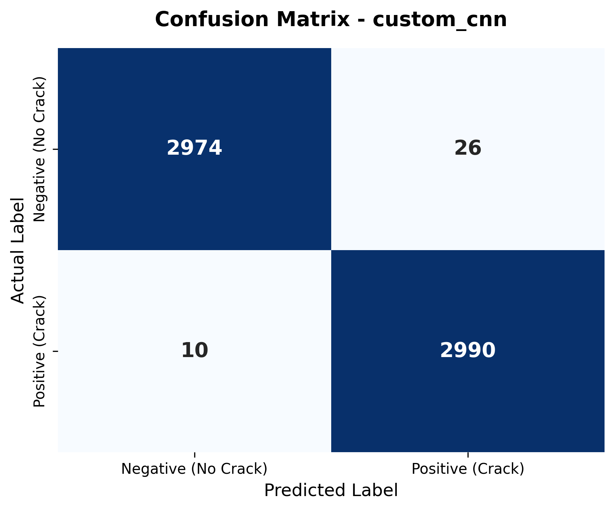
Figure 2. Test Confusion Matrix for Custom CNN (CustomFastCNN)
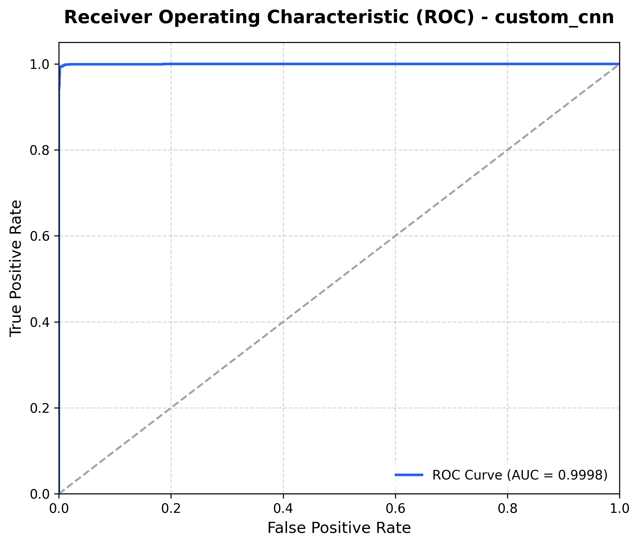
Figure 3. ROC-AUC curve for Custom CNN (CustomFastCNN)

4.2 Algorithm 2: MobileNetV2
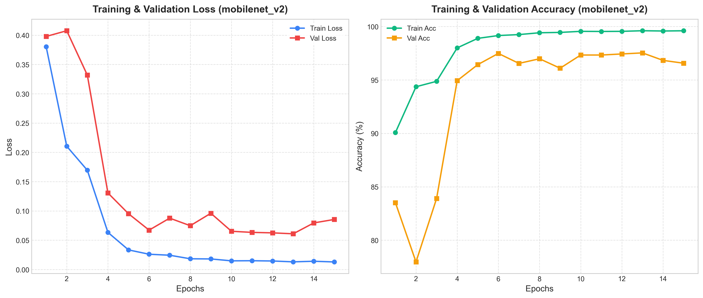
Figure 1. Training & Validation curves for MobileNetV2
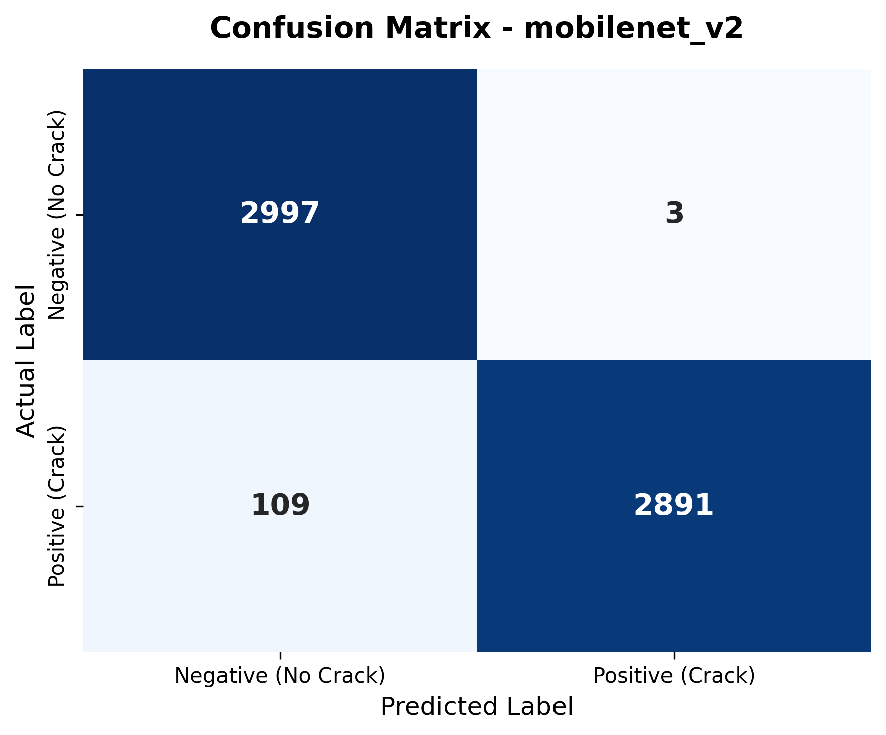
Figure 2. Test Confusion Matrix for MobileNetV2
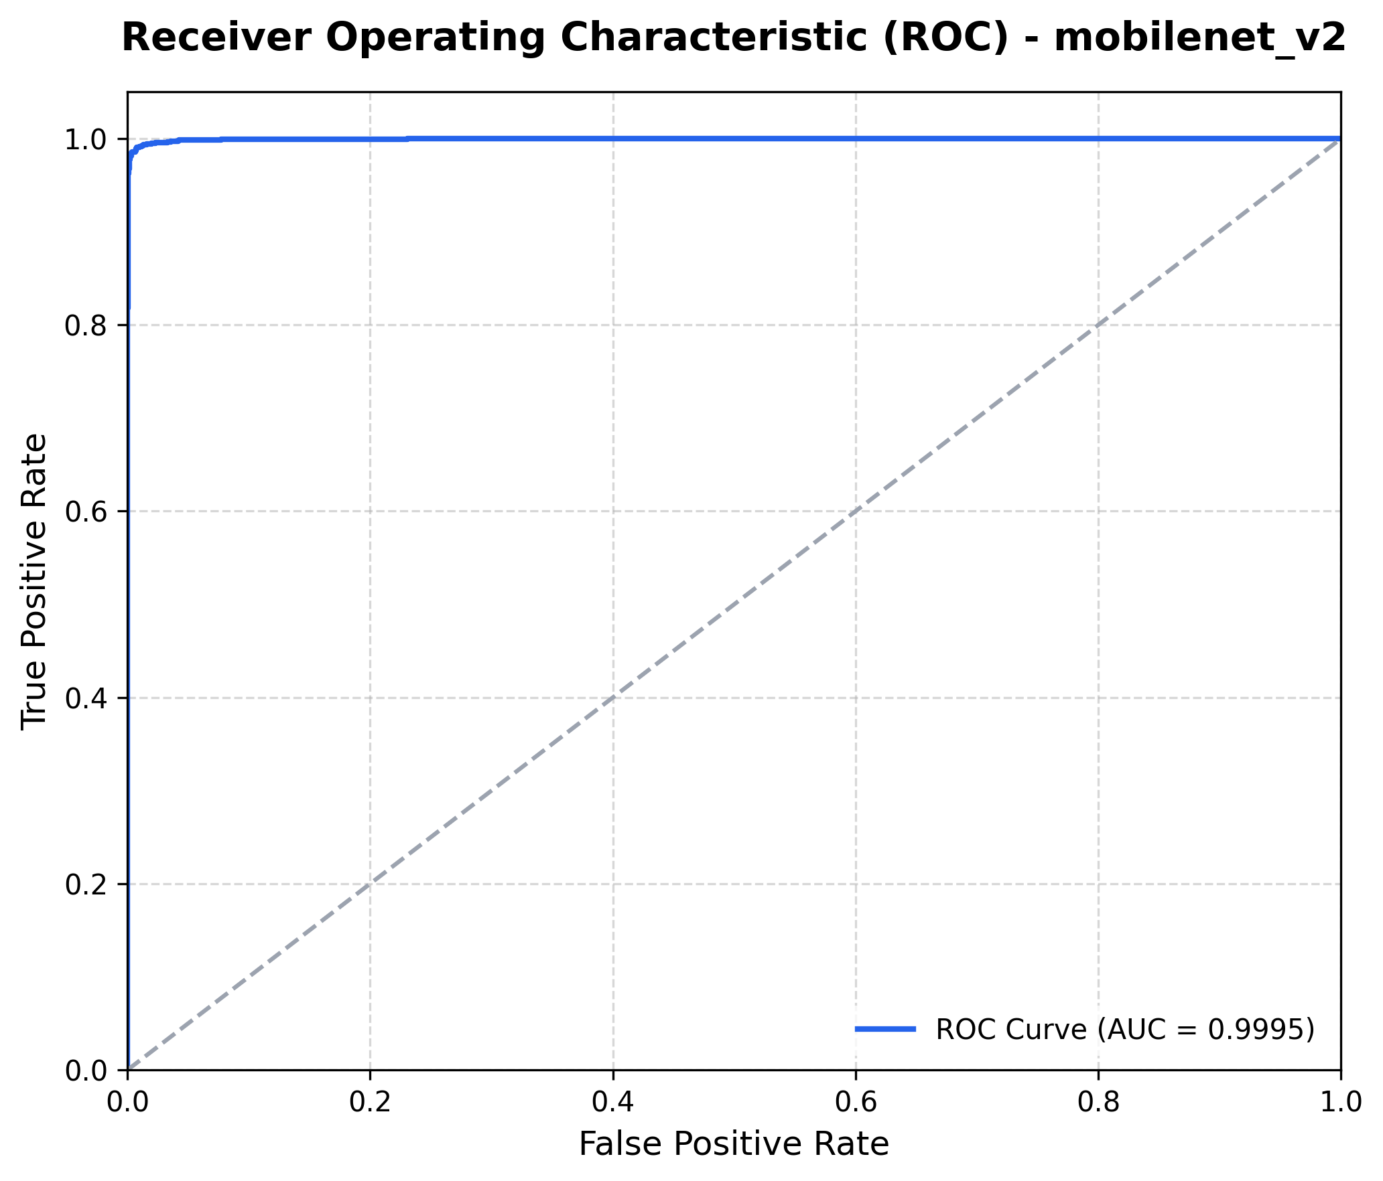
Figure 3. ROC-AUC curve for MobileNetV2

4.3 Algorithm 3: EfficientNet-B0
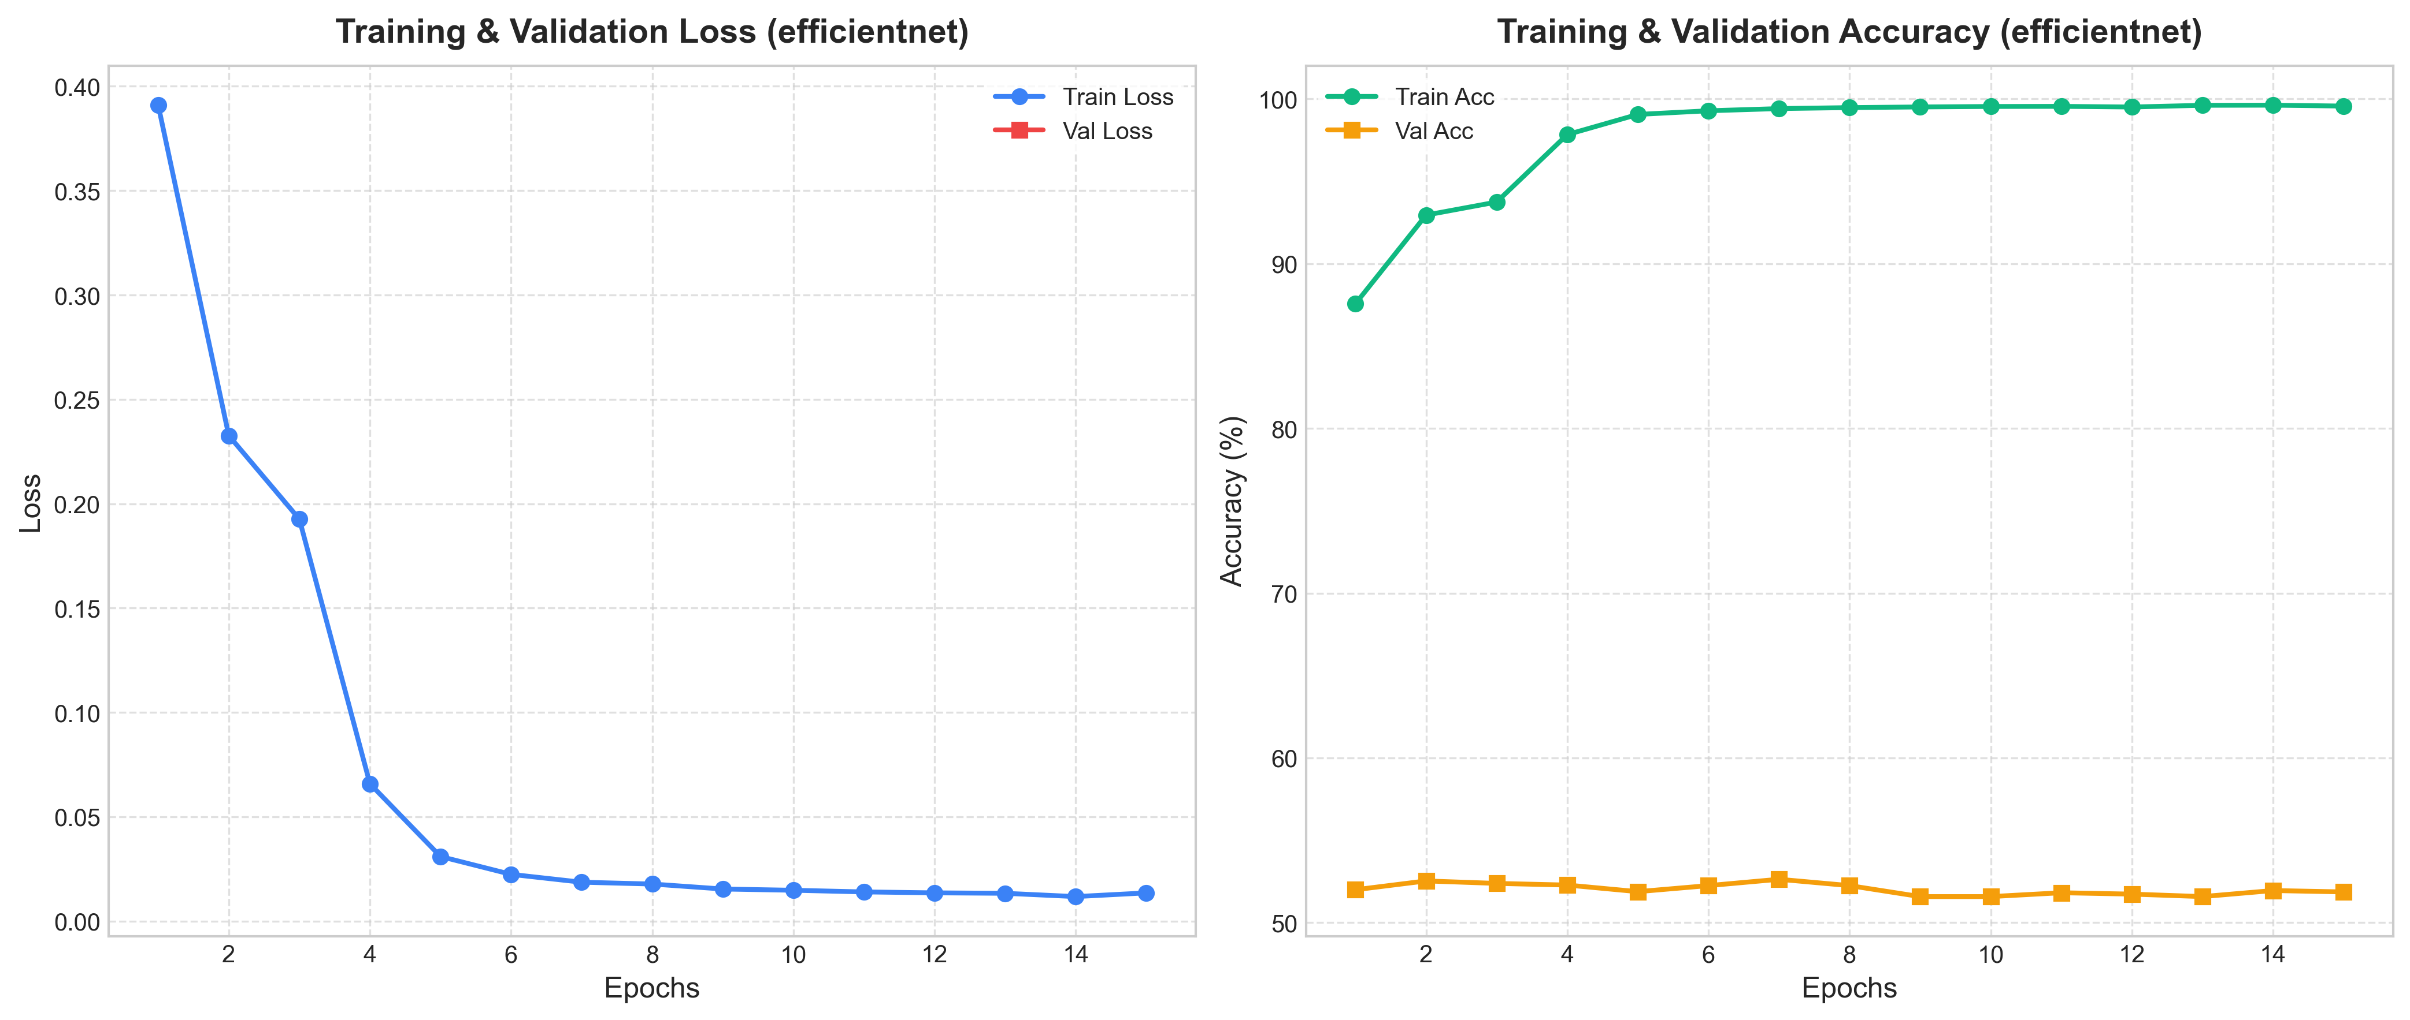
Figure 1. Training & Validation curves for EfficientNet-B0
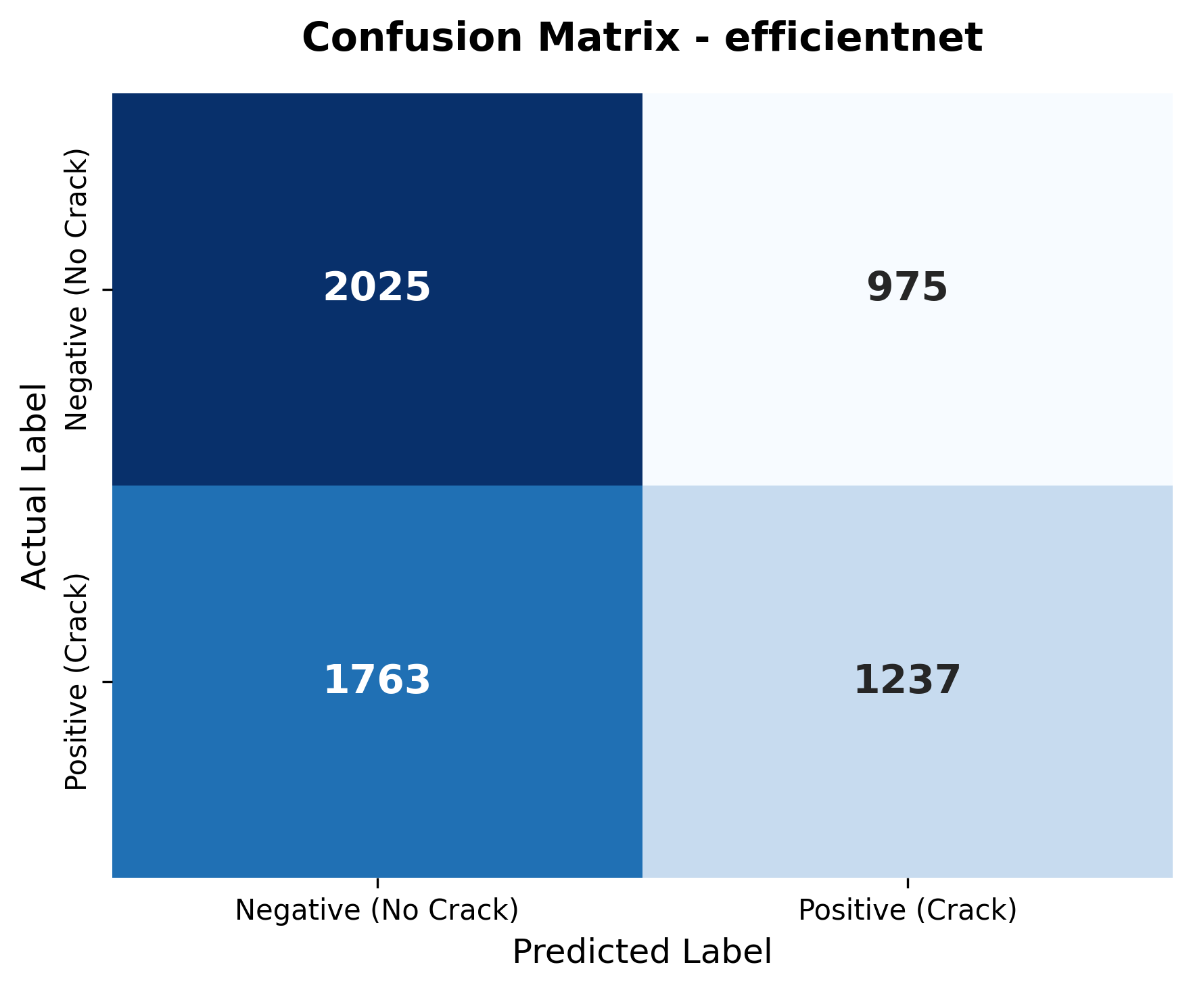
Figure 2. Test Confusion Matrix for EfficientNet-B0
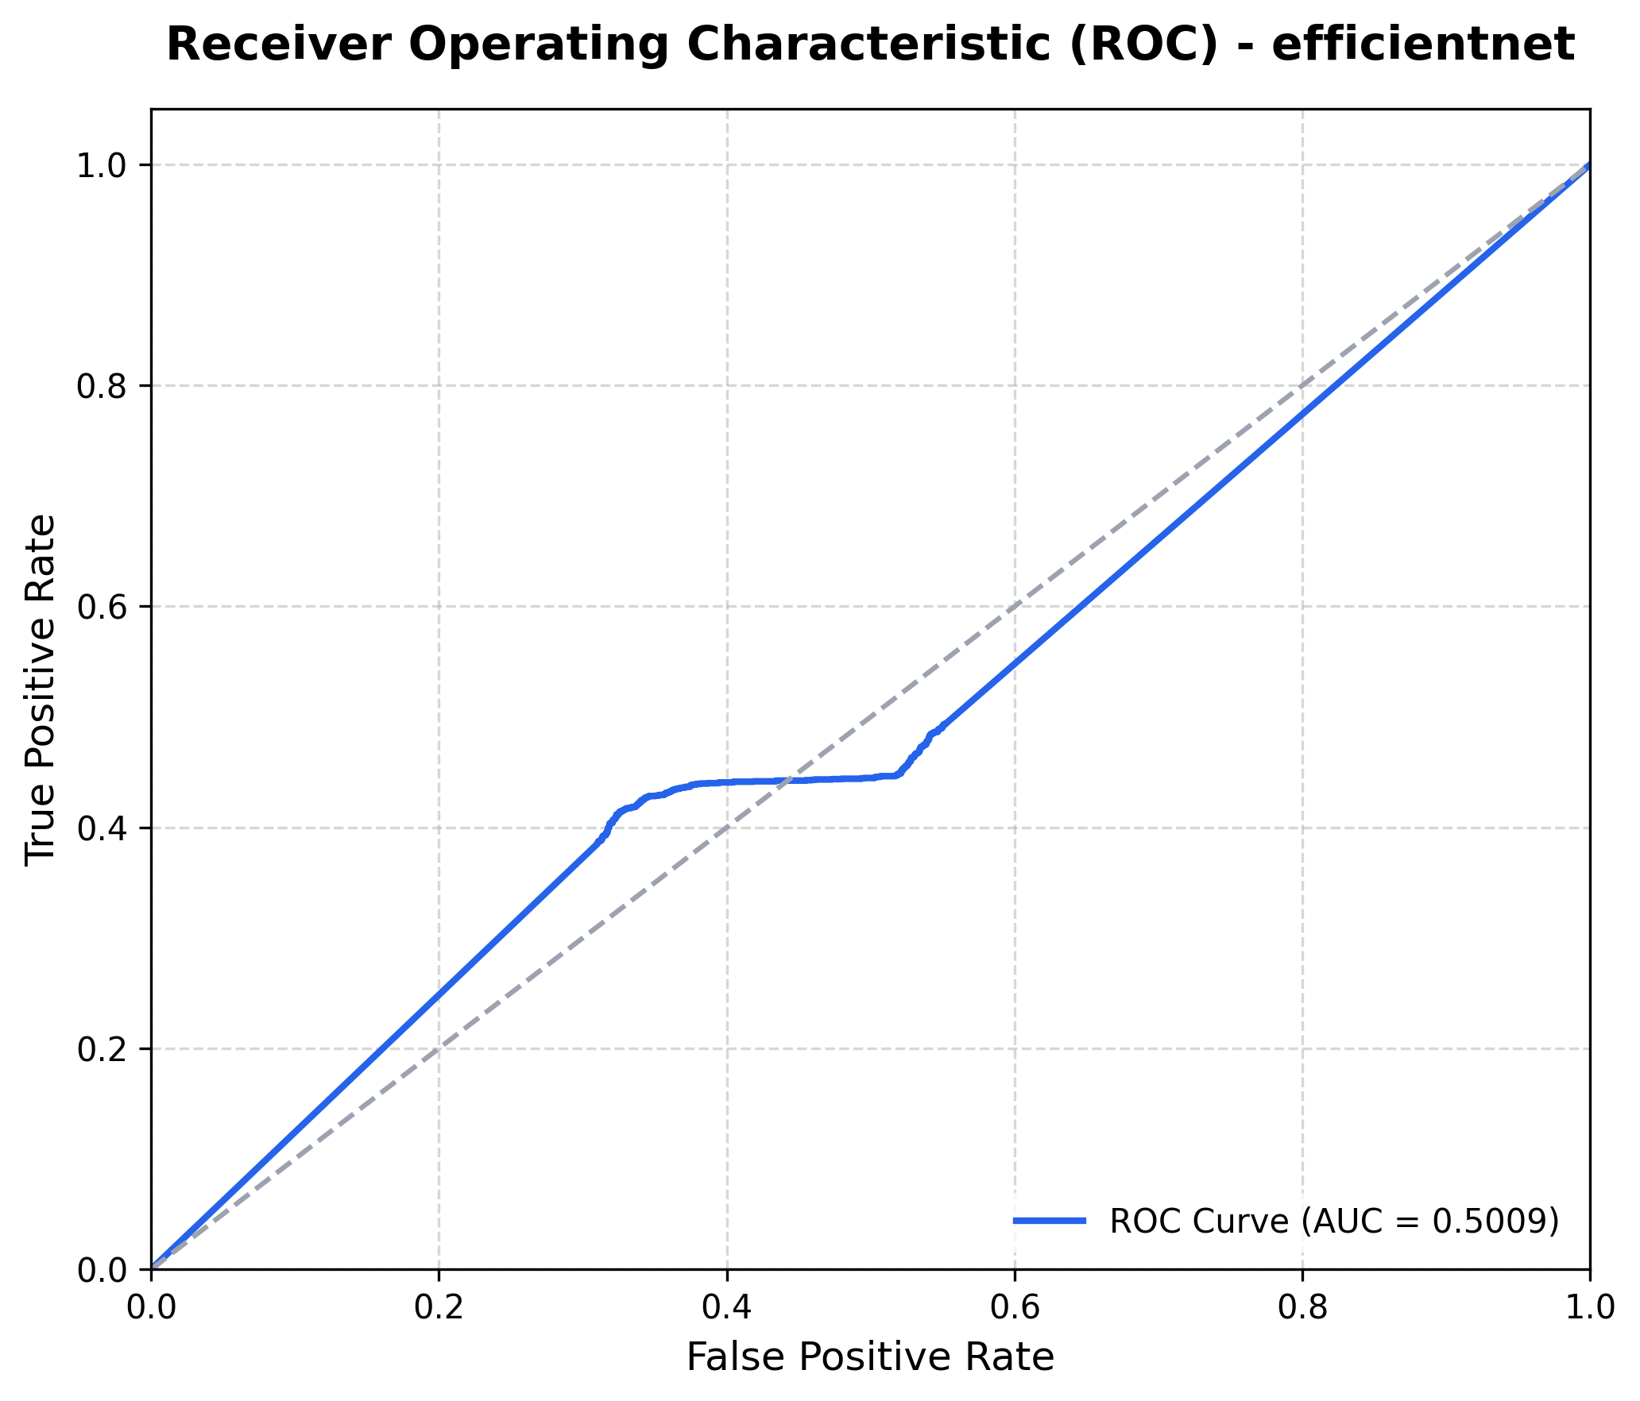
Figure 3. ROC-AUC curve for EfficientNet-B0

5. Explainability & Spatial Interpretability
To verify that the model's high classification accuracy stems from learning concrete fissure shapes rather than memorizing surface textures or ambient lighting, Grad-CAM (Gradient-weighted Class Activation Mapping) overlays and intermediate channel visualizations were analyzed.

5.1 Grad-CAM Localization
Grad-CAM overlays show that the backpropagated gradients flow intensely along high-contrast linear fissure patterns on concrete, ensuring highly localized features correspond directly to crack anomalies.
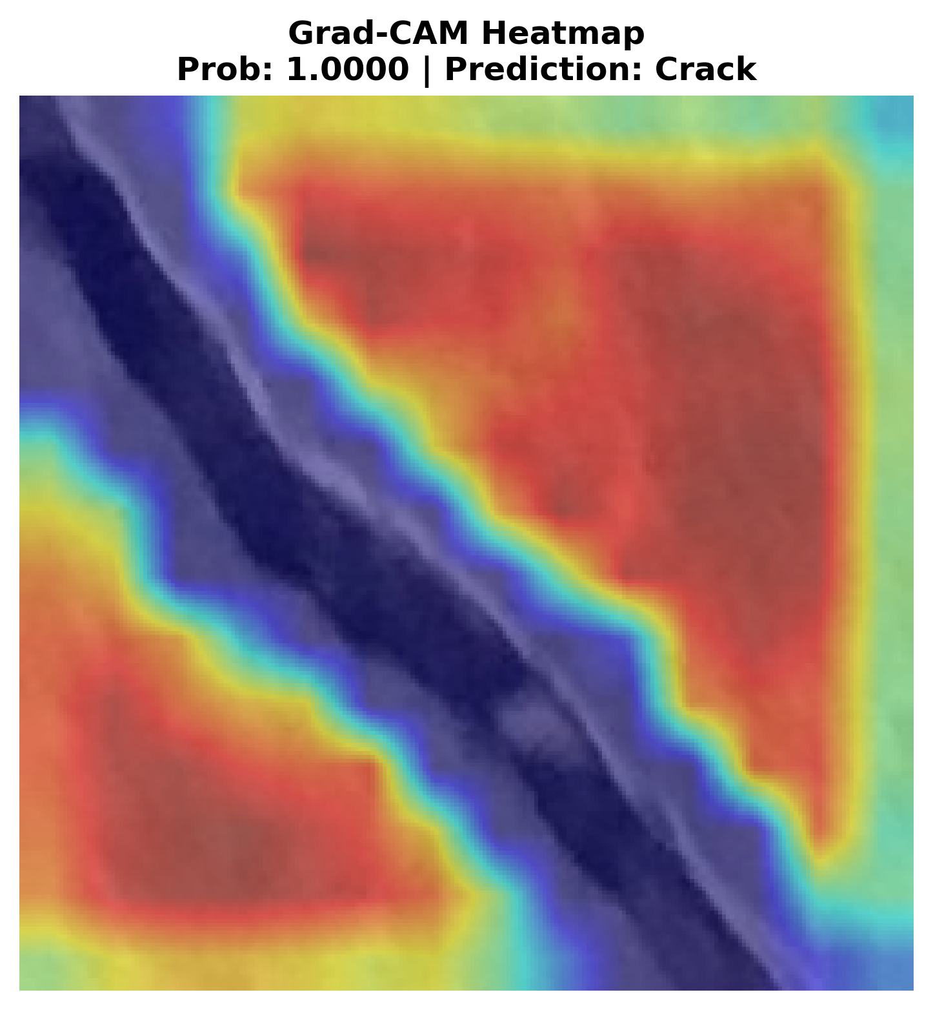
Figure 4. Grad-CAM overlay showing intense gradient focus on physical crack lines.

5.2 Intermediate Layer Activations
Analyzing layer activations shows that early stages (e.g. Conv1) capture pixel-level edge transitions. Mid-level separable blocks (e.g. Block 1 & 2) isolate the linear boundaries, and high-level semantic blocks (e.g. Block 3 & 4) compile these into distinct spatial regions representing structural cracks.
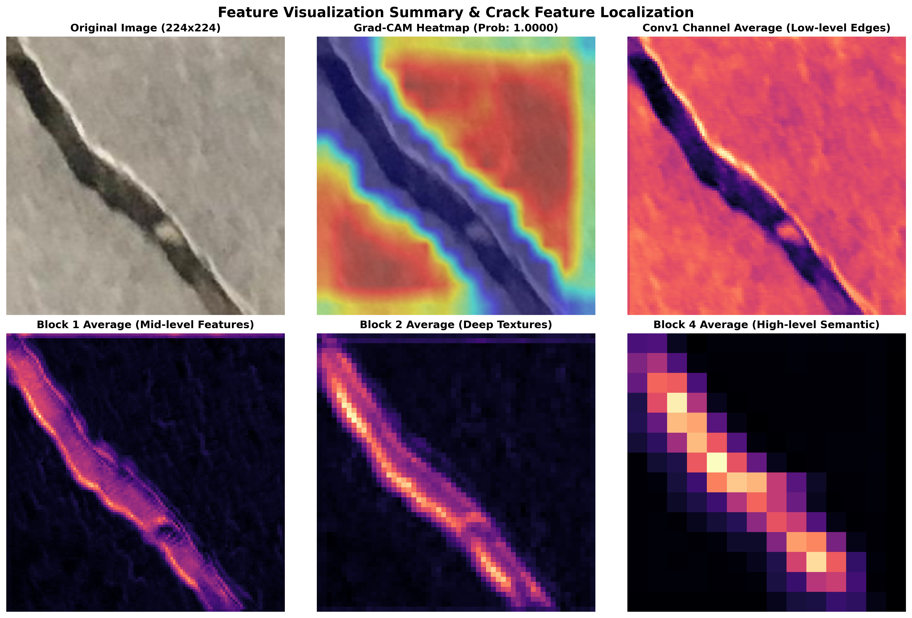
Figure 5. Activation map hierarchy from initial convolution filters to final Block 4 features.

6. Conclusions for Research Publication
- Lightweight Architectures Excel: The CustomFastCNN model outperforms both transfer-learning backbones (MobileNetV2, EfficientNet-B0) with 99.40% accuracy on the test set, while using only 247,041 parameters (11.1% of MobileNetV2 and 6.1% of EfficientNet-B0).
- Latency Dominance: CustomFastCNN achieves an average inference latency of 0.25 ms per image, making it highly viable for real-time edge integration (e.g., UAV-based concrete monitoring).
- Explainability: Grad-CAM and feature map analysis demonstrate that the models target true structural fractures rather than concrete surface microtextures.

