**Topic Title:** Denomination of Notes

**Screenshots:**

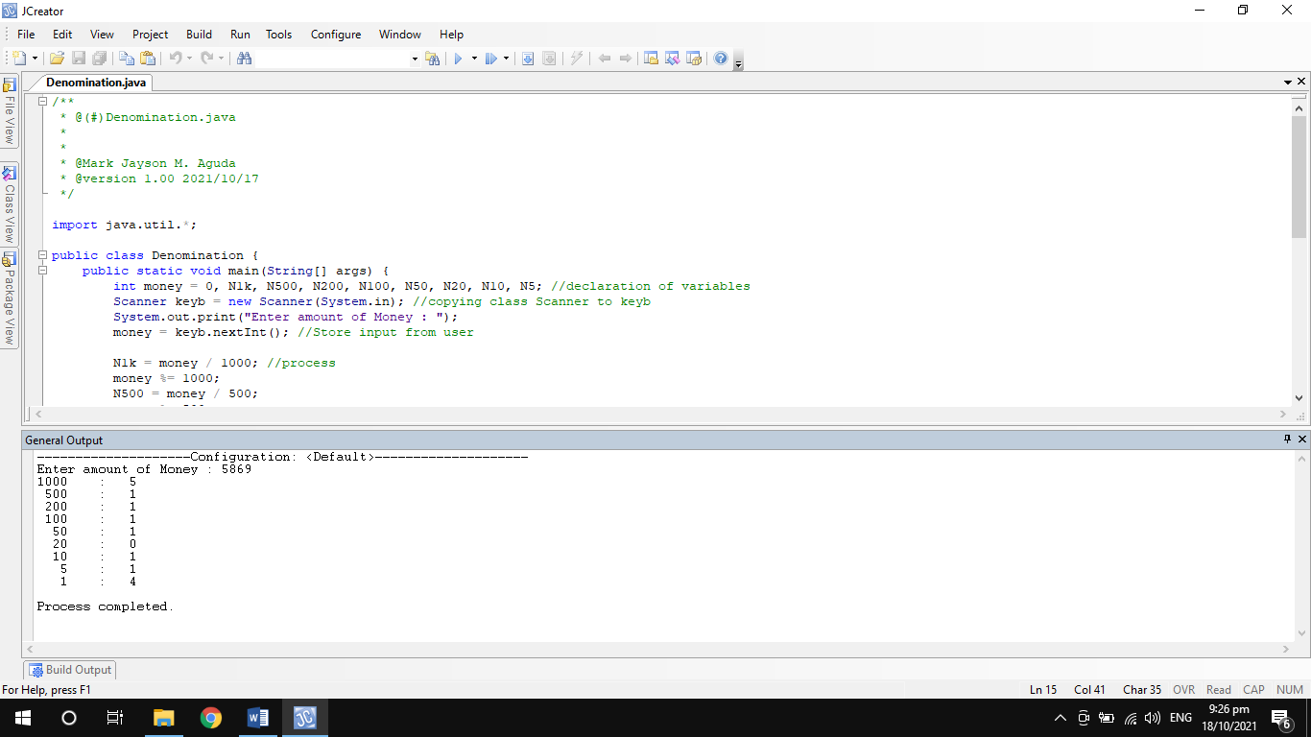

Figure 1. The above screenshot shows the bill breakdown with an input of 5869.

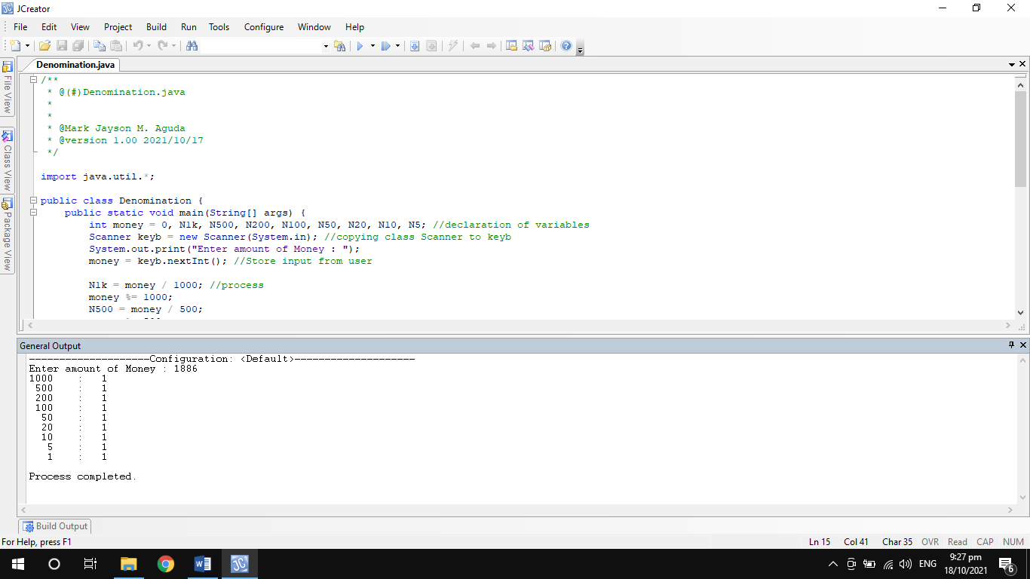

Figure 1. The above screenshot shows the bill breakdown with an input of 1886.

**Codes:**

/**

* @(#)Denomination.java

*

*

* @Mark Jayson M. Aguda

* @version 1.00 2021/10/17

*/

import java.util.*;

public class Denomination {

public static void main(String[] args) {

int money = 0, N1k, N500, N200, N100, N50, N20, N10, N5; //declaration of variables

Scanner keyb = new Scanner(System.in); //copying class Scanner to keyb

System.out.print("Enter amount of Money : ");

money = keyb.nextInt(); //Store input from user

N1k = money / 1000; //process

money %= 1000;

N500 = money / 500;

money %= 500;

N200 = money / 200;

money %= 200;

N100 = money / 100;

money %= 100;

N50 = money / 50;

money %= 50;

N20 = money / 20;

money %= 20;

N10 = money / 10;

money %= 10;

N5 = money / 5;

money %= 5;

System.out.println("1000\t:\t" + N1k); //output

System.out.println(" 500\t:\t" + N500);

System.out.println(" 200\t:\t" + N200);

System.out.println(" 100\t:\t" + N100);

System.out.println(" 50\t:\t" + N50);

System.out.println(" 20\t:\t" + N20);

System.out.println(" 10\t:\t" + N10);

System.out.println(" 5\t:\t" + N5);

System.out.println(" 1\t:\t" + money);

}

}