**Topic Title:** Temperature Conversion

**Screenshots:**

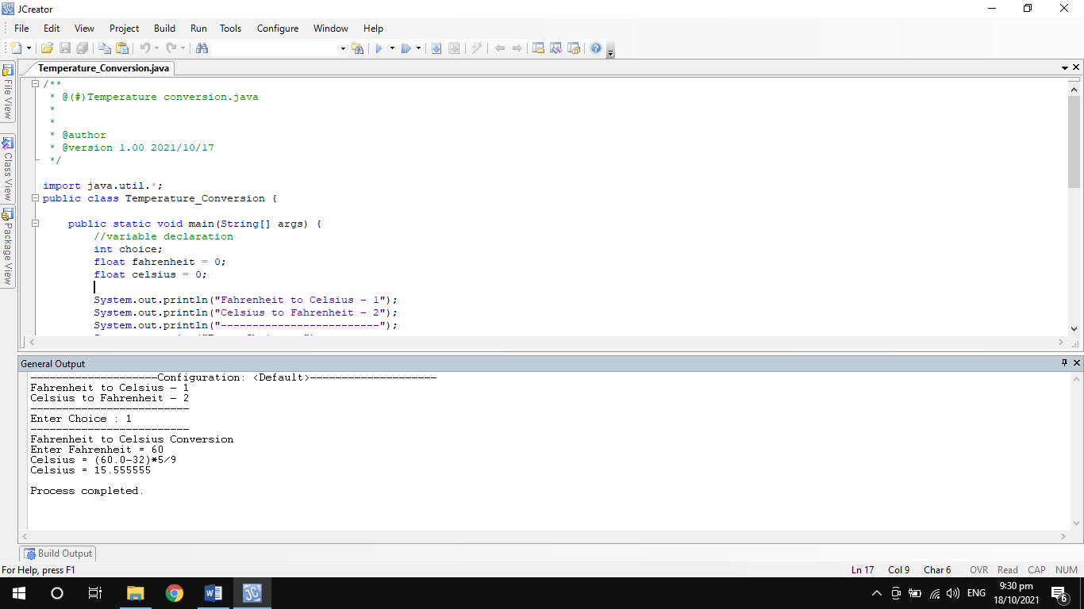

Figure 1. The above screenshot shows the conversion of temperature from Fahrenheit to Celsius.

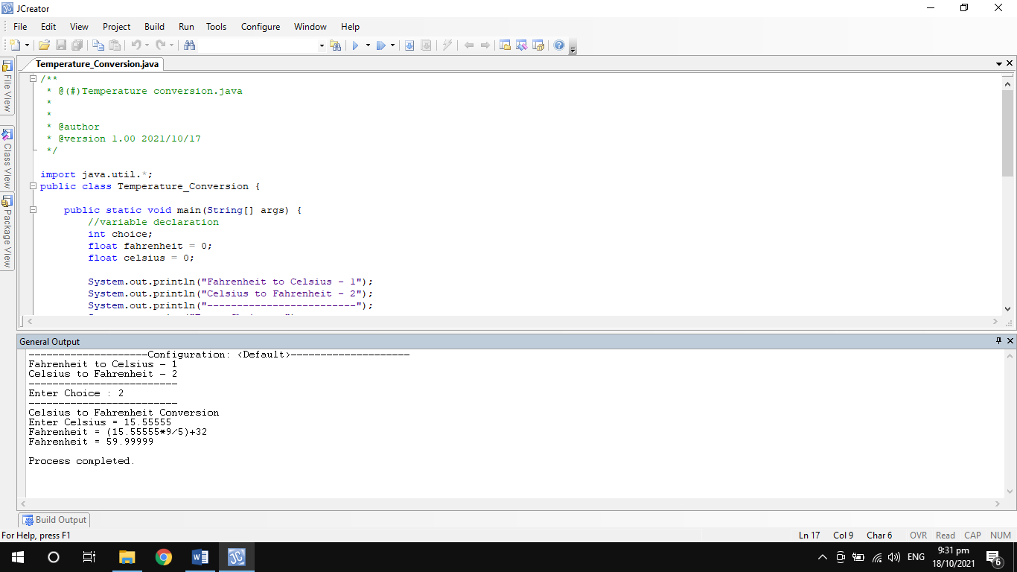

Figure 2. The above screenshot shows the conversion of temperature from Celsius to Fahrenheit.

**Codes:**

/**

* @(#)Temperature conversion.java

*

*

* @author

* @version 1.00 2021/10/17

*/

import java.util.*;

public class Temperature_Conversion {

public static void main(String[] args) {

//variable declaration

int choice;

float fahrenheit = 0;

float celsius = 0;

System.out.println("Fahrenheit to Celsius - 1");

System.out.println("Celsius to Fahrenheit - 2");

System.out.println("-------------------------");

System.out.print("Enter Choice : ");

Scanner keyb = new Scanner(System.in);

choice = keyb.nextInt();

System.out.println("-------------------------");

if(choice == 1){

System.out.println("Fahrenheit to Celsius Conversion");

System.out.print("Enter Fahrenheit = ");

fahrenheit = keyb.nextFloat();

celsius = ((fahrenheit - 32) * 5)/9;

System.out.println("Celsius = (" + fahrenheit + "-32)*5/9");

System.out.println("Celsius = " +celsius);

}

else if(choice == 2){

System.out.println("Celsius to Fahrenheit Conversion");

System.out.print("Enter Celsius = ");

celsius = keyb.nextFloat();

fahrenheit = ((celsius * 9)/5) + 32;

System.out.println("Fahrenheit = (" + celsius + "*9/5)+32");

System.out.println("Fahrenheit = " +fahrenheit);

}

}

}