HEX BARON – Class Diagram Tasks

Task 1 (2 marks)

A partially-complete UML class diagram for the Player class is shown below.

Fill in the missing details.

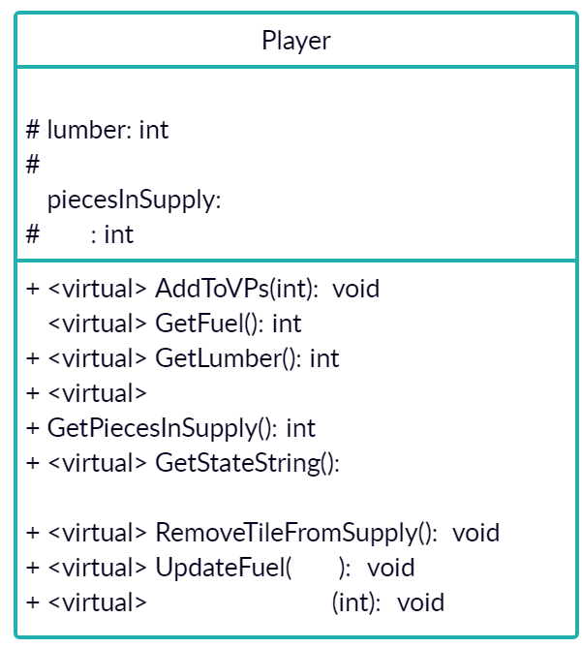

# name: string

Fuel: int

int
#
VPs

+

GetName(): string

+ <>

int
UpdateLumber

Task 2 (5 marks)
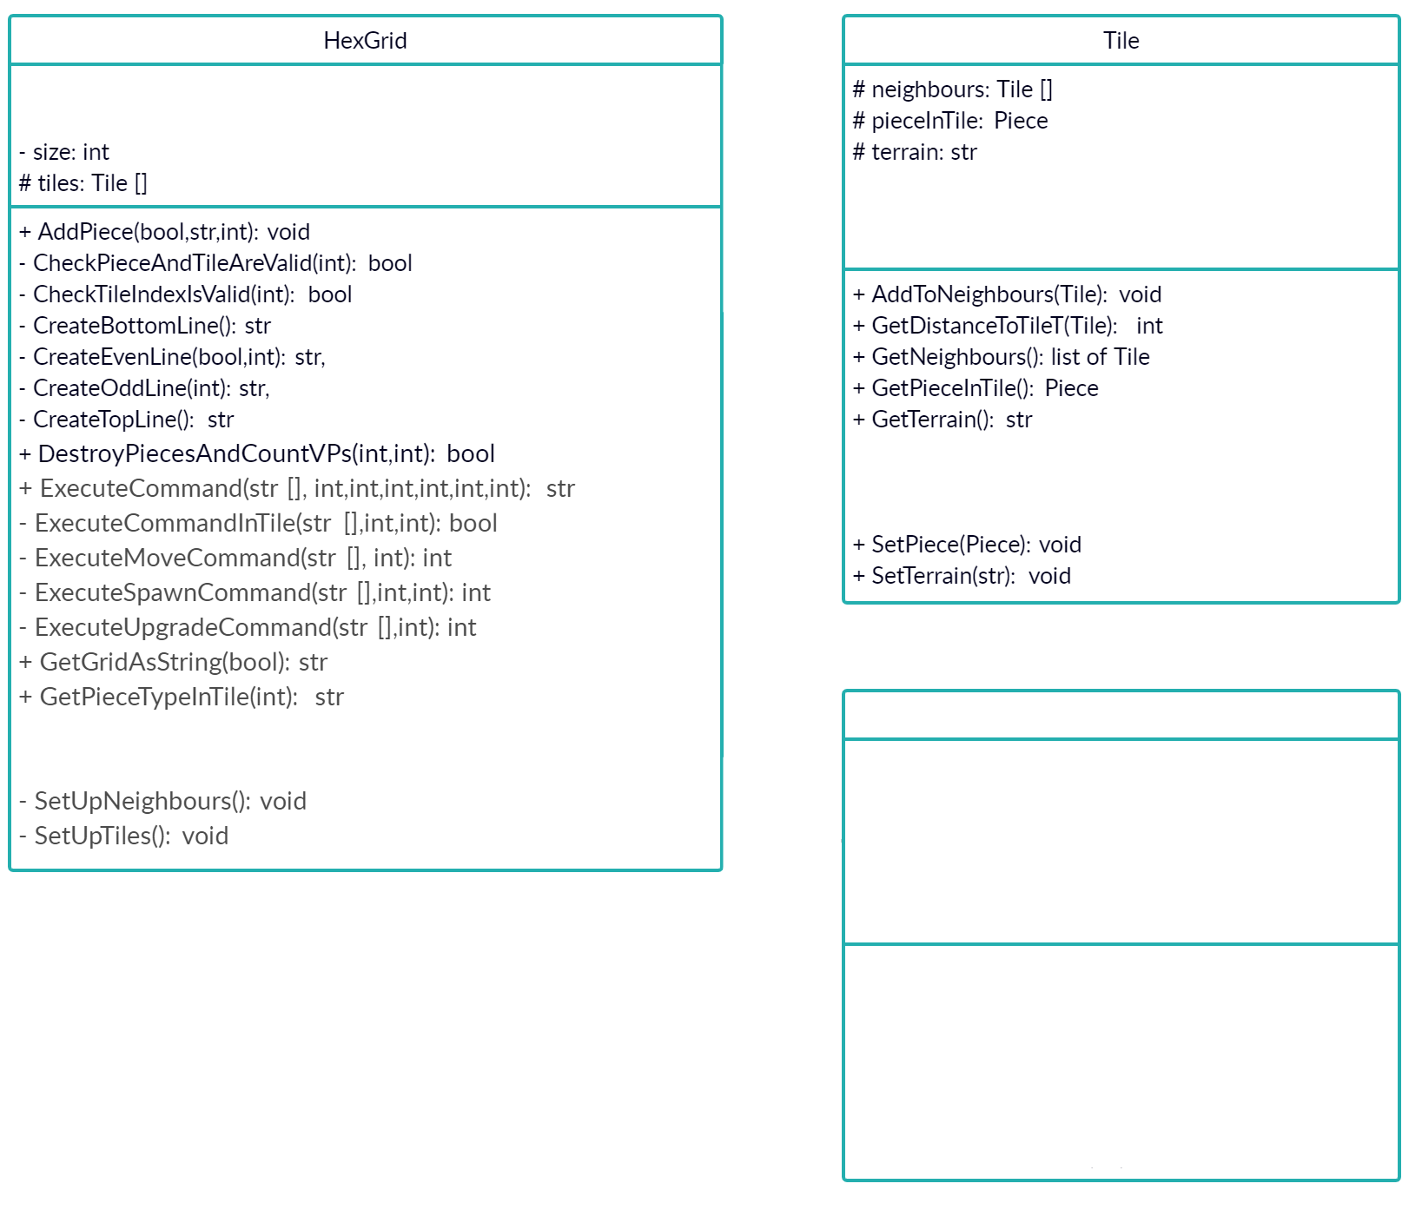
A partially-complete UML class diagram is shown.

Fill in the missing details,
including any relationships
between the classes shown.

Task 3 (4 marks)

There are two pieces of information missing from the UML class diagram below.

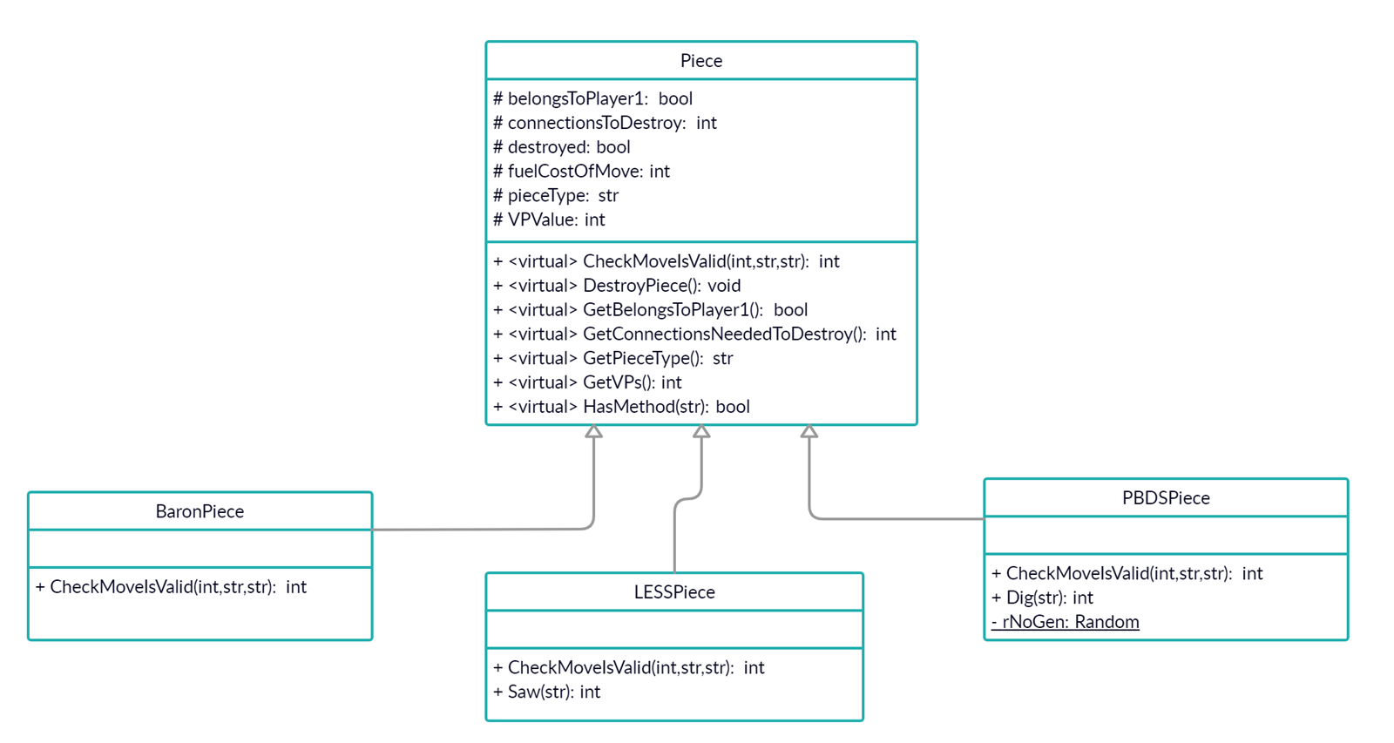

Explain what are they and why are they normally omitted?

