

Name
ZigZag Education supporting
A Level AQA Computer Science Paper 1
Summer 2021
HEX BARON
Electronic Answer Document (EAD)

Instructions

∙ Enter your name in the box at the top of this page
∙ Answer all questions by entering your answers into this document
∙ Remember to save this document regularly
∙ Save and print this document and any additional pages
∙ Answer all questions
∙ The marks available for each question are shown in brackets

∙ You will need:
□ access to a computer
□ access to a printer
□ access to appropriate software
□ electronic copies of the required skeleton code
□ EAD (Electronic Answer Document)

Total marks:

Programming Theory Questions
Answer all questions. Remember to save this document regularly.

Q | Answer |  | Mark  (leave blank)
1 | (a)
 | (b)
2
3
4 | (a)
 | (b)
5 | (a)
 | (b)
6 | (a)
 | (b)
7 | (a)
 | (b)
8
9 | HexGrid  Player  Tile  BaronPiece  LESSPiece
10 | (a)
 | (b)
11
12 | (a)
 | (b)
13 | (a)
 | (b)
 | (c)
14 | (a)
 | (b)
 | (c)
15

Programming Tasks
Answer all questions. Remember to save this document regularly.

Q | Answer | Mark  (leave blank)
1 | public static void PlayGame(Player player1, Player player2, HexGrid grid)  {  bool gameOver = false;  bool player1Turn = true;  bool validCommand;  List<string> commands = new List<string>();  Console.WriteLine("Player One current state - " + player1.GetStateString());  Console.WriteLine("Player Two current state - " + player2.GetStateString());  do  {  Console.WriteLine(grid.GetGridAsString(player1Turn));  if (player1Turn)  Console.WriteLine(player1.GetName() + " state your three commands, pressing enter after each one.");  else  Console.WriteLine(player2.GetName() + " state your three commands, pressing enter after each one.");  for (int count = 1; count <= 3; count++)  {  Console.Write("Enter command: ");  commands.Add(Console.ReadLine().ToLower().Trim());  }  foreach (var c in commands)  {  List<string> items = new List<string>(c.Split(' '));  validCommand = CheckCommandIsValid(items);  if (!validCommand)  Console.WriteLine("Invalid command");  else  {  int fuelChange = 0;  int lumberChange = 0;  int supplyChange = 0;  string summaryOfResult;  if (player1Turn)  {  summaryOfResult = grid.ExecuteCommand(items, ref fuelChange, ref lumberChange, ref supplyChange,  player1.GetFuel(), player1.GetLumber(), player1.GetPiecesInSupply());  player1.UpdateLumber(lumberChange);  player1.UpdateFuel(fuelChange);  if (supplyChange == 1)  player1.RemoveTileFromSupply();  }  else  {  summaryOfResult = grid.ExecuteCommand(items, ref fuelChange, ref lumberChange, ref supplyChange,  player2.GetFuel(), player2.GetLumber(), player2.GetPiecesInSupply());  player2.UpdateLumber(lumberChange);  player2.UpdateFuel(fuelChange);  if (supplyChange == 1)  {  player2.RemoveTileFromSupply();  }  }  Console.WriteLine(summaryOfResult);  }  }  commands.Clear();  player1Turn = !player1Turn;  int player1VPsGained = 0;  int player2VPsGained = 0;  if (gameOver)  {  grid.DestroyPiecesAndCountVPs(ref player1VPsGained, ref player2VPsGained);  }  else  gameOver = grid.DestroyPiecesAndCountVPs(ref player1VPsGained, ref player2VPsGained);  player1.AddToVPs(player1VPsGained);  player2.AddToVPs(player2VPsGained);  Console.WriteLine("Player One current state - " + player1.GetStateString());  Console.WriteLine("Player Two current state - " + player2.GetStateString());  Console.Write("Press Enter to continue...");  Console.ReadLine();  }  while (!gameOver || !player1Turn);  Console.WriteLine(grid.GetGridAsString(player1Turn));  DisplayEndMessages(player1, player2);  }  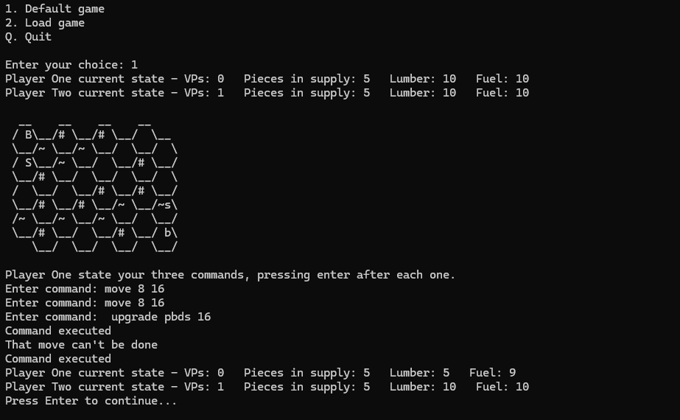
2 | public static void SetUpDefaultGame(out Player player1, out Player player2, out HexGrid grid)  {  List<string> t = new List<string>() {" ", "#", "#", " ", "~", "~", " ", " ", " ", "~", " ", "#", "#", " ", " ", " "  , " ", " ", "#", "#", "#", "#", "~", "~", "~", "~", "~", " ", "#", " ", "#", " "};  int gridSize = 8;  grid = new HexGrid(gridSize);  Console.Write("Player 1 enter your username: ");  string name1 = Console.ReadLine();  Console.Write("Player 2 enter your username: ");  string name2 = Console.ReadLine();  player1 = new Player(name1, 0, 10, 10, 5);  player2 = new Player(name2, 1, 10, 10, 5);  grid.SetUpGridTerrain(t);  grid.AddPiece(true, "Baron", 0);  grid.AddPiece(true, "Serf", 8);  grid.AddPiece(false, "Baron", 31);  grid.AddPiece(false, "Serf", 23);  }  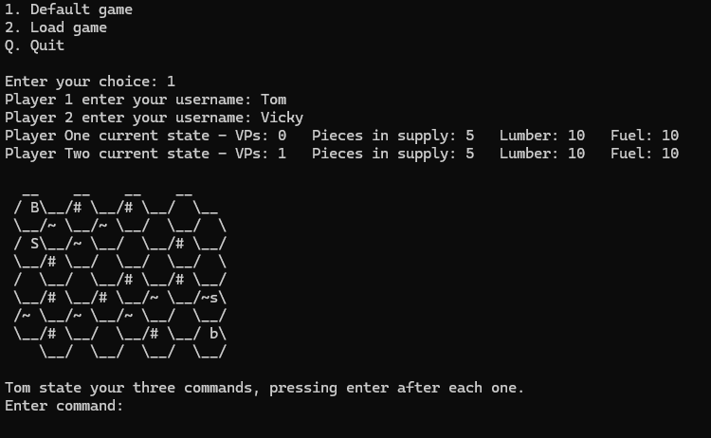
3 | public static void PlayGame(Player player1, Player player2, HexGrid grid)  {  bool gameOver = false;  bool player1Turn = true;  bool validCommand;  List<string> commands = new List<string>();  Console.WriteLine("Player One current state - " + player1.GetStateString());  Console.WriteLine("Player Two current state - " + player2.GetStateString());  do  {  Console.WriteLine(grid.GetGridAsString(player1Turn));  if (player1Turn)  Console.WriteLine(player1.GetName() + " state your three commands, pressing enter after each one.");  else  Console.WriteLine(player2.GetName() + " state your three commands, pressing enter after each one.");  for (int count = 1; count <= 3; count++)  {  Console.Write("Enter command: ");  commands.Add(Console.ReadLine().ToLower());  }  foreach (var c in commands)  {  List<string> items = new List<string>(c.Split(' '));  validCommand = CheckCommandIsValid(items);  if (!validCommand)  Console.WriteLine("Invalid command");  else  {  int fuelChange = 0;  int lumberChange = 0;  int supplyChange = 0;  string summaryOfResult;  if (player1Turn)  {  summaryOfResult = grid.ExecuteCommand(items, ref fuelChange, ref lumberChange, ref supplyChange,  player1.GetFuel(), player1.GetLumber(), player1.GetPiecesInSupply());  player1.UpdateLumber(lumberChange);  player1.UpdateFuel(fuelChange);  if (supplyChange == 1)  player1.RemoveTileFromSupply();  }  else  {  summaryOfResult = grid.ExecuteCommand(items, ref fuelChange, ref lumberChange, ref supplyChange,  player2.GetFuel(), player2.GetLumber(), player2.GetPiecesInSupply());  player2.UpdateLumber(lumberChange);  player2.UpdateFuel(fuelChange);  if (supplyChange == 1)  {  player2.RemoveTileFromSupply();  }  }  Console.WriteLine(summaryOfResult);  }  }  commands.Clear();  player1Turn = !player1Turn;  int player1VPsGained = 0;  int player2VPsGained = 0;  if (gameOver)  {  grid.DestroyPiecesAndCountVPs(ref player1, ref player2, ref player1VPsGained, ref player2VPsGained);  }  else  gameOver = grid.DestroyPiecesAndCountVPs(ref player1, ref player2, ref player1VPsGained, ref player2VPsGained);  player1.AddToVPs(player1VPsGained);  player2.AddToVPs(player2VPsGained);  Console.WriteLine("Player One current state - " + player1.GetStateString());  Console.WriteLine("Player Two current state - " + player2.GetStateString());  Console.Write("Press Enter to continue...");  Console.ReadLine();  }  while (!gameOver || !player1Turn);  Console.WriteLine(grid.GetGridAsString(player1Turn));  DisplayEndMessages(player1, player2);  }  public bool DestroyPiecesAndCountVPs(ref Player player1, ref Player player2, ref int player1VPs, ref int player2VPs)  {  bool baronDestroyed = false;  List<Tile> listOfTilesContainingDestroyedPieces = new List<Tile>();  foreach (var t in tiles)  {  if (t.GetPieceInTile() != null)  {  List<Tile> listOfNeighbours = new List<Tile>(t.GetNeighbours());  int noOfConnections = 0;  foreach (var n in listOfNeighbours)  {  if (n.GetPieceInTile() != null)  {  noOfConnections += 1;  }  }  Piece thePiece = t.GetPieceInTile();  if (noOfConnections >= thePiece.GetConnectionsNeededToDestroy())  {  thePiece.DestroyPiece();  if (thePiece.GetPieceType().ToUpper() == "B")  baronDestroyed = true;  listOfTilesContainingDestroyedPieces.Add(t);  if (thePiece.GetBelongsToPlayer1())  {  player2VPs += thePiece.GetVPs();  player1.AddPieceToSupply();  }  else  {  player1VPs += thePiece.GetVPs();  player2.AddPieceToSupply();  }  }  }  }  foreach (var t in listOfTilesContainingDestroyedPieces)  {  t.SetPiece(null);  }  return baronDestroyed;  }  class Player  {  protected int piecesInSupply, fuel, VPs, lumber;  protected string name;  public Player(string n, int v, int f, int l, int t)  {  name = n;  VPs = v;  fuel = f;  lumber = l;  piecesInSupply = t;  }  public virtual string GetStateString()  {  return "VPs: " + VPs.ToString() + " Pieces in supply: " + piecesInSupply.ToString() + " Lumber: " + lumber.ToString() + " Fuel: " + fuel.ToString();  }  public virtual int GetVPs()  {  return VPs;  }  public virtual int GetFuel()  {  return fuel;  }  public virtual int GetLumber()  {  return lumber;  }  public virtual string GetName()  {  return name;  }  public virtual void AddToVPs(int n)  {  VPs += n;  }  public virtual void UpdateFuel(int n)  {  fuel += n;  }  public virtual void UpdateLumber(int n)  {  lumber += n;  }  public int GetPiecesInSupply()  {  return piecesInSupply;  }  public void AddPieceToSupply()  {  piecesInSupply++;  }  public virtual void RemoveTileFromSupply()  {  piecesInSupply -= 1;  }  }  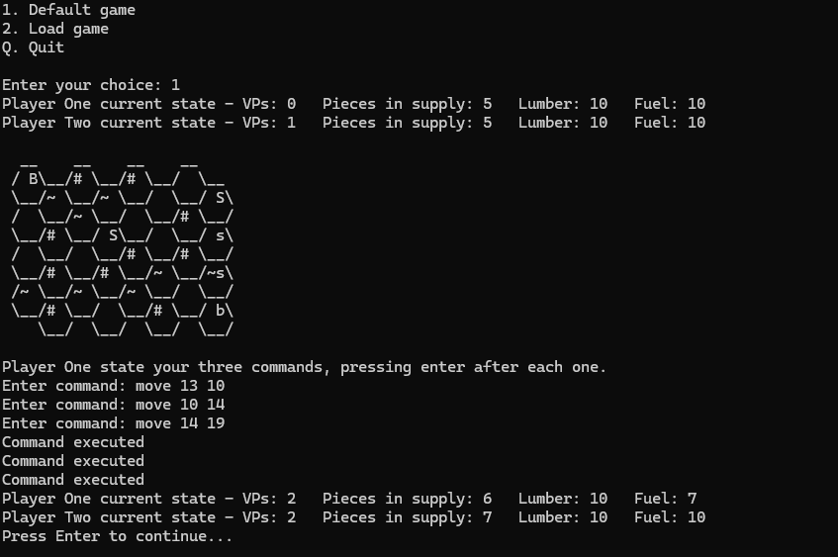
4 | private int ExecuteSpawnCommand(List<string> items, int lumberAvailable, int piecesInSupply)  {  int tileToUse = Convert.ToInt32(items[1]);  int numPieces1 = 0;  int numPieces2 = 0;  foreach (var piece in pieces)  {  if (piece.GetBelongsToPlayer1())  {  numPieces1++;  }  if (!piece.GetBelongsToPlayer1())  {  numPieces2++;  }  }  if (numPieces1 >=6 || numPieces2>=6)  {  Console.WriteLine("Spawn attempted to exceed max pieces.");  return -1;  }  if (piecesInSupply < 1 || lumberAvailable < 3 || !CheckTileIndexIsValid(tileToUse))  {  return -1;  }  Piece ThePiece = tiles[tileToUse].GetPieceInTile();  if (ThePiece != null)  {  return -1;  }  bool ownBaronIsNeighbour = false;  List<Tile> listOfNeighbours = new List<Tile>(tiles[tileToUse].GetNeighbours());  foreach (var n in listOfNeighbours)  {  ThePiece = n.GetPieceInTile();  if (ThePiece != null)  {  if (player1Turn && ThePiece.GetPieceType() == "B" || !player1Turn && ThePiece.GetPieceType() == "b")  {  ownBaronIsNeighbour = true;  break;  }  }  }  if (!ownBaronIsNeighbour)  {  return -1;  }  Piece newPiece = new Piece(player1Turn);  pieces.Add(newPiece);  tiles[tileToUse].SetPiece(newPiece);  return 3;  }  private int ExecuteSpawnCommand(List<string> items, int lumberAvailable, int piecesInSupply)  {  int tileToUse = Convert.ToInt32(items[1]);  int numPieces1 = 0;  int numPieces2 = 0;  foreach (var piece in pieces)  {  if (piece.GetBelongsToPlayer1())  {  numPieces1++;  }  if (!piece.GetBelongsToPlayer1())  {  numPieces2++;  }  }  if (numPieces1 >=6 || numPieces2>=6)  {  Console.WriteLine("Spawn attempted to exceed max pieces.");  return -1;  }  if (piecesInSupply < 1 || lumberAvailable < 3 || !CheckTileIndexIsValid(tileToUse))  {  return -1;  }  Piece ThePiece = tiles[tileToUse].GetPieceInTile();  if (ThePiece != null)  {  return -1;  }  bool ownBaronIsNeighbour = false;  List<Tile> listOfNeighbours = new List<Tile>(tiles[tileToUse].GetNeighbours());  foreach (var n in listOfNeighbours)  {  ThePiece = n.GetPieceInTile();  if (ThePiece != null)  {  if (player1Turn && ThePiece.GetPieceType() == "B" || !player1Turn && ThePiece.GetPieceType() == "b")  {  ownBaronIsNeighbour = true;  break;  }  }  }  if (!ownBaronIsNeighbour)  {  return -1;  }  Piece newPiece = new Piece(player1Turn);  pieces.Add(newPiece);  tiles[tileToUse].SetPiece(newPiece);  return 3;  }  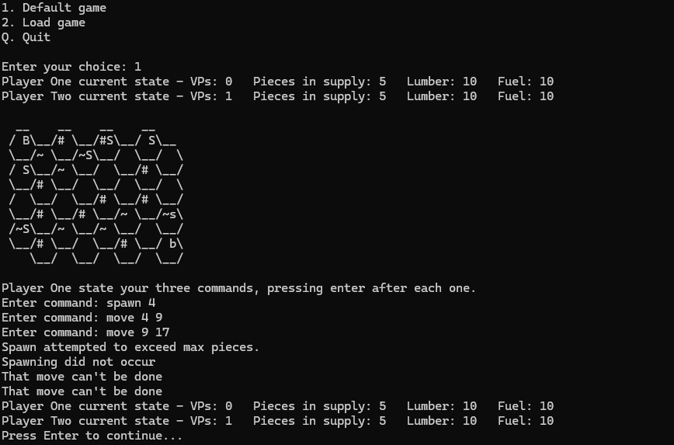
5
6
7
8
9
10
11
12
13
14
15

