Breast Cancer Classification Using Convolutional Neural Networks
Digital Image Processing F20

Intro:
Cancerous tumors have claimed countless lives over the course of human history. Breast cancer itself affects nearly 13% of women worldwide today. Needless to say this is a major problem and completely understandable as to why finding the cure for cancer has become such an all consuming dream for many scientists. The problem is many cancers are incredibly different and tumors can exist within a person without being cancerous. As we wait and push for that cure, humankind is left with cancer treatment. The trick with treatment is that in order for it to be effective, cancerous tumors have to be identified accurately and early on in a person. Especially difficult for humans is telling the difference between benign and malignant tumors. Benign tumors are simply masses in a human that do not have the potential to spread and are thus classified as non-cancerous. Malignant, however, spread across the body and are cancerous.
This detection and classification of tumors is where image processing and computer vision tools can be incredibly beneficial. Convolutional Neural Networks have proven very useful in solving many object detection and feature extraction problems and thus can and should be applied to detecting malignant versus benign forms of cancer.
I was the only person working on this project and implemented it on a machine with an AMD Ryzen 7 Threadripper processor, NVIDIA GeForce RTX 2060 GPU, 16 GB of RAM, and Ubuntu 20.04 OS.

Datasets:
As anybody who has worked with deep learning can tell you, the dataset selection is extremely important as the data quality directly impacts your results. They would also be able to tell you that deep learning is incredibly data hungry and thus requires many samples to get a good mapping. The datasets chosen for this project are retrieved from the cancer image archive and contain two distinct types of images, Region of Interest (RoI) and Full Mammograms. Both types of images are initially stored as Digital Communication in Medicine (.dcm) images and thus must be converted to a more usable format for the neural network to utilize it.
This natural split in the data means that there is a clearly definitive way of splitting the data and training two models, one for the RoI images and the other on the full images. This results in two different models and can help generalize the model, because as we saw in preliminary results the RoI images got better prediction results than the full mammograms. Once we started cropping the full mammograms it became apparent we could use the cropped full mammograms in the RoI model and obtain descent results. We ended up getting a better solution through using a distinct model, but this is an area that would be worth exploring if more time was permitted.
Regardless, once converted to PNGs, various pre-processing techniques were applied in an attempt to improve accuracy and feature detection discussed in the pre-processing section below. This took place before being fed into the neural network model. Various other datasets were attempted as well but ended up clashing with the original dataset and made prediction results worse, so those datasets are omitted.

Pre-Processing:
The entire point of the Digital Image Processing class focused on image processing techniques. Several of these techniques came into use during this project including image thresholding and canny edge detection. Thresholding provided a decent image to push through a neural network, so it’s results are discussed in the results section below. The canny edge detector ended up being a bit difficult to deal with and added noise to the neural network because of the number of resulting lines due to not having enough straight lines in the image.

Convolutional Neural Networks:
The Convolutional Neural Network (CNN) is the primary model in this project. Specifically in this project, ResNet50 trained on ImageNet was used as the backbone of the CNN architecture and all layers were frozen with the last fully connected layer being switched out from a 1000x1 layer to a 2x1 layer. This was chosen because a pretrained deep CNN architecture is incredibly beneficial and can require much less training time. Freezing all previous layers also allows for the model to focus on becoming more of a feature extractor instead of a classifier and as we are trying to classify a specific feature in the image (benign versus malignant tumors) this seemed the best direction to go.
Convolutional Neural Networks work because they pass a filter over an image very similarly to how we performed our filtering in assignment 2, the main difference being that CNNs determine what their filters should be rather then having them be established. This act of updating the filter values is done through the repetitive cycle of a forward pass followed by backpropagation using the outputs and labels. This happens for each batch of images in the training set and the number of epochs determine the number of times we feed the training image set through the model. In our case, we used 100 epochs and settled on a batch size of 4 images. We used Cross Entropy for a loss function and Stochastic Gradient Descent with momentum of 0.75, learning rate of 0.01, and a dropoff of 0.1 for every 7 epochs as the optimizer.

Results:
Results ended up being fairly decent but did not hit the initial goal. While the initial goal was ~70% the final mammogram accuracy was 63% and the RoI accuracy was 64%. As scene in figure 1 below, the accuracy and loss graphs start to plateau around 20 epochs. We continued running the epochs until 100 just to ensure there wasn’t any continuing trend upward in accuracy or downward in loss, and it was clearly seen. The hyperparameters used clearly changed how much variation there was. For instance, dropping the learning rate ended up smoothing our losses and accuracy.
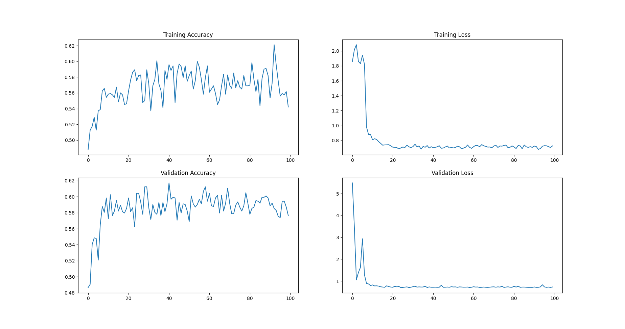
Figure 1: Accuracy and Losses vs Epoch for Full Mammograms
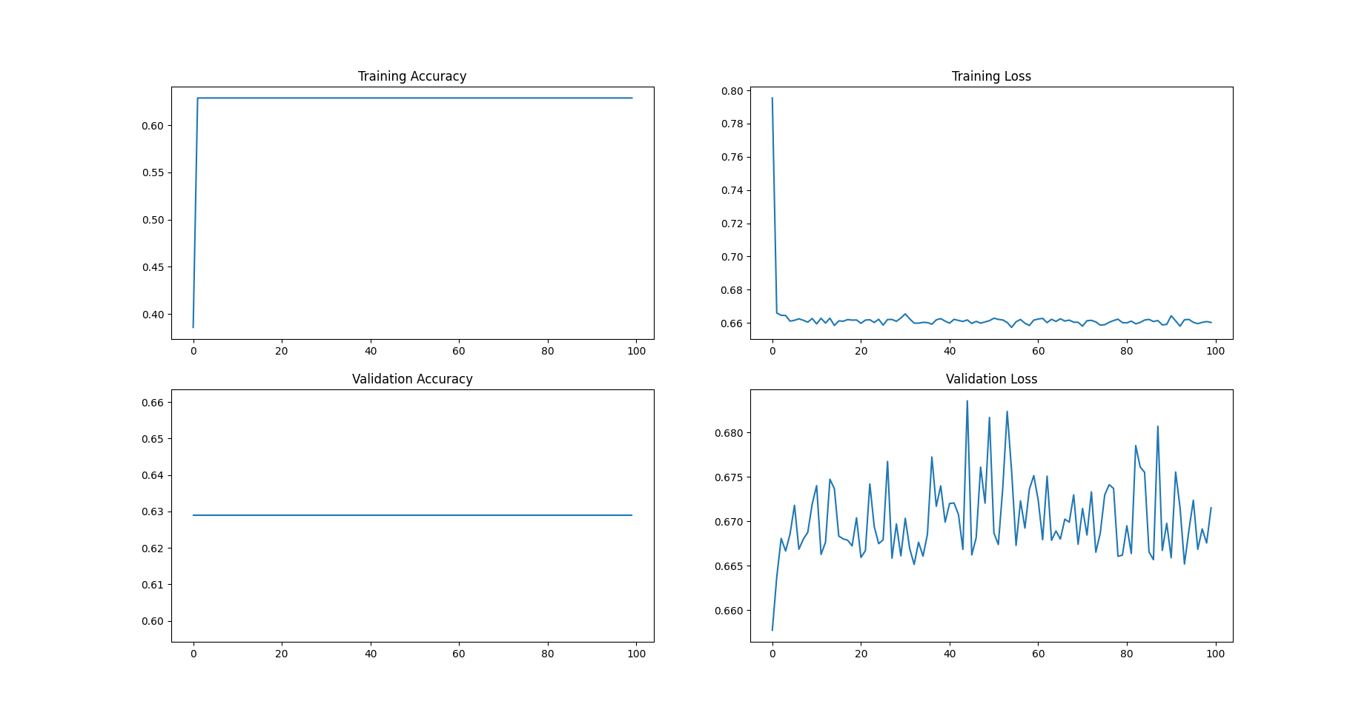
Figure 2: Accuracy and Losses vs Epoch for RoI

Conclusion:
Overall, results were a bit disappointing. While we were able to improve on the mid-project report results we still did not hit our initial goal of ~70% accuracy. This is likely due to a lot of different factors but the biggest issue facing this project is likely the amount of data. As discussed earlier, deep learning is incredibly data hungry, so even with over 1000 full mammograms and 500 RoI images, this still didn’t have enough variation to effectively train the model. The reason this is likely the biggest issue is because when the training data started being augmented the results started getting better. In fact, that is what bumped the full mammograms up from nearly 50% accuracy during the mid project report to now with upwards of 60%.
This was a known issue and attempted to be solved during the mid-project report but unfortunately the other datasets just added more noise to the network as they were substantially different images. If there was more time, the solution for the RoI images would probably have been to have a bit more targeted fragment the mammograms so the images appeared nearly identical to the RoIs without any of the background. In addition to this, we could’ve explored the extra datasets more and potentially reshaped the data to make a large combination of the two. As for the mammograms, the biggest improvement was seen with rotational adjustments to the training data. This leads to the conclusion that if we added more cuts to the data or rotated more than 90 degrees we might continue to increase accuracy, at least for a little bit. After that, the best solution would be finding more mammograms and fitting the new dataset with the current one to make an overall larger dataset.

References:
Dataset - https://wiki.cancerimagingarchive.net/display/Public/CBIS-DDSM#2251662997944ee0e4a54b15a8479efafa2064dd
PyTorch - https://pytorch.org/
Skimage - https://scikit-image.org/docs/dev/api/api.html
Pandas - https://pandas.pydata.org/
ResNet50 - https://arxiv.org/abs/1512.03385
Youtube -

