**Simple Pendulum Python Code without Control:**

import numpy as np

import matplotlib.pyplot as plt

import scipy.integrate as S

plt.close("all")

g = 9.81

L = 1.0

m = 5.0

K = 10.0

b = 10.0

c = 0.0

theta0 = 90*np.pi/180.

thetac = 0*30*np.pi/180.

def controller(x):

thetacdot = 0.0

theta = x[0]

thetadot = x[1]

eint = x[2]

e = thetac - theta

edot = thetacdot - thetadot

#T = K(s^2 + b*s + c)/s

#T = K*s + K*b + K*c/s

T = 0.0 #K*b*e + K*edot + K*c*eint

return T,e

def DerivativesNL(x,t):

theta = x[0]

thetadot = x[1]

eint = x[2]

T,e = controller(x)

thetaddot = -g/L*np.sin(theta) + T/(m*L**2)

eintdot = e

xdot = np.asarray([thetadot,thetaddot,eintdot])

return xdot

def Derivatives(x,t):

theta = x[0]

thetadot = x[1]

eint = x[2]

T,e = controller(x)

xdot = np.matmul(A,x) + B*T + B2*e

return xdot

A = np.asarray([[0,1,0],[-g/L,0,0],[0,0,0]])

B = np.asarray([0,1/(m*L**2),0])

B2 = np.asarray([0,0,1])

#eigs = np.linalg.eig(A)

#print(eigs)

xinitial = np.asarray([theta0,0,0])

tout = np.linspace(0,20,1000)

xout = S.odeint(Derivatives,xinitial,tout)

xoutNL = S.odeint(DerivativesNL,xinitial,tout)

plt.plot(tout,xout[:,0]*180/np.pi,label="Linear")

plt.plot(tout,xoutNL[:,0]*180./np.pi,'r-',label="Nonlinear")

plt.xlabel('Time (sec)')

plt.ylabel('Angle (deg)')

plt.legend()

plt.grid()

plt.show()

For this homework, the objective was to simulate a simple pendulum 30°, 60°, and 90°. For the simulation, both a linear and non-linear model were used. Both models were used to show how linear systems are only applicable in ideal conditions and not in the real world, whereas non-linear models can be used for most real-world applications.

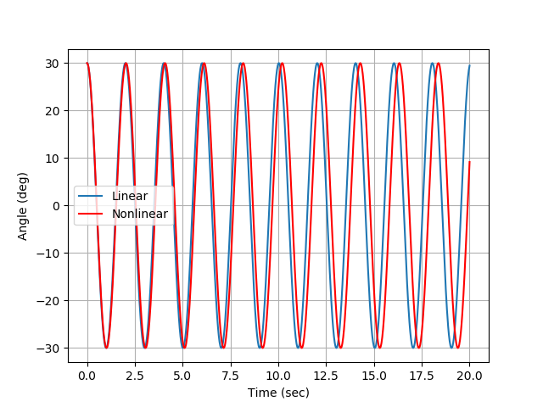

Figure 1: Simple Pendulum modeled at 30 degrees

For Fig. 1, we can see that the linear and non-linear model start out the same, but as the model progress the linear and non-linear models diverge. This divergence is due to the small angle approximation used to compute the linear model. At 30°, the angle is no longer small, and the model becomes inaccurate. However, the non-linear model does not depend on a small angle approximation and remains accurate through the duration of the simulation. Because there is no dampening term, the model does not decay to zero during the simulation.

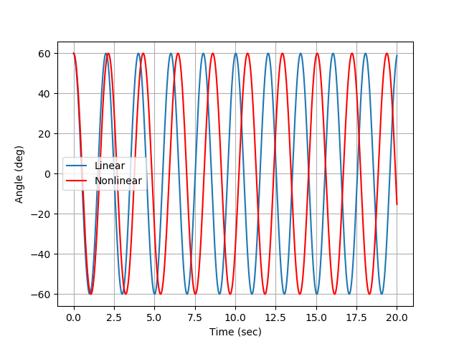

Figure 2: Simple Pendulum modeled at 60 degrees

For Fig. 2, we can see that the linear and non-linear model start out the same, but as the model progress the linear and non-linear models diverge. This divergence is due to the small angle approximation used to compute the linear model. At 60°, the angle is no longer small and is twice as large as the 30° model. This twice larger angle makes the linear and non-linear model diverge more quickly since the small angle approximation does not hold. However, the non-linear model does not depend on a small angle approximation and remains accurate through the duration of the simulation. Because there is no dampening term, the model does not decay to zero during the simulation.

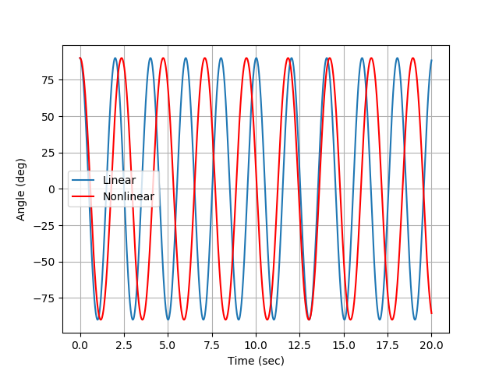

Figure 3: Simple Pendulum modeled at 90 degrees

For Fig. 3, we can see that the linear and non-linear model initially start out the same, but the linear and non-linear models diverge rather quickly. This divergence is due to the small angle approximation used to compute the linear model. At 90°, the angle is very large. This larger angle makes the linear and non-linear model diverge more quickly since the small angle approximation does not hold. However, the non-linear model does not depend on a small angle approximation and remains accurate through the duration of the simulation. Because there is no dampening term, the model does not decay to zero during the simulation.