**Chapter 2 Problem 2.2 Code:**

import numpy as np

import matplotlib.pyplot as plt

import scipy.integrate as I

import control as ctl

def Derivatives(xstate,t):

theta = xstate[0]

thetadot = xstate[1]

thetadbldot = -thetadot**2 - 0.5*theta

xstatedot = np.asarray([thetadot,thetadbldot])

return xstatedot

tout = np.linspace(0,60,1000)

xstateinitial = np.asarray([0.01,0])

stateout = I.odeint(Derivatives,xstateinitial,tout)

thetaout = stateout[:,0]

thetadotout = stateout[:,1]

plt.plot(tout,thetaout)

plt.figure()

for theta in np.arange(-np.pi/4,np.pi/4,0.5):

for thetadot in np.arange(-np.pi/4,np.pi/4,0.5):

xstateinitial = np.asarray([theta,thetadot])

stateout = I.odeint(Derivatives,xstateinitial,tout)

thetaout = stateout[:,0]

thetadotout = stateout[:,1]

plt.plot(thetaout,thetadotout)

#plt.pause(0.0001)

plt.axis([-np.pi,np.pi,-np.pi,np.pi])

plt.show()

For this homework, the phase portrait for problem 2.2 from chapter 2 was plotted to find the equilibrium points. Parts A, B, and C were all plotted. For Part A, the following system was analyzed:

$$\ddot{θ}+ \dot{θ}+0.5θ=0$$

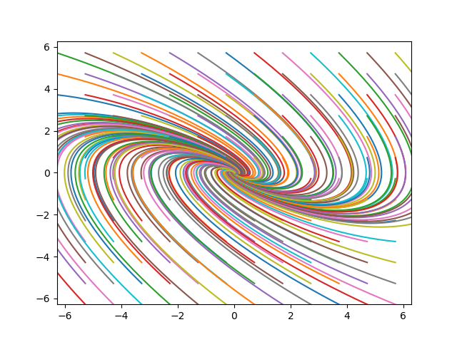

Figure 1: Phase portrait diagram for problem 2.2a

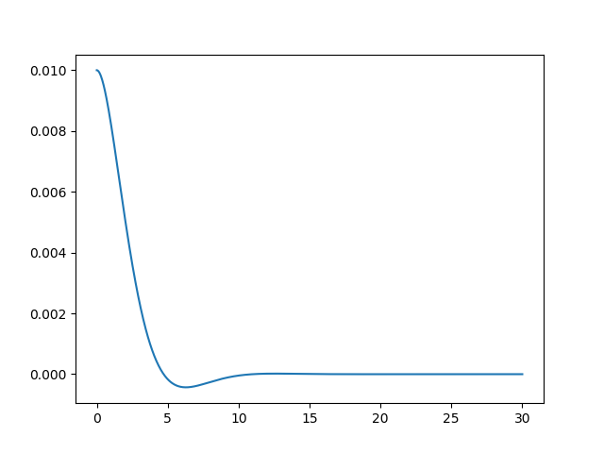

Figure 2: System response for problem 2.2a

For problem 2.2a, the phase portrait diagram is shown in Fig. 1. From the phase portrait diagram, an equilibrium point can be seen at approximately (0.0, -0.1). When simulated, the system tends towards this equilibrium point. From Fig. 2, the systems response can be seen. The system has slight overshoot but decays to zero. For Part b, the following system was analyzed:

$$\ddot{θ}+ \dot{θ}+0.5θ=1$$

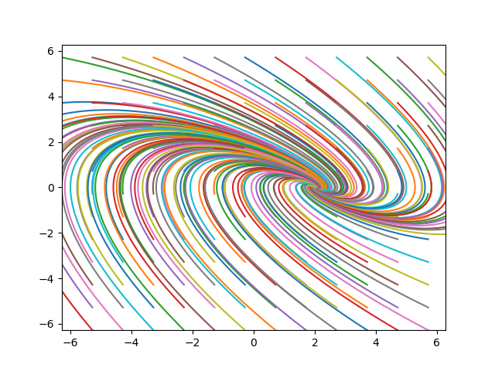

Figure 3: Phase portrait diagram for problem 2.2b

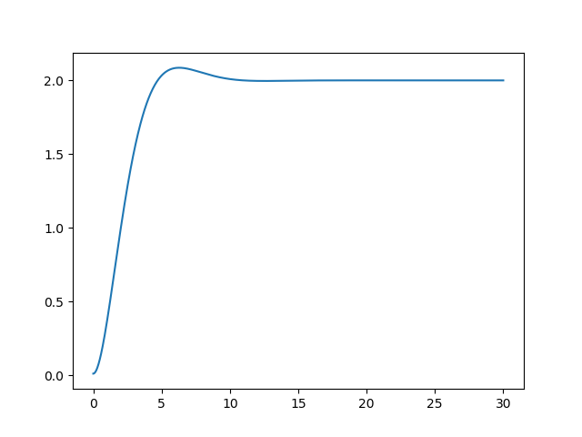

Figure 4: System response for problem 2.2b

For problem 2.2b, the phase portrait diagram is shown in Fig. 3. From the phase portrait diagram, an equilibrium point can be seen at approximately (2.0, -0.1). When simulated, the system tends towards this equilibrium point. From Fig. 4, the systems response can be seen. The system has slight overshoot but steadies out at a value of 2.0. For Part C, the following system was analyzed:

$$\ddot{θ}+ \dot{θ^{2}}+0.5θ=0$$

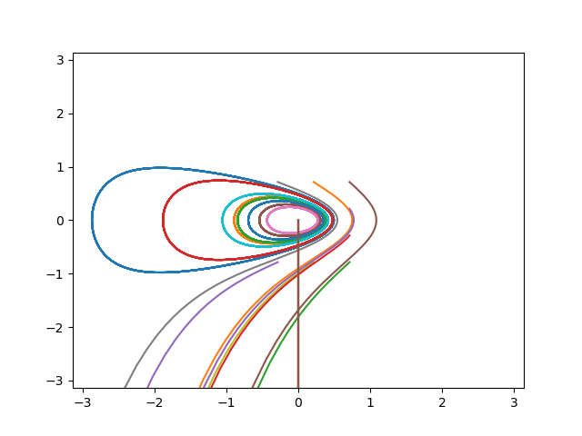

Figure 5: Phase portrait diagram for problem 2.2c

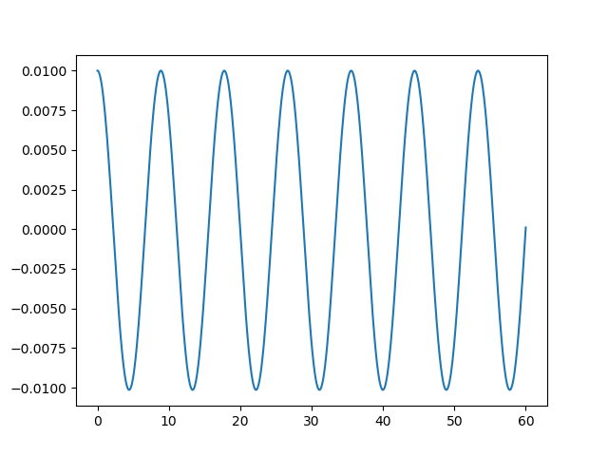

Figure 6: System response for problem 2.2c

For problem 2.2c, the phase portrait diagram is shown in Fig. 5. From the phase portrait diagram, an equilibrium point can be seen at approximately (0.0, 0.0), however when running the code, I received an error message and the phase portrait was not completed. I believe this is due to the ODE not being differentiable at some point. When simulated, the system tends towards this equilibrium point. From Fig. 6, the systems response can be seen. The system oscillates indefinitely and does not decay to any value.