**Lyapunov Stability Code for Problem 3.2a:**

import numpy as np

import matplotlib.pyplot as plt

x = np.linspace(-10,10,100)

gamma = x

u = -x**3 - np.sin(x)**4 - gamma

xdot = x**3 + np.sin(x)**4 + u

###if x is small

### sin(x) ~= x

### xdot ~= -x**3 + x**4

plt.plot(x,xdot)

plt.grid()

###Create a Lyap Function

V = 0.5*x**2

plt.figure()

plt.plot(x,V)

plt.grid()

###Look at Vdot

plt.figure()

plt.plot(x,x*xdot)

plt.grid()

plt.show()

For this homework, the objective was to complete problem 3.2a in order to learn how to apply Lyapunov Stability to a system. To do this, the equilibrium points of the system were found, a linear model for the equilibrium points was found to determine the systems stability, and a Lyapunov function was made to see if the system could be stabilized without a controller. For problem 3.2a, the following system was evaluated:

$\dot{x}= -x^{3}+ \sin^{4}(x)$ (1)

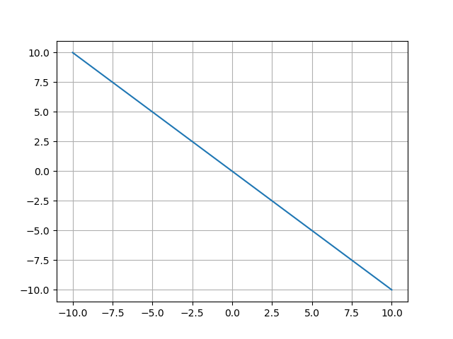

Figure : The system dynamics shown by plotting x versus xdot

To begin this problem, an equilibrium point was found at (0,0). Then $x$ is defined from -10 to 10 at 100 points. For Fig. 1, $x$ versus $\dot{x}$ where $x$ is plotted along the x-axis and $\dot{x}$ is plotted along the y-axis. This shows the dynamics of the system as it is simulated. From Fig. 1, it is shown that as $x$ increases $\dot{x}$ decreases.

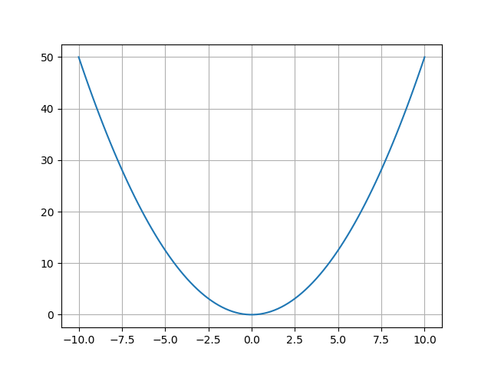

Figure : The Lyapunov function plotted against x

For Fig. 2, the Lyapunov function was plotted versus $x$ where $x$ is plotted along the x-axis and the Lyapunov function is plotted along the y-axis. The Lyapunov function chosen was:

$V=0.5x^{2}$ (2)

The Lyapunov function was found using Lyapunov’s direct method. From Fig. 2, it is shown that all values of the Lyapunov function are positive.

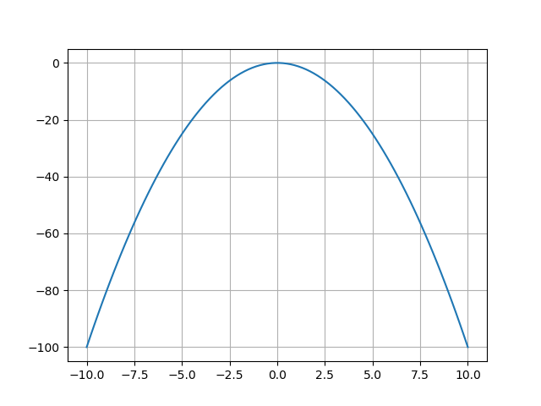

Figure : The derivative of the Lyapunov function plotted against x

For Fig. 3, the derivative of the Lyapunov function was plotted versus $x$ where $x$ is plotted along the x-axis and the derivative of the Lyapunov function is plotted along the y-axis. From Fig. 3, it is shown that all values of the derivative of the Lyapunov function are negative. This ensures global stability without using a controller, so the system is stable at all points. Work shown to find the equilibrium point and linearize the system at that point is shown below. From the linearization at the equilibrium point, the system is linearly marginally stable and nonlinearly inconclusive.