**Lab 1: Linear Controls Analysis of a 1-DOF 3U CubeSat**

Maxwell Cobar, Clifton Huett, and Carlos Montalvo

ME 494 – Nonlinear Systems Dynamics and Controls

February 07, 2020

**1 Introduction:**

A CubeSat is a small satellite on the order of 10 centimeters along each axis. A 1U satellite is a small cube with 10 cm sides. These satellites are used for a variety of missions and created by a variety of different organizations. When deployed from a rocket, a CubeSat may obtain a large angular velocity which must be reduced before most science missions or communications can take place. Maximizing solar energy charging also involves better pointing accuracy. To control the attitude of these small satellites, reaction wheels, magnetorquers and even the gravity gradient are used in low earth orbit (LEO) while reaction control thrusters are typically used in deep space. On a standard LEO CubeSat, 3 reaction wheels are used as well as 3 magnetorquers. In the initial phase of the CubeSat mission, the magnetorquers are used to reduce the angular velocity of the satellite down to a manageable level. Once the norm of the angular velocity is low enough, the reaction wheels can spin up reducing the angular velocity to zero. This paper investigates the necessary mathematics to understand the control architecture necessary for a simple CubeSat.

**2 Math Model:**

**2.1 Reaction Wheel Model:**

The reaction wheel model must be included before the attitude dynamics because they directly affect the inertia of the satellite. There are three reaction wheels on this satellite but to simplify the dynamics a 1-D system will be used. Thus, one reaction wheel will be modeled. This reaction wheel has an angular velocity ${\dot{θ}}_{R}$ and angular acceleration ${\ddot{θ}}_{R}$. The inertia of the reaction wheel is first written about the center of mass of the reaction wheel and is given by the equation below where the reaction wheel is modeled as a disk with finite radius ($r_{RW}$) and height ($h_{RW}$). The subscript R is used to denote that this inertia matrix is about the center of mass of the reaction wheel while the super script R is used to denote the frame of reference in this case the body frame of the CubeSat.

$I_{R}^{B}= m_{R}r^{2}/2$ (1)

The parallel axis theorem can then be used to shift the inertias to the center of mass of the satellite where the subscript RB denotes the reaction wheel inertia taken about the center of mass of the satellite.

$I_{RB}^{B}= I_{R}^{B}+ m_{R}(x_{R}^{2}+ y_{R}^{2})$ (2)

Where $x_{R}$, $y_{R}$ are the distances from the center of mass of the satellite to the center of mass of the reaction wheel in the satellite body reference frame. The total inertia of the entire satellite-reaction wheel system is then just a sum of the satellite and the reaction wheels.

$I_{S}= I_{B}+ I_{RB}^{B}$ (3)

The total angular momentum of the satellite is then equal to the following equation where $\dot{θ}$ is the angular velocity of the satellite.

$H_{s}= I_{B}\dot{θ}+ I_{RB}^{B}({\dot{θ}}_{R}+ \dot{θ})$ (4)

In a similar fashion, the total torque placed on the satellite is equal to the following:

$M_{R}= I_{RB}^{B}{\ddot{θ}}_{R}$ (5)

The reaction wheel acceleration is controlled by an input torque from a motor. However, the input torque is not constant since the reaction wheel cannot apply anymore torque once the reaction wheel has reached its maximum angular velocity. Thus, the equations of motion for the reaction wheel are given by:

${\ddot{θ}}_{R}=T/I_{RB}^{B}$ (6)

Where $\left|T_{MAX}\right|= \left|T_{0}- \frac{T_{0}}{{\dot{θ}}_{R,MAX}}{\dot{θ}}_{R}\right|$.

**2.2 Rotational Equation of Motion in 1-D:**

The equations of motion of a satellite in free space can be given using the equation below assuming the inertia matrix is constant.

$M_{R}= I_{S}\ddot{θ}$ (7)

**2.3 Control Schemes for Reaction Wheels:**

Assuming each reaction is aligned with a principal axis of inertia the control scheme is extremely simple. The derivation here will just be for the aligned case. In this analysis it is assumed that a torque can be applied to the reaction wheel and thus the angular acceleration of the reaction wheel can be directly controlled through the torque input T. Assuming this, a simple PD control law can be used to orient the satellite at any desired orientation.

$T_{C}= -k_{p}\left(\tilde{θ}- θ_{C}\right)- k_{d}(\tilde{\dot{θ}}- {\dot{θ}}_{C})$ (8)

Note that $T_{C}$ is used here since the system cannot generate torque from nowhere. As such, the torque must first pass through a first order filter.

$\dot{T}+aT= T_{C}$ (9)

where a is the cutoff frequency of the first order filter. Furthermore $\tilde{θ}$ is used since the sensor is not perfect or immediate and introduces some delay such that:

$\dot{\tilde{θ}}+b\tilde{θ}= θ$ (10)

where $b$ is the cutoff frequency of the sensor. In order to design and select reaction wheels the maximum angular momentum of the satellite must be obtained by assuming the worst-case angular velocity times the moment of inertia of the satellite.

$H_{required}=n\left\|I_{S}{\dot{θ}}_{MAX}\right\|$ (11)

With this reaction wheels can be selected based on this worst-case scenario plus a safety factor of $n$ which is typically set to 2 in spacecraft operations. If reaction wheels cannot be used in the event of saturation or other issues, reaction control thrusters can be used. Typically, a value of $\left|{\dot{θ}}_{MAX}\right|=5°/sec$ is used.

**3 Simulation Results:**

We began by referencing Blue Canyon to find the parameters of the reaction wheel. The parameters taken were moment=0.050 Nms, Mass=0.24kg, volume 58x58x25 mm, and max torque of 0.007 Nm. Length, width and thickness were taken as 0.1 m [1]. Mass of the satellite was taken from cubesat overview/NASA and was assumed to be around 1.33 kg [3]. Using equation 2, we found the inertia of the satellite to be 0.0022 kgm^2. From the same equation, the reaction wheel inertia was found to be 0.00062 kgm^2. Using equation 3, the total inertia was calculated to be 0.00282 kgm^2. The delay for the attitude stabilization of the reaction wheel was given as 760 msec. Solving for the time constant gives 1.3. Values for the saturation block limits were taken from values of magnetorquers from blue canopy technologies [1].

In order to stabilize this system, a lead compensator was used. A lead compensator helps to improve an undesirable frequency response in a feedback control system. This lead compensator added zeros to the system which helped to drive the poles to the left-hand plane stabilizing the system [2].

**4 Conclusion:**

From the simulation results,

**5 Acknowledgements:**

We would like to thank James Helton and Slater Dozier. Both students helped us with the MATLAB and Simulink Code as well as understanding how to stabilize the system. Without their help, this project would not have been finished.

**6 Appendix:**

**6.1 Code:**

clear

clc

close all

A = tf([1.3],[1,1.3])

G = tf([1],[.00303,0,0])

H = tf([1000],[1,1000])

GOL = A*G*H;

bode(GOL)

margin(GOL)

figure()

rlocus(GOL)

C1 = tf([1,1],[1,650])

C2 = tf([1,5],[1,300])

C = C1*C2;

CGOL = C*GOL

bode(CGOL)

margin(CGOL)

figure()

rlocus(CGOL)

K = 5;

GCL = K*CGOL/(1+K*CGOL);

figure()

step(GCL)

figure()

pzmap(GCL)

**6.2 Figures:**



Figure 1: Amplitude vs Time of the Satellite When Hit with a Step Function



Figure 2: A Root Locus Analysis of the Satellite Determining Stability



Figure 3: A Bode Plot of the Closed Loop Plant Dynamics Determining Gain and Phase Margin



Figure 4: A Bode Plot of the Open Loop Plant Dynamics Determining Gain and Phase Margin



Figure 5: PZ Map of the Satellite System to Show the Poles and Zeros of the System

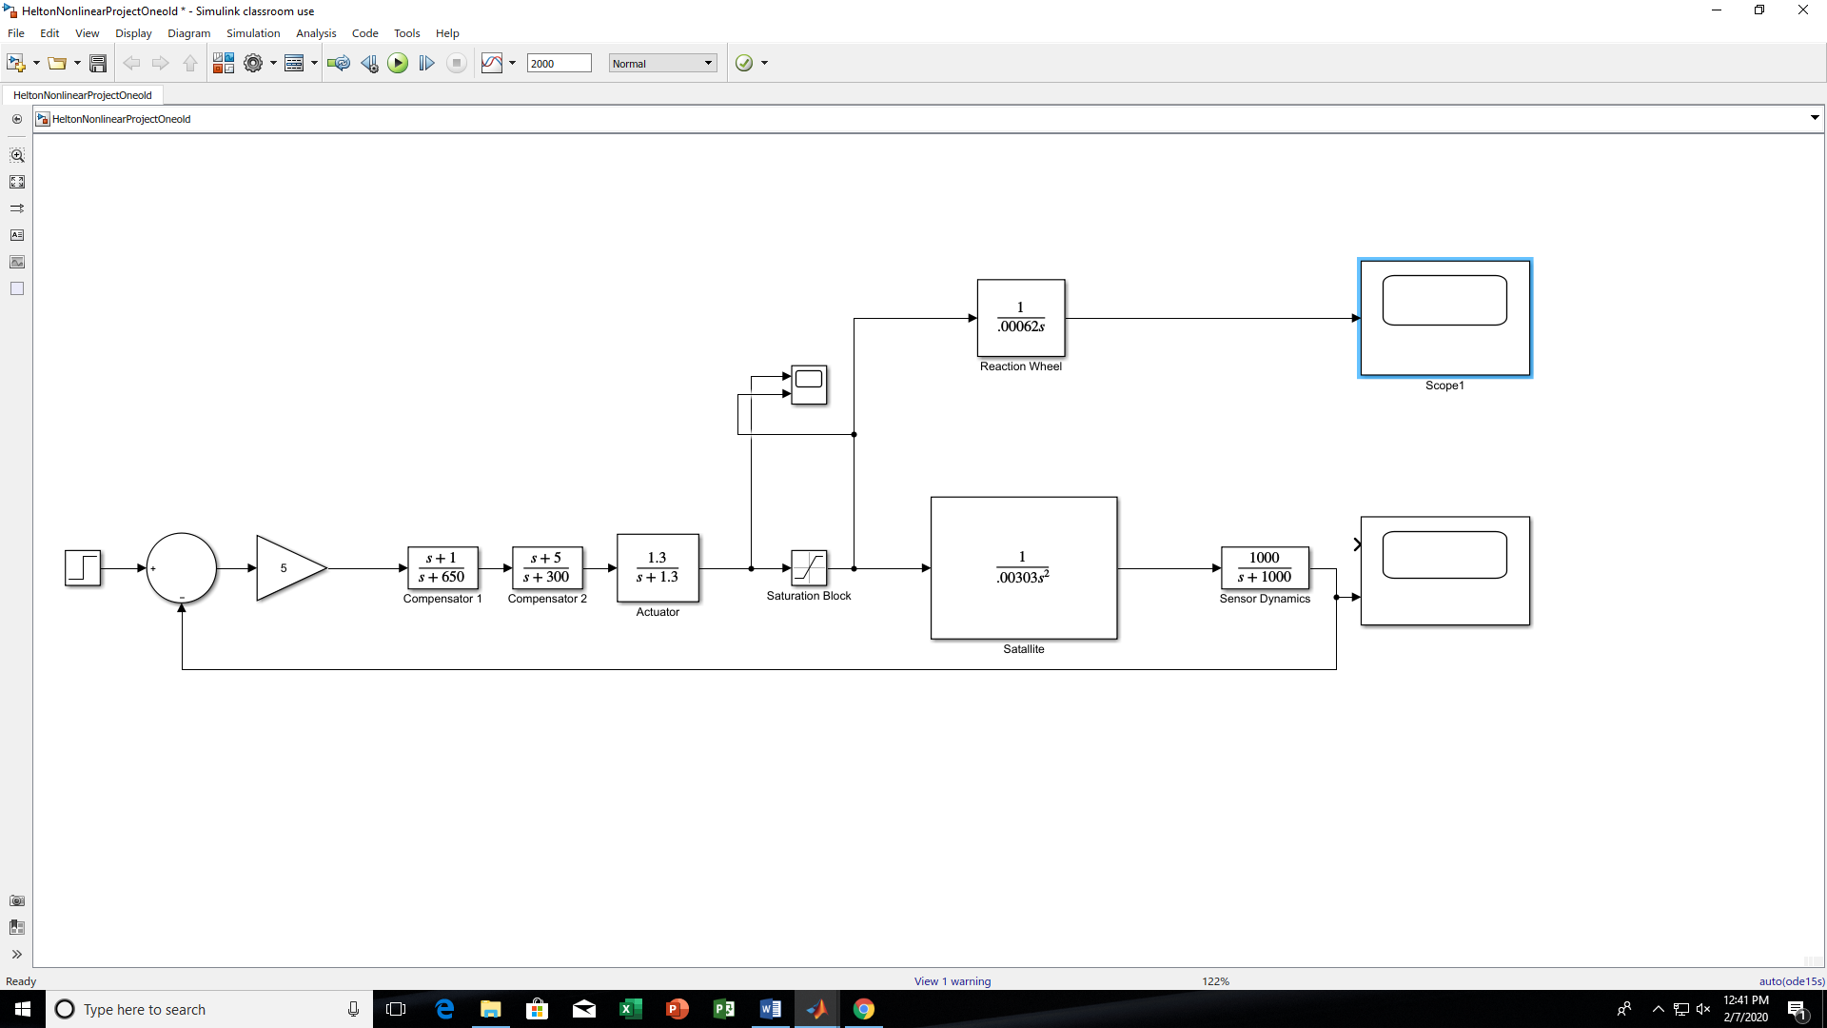

Figure 6: A Control Block Diagram of the Satellite System for Measuring Outputs of the Reaction Wheel, Torque, and Angle of the Satellite

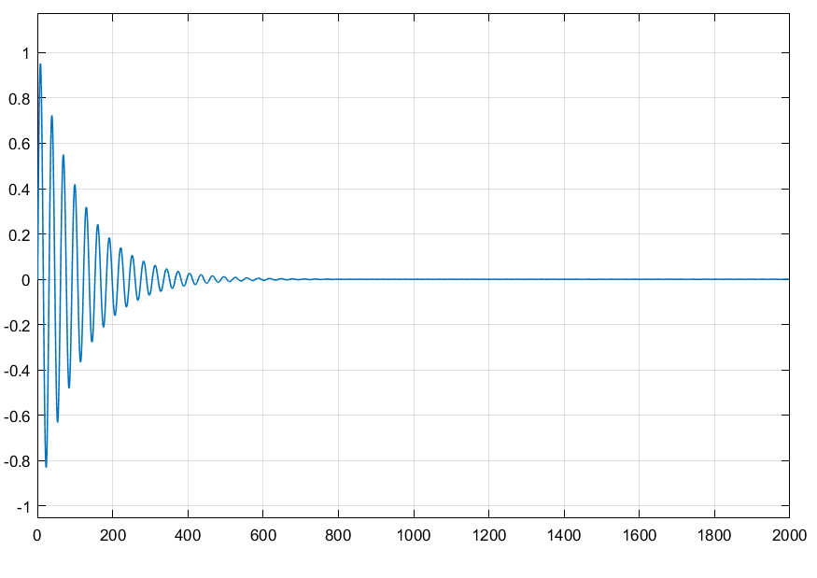

Figure 7: The Measured Theta of the Satellite with Theta along the X-axis and Time along the Y-axis



Figure 8: The Angular Velocity Measured from the Reaction Wheel with Angular Velocity along the X-axis and Time along the Y-axis

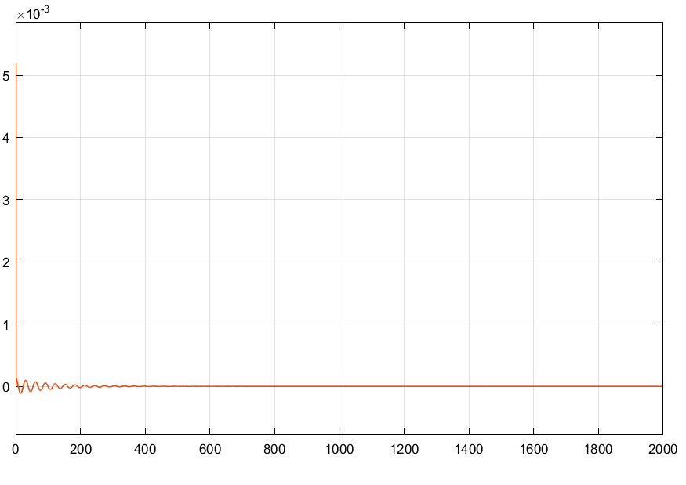

Figure 9: Torque Coming from the Actuator Dynamics Measured Before and After the Saturation Block with Torque along the X-axis, Time along the Y-axis, the Blue Line Pre-Saturation Torque, and the Orange Line Post-Saturation Torque

**6.3 References:**

1. Blue Canyon Technologies, “Blue Canyon Technologies Components,” *Blue Canyon Technologies* Available: <https://www.bluecanyontech.com/components>.
2. Franklin, G. F., Powell, J. D., and Emami-Naeini, A., *Feedback control of dynamic systems*, Upper Saddle River, NJ: Pearson, 2020.
3. Loff, S., “CubeSats Overview,” *NASA* Available: <https://www.nasa.gov/mission_pages/cubesats/overview>.