Background:

我们在开发Newegg Central框架的项目时, 需要在Silverlight端定义ViewModel, 用于在调用RestClient相关方法时进行json or xml反序列化. 在90%的场景下, ViewModel与你在Restful Service端定义的实体 or DataContract都是一摸一样的. 目前大部分Team的做法是, 将Restful service定义的Entity Copy到Silverlight的项目当中, 然后再稍作调整和修改.  虽然这个修改的过程不是太复杂, 但是还是会花费一定程度的工作量.因此编写了附件当中的工具, 用于根据Restful service端定义的Entity, 自动生成对应的Silverlight端的ViewModel, 以提高工作效率.

Summary:

.net Framework version of this tools: .net framework 4.0

适用范围: 所有以Newegg Central框架为基础, 并且Service端采用基于Restful service的相关技术(MS RIA Service不用使用该工具, IDE会自动帮你生成Siverlight Entity).

How to Use:

Step 1: 选择你定义Restful service端的Entity对应的assembly(.dll).

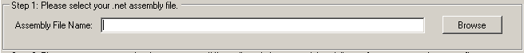

Step 2: 输入你需要生成ViewModel的Class, 多个Class以”;”隔开.

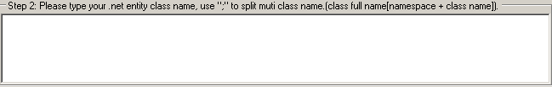

Step 3: 这一步是可选的. 输入生成ViewModel的命名空间(默认是根据Service端的Entity的namespace来生成), 以及对应的类名和.cs文件名(默认是ViewModel)的后缀.



Step 4: 点击Generate button. 如果提示成功, 则会在该工具的根目录下生成ViewModel的文件夹和相关的.cs文件.

NOTE:

1. 支持自动生成目标类型的base class的ViewModel.
2. 支持自动生成类型当中包含其他的复杂类型的ViewModel(递归查找.)
3. 支持枚举, Nullable, 泛型类型.

例如, 现在有一个Restful Service端有一个类定义为:

namespace SLModelGenerator.TestAssembly

{

    public class BaseModel

    {

        public string CompanyCode { get; set; }

        public DateTime InDate { get; set; }

        public string InUser { get; set; }

    }

    public class SOMaster : BaseModel

    {

        public List<string> SoMemo { get; set; }

        public DateTime? EditDate { get; set; }

        public int SoNumber { get; set; }

        public string CustomerName { get; set; }

        public decimal SoAmount { get; set; }

        public List<SoTransaction> SoDetailList { get; set; }

        public SoType? SoType { get; set; }

        public SoType SoType2 { get; set; }

        public AddressInfo AddressInformation { get; set; }

    }

    public class SoTransaction

    {

        public string ItemCode { get; set; }

        public decimal UnitPrice { get; set; }

        public AddressInfo AddressInformation { get; set; }

        public ItemType ItemType { get; set; }

    }

    public class ItemType

    {

        public string Normal { get; set; }

        public string COM { get; set; }

        public string Note { get; set; }

    }

    public class AddressInfo

    {

        public string ShippingAddress { get; set; }

        public string BillingAddress { get; set; }

    }

    public enum SoType

    {

        SO,

        ReplaceSO,

    }

}

运行该工具:

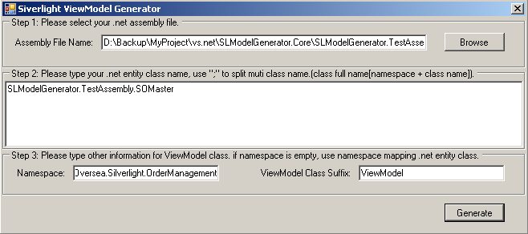

生成的ViewModel类为:

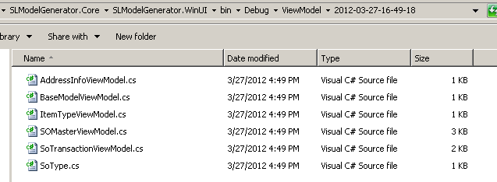

using System;

using Newegg.Oversea.Silverlight.ControlPanel.Core.Base;

namespace Newegg.Oversea.Silverlight.OrderManagement

{

   public class SOMasterViewModel : ModelClass

   {

       private List<String> m_SoMemo;

       public List<String> SoMemo

       {

           get { return this.m_SoMemo; }

           set { this.SetValue("SoMemo", ref m_SoMemo, value);  }

       }

       private DateTime? m_EditDate;

       public DateTime? EditDate

       {

           get { return this.m_EditDate; }

           set { this.SetValue("EditDate", ref m_EditDate, value);  }

       }

       private Int32 m_SoNumber;

       public Int32 SoNumber

       {

           get { return this.m_SoNumber; }

           set { this.SetValue("SoNumber", ref m_SoNumber, value);  }

       }

       private String m_CustomerName;

       public String CustomerName

       {

           get { return this.m_CustomerName; }

           set { this.SetValue("CustomerName", ref m_CustomerName, value);  }

       }

       private Decimal m_SoAmount;

       public Decimal SoAmount

       {

           get { return this.m_SoAmount; }

           set { this.SetValue("SoAmount", ref m_SoAmount, value);  }

       }

       private List<SoTransaction> m_SoDetailList;

       public List<SoTransaction> SoDetailList

       {

           get { return this.m_SoDetailList; }

           set { this.SetValue("SoDetailList", ref m_SoDetailList, value);  }

       }

       private SoType? m_SoType;

       public SoType? SoType

       {

           get { return this.m_SoType; }

           set { this.SetValue("SoType", ref m_SoType, value);  }

       }

       private SoType m_SoType2;

       public SoType SoType2

       {

           get { return this.m_SoType2; }

           set { this.SetValue("SoType2", ref m_SoType2, value);  }

       }

       private AddressInfo m_AddressInformation;

       public AddressInfo AddressInformation

       {

           get { return this.m_AddressInformation; }

           set { this.SetValue("AddressInformation", ref m_AddressInformation, value);  }

       }

   }

}