**Printing ALeP cards using DriveThruCards**

**1. Using an archive of images**

* Download either **7z** or **zip** archive for **DriveThruCards** (make sure that its name starts with **“DTC”**). Extract files from the archive. If there are no more than 130 cards in the set, it contains just two folders: **front** and **back**. Otherwise, on the top level, there are folders **deck1**, **deck2**, etc. and each of them contains two subfolders: **front** and **back**.
* Open [**http://www.drivethrucards.com**](http://www.drivethrucards.com) and click **Log In**.

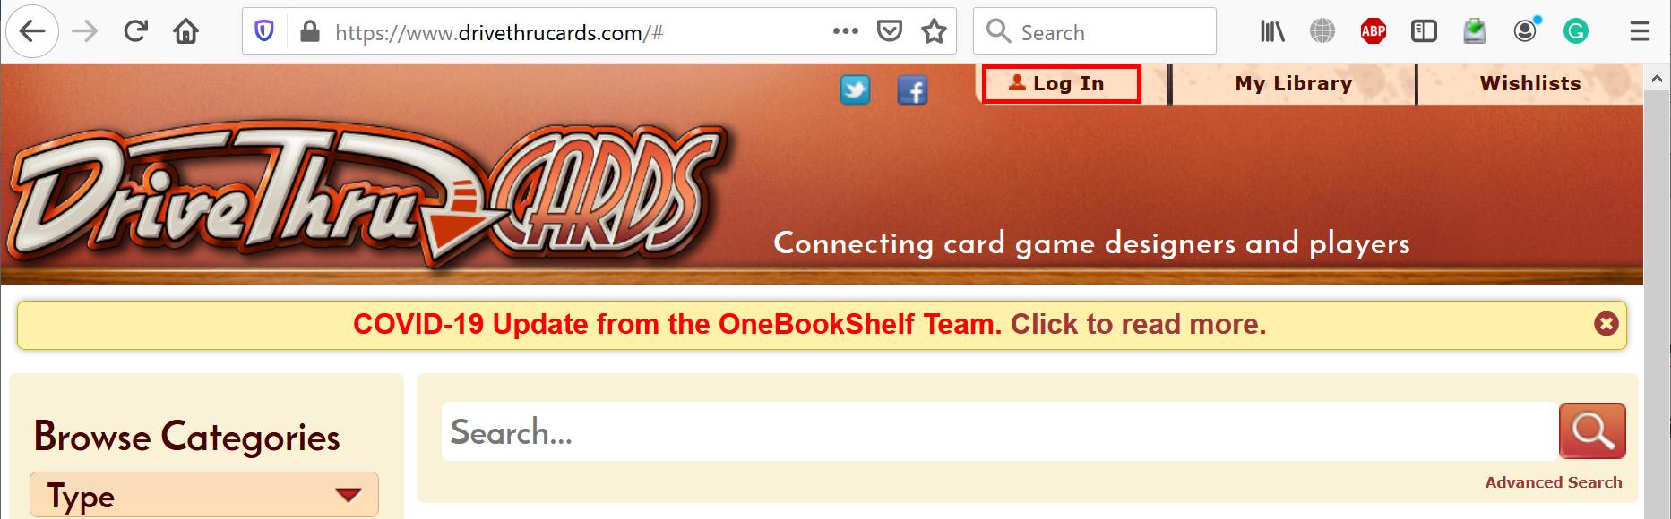

* If you already have an account, click **Log In** again. Otherwise, choose whether you want to **Create Account** or just login using **Facebook**.

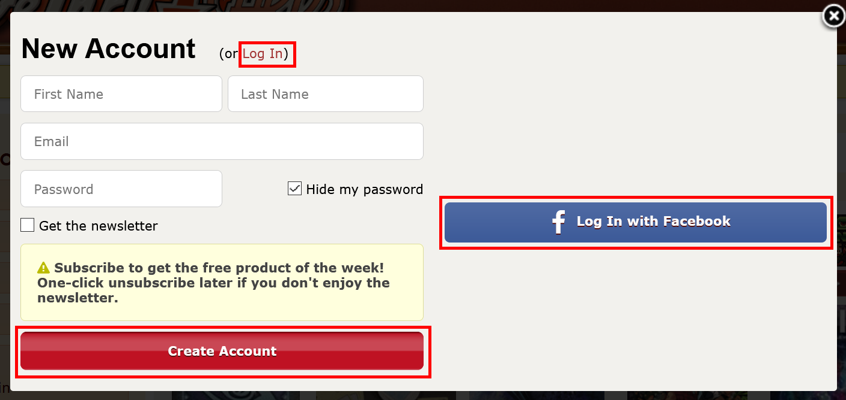

* Once you logged in, open this direct link: [**https://www.drivethrucards.com/joinchoice.php**](https://www.drivethrucards.com/joinchoice.php) and click **Create My Non-Exclusive Publisher Account** button (if you did not do that before).

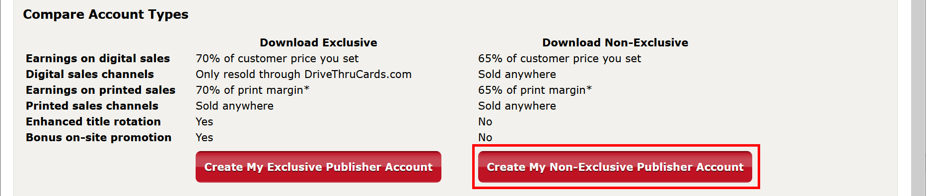

* Scroll to the bottom, check **I Agree**, enter **Publisher Account Name** (must be unique), and click **Set up My Publisher Account**.

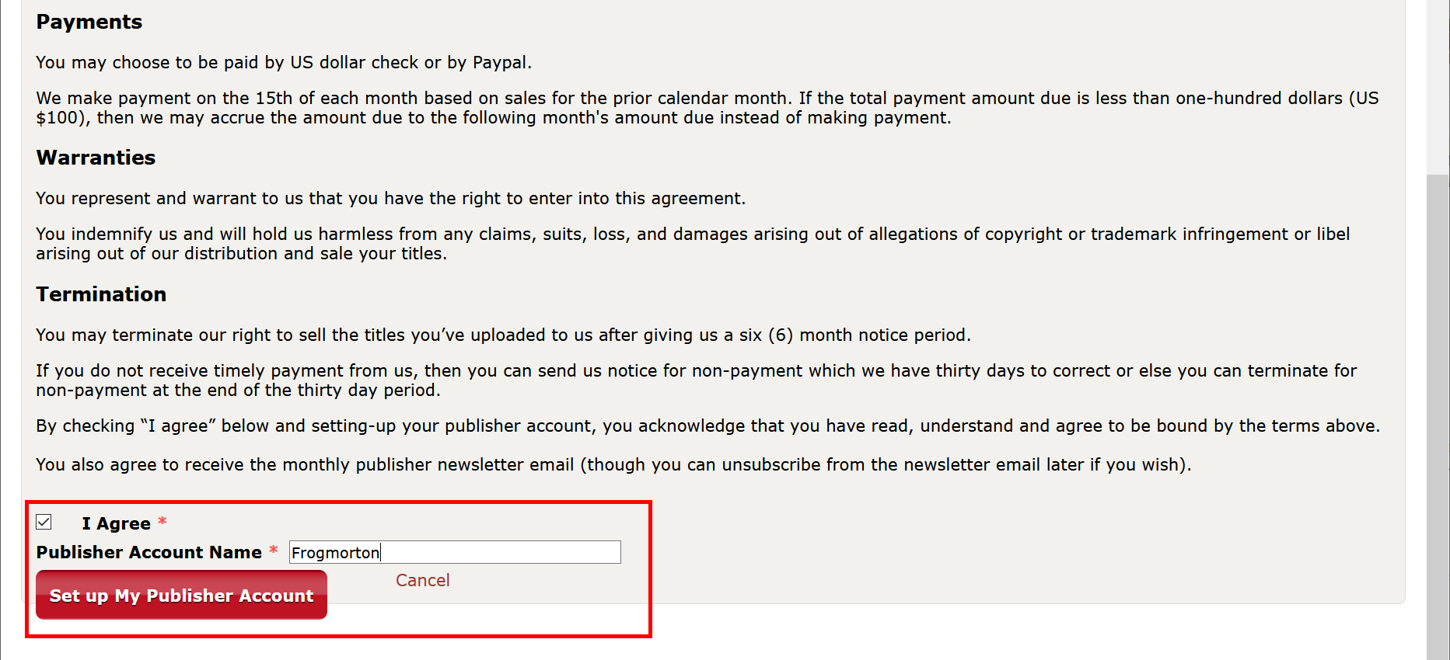

* If needed, update **PayPal Email** and click **Save** button.

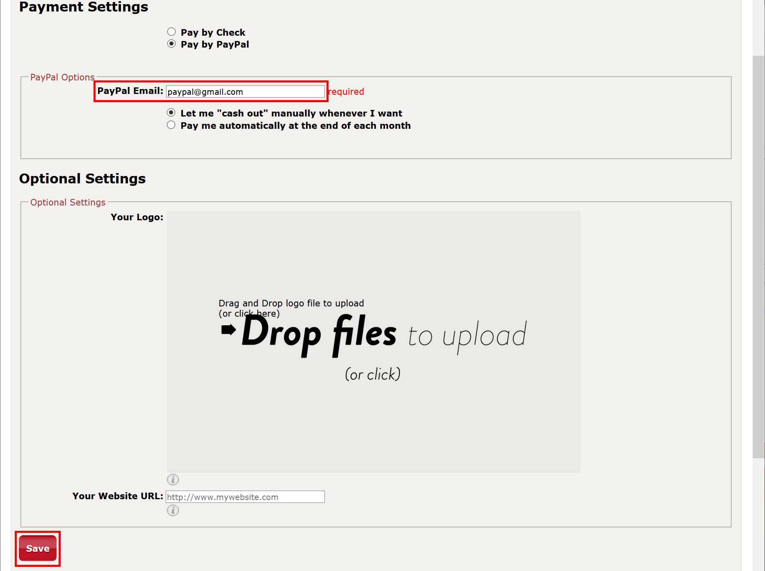

* Open this direct link: [**https://www.drivethrucards.com/builder/deck/**](https://www.drivethrucards.com/builder/deck/). Choose **US Poker on Premium Stock** as **Card Type**, specify **Deck Name** (any) and click **Add New Deck** button.



* Drag and drop images from the **back** folder (from **deck1/back** folder if there are several decks) and wait until all images have been uploaded (depending on your Internet connection speed, this may take a while).

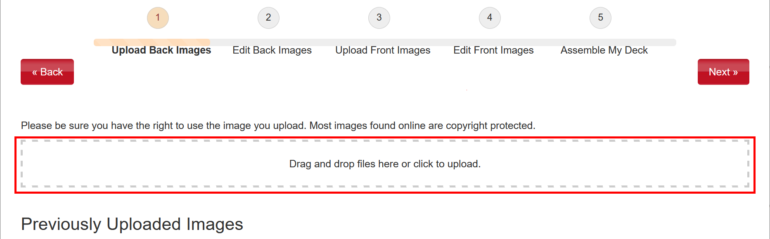

* Click **Next** button.

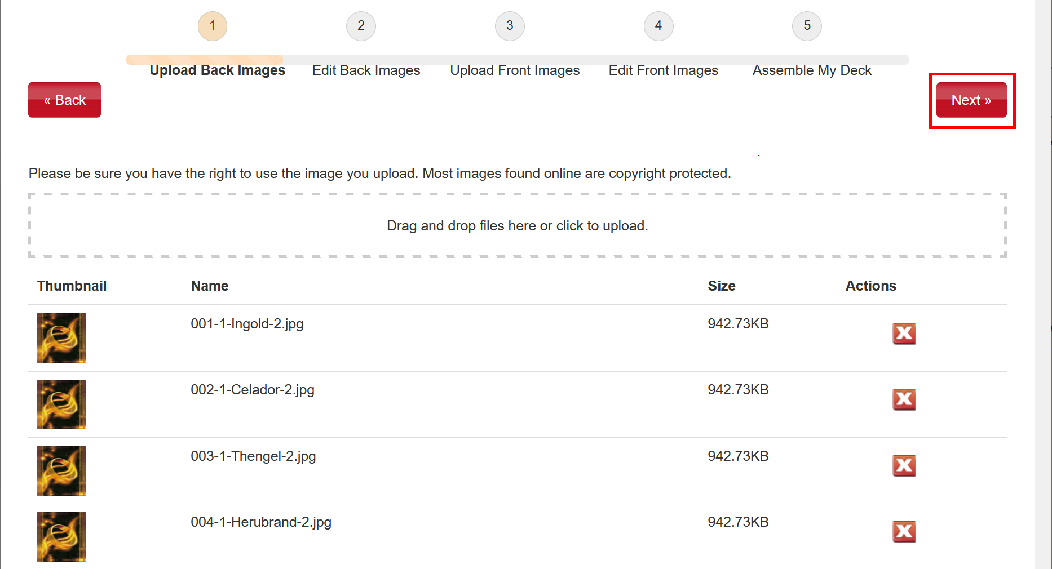

* Review all images and click **Next** button.

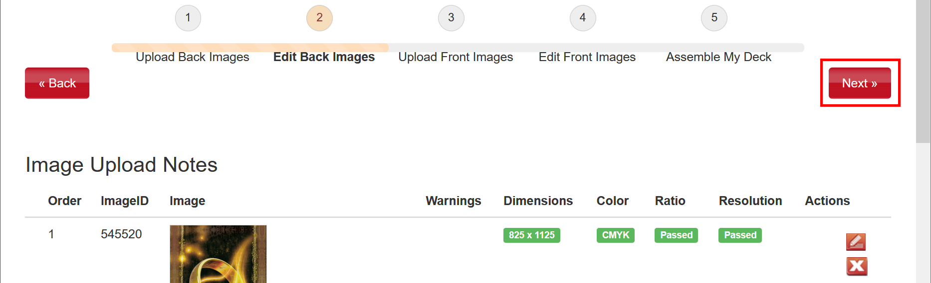

* Repeat for the front cards: drag and drop images from the **front** folder (from **deck1/front** folder if there are several decks) and wait until all images have been uploaded (depending on your Internet connection speed, this may take a while), then click **Next** button.

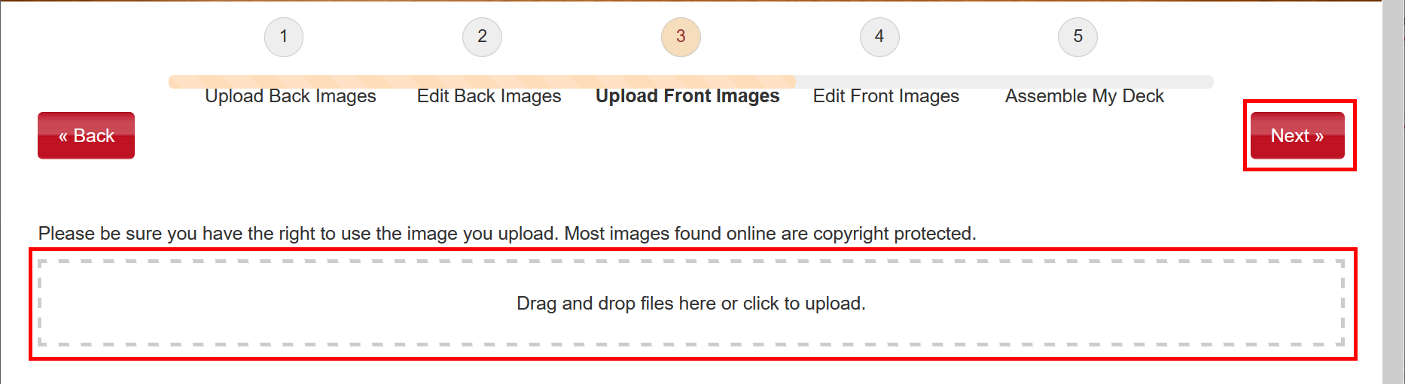

* Review all images and click **Next** button.

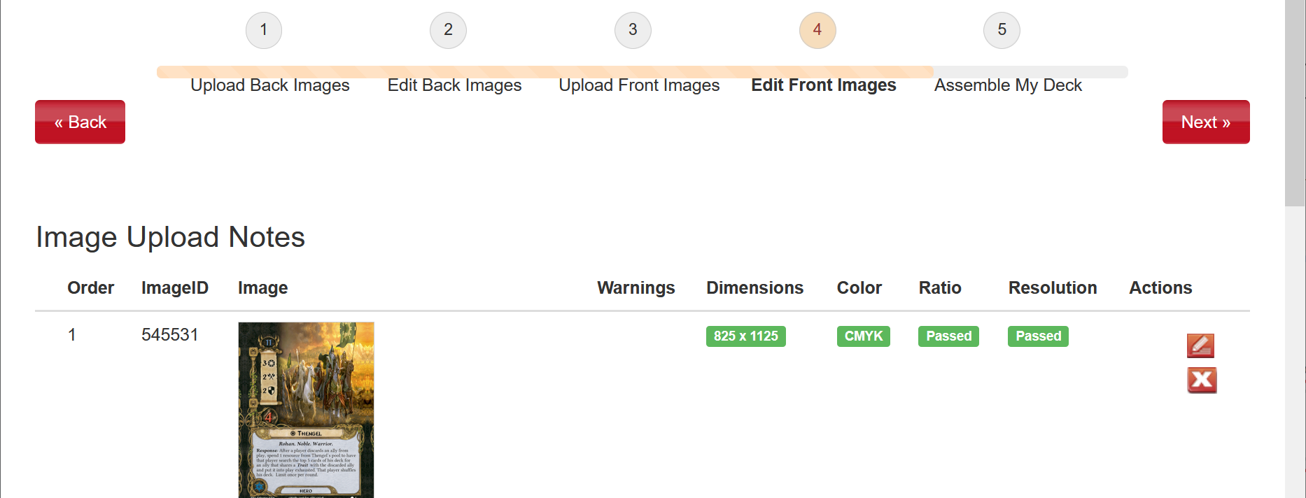

* Carefully review front and back sides of all cards. When finished, click **I’m finished** button.

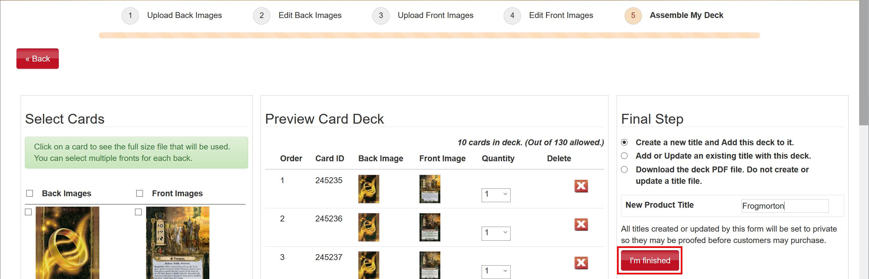

* Verify that the next screen says “**Your deck is complete!**”. Click “**you can order a print here**” link.

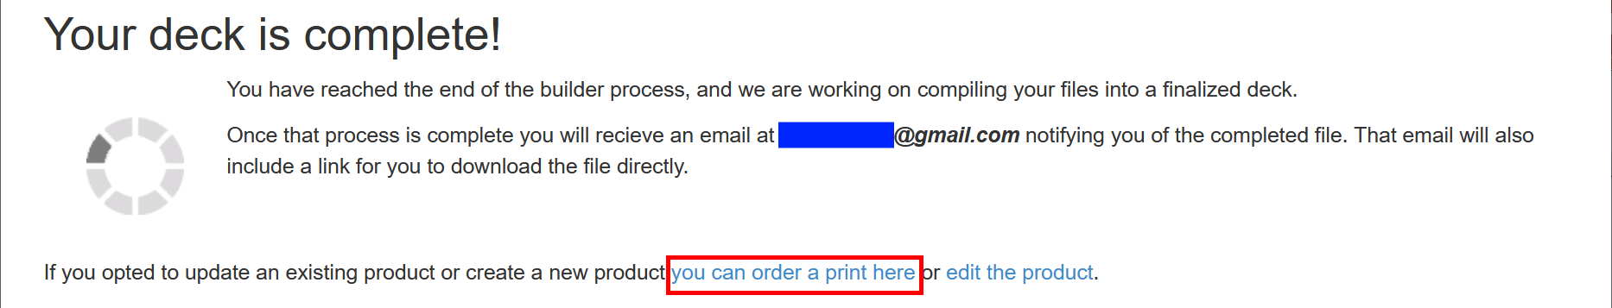

* If needed, update **quantity** and click **Checkout** button.

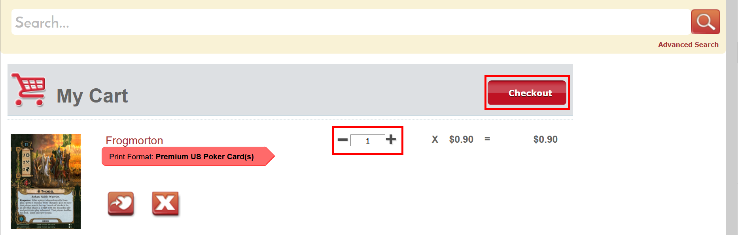

* Specify **Shipping Address**, **Shipping Method**, click **Next** button, and finish the order.
* Also, in some time (up to an hour) you will receive a link to a final PDF file generated by DriveThruCards. You can share this file with somebody else (see the next section below).

**2. Using a PDF file**

If you have a PDF file already generated by DriveThruCards, you don’t need to upload images manually and you can follow the steps below.

* Open [**http://www.drivethrucards.com**](http://www.drivethrucards.com) and click **Log In**.



* If you already have an account, click **Log In** again. Otherwise, choose whether you want to **Create Account** or just login using **Facebook**.



* Once you logged in, open this direct link: [**https://www.drivethrucards.com/joinchoice.php**](https://www.drivethrucards.com/joinchoice.php) and click **Create My Non-Exclusive Publisher Account** button (if you did not do that before).



* Scroll to the bottom, check **I Agree**, enter **Publisher Account Name** (must be unique), and click **Set up My Publisher Account**.



* If needed, update **PayPal Email** and click **Save** button.



* Open this direct link: [**https://www.drivethrucards.com/pub_enter_product.php**](https://www.drivethrucards.com/pub_enter_product.php). Enter **Title** (any), set **Selling Price** to **$0**, and choose **Cover image** (any image file).

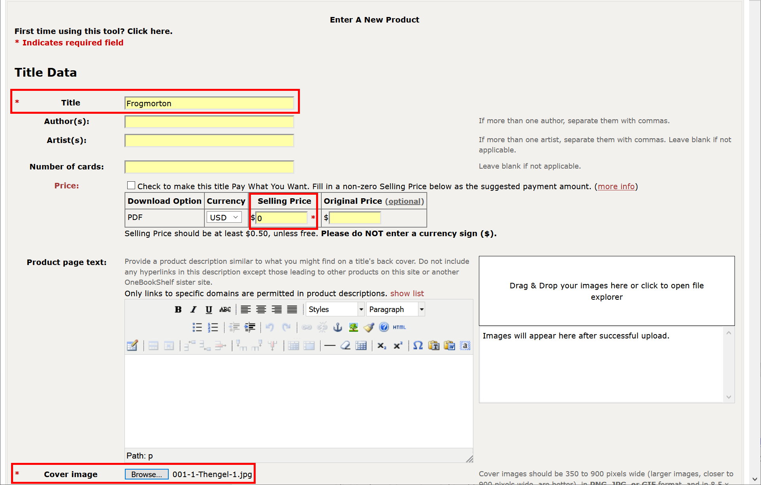

* Scroll to **Category Assignments** section and check one subcategory (any of them) under each main category: **Type**, **Theme**, **Age** and **Players**.

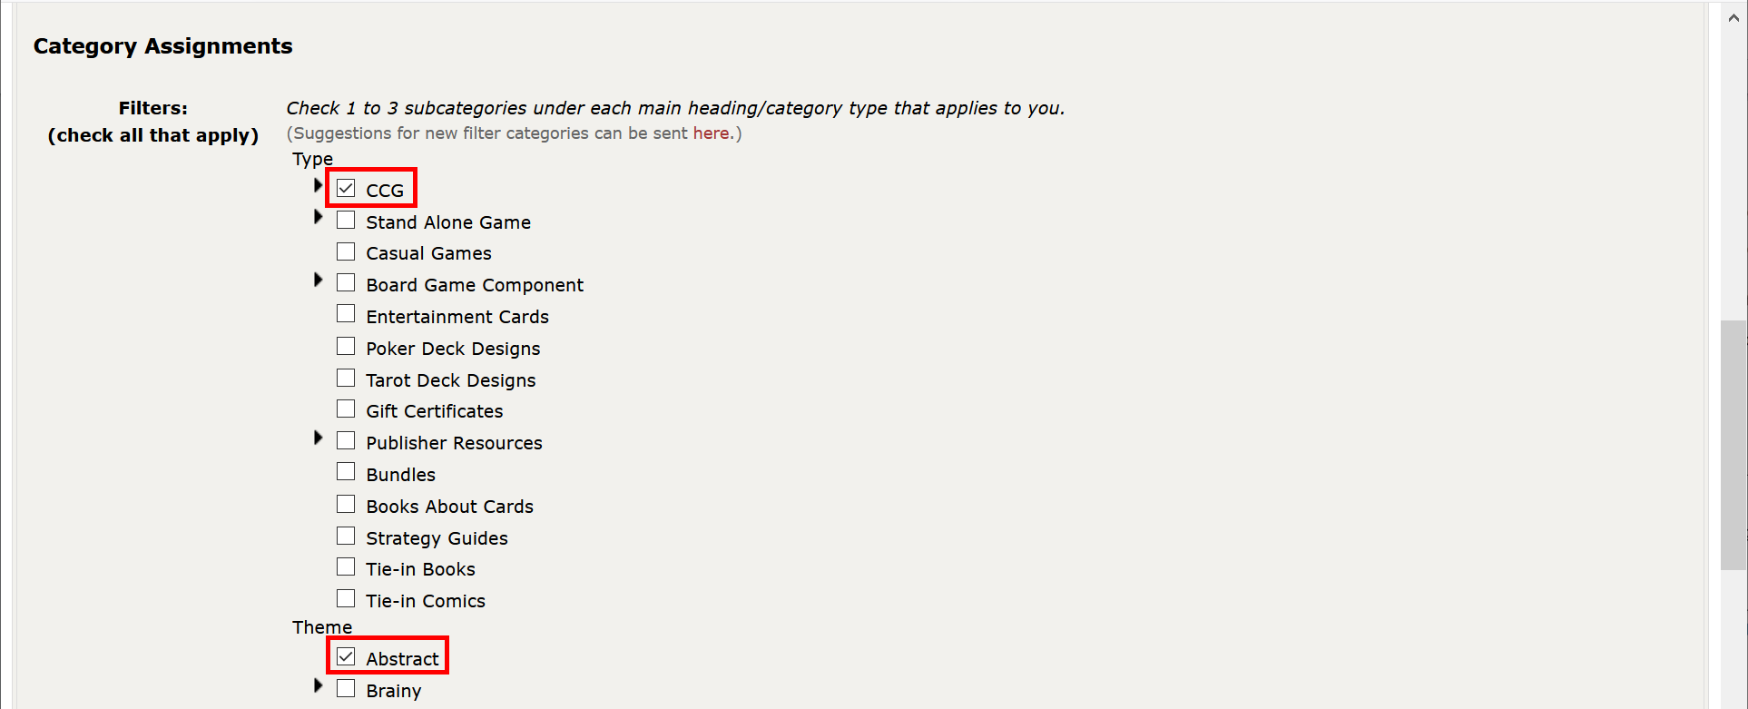

* Scroll to the bottom and click **Save Title Data and Continue to Preview Description**.

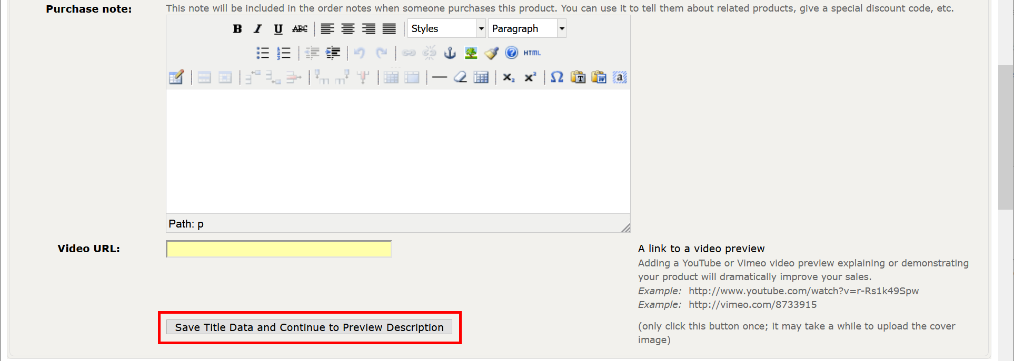

* Click Save and Continue button.

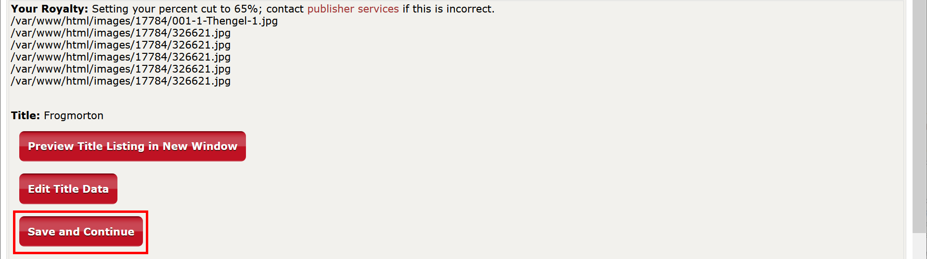

* Click **Upload print-ready file**.

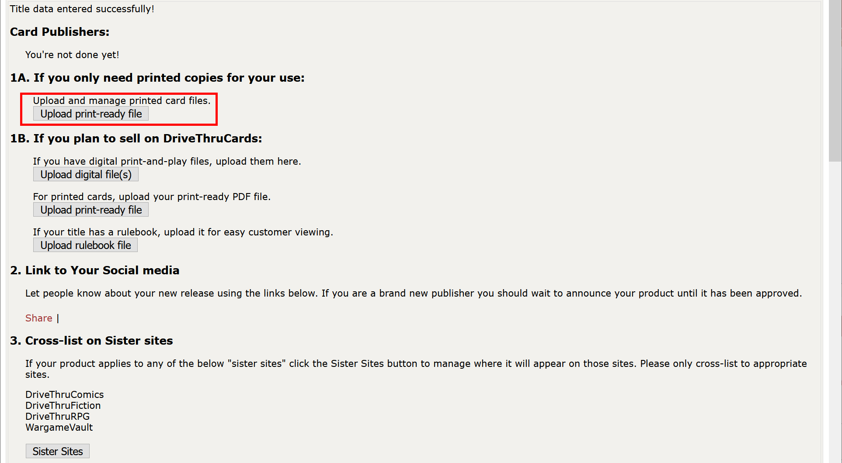

* Select **Premium US Poker Card(s)** in the dropdown, drag and drop your PDF file and click **Begin Card File Upload** button. Wait until the file has been uploaded (depending on your Internet connection speed, this may take a while).

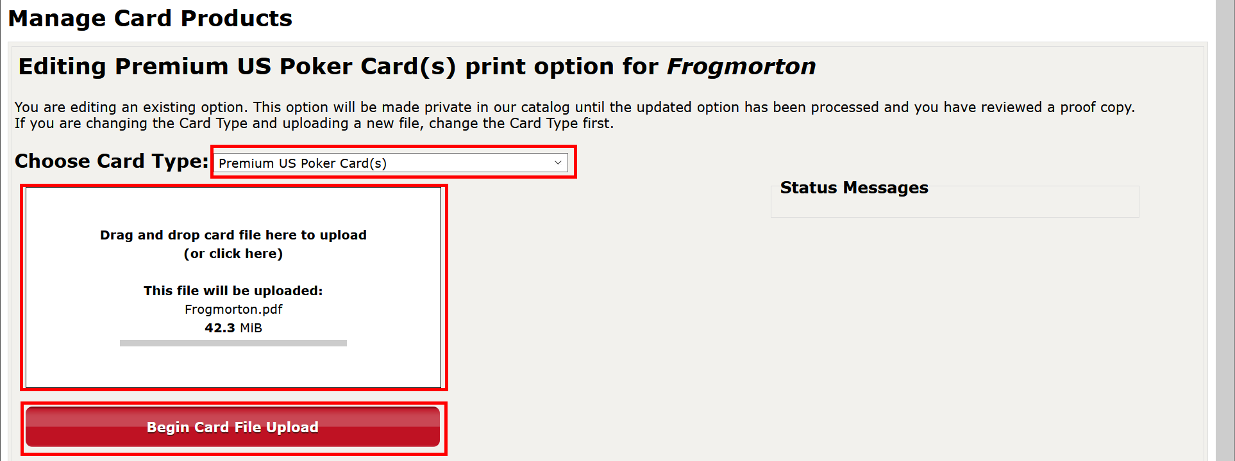

* Click **Click here after uploading your files** button.

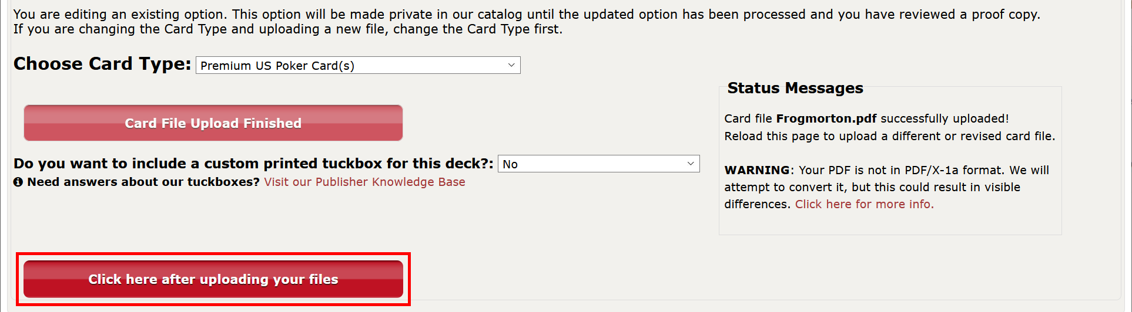

* Don’t change anything in the form, just click **Complete Setup** at the bottom.

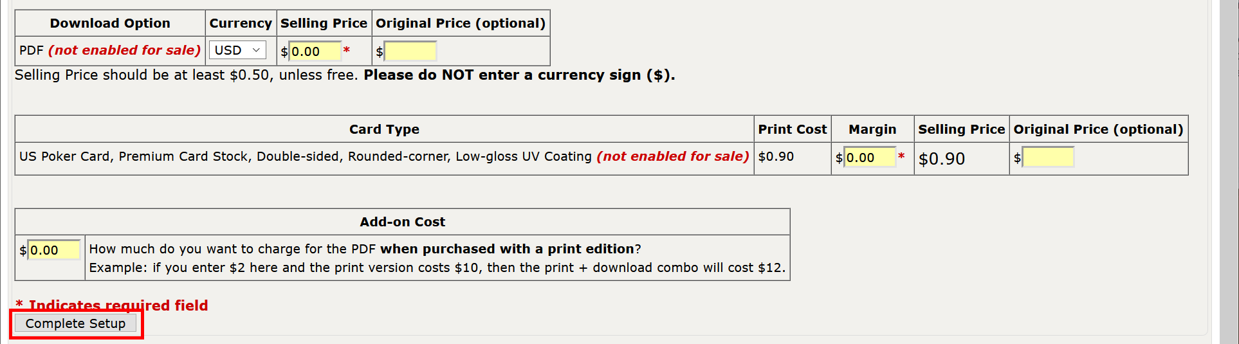

* Click the “**here**” link.



* If needed, update **quantity** and click **Checkout** button.



* Specify **Shipping Address**, **Shipping Method**, click **Next** button, and finish the order.
* If you want to print another deck, you don’t need to repeat all the steps related to creating a new product. Just proceed to this link: [**https://www.drivethrucards.com/pub_upload_podcard_files.php**](https://www.drivethrucards.com/pub_upload_podcard_files.php). Select an existing product from the dropdown, choose **Premium US Poker Card(s)**, and click **Enter New Print Option**.

