R setup tests

Terry N. Brown

Tuesday, February 02, 2016

# Basic output

Simple inline 3 x 11 = 33 and echoed block command with output

summary(cars)

## speed dist   
## Min. : 4.0 Min. : 2.00   
## 1st Qu.:12.0 1st Qu.: 26.00   
## Median :15.0 Median : 36.00   
## Mean :15.4 Mean : 42.98   
## 3rd Qu.:19.0 3rd Qu.: 56.00   
## Max. :25.0 Max. :120.00

## Plots

Plot output

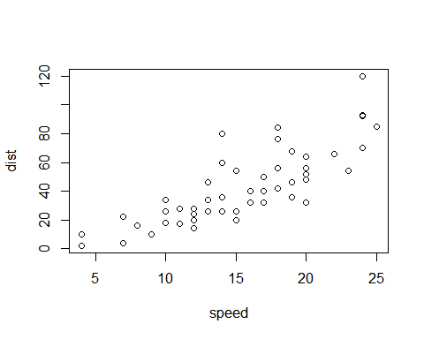

Equations with LaTeX inline $E=mc^{2}$ and displayed

$$I=∑\frac{P×V}{1}$$

Equation with MathML a ⁢ x2 +b⁢x +c

## Images

Image test 

## Tables

knitr kable() function:

## Warning: package 'knitr' was built under R version 3.1.3

|  |  |  |
| --- | --- | --- |
|  | speed | dist |
|  | Min. : 4.0 | Min. : 2.00 |
|  | 1st Qu.:12.0 | 1st Qu.: 26.00 |
|  | Median :15.0 | Median : 36.00 |
|  | Mean :15.4 | Mean : 42.98 |
|  | 3rd Qu.:19.0 | 3rd Qu.: 56.00 |
|  | Max. :25.0 | Max. :120.00 |

pander:

## Warning: package 'pander' was built under R version 3.1.3

|  |  |
| --- | --- |
| speed | dist |
| Min. : 4.0 | Min. : 2.00 |
| 1st Qu.:12.0 | 1st Qu.: 26.00 |
| Median :15.0 | Median : 36.00 |
| Mean :15.4 | Mean : 42.98 |
| 3rd Qu.:19.0 | 3rd Qu.: 56.00 |
| Max. :25.0 | Max. :120.00 |

xtable (doesn't translate to Word because it uses raw HTML not markdown):

## Warning: package 'xtable' was built under R version 3.1.3

speed

dist

1

Min. : 4.0

Min. : 2.00

2

1st Qu.:12.0

1st Qu.: 26.00

3

Median :15.0

Median : 36.00

4

Mean :15.4

Mean : 42.98

5

3rd Qu.:19.0

3rd Qu.: 56.00

6

Max. :25.0

Max. :120.00