**Velagapudi Ramakrishna Siddhartha**

**Engineering College**

**Kanuru, 520001**



**Code : 20IT6303**

**Web Programming and**

**Development Laboratory**

**Aim :** Create a Web application in which user enters an Employee

Number and fetch the Employee Information and print it on servlet

Page.

**Program :** Index.html

<html>

<head>

<title> Assignment 1 </title>

<meta charset="UTF-8">

<meta name="viewport" content="width=device-width, initial-scale=1.0">

</head>

<body>

<center>

<form action = "Servlet1" method = "GET">

<h1> <b> Employee Details </b> </h1>

<label for = "em"> Enter a Employee Number : </label>

<input type = "text" name = "id" /> <br> <br>

<input type = "submit" value = "SUBMIT" />

</form>

</center>

</body>

</html>

**Program :** Servlet1.java

import javax.servlet.http.*;

import javax.servlet.*;

import java.io.*;

import java.sql.*;

public class Servlet1 extends HttpServlet

{

@Override

public void doGet(HttpServletRequest req,HttpServletResponse res) throws ServletException,IOException

{

res.setContentType("text/html"); //setting the content type or mine type

PrintWriter pw=res.getWriter(); //get the stream to write the data

int id = Integer.parseInt(req.getParameter("id"));

try

{

Class.forName("com.mysql.jdbc.Driver");

Connection con = DriverManager.getConnection("jdbc:mysql://localhost/it", "root", "");

PreparedStatement ps = con.prepareStatement("select * from javaemployee where id = ?");

ps.setInt(1, id);

ResultSet rs = ps.executeQuery();

while(rs.next())

{

pw.println("<center>");

pw.println("<h1> Employeee Id : " + rs.getInt(1) + "</h1> <br> <br>");

pw.println("<h1> Employeee Name : " + rs.getString(2) + "</h1> <br> <br>");

pw.println("<h1> Employeee City : " + rs.getString(3) + "</h1> <br> <br>");

pw.println("<h1> Employeee Company : " + rs.getString(4) + "</h1> <br> <br>");

pw.println("<h1> Employeee Salary : " + rs.getFloat(5) + " Lakhs </h1> <br> <br>");

pw.println("</center>");

}

}

catch(Exception e)

{

pw.println("An unexcepted Error Occured");

}

}

}

**Output :**

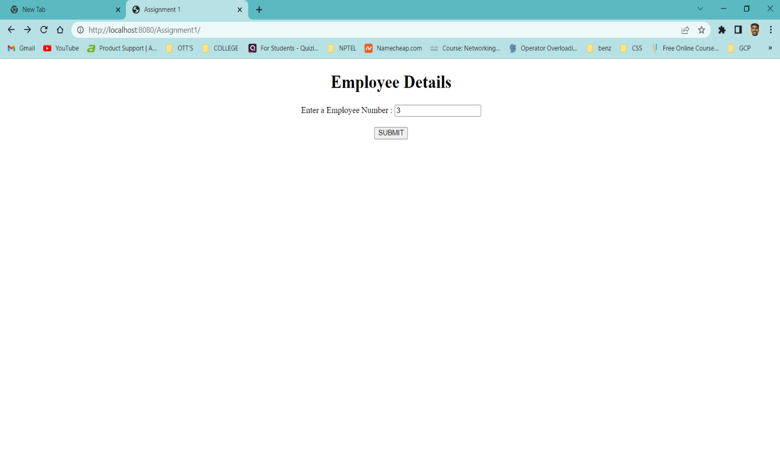

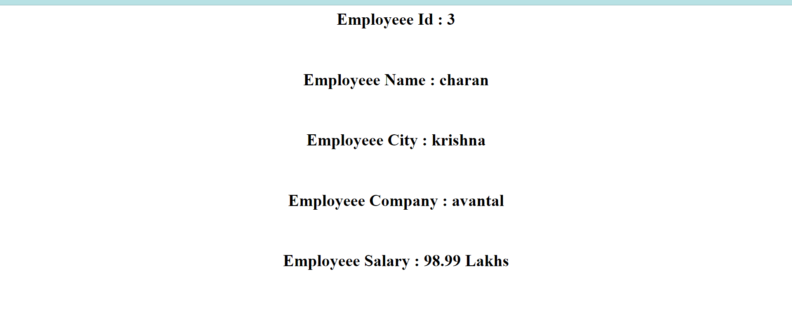

**Aim :** Create a Web Application that provides a web program to an end

User and he should be able to get the details in the form when it is

Entered provide the update control on the form to update the

Employee information in the database.

**Program :** Index.html

<html>

<head>

<title> Assignment 2 </title>

<meta charset="UTF-8">

<meta name="viewport" content="width=device-width, initial-scale=1.0">

</head>

<body>

<center>

<h1> <b> Book Details </b> </h1>

<form action = "Servlet1" method = "GET">

<label for = "is"> Enter Book ISBN Number : </label>

<input type = "text" name = "isbn" /> <br> <br>

<input type = "submit" value = "SUBMIT" />

</form>

</center>

</body>

</html>

**Program :** Book.html

<html>

<head>

<title> Book Details </title>

<meta charset="UTF-8">

<meta name="viewport" content="width=device-width, initial-scale=1.0">

</head>

<body>

<center>

<form action = "Servlet2" method = "GET">

<h1> <b> Update Book Details In Database </b> </h1>

<label for = "is1"> Enter ISBN Number : </label>

<input type="text" name="is1" /> <br> <br>

<label for = "au1"> Enter Book Name : </label>

<input type="text" name="au1" /> <br> <br>

<label for = "bo1"> Enter Book Price : </label>

<input type="text" name="bo1" /> <br> <br>

<input type = "submit" value = "UPDATE" />

</form>

</center>

</body>

</html>

**Program :** Servlet1.java

/*

* To change this license header, choose License Headers in Project Properties.

* To change this template file, choose Tools | Templates

* and open the template in the editor.

*/

import java.io.IOException;

import java.io.PrintWriter;

import javax.servlet.ServletException;

import javax.servlet.http.HttpServlet;

import javax.servlet.http.HttpServletRequest;

import javax.servlet.http.HttpServletResponse;

import java.io.*;

import java.sql.*;

/**

*

* @author itadmin

*/

public class Servlet1 extends HttpServlet

{

@Override

protected void doGet(HttpServletRequest request, HttpServletResponse response) throws ServletException, IOException

{

response.setContentType("text/html"); //setting the content type

PrintWriter pw = response.getWriter(); //get the stream to write the data

int isbn = Integer.parseInt(request.getParameter("isbn"));

try

{

Class.forName("com.mysql.jdbc.Driver");

Connection con = DriverManager.getConnection("jdbc:mysql://localhost/it", "root", "");

PreparedStatement ps = con.prepareStatement("select * from newbook where isbn = ?");

ps.setInt(1, isbn);

ResultSet rs = ps.executeQuery();

while(rs.next())

{

pw.println("<center>");

pw.println("<h1> Book ISBN Number : " + rs.getInt(1) + "</h1> <br> <br>");

pw.println("<h1> Book Name : " + rs.getString(2) + "</h1> <br> <br>");

pw.println("<h1> Book Price : " + rs.getFloat(3) + "</h1> <br> <br>");

pw.println("</center>");

}

pw.println("<center>");

//pw.println("<h1> Execution Completed </h1>");

pw.println("<br> <br>");

pw.println("<form action = 'book.html'>");

pw.println("<input type = 'submit' value = 'EDIT' />");

pw.println("</form>");

pw.println("</center>");

}

catch(Exception e)

{

pw.println(e);

}

}

}

**Program :** Servlet2.java

/*

* To change this license header, choose License Headers in Project Properties.

* To change this template file, choose Tools | Templates

* and open the template in the editor.

*/

import java.io.IOException;

import java.io.PrintWriter;

import javax.servlet.ServletException;

import javax.servlet.http.HttpServlet;

import javax.servlet.http.HttpServletRequest;

import javax.servlet.http.HttpServletResponse;

import java.io.*;

import java.sql.*;

/**

*

* @author itadmin

*/

public class Servlet2 extends HttpServlet

{

@Override

protected void doGet(HttpServletRequest request, HttpServletResponse response) throws ServletException, IOException

{

response.setContentType("text/html"); //setting the content type

PrintWriter pw = response.getWriter(); //get the stream to write the data

int isbn = Integer.parseInt(request.getParameter("is1"));

String author = request.getParameter("au1");

float price = Float.parseFloat(request.getParameter("bo1"));

try

{

Class.forName("com.mysql.jdbc.Driver");

Connection con = DriverManager.getConnection("jdbc:mysql://localhost/it", "root", "");

PreparedStatement ps = con.prepareStatement("update newbook set name = ?, price = ? where isbn = ?");

ps.setInt(3, isbn);

ps.setString(1, author);

ps.setFloat(2, price);

int check = ps.executeUpdate();

Statement st = con.createStatement();

ResultSet rs = st.executeQuery("select * from newbook");

while(rs.next())

{

pw.println("<center>");

pw.println("<h1> Book ISBN Number : " + rs.getInt(1) + "</h1> <br> <br>");

pw.println("<h1> Book Name : " + rs.getString(2) + "</h1> <br> <br>");

pw.println("<h1> Book Price : " + rs.getFloat(3) + "</h1> <br> <br>");

pw.println("<hr>");

pw.println("</center>");

}

pw.println("<center>");

pw.println("<h1> Execution Completed </h1>");

pw.println("<br> <br>");

pw.println("<form action = 'index.html'>");

pw.println("<input type = 'submit' value = 'Search' />");

pw.println("</form>");

pw.println("</center>");

}

catch(Exception e)

{

pw.println(e);

}

}

}

**Output :**

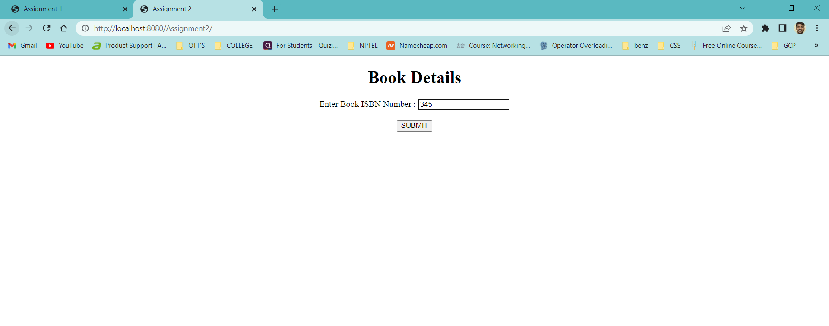

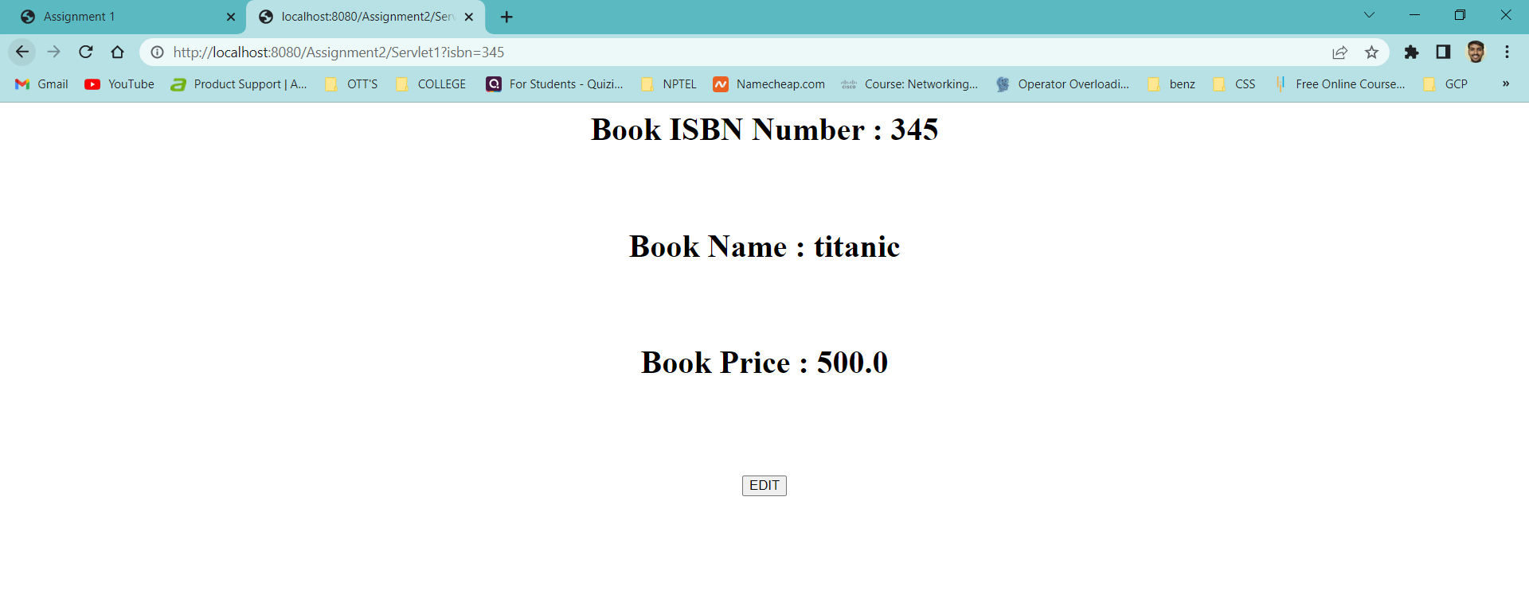

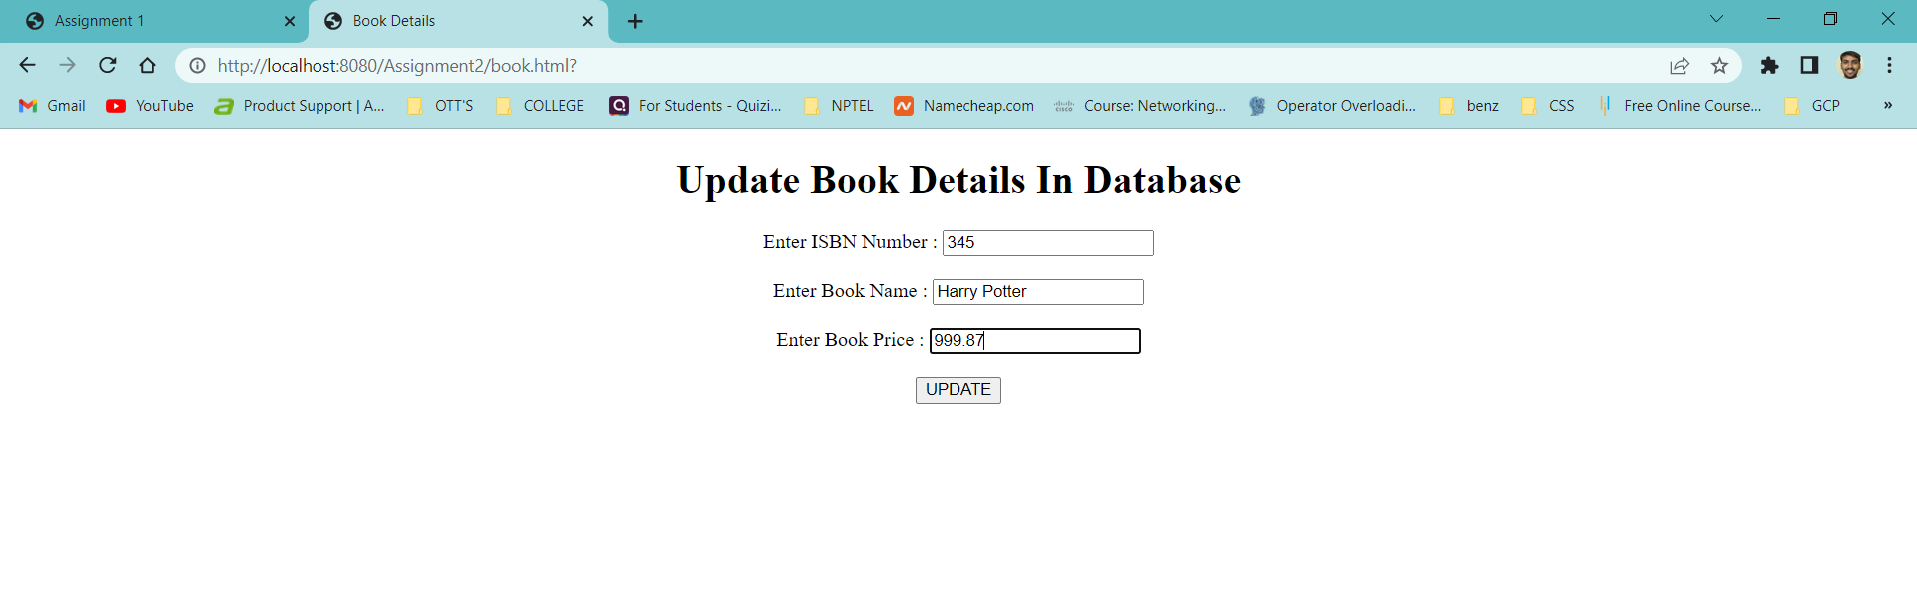

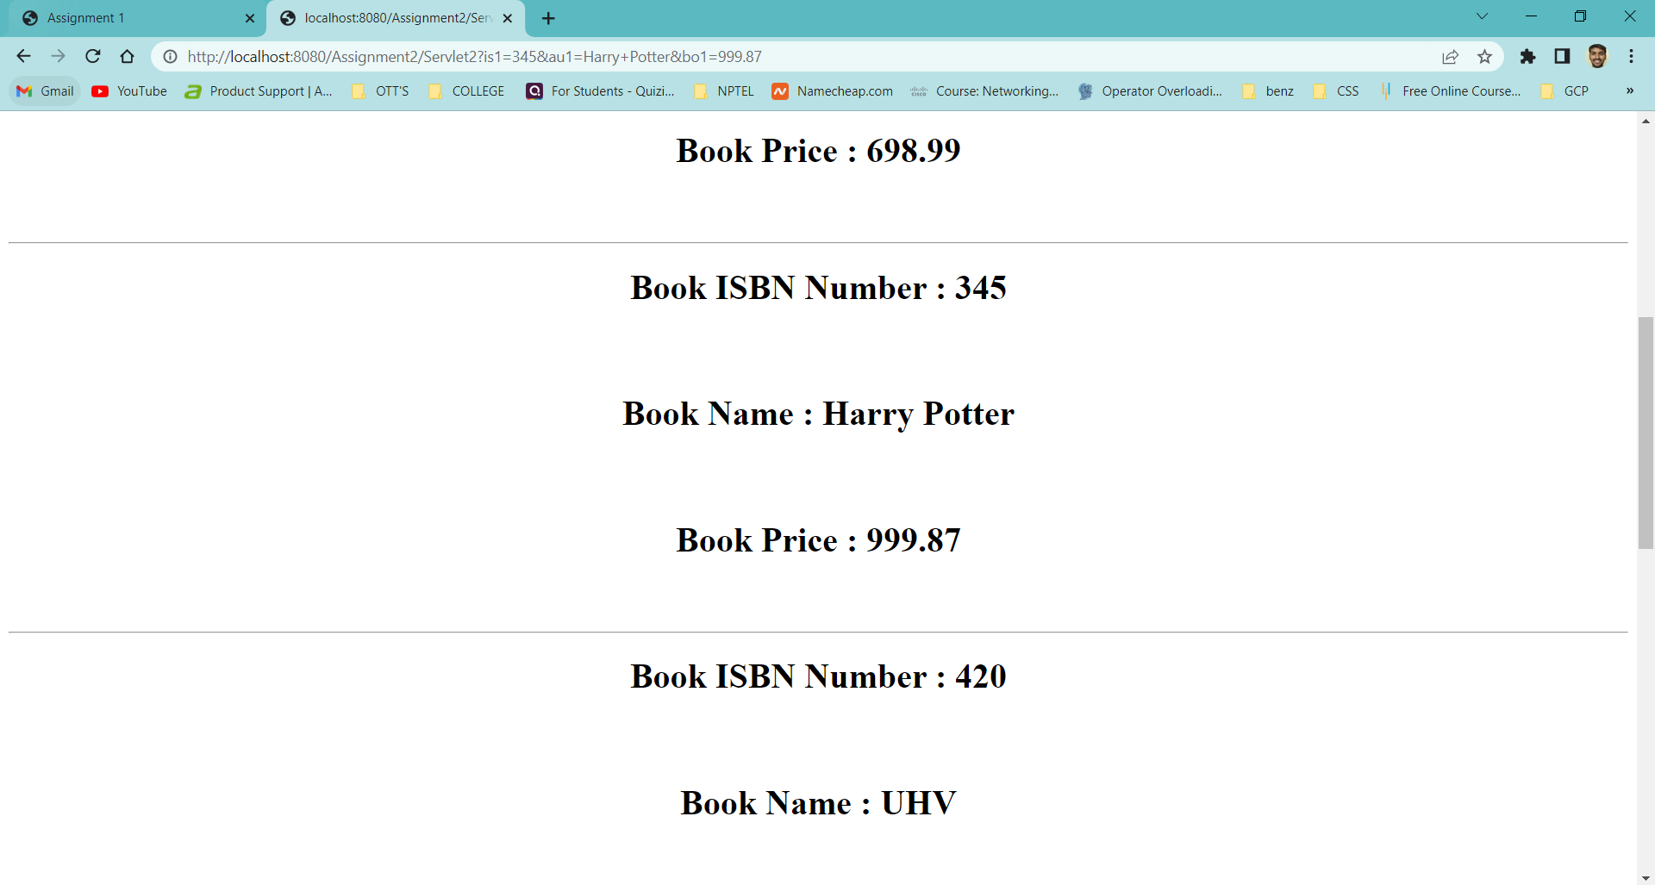

**Aim :** Create a Web application in which user enter the details of the

Book are isbn, book name, book cost in the web form insert those

Details as a new record in the database using servlets.

**Program :** Index.html

<html>

<head>

<title> Book Details </title>

<meta charset="UTF-8">

<meta name="viewport" content="width=device-width, initial-scale=1.0">

</head>

<body>

<center>

<form action = "Servlet1" method = "GET">

<h1> <b> Insert New Record Into Database </b> </h1>

<label for = "is1"> Enter Book ISBN Number : </label>

<input type="text" name="is1" /> <br> <br>

<label for = "au1"> Enter Book Name : </label>

<input type="text" name="au1" /> <br> <br>

<label for = "bo1"> Enter Book Price : </label>

<input type="text" name="bo1" /> <br> <br>

<input type = "submit" value = "SUBMIT" />

</form>

</center>

</body>

</html>

**Program :** Servlet1.java

/*

* To change this license header, choose License Headers in Project Properties.

* To change this template file, choose Tools | Templates

* and open the template in the editor.

*/

import java.io.IOException;

import java.io.PrintWriter;

import javax.servlet.ServletException;

import javax.servlet.http.HttpServlet;

import javax.servlet.http.HttpServletRequest;

import javax.servlet.http.HttpServletResponse;

import java.io.*;

import java.sql.*;

/**

*

* @author itadmin

*/

public class Servlet1 extends HttpServlet

{

@Override

protected void doGet(HttpServletRequest request, HttpServletResponse response) throws ServletException, IOException

{

response.setContentType("text/html"); //setting the content type

PrintWriter pw = response.getWriter(); //get the stream to write the data

int isbn = Integer.parseInt(request.getParameter("is1"));

String name = request.getParameter("au1");

float price = Float.parseFloat(request.getParameter("bo1"));

try

{

Class.forName("com.mysql.jdbc.Driver");

Connection con = DriverManager.getConnection("jdbc:mysql://localhost/it", "root", "");

PreparedStatement ps = con.prepareStatement("insert into newbook values(?, ?, ?)");

ps.setInt(1, isbn);

ps.setString(2, name);

ps.setFloat(3, price);

int check = ps.executeUpdate();

Statement st = con.createStatement();

ResultSet rs = st.executeQuery("select * from newbook");

while(rs.next())

{

pw.println("<center>");

pw.println("<h1> Book ISBN Number : " + rs.getInt(1) + "</h1> <br> <br>");

pw.println("<h1> Book Name : " + rs.getString(2) + "</h1> <br> <br>");

pw.println("<h1> Book Price : " + rs.getFloat(3) + "</h1> <br> <br>");

pw.println("<hr>");

pw.println("</center>");

}

pw.println("<center>");

pw.println("<h1> Execution Completed </h1>");

pw.println("<br> <br>");

pw.println("<form action = 'index.html'>");

pw.println("<input type = 'submit' value = 'New Record' />");

pw.println("</form>");

pw.println("</center>");

}

catch(Exception e)

{

pw.println(e);

}

}

}

**Output :**

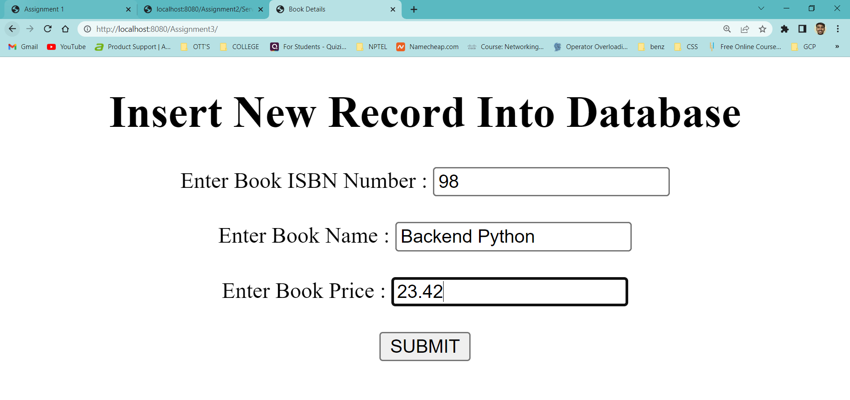

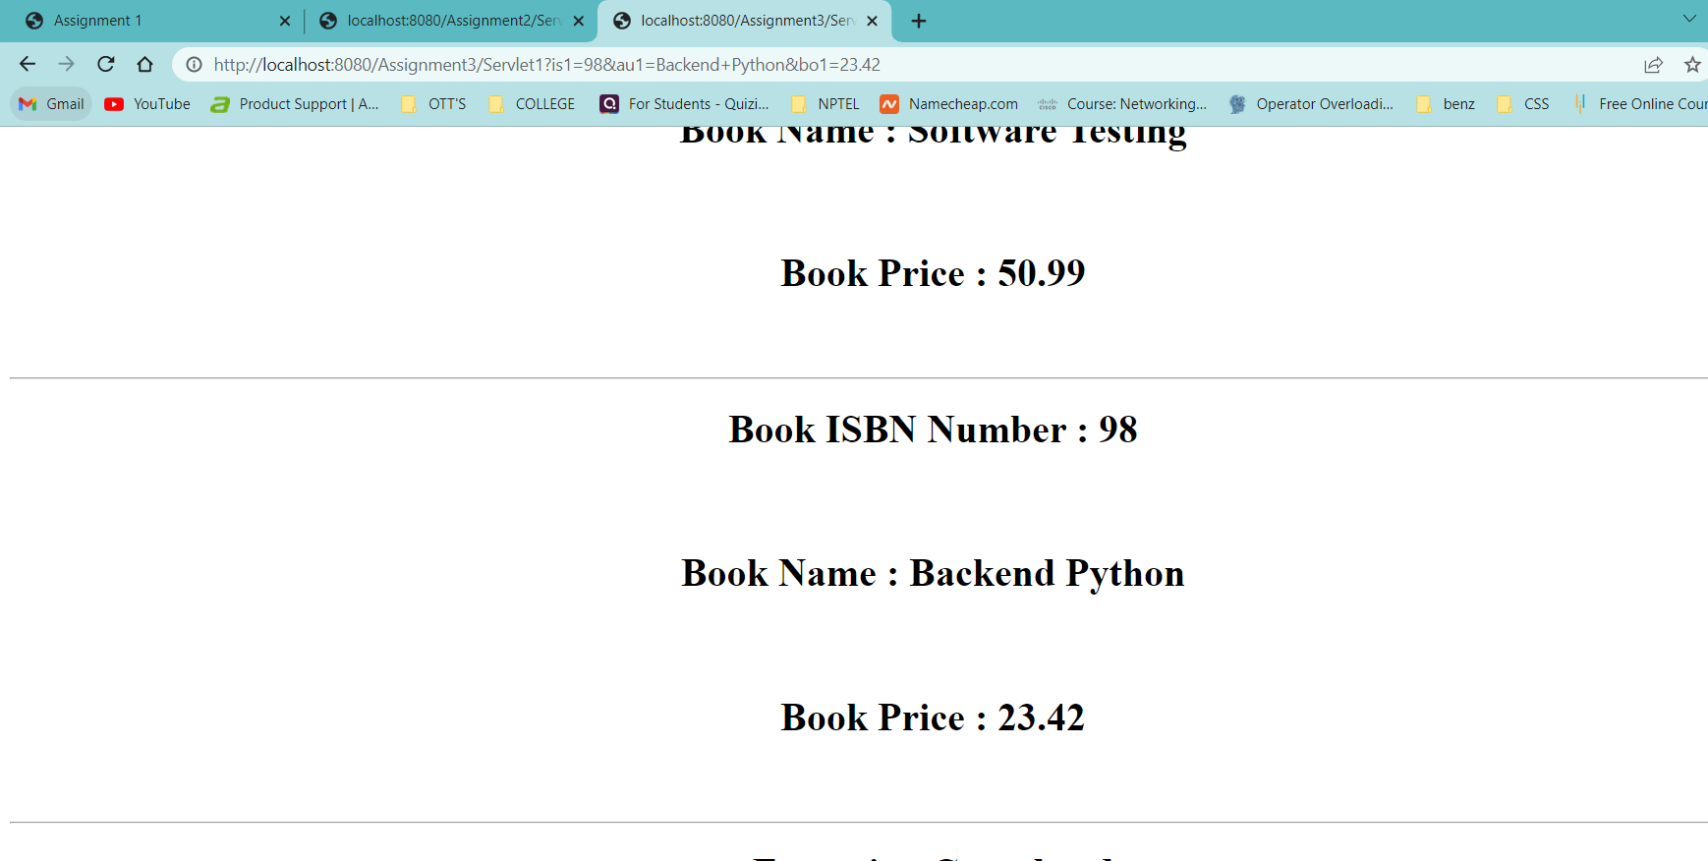

**Aim :** Create a Web application that gives a web form for the end user in

Which end user enters the salary range . server should sent to the

Employee details whose salary are beyond the range.

**Program :** Index.html

<html>

<head>

<title> Assignment - 4 </title>

<meta charset="UTF-8">

<meta name="viewport" content="width=device-width, initial-scale=1.0">

</head>

<body>

<center>

<form action = "Servlet1" method = "GET">

<h1> <b> Range Of Salary </b> </h1>

<label for = "mny"> Enter The Range Of Salary : </label>

<input type = "text" name = "sal" /> <br> <br>

<input type = "submit" value = "SUBMIT" />

</form>

</center>

</body>

</html>

**Program :** Servlet1.java

/*

* To change this license header, choose License Headers in Project Properties.

* To change this template file, choose Tools | Templates

* and open the template in the editor.

*/

import java.io.IOException;

import java.io.PrintWriter;

import javax.servlet.ServletException;

import javax.servlet.http.HttpServlet;

import javax.servlet.http.HttpServletRequest;

import javax.servlet.http.HttpServletResponse;

import java.io.*;

import java.sql.*;

/**

*

* @author itadmin

*/

public class Servlet1 extends HttpServlet

{

@Override

protected void doGet(HttpServletRequest request, HttpServletResponse response) throws ServletException, IOException

{

response.setContentType("text/html"); //setting the content type

PrintWriter pw = response.getWriter(); //get the stream to write the data

int range = Integer.parseInt(request.getParameter("sal"));

try

{

Class.forName("com.mysql.jdbc.Driver");

Connection con = DriverManager.getConnection("jdbc:mysql://localhost/it", "root", "");

PreparedStatement ps = con.prepareStatement("select * from javaemployee where salary >= ?");

ps.setInt(1, range);

ResultSet rs = ps.executeQuery();

while(rs.next())

{

pw.println("<center>");

pw.println("<h1> Employeee Id : " + rs.getInt(1) + "</h1> <br> <br>");

pw.println("<h1> Employeee Name : " + rs.getString(2) + "</h1> <br> <br>");

pw.println("<h1> Employeee City : " + rs.getString(3) + "</h1> <br> <br>");

pw.println("<h1> Employeee Company : " + rs.getString(4) + "</h1> <br> <br>");

pw.println("<h1> Employeee Salary : " + rs.getFloat(5) + " Lakhs </h1> <br> <br>");

pw.println("<hr>");

pw.println("</center>");

}

pw.println("<center>");

//pw.println("<h1> Execution Completed </h1>");

pw.println("<br> <br>");

pw.println("<form action = 'index.html'>");

pw.println("<input type = 'submit' value = 'HOME' />");

pw.println("</form>");

pw.println("</center>");

}

catch(Exception e)

{

pw.println(e);

}

}

}

**Output :**

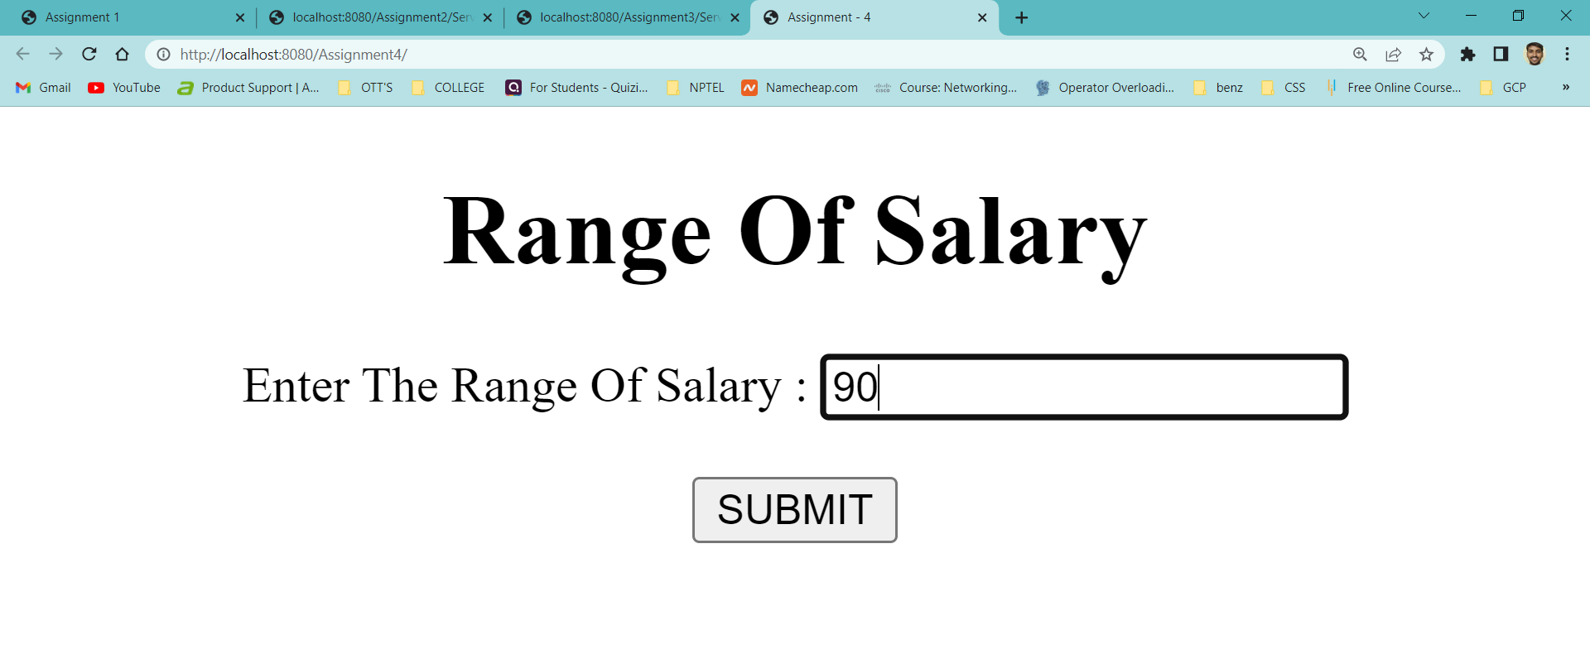

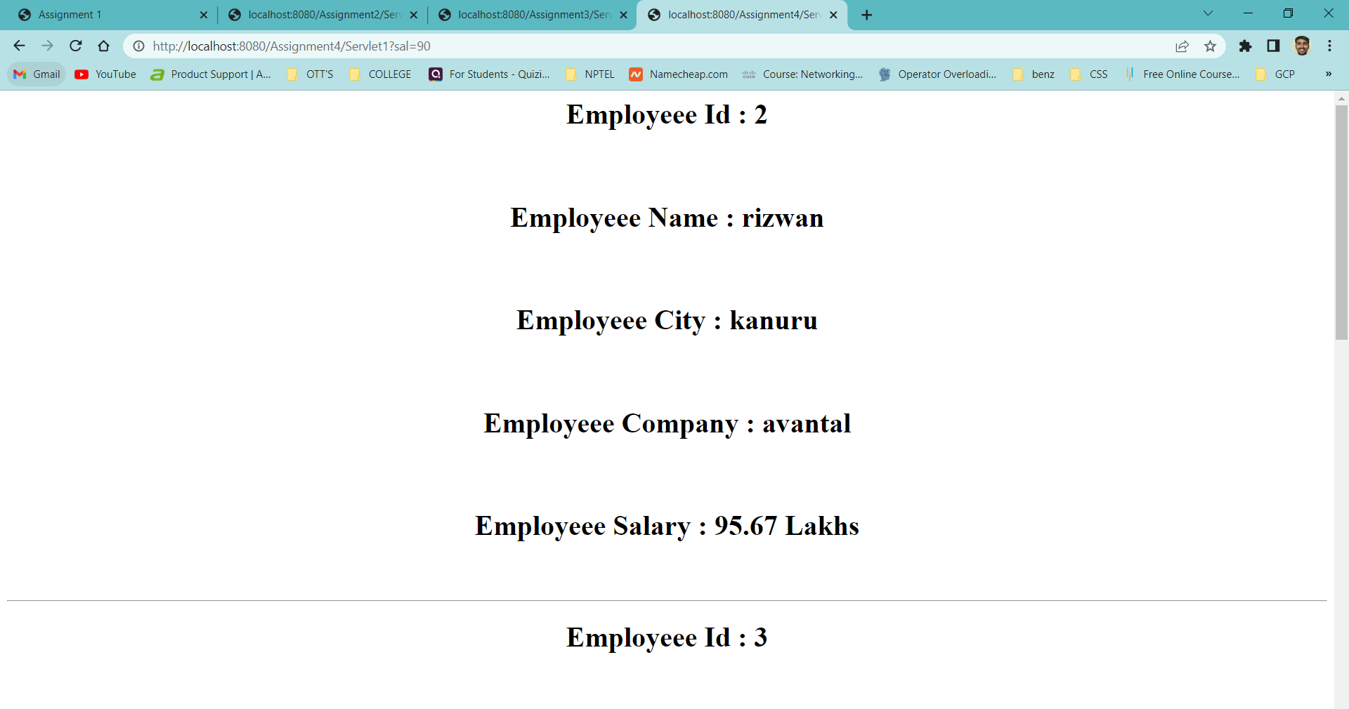

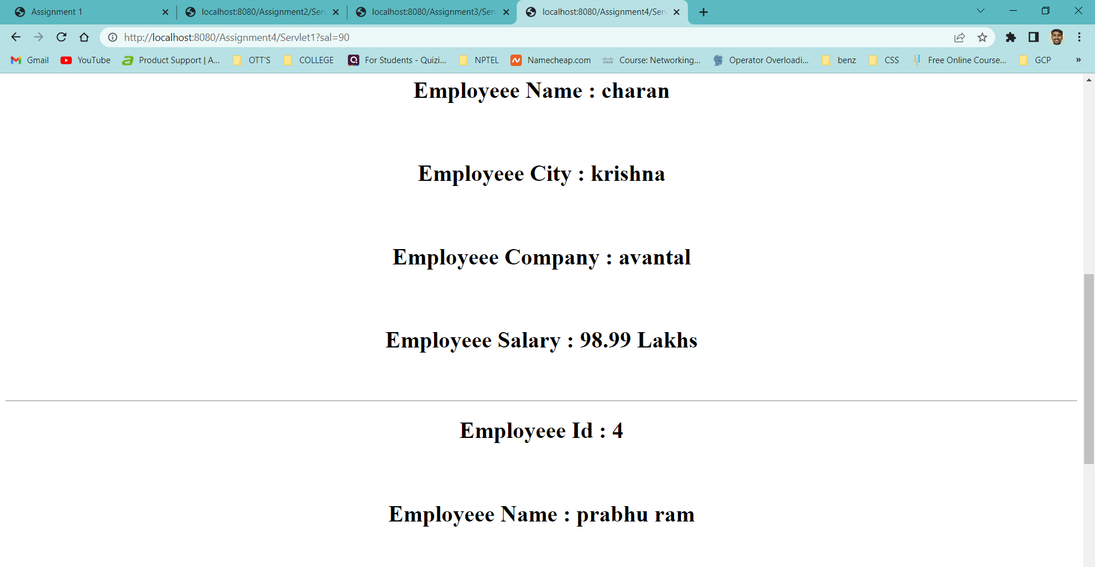

**Aim :** Create a web application for the Login and Logout Form using

Servlets and cookies where cookies stores the user information

In the web browser.

**Program :** index.html

<html>

<head>

<title> Login & Logout Using Cookies </title>

<meta charset="UTF-8">

<meta name="viewport" content="width=device-width, initial-scale=1.0">

</head>

<body>

<center>

<a href="login.html"> Login </a>|

<a href="LogoutServlet"> Logout </a>|

<a href="ProfileServlet"> Profile </a>

<hr>

</center>

</body>

</html>

**Program :** link.html

<html>

<head>

<title> Link Web Page </title>

<meta charset="UTF-8">

<meta name="viewport" content="width=device-width, initial-scale=1.0">

</head>

<body>

<center>

<a href="login.html"> Login </a>|

<a href="LogoutServlet"> Logout </a>|

<a href="ProfileServlet"> Profile </a>

<hr>

</center>

</body>

</html>

**Program :** login.html

<html>

<head>

<title>Login Web Page</title>

<meta charset="UTF-8">

<meta name="viewport" content="width=device-width, initial-scale=1.0">

</head>

<body bgcolor = "#ff8080">

<center>

<form action = "LoginServlet" method = "POST">

<h1> <strong> Login & Logout Using Cookies </strong> </h1>

<label for="un"> Enter Your Name : </label>

<input type = "text" name = "un" size = "25"/> <br> <br>

<label for="up"> Enter Your Password : </label>

<input type = "password" name = "up" /> <br> <br>

<input type = "submit" value = "Login" />

</form>

</center>

</body>

</html>

**Program :** LoginServlet.java

import java.io.IOException;

import java.io.PrintWriter;

import javax.servlet.ServletException;

import javax.servlet.http.Cookie;

import javax.servlet.http.HttpServlet;

import javax.servlet.http.HttpServletRequest;

import javax.servlet.http.HttpServletResponse;

public class LoginServlet extends HttpServlet

{

protected void doPost(HttpServletRequest request, HttpServletResponse response) throws ServletException, IOException

{

response.setContentType("text/html");

PrintWriter out = response.getWriter();

request.getRequestDispatcher("link.html").include(request, response);

String s1 = request.getParameter("un");

String s2 = request.getParameter("up");

if(s2.equals("admin"))

{

out.println("You Are Sucessfully Login");

out.println("<br> Welcome " + s1);

Cookie ck = new Cookie("name", s1);

response.addCookie(ck);

}

else

{

out.println("Error !!! UserName Or password Must be Wrong Please Check It Again ");

request.getRequestDispatcher("login.html").include(request, response);

}

out.close();

}

}

**Program :** LogoutServlet.java

import java.io.IOException;

import java.io.PrintWriter;

import javax.servlet.ServletException;

import javax.servlet.http.Cookie;

import javax.servlet.http.HttpServlet;

import javax.servlet.http.HttpServletRequest;

import javax.servlet.http.HttpServletResponse;

public class LogoutServlet extends HttpServlet

{

protected void doGet(HttpServletRequest request, HttpServletResponse response) throws ServletException, IOException

{

response.setContentType("text/html");

PrintWriter out = response.getWriter();

request.getRequestDispatcher("link.html").include(request, response);

Cookie ck = new Cookie("name", "");

ck.setMaxAge(0);

response.addCookie(ck);

out.println("You are Sucessfully Logout") } }

**Program :** ProfileServlet.java

import java.io.IOException;

import java.io.PrintWriter;

import javax.servlet.ServletException;

import javax.servlet.http.Cookie;

import javax.servlet.http.HttpServlet;

import javax.servlet.http.HttpServletRequest;

import javax.servlet.http.HttpServletResponse;

public class ProfileServlet extends HttpServlet

{

protected void doGet(HttpServletRequest request, HttpServletResponse response) throws ServletException, IOException

{

response.setContentType("text/html");

PrintWriter out = response.getWriter();

request.getRequestDispatcher("link.html").include(request, response);

Cookie ck[] = request.getCookies();

if(ck != null)

{

String name = ck[0].getValue();

if(!name.equals("") || name != null)

{

out.println("<b> Welcome to Profile </b> ");

out.println("Welcome" + name);

}

}

else

{

out.println("Please Login First");

request.getRequestDispatcher("login.html").include(request, response);

}

out.close();

}

}

**Output :**

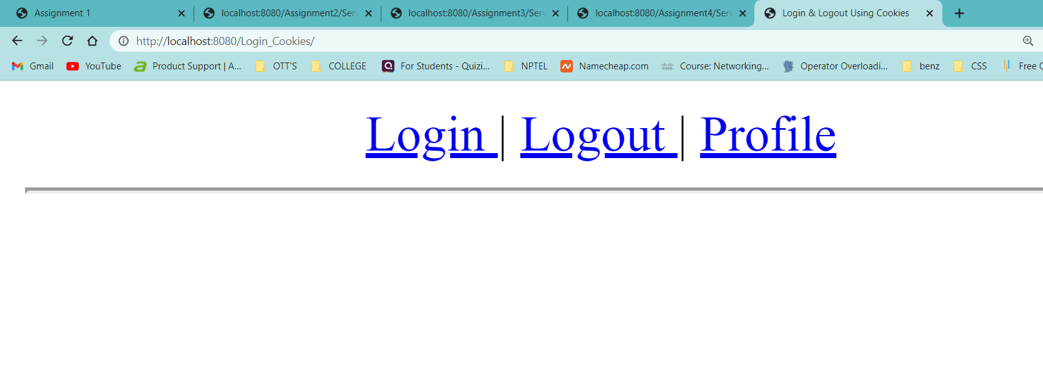

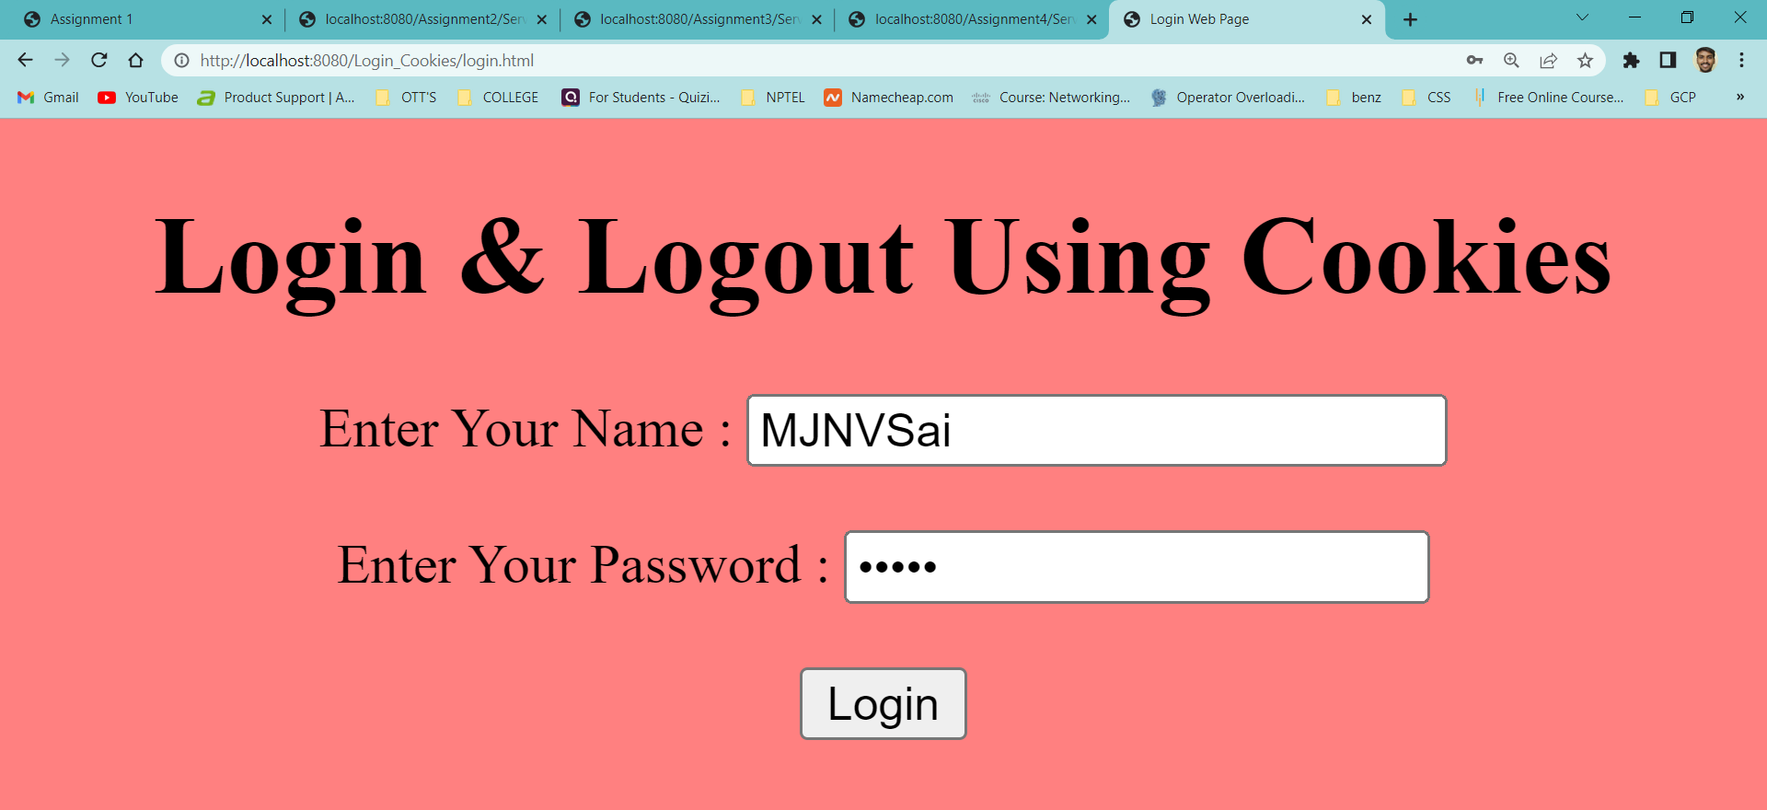

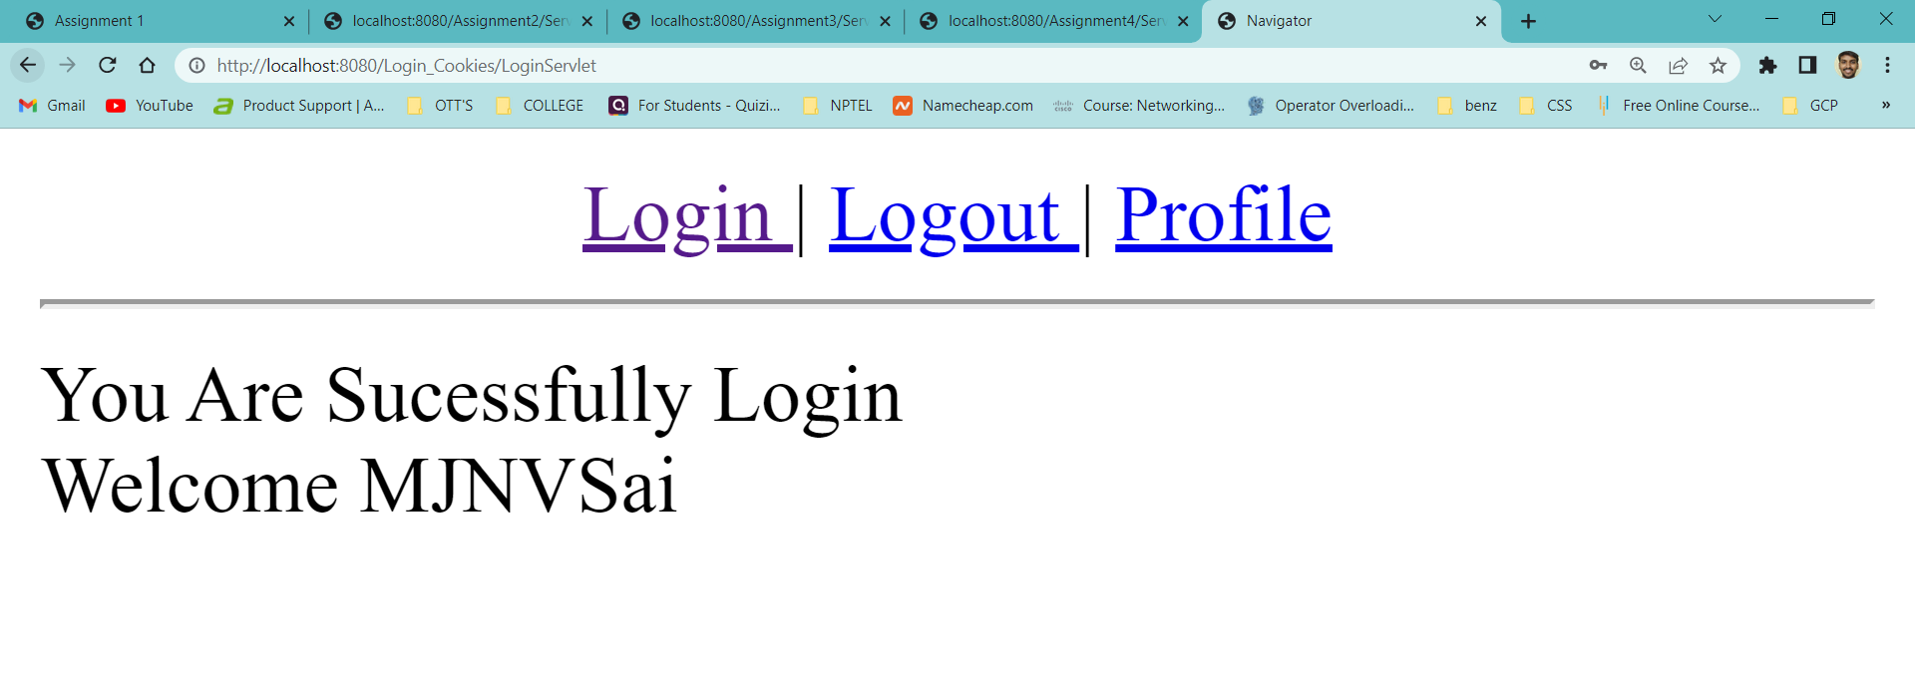

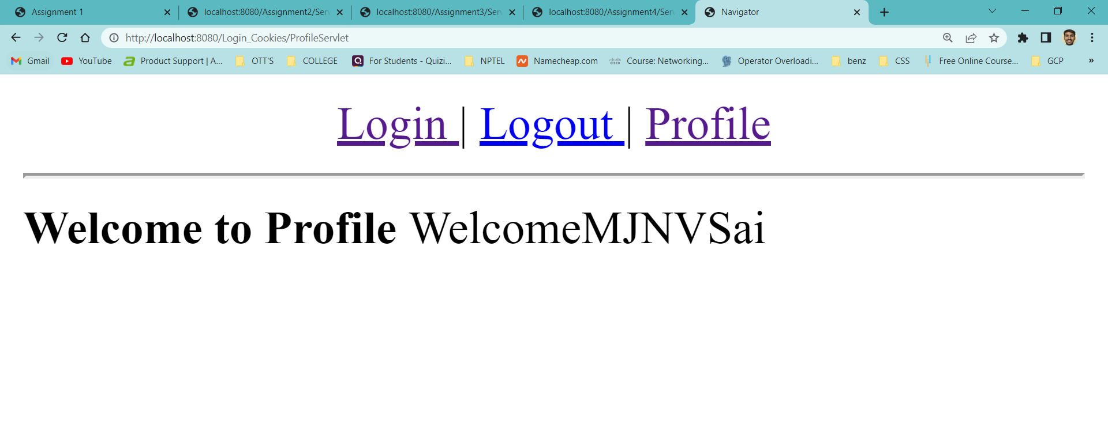

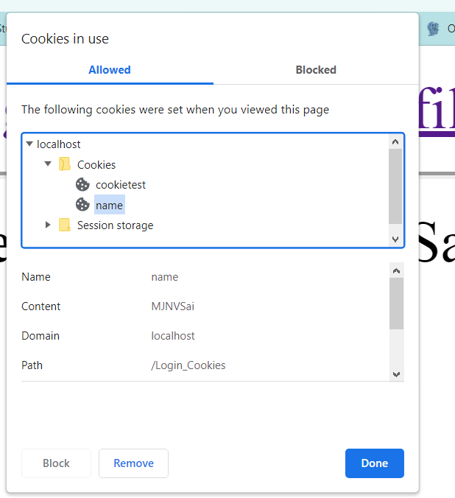

**Aim :** Create a web application in which, a web form allows the end user

To perform online transfer of funds from savings account to the

Current account and it will update in the database also.

**Program :** index.html

<html>

<head>

<title> Banking Application </title>

</head>

<body>

<center>

<h1> <b> <i> Online Fund Transfer Interface </i> </b> </h1>

<form action = "Transfer" method = "POST">

<label for = "sbno"> Enter Savings A/C Number : </label>

<input type="text" name="sbno" required /> <br> <br>

<label for = "cbno"> Enter Current A/C Number : </label>

<input type="text" name="cbno" required /> <br> <br>

<label for = "amount"> Enter Transfer : </label>

<input type="text" name="amount" required /> <br> <br>

<input type="submit" value="TRANSFER"/>

</form>

</center>

</body>

</html>

**Program :** web.xml

<?xml version="1.0" encoding="UTF-8"?>

<web-app version="3.1" xmlns="http://xmlns.jcp.org/xml/ns/javaee" xmlns:xsi="http://www.w3.org/2001/XMLSchema-instance" xsi:schemaLocation="http://xmlns.jcp.org/xml/ns/javaee http://xmlns.jcp.org/xml/ns/javaee/web-app_3_1.xsd">

<servlet>

<servlet-name>Transfer</servlet-name>

<servlet-class>Transfer</servlet-class>

<init-param>

<param-name>Driver</param-name>

<param-value>com.mysql.jdbc.Driver</param-value>

</init-param>

<init-param>

<param-name>DriverUrl</param-name>

<param-value>jdbc:mysql://localhost/it</param-value>

</init-param>

<init-param>

<param-name>Username</param-name>

<param-value>root</param-value>

</init-param>

<init-param>

<param-name>Password</param-name>

<param-value></param-value>

</init-param>

</servlet>

<servlet-mapping>

<servlet-name>Transfer</servlet-name>

<url-pattern>/Transfer</url-pattern>

</servlet-mapping>

<session-config>

<session-timeout>

30

</session-timeout>

</session-config>

</web-app>

**Program :** Transfer.java

import java.io.*;

import java.sql.*;

import java.lang.*;

import java.util.*;

import javax.servlet.*;

import javax.servlet.http.*;

//main code starts from here

public class Transfer extends HttpServlet

{

Connection con;

public void init(ServletConfig config) throws ServletException

{

try

{

String driver = config.getInitParameter("Driver");

String url = config.getInitParameter("DriverUrl");

String user = config.getInitParameter("Username");

String pwd = config.getInitParameter("Password");

Class.forName(driver);

con = DriverManager.getConnection(url, user, pwd);

}

catch(Exception e)

{

System.out.println(e);

}

}

public void doPost(HttpServletRequest req,HttpServletResponse res) throws ServletException,IOException

{

Statement st = null;

int sbaccno = Integer.parseInt(req.getParameter("sbno"));

int caccno = Integer.parseInt(req.getParameter("cbno"));

float amount = Float.parseFloat(req.getParameter("amount"));

res.setContentType("text/html");

PrintWriter out = res.getWriter();

out.println("<html>");

out.println("<body bgcolor='azure'>");

try

{

st = con.createStatement();

String sql1 = "update savings set balance = balance-" +amount+ "where accno=" +sbaccno;

String sql2 = "update current set balance = balance+" +amount+ "where accno=" +caccno;

if(sbaccno != caccno)

{

st.executeUpdate(sql1);

st.executeUpdate(sql2);

out.println("<h2> <b> <i> Funds Transfered Successfully ! </i> </b> </h2>");

}

else

{

out.println("Saving or Current Bank Account Number was incorrect. Please check and try again ! <a href='index.html'> Click here </a>");

}

}

catch(Exception e)

{

System.out.println(e);

}

finally

{

try

{

if(st!=null)

{

st.close();

}

}

catch(Exception e)

{

e.printStackTrace();

}

}

out.println("</body>");

out.println("</html>");

}

public void destroy()

{

try

{

if(con!=null)

{

con.close();

}

}

catch(Exception e)

{

e.printStackTrace();

}

}

}

**Output :**

