# Velagapudi Ramakrishna Siddhartha Engineering College

**Kanuru, 520001**



**WEB PROGRAMMING AND DEVELOPMENT HOME ASSIGNMENT - 1**

**Code : 20IT6303**

**Batch Members : 208W1A12A99**

**208W1A12A0**

**208W1A12A1**

**Submitted To :**

**Dr . M . Ashok Kumar Department Of IT**

**Question – 12**

Use The Given attributes related to the company table and implement operations using Statement and Prepared Statement Interfaces and Perform CRUD Operations.

## Program – 1 :

**CRUD Operations using Statement**

package javadbc; import java.io.*; import java.sql.*;

public class Home_Assignment1

{

public static void main(String[] args)

{

try

{

Class.forName("com.mysql.jdbc.Driver"); Connection con =

DriverManager.getConnection("jdbc:mysql://localhost/student","root",""); Statement st = con.createStatement();

//Create table

String sqltable = "create table Company_Details(companyid int, companyname varchar(50), companynumber bigint, addressline varchar(500), city varchar(50), state varchar(50), postalcode int, country varchar(50))";

//st.executeUpdate(sqltable);

// Insert Records

String sqlinsert = "insert into Company_Details values(2, 'EPAM', 456, 'Hyderbad India', 'Telangana', 'India', 4987, 'India')";

//st.executeUpdate(sqlinsert);

// Update Query

String sqlupdate = "update Company_Details set companyname='MicroSoft' where companyid = 1";

//st.executeUpdate(sqlupdate);

// Delete Query

String sqldelete = "delete from Company_Details where companyid=1"; st.executeUpdate(sqldelete);

// Select Query

ResultSet rs = st.executeQuery("select * from Company_Details");

while(rs.next())

{

System.out.println(rs.getInt(1) + " | " + rs.getString(2) + " | " + rs.getInt(3) + " | " + rs.getString(4) + " | " + rs.getString(5) + " | " + rs.getString(6) + " | " + rs.getInt(7) + " | " + rs.getString(8));

}

con.close();

}

catch(Exception e)

{

System.out.print("An UnKnown Error occured : \n\n" + e);

}

}

}

## Outputs : Create :

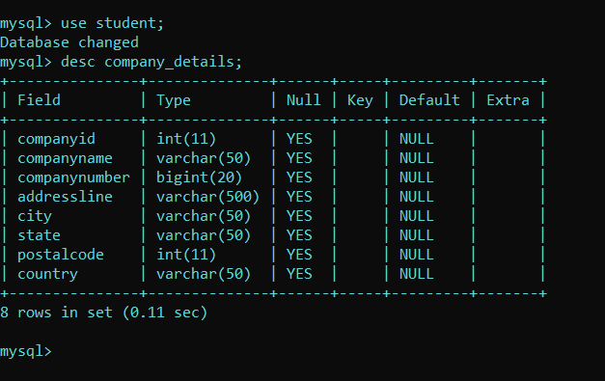

**Insert :**

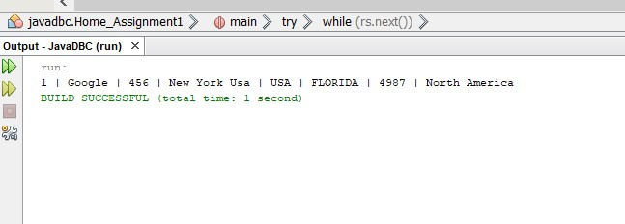

## Update :

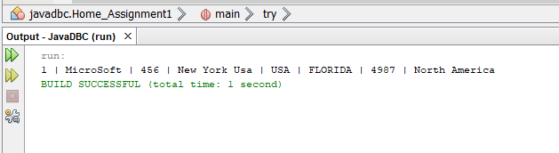

**Delete :**

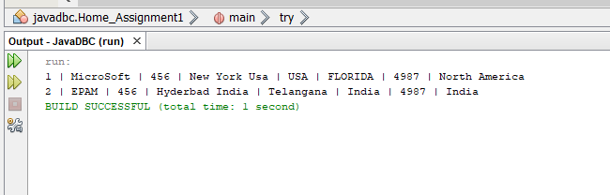

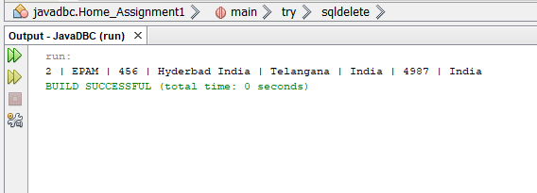

**Program – 2**

**CRUD Operation Using Prepared Statement**

package javadbc; import java.io.*; import java.sql.*;

public class Company_Home

{

public static void main(String[] args)

{

try

{

Class.forName("com.mysql.jdbc.Driver");

Connection con = DriverManager.getConnection("jdbc:mysql://localhost/college","root","");

// Crete table

String sqltable = "create table Company_Details(companyid int, companyname varchar(50), companynumber bigint, addressline varchar(500), city varchar(50), state varchar(50), postalcode int, country varchar(50))";

// PreparedStatement psc = con.prepareStatement(sqltable);

// int t = psc.executeUpdate();

// System.out.println("Sucess Query : " + t);

// Insert Query

String sqlinsert = "insert into Company_Details values(2, 'Amazon', 456, 'Hyderbad India', 'Telangana', 'India', 4987, 'India')";

// PreparedStatement ps = con.prepareStatement(sqlinsert);

// int t = ps.executeUpdate();

// System.out.println("Sucess Query : " + t);

// Update Query

String sqlupdate = "update Company_Details set companyname='MicroSoft' where companyid = 2";

// PreparedStatement ps = con.prepareStatement(sqlupdate);

// int t = ps.executeUpdate();

// System.out.println("Sucess Query : " + t);

// Delete Query

String sqldelete = "delete from Company_Details where companyid=2"; PreparedStatement ps = con.prepareStatement(sqldelete);

int t = ps.executeUpdate(); System.out.println("Sucess Query : " + t);

String sqlres = "select * from company_details"; PreparedStatement ps1 = con.prepareStatement(sqlres); ResultSet rs = ps1.executeQuery();

while(rs.next())

{

System.out.println(rs.getInt(1) + " | " + rs.getString(2) + " | " + rs.getInt(3) + " | " + rs.getString(4) + " | " + rs.getString(5) + " | " + rs.getString(6) + " | " + rs.getInt(7) + " | " + rs.getString(8));

}

}

catch(Exception e)

{

System.out.print("An UnKnown Error occured : \n\n" + e);

}

}

}

**Outputs : Create :**

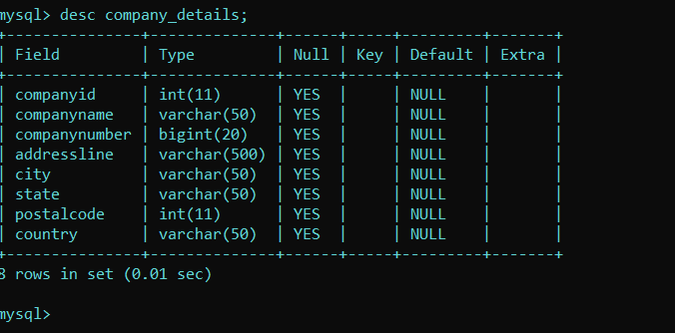

**Insert :**

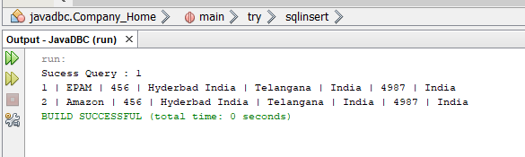

**Update :**

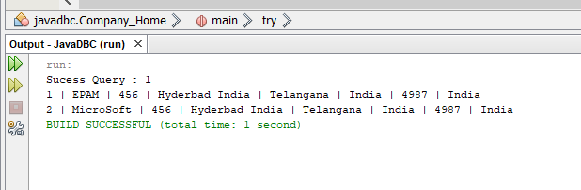

**Delete :**

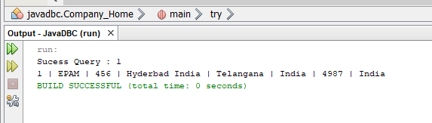

# Velagapudi Ramakrishna Siddhartha Engineering College

**Kanuru, 520001**



**WEB PROGRAMMING AND DEVELOPMENT HOME ASSIGNMENT - 3**

**Code : 20IT6303**

**Batch Members : 208W1A12A99**

**208W1A12A0**

**208W1A12A1**

**Submitted To :**

**Dr . M . Ashok Kumar Department Of IT**

**Question – 12**

Create a Class Customer with four fields cno, cname,cmail and caddress. Create a constructor, setters and getters.

Create a CustomerService class to insert the Customer details into the in- memory database and retrieve Customer information.

Test the application as a Spring Boot Application.

**Program – 1 :**

**CDetails.java**

**package** com.example.CustomerDetails;

**public class** CDetails

{

**private** String cno, cname, cmail, caddress;

**public** String getCno()

{

**return** cno;

}

**public void** setCno(String cno)

{

**this**.cno = cno;

}

**public** String getCname()

{

**return** cname;

}

**public void** setCname(String cname)

{

**this**.cname = cname;

}

**public** String getCmail()

{

**return** cmail;

}

**public void** setCmail(String cmail)

{

**this**.cmail = cmail;

}

**public** String getCaddress()

{

**return** caddress;

}

**public void** setCaddress(String caddress)

{

**this**.caddress = caddress;

}

**public** CDetails(String cno, String cname, String cmail, String caddress)

{

**super**(); **this**.cno = cno;

**this**.cname = cname; **this**.cmail = cmail; **this**.caddress = caddress;

}

}

**Program – 2:**

**CService.java**

**package** com.example.CustomerDetails;

**import** java.util.ArrayList; **import** java.util.List; **import** org.slf4j.Logger;

**import** org.slf4j.LoggerFactory;

**import** org.springframework.beans.factory.annotation.Autowired;

**import** org.springframework.jdbc.core.JdbcTemplate; **import** org.springframework.stereotype.Service; **import** javax.annotation.PostConstruct;

@Service

**public class** CService

{

**private static final** Logger ***log*** = LoggerFactory.*getLogger*(CService.**class**); @Autowired

JdbcTemplate jdbcTemplate; @PostConstruct

**public void** postConstruct()

{

CDetails cd1 = **new** CDetails("1", "Prabhas", ["actorprabhas@gmail.com"](mailto:actorprabhas@gmail.com), "Indian Film Industry, India");

CDetails cd2 = **new** CDetails("2", "Ram Charan", ["actorramcharan@gmail.com"](mailto:actorramcharan@gmail.com), "Indian Film Industry, India");

List<CDetails> customers = **new** ArrayList<>(); customers.add(cd1);

customers.add(cd2);

***log***.info("< Creating tables

>");

jdbcTemplate.execute("DROP TABLE Customer IF EXISTS");

jdbcTemplate.execute("CREATE TABLE Customer(" + " cno varchar(255), cname varchar(255),

cmail varchar(255), caddress varchar(255))");

customers.forEach(i->jdbcTemplate.update("INSERT INTO Customer VALUES (?, ?, ?, ?)", i.getCno(), i.getCname(), i.getCmail(), i.getCaddress()));

***log***.info("< Records Saved

>");

//retrieve saved records.

***log***.info("< Retrieving records

>");

customers = jdbcTemplate.query("select * from Customer", (rs, rowNum)-> **new** CDetails(rs.getString("cno"), rs.getString("cname"), rs.getString("cmail"), rs.getString("caddress")));

customers.forEach(i -> ***log***.info(i.getCno() + " | " + i.getCname() + " | " + i.getCmail()

+ " | " + i.getCaddress()));

}

}

**Output :**

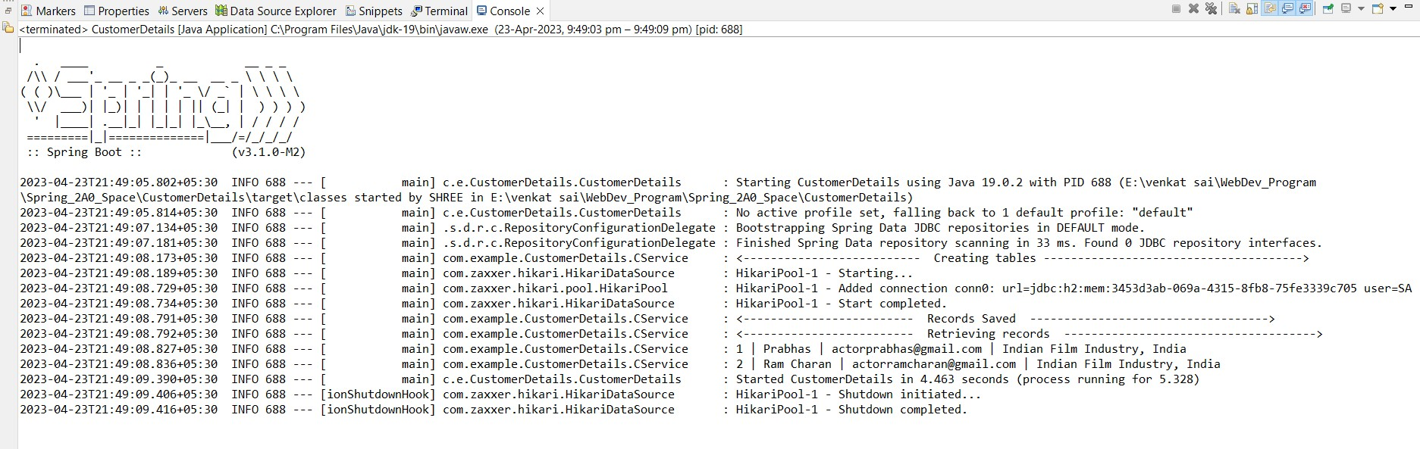

# Velagapudi Ramakrishna Siddhartha Engineering College

**Kanuru, 520001**



**WEB PROGRAMMING AND DEVELOPMENT HOME ASSIGNMENT - 4**

**Code : 20IT6303**

**Batch Members : 208W1A12A99**

**208W1A12A0**

**208W1A12A1**

**Submitted To :**

**Dr . M . Ashok Kumar Department Of IT**

**Question – 12**

Create a Class Customer with four fields cno, cname,cmail and caddress. Use parameterised constructor to set the values and write the getters to retrieve the data. Override the toString( ) method too. Create another CustomerController to return list of all objects as an array(the end point is

/customers). Test the classes using Spring Boot.

## Program – 1:

**CDetails.java**

**package** com.example.HomeAssignment4;

**public class** CDetails

{

**private** String cno, cname, cmail, caddress;

**public** String getCno()

{

**return** cno;

}

**public void** setCno(String cno)

{

**this**.cno = cno;

}

**public** String getCname()

{

**return** cname;

}

**public void** setCname(String cname)

{

**this**.cname = cname;

}

**public** String getCmail()

{

**return** cmail;

}

**public void** setCmail(String cmail)

{

**this**.cmail = cmail;

}

**public** String getCaddress()

{

**return** caddress;

}

**public void** setCaddress(String caddress)

{

**this**.caddress = caddress;

}

**public** CDetails(String cno, String cname, String cmail, String caddress)

{

**super**(); **this**.cno = cno;

**this**.cname = cname; **this**.cmail = cmail; **this**.caddress = caddress;

}

}

## Program – 2:

**HomeApplication4.java**

package com.example.HomeAssignment4;

import org.springframework.boot.SpringApplication;

import org.springframework.boot.autoconfigure.SpringBootApplication;

@SpringBootApplication

public class HomeAssignment4Application {

public static void main(String[] args) { SpringApplication.run(HomeAssignment4Application.class, args);

}

}

**Program – 3:**

**CContoller.java**

**package** com.example.HomeAssignment4;

**import** java.util.Arrays;

**import** java.util.List;

**import** org.springframework.web.bind.annotation.RequestMapping; **import** org.springframework.web.bind.annotation.RestController; @RestController

**public class** CController

{

@RequestMapping("/customers")

**public** List<CDetails> retrieveAllCourses()

{

**return** Arrays.*asList*(

**new** CDetails("1", "Rizwan", ["rizwan@gmail.co](mailto:rizwan@gmail.com)m", "AP India Asia"),

**new** CDetails("2", "mjnvsai", ["sai@g](mailto:sai@gmail.com)m[ail.com"](mailto:sai@gmail.com), "AP India Asia"),

**new** CDetails("3", "prabhas", ["actor](mailto:actorprabhas@gmail.com)p[rabhas@gmail.com](mailto:actorprabhas@gmail.com)", "AP India Asia")

);

}

}

## Output :

