**Velagapudi Ramakrishna Siddhartha**

**Engineering College**

**Kanuru, 520001**



**WEB PROGRAMMING AND DEVELOPMENT**

**HOME ASSIGNMENT - 1**

**Code : 20IT6303**

**Submitted To :**

**Dr . M . Ashok Kumar**

**Department Of IT**

**Batch Members :**

**208W1A12A99**

**208W1A12A0**

**208W1A12A1**

**Question – 12**

Use The Given attributes related to the company table and implement operations using Statement and Prepared Statement Interfaces and Perform CRUD Operations.

**Program – 1 :**

|  |
| --- |
| **CRUD Operations using Statement**  package javadbc;  import java.io.*;  import java.sql.*;  public class Home_Assignment1  {  public static void main(String[] args)  {  try  {  Class.forName("com.mysql.jdbc.Driver");  Connection con = DriverManager.getConnection("jdbc:mysql://localhost/student","root","");  Statement st = con.createStatement();    //Create table  String sqltable = "create table Company_Details(companyid int, companyname varchar(50), companynumber bigint, addressline varchar(500), city varchar(50), state varchar(50), postalcode int, country varchar(50))";  //st.executeUpdate(sqltable);    // Insert Records  String sqlinsert = "insert into Company_Details values(2, 'EPAM', 456, 'Hyderbad India', 'Telangana', 'India', 4987, 'India')";  //st.executeUpdate(sqlinsert);    // Update Query  String sqlupdate = "update Company_Details set companyname='MicroSoft' where companyid = 1";  //st.executeUpdate(sqlupdate);    // Delete Query  String sqldelete = "delete from Company_Details where companyid=1";  st.executeUpdate(sqldelete);    // Select Query  ResultSet rs = st.executeQuery("select * from Company_Details");  while(rs.next())  {  System.out.println(rs.getInt(1) + " | " + rs.getString(2) + " | " + rs.getInt(3) + " | " + rs.getString(4) + " | " + rs.getString(5) + " | " + rs.getString(6) + " | " + rs.getInt(7) + " | " + rs.getString(8));    }    con.close();    }  catch(Exception e)  {  System.out.print("An UnKnown Error occured : \n\n" + e);  }  }  } |

**Outputs :**

**Create :**

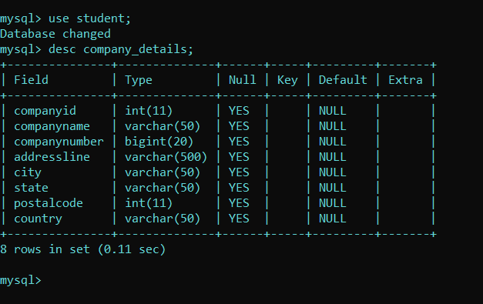

**Insert :**

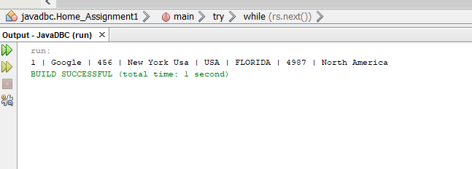

**Update :**

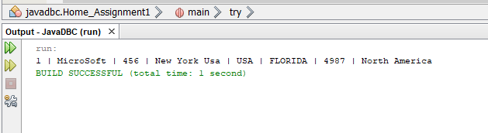

**Delete :**

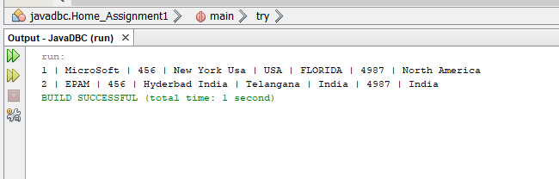

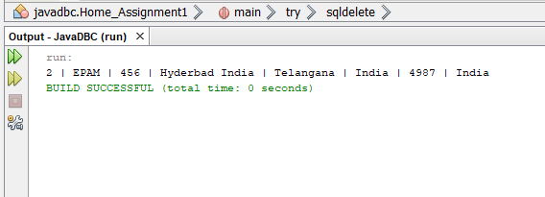

**Program – 2**

|  |
| --- |
| **CRUD Operation Using Prepared Statement**  package javadbc;  import java.io.*;  import java.sql.*;  public class Company_Home  {  public static void main(String[] args)  {  try  {  Class.forName("com.mysql.jdbc.Driver");  Connection con = DriverManager.getConnection("jdbc:mysql://localhost/college","root","");    // Crete table  String sqltable = "create table Company_Details(companyid int, companyname varchar(50), companynumber bigint, addressline varchar(500), city varchar(50), state varchar(50), postalcode int, country varchar(50))";  // PreparedStatement psc = con.prepareStatement(sqltable);  // int t = psc.executeUpdate();  // System.out.println("Sucess Query : " + t);  // Insert Query  String sqlinsert = "insert into Company_Details values(2, 'Amazon', 456, 'Hyderbad India', 'Telangana', 'India', 4987, 'India')";  // PreparedStatement ps = con.prepareStatement(sqlinsert);  // int t = ps.executeUpdate();  // System.out.println("Sucess Query : " + t);  // Update Query  String sqlupdate = "update Company_Details set companyname='MicroSoft' where companyid = 2";  // PreparedStatement ps = con.prepareStatement(sqlupdate);  // int t = ps.executeUpdate();  // System.out.println("Sucess Query : " + t);  // Delete Query  String sqldelete = "delete from Company_Details where companyid=2";  PreparedStatement ps = con.prepareStatement(sqldelete);  int t = ps.executeUpdate();  System.out.println("Sucess Query : " + t);    String sqlres = "select * from company_details";  PreparedStatement ps1 = con.prepareStatement(sqlres);  ResultSet rs = ps1.executeQuery();  while(rs.next())  {  System.out.println(rs.getInt(1) + " | " + rs.getString(2) + " | " + rs.getInt(3) + " | " + rs.getString(4) + " | " + rs.getString(5) + " | " + rs.getString(6) + " | " + rs.getInt(7) + " | " + rs.getString(8));    }  }  catch(Exception e)  {  System.out.print("An UnKnown Error occured : \n\n" + e);  }  }  } |

**Outputs :**

**Create :**

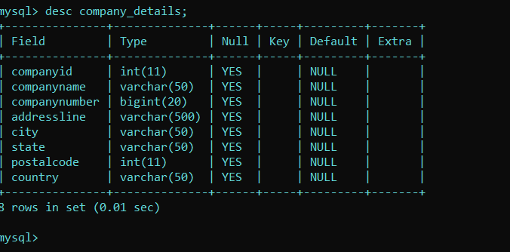

**Insert :**

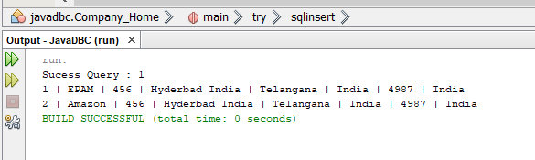

**Update :**

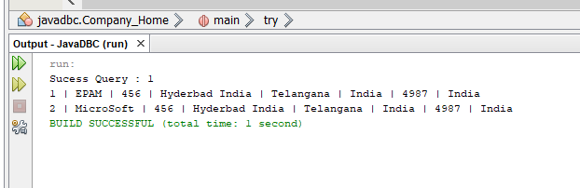

**Delete :**

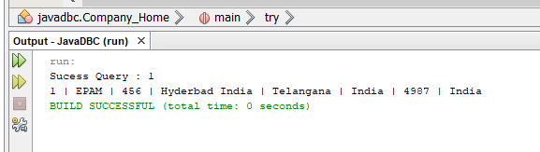

**Velagapudi Ramakrishna Siddhartha**

**Engineering College**

**Kanuru, 520001**



**WEB PROGRAMMING AND DEVELOPMENT**

**HOME ASSIGNMENT - 3**

**Code : 20IT6303**

**Submitted To :**

**Dr . M . Ashok Kumar**

**Department Of IT**

**Batch Members :**

**208W1A12A99**

**208W1A12A0**

**208W1A12A1**

**Question – 12**

Create a Class Customer with four fields cno, cname,cmail and caddress.

Create a constructor, setters and getters.

Create a CustomerService class to insert the Customer details into the in-memory database and retrieve Customer information.

Test the application as a Spring Boot Application.

**Program – 1 :**

|  |
| --- |
| **CDetails.java**  **package** com.example.CustomerDetails;  **public** **class** CDetails  {  **private** String cno, cname, cmail, caddress;  **public** String getCno()  {  **return** cno;  }  **public** **void** setCno(String cno)  {  **this**.cno = cno;  }  **public** String getCname()  {  **return** cname;  }  **public** **void** setCname(String cname)  {  **this**.cname = cname;  }  **public** String getCmail()  {  **return** cmail;  }  **public** **void** setCmail(String cmail)  {  **this**.cmail = cmail;  }  **public** String getCaddress()  {  **return** caddress;  }  **public** **void** setCaddress(String caddress)  {  **this**.caddress = caddress;  }  **public** CDetails(String cno, String cname, String cmail, String caddress)  {  **super**();  **this**.cno = cno;  **this**.cname = cname;  **this**.cmail = cmail;  **this**.caddress = caddress;  }  } |

**Program – 2:**

|  |
| --- |
| **CService.java**  **package** com.example.CustomerDetails;  **import** java.util.ArrayList;  **import** java.util.List;  **import** org.slf4j.Logger;  **import** org.slf4j.LoggerFactory;  **import** org.springframework.beans.factory.annotation.Autowired;  **import** org.springframework.jdbc.core.JdbcTemplate;  **import** org.springframework.stereotype.Service;  **import** javax.annotation.PostConstruct;  @Service  **public** **class** CService  {  **private** **static** **final** Logger ***log*** = LoggerFactory.*getLogger*(CService.**class**);  @Autowired  JdbcTemplate jdbcTemplate;  @PostConstruct  **public** **void** postConstruct()  {  CDetails cd1 = **new** CDetails("1", "Prabhas", "actorprabhas@gmail.com", "Indian Film Industry, India");  CDetails cd2 = **new** CDetails("2", "Ram Charan", "actorramcharan@gmail.com", "Indian Film Industry, India");  List<CDetails> customers = **new** ArrayList<>();  customers.add(cd1);  customers.add(cd2);  ***log***.info("<-------------------------- Creating tables -------------------------------------->");  jdbcTemplate.execute("DROP TABLE Customer IF EXISTS");  jdbcTemplate.execute("CREATE TABLE Customer(" + " cno varchar(255), cname varchar(255), cmail varchar(255), caddress varchar(255))");  customers.forEach(i->jdbcTemplate.update("INSERT INTO Customer VALUES (?, ?, ?, ?)", i.getCno(), i.getCname(), i.getCmail(), i.getCaddress()));  ***log***.info("<------------------------- Records Saved ----------------------------------->");  //retrieve saved records.  ***log***.info("<------------------------- Retrieving records ------------------------------------->");  customers = jdbcTemplate.query("select * from Customer", (rs, rowNum)-> **new** CDetails(rs.getString("cno"), rs.getString("cname"), rs.getString("cmail"), rs.getString("caddress")));  customers.forEach(i -> ***log***.info(i.getCno() + " | " + i.getCname() + " | " + i.getCmail() + " | " + i.getCaddress()));  }  } |

**Output :**

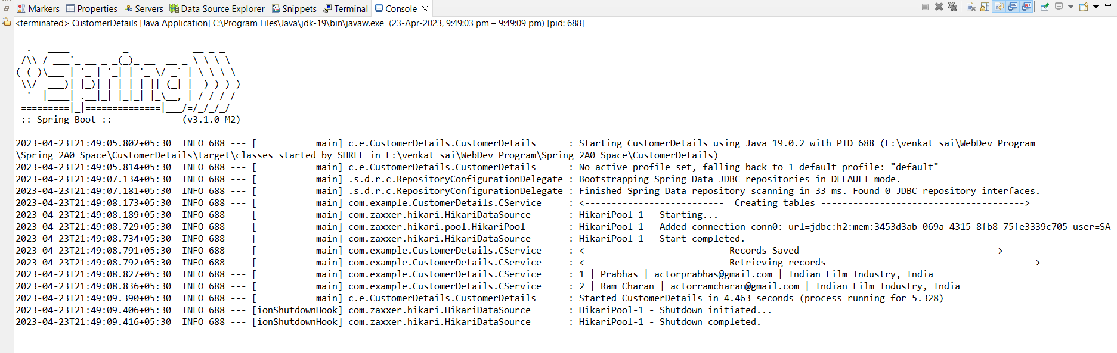

**Velagapudi Ramakrishna Siddhartha**

**Engineering College**

**Kanuru, 520001**



**WEB PROGRAMMING AND DEVELOPMENT**

**HOME ASSIGNMENT - 4**

**Code : 20IT6303**

**Submitted To :**

**Dr . M . Ashok Kumar**

**Department Of IT**

**Batch Members :**

**208W1A12A99**

**208W1A12A0**

**208W1A12A1**

**Question – 12**

Create a Class Customer with four fields cno, cname,cmail and caddress. Use parameterised constructor to set the values and write the getters to retrieve the data. Override the toString( ) method too. Create another CustomerController to return list of all objects as an array(the end point is /customers). Test the classes using Spring Boot