**Data Visualization**

**Home Assignment – 2**

**Code : 20IT6404A**

**Task :**  Different types of Charts and Its Significance in Visualizing the Data.

|  |  |  |  |
| --- | --- | --- | --- |
| **S.no** | **Chart Name** | **Parameters** | **Significance** |
| 1 | Dot Plot | X : 1  Y : min 1 | It is one of the way to visualize the similarity between 2 parameters by using an similarity matrix. |
| 2 | Bar Chart | X : 1  Y : 1 | This is a very simple chart to understand the status of work and also Compares the 2 variables like day and sales. |
| 3 | Floating Bar Chart | X : Category Value  Y : 1 | They visually show in a very effective at-a-glance way, the overall time line of the project, the current status & progress (or lack thereof) along with the assignment at considerable details. With this custom visual, |
| 4 | Pixelated Bar Chart | X : 1 or more  Y : 1 | The basic idea of a pixel bar chart is to present the data values directly instead of aggregating them into a few data values. The approach is to represent each data item (e.g. a customer) by a single pixel in the bar chart. |
| 5 | Histogram | X : 1 | By combining a histogram chart with points that show the actual data for each range. ​Easily track where data clusters (points) across your data distribution (bars) to identify patterns, trends, and areas of opportunity. |
| 6 | Pie Chart | variables | It displays the status percentage of the work or project in various categories |
| 7 | Tree Map Chart | Any number of variables | A treemap chart provides a hierarchical view of your data and makes it easy to spot patterns, such as which items are a store's best sellers. The tree branches are represented by rectangles and each sub-branch is shown as a smaller rectangle. |
| 8 | Bubble Chart | Categorical variables | Bubble Chart with categorical Data on X and Y axis will enable the user to visualise categorical data such as date, category or any text field on X-axis and Y-axis simultaneously. This chart will help you to visualise data in three dimensions on X axis, Y axis and size dimension. |

**Parallel sets (or parallel coordinates) Data variables:** Multiple x categorical, multiple x quantitative-ratio. Visual variables: Position, width, link, color-hue. Description: Parallel sets offer a unique way of visually exploring and analyzing datasets. The technique involves plotting all your data on to a series of axes, one for each of the variables you are interested in examining. This creates pathways that show the connections between the breakdown of values contained within your data for each variable. They are useful for learning about the potential correlations and consistencies that exist in our datasets. You'll notice certain similarities with the function of Sankey diagrams.

**Radial network (or chord diagram) Data variables**: Multiple x categorical, 2 x quantitative-ratio. Visual variables: Position, connection, width, color-hue, color-lightness, symbol, size. Description: A radial network or chord diagram creates a framework for comparing complex relationships between categorical values. The use of a radial layout offers the opportunity to move beyond the restrictions of an x and y axis pairing. The key explanatory property is the connections that exist between components, sometimes sized (thickness) and colored to incorporate extra layers of detail. In the following example, we see additional levels of detail represented by the encoded size of text and icons. One thing to note is that the length (and therefore prominence) of a line can slightly mislead by inferring significance (a more important relationship) when it is simply a by-product of the arrangement around the radial layout.

**Choropleth map Data variables:** 2 x quantitative-interval, 1 x quantitative-ratio. Visual variables: Position, color-saturation/lightness. Description: As described in the previous chapter, choropleth maps color the constituent geographic units (such as states or counties) based on quantitative values using a sequential or diverging scheme of saturation/lightness. While these are popular techniques, there is a recognized shortcoming caused by the fact that populations are not uniformly distributed. There is a potential distorting effect created by the prominence of larger geographic areas which may not be proportionately representative of the population of data. Make sure you choose your color classifications carefully to ensure you accurately represent the chronological prominence of increasing quantities.

**Isarithmic map (or contour map or topological map) :**

Data variables: Multiple x quantitative, multiple x categorical. Visual

variables: Position, color-hue, color-saturation, color-darkness.

**Description:** This is a technique for overcoming the flaws associated with the choropleth map and involves combining color-hue (to represent a political party), with color saturation (to represent the dominance of party persuasion), with a final dimension of color-darkness to represent the density of population. Algorithms are applied to help smooth the representation through the contour effect and this creates an elegant end result;

**Examples Of Some Charts :**

1. **Dot Plot :**

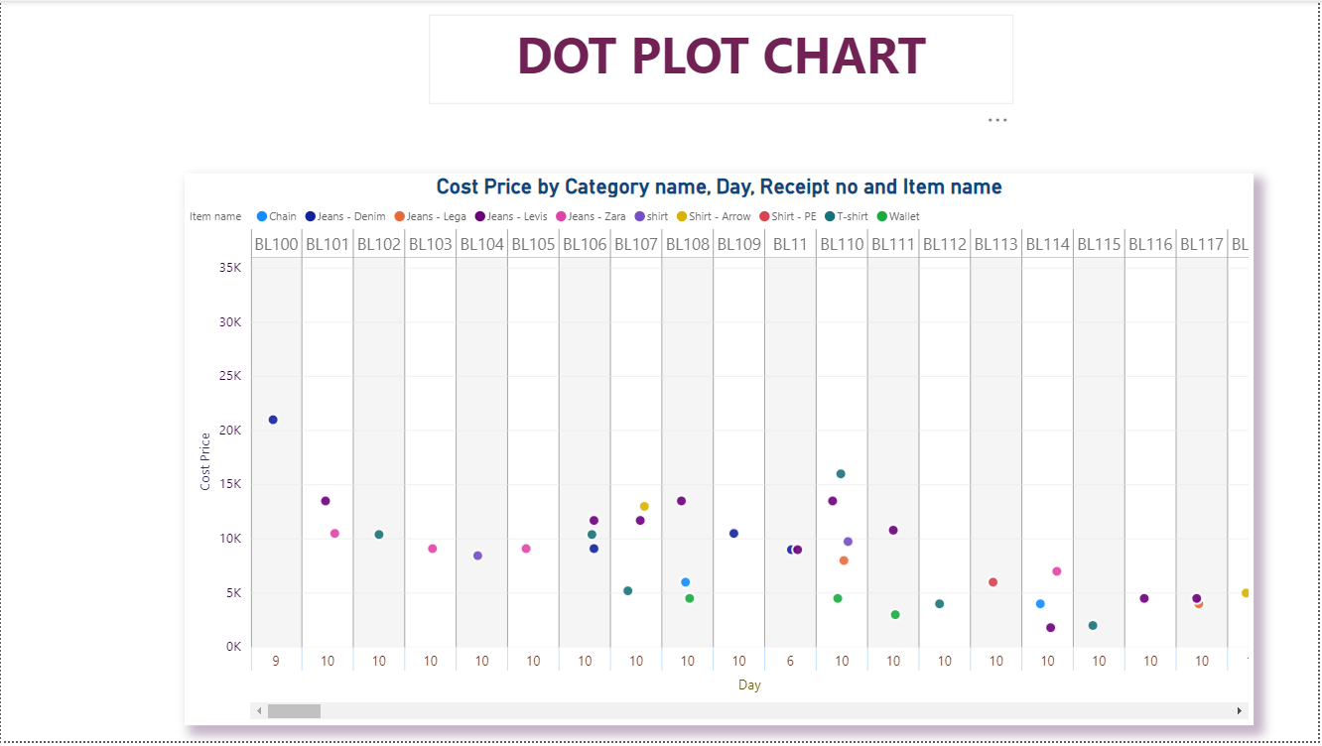

1. **Bar Chart :**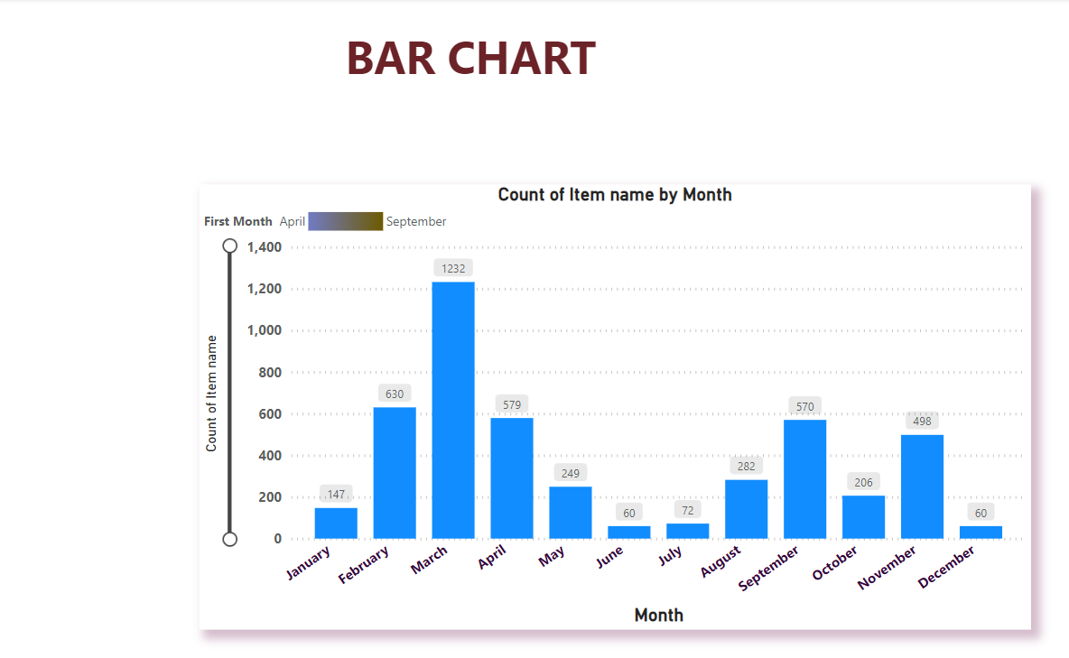
2. **Floating Bar Chart :**

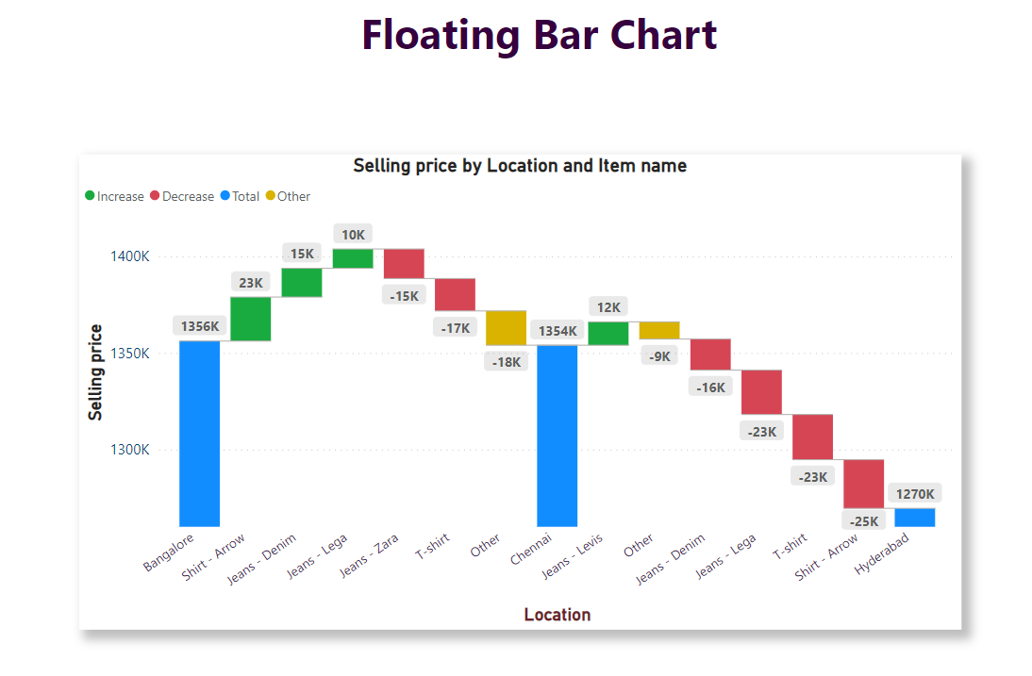

1. **Histogram Chart :**

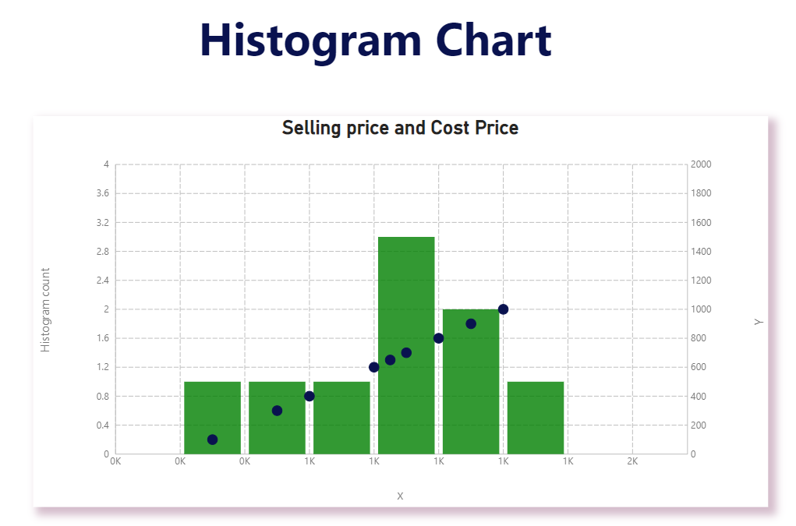

1. **Pie Chart :**

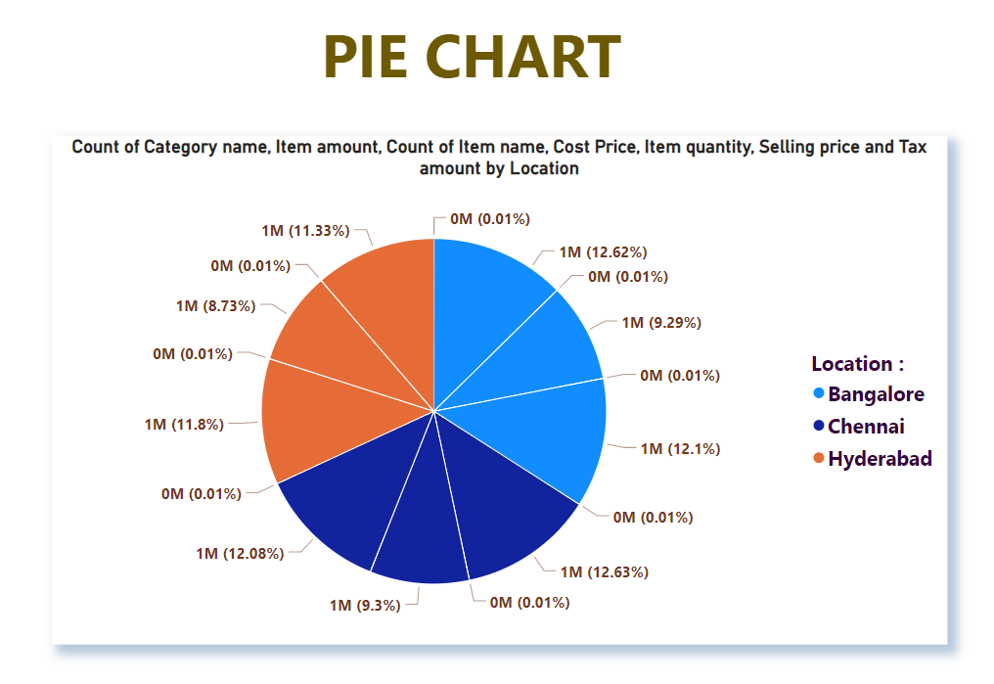

1. **Tree Map :**

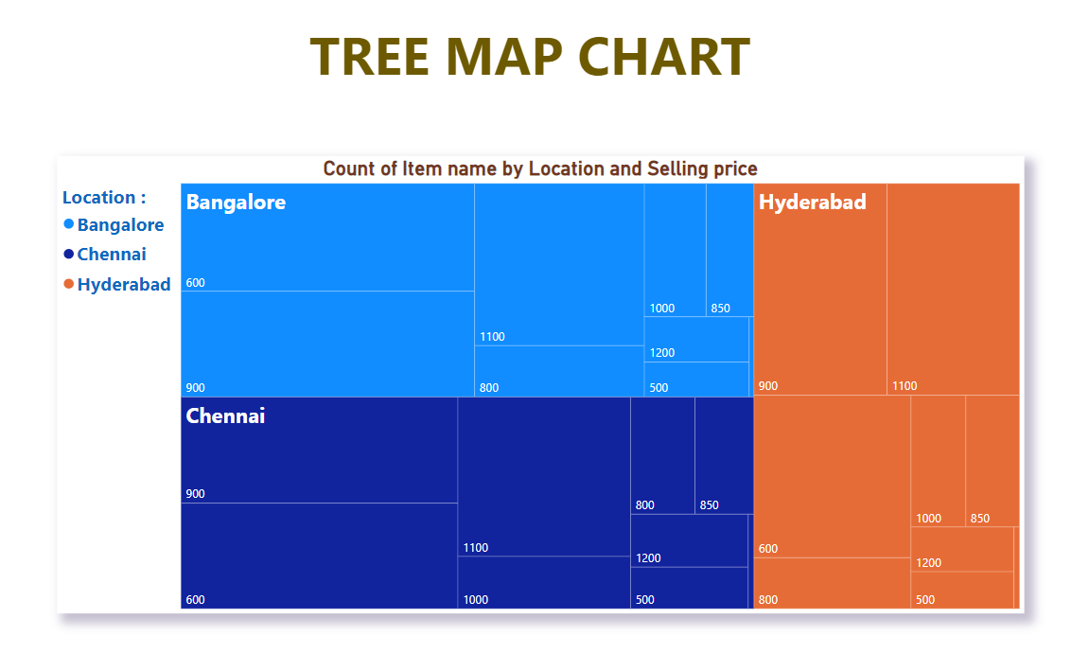

1. **Bubble Chart :**

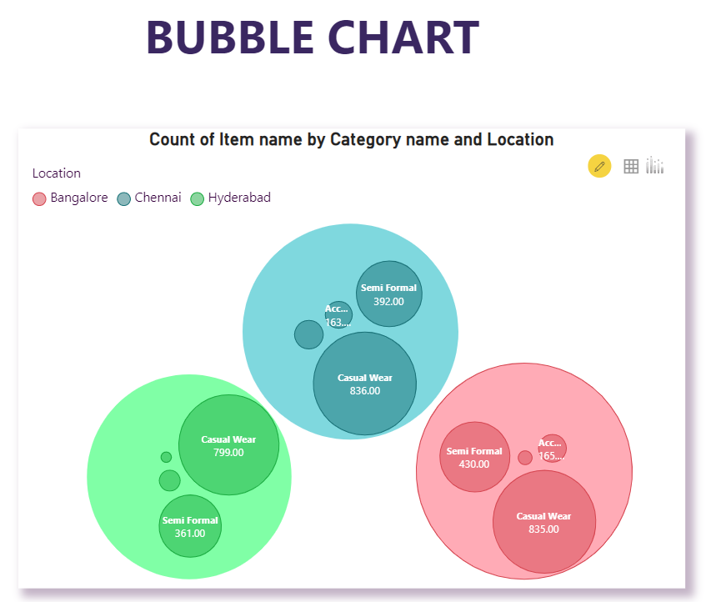

1. **Parallel Sets**

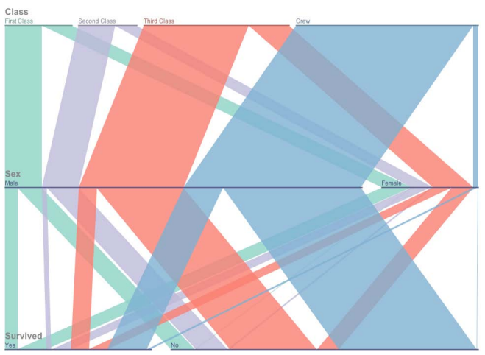

1. **Choropleth Map :**

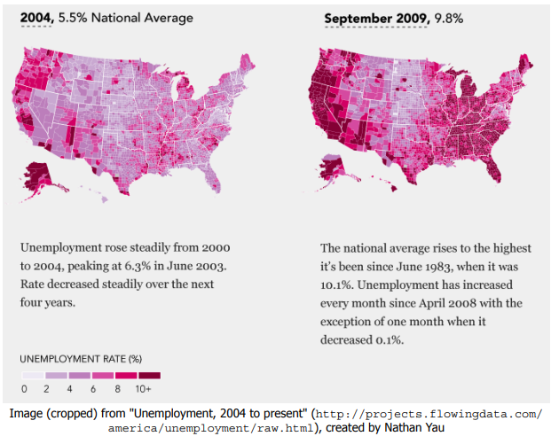

1. **Topological Map :**

