**Velagapudi Ramakrishna Siddhartha Engineering College**

**Program Elective - 1 Course**

**Dot Net Technologies Lab**

**Code : 20IT5404B**



**Week – 1**

**Aim :** Create C# class Employee with the fields eno, ename, address, designation, mobile number, salary, city, pincode. Create necessary methods to read the information and display the information. The employer contains 10 employees. The employer wants to know the total salary paid to its employees. As a programmer how do you suggest a solution to his problem?

**Program :**

using System;

using System.Collections.Generic;

using System.Linq;

using System.Security.Cryptography.X509Certificates;

using System.Text;

using System.Threading.Tasks;

namespace Employee_1

{

public class Program

{

public decimal total = 0;

public static void Main(string[] args)

{

decimal T = 0;

Employee[] obj = new Employee[10];

for(int i = 0; i < 3; i++)

{

obj[i] = new Employee();

obj[i].SetStudentDetails();

Console.WriteLine();

obj[i].GetStudentDetails();

decimal t = obj[i].salary;

T = T + t;

}

Console.WriteLine("Total Salary of all Employee's is : " + T);

}

}

class Employee

{

public int eno, pincode;

public string ename, address, designation, city;

public decimal salary;

public double mobile;

public void SetStudentDetails()

{

Console.Write("Enter Employee number : ");

eno = Convert.ToInt32(Console.ReadLine());

Console.Write("Enter Employee Name : ");

ename = Console.ReadLine();

Console.Write("Enter Employee Location Address : ");

address = Console.ReadLine();

Console.Write("Enter Employee Designation : ");

designation = Console.ReadLine();

Console.Write("Enter Employee's Mobile number : ");

mobile = Convert.ToDouble(Console.ReadLine());

Console.Write("Enter Employee Salary : ");

salary = Convert.ToDecimal(Console.ReadLine());

Console.Write("Enter Employee Located City's Name : ");

city = Console.ReadLine();

Console.Write("Enter Area pincode : ");

pincode = Convert.ToInt32(Console.ReadLine());

}

public void GetStudentDetails()

{

Console.WriteLine("Employee Number : " + eno);

Console.WriteLine("Employee's Name : " + ename);

Console.WriteLine("Employee Address : " + address);

Console.WriteLine("Employee Designation : " + designation);

Console.WriteLine("Employee's Mobile Number : " + mobile);

Console.WriteLine("Employee's Salary : " + salary);

Console.WriteLine("Employee City : " + city);

Console.WriteLine("Employee Area Pincode : " + pincode);

}

}

}

**Output :**

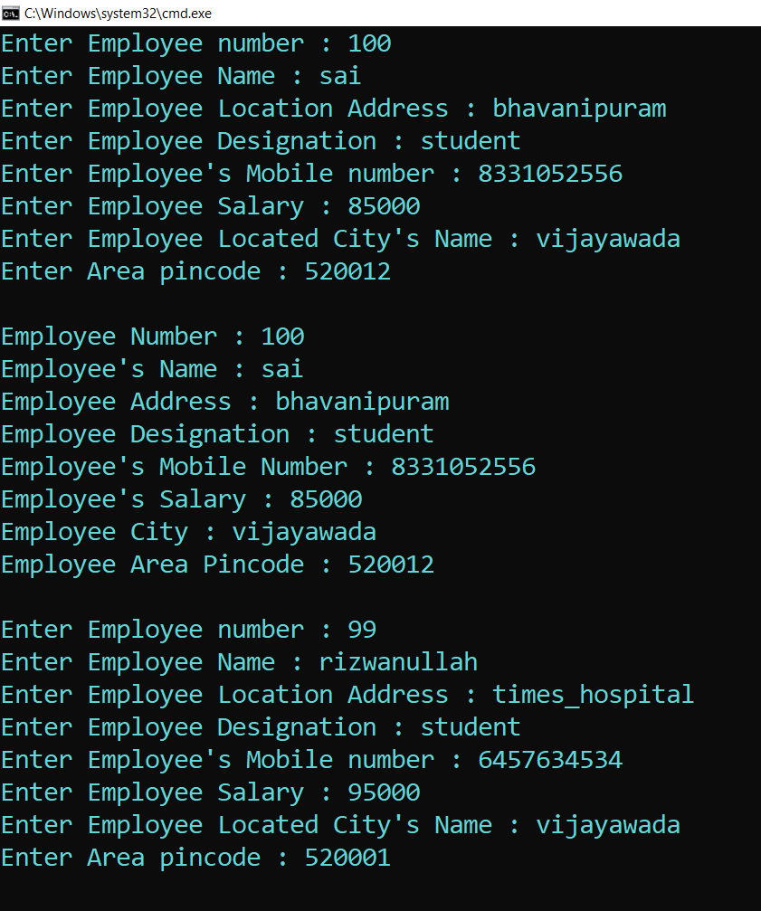

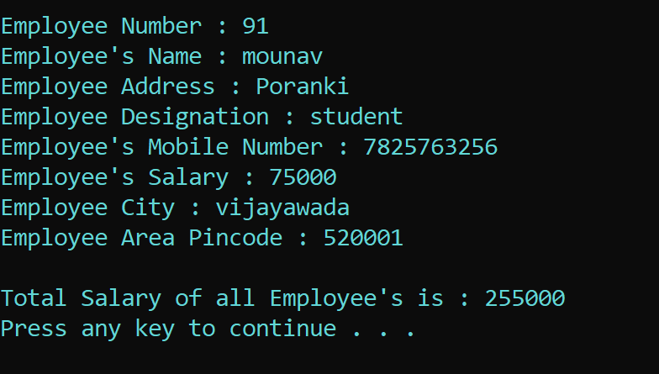

**Result :** Sucessfully Executed the program.

**Aim :** Create a C# class to read the book information to a library which includes booknumber, name, pages, issn number, price, year_of_publication. Use C# Properties to store the information into these variables and retrieve the information.

**Program :**

using System;

using System.Collections.Generic;

using System.Linq;

using System.Text;

using System.Threading.Tasks;

namespace Properties_1

{

internal class Program

{

public static void Main(string[] args)

{

Person obj = new Person();

Console.Write("Enter Book Number : ");

obj.book_no = Convert.ToInt32(Console.ReadLine());

Console.Write("Enter Book Name : ");

obj.name = Console.ReadLine();

Console.Write("Enter No.of Pages in Book : ");

obj.pages = Convert.ToInt32(Console.ReadLine());

Console.Write("Enter Book ISSN Number : ");

obj.issn = Convert.ToInt32(Console.ReadLine());

Console.Write("Enter Book Price : ");

obj.price = Convert.ToInt32(Console.ReadLine());

Console.Write("Enter Book Publishe Year : ");

obj.pub = Convert.ToInt32(Console.ReadLine());

Console.WriteLine();

Console.WriteLine("Book Number : " + obj.book_no);

Console.WriteLine("Book Name : " + obj.name);

Console.WriteLine("No.of Pages in That Book : " + obj.pages);

Console.WriteLine("Book ISSN Number : " + obj.issn);

Console.WriteLine("Book Price : " + obj.price);

Console.WriteLine("Year of Published : " + obj.pub);

}

}

class Person

{

public int book_no { get; set; }

public string name { get; set; }

public int pages { get; set; }

public int issn { get; set; }

public int price { get; set; }

public int pub { get; set; }

}

}

**Output :**

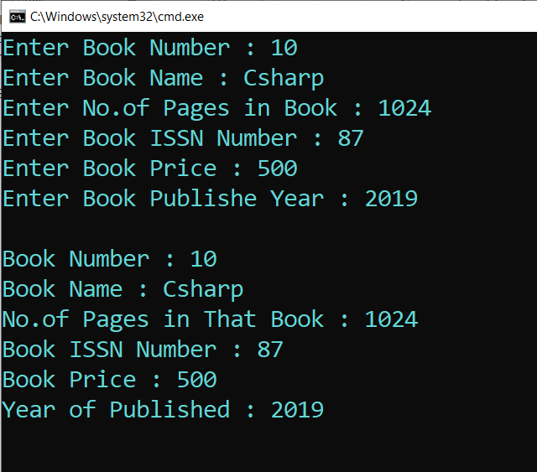

**Result :** Sucessfully Executed the Program.

**Aim :** Write a C# program of jagged array which declares, initializes and traverse jagged arrays.

**Program :**

using System;

using System.Collections.Generic;

using System.Linq;

using System.Text;

using System.Threading.Tasks;

namespace Jagged_Arrays

{

internal class Program

{

static void Main(string[] args)

{

int[][] arr = new int[2][]; // Declare the array

arr[0] = new int[] { 11, 21, 56, 78 };// Initialize the array

arr[1] = new int[] { 42, 61, 37, 41, 59, 63 };

Console.WriteLine("Jagged Array : ");

// Traverse array elements

for (int i = 0; i < arr.Length; i++)

{

for (int j = 0; j < arr[i].Length; j++)

{

System.Console.Write(arr[i][j] + " ");

}

System.Console.WriteLine();

}

}

}

}

**Output :**

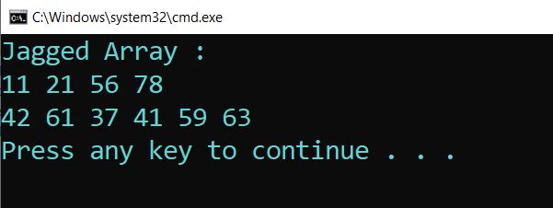

**Result :** Sucessfully Executed the program.

**Aim :** Create a class Student with the filed sno, sname, marks in three subjects. Create a method SetStudentDetails() which will read the information from the student. Create another method GetStudentDetails() which will display the information. Also, another method to compute the average mark of the student in three subject. Display the information.

**Program :**

using System;

using System.Collections.Generic;

using System.Linq;

using System.Text;

using System.Threading.Tasks;

namespace Student_Class

{

public class Program

{

static void Main(string[] args)

{

Student obj = new Student();

obj.SetStudentDetails();

obj.average();

Console.WriteLine();

obj.GetStudentDetails();

}

}

class Student

{

public int sno;

public string sname;

public Decimal m1, m2, m3;

public void SetStudentDetails()

{

Console.Write("Enter the Student Number : ");

sno = Convert.ToInt32(Console.ReadLine());

Console.Write("Enter the Student Name : ");

sname = Console.ReadLine();

Console.Write("Enter the Student marks in Subject 1: ");

m1 = Convert.ToDecimal(Console.ReadLine());

Console.Write("Enter the Student marks in Subject 2: ");

m2 = Convert.ToDecimal(Console.ReadLine());

Console.Write("Enter the Student marks in Subject 3: ");

m3 = Convert.ToDecimal(Console.ReadLine());

}

public void GetStudentDetails()

{

Console.WriteLine("Student Number is : " + sno);

Console.WriteLine("Student Name : " + sname);

Console.WriteLine("Student Marks : " + m1 + " " + m2 + " " + m3);

}

public void average()

{

Console.WriteLine("Average of 3 Subjects : " + ((m1 + m2 + m3) / 3));

}

}

}

**Output :**

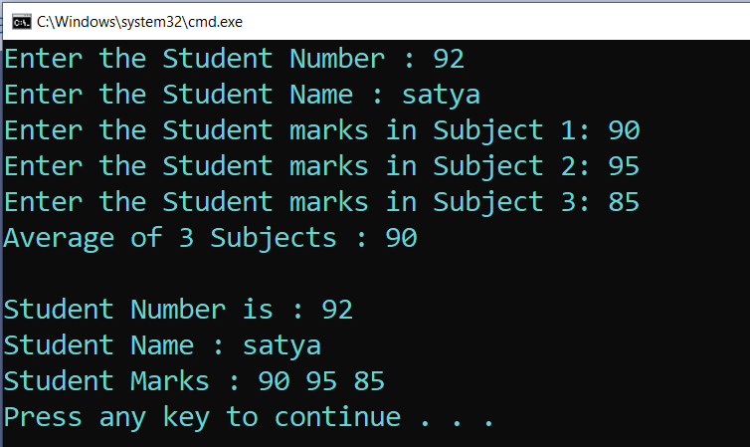

**Result :** Sucessfully Executed the Program .

**Aim :** Write a C# program which takes variable number of parameters i.e using params.

**Program :**

using System;

namespace Params_Keyword

{

internal class Program

{

public void Show(params int[] val) // Params Paramater

{

Console.Write("List of all values : ");

for (int i = 0; i < val.Length; i++)

{

Console.Write(val[i] + " ");

}

Console.ReadLine();

}

static void Main(string[] args)

{

Program p = new Program(); // Creating Object

p.Show(2, 4, 6, 8, 10, 12, 14); // Passing arguments of variable length

p.Show(1, 2, 3, 4, 5);

}

}

}

**Output :**

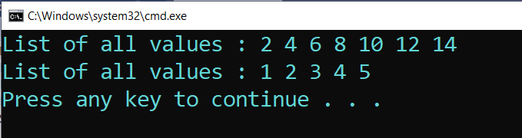

**Result :** Sucessfully executed the program.

**Aim :** Write a C# program to create a struct Rectangle which has two data members width and height, where we are using constructor to initialize data and method to calculate area of rectangle.

**Program :**

using System;

namespace Structures_2

{

internal class Program

{

public static void Main(string[] args)

{

Rectangle r = new Rectangle(4,5);

Console.WriteLine("Area of the Rectangle with parameterized values");

r.Area_Rectangle();

Console.WriteLine();

Console.WriteLine("Area of the Rectangle with Customized values : ");

r.width = 10;

r.height = 20;

r.Area_Rectangle();

}

}

public struct Rectangle

{

public int width, height;

public Rectangle(int w, int h)

{

this.width = w;

this.height = h;

}

public void Area_Rectangle()

{

Console.WriteLine("Area of the Rectangle : " + (width * height));

}

}

}

**Output :**

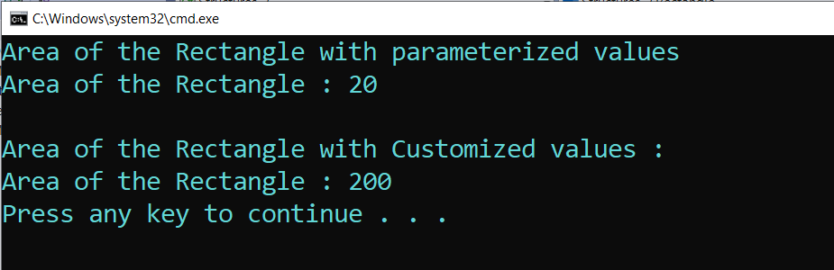

**Result :** Sucessfully Executed the Program.

**Aim :** Write a C# program on Multicast Delegates.

**Program :**

using System;

namespace Multicast_Delegates

{

internal class Program

{

public delegate void delmethod(int x, int y);

public void plus_Method1(int x, int y)

{

Console.Write("You are in plus_Method");

Console.WriteLine(x + y);

}

public void subtract_Method2(int x, int y)

{

Console.Write("You are in subtract_Method");

Console.WriteLine(x - y);

}

static void Main(string[] args)

{

Program obj = new Program();

delmethod del = new delmethod(obj.plus_Method1);

// Here we have multicast

del += new delmethod(obj.subtract_Method2);

// plus_Method1 and subtract_Method2 are called

del(50, 10);

Console.WriteLine();

//Here again we have multicast

del -= new delmethod(obj.plus_Method1);

//Only subtract_Method2 is called

del(20, 10);

Console.ReadLine();

}

}

}

**Output :**

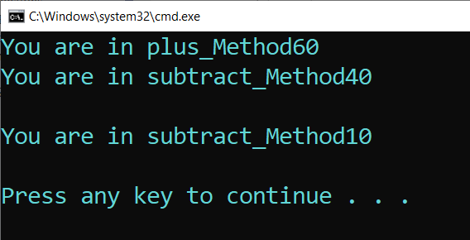

**Result :** Sucessfully Executed the program.

**Aim :** Write a C# program to create an interface Drawable which has draw() method. Its implementation is provided by two classes: Rectangle and Circle.

**Program :**

using System;

using System.Collections.Generic;

using System.Linq;

using System.Text;

using System.Threading.Tasks;

namespace Interfaces

{

internal class Program

{

static void Main(string[] args)

{

Drawable d;

d = new Rectangle();

d.draw();

d = new Circle();

d.draw();

}

}

public interface Drawable

{

void draw();

}

public class Rectangle : Drawable

{

public void draw()

{

Console.WriteLine("drawing rectangle...");

}

}

public class Circle : Drawable

{

public void draw()

{

Console.WriteLine("drawing circle...");

}

}

}

**Output :**

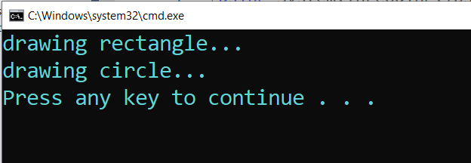

**Result :** Sucessfully Executed the Program.

**Aim :** Create a Class Polygon with three variables l,b,h. Create a parameterised method to set the values to l,b,h. Create an abstract method compute().

**Program :**

using System;

using System.Collections.Generic;

using System.Linq;

using System.Text;

using System.Threading.Tasks;

namespace Abstract_Class

{

internal class Program

{

static void Main(string[] args)

{

Cuboid c1 = new Cuboid(5, 10, 15);

c1.Compute();

Cube c2 = new Cube(2, 8, 4);

c2.Compute();

}

}

abstract class Polygon

{

public int l, b, h;

public Polygon(int l, int b, int h)

{

this.l = l;

this.b = b;

this.h = h;

}

public abstract void Compute();

}

class Cuboid : Polygon

{

public Cuboid(int l, int b, int h) : base(l, b, h)

{

//base(l, b, h);

}

public override void Compute()

{

Console.WriteLine("Volume of Cuboid : " + (l * b * h));

}

}

class Cube : Polygon

{

public Cube(int l, int b, int h) : base(l, b, h)

{

//base(l, b, h);

}

public override void Compute()

{

Console.WriteLine("Area of the Cube : " + (l * b * h));

}

}

}

**Output :**

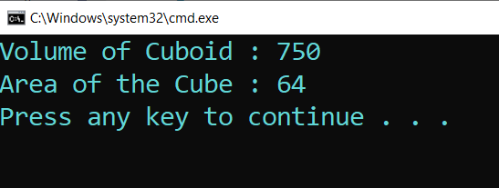

**Result :** Sucessfully executed the program.

**Aim :** Implement the following inheritance :

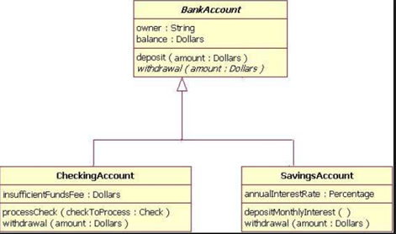

**Program :**

using System;

using System.Collections.Generic;

using System.Linq;

using System.Text;

using System.Threading.Tasks;

namespace Bank_Console

{

internal class Program

{

static void Main(string[] args)

{

CheckAccount ca = new CheckAccount();

Console.WriteLine("Initial Amount in Account : " + ca.amount);

ca.ProcessCheck(2000);

Console.WriteLine("Total Amount after WithDraw : " + ca.amount);

ca.Deposit(6000);

Console.WriteLine("Total amount after Deposited : " + ca.amount);

SavingsAccount sa = new SavingsAccount();

sa.DepositMonthlyInterest();

Console.WriteLine(" Amount with Interest : " + sa.amount);

}

}

class BankAccount

{

public string owner;

public float balance;

public float amount = 10000;

public void Deposit(float new_amount)

{

this.amount = this.amount + new_amount;

}

public void WithDrawl(float old_amount)

{

this.amount = this.amount - old_amount;

}

}

class CheckAccount : BankAccount

{

public float InsufficentFee;

public void ProcessCheck(float check_amount)

{

if (check_amount > base.amount)

{

Console.WriteLine(" You Don't Have Sufficent Amount in Account");

}

else

{

base.WithDrawl(check_amount);

}

}

}

class SavingsAccount : BankAccount

{

public float AnnualInterest = 0.9f;

public void DepositMonthlyInterest()

{

base.amount = base.amount * AnnualInterest;

}

}

}

**Output :**

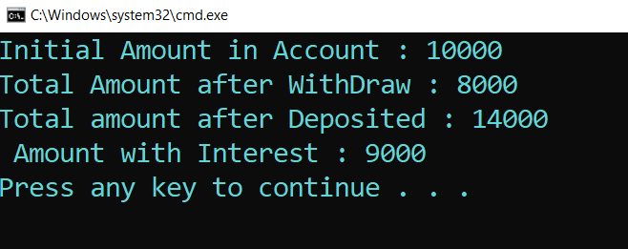

**Result :** Sucessfully Executed the program.