**Dot Net Technologies**

**Employee Database**

1. First Create a table with in the data base with below query

|  |
| --- |
| **Query :**  CREATE TABLE EmployeeData  (  [Emp_ID] INT NOT NULL PRIMARY KEY DEFAULT 0,  [Emp_Name] VARCHAR(50) NULL,  [Age] INT NULL,  [Gender] VARCHAR(50) NULL,  [Designation] VARCHAR(50) NULL,  [Dept_ID] INT NULL,  [Dept_Name] VARCHAR(50) NULL,  [Location] VARCHAR(50) NULL,  [Work_Project] VARCHAR(50) NULL,  [Company] VARCHAR(50) NULL,  [Salary] FLOAT NULL  ) |

1. After creating the table then save it with name EmployeeData
2. Now, Create a windows form in the visual studio just like the below one

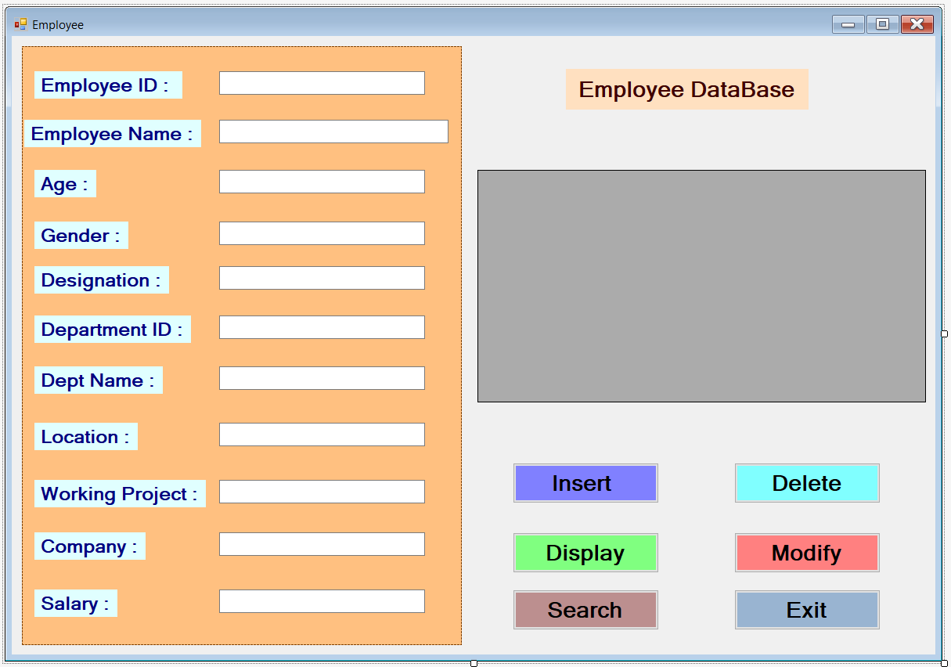

1. After creating the windows form now, write the code for each button
2. The code is just below down there.

|  |
| --- |
| **Code For Each button :**  using System;  using System.Collections.Generic;  using System.ComponentModel;  using System.Data;  using System.Drawing;  using System.Linq;  using System.Text;  using System.Threading.Tasks;  using System.Windows.Forms;  using System.Data.SqlClient;  namespace Employee_CRUD  {  public partial class Form1 : Form  {  public Form1()  {  InitializeComponent();  }  private void button1_Click(object sender, EventArgs e)  {  //Insert Button  SqlConnection con = new SqlConnection("Data Source=(LocalDB)\\MSSQLLocalDB;AttachDbFilename=C:\\Users\\SHREEE\\OneDrive\\Documents\\MyDataBase.mdf;Integrated Security=True;Connect Timeout=30");  con.Open();  SqlCommand cmd = new SqlCommand("insert into EmployeeData values(@Emp_ID,@Emp_Name,@Age,@Gender,@Designation,@Dept_ID,@Dept_Name,@Location,@Work_Project,@Company,@Salary)",con);  cmd.Parameters.AddWithValue("@Emp_ID", int.Parse(textBox1.Text));  cmd.Parameters.AddWithValue("@Emp_Name", textBox2.Text);  cmd.Parameters.AddWithValue("@Age", int.Parse(textBox3.Text));  cmd.Parameters.AddWithValue("@Gender", textBox4.Text);  cmd.Parameters.AddWithValue("@Designation", textBox5.Text);  cmd.Parameters.AddWithValue("@Dept_ID", int.Parse(textBox6.Text));  cmd.Parameters.AddWithValue("@Dept_Name", textBox7.Text);  cmd.Parameters.AddWithValue("@Location", textBox8.Text);  cmd.Parameters.AddWithValue("@Work_Project", textBox9.Text);  cmd.Parameters.AddWithValue("@Company", textBox10.Text);  cmd.Parameters.AddWithValue("@Salary", double.Parse(textBox11.Text));  cmd.ExecuteNonQuery();  con.Close();  MessageBox.Show(" Sucessfully Inserted the Data into Table.. ");  }  private void button4_Click(object sender, EventArgs e)  {  // Update Button  SqlConnection con = new SqlConnection("Data Source=(LocalDB)\\MSSQLLocalDB;AttachDbFilename=C:\\Users\\SHREEE\\OneDrive\\Documents\\MyDataBase.mdf;Integrated Security=True;Connect Timeout=30");  con.Open();  SqlCommand cmd = new SqlCommand();  cmd.Connection = con;  cmd.CommandText = "Update EmployeeData set Emp_Name='" + textBox2.Text + "', Age='" + textBox3.Text + "', Gender='" + textBox4.Text + "', Designation='" + textBox5.Text + "', Dept_ID='" + textBox6.Text + "', Dept_Name='" + textBox7.Text + "', Location='" + textBox8.Text + "', Work_Project='" + textBox9.Text + "', Company='" + textBox10.Text + "', Salary='" + textBox11.Text + "' where Emp_ID='" + textBox1.Text + "'";  cmd.ExecuteNonQuery();  con.Close();  MessageBox.Show(" Sucessfully Updated the Data into Table");  }  private void button2_Click(object sender, EventArgs e)  {  // Delete Button  SqlConnection con = new SqlConnection("Data Source=(LocalDB)\\MSSQLLocalDB;AttachDbFilename=C:\\Users\\SHREEE\\OneDrive\\Documents\\MyDataBase.mdf;Integrated Security=True;Connect Timeout=30");  con.Open();  SqlCommand cmd = new SqlCommand("Delete EmployeeData where Emp_ID = @Emp_ID", con);  cmd.Parameters.AddWithValue("@Emp_ID", int.Parse(textBox1.Text));  cmd.ExecuteNonQuery();  con.Close();  MessageBox.Show(" Sucessfully Deleted the Data into Table.. ");  }  private void button3_Click(object sender, EventArgs e)  {  // Display Button  SqlConnection con = new SqlConnection("Data Source=(LocalDB)\\MSSQLLocalDB;AttachDbFilename=C:\\Users\\SHREEE\\OneDrive\\Documents\\MyDataBase.mdf;Integrated Security=True;Connect Timeout=30");  con.Open();  SqlCommand cmd = new SqlCommand("Select * from EmployeeData",con);  SqlDataAdapter da = new SqlDataAdapter(cmd);  DataTable dt = new DataTable();  da.Fill(dt);  dataGridView1.DataSource = dt;  }  private void button5_Click(object sender, EventArgs e)  {  // Exit Button  this.Close();  }  private void button6_Click(object sender, EventArgs e)  {  // Search Button  SqlConnection con = new SqlConnection("Data Source=(LocalDB)\\MSSQLLocalDB;AttachDbFilename=C:\\Users\\SHREEE\\OneDrive\\Documents\\MyDataBase.mdf;Integrated Security=True;Connect Timeout=30");  con.Open();  SqlCommand cmd = new SqlCommand("Select * from EmployeeData where Emp_ID=@Emp_ID", con);  cmd.Parameters.AddWithValue("Emp_ID", int.Parse(textBox1.Text));    SqlDataAdapter da = new SqlDataAdapter(cmd);  DataTable dt = new DataTable();  da.Fill(dt);  dataGridView1.DataSource = dt;  }  }  } |

1. **Make Sure That Use the Connection String of Your Database.**
2. Save All Changes.
3. Now, Finally You can Run the Windows Form

**Windows Form :**

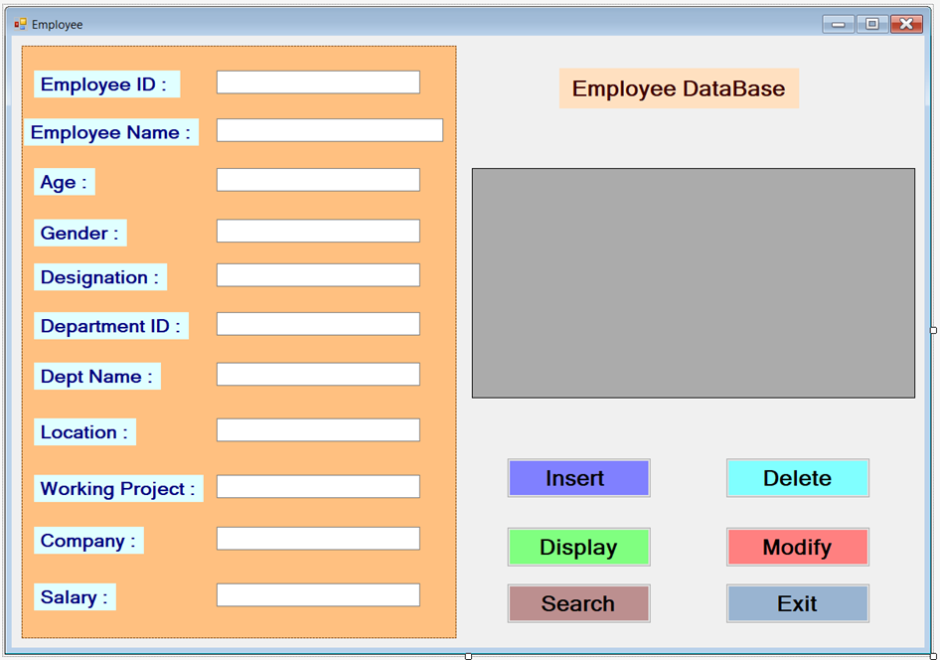

**Insert Query :**

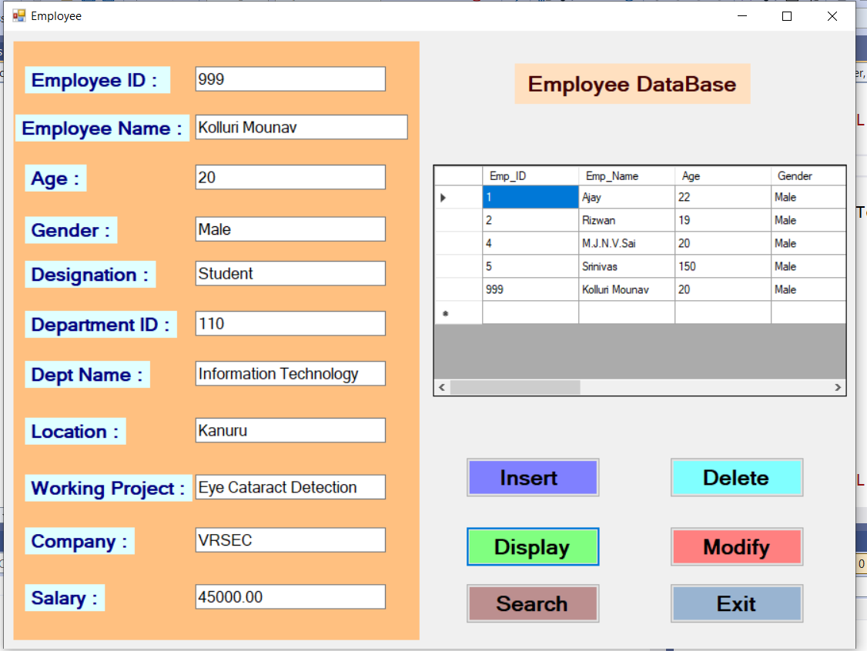

**Modify Query :**

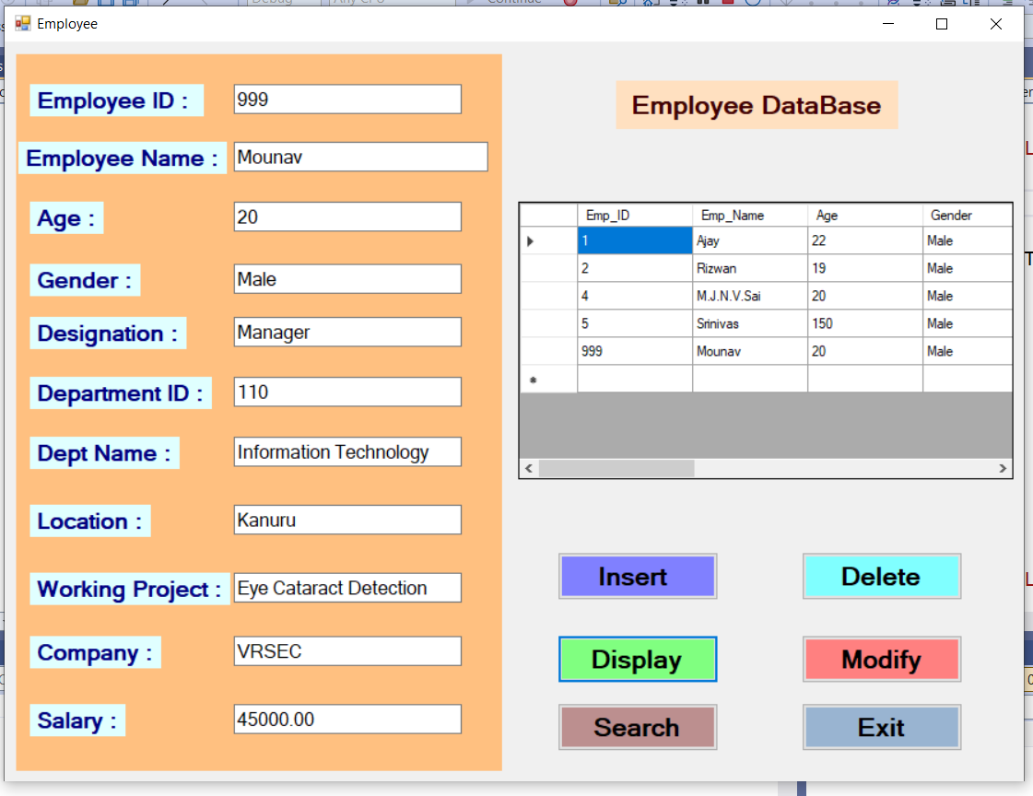

**Delete Query :**

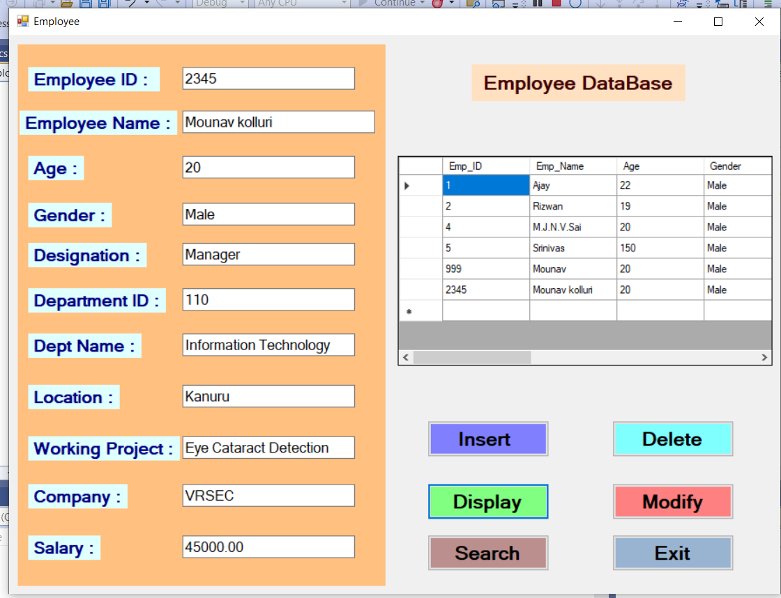

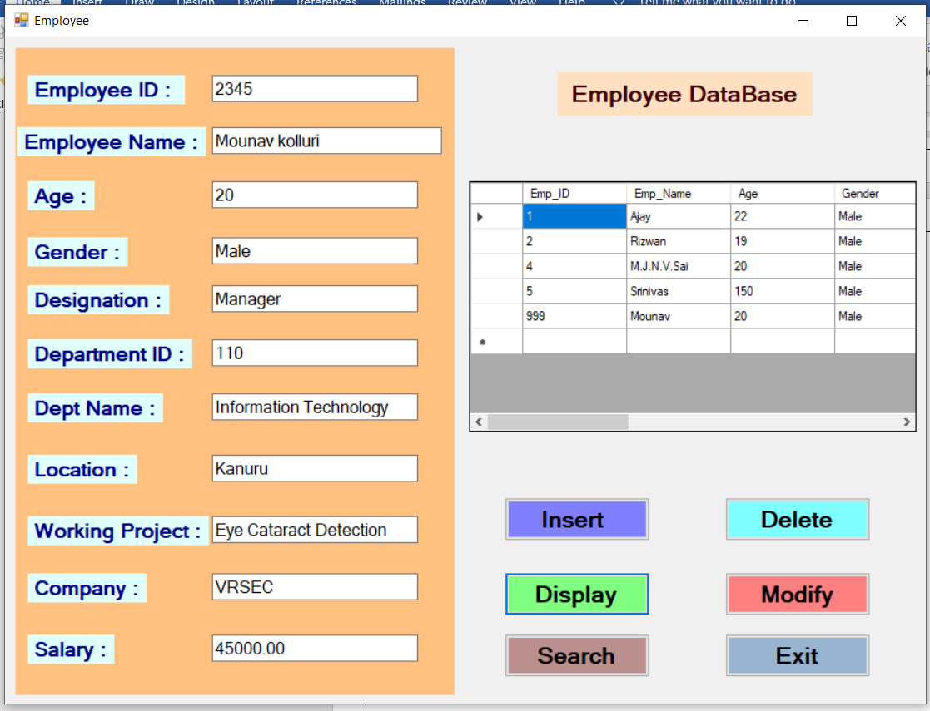

**Search Query :**

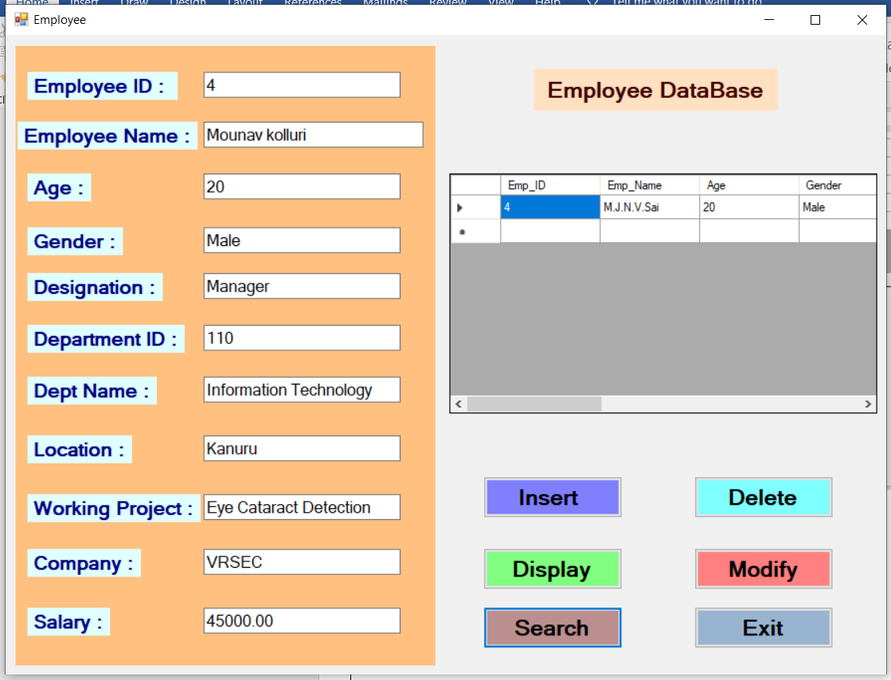

**Display Query :**

When we click on that button it displays the table from the database

**Exit :**

When we click on the exit button it exits the total application.

**End Of The Task**