**Dot Net Technologies**

**VRSEC Student Registration Using Asp.Net Core Web**

1. First we will create an database with a name studentdatabase and this database contains a table with a name called “ StudentRegistration “

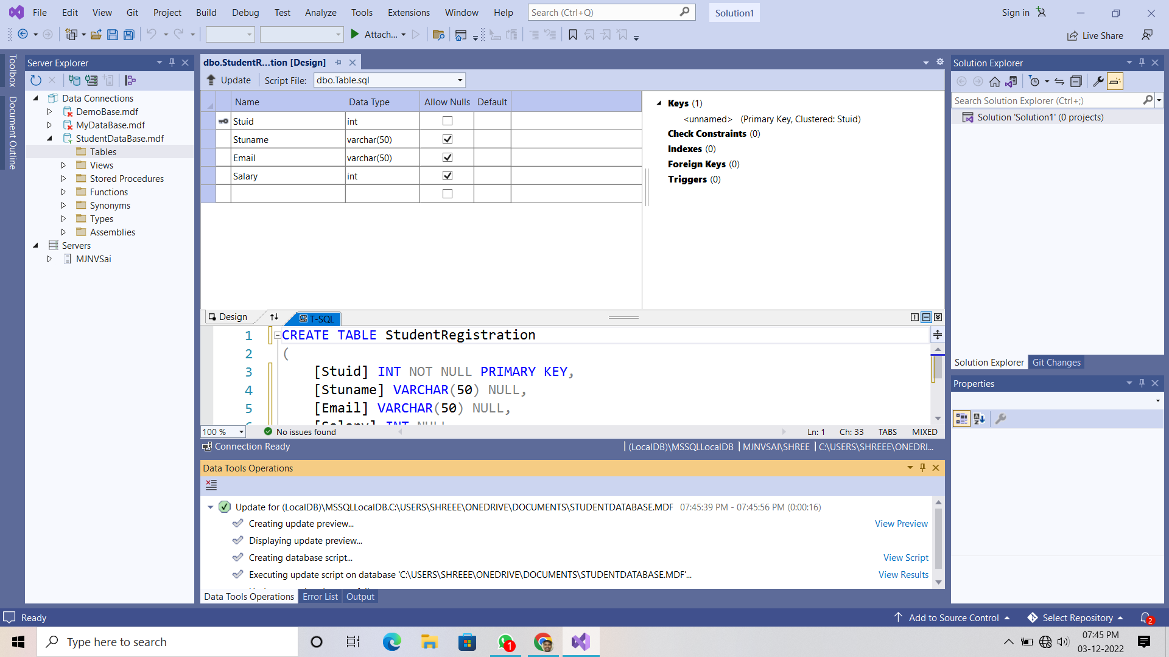

1. After creating the database and table now click on new project and select “ ASP.NET Core Web App “

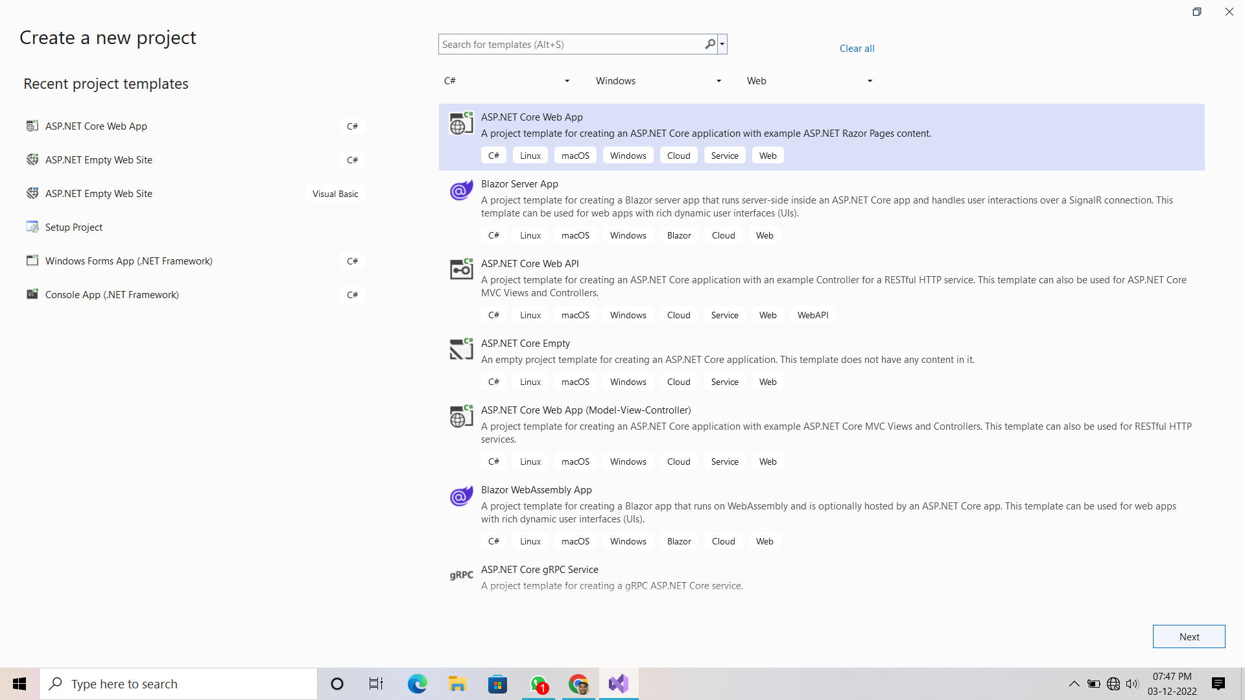

1. Click on next and give the project name and set the destination path.

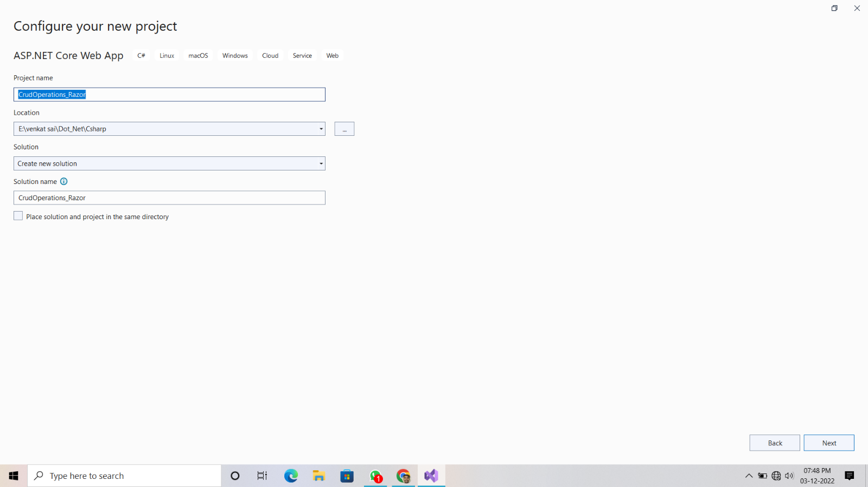

1. Then click on again next set the highest framework and check the https

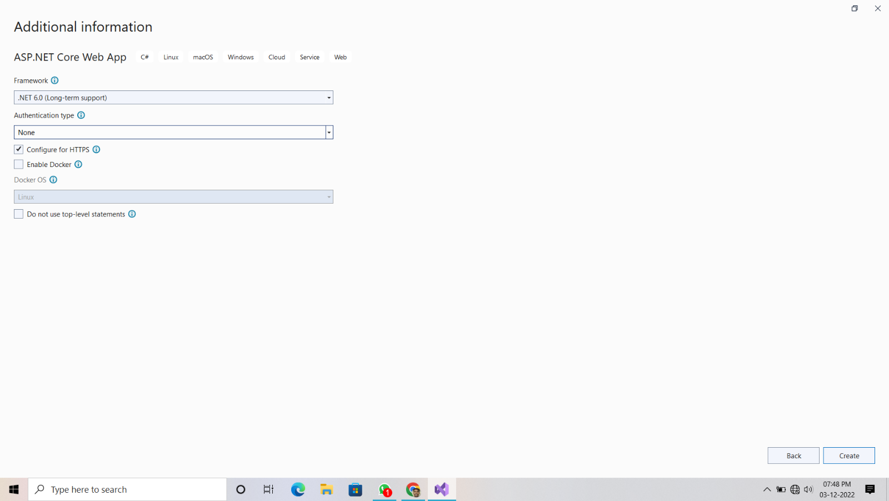

1. After completing all your home page will be like below one

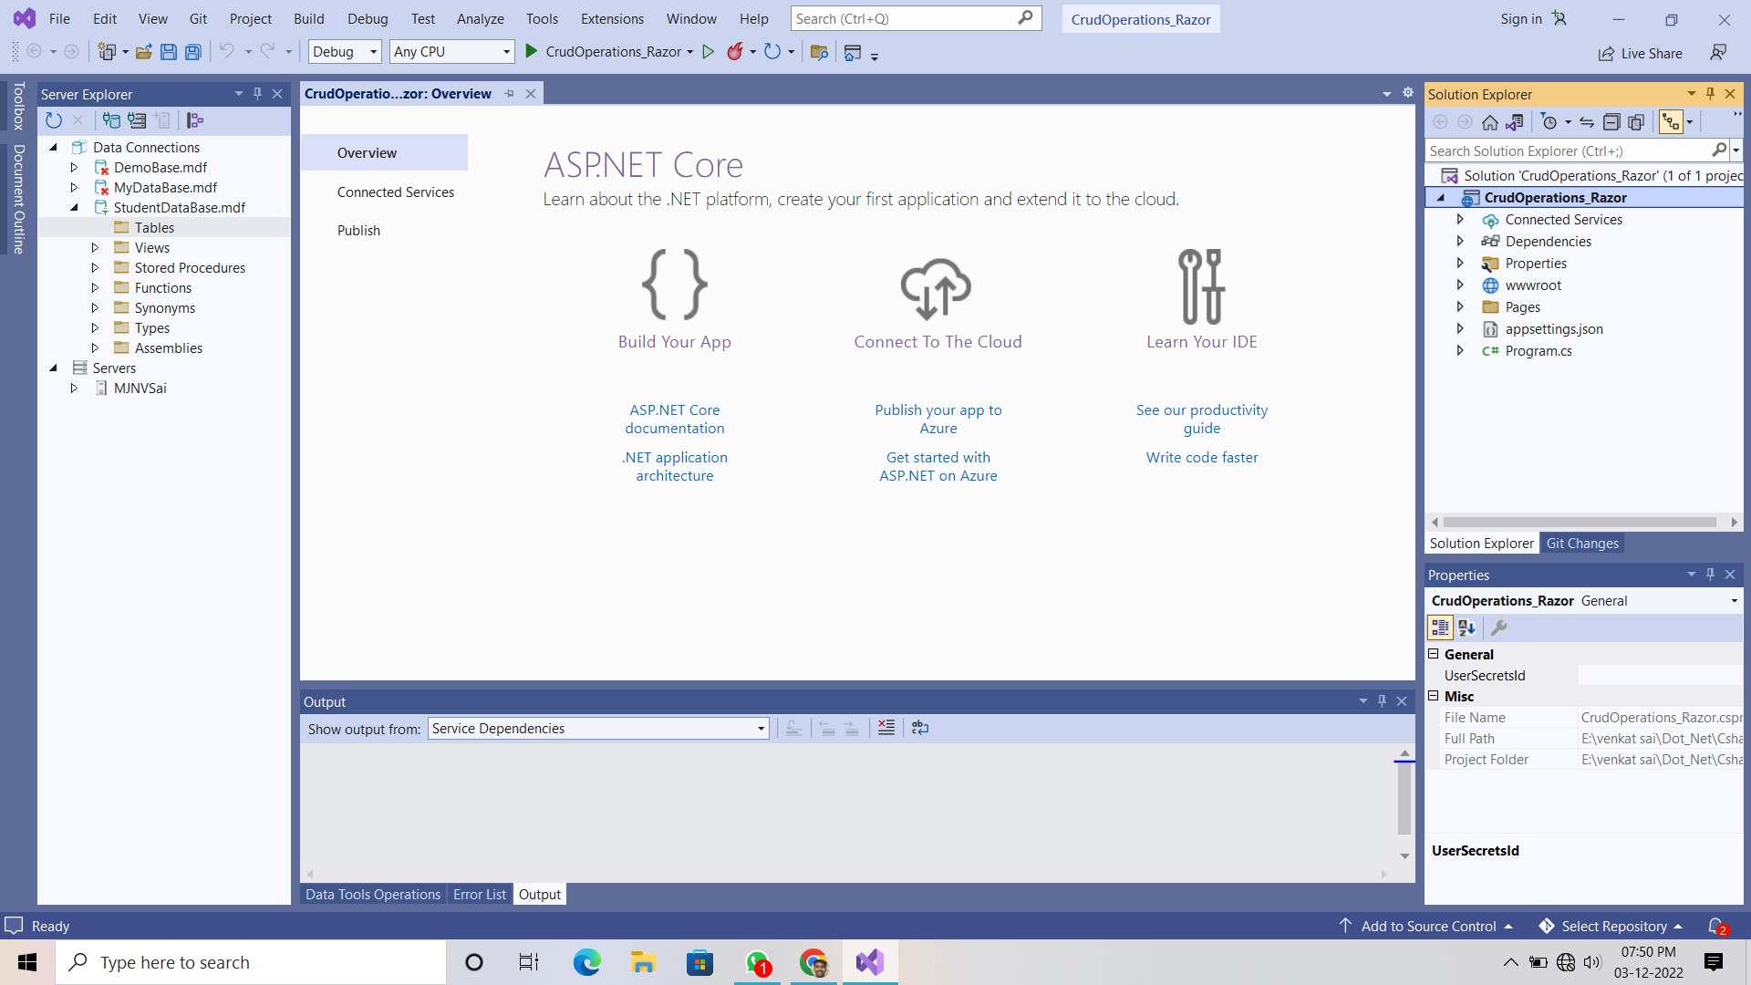

1. Now right click on the project name in the solution explorer and select “ add an item “ and then select the new folder option and give it as a name “ Models “
2. Right click on the models and then add a class component file and save it with an name “StudentRegistration.cs”
3. a sample pic is below down is there

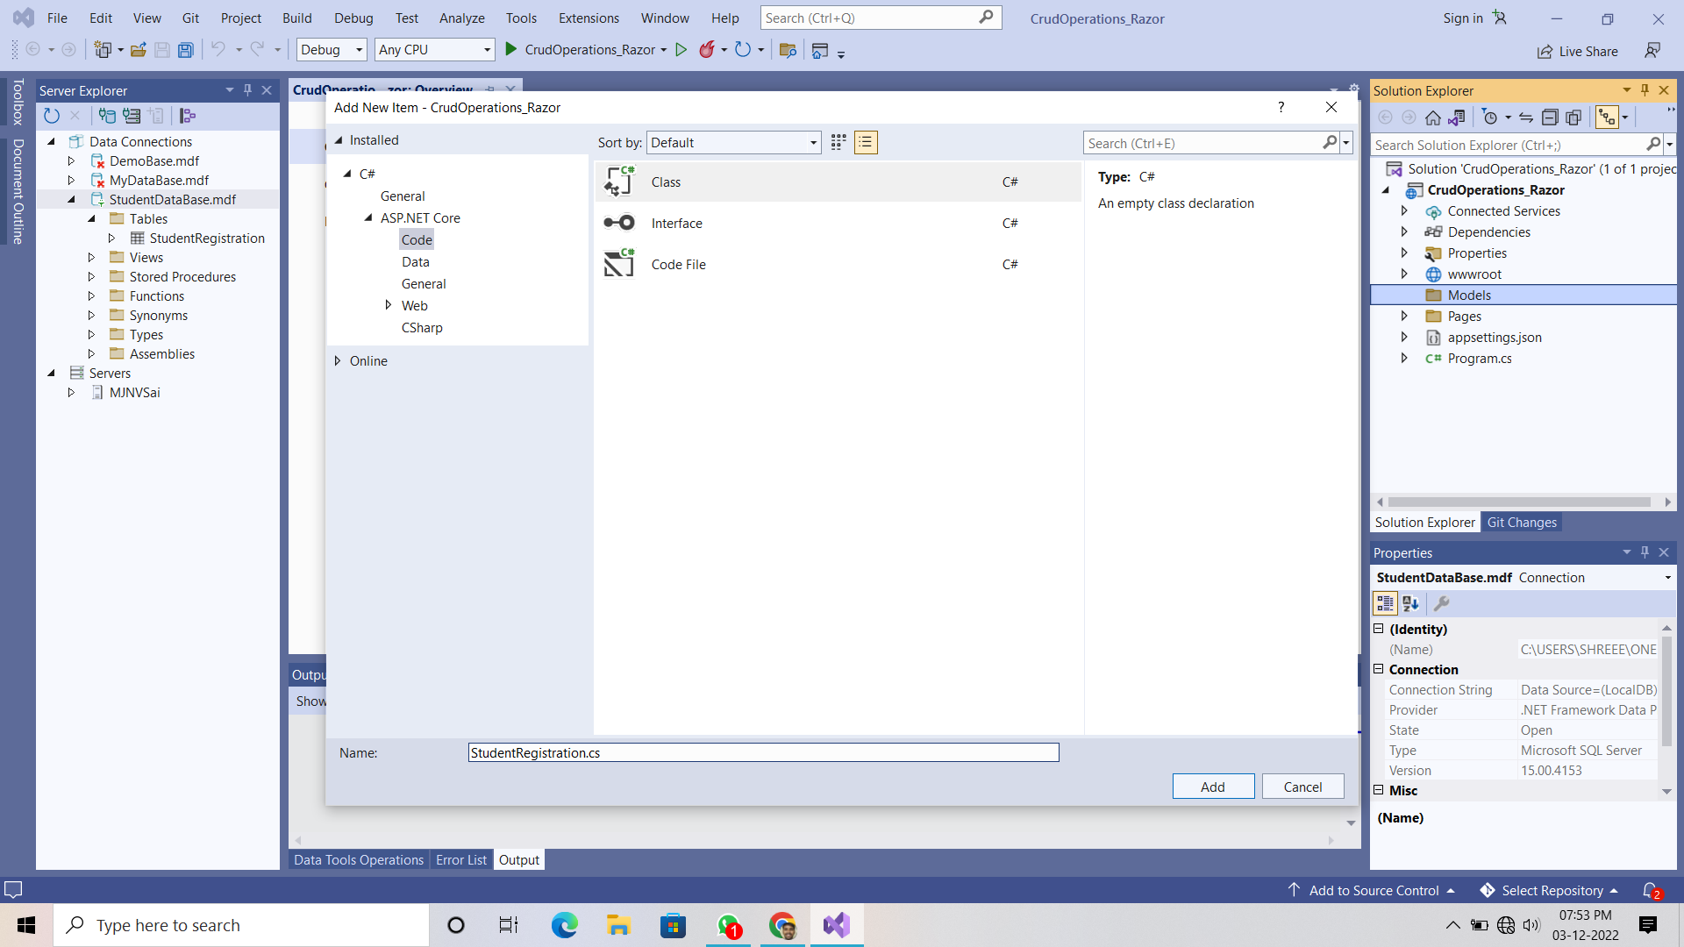

1. Now write a program on “StudentRegistration.cs” file which declares the attributes in a table as an properties in the class with get and set methods.

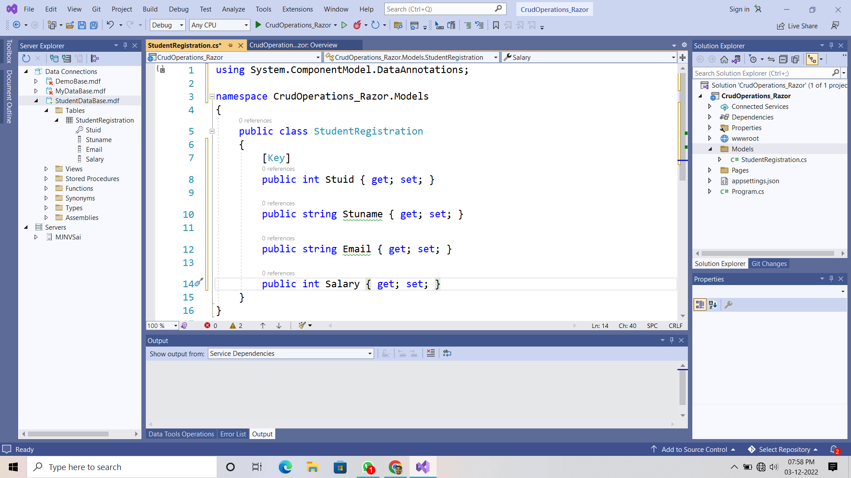

1. Now right click on the “ Models Folder “ and add an razor page .

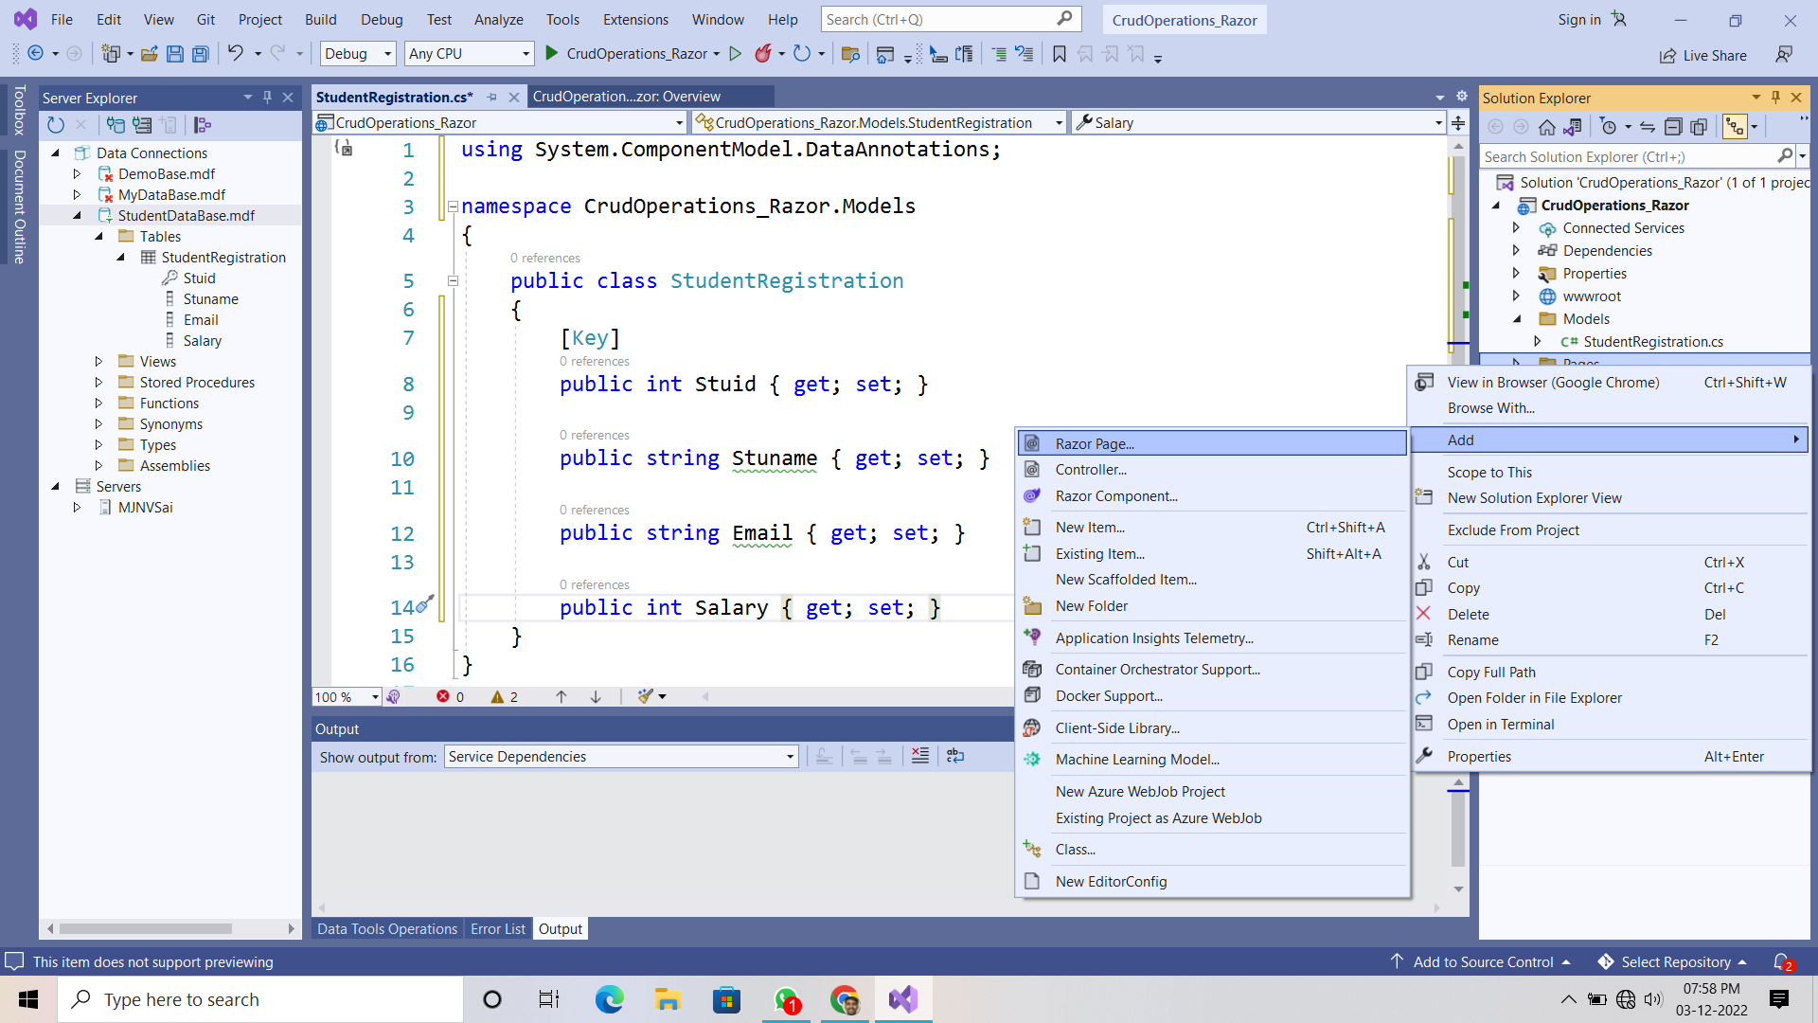

1. Now choose the “ Razor pages using Enity Framework (CRUD) option.
2. In model class select the student registration option

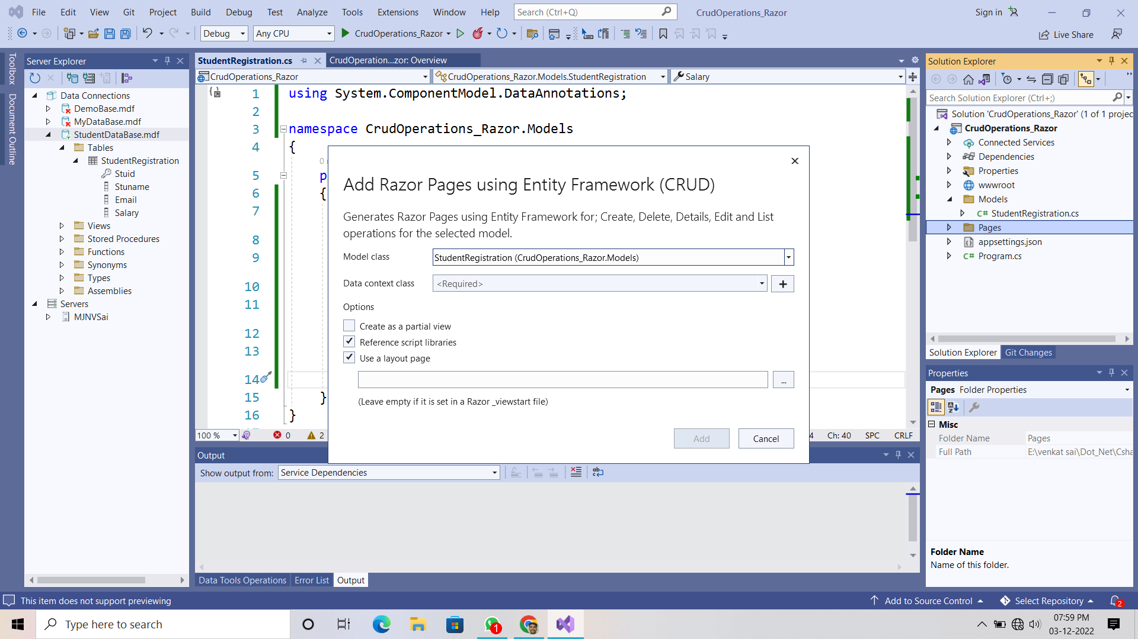

1. Now click on the “ plus button “ and then add data context and then save all .

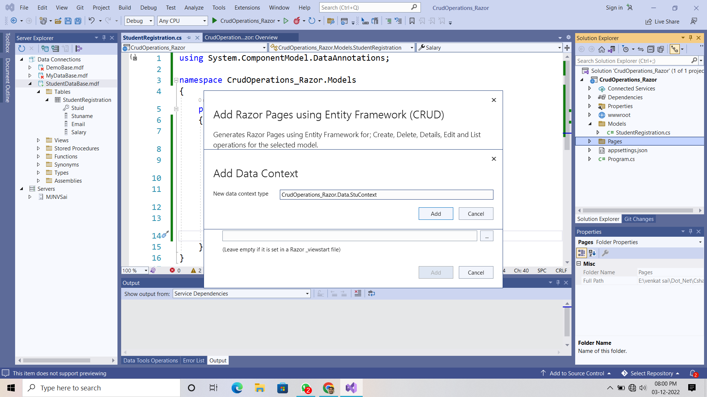

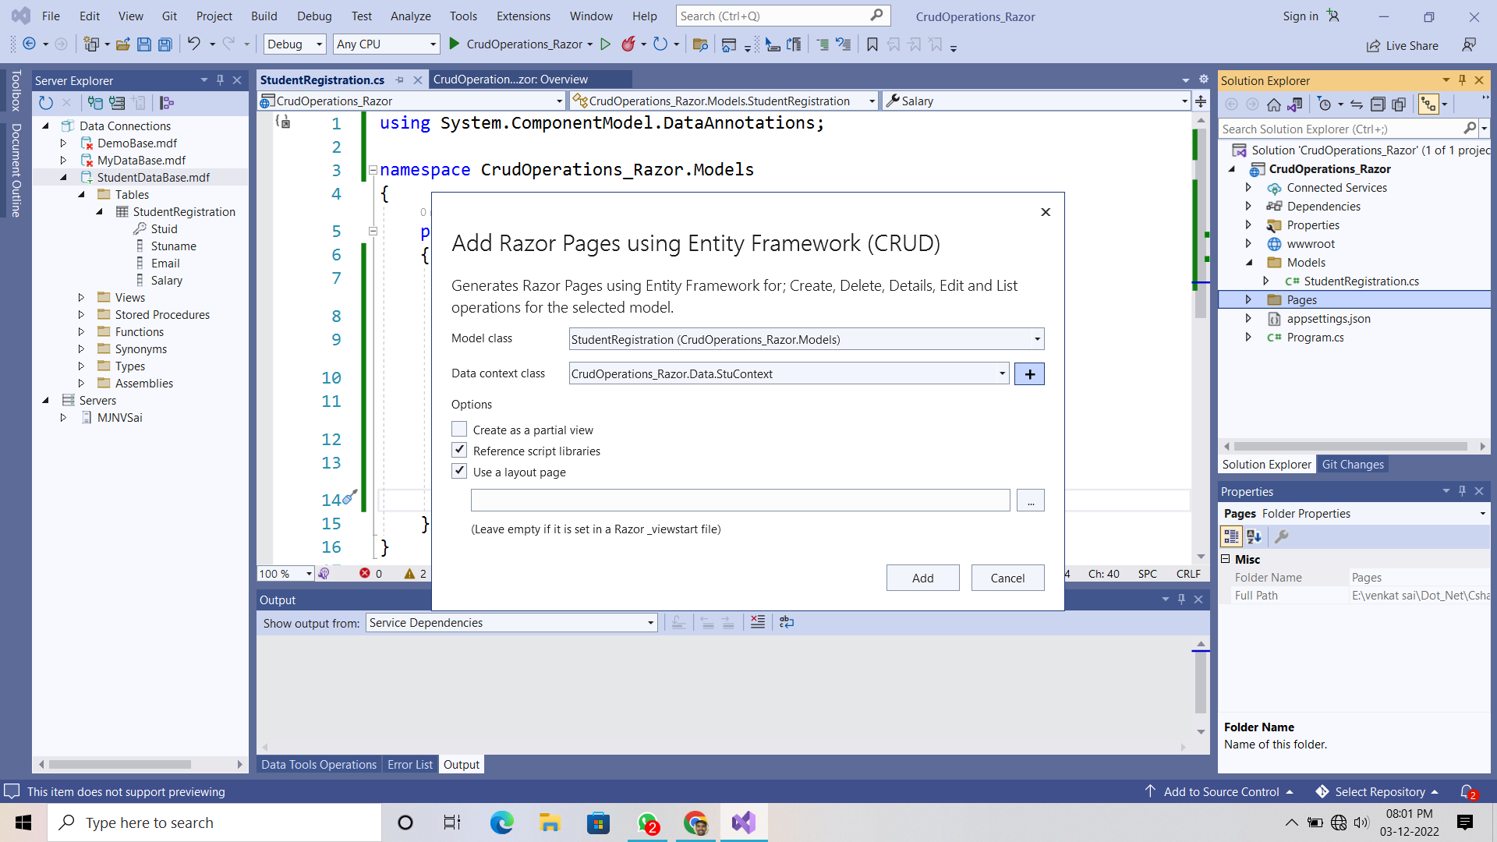

**In Solution Explorer “ /pages/Create.cshtml “ file**

**Add this small piece of code**

<div class="form-group">

<**label** **asp-for**="StudentRegistration.Stuid" class="control-label"></**label**>

<**input** **asp-for**="StudentRegistration.Stuid" class="form-control" />

<**span** **asp-validation-for**="StudentRegistration.Stuid" class="text-danger"></**span**>

</div>



**In Appsettings.json file change the Database Connection string.**

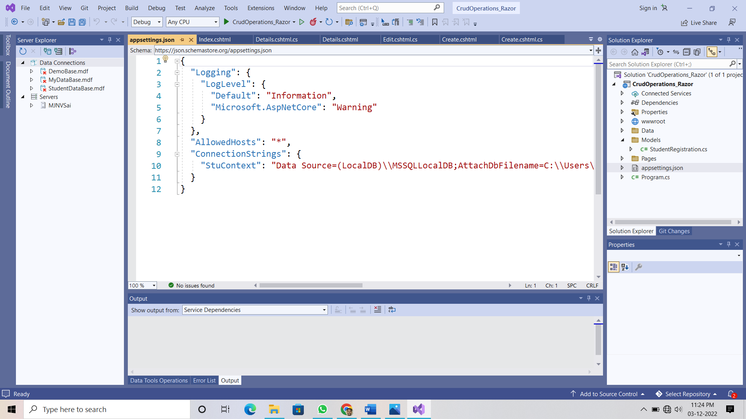

**Outputs :**

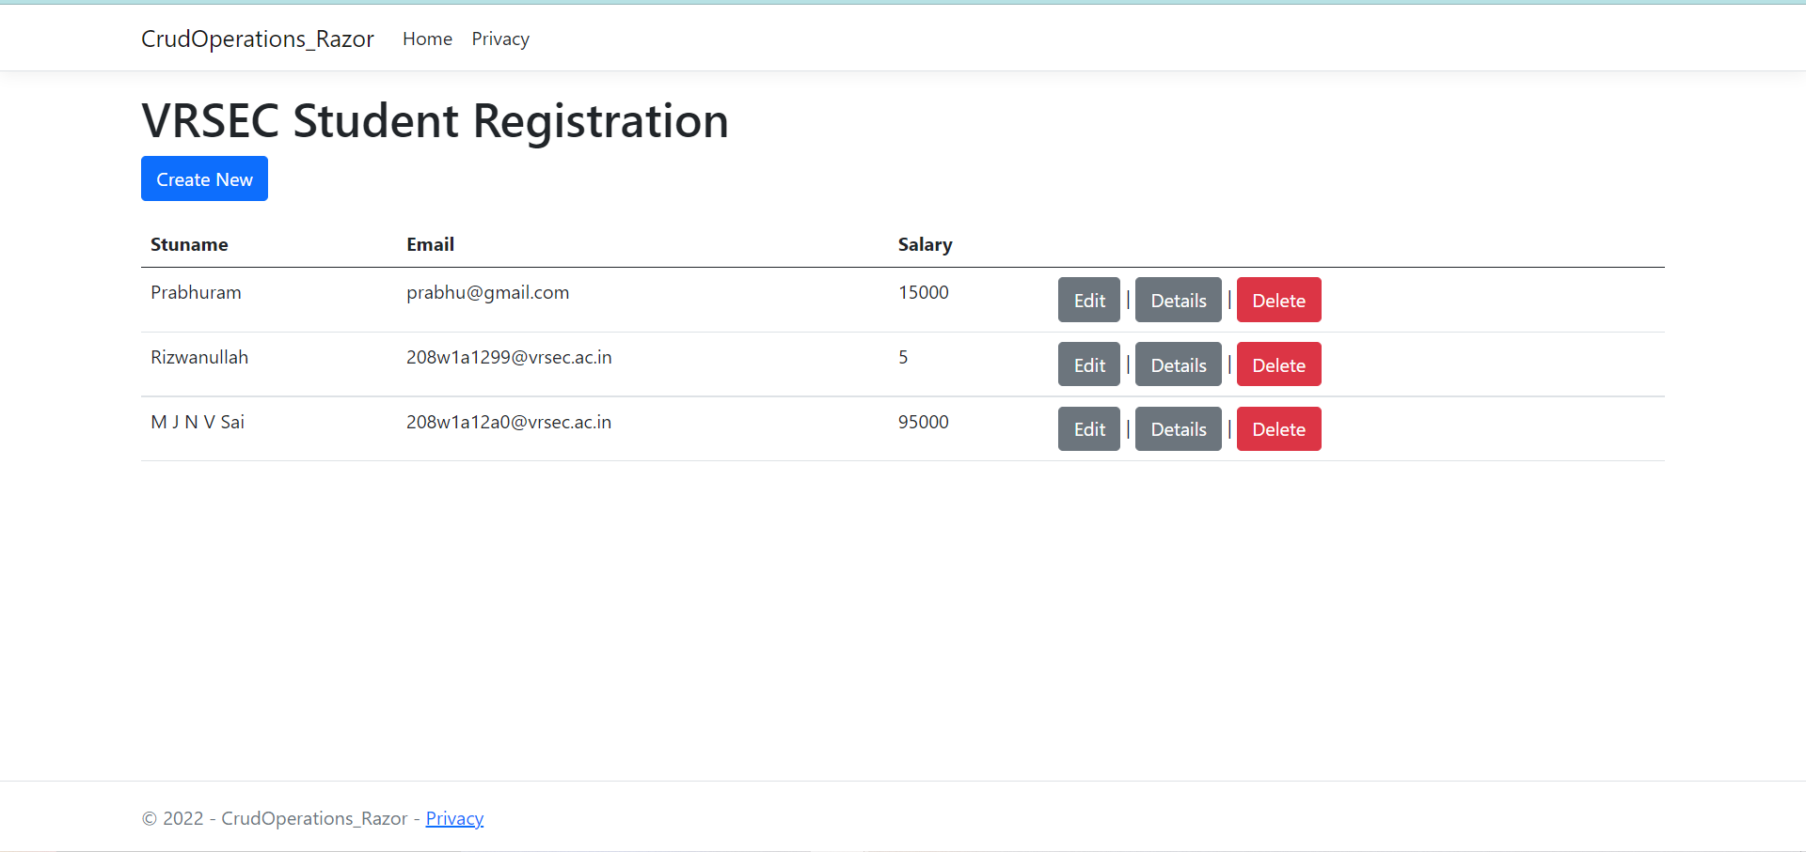

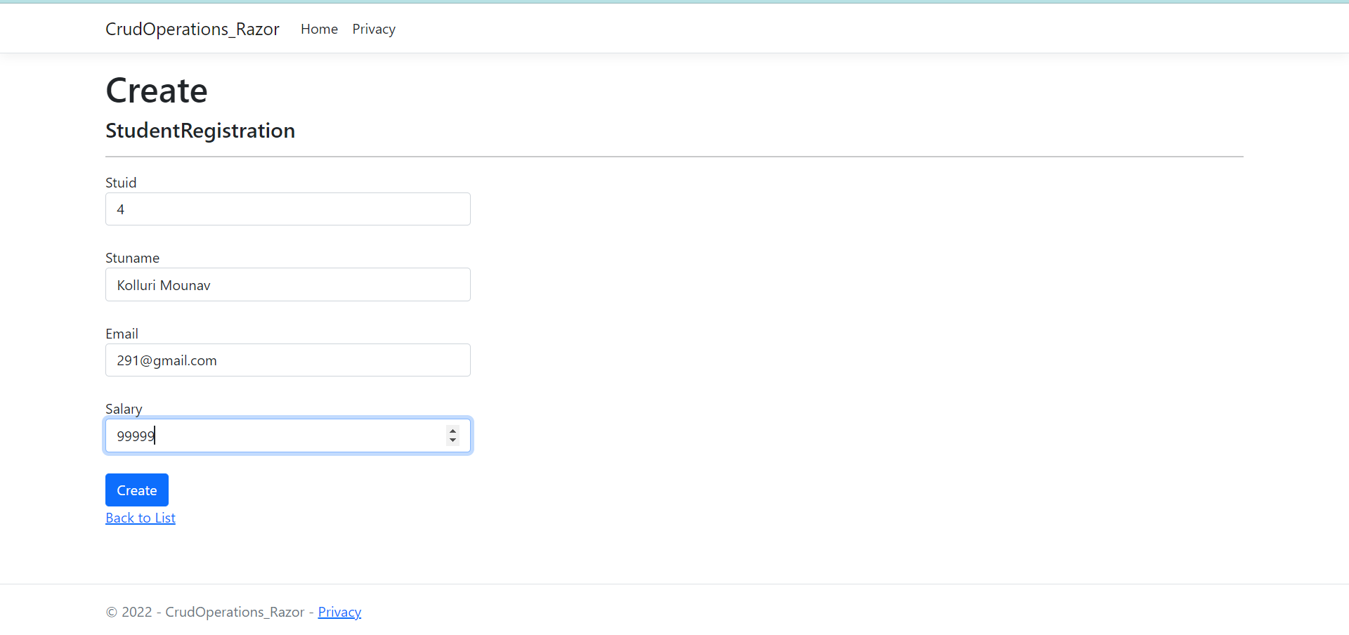

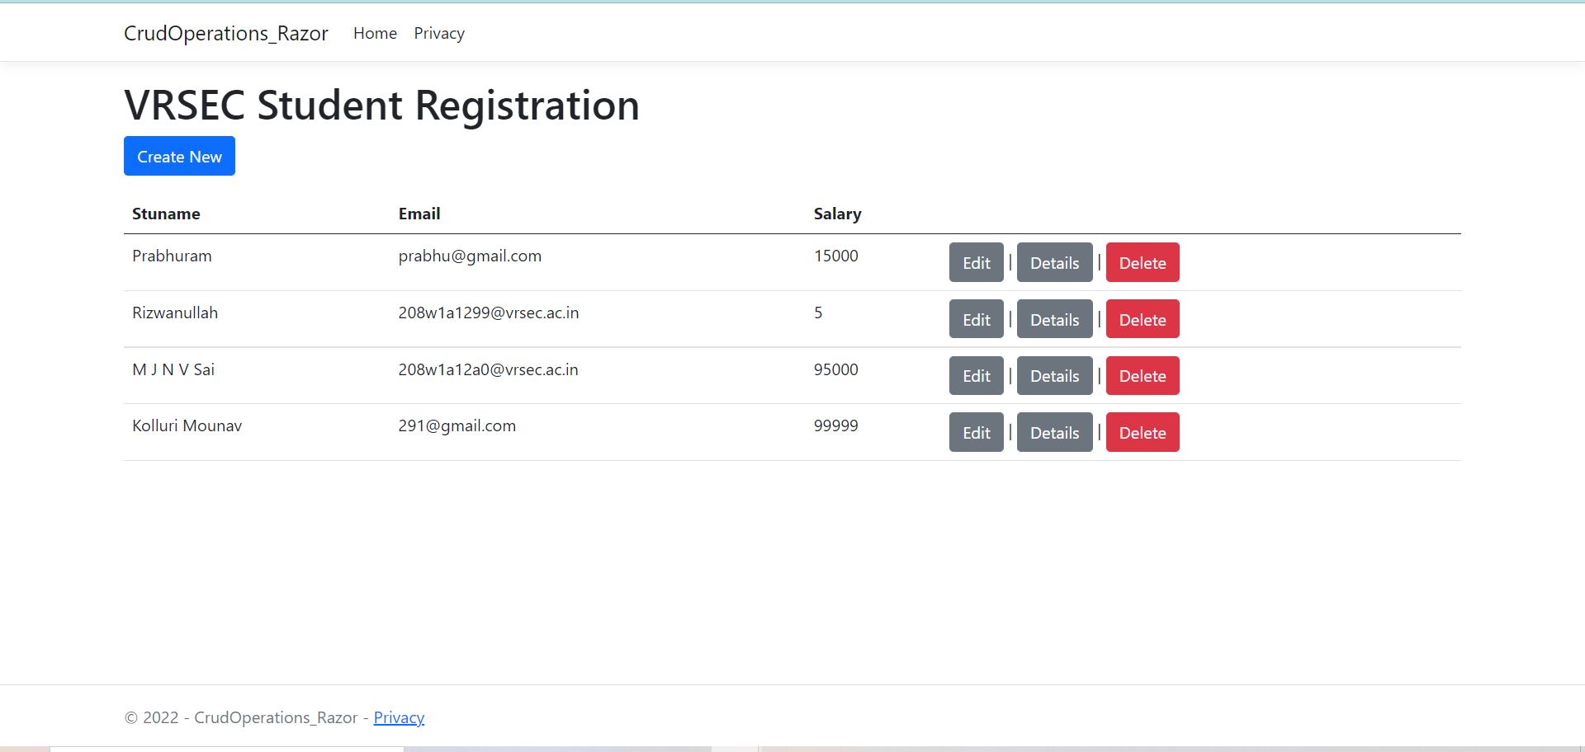

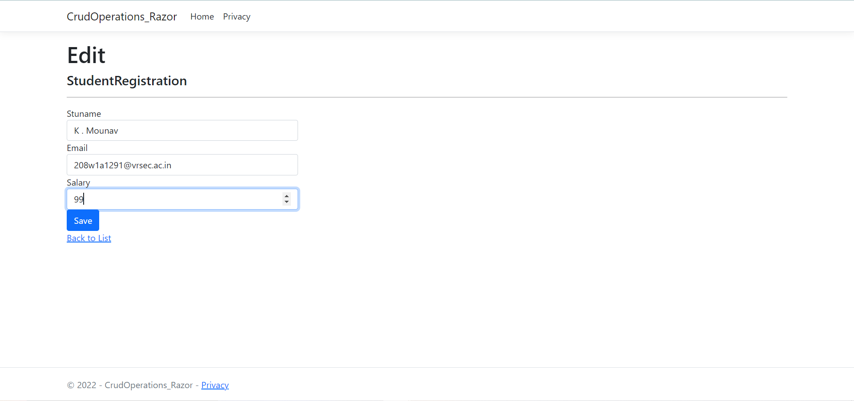

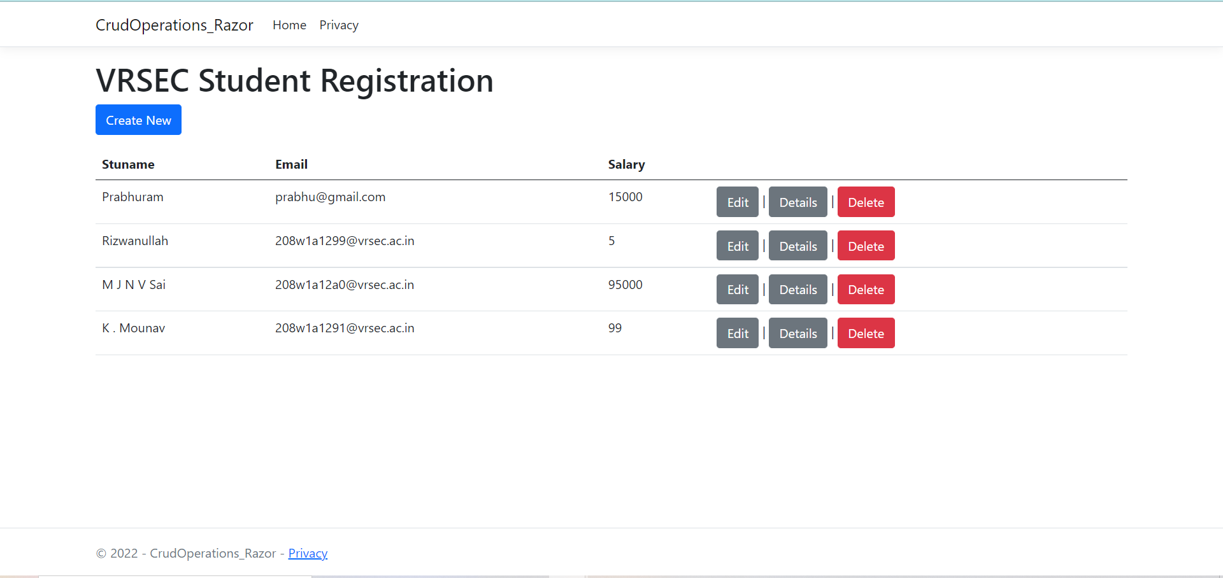

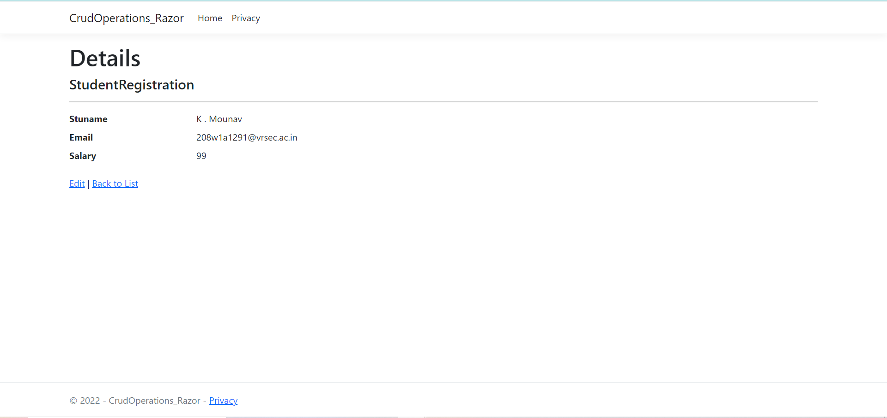

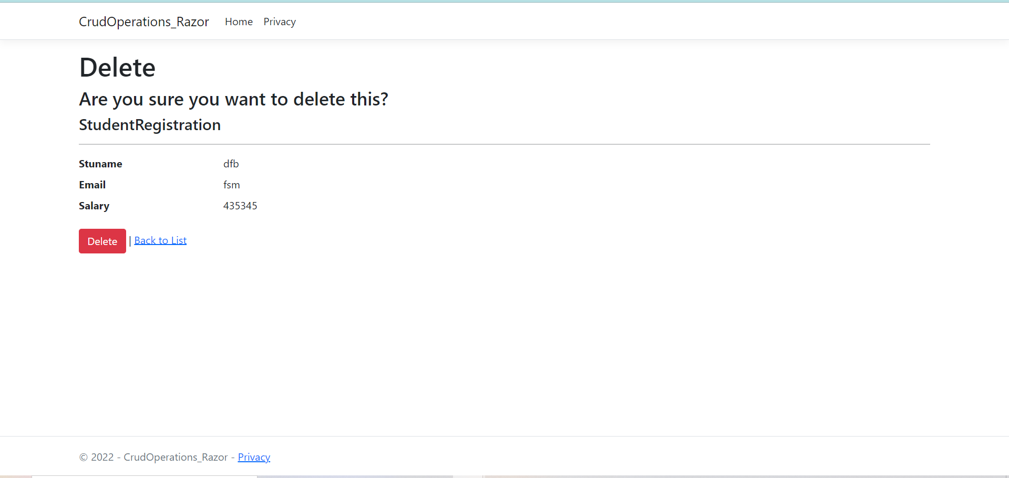

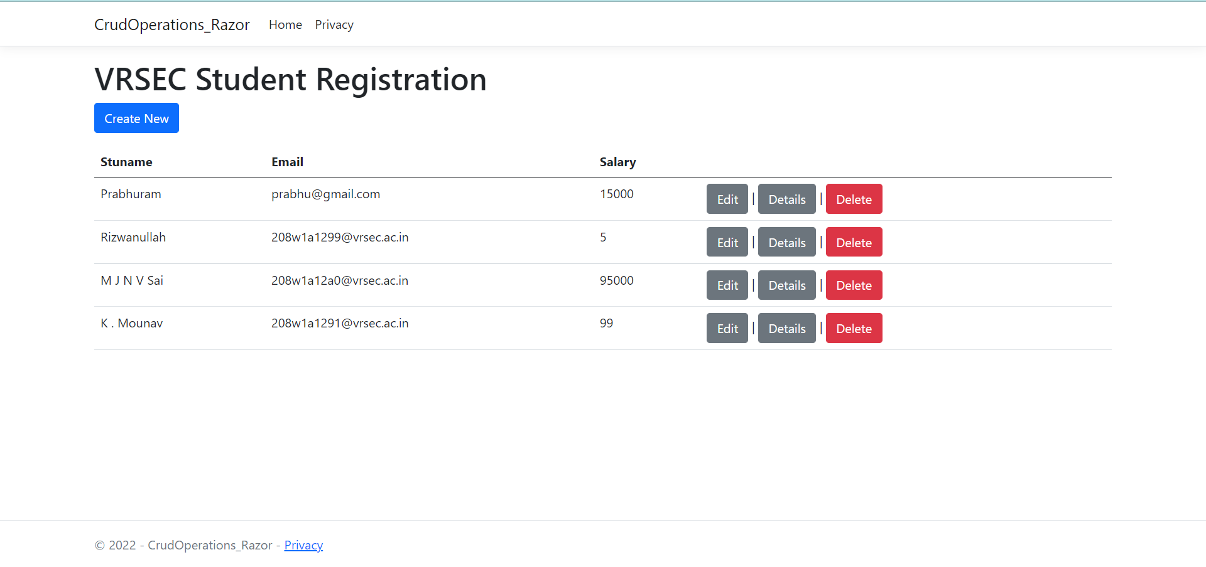

**References :**

**https://youtu.be/7960lQIYoe0**