***REPORT GENERATION ON CHEST X-RAYS USING DEEP LEARNING***

**Motamarri Jaya Naga Venkata Sai1,** [**sai.doc.45@gmail.com1**](mailto:sai.doc.45@gmail.com1)

**Panitini Monica2,** [**panitinimonica2002@gmail.com2**](mailto:panitinimonica2002@gmail.com2)

**Vemulapalli Saiesh3,** [**saieshvemulapalli07@gmail.com3**](mailto:saieshvemulapalli07@gmail.com3)

**Dr.M. Ashok Kumar4,** [**ashokkumar.munnangi@gmail.com4**](mailto:ashokkumar.munnangi@gmail.com4)

1STUDENT, Department of Information Technology, Velagapudi Ramakrishna Siddhartha Engineering College, Vijayawada, AP, INDIA

2STUDENT, Department of Information Technology, Velagapudi Ramakrishna Siddhartha Engineering College, Vijayawada, AP, INDIA

3STUDENT, Department of Information Technology, Velagapudi Ramakrishna Siddhartha Engineering College, Vijayawada, AP, INDIA

4Associate Professor, Department of Information Technology, Velagapudi Ramakrishna Siddhartha Engineering College, Vijayawada, AP, INDIA

***Abstract—* The chest x-ray is used to perform diagnostic x-ray examination. To examine the x-rays, it is the duty of radiologist to conclude these x-rays so that to give appropriate treatment. It takes often time-consuming to get detailed medical reports from these x-rays. A chest x-ray produces images of heart, lungs, airways and the bones of the spine and chest. In population countries, a radiologist may come across 1000s of x-ray images. This project aims to present a compilation of the most outstanding deep learning strategies focused on the automatic generation of medical reports from X-Ray images. To handle this challenging problem, deep learning algorithms have been included with models, to get accurate results. So if a properly learned deep learning model can automatically generate these medical reports, considerable work and time can be saved. In this project an Encoder and decoder with attention model is used to generate the text report and pretrained CheXnet model is used to obtain the image features. The generated text report is evaluated by BLEU score.**

**Keywords: Chest x-rays, Radiologist, Encoder, Decoder, Attention, BLEU, Chexnet**

1. INTRODUCTION

This chapter summarizes the project's goal, origins, and applications. It also explains the project's need and scope, as well as the project's roadblocks, which provides useful information. The specifics of how and where the project can be used 1. Origin of the problem: Image captioning is one of the most important and challenging tasks in deep learning. It is the process of generating textual information of an image. From the images, we can come up with a caption or description. This is the main idea behind the project And so far many deep learning models are achieved to perform this task. The model get trained and can understands the contexts of the image and generates the corresponding textual description.

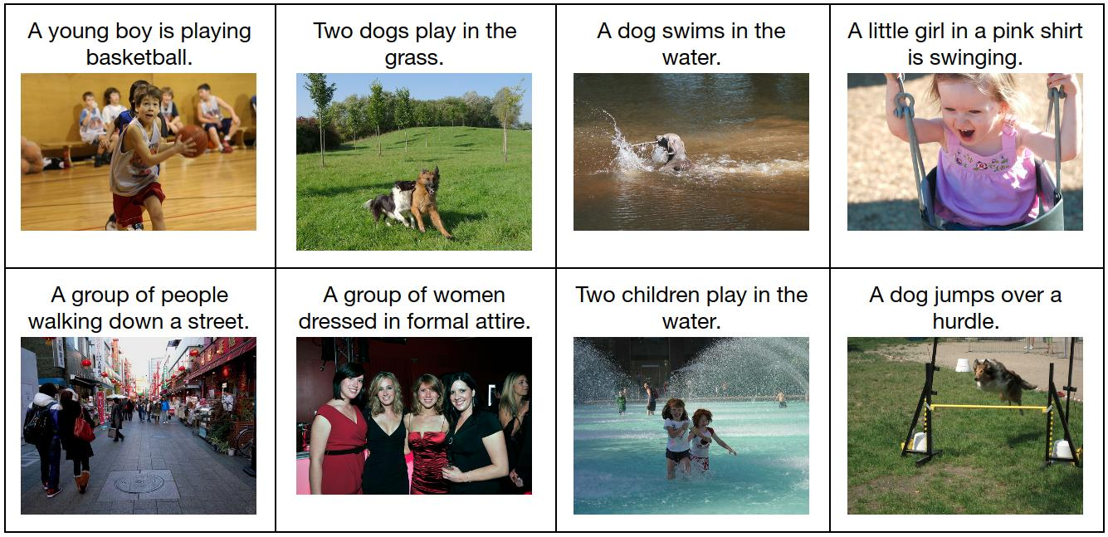

Fig.1 Image Captioning

For example The applications of image captioning include Google Image search, medical report generation, etc.

Image captioning is very helpful in medical field where the nessacity of radiologist is to describe medical report X-ray images. Summarizing the X-ray in a form of radiology report is a complex task and it is very difficult to generate the medical reports. The radiology report is a complete study of x-ray images describing normal and abnormal conditions which helps to make the right decission model. Which makes the right decision to take proper medication.