**Designing a built-in web server in GO Programming Language**

*PROJECT REPORT*

*Submitted by*

**P.Latha Sri (218W5A1209)**

*Under the Guidance of*

**M . Ramesh**

**Assistant Professor**

*For the award of the degree*

**BACHELOR OF TECHNOLOGY**

**IN**

**INFORMATION TECHNOLOGY**

**DEPARTMENT OF INFORMATION TECHNOLOGY**

**V R SIDDHARTHA ENGINEERING COLLEGE**

**(AUTONOMOUS - AFFILIATED TO JNTU-K, KAKINADA)**

**Approved by AICTE &Accredited by NBA**

**KANURU, VIJAYAWADA-7 ACADEMIC YEAR**

**(2022-23)**

### ACKNOWLEDGEMENT

First and foremost, I sincerely salute our esteemed institution **V.R SIDDHARTHA ENGINEERING COLLEGE** for giving me this opportunity for fulfilling my project. I am grateful to our principal **Dr. A.V.RATNA PRASAD**, for his encouragement and support all through the way of my project.

On the submission of this Project report, I would like to extend my honor to **Dr.M. Suneetha**, Head of the Department, IT for her constant motivation and support during the course of my work.

I feel glad to express my deep sense of gratitude to my project guide **Dr.M.Ramesh, Assistant Professor** for his guidance and assistance in completing this project successfully.

I would also like to convey my sincere indebtedness to all faculty members, including supporting staff of the Department, friends and family members who bestowed their great effort and guidance at appropriate times without which it would have been very difficult on my part to finish the project work.

**Introduction :**

Go is an open-source, statically typed,  and compiled programming language designed by Rob Pike, Robert Griesemer, and Ken Thompson. The language, that appeared in the market in 2009, was designed with an intention to enhance programming productivity in the era of networked machines, multicore, and huge codebases. Something for which the Google team picked the best characteristics of the popular languages, like:

* Static typing and runtime efficiency of C++.
* Usability and Readability of Python and JavaScript.
* Object Oriented Programming (OOPs) concept ofSmalltalk.
* Concurrency element of Newsqueak.

**Features of GO:**

### 1. Open-Source

The foremost characteristic of Golang programming language is that it is open-source. That means, anyone can download and experiment with the code to bring better codes into picture and fix related bugs.

### 2. Static Typing

Go is a statically typed programming language and works with a mechanism that makes it possible to compile code accurately while taking care of type conversions and compatibility level. This gives developers freedom from challenges associated with dynamically typed languages.

### 3. Concurrency Support

One of the prime characteristics of go programming language is its concurrency support.

Golang, unlike other programming languages, offers easier and trackable concurrency options. This makes it easier for app developers to complete requests at a faster pace, free up allocated resources and network earlier, and much more.

### 4. Powerful Standard Library and Tool Set

This programming language also comes loaded with a robust standard library. This libraries offer ample components that gives developers an escape from turning towards third party packages anymore.

Also, it offers a wider range of tools that makes [development process](https://appinventiv.com/blog/mobile-app-development-process/) efficient. This includes:

* **Gofmt:** It automatically formats your Go code, which eventually brings a major impact on readability.
* **Gorun:** This tool is used to add a ‘bang line’ in the source code to run it, or run a similar sode code file explicitly. It is often used by Go developers when experimenting with codes written in Python.
* **Goget:** The Goget tool downloads libraries from GitHub and save it to your GoPath so that you can easily import the libraries in your app project.
* **Godoc:** The tool parses Go source code, including comments and creates a documentation in HTML or plain text format. The documentation made is tightly coupled with codes it documents and can be easily navigated with one click.

### 5. Testing Capabilities

Go language also offers an opportunity to write unit tests along with writing the app codes. Besides, it avails support to understand code coverage, benchmark tests, and write example codes to create your own code documentation.

**ABSTRACT :**

Go is a great language for creating simple yet efficient web servers and web services. It provides a built-in HTTP package that contains utilities for quickly creating a web or file server.

The goal of this tutorial is to create a web server that can accept a GET request and serve a response. We’ll use the server to serve static files, acting as a file server. We’ll then make the web server respond to a POST request coming from a form submission

## **Setup**

You’ll need Go version 1.11 or higher to follow this tutorial.

Create the following files index. And about.

**SOFTWARE REQUIRMENTS OF THE PROJECT :**

Any editor like Notepad and Visual Studio Code,

**VS CODE**

Visual Studio Code is a source-code editor that can be used with a variety of programming languages, including C#, Java, JavaScript, Go, Node.js, Python, C++, C, Rust and Fortran. It is based on the Electron framework,[20] which is used to develop Node.js web applications that run on the Blink layout engine. Visual Studio Code employs the same editor component (code named "Monaco") used in Azure DevOps (formerly called Visual Studio Online and Visual Studio Team Services). Out of the box, Visual Studio Code includes basic support for most common programming languages. This basic support includes syntax highlighting, bracket matching, code folding, and configurable snippets. Visual Studio Code also ships with IntelliSense for JavaScript, TypeScript, JSON, CSS, and HTML, as well as debugging support for Node.js. Support for additional languages can be provided by freely available extensions on the VS Code Marketplace.

**CODE :**

package main  
import("fmt"  
"net/http")  
func index_handler(w http.ResponseWriter, r *http.Request){  
fmt.Fprintf(w,"Whoa, Go is neat!")  
}  
func about_handler(w http.ResponseWriter, r *http.Request){  
fmt.Fprintf(w,"Expert web design by Sentdex")  
}  
  
  
func main(){  
http.HandleFunc("/",index_handler)  
http.HandleFunc("/about/",about_handler)  
http.ListenAndServe(":8000",nil)  
}

**OUTPUT:**

**Running the application**

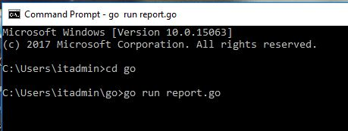

**Give the permissions to access your system**

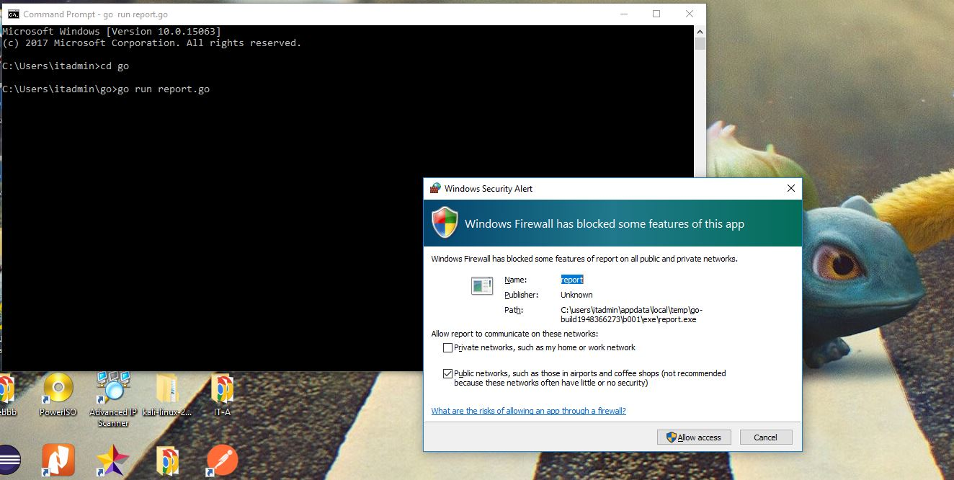

**Port 8000 was used to retrive:**

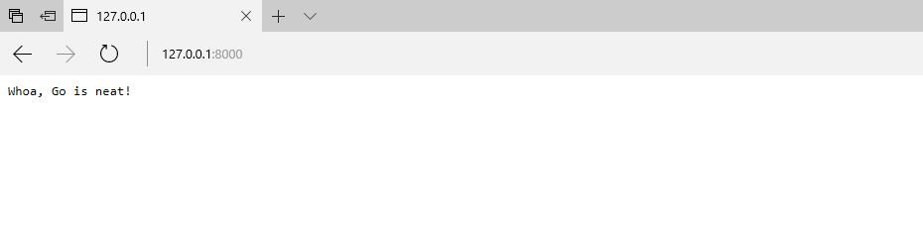

**Using Index:**

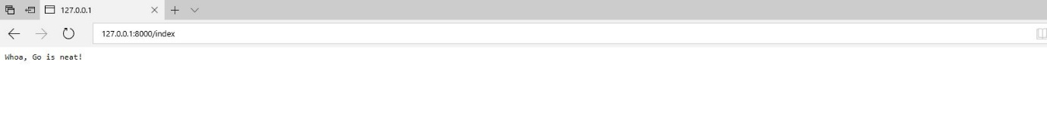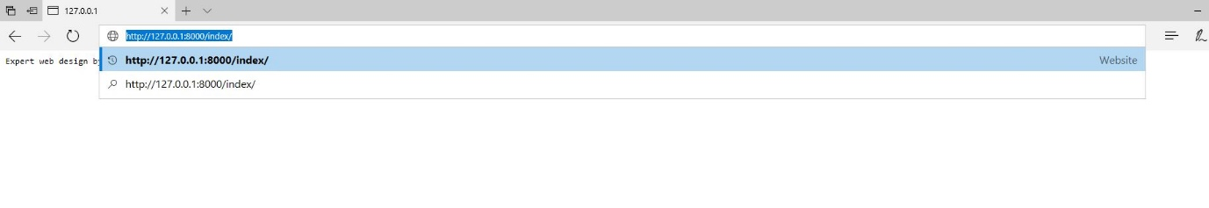

**Using about:**

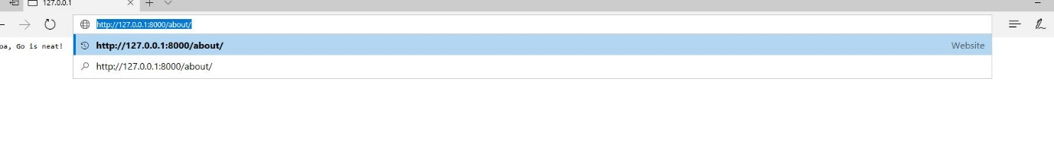

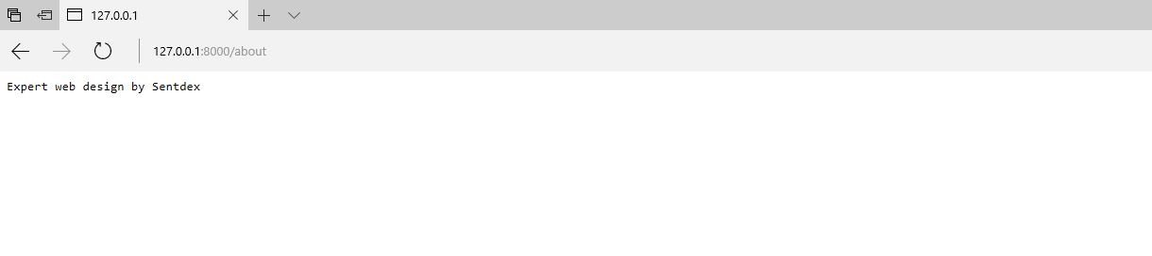

**Conclusion :**

In this project we learn the creating a built-in web server task. But with the help of some basic knowledge of GO programming we can create a basic application for user and it will help them to to build a web server in any place easily.