**VELAGAPUDI RAMAKRISHNA SIDDHARTHA**

**ENGINEERING COLLEGE**

**(** AUTONOMOUS **)**



Statistics with R language

HOME – ASSIGNMENT - 2

**Submitted To :** **Submitted By :**

Ch. Nanda Krishna 208W1A1296

208W1A1297

208W1A1298

208W1A1299

208W1A12A0

**UNIT – 3**

**10)** Formula for poisson Distribution

A) The Formula for poisson Distribution is

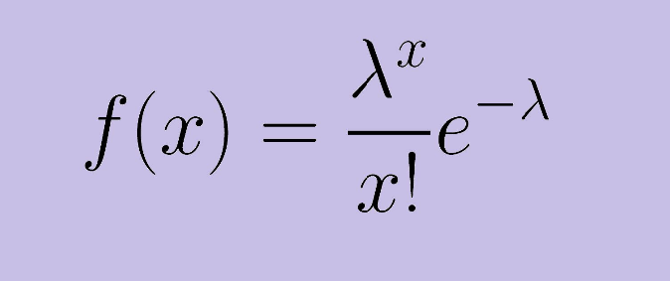

Where,

Mean = varience = lambda

This distribution is used to count the data

**11)**  What is the use of rpois( ) ?

A) rpois( ) is an inbuilt function in the r studio where this function is

Used to generate the random numbers in the poisson -

Distribution .

**Syntax :**

rpois(n = value, lambda = value)

**12)** what is the use of summary( ) ?

A) summary( ) is also an inbuilt function in the r studio where this

Function is used to take an vector as an input and gives the

Multiple results as the output the multiple results are the

Minimum value, 1st quartile value, mean value, median value,

3rd quartile value, maximum value

And It also reduses the calculation time of a function

Independently also.

**Syntax :**

summary(vector name)

**13)** what is the use of quantile( ) ?

A) Quantiles are numbers in a set where a certain percentage of the numbers are smaller than the quantile. For instance, of the numbers one through 200, the 75th quantile the number that is larger than 75% of the numbers is 150.25

Ex : quantile(x, probs = c(0.25, 0.75))

Where, x is a vector and 0.25 and 0.75 are the probability values then it will give the 25% and 75% quantile values of the that vector

**14)**  Difference between cor( ) and cov( )

|  |  |
| --- | --- |
| **Correlation** | **Covariance** |
| Correlation is a measure used to represent how strongly two random variables are related to each other. | Covariance is a measure to indicate the extent to which two random variables change in tandem. |
| Correlation refers to the scaled form of covariance. | Covariance is nothing but a measure of correlation. |
| Correlation on the other hand measures both the strength and direction of the linear relationship between two variables. | Covariance indicates the direction of the linear relationship between variables. |
| Correlation ranges between -1 and +1 | Covariance can vary between -∞ and +∞ |
| Correlation is not influenced by the change in scale. | Covariance is affected by the change in scale. |
| Correlation is dimensionless, i.e. It’s a unit-free measure of the relationship between variables. | Covariance assumes the units from the product of the units of the two variables |
| Rcode :  cor(vector 1, vector 2) | Rcode :  cov(vector 1, vector 2) |

A)

**15)** what is the use of one – sample T – test( ) and syntax ?

A) when population varience is unknown then we go for the t tests

A one sample t test is the mean of a single group against a

Known mean of the data.

**Syntax :**

t.test(tips$tip,alternative=“two.sided”, mu=2.5)

**16)** What is the use of two – sample t – test( ) and syntax ?

A) the two sample t – test() is also known as independent samples

T – test .

It is a method to test whether the unknown population means are

Equal or not equal.

**Syntax :**

t.test(tip~sex, data=tips, var.equal=TRUE)

**17)**  What is the use of paired two sample t – test() and syntax ?

A) the paired two sample t test is also known as dependent

Sample test.

It is used to determine the whether mean difference between

Two sets of observations is zero.

**Syntax :**

t.test(father.son$fheight, father.son$sheight, paired=TRUE)

**18)** What is full form of ANOVA and it’s use ?

A) ANOVA 🡺 analysis of the varience

It determines whether three or more populations are statistically

Different from each other is known as anova.

**Formula :**

