**Velagapudi Ramakrishna Siddhartha**

**Engineering College**

**Kanuru, 520001**



**ADVANCE PROGRAMMING LAB - III**

**Code : 20IT6353**

**WEEK – 1**

**Aim :** Implement and validate the Stack Sequences.

**Program :**

class Solution:

def validateStackSequences(self, pushed: List[int], popped: List[int]) -> bool:

stack=[]

for i in pushed:

stack.append(i)

while stack and popped and stack[-1] == popped[0]: # stack top

stack.pop()

popped.pop(0)

return not stack

**Output :**

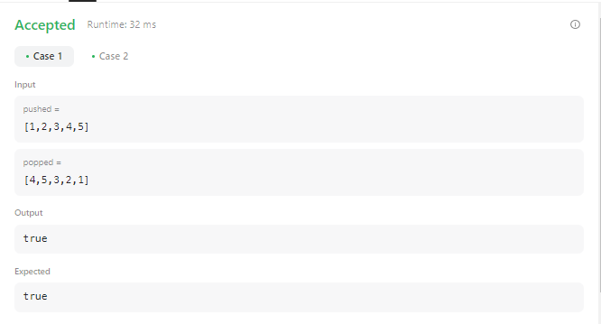

**Result :** Sucessfully Executed the Program.

**Aim :** There are a number of plants in a garden. Each of the plants has been treated with some amount of pesticide. After each day, if any plant has more pesticide than the plant on its left, being weaker than the left one, it dies.

You are given the initial values of the pesticide in each of the plants. Determine the number of days after which no plant dies, i.e. the time after which there is no plant with more pesticide content than the plant to its left.

**Program :**

import math

import os

import random

import re

import sys

def poisonousPlants(p):

stack = []

max_days = 0

for i in range(len(p)-1, -1, -1):

kills = 0

while (len(stack) > 0) and stack[-1][0] > p[i]:

kills = max(kills + 1, stack.pop()[1])

max_days = max(max_days, kills)

stack.append((p[i], kills))

return max_days

if __name__ == '__main__':

fptr = open(os.environ['OUTPUT_PATH'], 'w')

n = int(input().strip())

p = list(map(int, input().rstrip().split()))

result = poisonousPlants(p)

fptr.write(str(result) + '\n')

fptr.close()

**Output :**

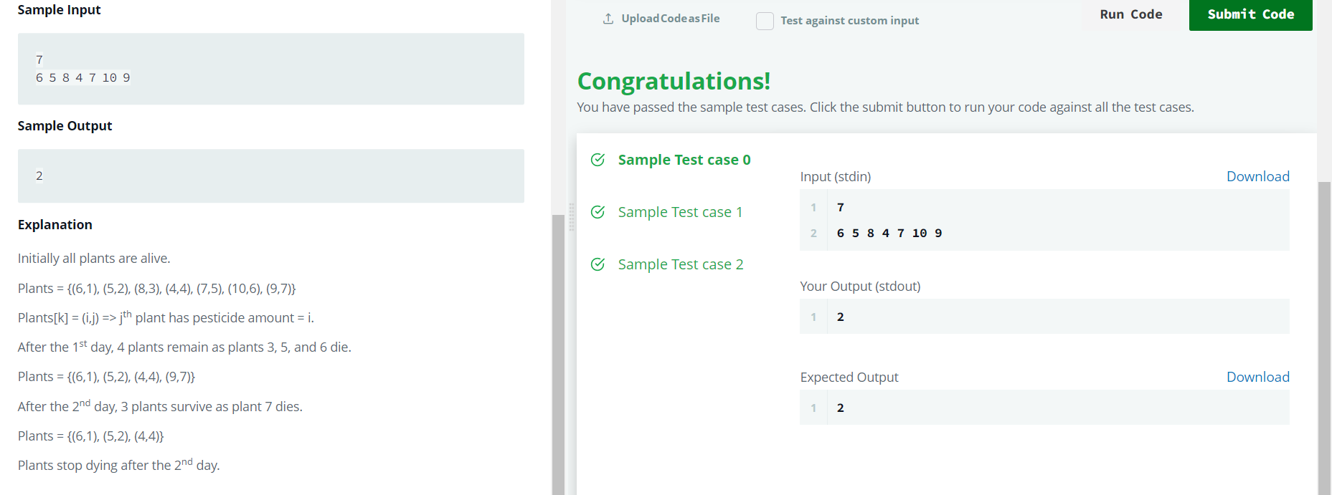

**Result :** Sucessfully Executed the Program

**Week – 2**

**Aim :** implement Stacks using Queues.

**Program :**

from collections import deque

class MyStack:

def __init__(self):

self.queue1 = deque()

self.queue2 = deque()

def push(self, x: int) -> None:

self.queue1.append(x)

def pop(self) -> int:

while len(self.queue1) > 1:

self.queue2.append(self.queue1.popleft())

item = self.queue1.popleft()

self.queue1, self.queue2 = self.queue2, self.queue1

return item

def top(self) -> int:

while len(self.queue1) > 1:

self.queue2.append(self.queue1.popleft())

item = self.queue1.popleft()

self.queue2.append(item)

self.queue1, self.queue2 = self.queue2, self.queue1

return item

def empty(self) -> bool:

return len(self.queue1) == 0

**Output :**

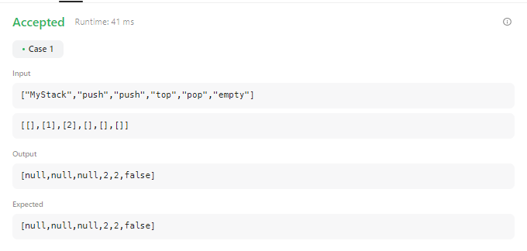

**Result :** Sucessfully Executed The Program.

**Aim :** Implement Circular Queue using OOPS Concepts.

**Program :**

class MyCircularQueue:

def __init__(self, k: int):

self.queue = [None] * k

self.head = 0

self.tail = 0

self.size = 0

self.capacity = k

def enQueue(self, value: int) -> bool:

if self.isFull():

return False

self.queue[self.tail] = value

self.tail = (self.tail + 1) % self.capacity

self.size += 1

return True

def deQueue(self) -> bool:

if self.isEmpty():

return False

self.head = (self.head + 1) % self.capacity

self.size -= 1

return True

def Front(self) -> int:

if self.isEmpty():

return -1

return self.queue[self.head]

def Rear(self) -> int:

if self.isEmpty():

return -1

return self.queue[(self.tail - 1 + self.capacity) % self.capacity]

def isEmpty(self) -> bool:

return self.size == 0

def isFull(self) -> bool:

return self.size == self.capacity

**Output :**

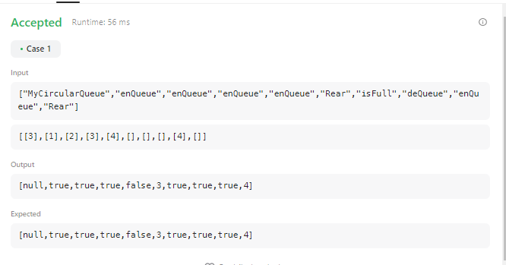

**Result :** Sucessfully Executed The Program.

**WEEK – 3**

**Aim :** Given pointers to the head nodes of linked lists that merge together at some point, find the node where the two lists merge. The merge point is where both lists point to the same node, i.e. they reference the same memory location. It is guaranteed that the two head nodes will be different, and neither will be NULL. If the lists share a common node, return that node's data value.

Note: After the merge point, both lists will share the same node pointers.

**Example :**

In the diagram below, the two lists converge at Node x:

[List #1] a--->b--->c

\

x--->y--->z--->NULL

/

[List #2] p--->q

**Program :**

import math

import os

import random

import re

import sys

class SinglyLinkedListNode:

def __init__(self, node_data):

self.data = node_data

self.next = None

class SinglyLinkedList:

def __init__(self):

self.head = None

self.tail = None

def insert_node(self, node_data):

node = SinglyLinkedListNode(node_data)

if not self.head:

self.head = node

else:

self.tail.next = node

self.tail = node

def print_singly_linked_list(node, sep, fptr):

while node:

fptr.write(str(node.data))

node = node.next

if node:

fptr.write(sep)

def findMergeNode(head1, head2):

li=[]

while head1 :

li.append(head1)

head1=head1.next

temp=head2

while head2:

if head2 in li:

return head2.data

head2=head2.next

if __name__ == '__main__':

fptr = open(os.environ['OUTPUT_PATH'], 'w')

tests = int(input())

for tests_itr in range(tests):

index = int(input())

llist1_count = int(input())

llist1 = SinglyLinkedList()

for _ in range(llist1_count):

llist1_item = int(input())

llist1.insert_node(llist1_item)

llist2_count = int(input())

llist2 = SinglyLinkedList()

for _ in range(llist2_count):

llist2_item = int(input())

llist2.insert_node(llist2_item)

ptr1 = llist1.head;

ptr2 = llist2.head;

for i in range(llist1_count):

if i < index:

ptr1 = ptr1.next

for i in range(llist2_count):

if i != llist2_count-1:

ptr2 = ptr2.next

ptr2.next = ptr1

result = findMergeNode(llist1.head, llist2.head)

fptr.write(str(result) + '\n')

fptr.close()

**Output :**

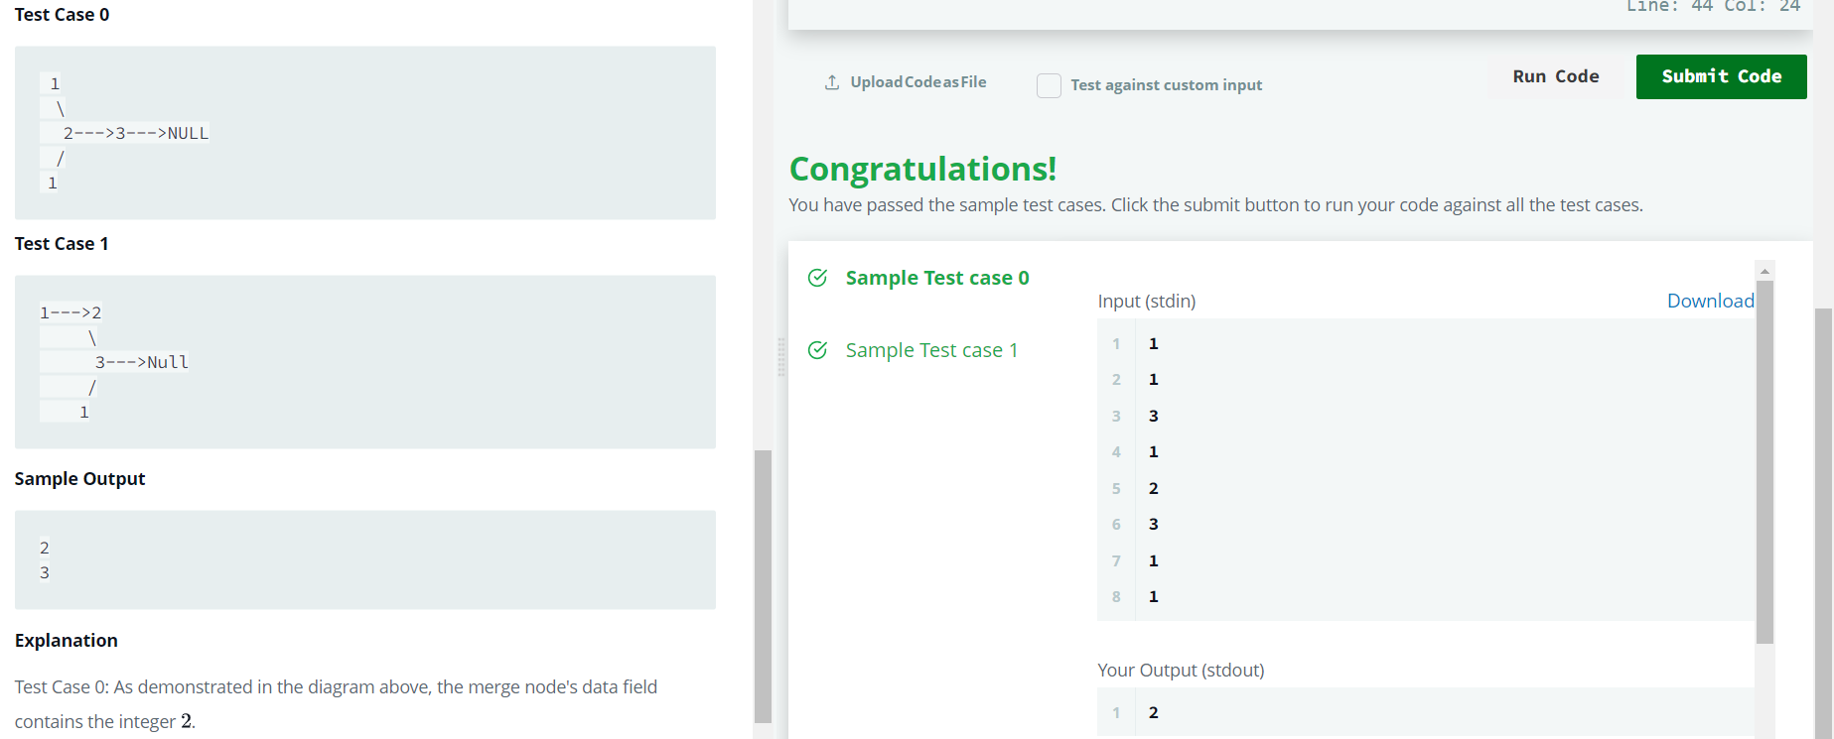

**Result :** Sucessfully Executed The Program.

**Aim :** Given pointers to the heads of two sorted linked lists, merge them into a single, sorted linked list. Either head pointer may be null meaning that the corresponding list is empty.

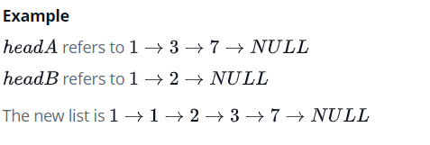

**Program :**

import math

import os

import random

import re

import sys

class SinglyLinkedListNode:

def __init__(self, node_data):

self.data = node_data

self.next = None

class SinglyLinkedList:

def __init__(self):

self.head = None

self.tail = None

def insert_node(self, node_data):

node = SinglyLinkedListNode(node_data)

if not self.head:

self.head = node

else:

self.tail.next = node

self.tail = node

def print_singly_linked_list(node, sep, fptr):

while node:

fptr.write(str(node.data))

node = node.next

if node:

fptr.write(sep)

def mergeLists(head1, head2):

li=[]

temp1=head1

temp2=head2

while temp1 is not None:

li.append(temp1.data)

temp1=temp1.next

while temp2 is not None:

li.append(temp2.data)

temp2=temp2.next

li.sort()

ll=SinglyLinkedList()

for i in range(0,len(li)):

ll.insert_node(li[i])

return ll.head

if __name__ == '__main__':

fptr = open(os.environ['OUTPUT_PATH'], 'w')

tests = int(input())

for tests_itr in range(tests):

llist1_count = int(input())

llist1 = SinglyLinkedList()

for _ in range(llist1_count):

llist1_item = int(input())

llist1.insert_node(llist1_item)

llist2_count = int(input())

llist2 = SinglyLinkedList()

for _ in range(llist2_count):

llist2_item = int(input())

llist2.insert_node(llist2_item)

llist3 = mergeLists(llist1.head, llist2.head)

print_singly_linked_list(llist3, ' ', fptr)

fptr.write('\n')

fptr.close()

**Output :**

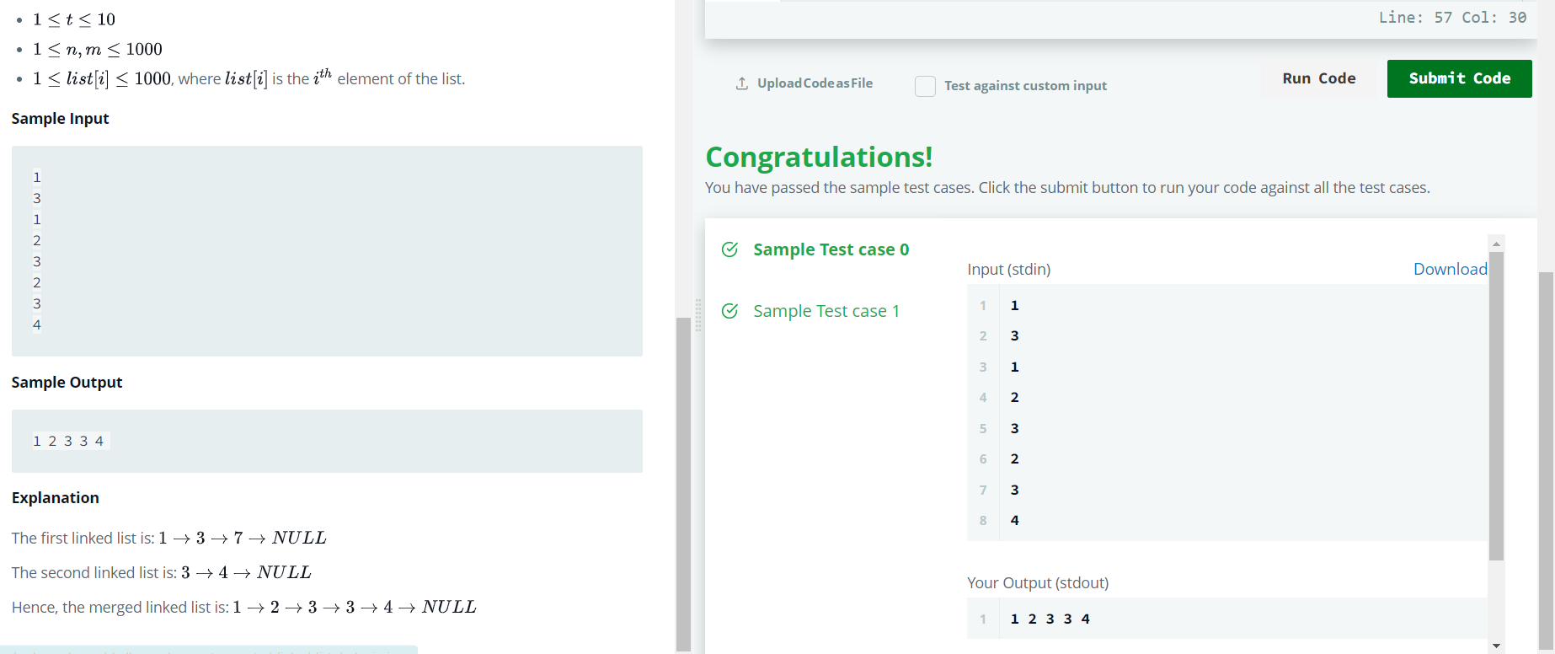

**Result :** Sucessfully Executed The Program .

**WEEK – 4**

**Aim :** Given the pointer to the head node of a doubly linked list, reverse the order of the nodes in place. That is, change the *next* and *prev* pointers of the nodes so that the direction of the list is reversed. Return a reference to the head node of the reversed list.

Note: The head node might be NULL to indicate that the list is empty.

**Function Description :**

Complete the *reverse* function in the editor below.

reverse has the following parameter(s):

* *DoublyLinkedListNode head*: a reference to the head of a DoublyLinkedList

Returns  
- *DoublyLinkedListNode*: a reference to the head of the reversed list

**Program :**

import math

import os

import random

import re

import sys

class DoublyLinkedListNode:

def __init__(self, node_data):

self.data = node_data

self.next = None

self.prev = None

class DoublyLinkedList:

def __init__(self):

self.head = None

self.tail = None

def insert_node(self, node_data):

node = DoublyLinkedListNode(node_data)

if not self.head:

self.head = node

else:

self.tail.next = node

node.prev = self.tail

self.tail = node

def print_doubly_linked_list(node, sep, fptr):

while node:

fptr.write(str(node.data))

node = node.next

if node:

fptr.write(sep)

def reverse(llist):

# Write your code here

head = llist

while llist:

curr = llist.prev

llist.prev = llist.next

llist.next = curr

head = llist

llist = llist.prev

return head

if __name__ == '__main__':

fptr = open(os.environ['OUTPUT_PATH'], 'w')

t = int(input())

for t_itr in range(t):

llist_count = int(input())

llist = DoublyLinkedList()

for _ in range(llist_count):

llist_item = int(input())

llist.insert_node(llist_item)

llist1 = reverse(llist.head)

print_doubly_linked_list(llist1, ' ', fptr)

fptr.write('\n')

fptr.close()

**Output :**

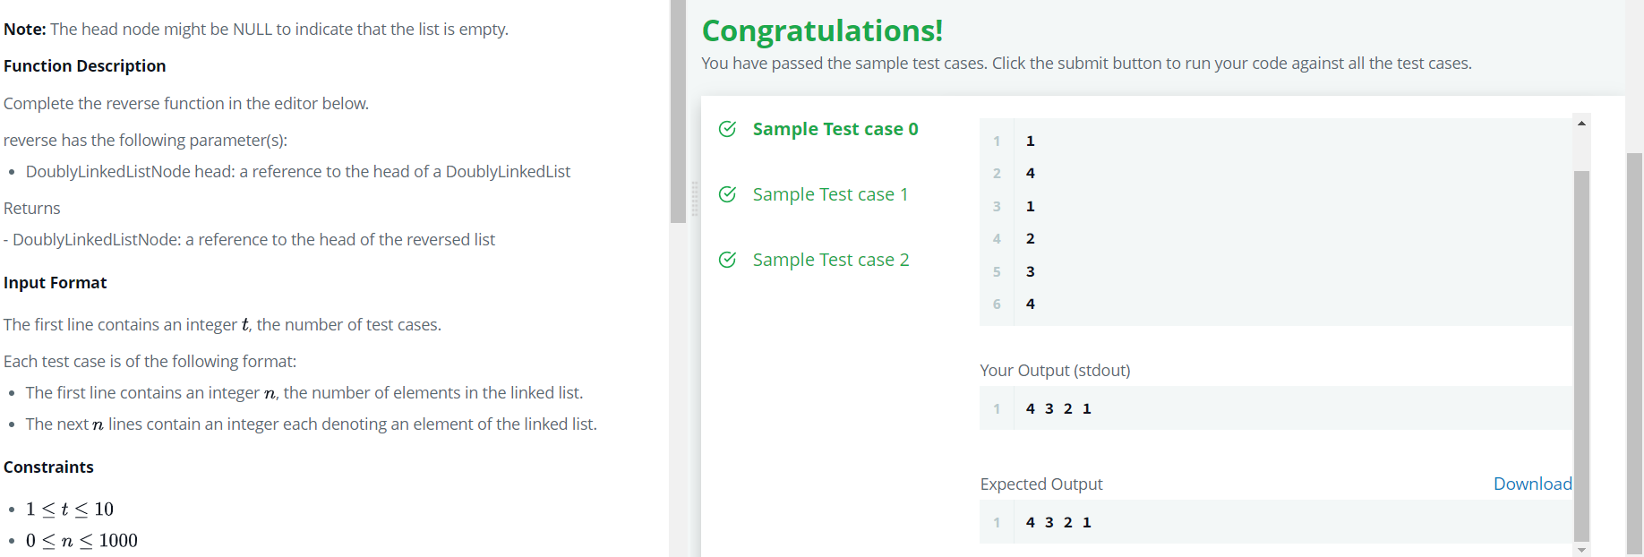

**Result :** Sucessfully Executed The Program.

**Aim :** You have a browser of one tab where you start on the homepage and you can visit another url, get back in the history number of steps or move forward in the history number of steps.

Implement the BrowserHistory class:

BrowserHistory(string homepage) Initializes the object with the homepage of the browser.

void visit(string url) Visits url from the current page. It clears up all the forward history.

string back(int steps) Move steps back in history. If you can only return x steps in the history and steps > x, you will return only x steps. Return the current url after moving back in history at most steps.

string forward(int steps) Move steps forward in history. If you can only forward x steps in the history and steps > x, you will forward only x steps. Return the current url after forwarding in history at most steps.

**Program :**

class BrowserHistory:

def __init__(self, homepage: str):

self.history = [homepage]

self.current = 0

def visit(self, url: str) -> None:

self.history = self.history[:self.current+1] + [url]

self.current += 1

def back(self, steps: int) -> str:

self.current = max(0, self.current - steps)

return self.history[self.current]

def forward(self, steps: int) -> str:

self.current = min(len(self.history)-1, self.current + steps)

return self.history[self.current]

# Your BrowserHistory object will be instantiated and called as such:

# obj = BrowserHistory(homepage)

# obj.visit(url)

# param_2 = obj.back(steps)

# param_3 = obj.forward(steps)

**Output :**

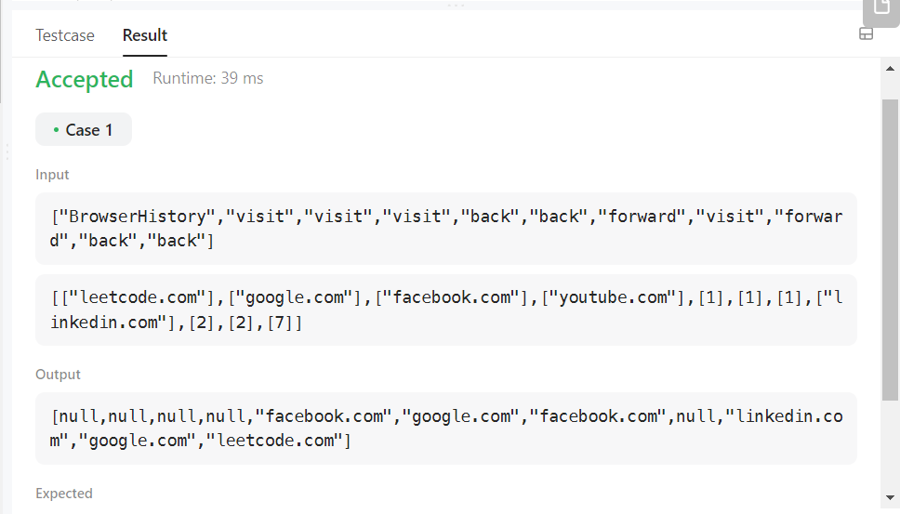

**Result :** Sucessfully Executed The Program .

**WEEK – 5**

**Aim :** Implement Symmentric Tree

**Program :**

class Solution:

def isSymmetric(self, root):

if root is None:

return True

else:

return self.isMirror(root.left, root.right)

def isMirror(self, left, right):

if left is None and right is None:

return True

if left is None or right is None:

return False

if left.val == right.val:

outPair = self.isMirror(left.left, right.right)

inPiar = self.isMirror(left.right, right.left)

return outPair and inPiar

else:

return False

**Output :**

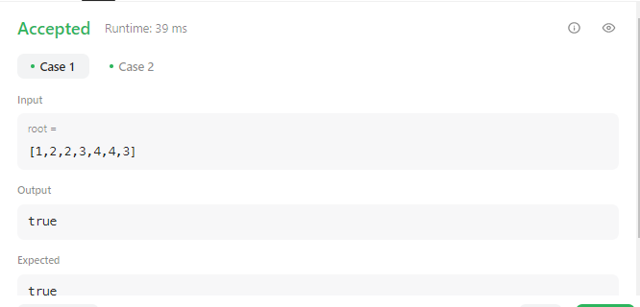

**Result :** Sucessfully Executed The Program.

**Aim :** Given the root of a binary tree, determine if it is a valid binary search tree (BST).

A valid BST is defined as follows:

The left subtree of a node contains only nodes with keys less than the node's key.

The right subtree of a node contains only nodes with keys greater than the node's key.

Both the left and right subtrees must also be binary search trees.

**Program :**

class Solution:

def isValidBST(self, root: Optional[TreeNode]) -> bool:

low, high = float("-inf"), float("inf")

def isValidbst(root, low, high):

if not root:

return True

if root.val <= high and root.val >= low:

left_sub_tree = isValidbst(root.left, low, root.val - 1)

right_sub_tree = isValidbst(root.right, root.val + 1, high)

return left_sub_tree and right_sub_tree

else:

return False

return isValidbst(root, low, high)

**Output :**

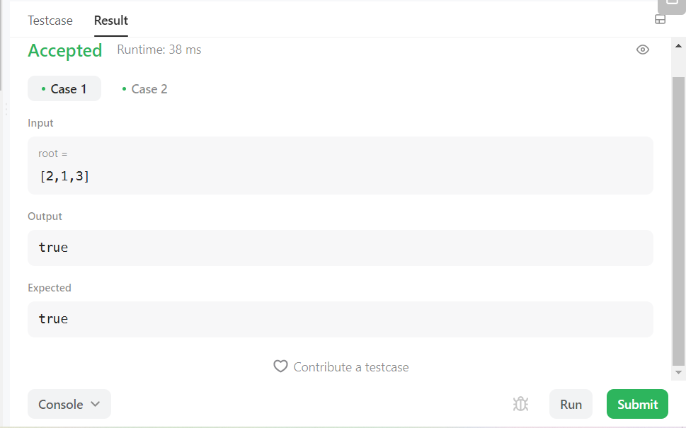

**Result :** Sucessfully Executed The Program.

**WEEK – 6**

**Aim :** Given an integer array nums where the elements are sorted in ascending order, convert it to a height-balanced binary search tree.

**Program :**

# Definition for a binary tree node.

# class TreeNode:

# def __init__(self, val=0, left=None, right=None):

# self.val = val

# self.left = left

# self.right = right

class Solution:

def sortedArrayToBST(self, nums: List[int]) -> Optional[TreeNode]:

total_nums = len(nums)

if not total_nums:

return None

mid_node = total_nums // 2

return TreeNode(

nums[mid_node],

self.sortedArrayToBST(nums[:mid_node]), self.sortedArrayToBST(nums[mid_node + 1 :])

)

**Output :**

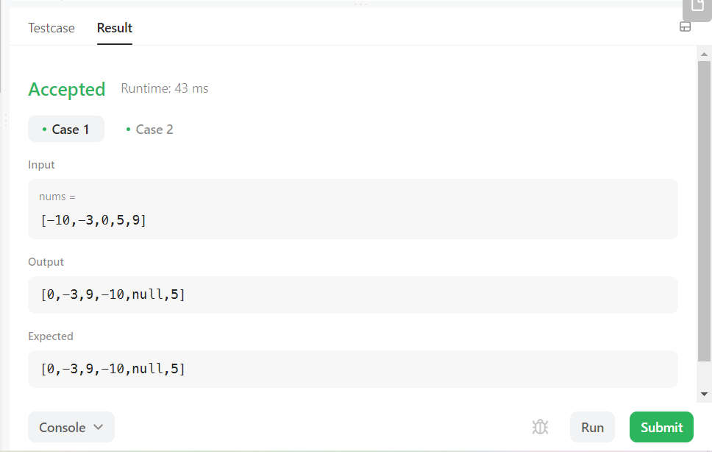

**Result :** Sucessfully Executed the Program.

**Aim :** You are given two binary trees root1 and root2.

Imagine that when you put one of them to cover the other, some nodes of the two trees are overlapped while the others are not. You need to merge the two trees into a new binary tree. The merge rule is that if two nodes overlap, then sum node values up as the new value of the merged node. Otherwise, the NOT null node will be used as the node of the new tree.

Return the merged tree.

Note: The merging process must start from the root nodes of both trees.

**Program :**

#Definition for a binary tree node.

class TreeNode:

def __init__(self, val=0, left=None, right=None):

self.val = val

self.left = left

self.right = right

class Solution:

def mergeTrees(self, root1: TreeNode, root2: TreeNode) -> TreeNode:

if not root1:

return root2

if not root2:

return root1

# merge the nodes that are overlapped

root1.val += root2.val

root1.left = self.mergeTrees(root1.left, root2.left)

root1.right = self.mergeTrees(root1.right, root2.right)

return root1

**Output :**

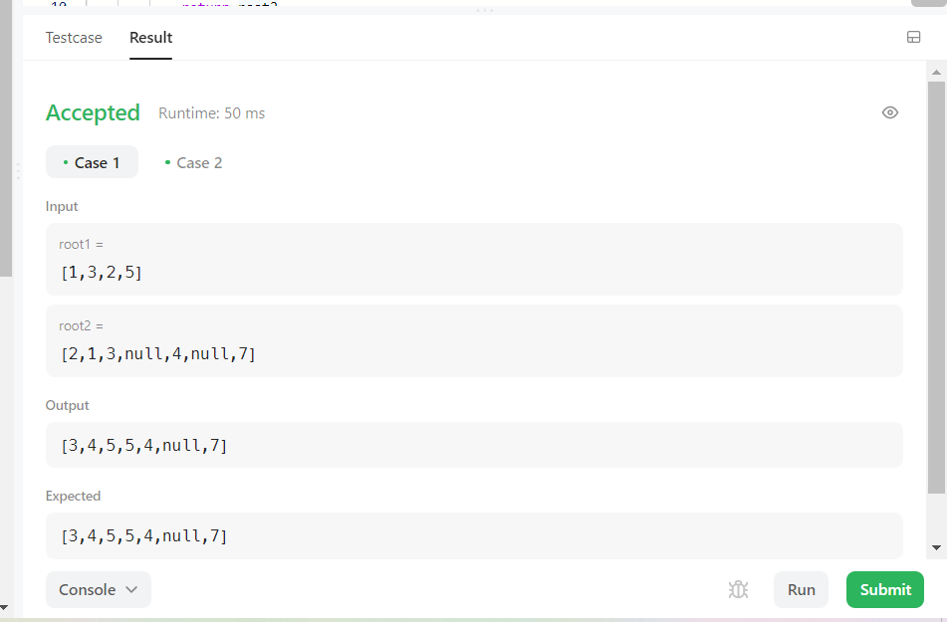

**Result :** Sucessfully Executed The Program.

**WEEK – 7**

**Aim :** You are given an array of variable pairs equations and an array of real numbers values, where equations[i] = [Ai, Bi] and values[i] represent the equation Ai / Bi = values[i]. Each Ai or Bi is a string that represents a single variable.

You are also given some queries, where queries[j] = [Cj, Dj] represents the jth query where you must find the answer for Cj / Dj = ?.

Return the answers to all queries. If a single answer cannot be determined, return -1.0.

Note: The input is always valid. You may assume that evaluating the queries will not result in division by zero and that there is no contradiction.

**Program :**

class Solution:

def calcEquation(self, equations: List[List[str]], values: List[float], queries: List[List[str]]) -> List[float]:

# Build the graph

graph = defaultdict(dict)

for i in range(len(equations)):

u, v = equations[i]

graph[u][v] = values[i]

graph[v][u] = 1 / values[i]

# Helper function to perform DFS and find the path value

def dfs(start, end, visited):

# If we have already visited this node or it doesn't exist in the graph, return -1.0

if start in visited or start not in graph:

return -1.0

# If we have reached the end node, return the path value

if start == end:

return 1.0

# Mark the current node as visited

visited.add(start)

# Traverse the neighbors and find the path value recursively

for neighbor, value in graph[start].items():

path_value = dfs(neighbor, end, visited)

# If we have found a valid path, return the product of the current value and path value

if path_value != -1.0:

return value * path_value

# If we haven't found a valid path, return -1.0

return -1.0

# Calculate the answer for each query

result = []

for query in queries:

start, end = query

# Perform DFS to find the path value

result.append(dfs(start, end, set()))

return result

**Output :**

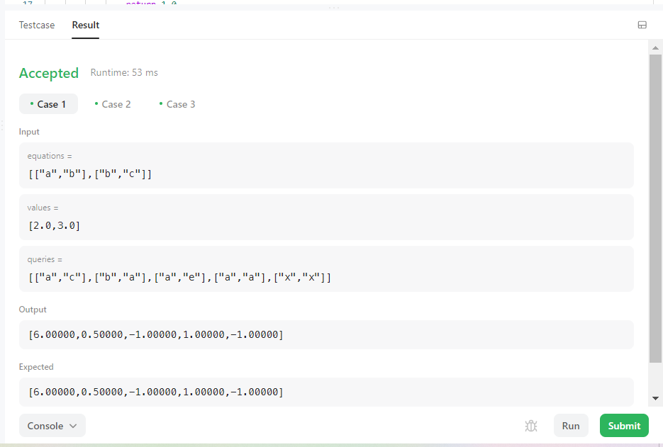

**Result :** Sucessfully Executed The program.

**Aim :** You are given a network of n nodes, labeled from 1 to n. You are also given times, a list of travel times as directed edges times[i] = (ui, vi, wi), where ui is the source node, vi is the target node, and wi is the time it takes for a signal to travel from source to target.

We will send a signal from a given node k. Return the minimum time it takes for all the n nodes to receive the signal. If it is impossible for all the n nodes to receive the signal, return -1.

**Program :**

class Solution:

def networkDelayTime(self, times: List[List[int]], n: int, k: int) -> int:

adj_list = defaultdict(list)

for x,y,w in times:

adj_list[x].append((w, y))

visited=set()

heap = [(0, k)]

while heap:

travel_time, node = heapq.heappop(heap)

visited.add(node)

if len(visited)==n:

return travel_time

for time, adjacent_node in adj_list[node]:

if adjacent_node not in visited:

heapq.heappush(heap, (travel_time+time, adjacent_node))

return -1

**Output :**

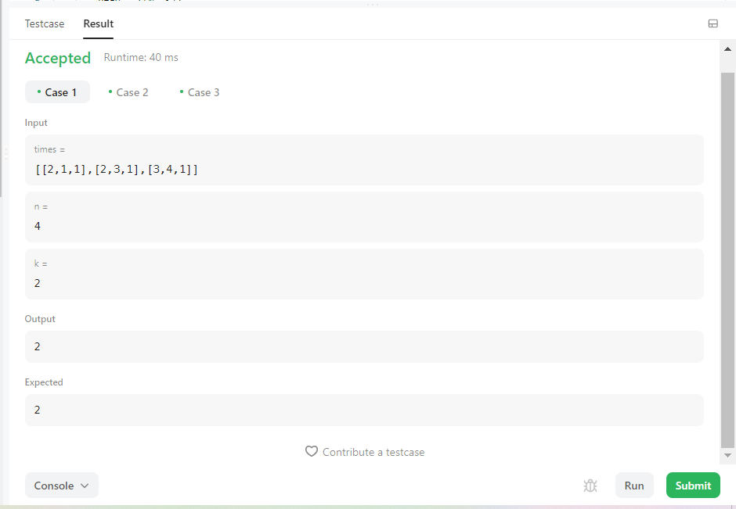

**Result :** Sucessfully Executed The Program.

**WEEK – 8**

**Aim :** Kitty has a tree,T , consisting of n nodes where each node is uniquely labeled from 1 to n. Her friend Alex gave her q sets, where each set contains k distinct nodes. Kitty needs to calculate the following expression on each set:

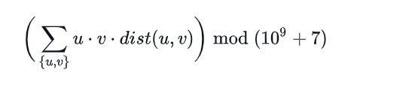

**Program :**

import networkx as nx

from itertools import combinations

import matplotlib.pyplot as plt

def dist(u,v):

#print("Distance Nodes : " , int(sp[u][v]))

duv = sp[u][v]

return duv

def product_tuple(x):

prodt = 1

for i in range(len(x)):

prodt *= x[i]

return prodt

def kitty_formula(combi):

res = 1

for k in range(len(combi)):

dtup = combi[k]

temp = product_tuple(dtup) * dist(dtup[0], dtup[1])

res = res + temp

print("\n\nFinal Result : ", res-1)

# inputs taking

nodes, queries = map(int, input("Enter Nodes And Queries : ").split())

#print(nodes, queries)

edges = []

for i in range(nodes-1):

edge = list(map(int, input("Enter intial and final nodes : ").split()))

#print("edge entered is : ", edge)

edges.append(edge)

print("All Edge List : ", edges)

for i in range(queries):

lq = int(input("Enter length of the query set : "))

q1 = list(map(int, input("Enter a pair : ").split()[:lq]))

#print("q1 : ", q1)

if len(q1) == 1:

# calculation Start

print("Final result : ", 0)

else:

# calculation Start

combi = list(combinations(q1, 2))

G = nx.Graph()

G.add_nodes_from([h for h in range(1, nodes+1)])

G.add_edges_from(edges)

sp = dict(nx.all_pairs_shortest_path_length(G))

kitty_formula(combi)

nx.draw(G, with_labels=True)

plt.show()

**Output :**

Enter Nodes And Queries : 7 3

Enter intial and final nodes : 1 2

Enter intial and final nodes : 1 3

Enter intial and final nodes : 1 4

Enter intial and final nodes : 3 5

Enter intial and final nodes : 3 6

Enter intial and final nodes : 3 7

All Edge List : [[1, 2], [1, 3], [1, 4], [3, 5], [3, 6], [3, 7]]

Enter length of the query set : 2

Enter a pair : 2 4

Final Result : 16

Enter length of the query set : 1

Enter a pair : 5

Final result : 0

Enter length of the query set : 3

Enter a pair : 2 4 5

Final Result : 106

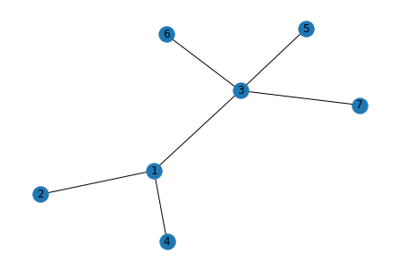

**Result :** Sucessfully Executed The Program.

**Aim :** Implement Emergence Of Connectivity Problem Using Networkx module.

**Program :**

import networkx as nx

import matplotlib.pyplot as plt

import random

import numpy as np

# Add n number of nodes in the graph and return it.

def add_nodes(n):

G = nx.Graph()

G.add_nodes_from(range(n))

return G

# add one random edge

def add_random_edge(G):

v1 = random.choice(list(G.nodes()))

v2 = random.choice(list(G.nodes()))

if v1 != v2:

G.add_edge(v1,v2)

return G

# it add random edges in graph until it becomes connected

def add_till_connectivity(G):

while nx.is_connected(G) == False:

G = add_random_edge(G)

return G

# creates an instance od entire process. it takes as input number of nodes and

# returns the number of edges for connectivity.

def create_instance(n):

G = add_nodes(n)

G = add_till_connectivity(G)

return G.number_of_edges()

# Average it over 100 instances

def create_avg_instance(n):

list1 = []

for i in range(0,100):

list1.append(create_instance(n))

return np.average(list1)

# plot the desired for different number of edges

def plot_connectivity():

x = []

y = []

i = 10 # it tells no of nodes

while i <= 100:

x.append(i)

y.append(create_avg_instance(i))

i = i + 10

plt.xlabel("Number of Nodes")

plt.ylabel("Number of edges required to connect the graph")

plt.title("Emergence of Connectivity")

plt.plot(x,y)

x1 = []

y1 = []

i1 = 10

while i1 <= 100:

x1.append(i1)

y1.append(i1*np.log(i1))

# y1.append(i1*float(np.log(i1))//2)

i1 = i1 + 10

plt.plot(x1, y1)

plt.show()

g = add_nodes(10)

print("No of nodes : ", g.number_of_nodes())

print("Connected or not : ", nx.is_connected(g))

g1 = add_random_edge(g)

print("new edge added : ", g1.edges())

g2 = add_till_connectivity(g1)

print("Total edges in a g2 : ", g2.edges())

print("Total no of edges : ", g2.number_of_edges())

print("Connected or not : ", nx.is_connected(g2))

d = create_instance(10)

print("No of edges required for connectivity : ", d)

plot_connectivity()

**Output :**

No of nodes : 10

Connected or not : False

new edge added : [(2, 9)]

Total edges in a g2 : [(0, 8), (0, 6), (1, 9), (1, 7), (2, 9), (3, 9), (3, 4), (3, 7), (3, 5), (5, 6)]

Total no of edges : 10

Connected or not : True

No of edges required for connectivity : 13

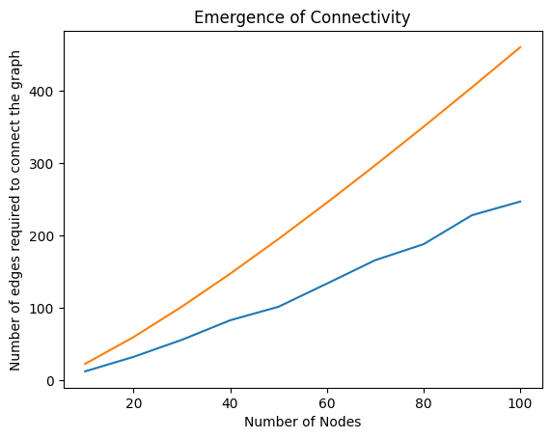

**Result :** Sucessfully Executed The Program.

**WEEK – 9**

**Aim :** Given n pairs of parentheses, write a function to generate all combinations of well-formed parentheses.

**Example 1:**

Input: n = 3

Output: ["((()))","(()())","(())()","()(())","()()()"]

**Example 2:**

Input: n = 1

Output: ["()"]

**Program :**

class Solution:

def generateParenthesis(self, n: int) -> List[str]:

# Memo to store the already visited combinaison of the rest of parentheses to open (named r for rest) and already opened parentheses (named o for opened)

memo = [[[] for _ in range(n + 1)] for _ in range(n + 1)]

# Base value

memo[0][0] = ["", ]

memo[0][1] = [")",]

memo[1][0] = ["()",]

def f(r, o): # r rest o opened

if memo[r][o]:

return memo[r][o]

if o == 0: # if there is no resting parentheses, then close the ones already openend

memo[r][o] = ["("+e for e in f(r-1, o+1)]

elif r == 0: # if there is no opened parentheses, then open one

memo[r][o] = [")"+e for e in f(r, o-1)]

else: # If there is opened and resting combinaison, then it is the combinaison of two

memo[r][o] = ["("+e for e in f(r-1, o+1)] + [")"+e for e in f(r, o-1)]

return memo[r][o]

return f(n, 0)

**Output :**

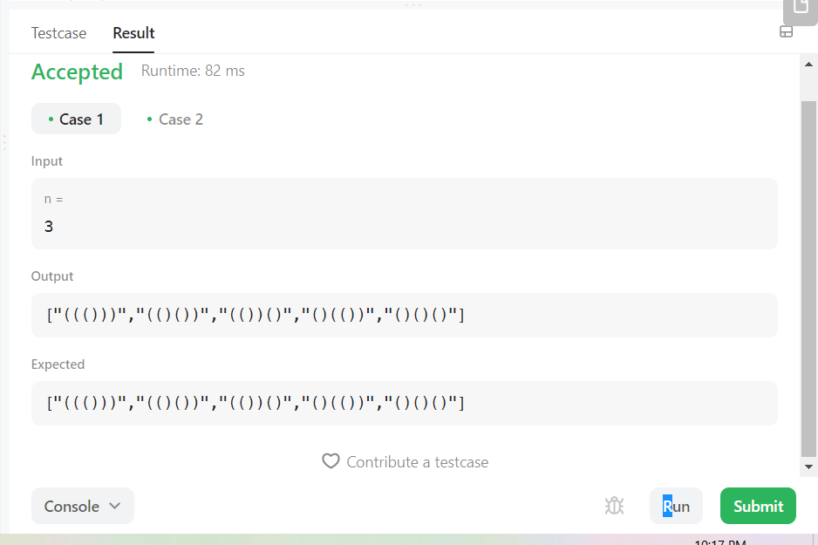

**Result :** Sucessfully Executed The program.

**Aim :** There is a robot on an m x n grid. The robot is initially located at the top-left corner (i.e., grid[0][0]). The robot tries to move to the bottom-right corner (i.e., grid[m - 1][n - 1]). The robot can only move either down or right at any point in time.

Given the two integers m and n, return the number of possible unique paths that the robot can take to reach the bottom-right corner.

The test cases are generated so that the answer will be less than or equal to 2 * 109.

**Example :**

Input: m = 3, n = 2

Output: 3

Explanation: From the top-left corner, there are a total of 3 ways to reach the bottom-right corner:

1. Right -> Down -> Down

2. Down -> Down -> Right

3. Down -> Right -> Down

**Program :**

class Solution:

def uniquePaths(self, m: int, n: int) -> int:

memo=[[0 for _ in range(n+1)] for _ in range(m+1)]

def db(x,y):

if x==m and y==n:

return 1

elif x==m:

if memo[x][y+1]==0:

memo[x][y+1]=db(x,y+1)

return memo[x][y+1]

elif y==n:

if memo[x+1][y]==0:

memo[x+1][y]=db(x+1,y)

return memo[x+1][y]

else:

if memo[x][y+1]==0:

memo[x][y+1]=db(x,y+1)

if memo[x+1][y]==0:

memo[x+1][y]=db(x+1,y)

return memo[x][y+1]+memo[x+1][y]

return db(1,1)

**Output :**

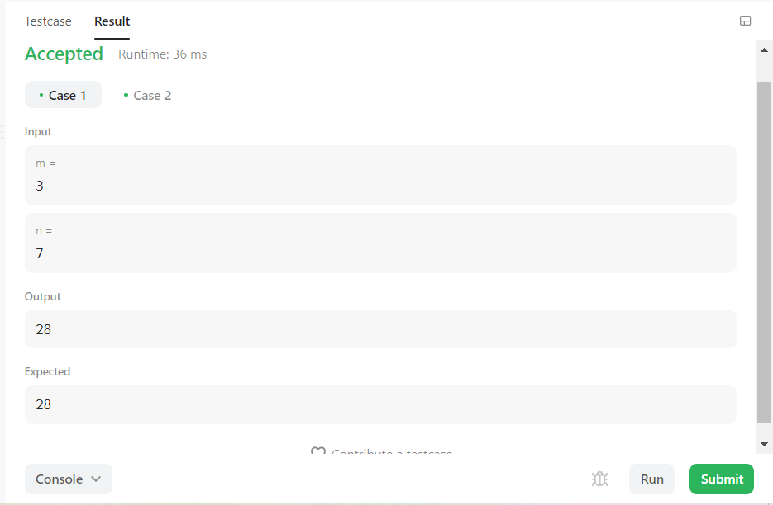

**Result :** Sucessfully Executed The program.

**WEEK – 10**

**Aim :** Implement minimum path sum.

Given a m x n grid filled with non-negative numbers, find a path from top left to bottom right, which minimizes the sum of all numbers along its path.

Note: You can only move either down or right at any point in time.

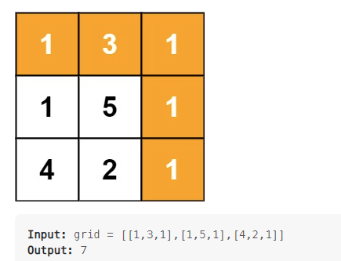

**Program :**

class Solution:

def minPathSum(self, grid: List[List[int]]) -> int:

m, n = len(grid), len(grid[0])

for i in range(1, m):

grid[i][0] += grid[i-1][0]

for i in range(1, n):

grid[0][i] += grid[0][i-1]

for i in range(1, m):

for j in range(1, n):

grid[i][j] += min(grid[i-1][j], grid[i][j-1])

return grid[-1][-1]

**Output :**

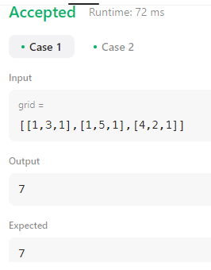

**Result :** Sucessfully Executed The program.

**Aim :** Implement Counting Bits.

Given an integer n, return an array ans of length n + 1 such that for each i (0 <= i <= n), ans[i] is the number of 1's in the binary representation of i.

**Program :**

class Solution

{

public int[] countBits(int n)

{

int[] a = new int[n+1];

a[0]=0;

if(n>0){a[1]=1;}

if(n>1){

int sum=2;

for (int i =2;1<2;i*=2 ){

for (int j=0;j<i;j++){

a[i+j]=a[j]+1;

sum++;

if(sum==n+1){

break;

}

}

if(sum==n+1){

break;

}

}

}

return a;

}

}

**Output :**

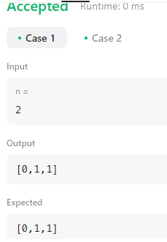

**Result :** Sucessfully Executed The program.

**WEEK – 11**

**Aim :** Implement Regular Expression Matching.

Given an input string s and a pattern p, implement regular expression matching with support for '.' and '*' where:

'.' Matches any single character.

'*' Matches zero or more of the preceding element.

The matching should cover the entire input string (not partial).

**Program ;**

class Solution:

@lru_cache()

def isMatch(self, s: str, p: str) -> bool:

if not p: return not s

x = bool(s) and p[0] in {'.',s[0]}

if len(p)>=2 and p[1] == '*':

return self.isMatch(s,p[2:]) or (x and self.isMatch(s[1:],p))

else:

return x and self.isMatch(s[1:],p[1:])

**Output :**

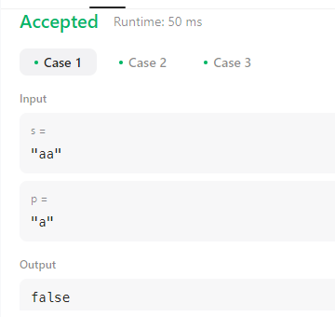

**Result :** Sucessfully Executed the Program.

**Aim :** Implement Program to Detect HTML Links in given input.

**Program :**

import re

for i in range(int(input().strip())):

data = input().strip()

matches = re.findall(r'[^<]*<a href="([^"]+)".*?>(?:[^<]<\w+>)*([^<]*?)(?:<\/\w+>)*<\/a>', data)

if matches:

for m in matches:

print("{0},{1}".format(m[0].strip(), m[1].strip()))

**Output:**

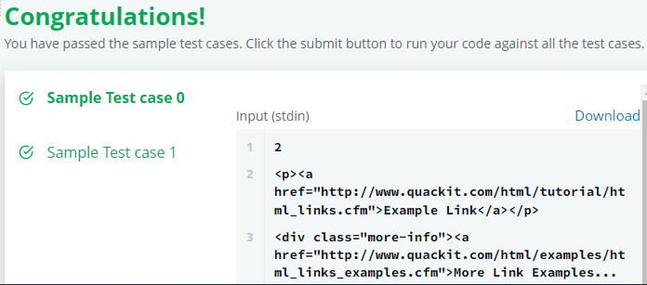

**Result :** Sucessfully Executed The Program.

**WEEK – 12**

**Aim :** Building a Smart IDE: Programming Language Detection

We are trying to hack together a smart programming IDE. Help us build a feature which auto-detects the programming language, given the source code. There are only three languages which we are interested in "auto-detecting": Java, C and Python.

**Program :**

import re

from sys import stdin

java = r'public class|java\.io'

c = r'#include'

code = ''.join(stdin.read())

if re.search(java, code):

print('Java')

elif re.search(c, code):

print('C')

else:

print('Python')

**Output:**

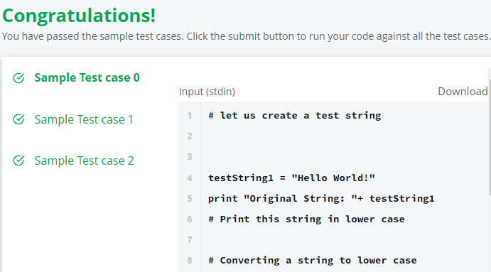

**Result :** Sucessfully Executed The program.

**Aim : :** Implement Program to Detect Domain names.

**Program :**

import re

txt='\n'.join([input() for _ in range(int(input()))])

print(*sorted(set(re.findall(r'https?://(?:ww(?:w|2)\.)?([\w\.\-]*\.[a-zA-Z]+)',txt,re.DOTALL))),sep=';')

**Output :**

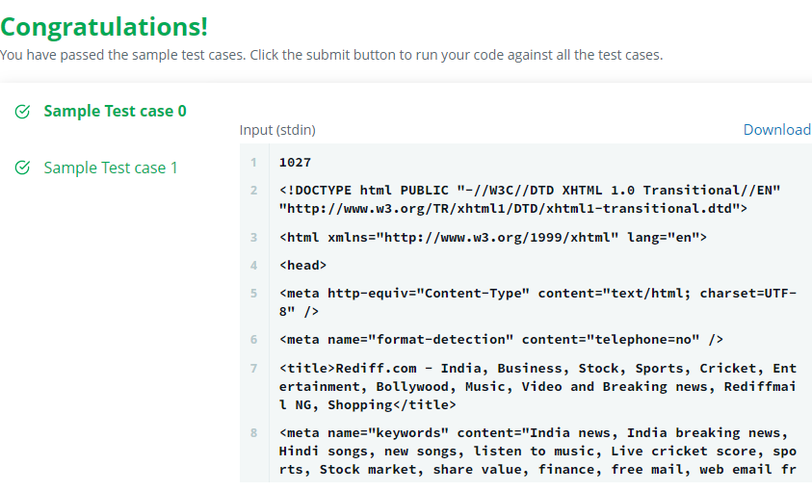

**Result :** Sucessfully Executed the program.