**Velagapudi Ramakrishna Siddhartha Engineering College**

**ADVANCE PROGRAMMING LAB – 2**

**Code : 20IT5352**



**WEEK – 1**

**Aim :** Given the list of numbers, you are to sort them in non decreasing order.

**Program :**

lis=[]

t=int(input())

while t>0:

n=int(input())

lis.append(n)

t-=1

lis.sort()

for i in range(0,len(lis)):

print(lis[i])

**Output :**

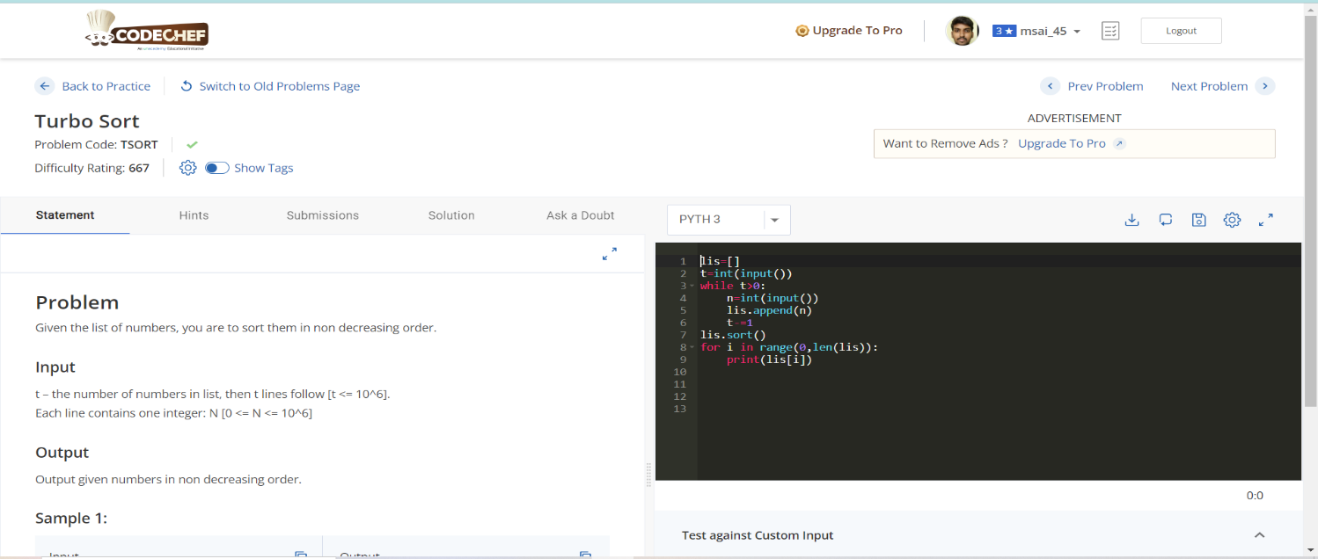

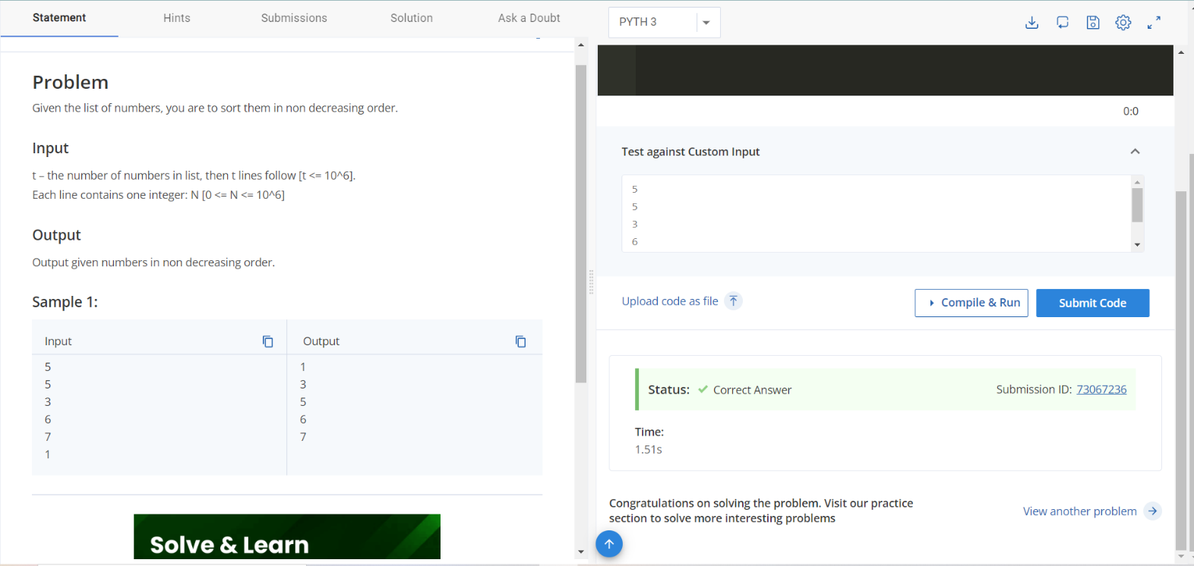

**Result :** Sucessfully Executed the Program.