1. **User Group Profile** – Demographics, pain points, habits

**Demographics**:

- Age Range: 18–24 years old

- Education Level: Undergraduate students (freshmen to seniors)

- Location: Primarily campus-based, with some commuting students

- Income Source: Financial aid, part-time jobs, parental support

- Tech Usage: Mobile-first; frequent users of budgeting, food delivery, and campus apps

**Pain Points:**

- Unpredictable Spending: Students often overspend early in the semester and run out of food credits before finals.

- Underutilization: Others forget or neglect to use their credits, leaving money on the table.

- Lack of Visibility: Many don’t track their food credit balance or understand how it’s allocated.

- Financial Stress: Juggling tuition, rent, and daily expenses makes food budgeting feel overwhelming.

- Aid Confusion: Uncertainty around how food credits interact with financial aid packages.

**Habits:**

- Impulse Purchases: Frequent snack buys or premium meal upgrades drain credits quickly.

- End-of-Term Panic: Sudden realization of leftover credits leads to binge spending or waste.

- Low Planning: Few students plan meals or budget weekly food usage.

- Social Influence: Dining decisions often driven by peer activity rather than budget.

- App Fatigue: Students use multiple apps but rarely stick with one unless it’s intuitive and rewarding.

1. **Market Size & Opportunity** – Use data to show demand

**Market Size & Demand Overview**

College Student Population & Spending Power

- There are approximately 19.7 million college students in the U.S.

- Collectively, students wield a spending power of $593 billion annually, with food being one of the largest expense categories.

Food Spending & Budgeting Challenges

- Students spend an average of $160/month on food, which is 30.4% of their monthly income—a significantly higher proportion than the general population.

- The average monthly income for students is $868, meaning food is a major financial pressure point.

- 34% of students report difficulty affording sufficient food each month.

- 45–50% of students experience food insecurity, with many worrying about running out of food.

- Nearly 70% of students cite the high cost of living—including food—as their top concern.

**Food Credit Utilization & Waste**

Meal Plan & Food Credit Usage

- The average college meal plan costs $375/month, or $4,500/year.

- Many students either overspend early in the semester or underuse their credits due to lack of tracking.

- Studies estimate that 15–25% of food credits go unused each semester due to poor budgeting and lack of visibility.

- With ~20 million students and average food credit allocations of ~$1,000/year, this translates to $3–5 billion in unused food credits annually.

**App Opportunity: Budgeting & Optimization**

Target Audience

- Students on meal plans, prepaid dining accounts, or tight food budgets.

- Institutions seeking to reduce food waste and improve student satisfaction.

Key Features in Demand

- Real-time tracking of food credit usage

- Forecasting tools to prevent overspending or underuse

- Alerts and reminders for budgeting milestones

- Integration with campus dining systems or student ID cards

**Sources**

[The Spending Habits of College Students | The Vector Impact](https://thevectorimpact.com/spending-habits-of-college-students/)

[Average College Student Spending 2025 [Monthly Allowance]](https://www.thinkimpact.com/average-college-student-spending/)

<https://eujournal.org/index.php/esj/article/download/10141/9629>

1. **Competitor Analysis** – Compare 2–3 similar apps on features, gaps, and reviews

Similar Budgeting Apps for College Students

1. **Digit**

Best For: Automated savings and spending analysis

Key Features:

- Connects to bank accounts and analyzes spending habits

- Automatically sets aside savings based on behavior

- Personalized recommendations for saving and investing

- Savings goal tracker

- 6-month free trial, then $5/month

User Review:

_"Digit helped me save without even thinking about it. I didn’t realize how much I was overspending until the app showed me patterns I’d never noticed."_ — WalletMoth Review

2. **Goodbudget**

Best For: Envelope-style budgeting and category control

Key Features:

- Digital envelope system for allocating money to categories (e.g., groceries, dining)

- Debt tracker

- Syncs across multiple devices

- Manual transaction entry encourages mindful spending

User Review:

_"I love how Goodbudget makes me think before I spend. It’s like having a virtual envelope for every part of my life."_ — WalletMoth Review

3. **Mint**

Best For: All-in-one financial tracking

Key Features:

- Tracks bank accounts, credit cards, student loans

- Budget suggestions based on spending history

- Alerts for bills, low balances, and budget limits

- Free credit score access

- No bill pay feature, but strong reminders

User Review:

_"Mint keeps me from over drafting and missing bills. It’s not perfect, but it’s saved me from late fees more than once."_ — CollegeFinance Review

1. **Unique Value Proposition (UVP)** – Why yours stands out

Our app is a purpose-built for college students to master their campus meal plans. It helps them stretch every food credit, avoid end-of-semester panic, and stay nourished without financial stress.

1. **At Least One Graph or Visualization**

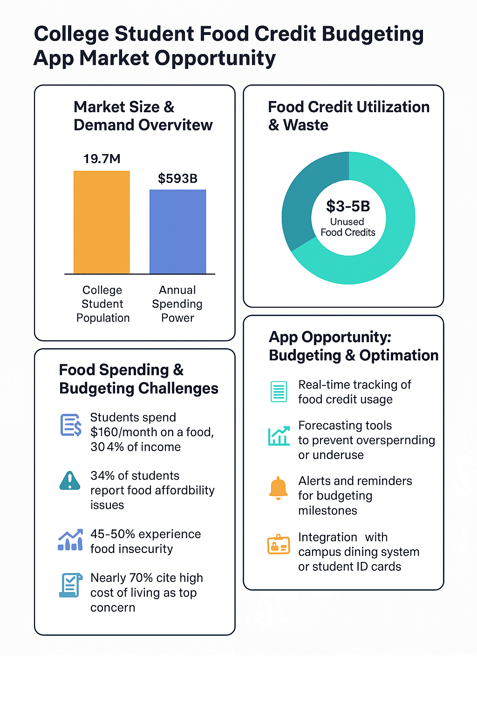

1. **AI Use Section** – Clearly explain:
   * Which GenAI tools were used
   * What prompts were used
   * How you fact-checked or verified output

I used Co-Pilot to generate formatted paragraphs. The research that the AI provided came from several sources. I rechecked the data and validated it all. Also, I included all the websites and articles that the AI pulled from in order to confirm all of this.

Here is the prompt that I used:

**Prompt 1**: Create a user group profile for a college student food credit budgeting app. The demographics are college students between the ages of 18 and 24. Their pain points are money and financial aid management and budgeting. Their habits are being careless in food credit usage (either ending up with too much credit left over or none left).

**Prompt 2**: Provide statistics for the market size and demand of a college student food credit budgeting app using the statistics about students that have trouble budgeting. Also, include information about the amount of food credits that are used and aren’t. Also, generate a graph that uses this information to prove the need for a college student food credit budgeting app.

**Prompt 3**: Provide a list of apps that are similar to a college student food credit budgeting app. Give a list of each of their features and select a user review of the app as well.

**Additional Sources**:

Average in America Meal plan cost: <https://educationdata.org/average-monthly-food-spend-college-student>

Murray State Meal Plan costs: <https://www.murraystate.edu/campus/Dining/index.aspx>

Student Ages: [https://nces.ed.gov/programs/coe/indicator/cpb/college-enrollment-rate#:~:text=The%20college%20enrollment%20rate%20for%2018%2D%20to,sex:%20*%20**Females**%2044%25%20*%20**Males**%2034%25](https://nces.ed.gov/programs/coe/indicator/cpb/college-enrollment-rate#:~:text=The%20college%20enrollment%20rate%20for%2018%2D%20to,sex:%20*%20**Females**%2044%25%20*%20**Males**%2034%25)