
UNIVERSITY OF BELIZE
FACULTY OF SCIENCE & TECHNOLOGY
CMPS 3111 — PROGRAMMING LANGUAGES
PROGRAM 1 REPORT
Language Recognizer Based on a Context-Free Grammar
Student | Marlon [Last Name]
Student ID | [Insert Student ID]
Course | CMPS 3111 — Programming Languages
Assignment | Program 1
Submission Date | September 17, 2026
Programming Language | C# / .NET
WORKING DRAFT — FOR REVIEW

Table of Contents
Executive Summary

A. Descriptions and Explanations
A.1 BNF Grammar
A.2 Interpretation of the Grammar
A.2.1 <program>
A.2.2 <instructions> and Recursion
A.2.3 <instruction>
A.2.4 <coord>, <x>, and <y>
A.3 Syntax, Semantics, Sentences, and Language
A.4 Derivation and Sentential Forms
A.5 Parse Tree
A.6 Language, Version, Compiler, and Development Environment
A.7 Data Types Used in the Implementation
A.8 Program Objectives
A.9 Program Process Flow
A.10 Main Program
A.11 Subprograms / Components
A.12 Testing and Validation

B. Program Flowchart

C. Program Code
C.1 Program.cs
C.2 Validator.cs
C.3 Derivation.cs
C.4 ParseTree.cs

Conclusion

References and Course Materials

Executive Summary
This report documents the design and implementation of a language recognizer for the CMPS 3111 Programming Languages Program 1 assignment. The recognizer determines whether an input string follows the BNF grammar provided in the assignment. Valid strings are accepted and processed further, while invalid strings are rejected with an appropriate error message.
The program was implemented as a C# console application using .NET. Its main components are a main program for controlling the program flow, a validator for checking the input against the grammar, a rightmost-derivation component for displaying the derivation of valid strings, and a parse-tree component for displaying the grammatical structure of valid strings.
The recognizer supports the required begin and end program structure, SQR and TRI instructions, valid coordinates, and multiple instructions separated by periods. The program also provides on-screen instructions, valid examples, error feedback, an INFO command for displaying the instructions again, and an EXIT command for terminating the program.
For valid input, the program displays a rightmost derivation showing the sequence of sentential forms from <program> to the final sentence. It can also display a parse tree representing the hierarchical structure of the recognized sentence. These features demonstrate the application of the syntax, BNF, derivation, and parse-tree concepts covered in CMPS 3111.
The completed program is designed to satisfy the functional requirements of the assignment while remaining organized and easy to test and demonstrate.

A. Descriptions and Explanations

A.1 BNF Grammar
The recognizer is based on the following grammar supplied in the Program 1 assignment:
<program> → begin <instructions> end
<instructions> → <instruction>
| <instruction> . <instructions>
<instruction> → SQR <coord>-<coord>
| TRI <coord>-<coord>-<coord>
<coord> → <x><y>
<x> → A | B | C | D | E | F | G
<y> → 1 | 2 | 3 | 4 | 5 | 6
In the Syntax lecture's terms, this grammar is a formal explanation of syntax. BNF is a metalanguage that describes another language and is analogous to context-free grammars. The objects encompassed in angle brackets are abstractions, also known as non terminal symbols or syntactic variables, whereas the literal words, letters, numerals, punctuation, and symbols that occur in real input are terminals. A grammar consists of rules, each of which has a left-hand side (LHS) and a right-hand side (RHS).

A.2 Interpretation of the Grammar

A.2.1 <program>
<program> → begin <instructions> end
The <program> rule defines the overall form of a valid sentence in the language. The sentence must start with the terminal begin, contain one or more instructions, and end with the terminal end.

A.2.2 <instructions> and Recursion
<instructions> → <instruction>
| <instruction> . <instructions>
This production allows either one instruction or an instruction followed by a period and another <instructions> sequence. The second alternative is recursive because <instructions> appears again on the right-hand side.
This allows the language to contain multiple instructions, such as:
begin SQR A1-C4. TRI A1-C6-G3 end

A.2.3 <instruction>
<instruction> → SQR <coord>-<coord>
| TRI <coord>-<coord>-<coord>
An instruction has two possible forms. SQR requires exactly two coordinates, while TRI requires exactly three coordinates. The dash is a terminal separator between coordinates.

A.2.4 <coord>, <x>, and <y>
<coord> → <x><y>
<x> → A | B | C | D | E | F | G
<y> → 1 | 2 | 3 | 4 | 5 | 6
A coordinate consists of an X value followed by a Y value. The X value must be a letter from A through G, and the Y value must be a number from 1 through 6.
Examples of valid coordinates include A1, C4, and G6. Coordinates such as H2 and C8 are invalid because they cannot be generated by the grammar.

A.3 Syntax, Semantics, Sentences, and Language
The CMPS 3111 Syntax lecture distinguishes syntax from semantics. Syntax concerns the form or structure of a program, while semantics concerns its meaning. This project focuses mainly on syntax because the recognizer checks whether an input string follows the structure defined by the supplied BNF grammar.
A sentence is a string that belongs to a language, while a language is a set of sentences. In this project, begin SQR A1-C4 end is an example of a valid sentence because it follows the grammar. The program acts as a language recognizer by accepting strings that follow the grammar and rejecting strings that do not.
The input can also be considered in terms of lexemes and tokens. Elements such as begin, end, SQR, TRI, coordinates, periods, and dashes form parts of the input's syntactic structure. The recognizer checks these elements as part of the grammar validation rather than using a separate general-purpose lexical analyzer.

A.4 Derivation and Sentential Forms
A derivation is the repeated application of grammar productions, beginning with the start symbol and continuing until a sentence containing only terminal symbols is produced. Each intermediate form is called a sentential form.
This program uses a rightmost derivation, which means that the rightmost non terminal is expanded at each step. For example, the valid input `begin SQR A1-C4 end` can be derived as follows:
<program>
=> begin <instructions> end
=> begin <instruction> end
=> begin SQR <coord>-<coord> end
=> begin SQR <coord>-<x><y> end
=> begin SQR <coord>-<x>4 end
=> begin SQR <coord>-C4 end
=> begin SQR <x><y>-C4 end
=> begin SQR <x>1-C4 end
=> begin SQR A1-C4 end
The program displays the derivation sequence for each accepted input. For programs containing multiple instructions, the recursive `<instructions>` production is expanded as necessary, and the program continues applying rightmost derivation steps until the complete input sentence is generated.

A.5 Parse Tree

A parse tree is a hierarchical representation of a derivation. It shows how the non terminal symbols in the grammar are expanded into the terminal symbols of the final sentence.
For the valid sentence `begin SQR A1-C4 end`, the parse tree has `<program>` as its root. It contains `begin`, `<instructions>`, and `end`. The `<instructions>` node contains an `<instruction>`, which expands into `SQR` and two `<coord>` nodes. Each `<coord>` is further expanded into `<x>` and `<y>`.
The program generates and displays the parse tree after a successful derivation. This provides a visual representation of the grammatical structure of the recognized sentence and helps demonstrate how the BNF productions are applied.

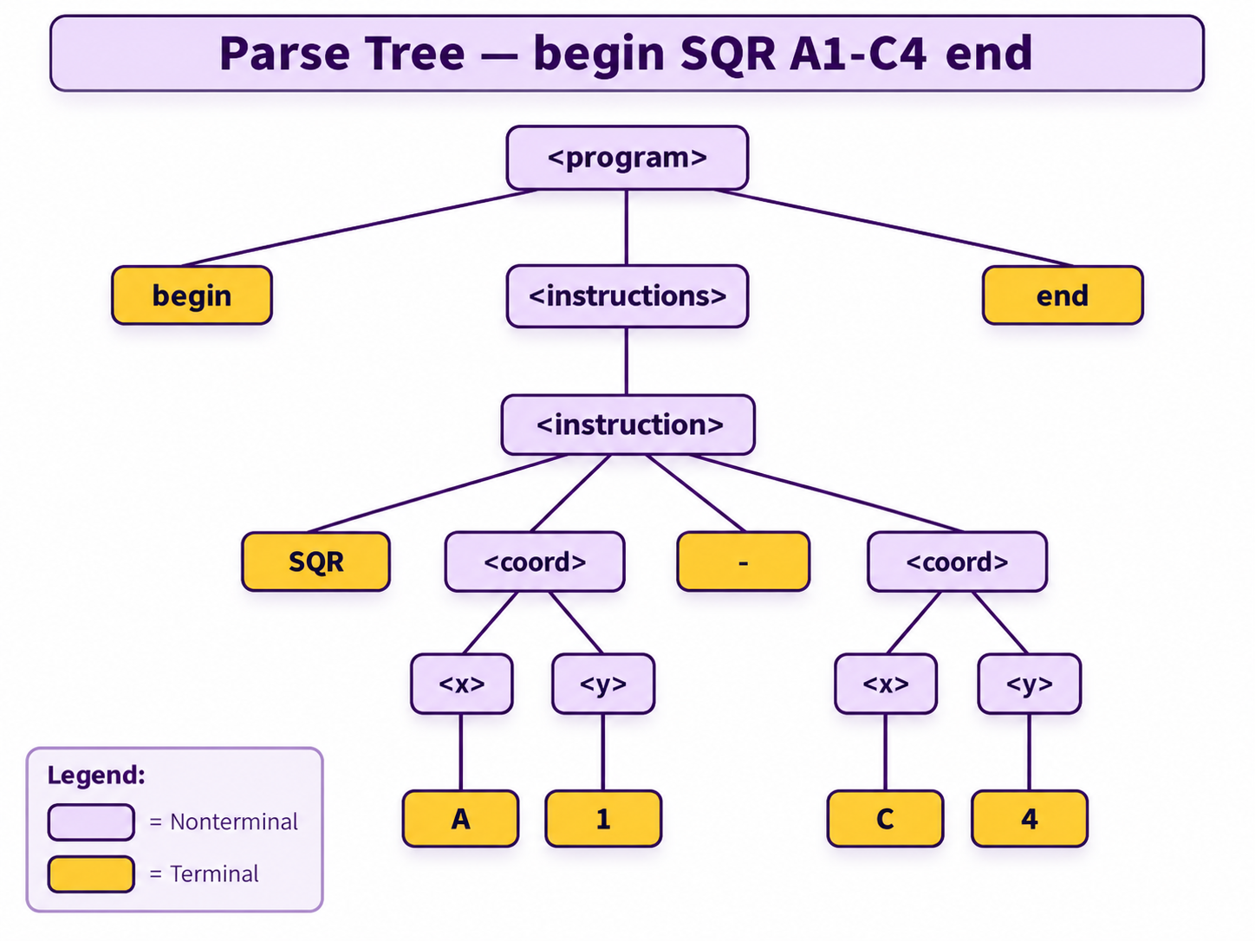
Figure 1. Parse tree for the valid sentence “begin SQR A1-C4 end.”

A.6 Language, Flavor/Version, Compiler/Interpreter, and Development Environment
Item | Project Information
Programming language | C#
Runtime / platform | .NET 10
Compiler / command-line tool | dotnet CLI / .NET SDK
Target framework | net10.0
Development environment | Visual Studio Code and terminal
Operating systems used during development | Ubuntu 24.04 LTS and Windows 11

The project is implemented in C#. The Data Types lecture specifically discusses C# in several places, including its character and string support, Boolean type, enumeration support, and arrays. For this project, the most directly relevant types are character strings, characters, Boolean values, and arrays used to organize pieces of the input.

A. 7 Data Types Used in the Implementation
The implementation makes practical use of several C# data types and structures. The Data Types lecture explains that a data type defines a collection of data objects and a set of operations on those objects.
- string — represents the complete input sentence and text fragments such as commands, coordinates, and error messages.
- char — represents an individual X or Y character when validating a coordinate.
- bool — represents whether a validation operation succeeds or fails.
- string[] — stores lists of instructions or coordinate components after the input is separated.

The Data Types lecture describes character strings as sequences of characters and notes that C# provides a string class. It also describes Boolean values as having two possible values, true and false, which matches the program's use of Boolean validation results.

A.8 Program Objectives
- Recognize valid and invalid strings according to the supplied BNF grammar.
- Display the BNF grammar and user instructions when the program starts.
- Display a rightmost derivation for each accepted string.
- Display each sentential form and the final generated sentence.
- Provide useful error feedback for rejected strings.
- Display a hierarchical parse tree for accepted strings.
- Allow repeated recognition attempts until the user enters EXIT.

A.9 Program Process Flow
The program follows a continuous input-and-processing cycle. When the program starts, it displays instructions and an example of valid input. The user is then prompted to enter a program.
The input is first checked for the EXIT command. If EXIT is entered, the program terminates. Otherwise, the input is validated against the required grammar and program structure.
If the input is invalid, the program displays an appropriate error message and returns to the input prompt. If the input is valid, the program confirms the successful validation and displays the rightmost derivation.
After the derivation is completed, the user is given the option to display the parse tree. The program then returns to the input prompt, allowing additional programs to be tested until EXIT is entered.
The complete program flow is represented in the flowchart provided in Section B

A.10 Main Program
The Main method controls the overall execution of the program. It begins by displaying the program title, instructions, and a valid input example. It then repeatedly prompts the user to enter a program.
The main program checks for the EXIT command before sending other input to the validator. If the input is invalid, an appropriate error message is displayed. If the input is valid, the program displays a successful validation message, performs the rightmost derivation, and gives the user the option to display the parse tree.
The loop continues so that multiple programs can be tested during one execution. The program terminates when the user enters EXIT.

A.11Subprograms / Components

A.11.1 Validator
Validator is responsible for recognition. It checks coordinates, individual instructions, and complete programs. It also produces specific error messages, such as identifying that C is a valid X value while 8 is not a valid Y value when the input contains C8.

A.11.2 Derivation
Derivation is responsible for displaying the rightmost derivation. It starts with the start symbol <program>, applies the grammar rules in rightmost order, displays the resulting sentential form at each step, and ends with the final generated sentence.

A.11.3 Parse Tree
Parse Tree is responsible for displaying the hierarchical structure represented by the grammar. It includes <program>, <instructions>, <instruction>, <coord>, <x>, and <y>, together with the terminals that appear in the accepted sentence.

A.11.4 Main Program
The `Program` component contains the Main method and controls the overall interaction with the user. It displays instructions, receives input, handles commands such as INFO and EXIT, calls the validator, displays results, and coordinates the derivation and parse-tree processes.
Together, these components separate input control, validation, derivation, and parse-tree generation, making the program easier to understand, test, and maintain.

A.12 Testing and Validation
The implementation was tested using both valid and invalid examples. The valid tests included single SQR instructions, single TRI instructions, and multiple instructions. Invalid tests included invalid coordinate values, invalid commands, incorrect numbers of coordinates, missing begin/end delimiters, and malformed separators.

Test Category | Example | Expected Result
Valid SQR | begin SQR A1-C4 end | Accepted; derivation and parse tree available
Valid TRI | begin TRI A1-C6-G3 end | Accepted; derivation and parse tree available
Multiple instructions | begin SQR A1-C4. TRI A1-C6-G3 end | Accepted; recursive derivation and parse tree
Invalid coordinate | begin SQR A1-C8 end | Rejected with coordinate-specific error
Invalid command | begin CIR A1-C4 end | Rejected with command error
Wrong coordinate count | begin SQR A1-C4-G3 end | Rejected with SQR coordinate-count error
Missing end | begin SQR A1-C4 | Rejected because program does not end with end

The successful tests confirm the central recognizer behavior: valid strings are accepted, invalid strings are rejected, rightmost derivations are displayed as sentential forms, and parse trees are displayed for accepted strings.

B. Program Flowchart
The following flowchart summarizes the control flow of the recognizer. The design uses standard flowchart conventions: start/end, input/output, process, and decision symbols.
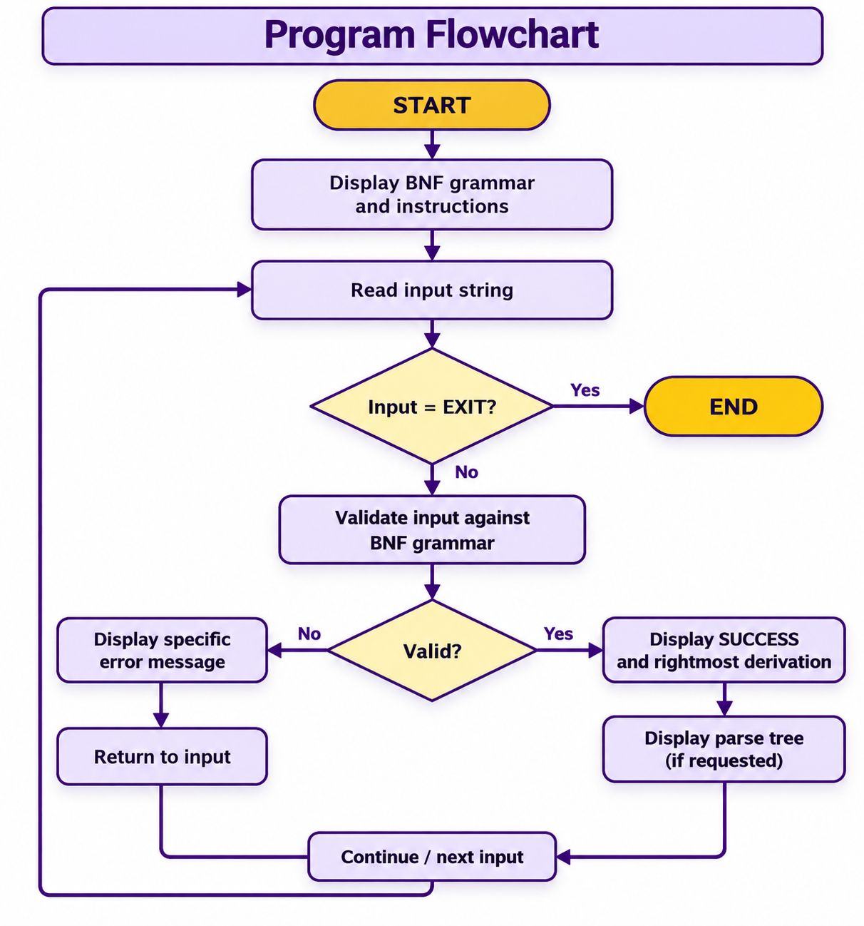

Figure 3. Detailed program flowchart.

B.1 Flowchart Symbols
The flowchart uses standard symbols to represent the different types of operations performed by the program:
Oval — Terminator: Represents the beginning and end of the program.
Rectangle — Process: Represents an operation performed by the program, such as displaying instructions, validating input, performing the derivation, or generating the parse tree.
Diamond — Decision: Represents a condition that requires a Yes/No or True/False decision, such as checking whether the user entered `EXIT` or whether the input is valid.
Parallelogram — Input/Output: Represents information entered by the user or displayed by the program.
Arrows — Flow Lines: Show the direction in which control moves from one step to the next.
These symbols provide a clear visual representation of the program's control flow and make the sequence of operations easier to understand.

C. Program Code
The following source code represents the implementation used for the recognizer. The project is organized into separate C# files so that recognition, derivation, parse-tree display, and program control have distinct responsibilities.

Conclusion
The CMPS 3111 Program 1 implementation demonstrates the central concepts of syntax analysis covered in the course. The program treats the assignment grammar as a formal specification of a small language, recognizes sentences that conform to that grammar, and demonstrates successful recognition using both a rightmost derivation and a parse tree.
The implementation also reflects terminology from the course lectures: grammar, terminals, non terminals, LHS and RHS, recursion, sentential forms, derivation, rightmost derivation, parse tree, syntax, semantics, language, and language recognizer. These concepts are directly connected to the behavior of the program.
The final implementation was tested with valid and invalid examples and is structured so that the main program coordinates separate components for validation, derivation, and parse-tree display. The resulting program provides a practical demonstration of how a context-free grammar can be connected to a language recognizer.

References and Course Materials
- University of Belize. CMPS 3111 Programming Languages. Program 1 assignment, 2026.
- CMPS 3111. SC03-1 — Syntax. University of Belize course lecture slides.
- CMPS 3111. SC03-2 — Semantics. University of Belize course lecture slides.
- CMPS 3111. SC06 — Data Types, Part 1 & 2/3. University of Belize course lecture slides.

