DBT E-Commerce Analysist

**INTRODUCTION**

**DATASET**

This is a Brazilian ecommerce public dataset of orders made at [Olist Store](http://www.olist.com/" \t "https://www.kaggle.com/datasets/olistbr/_blank). The dataset has information of 100k orders from 2016 to 2018 made at multiple marketplaces in Brazil. Its features allows viewing an order from multiple dimensions: from order status, price, payment and freight performance to customer location, product attributes and finally reviews written by customers.

The dataset have 7 table csv

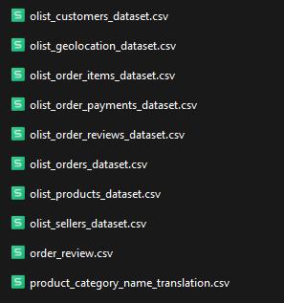

## Data Schema

The data is divided in multiple datasets for better understanding and organization. Please refer to the following data schema when working with it:

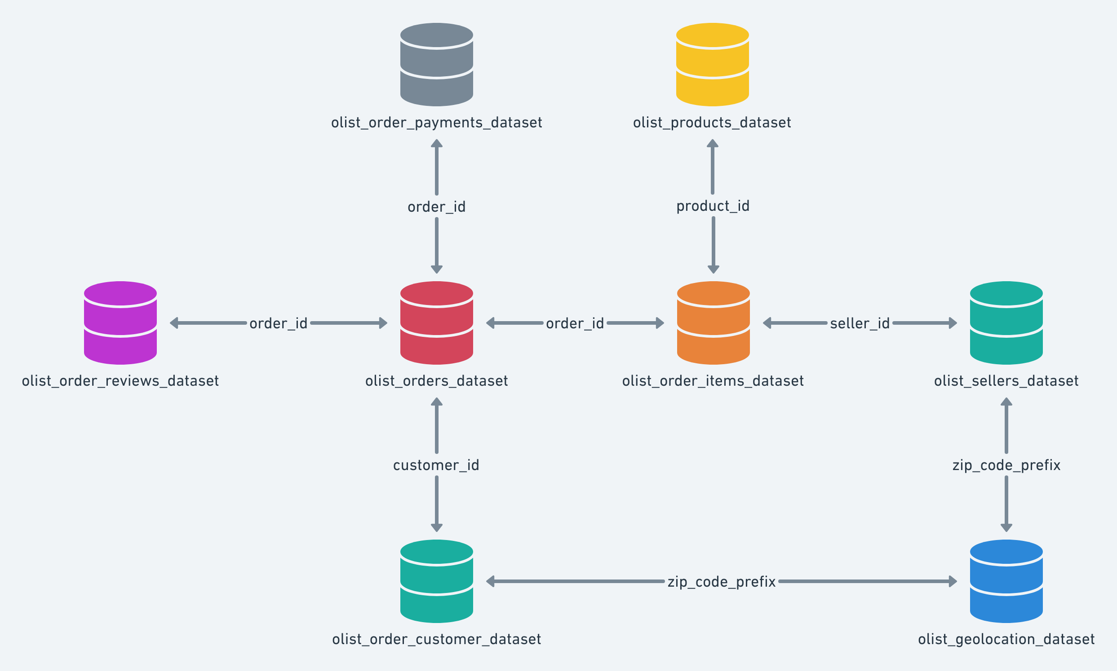

**ARCHITECTURE DIAGRAM**

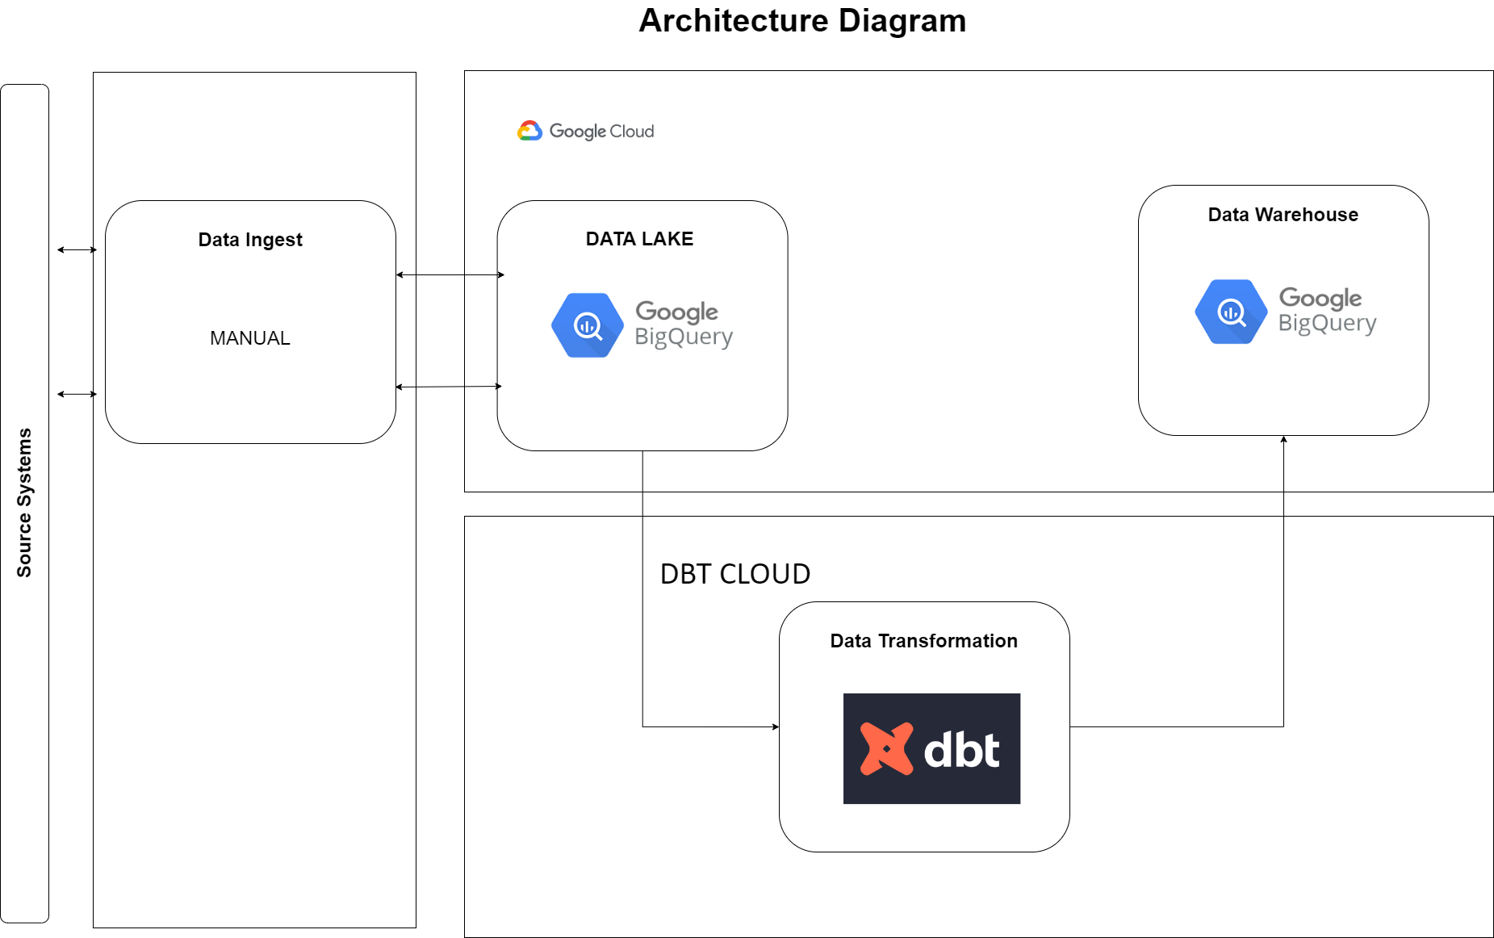

**PURPOSE**

1. Number of orders per Day, Week, Month

2. Active Customers: Customers with >=1 order within the period per Day, Week, Mont h

3. Average Order amount per user within the period

4. Weekly Customer Retention: Customers that ordered in the week that was already a

customer before.

5. Category Retention: Orders of an item in a category from users that already

purchased the same category from the previous order

6. Cross-Category Retention: Percentage of orders in a category that comes from users

who purchased in a different category on the previous order

**HOW TO RUN APPLICATION**

Registration Step:

1. Registration kaggle
2. Registration Google Cloud Platform
3. Registration DBT Cloud

Step

1. Download dataset e-commece in kaggle.com

Link download:

<https://www.kaggle.com/datasets/olistbr/brazilian-ecommerce/download?datasetVersionNumber=2>

<https://www.kaggle.com/datasets/olistbr/brazilian-ecommerce>

1. Upload all data to big Query
   1. Create database <name set>
   2. Create table / upload all of data to BigQuery

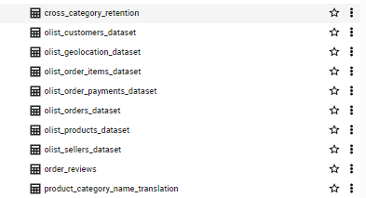

1. Fork repository github <https://github.com/muhajir29/dbt-ecommerce>
2. Create credential json Google cloud platform
3. Create DBT project
   1. Login dbt cloud
   2. Choice a warehouse Big Query

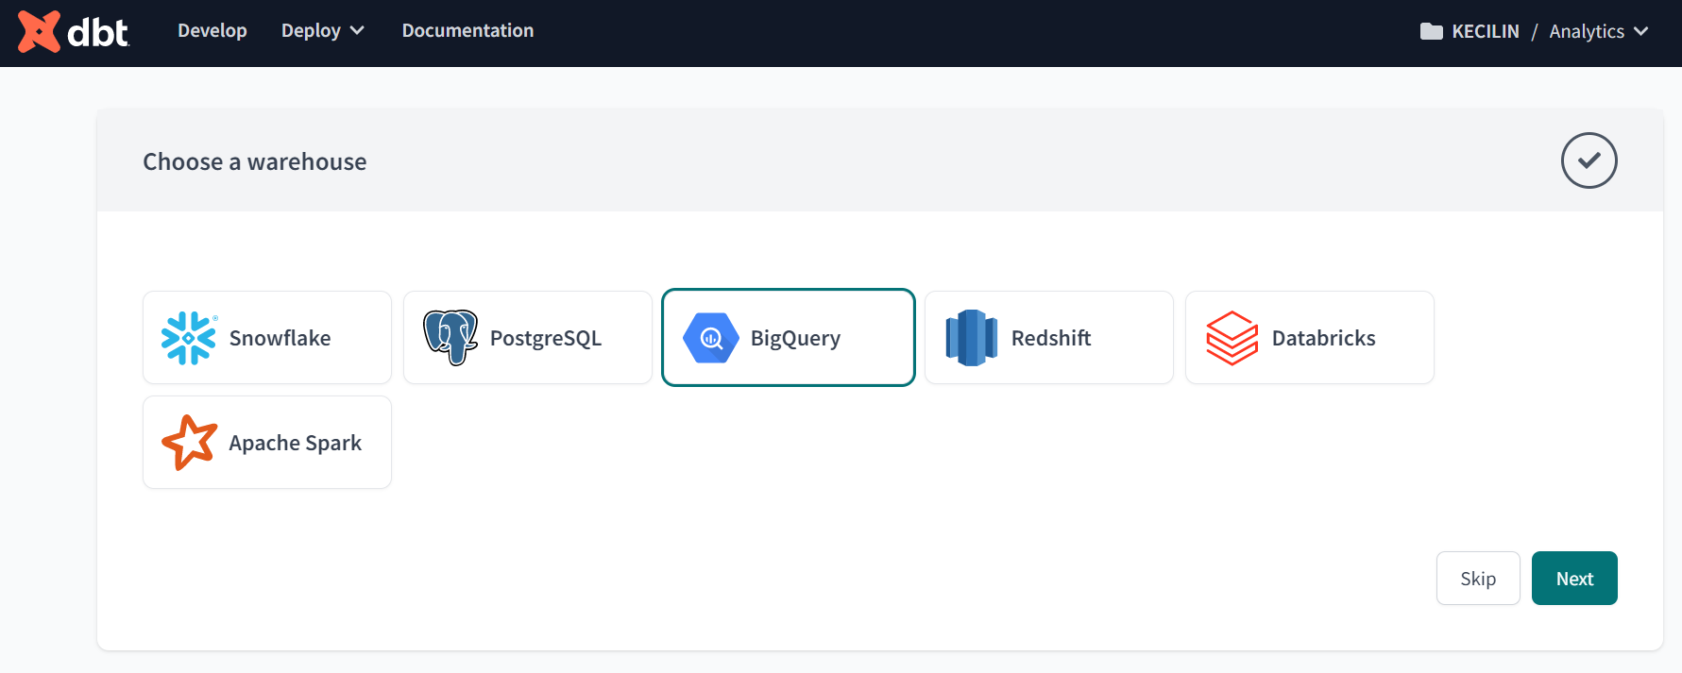

* 1. Configure your environment

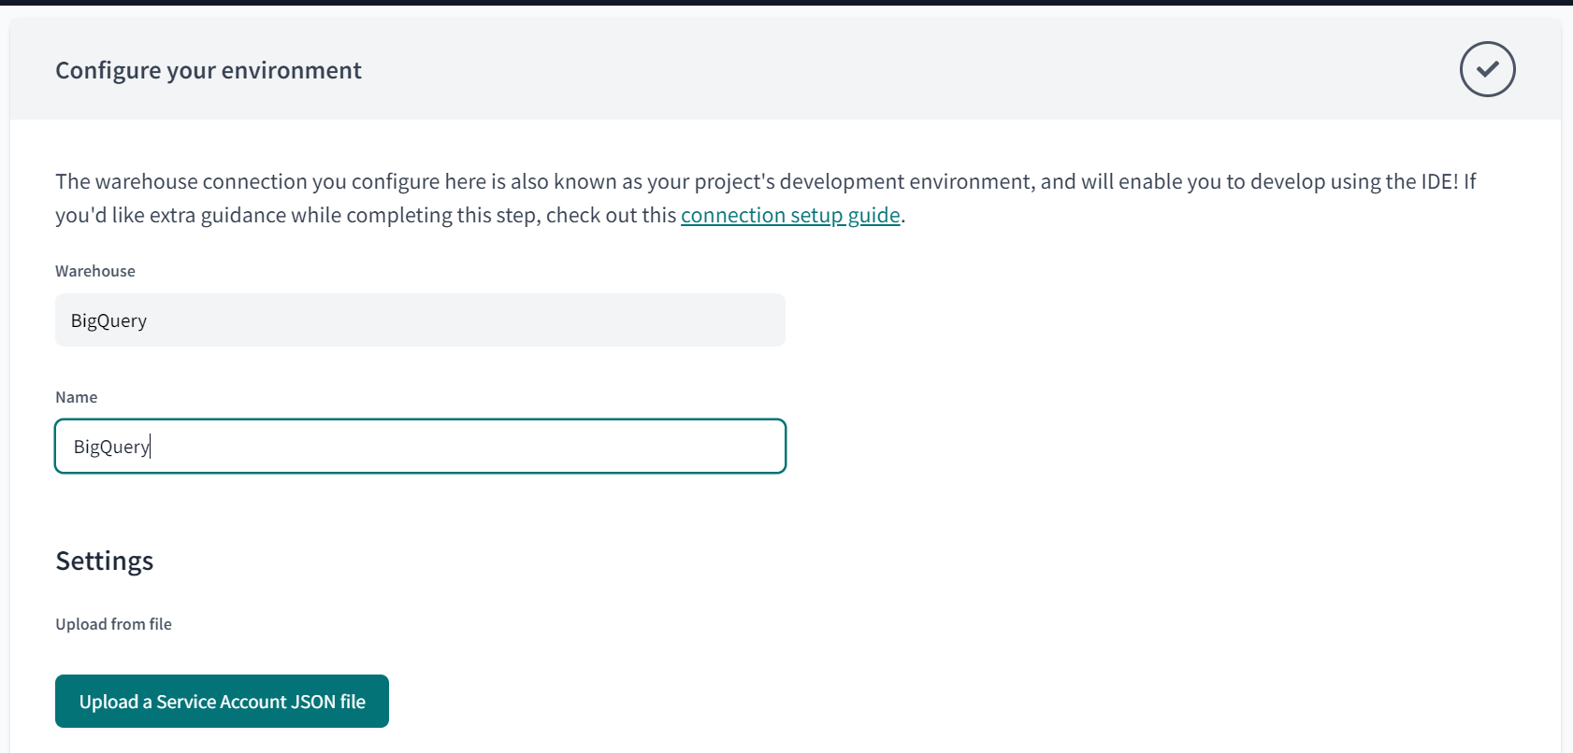

Upload service json from you big query, if you are done upload service.json the data can automatic fill by sistem.

* 1. Create database target or output and than test connection

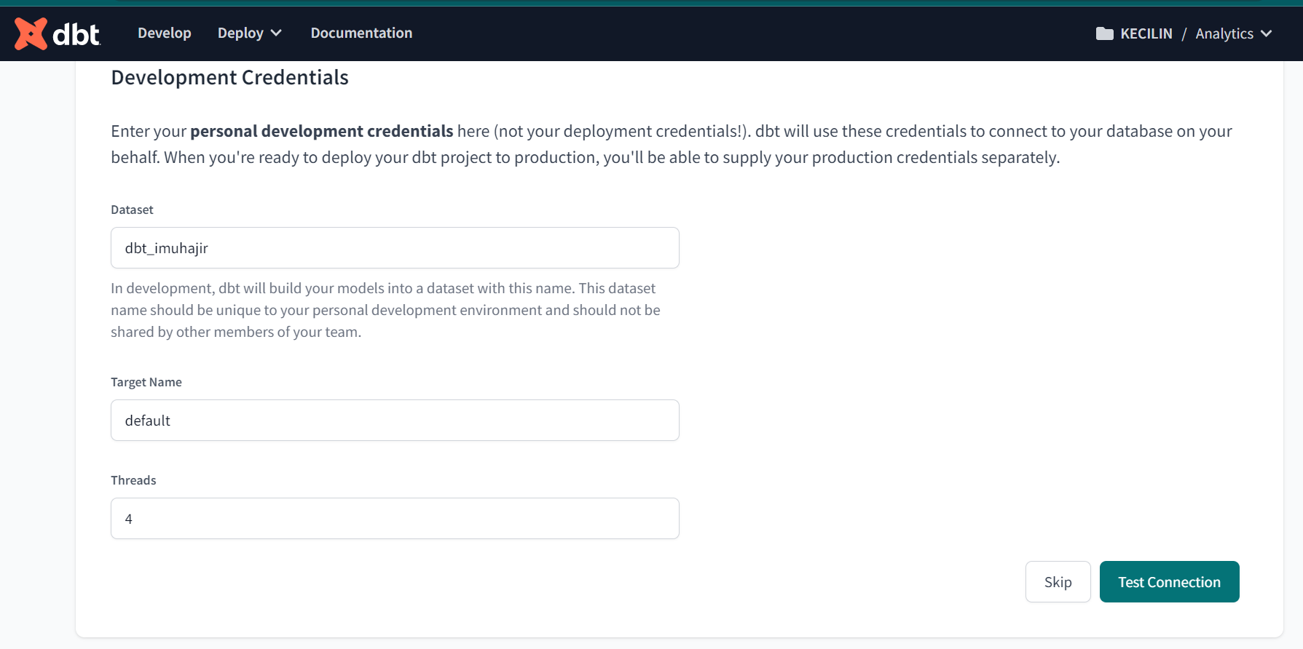

* 1. Set up repository

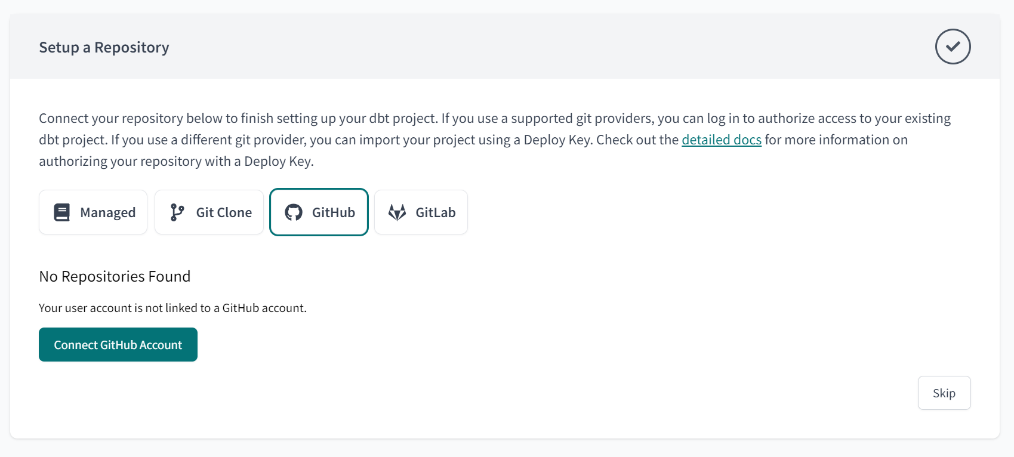

Connect to your github, and choice the repository <https://github.com/muhajir29/dbt-ecommerce>

* 1. Your project is ready

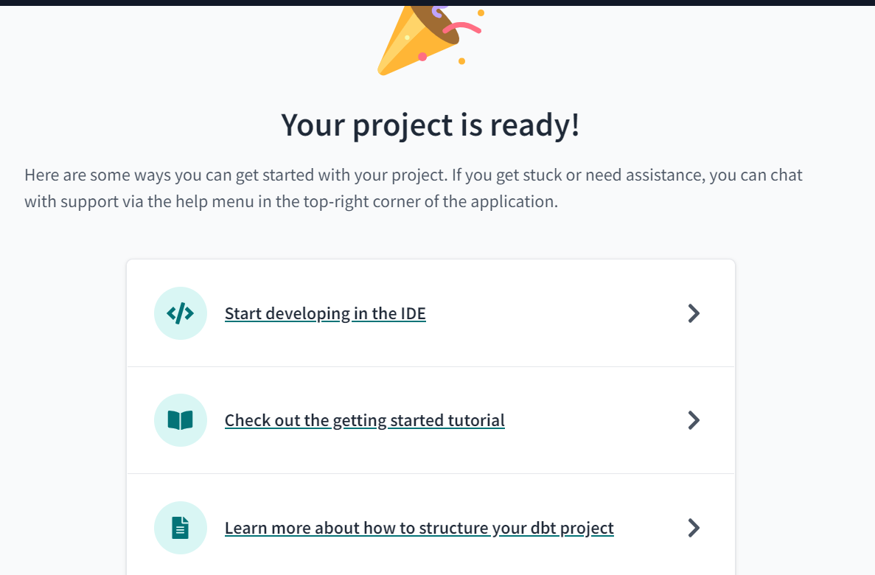

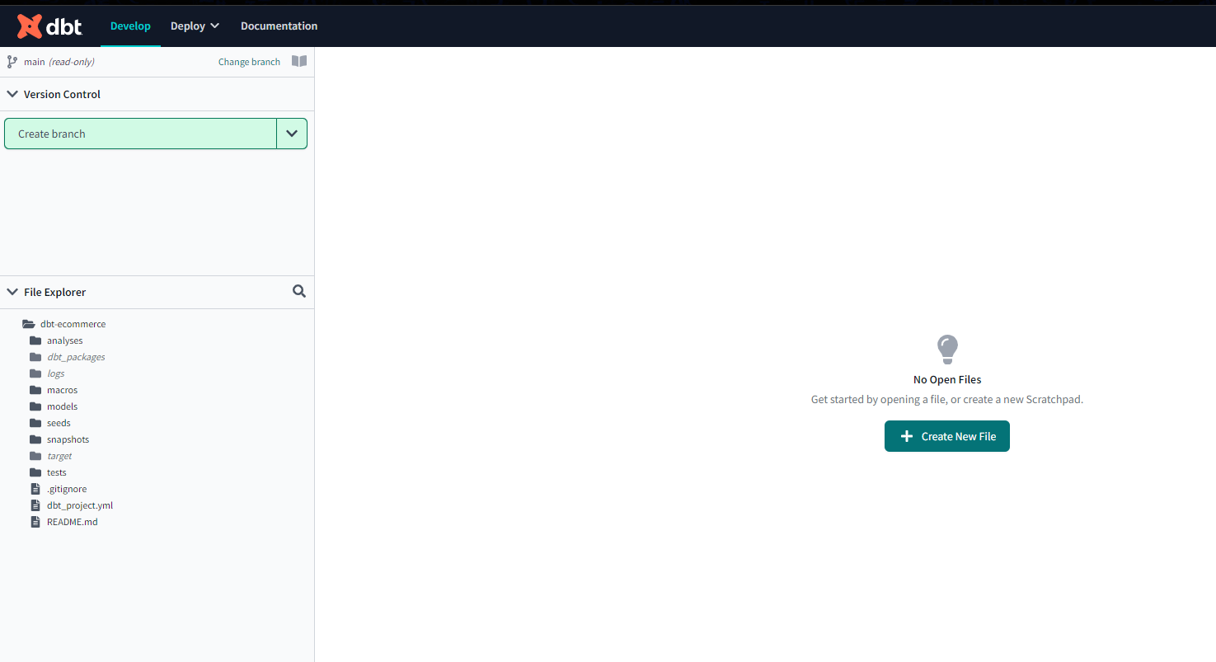

1. Build DBT project

In bottom, typing

“ dbt run”

And than

“dbt test”

If evertything already done

You can see output model in BigQuery

1. Create Jobs

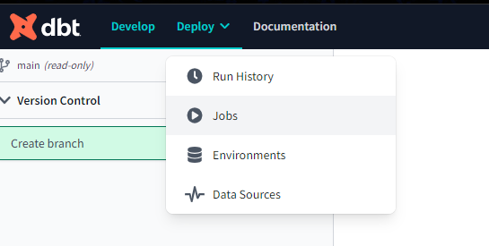

And than



And fill

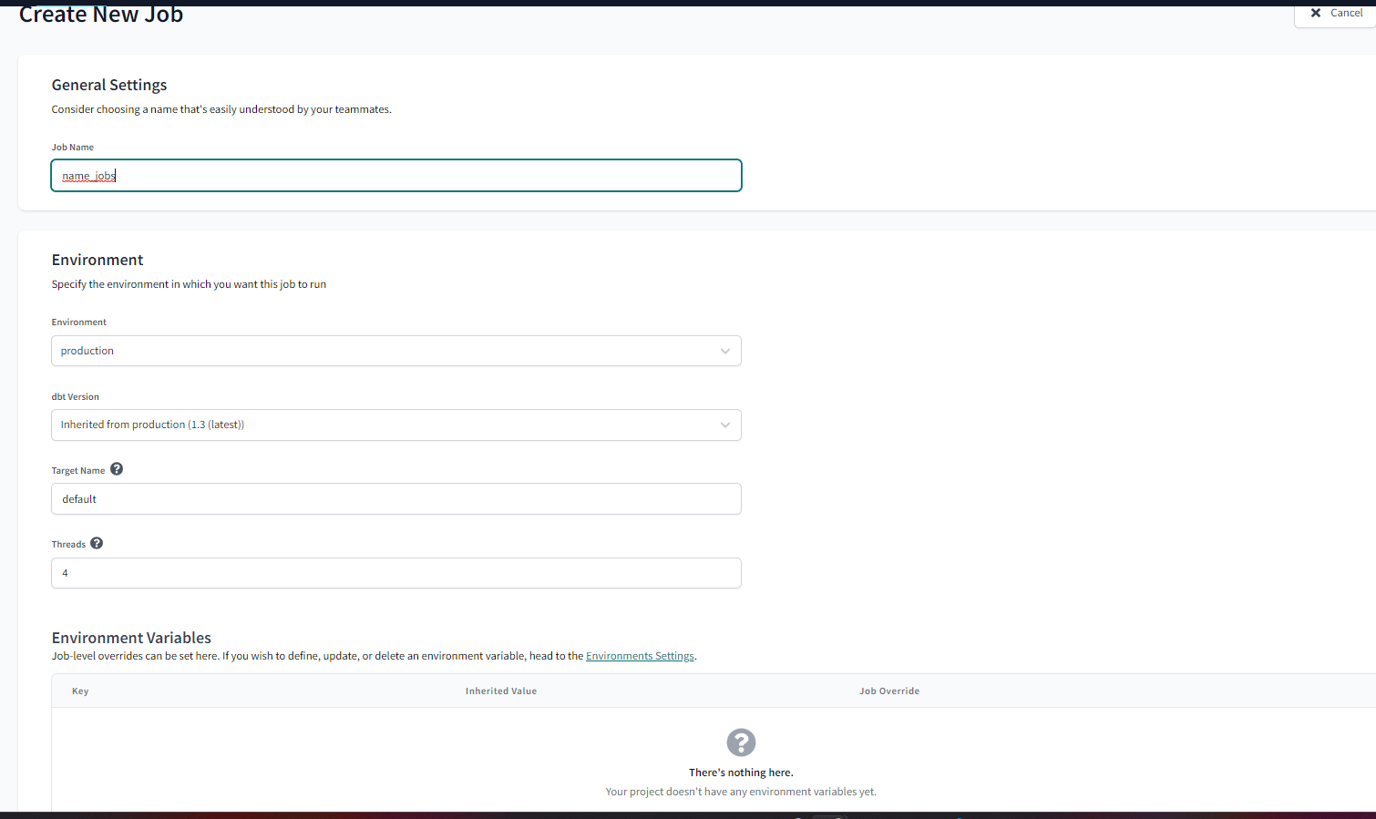

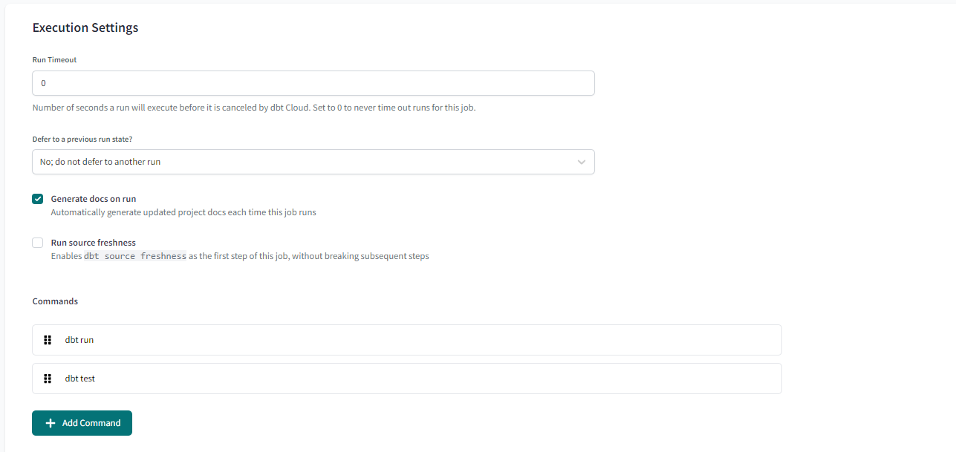

Checklist generate docs on run

And create command like this

And save

Run now

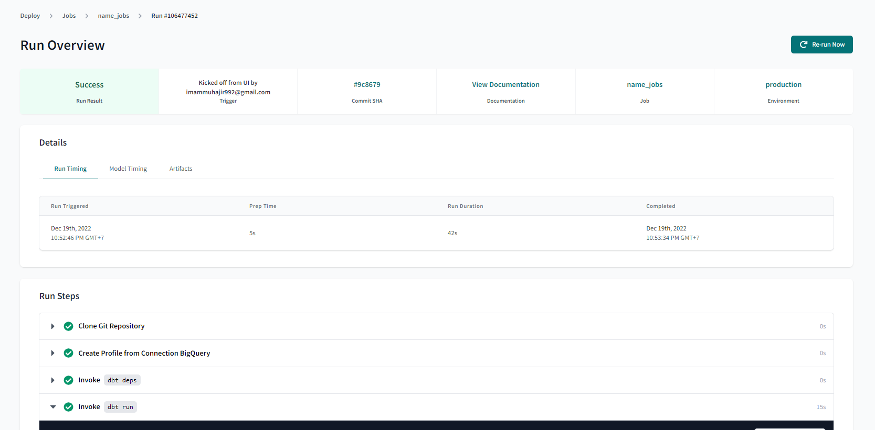

1. View Documentation

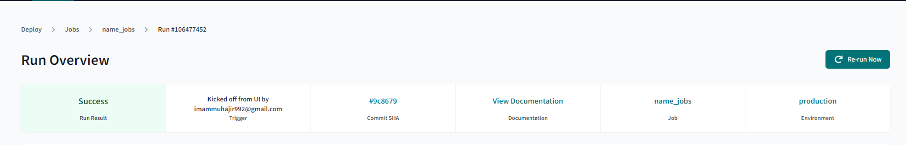

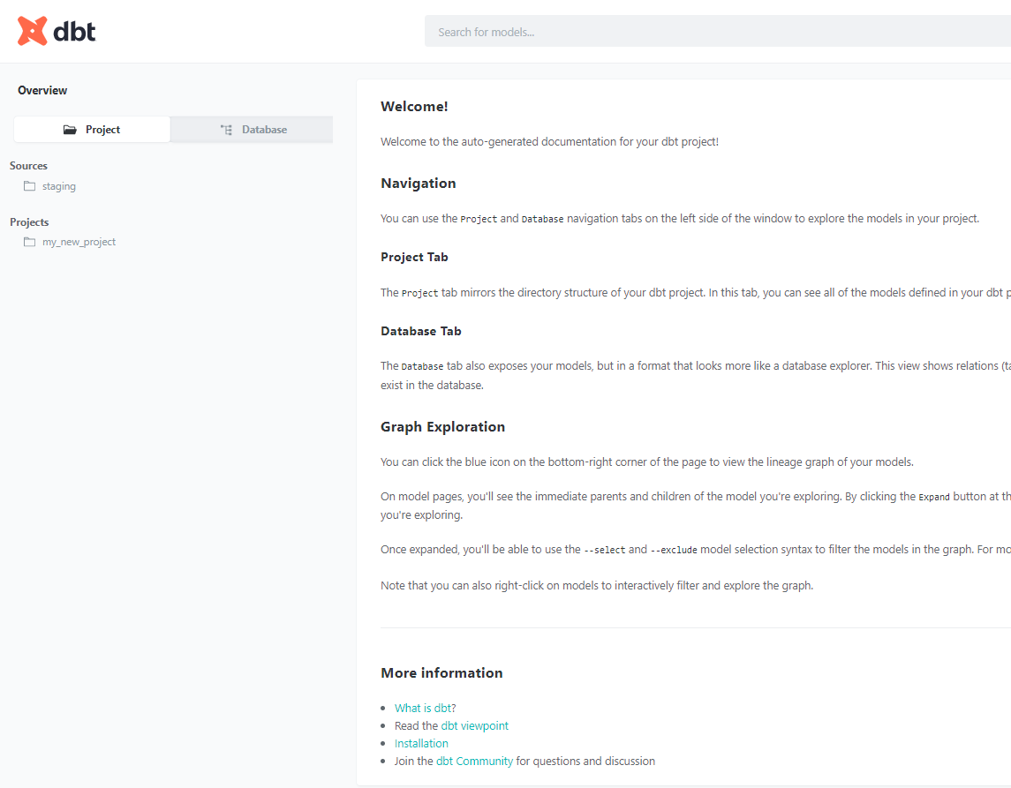

You can se documentation in here, about project or database.

For the testing data.

I am testing data with basic testing like unique, not null and reference.

and this in linegraph, you can see to in documentation --> line

