Linear Regression – Azure Designer Tool

Step 1: Create a compute instance to run your Linear regression model – you create this in the Azure Machine Learning workspace under compute
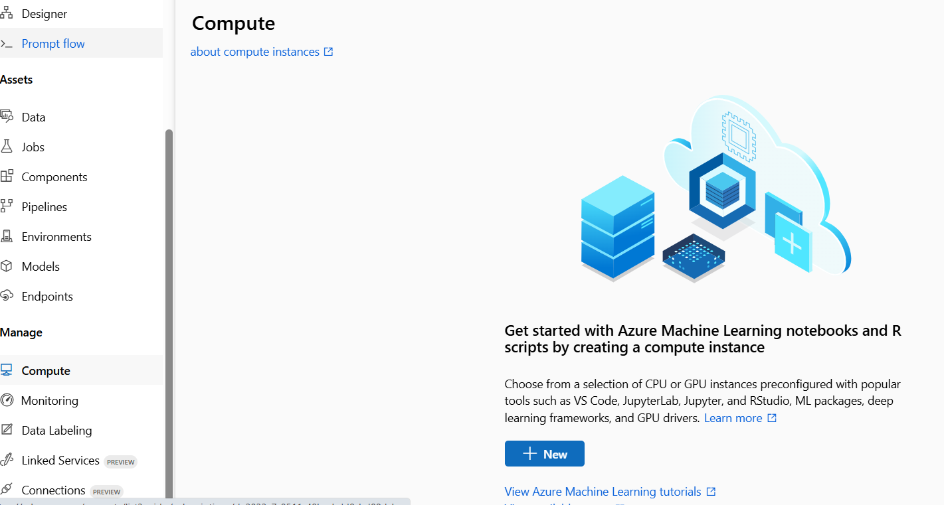
The designer tool does not require a lot of computational power so a standard VM will work
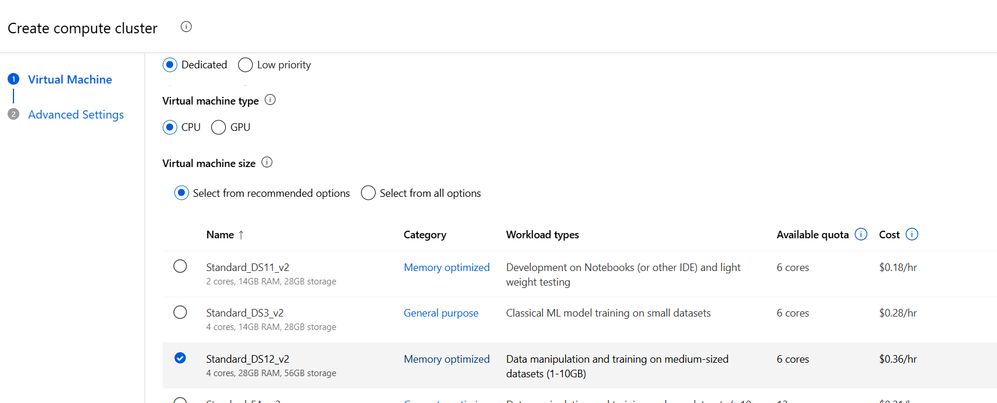
Enable Auto Shutdown – This will shut down the compute instance
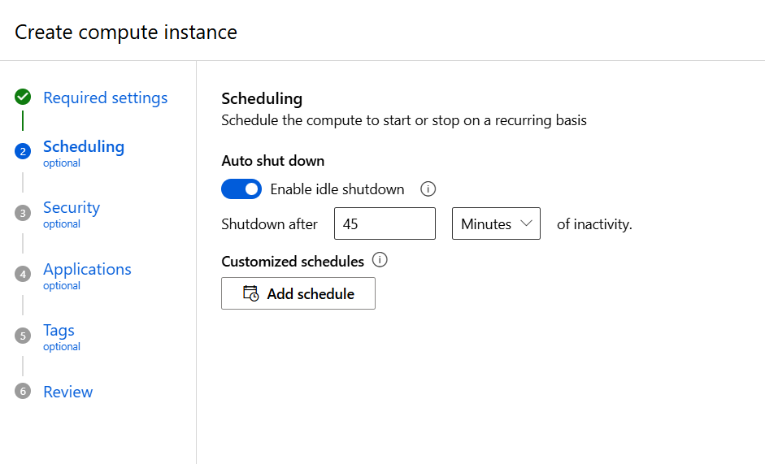

There is no need to add a setup script so we can skip this part and create our compute instance this will take a few minutes to spin up.

Step 2: Lad your dataset into the Blob storage in your Azure portal – your blob storage is automatically created when creating a Machine Learning workspace in Azure.
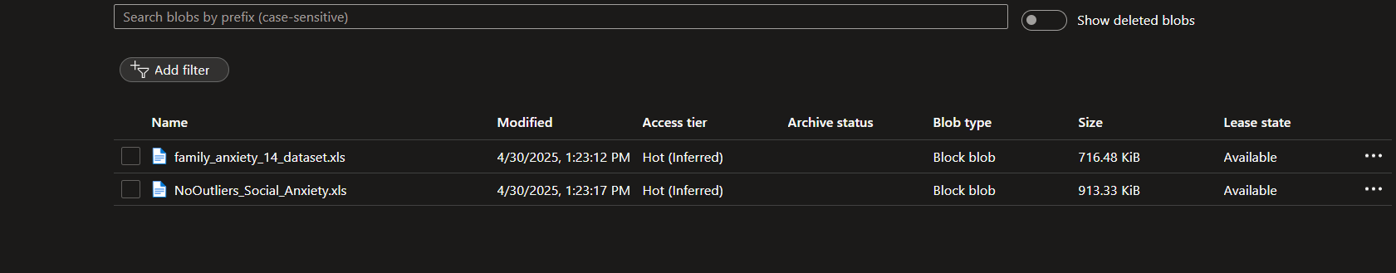

Next you have to create the dataset in azure machine learning workspace – select data from the right side of the menu and select create
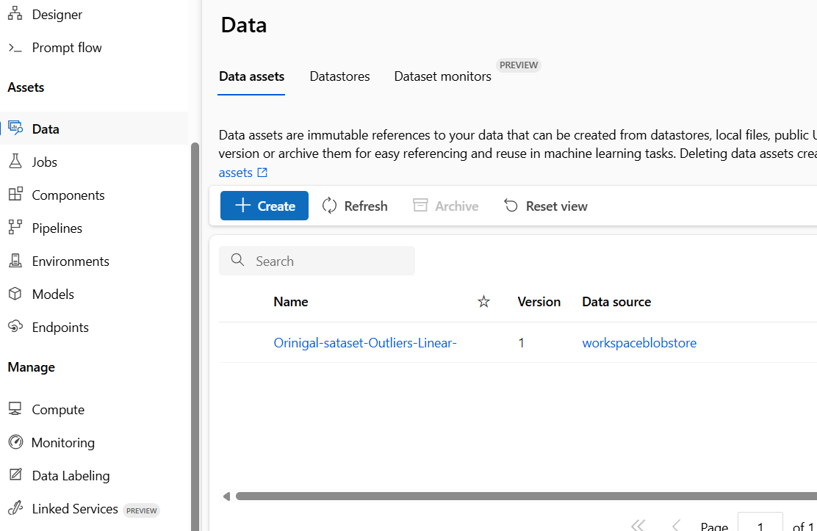

Enter a name for your dataset and select Tabular –choose a source for your dataset - as you have added the dataset to the blob storage you select FROM AZURE STORAGE
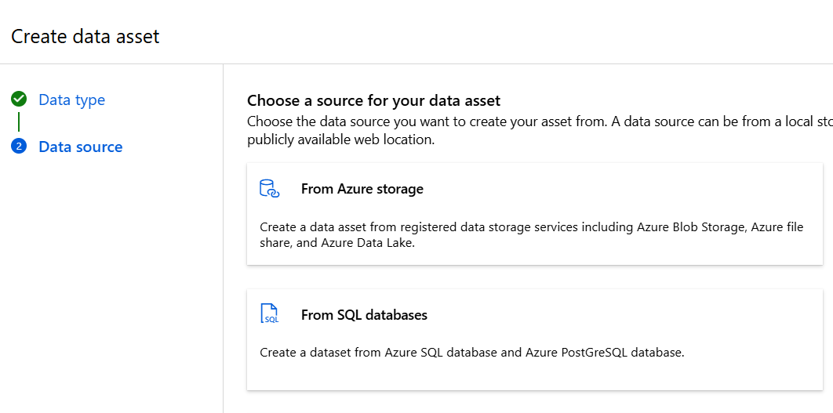

Select workspaceblobstorage and select your dataset which you added in the azure portal. In here you are allowed to preview the data and determine how the data is parsed.

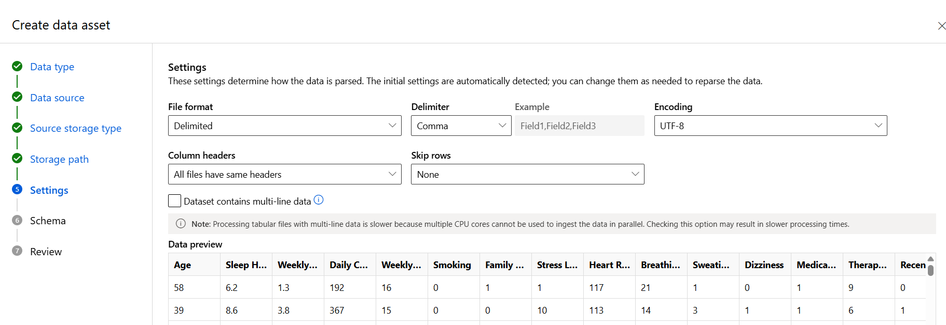

Next you can view the schema of your dataset and remove columns that are not needed like the first column in our schema below – ‘Path’ and the option to change the Data types is available
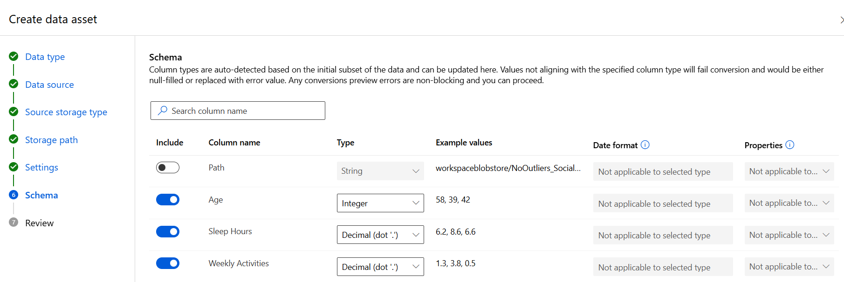
Review and Create

Step 3: Designer Tool – New Pipeline
In the menu select Designer and select new Pipelines
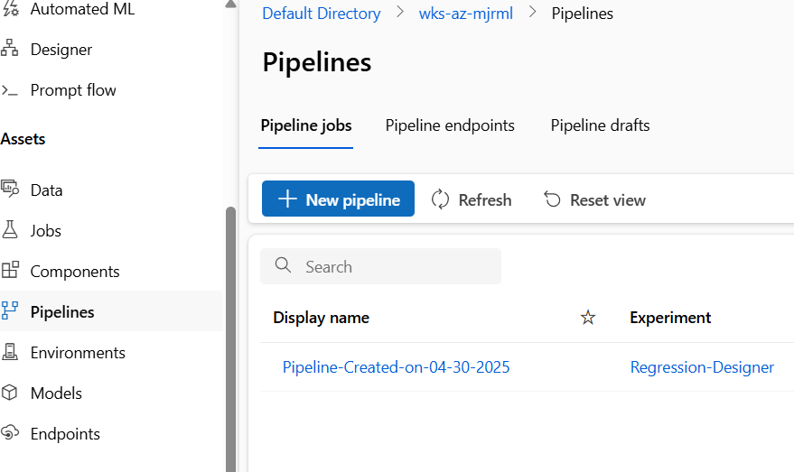

Select a black pipeline
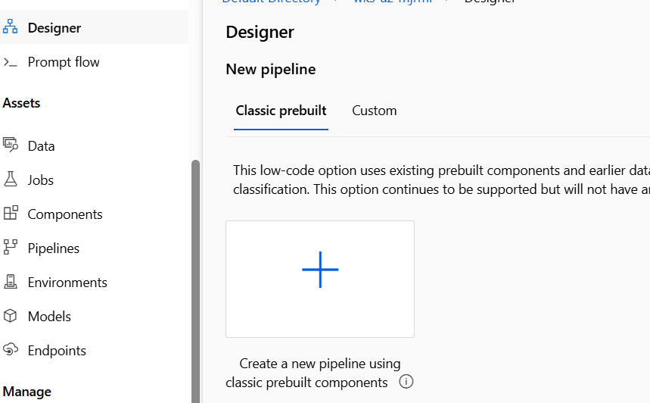

Drag and drop your newly created dataset to the canvas
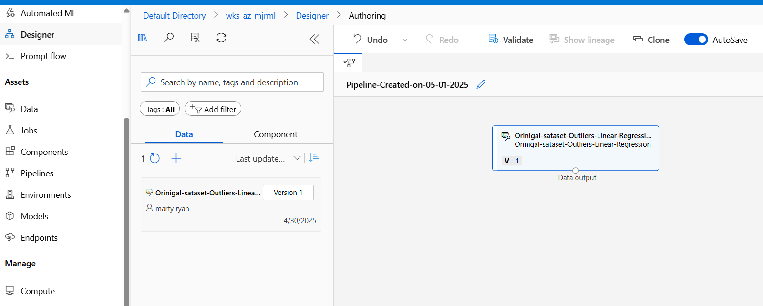

Below is the final structure of our designer tool for the Linear regression model
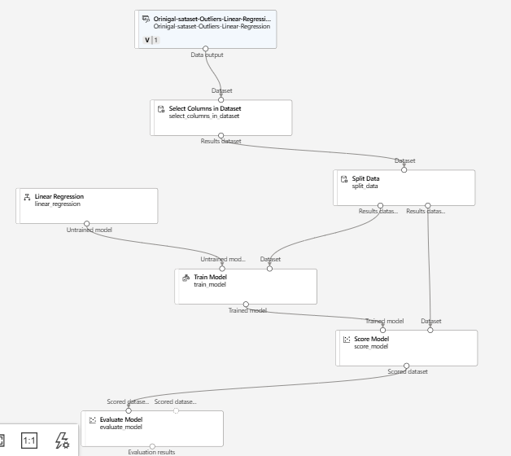
When the Pipeline job has finished you can review the metrics and output logs under job overview
